SUPPLEMENTARY INFORMATION

Production of biostable drinking water using a lab-scale biological trickling filter enriched with hydrogen-oxidizing bacteria

Authors: Jorien Favere^{1,2}, Fien Waegenaar^{1,2}, Mingsheng Jia^{1,2}, Karel Folens^{1,2}, Milan Verhoeven^{1,2}, Elien Balliu^{1,2}, Andreja Rajkovic³, Bart De Gusseme^{1,2,4}, Nico Boon^{1,2*}

¹ Center for Microbial Ecology and Technology (CMET), Ghent University, Coupure Links 653, 9000 Gent, Belgium,
² Center for Advanced Process Technology for Urban Resource Recovery (CAPTURE), Ghent University, 9000 Gent, Belgium
³ Department of Food Technology, Food Safety and Health, Ghent University, Coupure Links 653, 9000 Gent, Belgium
⁴ FARYS|TMVW, Department Innovation Water, Stropstraat 1, 9000 Gent, Belgium

*Corresponding author email: nico.boon@ugent.be

Key words: biostability; bioassay; drinking water distribution system (DWDS); invasion; nutrients

Additional information growing Lelliottia amnigena isolate from – 80 °C.
The strain was grown in R2A (3 g/L, 24 h at 28 °C and 100 rpm), washed thrice and transferred to a diluted R2A broth (50 mg/L, 24 h at 28 °C and 100 rpm). The culture was then washed thrice and the cell concentration was quantified using flow cytometry. Washing was performed by centrifuging (2500 g, 5 minutes), removing supernatant and adding sterile isotonic NaCl (0.85 %) to remove excess nutrients from the culture broth.

Processing of amplicon data
First, forward and reverse reads were assembled into contigs, after which sequences are screened based on their length (between 380 – 435 basepairs) and ambiguity of base calls (max = 0). Alignment was then performed to the Mothur-reconstructed SILVA SEED alignment, v. 138.1 for the 341F and 785Rmod primers. After alignment-based quality filtering, sequences were pre-clustered (difference threshold = 4 base pairs) and chimeras were dereplicated and removed (VSEARCH v. 2.13.3). Classification was performed by assigning taxonomy using a naive Bayes classifier (Wang et al. 2007) and SILVA v. 138.1, and contigs were clustered into OTUs at 97% sequence similarity (final sequence lengths between 381 and 432 basepairs). All sequences that were classified as Eukaryota, Archaea, Chloroplasts, Mitochondria and those that could not be classified were removed. For each OTU representative sequences were picked as the most abundant sequence within that OTU. Also, singletons (OTUs that were present in a sample in a total read count of 1 or less) were removed. Samples with final read counts below 9 000 (n = 2) were removed. This resulted in a data set of 35 samples with read counts between 9247 and 86 463 (median = 42 317). For biofilm samples, the sequencing data obtained by sequencing duplicate samples per sampling time was pooled before processing, as they had a similar microbial community composition (Figure SI.1).
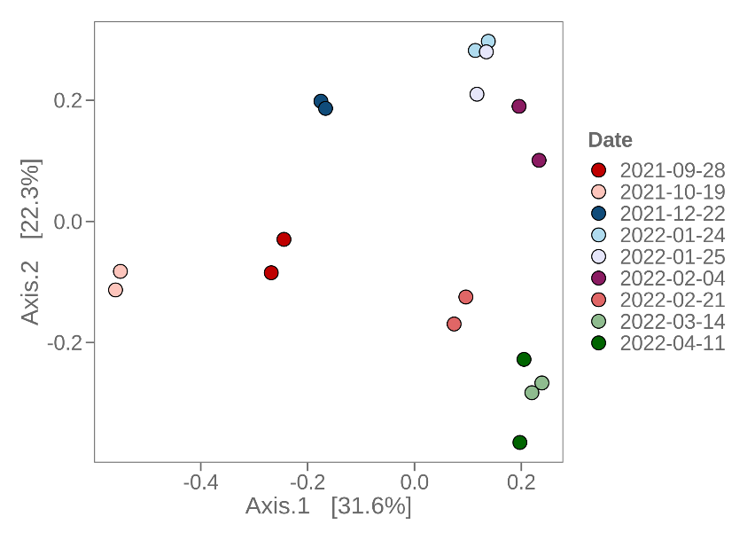
Figure SI.1 – Beta diversity of the microbial community composition of the biofilm samples taken throughout the experimental phase. Samples taken at the same sampling time cluster together, and were pooled for further analysis.
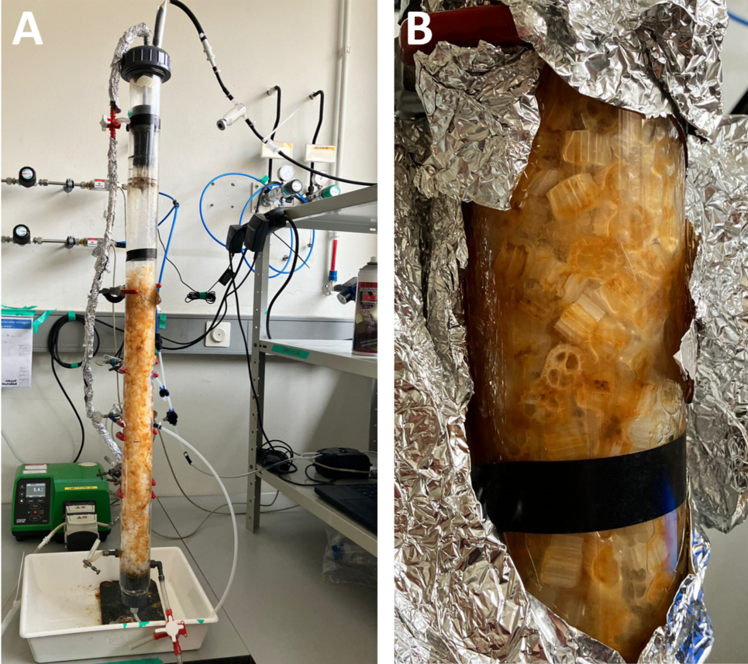
Figure SI.1 – (A) Picture of the reactor setup without aluminum foil. (B) Close-up of the biofilm formed after the second stage with recirculation for natural enrichment and biofilm formation.

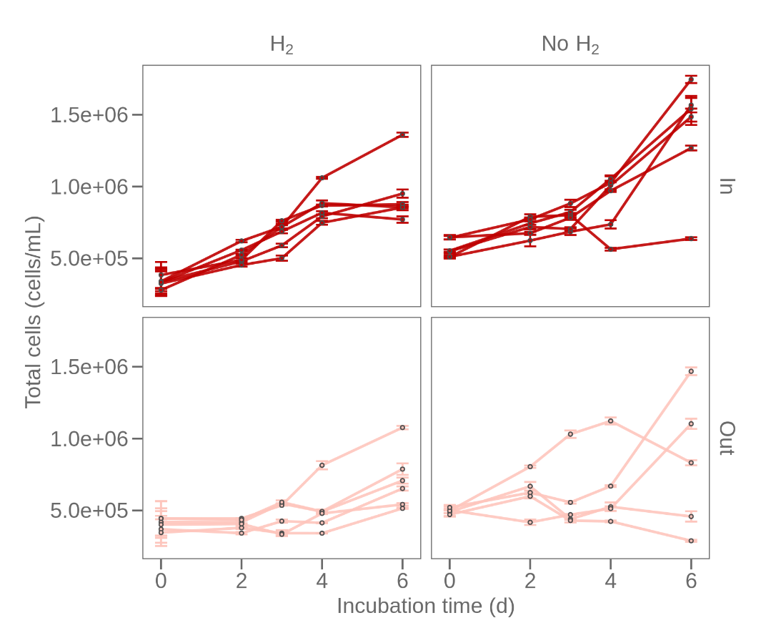
Figure SI.2 – Regrowth potential of all replicates at the in- and outlet of the trickling filter, tested with (n = 2 x 6) and without (n = 2 x 6) hydrogen supply.
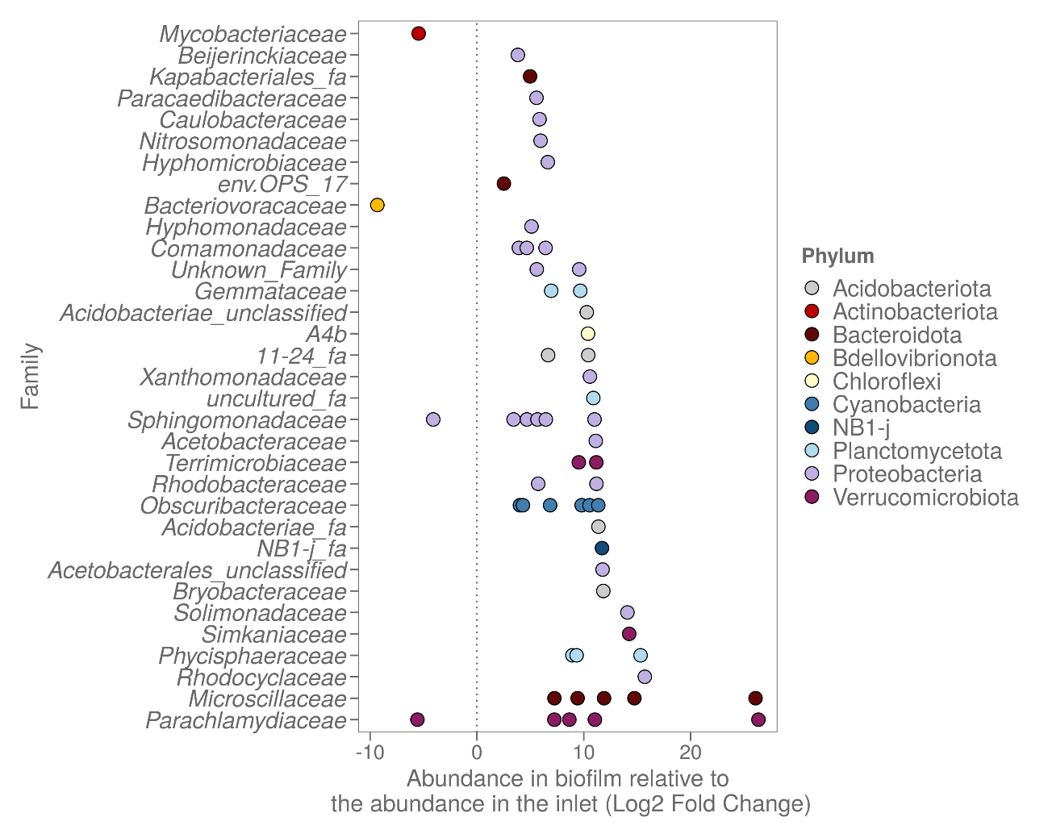
Figure SI.3 – Differential analysis of the microbial community in the biofilm compared to the water at the inlet. Only OTUs with significant changes in abundance are taken into account (visualized the 60 most abundant of 158 differentially enriched OTUs, p < 0.05). Positive values indicate a significantly higher abundance in the biofilm, whereas negative values indicate a significantly lower abundance of this OTU in the biofilm. A log with base 2 is the effect size estimate of the in- or decrease in abundance.

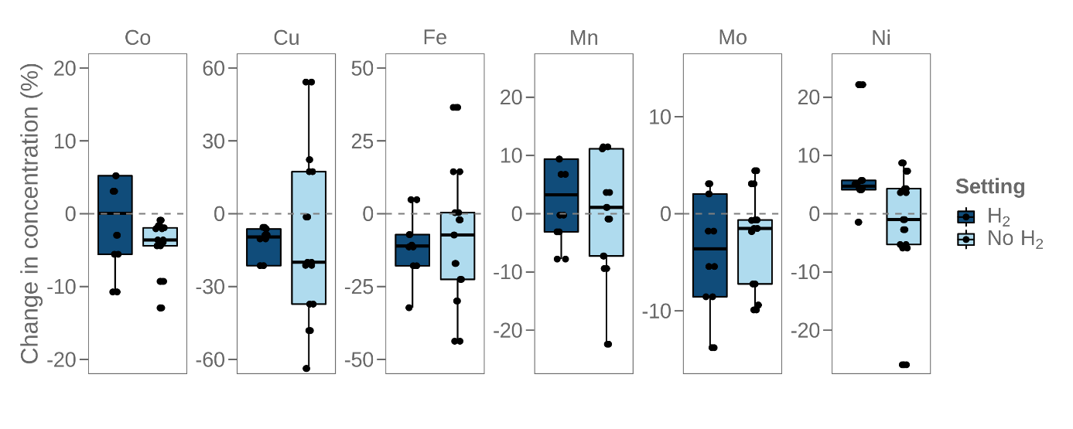
Figure SI.4 – Change in micronutrient concentration through the trickling filter (dots = samples). Values < 0 indicate a lower concentration in the outgoing water (removal), whereas values > 0 indicate an increase in the concentration of the outgoing water (addition).
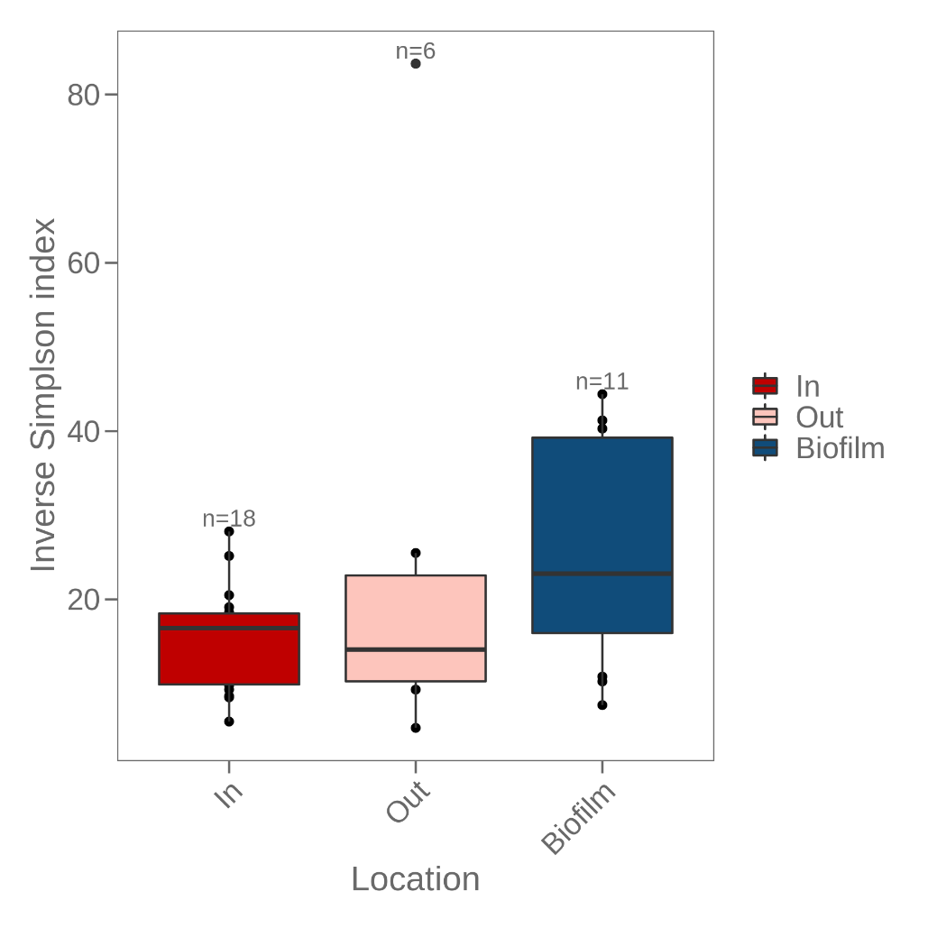
Figure SI.5 – Boxplot of the alpha diversity of the microbial community at the different locations in the trickling filter, measured using the Inverse Simpson index. No significant difference was observed between the different locations.

