Supplementary Information to:

UNRAVELING KEY FEATURES OF BACTERIAL ALPHA-DIVERSITY METRICS AND THEIR PRACTICAL APPLICATIONS

List of Supplementary Information

The following materials are included in the online Supporting Information, i.e., this pdf document.

Supplementary figures to “Results” and “Discussion” sections.
Supp. Figure S1a. Relationship between the abundance of each sample and alpha metrics, included in the Abundance category.
Supp. Figure S1b. Chart of Abundance metrics correlation matrix.
Supp. Figure S1c. Relationship between the dominance of each sample and alpha metrics included in the Dominance category.
Supp. Figure S1d. Chart of Dominance metrics correlation matrix.
Supp. Figure S1e. Relationship between the Information of each sample and alpha metrics included in the Information category.
Supp. Figure S1f. Chart of Information metrics correlation matrix.

Supplementary information to PCA performed in each category, “Results” section.
Supp. Table S1. PCA report from each category.
Supp. Figure S2. PCA vectors of each category.

Supp. Table S2. Experimental studies that apply alpha metrics to its results.

Supp. Table S3. Metadata of the 15 public human microbiota experimental bioprojects used to perform the selected alpha metrics.

Supp. Table S4. Table with alpha diversity mathematical formulas, grouped by categories, included in this study.

Supp. Figure S3. Scatter plot that shows the relationship between Berger Parker metric and the proportion between the most dominant microbe and the second most dominant microbe, applied on the 4,596 samples.

Supp. Figure S4. Correlations among the three proposed metrics as representative for the categories Information (Shannon), Abundance (Observed_features) and Dominance (Berger Parker).

Figure S1a.

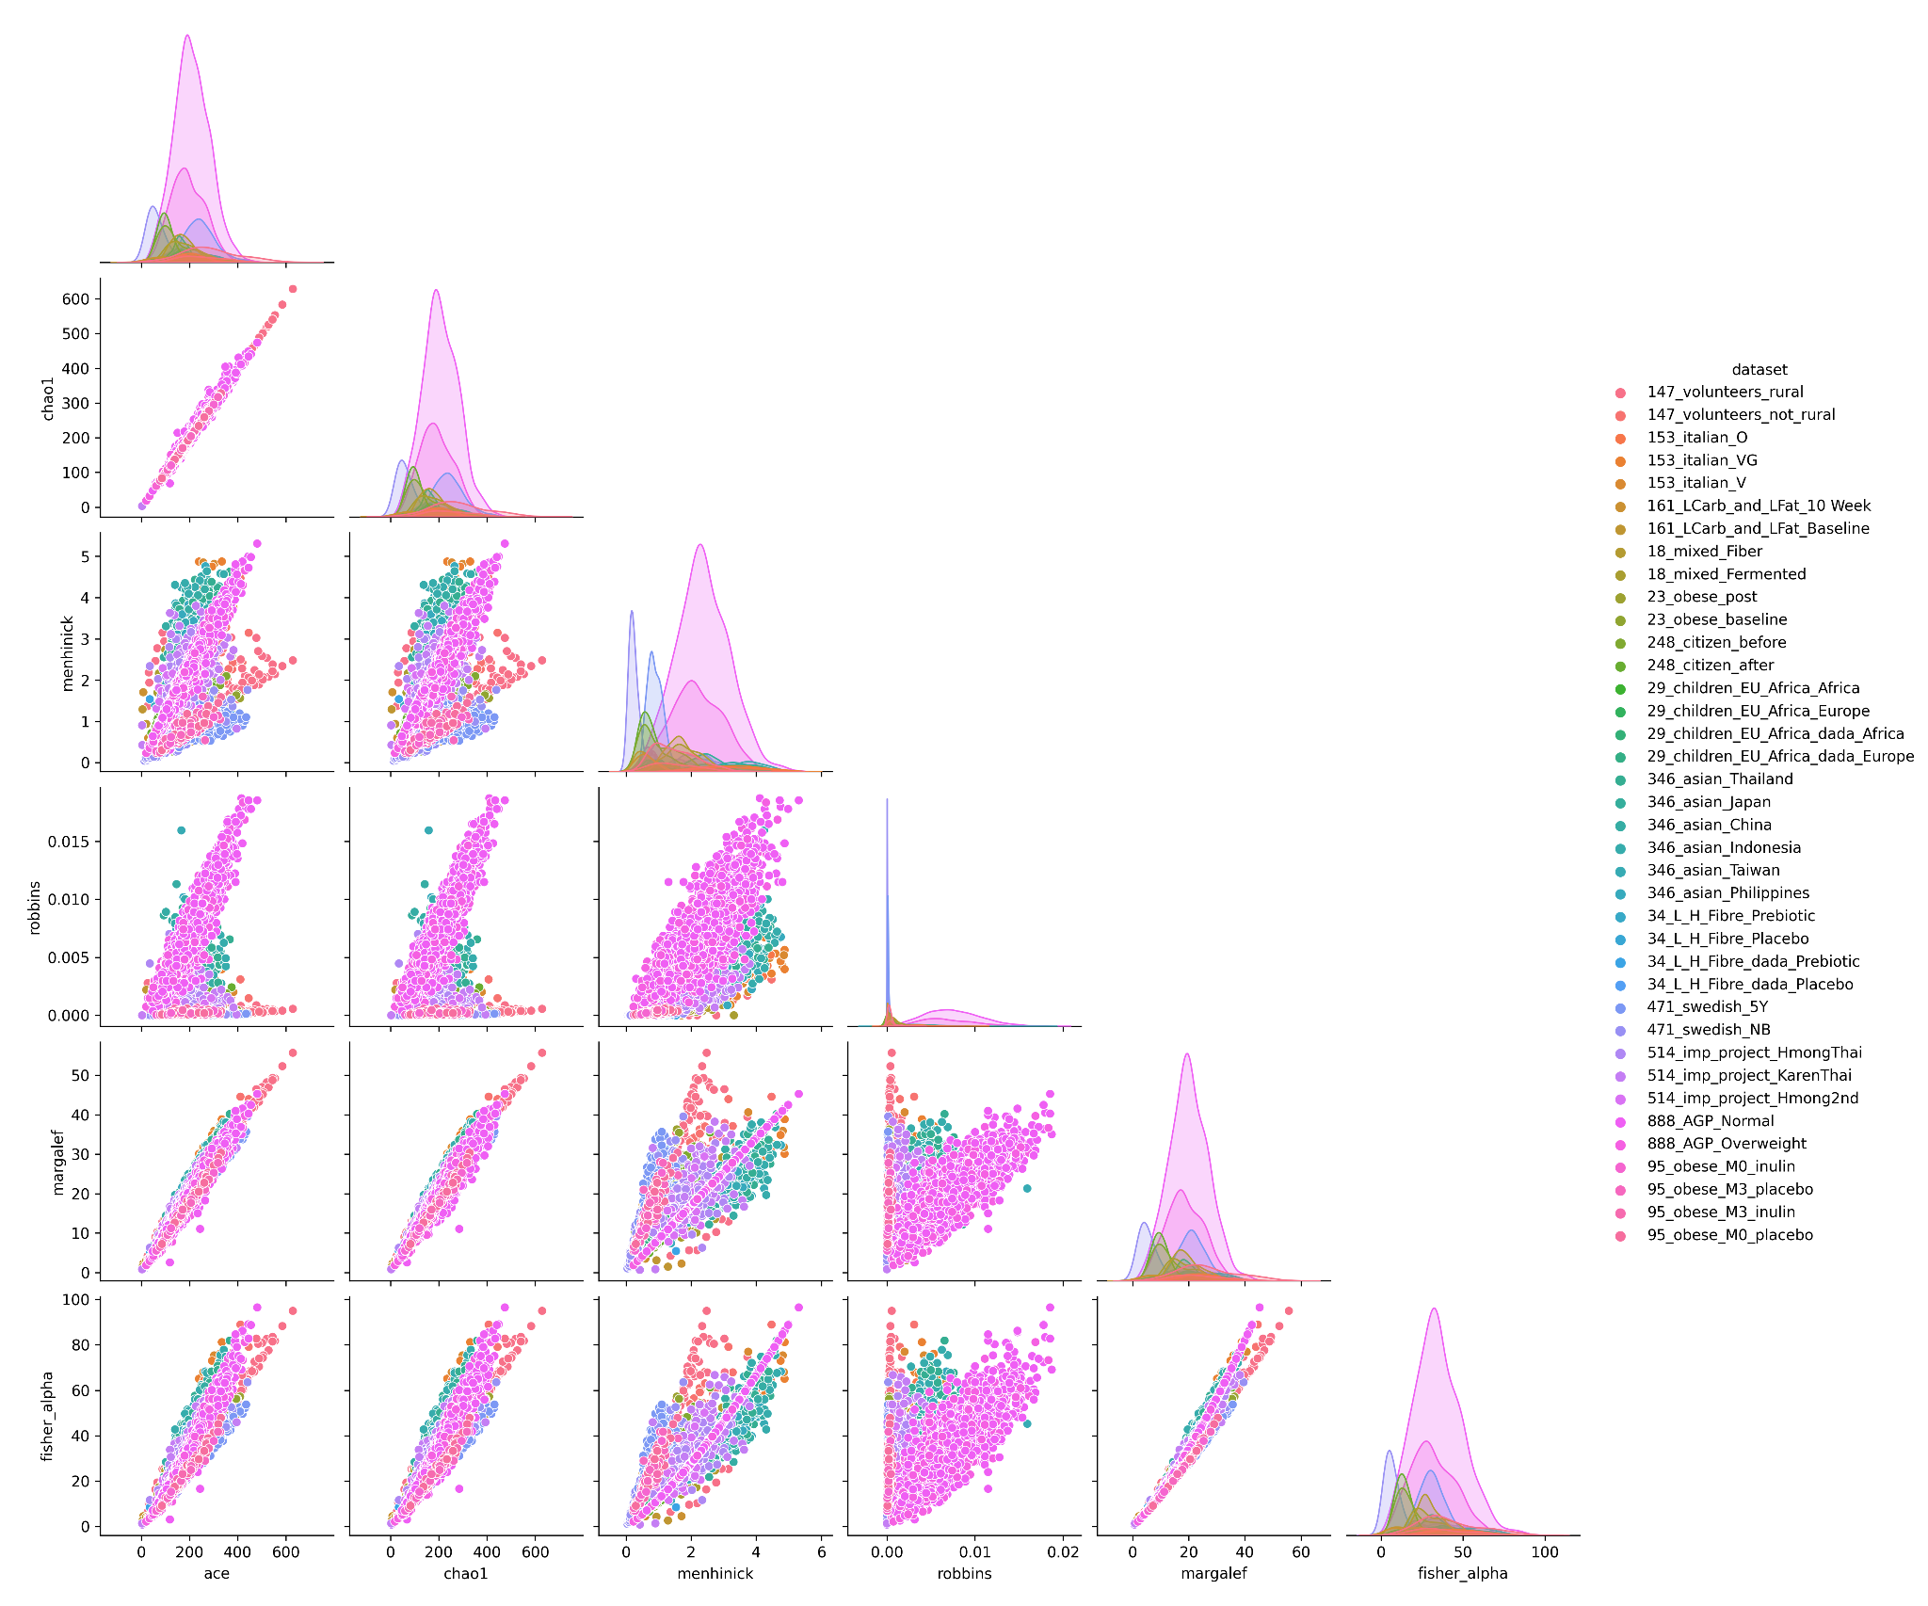

Figure S1b. The distribution of each metric is shown on the diagonal. The bivariate scatter plots with a fitted line are displayed on the bottom of the diagonal. On the top of the diagonal: the coefficient (Pearson method) plus the significance level as stars. Each significance level is associated to symbols as follows: [0 , 0.001) -> "***"; [0.001, 0.01) -> "**"; [0.01 , 0.05) -> "*"; [0.05 , 0.1) -> "." and ; [0.1 , 1) -> " ".
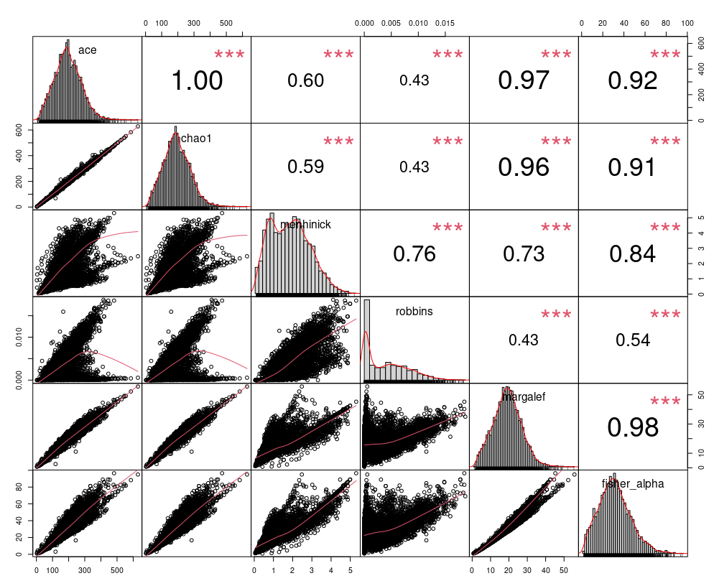

Figure S1c.

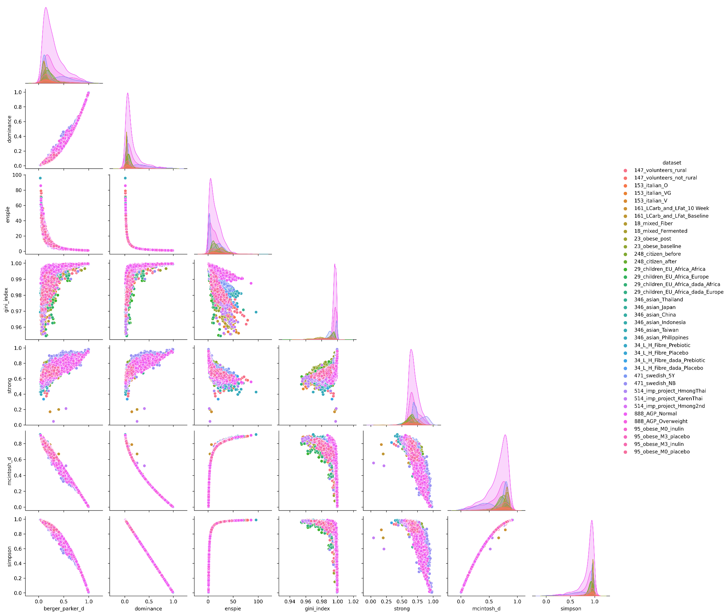

Figure S1d. The distribution of each metric is shown on the diagonal. The bivariate scatter plots with a fitted line are displayed on the bottom of the diagonal. On the top of the diagonal: the coefficient (Pearson method) plus the significance level as stars. Each significance level is associated to symbols as follows: [0 , 0.001) -> "***"; [0.001, 0.01) -> "**"; [0.01 , 0.05) -> "*"; [0.05 , 0.1) -> "." and ; [0.1 , 1) -> " ".

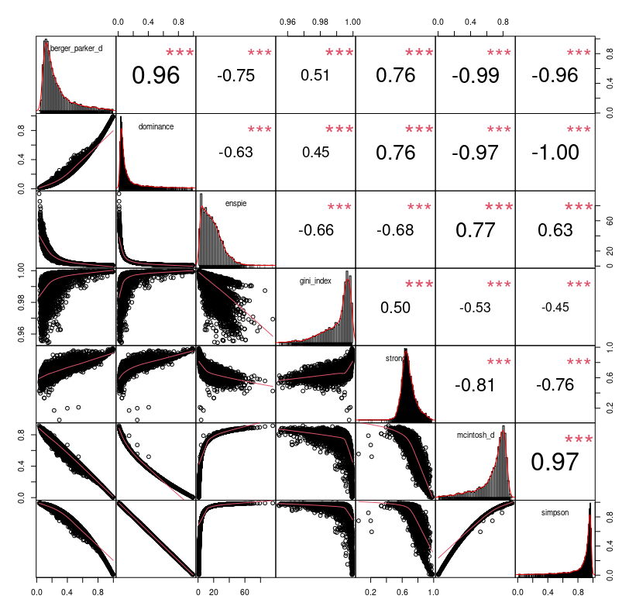

Figure S1e.

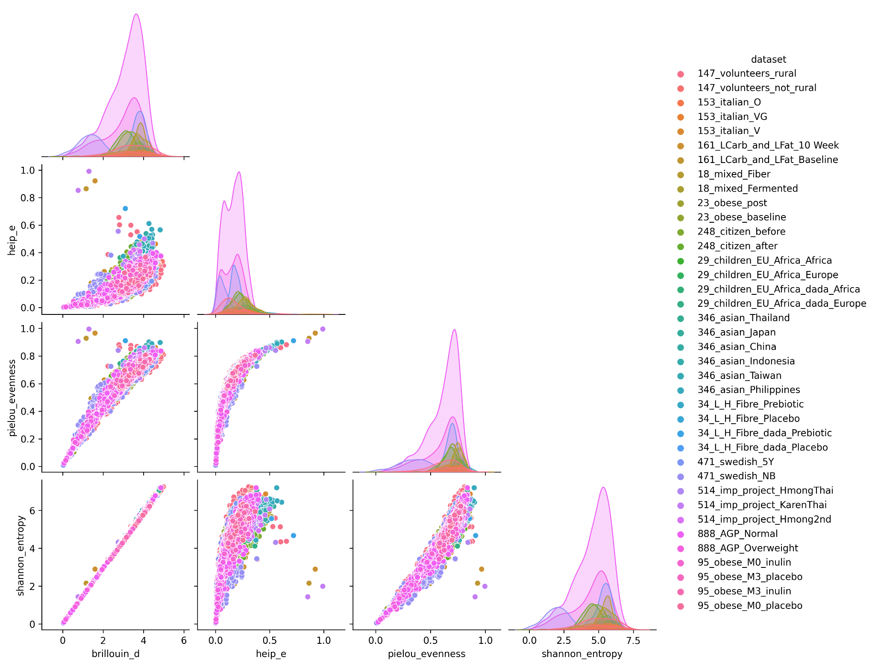

Figure S1f. The distribution of each metric is shown on the diagonal. The bivariate scatter plots with a fitted line are displayed on the bottom of the diagonal. On the top of the diagonal: the coefficient (Pearson method) plus the significance level as stars. Each significance level is associated to symbols as follows: [0 , 0.001) -> "***"; [0.001, 0.01) -> "**"; [0.01 , 0.05) -> "*"; [0.05 , 0.1) -> "." and ; [0.1 , 1) -> " ".
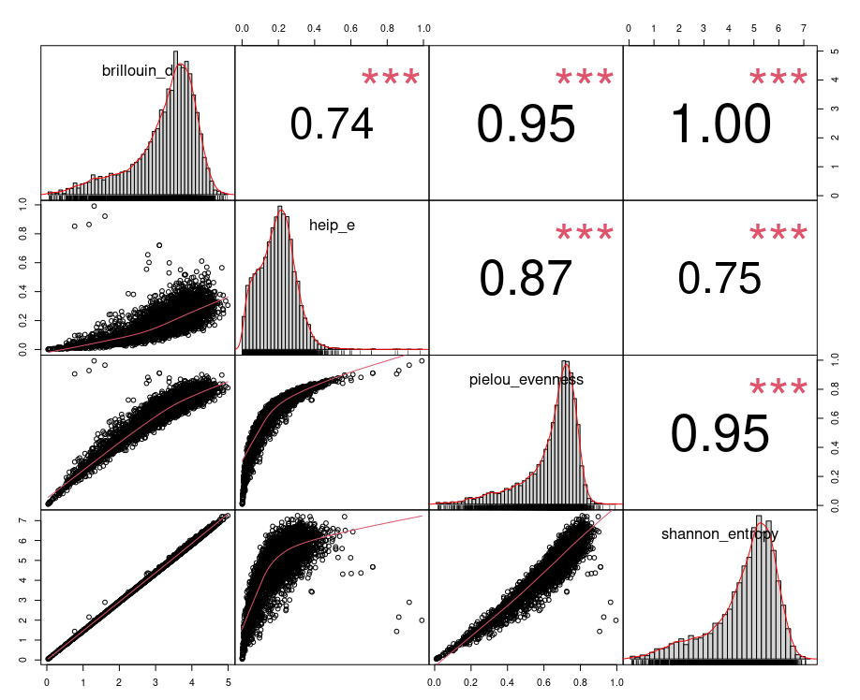

Supplementary information to PCA performed in each category, “Results” section.

PCA was performed on each category with the 4596 samples in order to provide robustness to the clustering proposal. The report of the first two principal components is shown in Table S2.

Table S1. PCA report from each category.

 | Abundance |  | Dominance |  | Information
 | PC1 | PC2 | PC1 | PC2 | PC1 | PC2
Standard deviation | 2.183 | 0.975 | 2.152 | 0.865 | 1.906 | 0.579
Proportion of Variance | 0.794 | 0.158 | 0.772 | 0.124 | 0.908 | 0.084
Cumulative Proportion | 0.794 | 0.953 | 0.772 | 0.897 | 0.908 | 0.992

Figure S2. PCA vectors of each category.
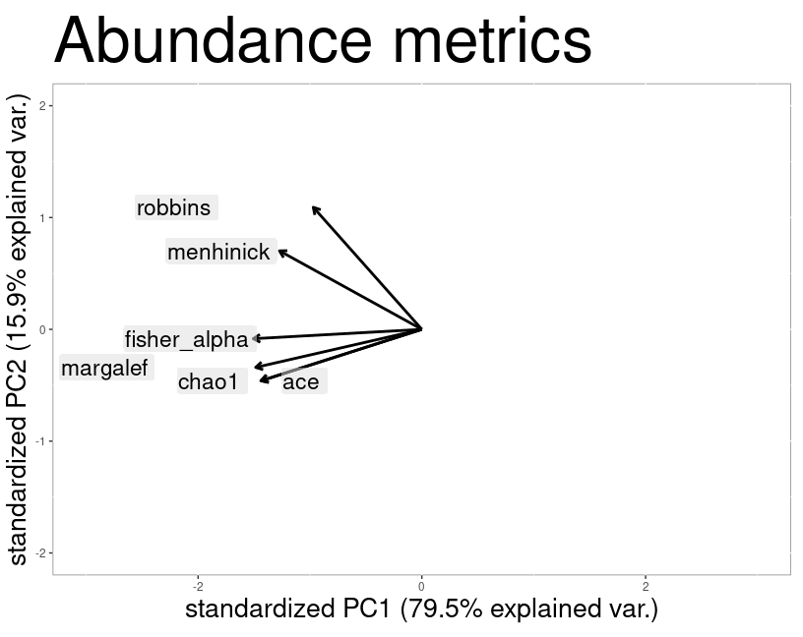
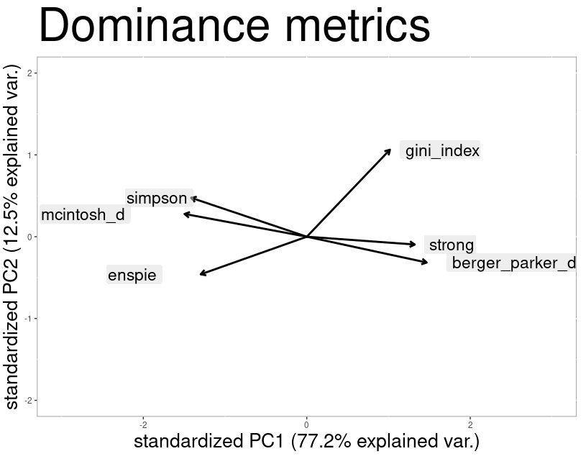
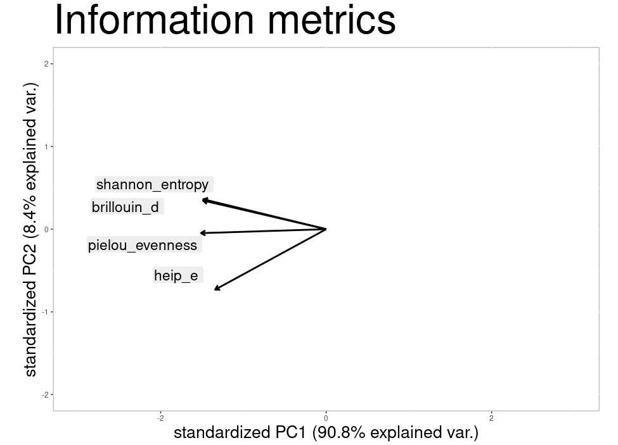
b
c
a

Abundance. Figure S2a shows that Robbins and Menhinick are closely characterized and Margalef, Chao1, ACE and Fisher are also close vectors. These results are coherent with correlation analysis (in the Additional Information Section, Figure S1a). PC1 and PC2 of Abundance Category explain 95.2 % of the total variance among all abundance metrics.
Dominance. Figure S2b supports observations related to the Gini metric in the theoretical analysis section: the vector of this metric is not related to the others. Strong and Berger Parker vectors are closely characterized and it is coherent with the correlation analysis reported in the Additional Information Section, Figure S1b. The same remark is applicable to Simpson and Mcintosh vectors. The opposite directions are also coherent since they have negative correlation. The total variance corresponding to PC1 and PC2 is 89.6 % among all dominance metrics.
Information: All vectors of Figure S2c contribute to the same direction and it is coherent since, as reported, all metrics grouped in the information category inherit from the mathematical Shannon formula. PC1 and PC2 of this category explain 99.2 % of the total variance.

Table S2. Selected experimental studies that apply alpha-diversity metrics to its results.

Cod | Link | Chao1 | Shannon | Observed | Simpson | Jost | Berger-Parker | ACE | Reyni | Faith | fisher | Gini | Pielou | Magalef
1 | Gut Microbiota and Dietary Intake of Normal-Weight and Overweight Filipino Children | x | x
2 | Response of the Human Milk Microbiota to a Maternal Prebiotic Intervention Is Individual and Influenced by Maternal Age | x | x | x
3 | Using compositional principal component analysis to describe children's gut microbiota in relation to diet and body composition |  | x
4 | Structured exercise alters the gut microbiota in humans with overweight and obesity—A randomized controlled trial |  | x | x
5 | Longitudinal gut microbiome changes in alcohol use disorder are influenced by abstinence and drinking quantity |  | x
6 | Impact of Individual Traits, Saturated Fat, and Protein Source on the Gut Microbiome |  | x
7 | Randomized controlled trial on the impact of early-life intervention with bifidobacteria on the healthy infant fecal microbiota and metabolome |  |  | x |  | x
8 | Multidomain analyses of a longitudinal human microbiome intestinal cleanout perturbation experiment |  | x
9 | Impact of Dietary Resistant Starch on the Human Gut Microbiome, Metaproteome, and Metabolome |  | x
10 | Exercise and associated dietary extremes impact on gut microbial diversity |  | x |  | x
11 | Short-Term Effect of Antibiotics on Human Gut Microbiota | x |  | x
12 | Diet rapidly and reproducibly alters the human gut microbiome |  | x
13 | Alterations in intestinal microbiota of elderly Irish subjects post-antibiotic therapy | x | x | x | x |  |  |  |  | x
14 | Differential Responses to Dietary Protein and Carbohydrate Ratio on Gut Microbiome in Obese vs. Lean Cats |  | x | x |  |  |  |  |  | x
15 | Diabetic cats have decreased gut microbial diversity and a lack of butyrate producing bacteria | x | x | x | x
16 | Diabetic cats have decreased gut microbial diversity and a lack of butyrate producing bacteria | x | x | x | x
17 | Synbiotic-driven improvement of metabolic disturbances is associated with changes in the gut microbiome in diet-induced obese mice |  | x | x
18 | Diet-Microbiome Interactions in Health Are Controlled by Intestinal Nitrogen Source Constraints |  |  |  | x |  |  |  | x
19 | Prolonged transfer of feces from the lean mice modulates gut microbiota in obese mice | x |  |  | x
20 | Diet-induced extinctions in the gut microbiota compound over generations |  | x
21 | Unusual sub-genus associations of faecal Prevotella and Bacteroides with specific dietary patterns |  |  | x
22 | Ethnic diversity in infant gut microbiota is apparent before the introduction of complementary diets |  | x
23 | Persistent gut microbiota immaturity in malnourished Bangladeshi children |  | x
24 | The effect of legume supplementation on the gut microbiota in rural Malawian infants aged 6 to 12 months |  |  |  |  |  |  |  |  | x
25 | The Pervasive Effects of an Antibiotic on the Human Gut Microbiota, as Revealed by Deep 16S rRNA Sequencing |  |  |  |  | x
26 | Impact of diet in shaping gut microbiota revealed by a comparative study in children from Europe and rural Africa | x | x
27 | Impact of Westernized Diet on Gut Microbiota in Children on Leyte Island | x |  | x
28 | Gut Microbiota and Dietary Intake of Normal-Weight and Overweight Filipino Children | x | x
29 | Diversity in gut bacterial community of school-age children in Asia |  | x | x
30 | Environmental exposures and child and maternal gut microbiota in rural Malawi |  | x
31 | Population structure of human gut bacteria in a diverse cohort from rural Tanzania and Botswana |  | x
32 | Response of the human gut and saliva microbiome to urbanization in Cameroon |  |  | x | x | x | x |  |  | x
33 | Response of the human gut and saliva microbiome to urbanization in Cameroon |  | x
34 | Seasonal cycling in the gut microbiome of the Hadza hunter-gatherers of Tanzania | x | x | x
35 | Age-related changes in gut microbiota composition from newborn to centenarian: a cross-sectional study | x | x | x
36 | Diet Quality, Food Groups and Nutrients Associated with the Gut Microbiota in a Nonwestern Population |  | x | x
37 | Gut Microbiota Bacterial Species Associated with Mediterranean Diet-Related Food Groups in a Northern Spanish Population |  | x
38 | Influence of habitual dietary fibre intake on the responsiveness of the gut microbiota to a prebiotic: protocol for a randomised, double-blind, placebo-controlled, cross-over, single-centre study | x | x | x | x |  | x |  |  | x
39 | Diversity in gut bacterial community of school-age children in Asia |  | x | x |  |  |  |  |  | x
40 | Taxonomic Composition and Diversity of the Gut Microbiota in Relation to Habitual Dietary Intake in Korean Adults |  | x | x |  |  |  |  |  | x
41 | Developmental trajectory of the healthy human gut microbiota during the first 5 years of life |  | x | x |  |  |  |  |  | x
42 | Effects of dietary fat on gut microbiota and faecal metabolites, and their relationship with cardiometabolic risk factors: a 6-month randomised controlled-feeding trial | x | x |  |  |  |  | x
43 | Ethnic diversity in infant gut microbiota is apparent before the introduction of complementary diets |  | x
44 | US Immigration Westernizes the Human Gut Microbiome |  | x |  |  |  |  |  |  | x
45 | Evolution of gut microbiota composition from birth to 24 weeks in the INFANTMET Cohort |  | x
46 | Impact of a Moderately Hypocaloric Mediterranean Diet on the Gut Microbiota Composition of Italian Obese Patients |  | x
47 | Microbiome Responses to an Uncontrolled Short-Term Diet Intervention in the Frame of the Citizen Science Project | x | x
48 | Dynamics of Human Gut Microbiota and Short-Chain Fatty Acids in Response to Dietary Interventions with Three Fermentable Fibers |  |  |  | x
49 | Gut microbiota plasticity is correlated with sustained weight loss on a low-carb or low-fat dietary intervention |  |  |  |  |  |  |  |  | x
50 | American Gut: an Open Platform for Citizen Science Microbiome Research |  |  |  |  |  |  |  |  | x
51 | Gut-microbiota-targeted diets modulate human immune status |  | x | x |  |  |  |  |  | x
52 | Differential Analysis of Hypertension-Associated Intestinal Microbiota | x | x |  | x |  |  | x
53 | Gut Microbiota and Fecal Levels of Short-Chain Fatty Acids Differ Upon 24-Hour Blood Pressure Levels in Men | x |  |  | x
54 | Gut microbiota associations with common diseases and prescription medications in a population-based cohort |  | x | x |  |  |  |  |  | x
55 | Gut microbiota diversity after autologous fecal microbiota transfer in acute myeloid leukemia patients |  | x |  | x
56 | Altered fecal microbiota composition in patients with major depressive disorder | x | x |  | x |  |  | x
57 | Possible association of Firmicutes in the gut microbiota of patients with major depressive disorder | x | x |  |  |  |  | x |  | x
58 | Shotgun metagenomics reveals both taxonomic and tryptophan pathway differences of gut microbiota in major depressive disorder patients |  | x |  |  |  |  |  |  |  | x
59 | Similarly in depression, nuances of gut microbiota: Evidences from a shotgun metagenomics sequencing study on major depressive disorder versus bipolar disorder with current major depressive episode patients | x | x |  | x |  |  |  |  |  |  | x
60 | Age-specific differential changes on gut microbiota composition in patients with major depressive disorder | x |  |  |  |  |  | x
61 | Shotgun metagenomics reveals both taxonomic and tryptophan pathway differences of gut microbiota in bipolar disorder with current major depressive episode patients |  | x |  | x |  |  |  |  |  | x
62 | Functional microbiome deficits associated with ageing: Chronological age threshold |  | x |  |  |  |  |  |  |  |  |  | x | x
63 | Associations of physical activity with gut microbiota in pre-adolescent children |  |  | x |  |  |  |  |  | x |  |  | x
64 | Comparative Studies of the Gut Microbiota in the Offspring of Mothers With and Without Gestational Diabetes |  | x | x |  |  |  |  |  |  |  |  | x
65 | Characteristics and Mediating Effect of Gut Microbiota With Experience of Childhood Maltreatment in Major Depressive Disorder | x | x | x | x |  |  |  |  | x |  |  | x
66 | The Gut Microbiota Profile According to Glycemic Control in Type 1 Diabetes Patients Treated with Personal Insulin Pumps | x | x | x | x |  |  |  |  |  |  |  | x
67 | Alterations of gut microbiome in patients with type 2 diabetes mellitus who had undergone cholecystectomy | x | x |  | x |  |  |  |  |  |  |  | x
68 | Effects of HIV, antiretroviral therapy and prebiotics on the active fraction of the gut microbiota |  | x |  |  |  |  |  |  |  |  |  | x | x

Table S3. Metadata of the 13 public human microbiota experimental bioprojects used to perform the selected alpha metrics. Studies are referenced according to the column “Code”. Column “Groups” contain experimental design information. Column “Link” contains the link to the online version of the paper or the bioproject code. The total number of samples from the combined projects analyzed in this study is 4,596.

Code | Title | Year | doi | 16S Region | Groups | Number of samples | Longitudinal?
147_volunteers | Response of the human gut and saliva microbiome to urbanization in Cameroon | 2020 | 10.1038/s41598-020-59849-9 | V4 | rural (79)  semiurban (32)  urban (32) | 143 | NO
303_asian | Diversity in gut bacterial community of school-age children in Asia | 2015 | 10.1038/srep08397 | V6-V8 | Japan (83)  China (59)  Indonesia (55)  Taiwan (53)  Thailand (52) | 302 | NO
34_L_H_fibre | Influence of habitual dietary fibre intake on the responsiveness of the gut microbiota to a prebiotic: protocol for a randomised, double-blind, placebo-controlled, cross-over, single-centre study | 2016 | 10.1136/bmjopen-2016-012504 | V3-V4 | Fiber_H_pre (20)  Fiber_H_post (20)  Fiber_L_pre (14)  Fiber_L_post (14) | 40 | YES
 |  |  |  |  |  | 28 | YES
514_IMP_project | US Immigration Westernizes the Human Gut Microbiome | 2019 | 10.1016/j.cell.2018.10.029 | V4 | Thailand (179)  Th->USA (281)  USA (54)  CtrL (36) | 235 | NO
23_obese | Impact of a Moderately Hypocaloric Mediterranean Diet on the Gut Microbiota Composition of Italian Obese Patients | 2020 | 10.3390/nu12092707 | V3 - V4 | BL (23)  3M (23) | 46 | YES
248_citizen | Microbiome Responses to an Uncontrolled Short-Term Diet Intervention in the Frame of the Citizen Science Project | 2018 | 10.3390/nu10050576 | V4 | Before (265)  After (246) | 511 | YES
153_italian | Unusual sub-genus associations of faecal Prevotella and Bacteroides with specific dietary patterns | 2016 | 10.1136/gutjnl-2015-309957 | V1 - V3 | Omnivore (47)  Vegetarian (50)  Vegan (53) | 99 | NO
95_obese | Link between gut microbiota and health outcomes in inulin -treated obese patients: Lessons from the Food4Gut multicenter randomized placebo-controlled trial | 2020 | 10.1016/j.clnu.2020.04.005 | V5 - V6 | Prebiotic_BL (48)  Placebo_BL (47)  Prebiotic_3M (48)  Placebo_3M (47) | 96 | YES
29_children_EU_Africa | Impact of diet in shaping gut microbiota revealed by a comparative study in children from Europe and rural Africa | 2010 | 10.1073/pnas.1005963107 | V5 - V6 | Eu (15)  Af (14) | 29 | NO
471_swedish | Developmental trajectory of the healthy human gut microbiota during the first 5 years of life | 2021 | 10.1016/j.chom.2021.02.021 | V4 | M (357)  NB (246)  4M (412)  12M (397)  3Y (336)  5Y (288) | 534 | YES
161_LCarb_and_LFat | Gut microbiota plasticity is correlated with sustained weight loss on a low-carb or low-fat dietary intervention | 2020 | 10.1038/s41598-020-58000-y | V4 | BL_VS (52)  10W_VS (46) | 98 | YES
888_AGP | American Gut: an Open Platform for Citizen Science Microbiome Research | 2018 | 10.1128/mSystems.00031-18 | V4 | several conditions | 2446 | NO
18_mixed | Gut-microbiota-targeted diets modulate human immune status | 2021 | 10.1016/j.cell.2021.06.019 | V4 | High Fiber (18)  High Fermented (18) | 311 | YES

Table S4. Mathematical formulas used in the alpha diversity metrics included in this study, grouped by categories. A formula for the Faith metric, under the Phylogenetic category, was not included because the metric does not perform a mathematical approach but an algorithmic one, which is continuous suffering changes, but basically it is computed by summing the branch lengths (edge weights) of the phylogenetic tree that exclusively represents the sequences contained in a biological sample.

Category | Name | Expression | Parameters
Abundance | Chao1 | $S + \frac{a^{2}}{2b}$ | S: number of observed taxa (e.g. species, OTUs, sequence variants).  a: number of singletons (taxa observed only once)  b: number of doubletons (taxa observed two times).
Abundance | ACE | $\hat{S_{abun}}+\frac{\hat{S_{rare}}}{{\hat{C}}_{rare}}+γ(CV)$ | $S_{abund}=\sum_{i>k}{}f_{i}$ is the sum of abundances of the taxa more abundant by considering k the threshold from where taxa are considered “abundant”.  $S_{rare}=\sum_{1}^{k}{}f_{i}$ is the sum of abundances of the taxa considered “not abundant”.  $n_{rare}=\sum_{1}^{k}{}f_{i}$ is the sum of abundances of the taxa considered “abundant”.  ${\hat{C}}_{rare}=1-\frac{f_{1}}{n_{rare}}$ is the size of the group that contains “not abundants” taxa.  $γ(CV)$ is an estimation function that fits the heterogeneity in the “not abundant” taxa.
Abundance | Fisher | $αx , \frac{αx^{2}}{2},\frac{αx^{3}}{3}, \frac{αx^{i}}{i},...,\frac{αx^{n}}{n}$ | x: abundance of ASV i.  $α$: is the parameter of the metric.
Abundance | Margalef | $\frac{(S-1)}{Ln N}$ | S: number of observed taxa.  N: total number of reads.
Abundance | Menhinick | $\frac{S}{\sqrt{N}}$ | S: number of observed taxa.  N: total number of reads.
Abundance | Robbins | $\frac{a}{n + 1}$ | a: number of singletons.  n: total number of ASVs.
Dominance | Berger Parker | $\frac{N_{max}}{N}$ | $N_{max}:$ number of microorganisms observed in the most abundant taxon.  N: taxon abundance.
Dominance | Simpsons | $1-\sum_{i = 1}^{k}{} p_{i}^{2}$ | $p_{i}$: the rate of reads of the i taxa in a sample with k taxa.
Dominance | ENSPIE | $\frac{1}{\sum_{i=1}^{s}{}p_{i}^{2}}$ | S: number of ASVs.  $p_{i}$: the proportion of the i ASV.
Dominance | Gini | $\frac{2}{mS^{2}}\left(\sum_{i = 1}^{n}{}\left(S + 1 - i\right) x_{i}\right)-\frac{1}{S}$ | S: number of observed taxa.  $x_{i}:$ abundance of the i taxa ordered decreasingly.  $m$: $x_{i}$ mean.
Dominance | Mcintosh | $\frac{N - U}{N - \sqrt{N}}$ | N: total number of microorganisms.  $U = \sqrt{\sum_{i = 1}^{S}{}n_{i}^{2}}$ where $n_{i}^{}$is the number of microorganisms of the i taxa and S is the total number of taxa.
Dominance | Strong | $\max_{i} \left[\left(\frac{b_{i}}{Q}\right)- \frac{i}{R}\right]$ | $b_{i}$: the cumulative abundance til taxa i ordered decreasingly.  Q: The total number of microorganisms.  R: The number of taxa.  $max_{i}$ : the max of all i.
Information | Shannon | $-\sum_{i = 1}^{S}{}{p(x_{i})}_{}log_{2}(p(x_{i}))$ | ${p(x}_{i})$: the likelihood to observe the i taxa. Namely the rate between the number of reads for taxa i and the total number of reads.  S: the number of taxa.
Information | Brillouin | $\frac{ln N! -\sum{} ln N_{i}!}{N}$ | N: number of microorganisms.
Information | Heip | $\frac{\left(e^{H} - 1\right)}{\left(S - 1\right)}$ | $H$: Shannon entropy.  S: number of taxa.
Information | Pielou | $\frac{H'}{ln (S)}$ | $H'$: Shannon entropy.  S: number of taxa.

Figure S3. Scatter plot that shows the relationship between Berger Parker metric and the proportion between the most dominant microbe and the second most dominant microbe, applied on the 4,596 samples.
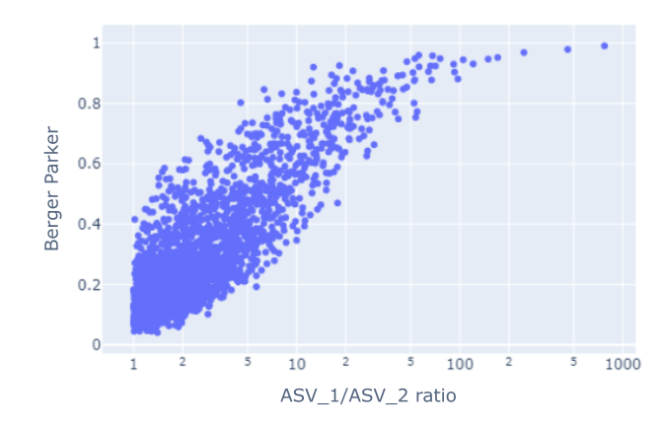
Extreme values of the proportion between the most dominant microbe and the second most dominant microbe metric singled out samples where one microorganism was observed 100x over the next most abundant one. These samples were easiest to identify by this metric and while they did have a reduced number of ASVs they showed no other relevant features in their frequency distributions.

Figure S4. Correlation among Shannon, Berger Parker and Observed_features of 4,596 samples. On the top of the diagonal: the correlation coefficient (Pearson method) plus the significance level as stars. Each significance level is associated to symbols as follows: [0 , 0.001) -> "***"; [0.001, 0.01) -> "**"; [0.01 , 0.05) -> "*"; [0.05 , 0.1) -> "." and ; [0.1 , 1] -> " ".

