Supplementary material: Is it up there? - an MR spectroscopy study of frontal lobes and non-primary-auditory temporal areas in subjective bilateral and unilateral tinnitus
Joanna Wójcik^{1,*}, Bartosz Kochański^{1,*}, Katarzyna Cieśla^{1,*}, Monika Lewandowska², Lucyna Karpiesz³, Iwona Niedziałek³, Danuta Raj-Koziak^{3,5}, Piotr Henryk Skarżyński^{4,6,7}, Tomasz Wolak¹
* equal authorship
Corresponding author: Katarzyna Cieśla (kasia.j.ciesla@gmail.com)
1. Bioimaging Research Center, World Hearing Center, Institute of Physiology and Pathology of Hearing, Mokra 17 Street, Kajetany 05-830 Nadarzyn, Poland;
2. Institute of Psychology, Faculty of Philosophy and Social Sciences, Nicolaus Copernicus University, Fosa Staromiejska 1a Street 87-100 Toruń, Poland;
3. Tinnitus Department, World Hearing Center, Institute of Physiology and Pathology of Hearing, Mokra 17 Street, Kajetany 05-830 Nadarzyn, Poland;
4. Department of Teleaudiology and Screening, World Hearing Center, Institute of Physiology and Pathology of Hearing, Mokra 17 Street, Kajetany 05-830 Nadarzyn, Poland;
5. Audiology and Phoniatrics Clinic, World Hearing Center, Institute of Physiology and Pathology of Hearing, Mokra 17 Street, Kajetany 05-830 Nadarzyn, Poland;
6. Institute of Sensory Organs, Mokra 17 Street, Kajetany 05-830 Nadarzyn, Poland;
7. Heart Failure and Cardiac Rehabilitation Department, Faculty of Medicine, Medical University of Warsaw, Kondratowicza 8 Street, 03-242 Warsaw, Poland;

Table S1. Detailed PTA values and comparisons between groups.
Characteristic¹ | C, N = 25² | TU, N = 24² | TB, N = 28² | p-value³
PTA Right/Contra Ear |  |  |  | 0.060
Median (IQR) | 12 (9 - 16) | 9 (6 - 12) | 10 (5 - 17)
Mean (SD) | 14 (7) | 10 (5) | 13 (10)
Range | 5 - 35 | 0 - 25 | 2 - 41
Missing | 2 | 0 | 0
PTA Left/Ipsi Ear |  |  |  | 0.2
Median (IQR) | 11 (9 - 19) | 9 (7 - 13) | 9 (7 - 15)
Mean (SD) | 16 (11) | 11 (7) | 13 (10)
Range | 4 - 41 | 0 - 29 | 1 - 46
Missing | 2 | 0 | 0
PTA Better Ear |  |  |  | 0.093
Median (IQR) | 11 (8 - 16) | 8 (6 - 9) | 8 (5 - 15)
Mean (SD) | 13 (8) | 9 (5) | 12 (10)
Range | 4 - 35 | 0 - 25 | 1 - 41
Missing | 2 | 0 | 0
PTA Worse Ear |  |  |  | 0.2
Median (IQR) | 12 (10 - 19) | 11 (8 - 14) | 11 (8 - 17)
Mean (SD) | 17 (10) | 12 (7) | 14 (11)
Range | 8 - 41 | 1 - 29 | 2 - 46
Missing | 2 | 0 | 0
PTA Right/Contra - Left/Ipsi |  |  |  | 0.8
Median (IQR) | 0.0 (-3.8 - 1.3) | 0.0 (-2.5 - 2.5) | 0.0 (-1.6 - 2.5)
Mean (SD) | -1.6 (6.0) | -1.3 (5.8) | 0.0 (2.9)
Range | -22.5 - 5.0 | -22.5 - 3.8 | -6.2 - 3.8
Missing | 2 | 0 | 0
¹SD - standard deviation, IQR - interquartile interval, Ipsi – side ipsilateral to the perceived unilateral tinnitus, Contra – side contralateral to the perceived unilateral tinnitus
²C - control, TU - tinnitus unilateral, TB - tinnitus bilateral
³Kruskal-Wallis rank sum test

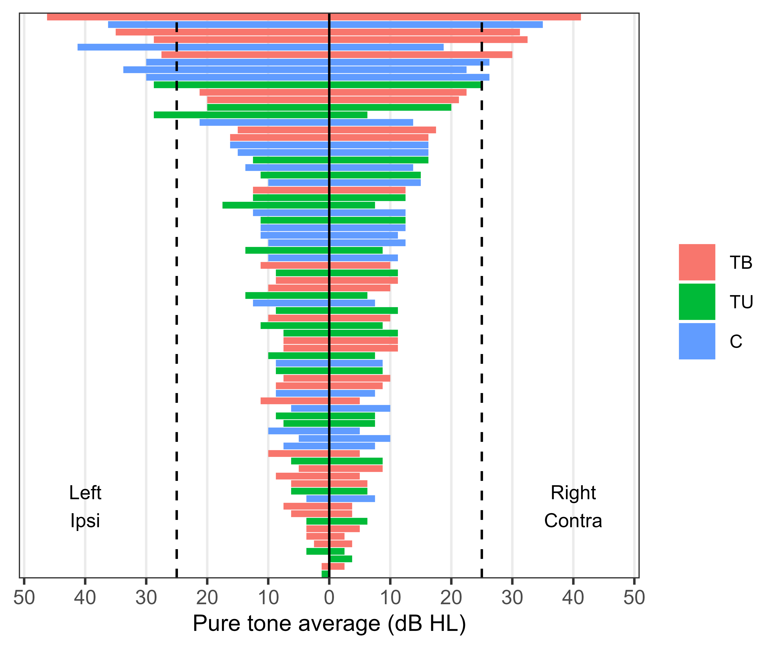
Figure S1. Individual PTA values (500-4000 Hz) for each participant. Dashed lines represent the threshold for normal hearing level, Ipsi – side ipsilateral to the perceived unilateral tinnitus, Contra – side contralateral to the perceived unilateral tinnitus.

Table S2. Glx/tCr quality control measurements.
Region¹ | Characteristic¹ | C, N = 25² | TU, N = 24² | TB, N = 28² | p-value³
Left frontal | FWHM (ppm) |  |  |  | 0.9
 | Mean (SD) | 0.050 (0.008) | 0.051 (0.009) | 0.051 (0.009)
 | Range | 0.038 - 0.067 | 0.038 - 0.067 | 0.038 - 0.076
 | SNR |  |  |  | 0.2
 | Mean (SD) | 16.08 (1.98) | 15.12 (2.49) | 14.89 (2.70)
 | Range | 13.00 - 20.00 | 11.00 - 19.00 | 10.00 - 20.00
 | CRLB |  |  |  | 0.5
 | Mean (SD) | 8.36 (1.08) | 8.83 (1.46) | 8.39 (1.50)
 | Range | 7.00 - 12.00 | 7.00 - 12.00 | 6.00 - 12.00
 | Rejected | 0 | 0 | 0
Right frontal | FWHM (ppm) |  |  |  | 0.035
 | Mean (SD) | 0.048 (0.009) | 0.049 (0.008) | 0.054 (0.009)
 | Range | 0.033 - 0.076 | 0.038 - 0.076 | 0.038 - 0.067
 | SNR |  |  |  | 0.021
 | Mean (SD) | 16.28 (1.97) | 16.22 (2.49) | 14.54 (2.60)
 | Range | 13.00 - 19.00 | 12.00 - 20.00 | 9.00 - 20.00
 | CRLB |  |  |  | 0.2
 | Mean (SD) | 8.16 (1.14) | 8.13 (1.01) | 8.71 (1.30)
 | Range | 7.00 - 11.00 | 7.00 - 10.00 | 7.00 - 12.00
 | Rejected | 0 | 1 | 0
Left/Ipsi temporal | FWHM (ppm) |  |  |  | 0.8
 | Mean (SD) | 0.061 (0.010) | 0.064 (0.010) | 0.064 (0.011)
 | Range | 0.038 - 0.076 | 0.048 - 0.086 | 0.048 - 0.086
 | SNR |  |  |  | 0.4
 | Mean (SD) | 12.00 (1.84) | 11.18 (1.65) | 11.38 (2.28)
 | Range | 9.00 - 16.00 | 8.00 - 14.00 | 8.00 - 17.00
 | CRLB |  |  |  | 0.6
 | Mean (SD) | 10.33 (1.99) | 10.55 (1.47) | 10.75 (1.89)
 | Range | 8.00 - 14.00 | 8.00 - 13.00 | 8.00 - 14.00
 | Rejected | 1 | 2 | 4
Right/Contra temporal | FWHM (ppm) |  |  |  | 0.8
 | Mean (SD) | 0.059 (0.009) | 0.059 (0.014) | 0.060 (0.011)
 | Range | 0.043 - 0.076 | 0.038 - 0.086 | 0.038 - 0.076
 | SNR |  |  |  | 0.2
 | Mean (SD) | 11.83 (1.37) | 12.19 (2.09) | 11.42 (1.84)
 | Range | 9.00 - 14.00 | 8.00 - 16.00 | 8.00 - 15.00
 | CRLB |  |  |  | >0.9
 | Mean (SD) | 9.50 (1.56) | 9.52 (1.86) | 9.65 (1.77)
 | Range | 7.00 - 13.00 | 7.00 - 14.00 | 7.00 - 13.00
 | Rejected | 1 | 3 | 2
¹SD - standard deviation, FWHM (ppm) – full width at half maximum in parts per million, SNR – signal to noise ratio, CRLB – Cramér-Rao lower bound of relative standard deviation of estimated metabolite concentration, Ipsi – side ipsilateral to the perceived unilateral tinnitus, Contra – side contralateral to the perceived unilateral tinnitus
²C - control, TU - tinnitus unilateral, TB - tinnitus bilateral
³Kruskal-Wallis rank sum test

Table S3. CRLB values and rejected spectra of ml, tCho, tNAA.
Region¹ | Metabolite | Characteristic¹ | C, N = 25² | TU, N = 24² | TB, N = 28² | p-value³
Left frontal | mI | CRLB |  |  |  | 0.2
 |  | Mean (SD) | 5.96 (0.98) | 6.12 (1.33) | 6.54 (1.10)
 |  | Range | 4.00 - 8.00 | 4.00 - 9.00 | 5.00 - 9.00
 |  | Rejected | 0 | 0 | 0
 | tCho | CRLB |  |  |  | 0.7
 |  | Mean (SD) | 2.92 (0.57) | 2.79 (0.41) | 2.82 (0.48)
 |  | Range | 2.00 - 4.00 | 2.00 - 3.00 | 2.00 - 4.00
 |  | Rejected | 0 | 0 | 0
 | tNAA | CRLB |  |  |  | 0.11
 |  | Mean (SD) | 2.76 (0.44) | 2.83 (0.56) | 3.07 (0.60)
 |  | Range | 2.00 - 3.00 | 2.00 - 4.00 | 2.00 - 4.00
 |  | Rejected | 0 | 0 | 0
Right frontal | mI | CRLB |  |  |  | 0.2
 |  | Mean (SD) | 6.28 (1.37) | 6.04 (1.40) | 6.64 (1.13)
 |  | Range | 4.00 - 10.00 | 4.00 - 9.00 | 5.00 - 9.00
 |  | Rejected | 0 | 1 | 0
 | tCho | CRLB |  |  |  | 0.12
 |  | Mean (SD) | 2.84 (0.47) | 2.67 (0.64) | 2.96 (0.51)
 |  | Range | 2.00 - 4.00 | 2.00 - 4.00 | 2.00 - 4.00
 |  | Rejected | 0 | 0 | 0
 | tNAA | CRLB |  |  |  | 0.7
 |  | Mean (SD) | 2.80 (0.58) | 2.79 (0.72) | 2.89 (0.63)
 |  | Range | 2.00 - 4.00 | 2.00 - 5.00 | 2.00 - 4.00
 |  | Rejected | 0 | 0 | 0
Left/Ipsi temporal | mI | CRLB |  |  |  | 0.8
 |  | Mean (SD) | 8.61 (2.06) | 9.09 (2.65) | 9.09 (2.29)
 |  | Range | 6.00 - 14.00 | 6.00 - 14.00 | 6.00 - 15.00
 |  | Rejected | 2 | 2 | 6
 | tCho | CRLB |  |  |  | 0.3
 |  | Mean (SD) | 3.75 (0.68) | 4.12 (0.80) | 4.00 (0.96)
 |  | Range | 3.00 - 5.00 | 3.00 - 6.00 | 3.00 - 7.00
 |  | Rejected | 1 | 0 | 1
 | tNAA | CRLB |  |  |  | 0.3
 |  | Mean (SD) | 3.62 (0.65) | 3.96 (0.69) | 3.93 (1.04)
 |  | Range | 3.00 - 5.00 | 3.00 - 5.00 | 3.00 - 7.00
 |  | Rejected | 1 | 0 | 1
Right/Contra temporal | mI | CRLB |  |  |  | 0.5
 |  | Mean (SD) | 8.95 (1.99) | 8.52 (1.81) | 9.16 (2.10)
 |  | Range | 6.00 - 15.00 | 6.00 - 14.00 | 6.00 - 14.00
 |  | Rejected | 3 | 3 | 3
 | tCho | CRLB |  |  |  | 0.9
 |  | Mean (SD) | 3.96 (0.73) | 4.04 (0.82) | 3.96 (0.85)
 |  | Range | 3.00 - 6.00 | 3.00 - 6.00 | 3.00 - 7.00
 |  | Rejected | 0 | 1 | 1
 | tNAA | CRLB |  |  |  | 0.3
 |  | Mean (SD) | 3.76 (0.60) | 3.91 (0.90) | 4.04 (0.65)
 |  | Range | 3.00 - 5.00 | 3.00 - 6.00 | 3.00 - 5.00
 |  | Rejected | 0 | 1 | 1
¹SD - standard deviation, Ipsi – side ipsilateral to the perceived unilateral tinnitus, Contra – side contralateral to the perceived unilateral tinnitus
²C - control, TU - tinnitus unilateral, TB - tinnitus bilateral
³Kruskal-Wallis rank sum test

Table S4. Brain tissue segmentation and between-group comparisons.
Region¹ | Tissue¹ | C, N = 24² | TU, N = 23² | TB, N = 28² | p-value³
Left frontal | GM |  |  |  | 0.4
 | Mean (SD) | 15.5 (5.8) | 17.9 (7.1) | 16.9 (6.1)
 | Range | 5.2 - 26.1 | 2.8 - 29.3 | 7.1 - 29.7
 | WM |  |  |  | 0.5
 | Mean (SD) | 84 (6) | 82 (7) | 83 (7)
 | Range | 73 - 95 | 70 - 97 | 68 - 93
Right frontal | GM |  |  |  | 0.8
 | Mean (SD) | 16 (8) | 17 (6) | 17 (7)
 | Range | 3 - 35 | 3 - 30 | 3 - 35
 | WM |  |  |  | 0.8
 | Mean (SD) | 83 (9) | 82 (7) | 83 (7)
 | Range | 61 - 97 | 69 - 97 | 65 - 97
Left/Ipsi temporal | GM |  |  |  | 0.9
 | Mean (SD) | 34 (8) | 36 (9) | 35 (7)
 | Range | 19 - 49 | 20 - 56 | 21 - 48
 | WM |  |  |  | 0.8
 | Mean (SD) | 64 (8) | 62 (10) | 64 (7)
 | Range | 50 - 80 | 43 - 80 | 51 - 79
Right/Contra temporal | GM |  |  |  | 0.6
 | Mean (SD) | 44 (7) | 43 (6) | 45 (6)
 | Range | 31 - 58 | 33 - 55 | 33 - 60
 | WM |  |  |  | 0.6
 | Mean (SD) | 53 (7) | 54 (6) | 52 (7)
 | Range | 38 - 64 | 43 - 63 | 38 - 65
¹SD - standard deviation, Ipsi – side ipsilateral to the perceived unilateral tinnitus, Contra – side contralateral to the perceived unilateral tinnitus
²C - control, TU - tinnitus unilateral, TB - tinnitus bilateral
³Kruskal-Wallis rank sum test

Figure S2. tNAA/tCr, tCho/tCr and mI/tCr levels in the four ROIs. Individual subjects are depicted as points in the violin plots. White dots represent group means while middle horizontal bars on box plots represent medians. TB - bilateral tinnitus, TU - unilateral tinnitus, C - control; Ipsi - the side corresponding to the side of tinnitus in the TU group (for 4 TU participants that were experiencing tinnitus on the right side, the sides were switched), Contra – side opposite to tinnitus laterality.

Table S5. tNAA/tCr levels in four regions of interest compared across the groups.
 | Descriptive statistics |  |  | Welch’s ANOVA |  |  |  | Post-hoc tests
Region¹ | C, N = 25² | TU, N = 24² | TB, N = 28² | F | p | df1 | df2 | C vs. TU³ | C vs. TB³ | TU vs. TB³
Left frontal |  |  |  | 1.2 | 0.3 | 2.00 | 48.9 | > 0.9 | 0.4 | 0.9
Median (IQR) | 1.46 (1.41 - 1.60) | 1.45 (1.38 - 1.56) | 1.46 (1.37 - 1.51)
Mean (SD) | 1.49 (0.13) | 1.47 (0.13) | 1.43 (0.13)
Range | 1.24 - 1.71 | 1.28 - 1.82 | 1.17 - 1.62
S-W test | 0.48 | 0.22 | 0.10
Missing | 0 | 0 | 0
Right frontal |  |  |  | 2.1 | 0.14 | 2.00 | 48.2 | 0.2 | 0.3 | > 0.9
Median (IQR) | 1.49 (1.42 - 1.55) | 1.40 (1.31 - 1.49) | 1.38 (1.34 - 1.50)
Mean (SD) | 1.48 (0.13) | 1.41 (0.13) | 1.42 (0.12)
Range | 1.21 - 1.76 | 1.17 - 1.68 | 1.23 - 1.67
S-W test | 0.37 | 0.95 | 0.36
Missing | 0 | 0 | 0
Left/Ipsi temporal |  |  |  | 0.61 | 0.5 | 2.00 | 47.6 | > 0.9 | > 0.9 | > 0.9
Median (IQR) | 1.54 (1.44 - 1.61) | 1.44 (1.31 - 1.58) | 1.48 (1.39 - 1.57)
Mean (SD) | 1.51 (0.15) | 1.46 (0.18) | 1.46 (0.17)
Range | 1.10 - 1.82 | 1.22 - 1.82 | 1.02 - 1.81
S-W test | 0.23 | 0.20 | 0.75
Missing | 1 | 0 | 1
Right/Contra temporal |  |  |  | 1.6 | 0.2 | 2.00 | 45.1 | 0.4 | > 0.9 | 0.3
Median (IQR) | 1.34 (1.26 - 1.39) | 1.37 (1.28 - 1.51) | 1.32 (1.24 - 1.42)
Mean (SD) | 1.32 (0.10) | 1.39 (0.16) | 1.32 (0.13)
Range | 1.12 - 1.49 | 1.05 - 1.70 | 1.01 - 1.51
S-W test | 0.62 | 1.00 | 0.21
Missing | 0 | 1 | 1
¹SD - standard deviation, IQR - interquartile interval, S-W test - Shapiro-Wilk test of normality result (p-value), Ipsi – side ipsilateral to the perceived unilateral tinnitus, Contra – side contralateral to the perceived unilateral tinnitus
²C - control, TU - tinnitus unilateral, TB - tinnitus bilateral
³Welch t test; Bonferroni correction

Table S6. tCho/tCr levels in four regions of interest compared across the groups.
 | Descriptive statistics |  |  | Welch’s ANOVA |  |  |  | Post-hoc tests
Region¹ | C, N = 25² | TU, N = 24² | TB, N = 28² | F | p | df1 | df2 | C vs. TU³ | C vs. TB³ | TU vs. TB³
Left frontal |  |  |  | 0.82 | 0.4 | 2.00 | 48.5 | 0.7 | > 0.9 | > 0.9
Median (IQR) | 0.35 (0.33 - 0.37) | 0.36 (0.33 - 0.40) | 0.35 (0.32 - 0.40)
Mean (SD) | 0.35 (0.04) | 0.37 (0.05) | 0.36 (0.05)
Range | 0.25 - 0.42 | 0.27 - 0.46 | 0.29 - 0.48
S-W test | 0.34 | 0.69 | 0.24
Missing | 0 | 0 | 0
Right frontal |  |  |  | 0.47 | 0.6 | 2.00 | 49.1 | > 0.9 | > 0.9 | > 0.9
Median (IQR) | 0.34 (0.32 - 0.36) | 0.35 (0.33 - 0.39) | 0.35 (0.32 - 0.38)
Mean (SD) | 0.35 (0.05) | 0.36 (0.05) | 0.35 (0.05)
Range | 0.24 - 0.45 | 0.29 - 0.50 | 0.25 - 0.48
S-W test | 0.35 | 0.16 | 0.69
Missing | 0 | 0 | 0
Left/Ipsi temporal |  |  |  | 0.57 | 0.6 | 2.00 | 47.7 | > 0.9 | > 0.9 | > 0.9
Median (IQR) | 0.32 (0.28 - 0.34) | 0.30 (0.28 - 0.34) | 0.32 (0.30 - 0.36)
Mean (SD) | 0.32 (0.04) | 0.31 (0.05) | 0.33 (0.05)
Range | 0.24 - 0.39 | 0.25 - 0.41 | 0.21 - 0.47
S-W test | 0.95 | 0.02 | 0.75
Missing | 1 | 0 | 1
Right/Contra temporal |  |  |  | 0.56 | 0.6 | 2.00 | 47.7 | 0.9 | > 0.9 | > 0.9
Median (IQR) | 0.28 (0.26 - 0.31) | 0.29 (0.27 - 0.33) | 0.29 (0.26 - 0.31)
Mean (SD) | 0.28 (0.04) | 0.29 (0.04) | 0.29 (0.04)
Range | 0.19 - 0.35 | 0.23 - 0.37 | 0.22 - 0.38
S-W test | 0.48 | 0.35 | 0.54
Missing | 0 | 1 | 1
¹SD - standard deviation, IQR - interquartile interval, S-W test - Shapiro-Wilk test of normality result (p-value), Ipsi – side ipsilateral to the perceived unilateral tinnitus, Contra – side contralateral to the perceived unilateral tinnitus
²C - control, TU - tinnitus unilateral, TB - tinnitus bilateral
³Welch t test; Bonferroni correction

Table S7. mI/tCr levels in four regions of interest compared across the groups.
 | Descriptive statistics |  |  | Welch’s ANOVA |  |  |  | Post-hoc tests
Region¹ | C, N = 25² | TU, N = 24² | TB, N = 28² | F | p | df1 | df2 | C vs. TU³ | C vs. TB³ | TU vs. TB³
Left frontal |  |  |  | 1.2 | 0.3 | 2.00 | 45.6 | > 0.9 | 0.8 | 0.6
Median (IQR) | 1.12 (0.97 - 1.31) | 1.09 (0.96 - 1.25) | 1.08 (0.94 - 1.15)
Mean (SD) | 1.11 (0.21) | 1.13 (0.24) | 1.05 (0.15)
Range | 0.77 - 1.47 | 0.69 - 1.61 | 0.76 - 1.33
S-W test | 0.36 | 0.66 | 0.42
Missing | 0 | 0 | 0
Right frontal |  |  |  | 0.06 | >0.9 | 2.00 | 47.3 | > 0.9 | > 0.9 | > 0.9
Median (IQR) | 0.97 (0.87 - 1.20) | 1.06 (0.92 - 1.17) | 1.03 (0.92 - 1.17)
Mean (SD) | 1.04 (0.21) | 1.05 (0.21) | 1.04 (0.19)
Range | 0.70 - 1.60 | 0.64 - 1.45 | 0.65 - 1.42
S-W test | 0.06 | 0.99 | 0.84
Missing | 0 | 1 | 0
Left/Ipsi temporal |  |  |  | 0.12 | 0.9 | 2.00 | 41.9 | > 0.9 | > 0.9 | > 0.9
Median (IQR) | 1.05 (0.96 - 1.17) | 1.02 (0.86 - 1.33) | 1.11 (0.84 - 1.18)
Mean (SD) | 1.08 (0.24) | 1.09 (0.30) | 1.05 (0.22)
Range | 0.63 - 1.65 | 0.69 - 1.73 | 0.69 - 1.47
S-W test | 0.59 | 0.19 | 0.17
Missing | 2 | 2 | 6
Right/Contra temporal |  |  |  | 0.93 | 0.4 | 2.00 | 42.0 | 0.9 | > 0.9 | 0.6
Median (IQR) | 0.95 (0.83 - 0.99) | 0.94 (0.88 - 1.11) | 0.93 (0.81 - 0.96)
Mean (SD) | 0.94 (0.20) | 1.01 (0.22) | 0.93 (0.19)
Range | 0.56 - 1.54 | 0.70 - 1.49 | 0.62 - 1.44
S-W test | 0.12 | 0.03 | 0.10
Missing | 3 | 3 | 3
¹SD - standard deviation, IQR - interquartile interval, S-W test - Shapiro-Wilk test of normality result (p-value), Ipsi – side ipsilateral to the perceived unilateral tinnitus, Contra – side contralateral to the perceived unilateral tinnitus
²C - control, TU - tinnitus unilateral, TB - tinnitus bilateral
³Welch t test; Bonferroni correction

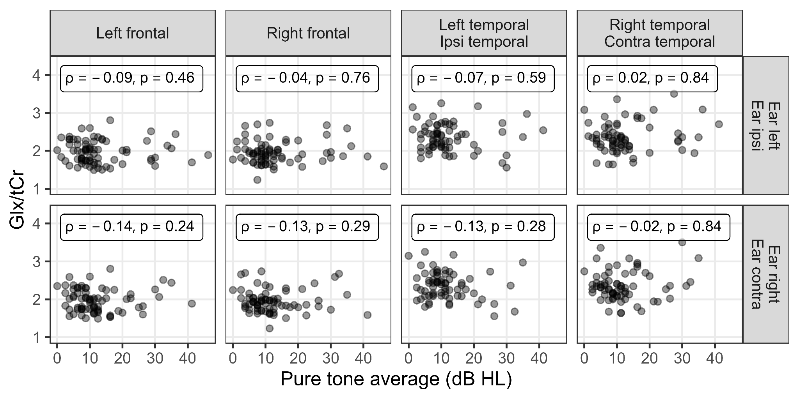
Figure S3. Scatterplots and Spearman’s ρ tests for correlation between PTA values (500-4000 Hz) in both ears separately and levels of Glx/tCr in each ROI. The analysis was performed on data points conforming with the quality criteria. Ipsi – side ipsilateral to the perceived unilateral tinnitus, Contra – side contralateral to the perceived unilateral tinnitus.

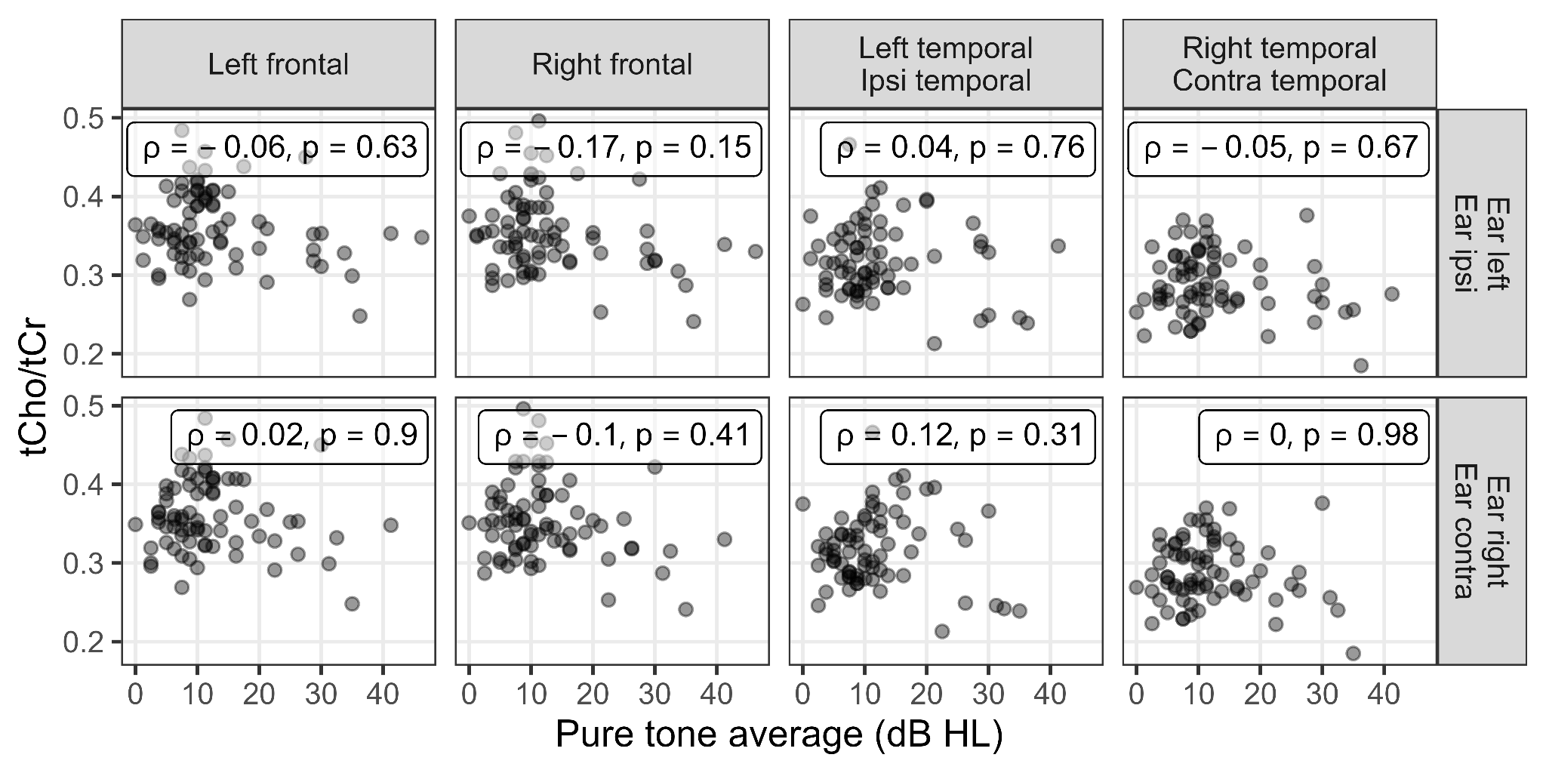
Figure S4. Scatterplots and Spearman’s ρ tests for correlation between PTA values (500-4000 Hz) in both ears separately and levels of tCho/tCr in four ROIs. The analysis was performed on data points conforming with the quality criteria. Ipsi – side ipsilateral to the perceived unilateral tinnitus, Contra – side contralateral to the perceived unilateral tinnitus.

Supplementary File 1. (File_1_LF.nii) Group coverage mask for left frontal ROI.
Supplementary File 2. (File_2_RF.nii) Group coverage mask for right frontal ROI.
Supplementary File 3. (File_3_LT.nii) Group coverage mask for left temporal ROI.
Supplementary File 4. (File_4_RT.nii) Group coverage mask for right temporal ROI.

