Supplementary Data

Novel multiredox π-conjugated perimidine polymers with
ultra-low band gap

Patryk Janasik ^{a, b}, Pavel Chulkin ^{a, b}*, Malgorzata Czichy ^{a, b}, Mieczyslaw Lapkowski ^{a, b, c}*
ª Faculty of Chemistry, Silesian University of Technology, M. Strzody 9, 44-100 Gliwice, Poland
^{b} Centre for Organic and Nanohybrid Electronics, Silesian University of Technology, Konarskiego 22b, 44-100 Gliwice, Poland
^{c} Centre of Polymer and Carbon Materials, Polish Academy of Sciences,
34 Curie-Sklodowska Str., 41-819 Zabrze, Poland
* ^{corresponding author}

Materials

Monomer synthesis
Figure 1 | Monomer synthesis: 1 (a) and 2 (b).

Scheme of electropolymerization

Figure 8 | Mechanism of less-efficient electropolymerization of monomer 1.
Figure 9 | Mechanism of efficient electropolymerization of monomer 2 as a subject of our discussion

Electrochemical measurements
Figure 2 | Cyclic voltammetry measurements for monomers 1 (a) and 2 (b). Concentrations were equal to 28 μM for monomer 1 and 23 μM for monomer 2, in 0.1 M Bu₄NBF₄/DCM electrolyte.
Figure 3 | Cyclic voltammetry measurements for monomers 1 (a) and 2 (b), for deposition only in anodic waveforms. Concentrations were equal to 28 μM for monomer 1 and 23 μM for monomer 2, in 0.1 M Bu₄NBF₄/DCM electrolyte.
Figure 4 | Chronoamperometric deposition of p2 with constant oxidation potential (a) and alternating potential between the oxidation state of the monomer and deprotonated state of p2 (b). (a) Deposition at a constant potential equal to 0.9 V for 300s; (b) Deposition with alternating potential from 0.7 to 0.9 V, 20 pulses 5 s each; (c) CVs of p2 deposited in (a) process; (d) CVs of film deposited in (b) process. The concentration of monomer 2 was equal to 23 μM, in 0.1 M Bu₄NBF₄/DCM electrolyte.
Figure 5 | Cyclic voltammetry measurements for monomers 1 (a) and 2 (b) over a wide range of potential window. Concentration was 28 μM for monomer 1 and 23 μM for monomer 2, in 0.1 M Bu₄NBF₄/DCM electrolyte.
Figure 6 | CV for perylene. The concentration was 1 mM, in 0.1 M Bu₄NBF₄/DCM electrolyte.
Figure 10 | Band gap estimated using CV technique for p2 deposited with 15 CV cycles.
Table 1 | Potentials of redox couples for p1 and p2.

DFT measurements
Figure 7 | Determination of the minimum of band gap for [(syn-2)+(anti-2)]_{n} p2 via 3,4;3,4 bonds (a). (b) Extension of the designated function for one million mers, revealing the small effect of only intramolecular electron delocalization on E_{g} narrowing.
Table 2 | Shape of frontier orbitals calculated at B3LYP/3-21G/CPCM(DCM) for syn- and anti-isomer of monomers 1 and 2.
The isovalue was 0.03 e⁻/au³ in each case.
Table 3 | Spin density of oxidized and reduction of monomers 1 and 2 and their syn- and anti-isomer, calculated at B3LYP/3-21G/CPCM(DCM),
The isovalue was 0.005 e⁻/au³.
Table 4 | The shape of frontier orbitals of dicationic (protonated)
dimer (2)₂ ⁺⁺ calculated at B3LYP/3-21G/CPCM(DCM).
The isovalue was 0.03 e⁻/au³ in each case.
Table 5 | The shape of frontier orbitals of deprotonated neutral dimer (2)₂, calculated at B3LYP/3-21G/CPCM(DCM). The isovalue was 0.03 e⁻/au³ in each case.
Table 6 | The shape of frontier orbitals of ladder dimers L(2)₂, calculated at B3LYP/3-21G/CPCM(DCM).The isovalue was 0.03 e⁻/au³ in each case.
Table 7 | Calculated energies ​​of HOMO and LUMO orbitals for monomer 2 and its electrocoupling products.
Table 8 | Orbital shapes calculated at B3LYP/3-21G/CPCM(DCM) for total deprotonated ladder tetramers L(2)₄ bonded at different positions. The isovalue was 0.03 e⁻/au³ in each case.
Table 9 | Orbital shapes calculated at B3LYP/3-21G/CPCM(DCM) for total deprotonated ladder octamers L(2)₈ bonded at different positions. The isovalue was 0.03 e⁻/au³ in each case.
Table 10 | Calculated energies of HOMO, LUMO orbitals,
and band gap E_{g} of monomer 2 and its non-ladder dimer (2)₂ and ladder products.

Materials
Pyromellitic dianhydride (3); naphthalene-1,4,5,8-tetracarboxylic dianhydride (4); 1,8-naphthalenediamine (5); tetrabutylammonium tetrafluoroborate; dichloromethane; toluene; benzene; nitrobenzene; methanol; isobuthanol, perylene, and 3,4-ethylenedioxythiophene (EDOT).

Monomer synthesis
Unless otherwise stated, all reagents and starting materials were purchased from commercial vendors and used without further purification. All experiments were conducted in the air unless otherwise stated. NMR spectra were recorded using a 300 MHz Agilent spectrometer and referenced internally using the residual protonated solvent resonances relative to tetramethylsilane (δ = 0 ppm).
Monomer 1 (as a mixture of anti-isomer perimidino[1',2':1,5]pyrrolo[3,4-m]phthaloperine-9,19-dione and syn-isomer 17H,19H-perimidino[1',2':1,2]pyrrolo[3,4-m]phthaloperine-17,19-dione) was obtained via the condensation reaction of compound 3 (0.218 g, 1 mmol) with compound 5 (0.316 g, 2 mmol) (Fig. S1a). Compound 5 was purified by recrystallization in methanol prior to use. The reaction was carried out in 5 mL of nitrobenzene for 3 h under reflux. Then, the reaction mixture was allowed to cool to room temperature and the precipitate was filtered and washed with methanol. This was first heated in toluene for 1 h, and after in methanol for 1 h under reflux. The precipitate was filtered and dried under vacuum generating monomer 1 as a purple solid (0.273 g, 59%).
Mp: >400 °C (lit.⁴² 469‒473 °C). ¹H NMR: δ/ppm (300 MHz, CDCl₃ and 10% CF₃COOD, Me₄Si, mixture of syn and anti) = 11.02 (CF₃COOH); 9.26 (syn, s, 1H); 9.1 (anti, s, 2H); 8.87 (syn, s, 1H); 8.58 (anti, d, 2H, J = 7.7 Hz; syn, d, 2H, J = 7.7 Hz); 7.78 (anti, d, 2H, J = 7.9 Hz; syn, d, 2H, J = 7.9 Hz); 7.73 (anti, d, 2H, J = 8.3 Hz; syn, d, 2H, J = 8.3 Hz); 7.64‒7.55 (anti, m, 6H; syn, m, 6H). IR: ν_{max}/cm⁻¹ = 1714, 1645, 1576, 1498, 1482, 1456, 1403, 1385, 1363, 1329, 1278, 1222, 1206, 1166, 1145, 1133, 1105, 1032, 993, 885, 827, 772, 749, 702.
Monomer 2 (as a mixture of anti-isomer benzo[lmn]diperimidino[2,1-b:2',1'-i][3,8]phenanthroline-7,18-dione and syn-isomer benzo[lmn]diperimidino[2,1-b:1',2'-j][3,8]phenanthroline-5,8-dione) was obtained via the condensation reaction of compound 4 (0.270 g, 1 mmol) with compound 5 (0.316 g, 2 mmol) (Supplementary Fig. 1b). The reaction was carried out in 10 mL of isobutanol for 24 h under reflux. Then, the mixture was allowed to cool to room temperature and the precipitate was filtered and washed with methanol. This was first heated in hexane for 1 h and methanol for 1 h under reflux. The precipitate was filtered and dried under vacuum generating monomer 2 was isolated as a black purple solid (0.399 g, 78%).
Mp: >400 °C (lit.⁴² >500 °C). ¹H NMR: δ/ppm (300 MHz, CDCl₃ and 10% CF₃COOD, Me₄Si, mixture of syn and anti) = 11.05 (CF₃COOH); 9.28 (m, 2H); 9.05 (m, 2H); 8.59 (m, 2H); 7.76 (m, 4H); 7.65 (m, 2H); 7.56–7.48 (m, 4H). IR: ν_{max}/cm⁻¹ = 1678, 1624, 1595, 1548, 1528, 1492, 1469, 1394, 1369, 1342, 1319, 1284, 1257, 1225, 1165, 1121, 1106, 1072, 1043, 1003, 905, 865, 829, 793, 752.
¹Mamada, M., Pérez-Bolívar, C. & Anzenbacher, P. Green Synthesis of Polycyclic Benzimidazole Derivatives and Organic Semiconductors. Org. Lett. 13, 4882–4885 (2011).

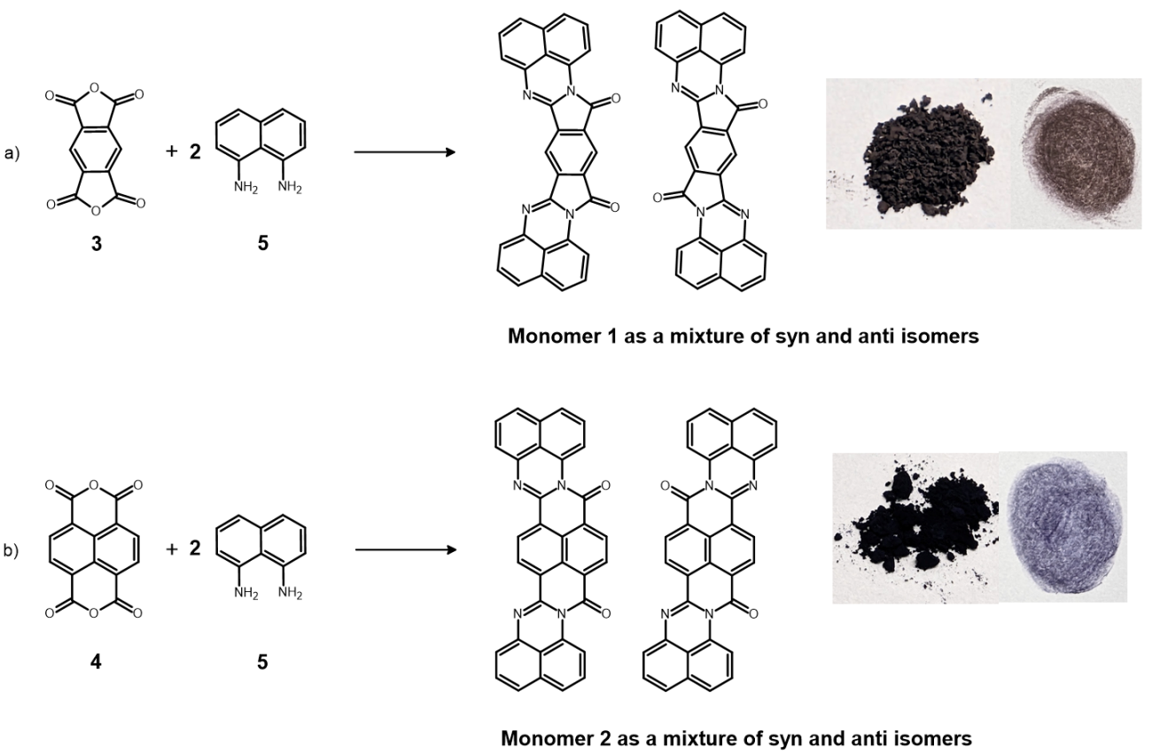

Supplementary Figure 1 | Synthesis of monomer 1 (a) and 2 (b).

- (b)
Supplementary Figure 2 | Cyclic voltammetry measurements for monomer 1 (a) and 2 (b). The concentration was 28 μM for monomer 1 and 23 μM for monomer 2, in 0.1 M Bu₄NBF₄/DCM electrolyte.

- (b)
Supplementary Figure 3 | Cyclic voltammetry measurements for monomer 1 (a) and 2 (b), for deposition only in anodic waveforms. The concentration was 28 μM for monomer 1 and 23 μM for monomer 2, in 0.1 M Bu₄NBF₄/DCM electrolyte.

(a) (b)

(c) (d)
Supplementary Figure 4 | Chronoamperometric deposition of p2 with a constant oxidation potential (a) and alternating potential between the oxidation state of the monomer and deprotonated state of p2 (b). (a) Deposition at constant potential was 0.9 V for 300 s; (b) Deposition with alternating potential was from 0.7 to 0.9 V, 20 pulses 5s each; (c) CVs of p2 deposited in (a) process; (d) CVs of film deposited in (b) process. The concentration of monomer 2 was 23 μM, in 0.1 M Bu₄NBF₄/DCM electrolyte.

- (b)
Supplementary Figure 5 | Cyclic voltammetry measurements for monomer 1 (a) and 2 (b) over a wide range of potential window. The concentration was 28 μM for monomer 1 and 23 μM for monomer 2, in 0.1 M Bu₄NBF₄/DCM electrolyte.

Supplementary Table 2 | Shape of frontier orbitals calculated at B3LYP/3-21G/CPCM(DCM) for syn- and anti-isomer of monomer 1 and 2.
The isovalue was 0.03 e⁻/au³ in each case.
Compound | HOMO-1 / eV | HOMO /eV | LUMO / eV | LUMO+1 / eV
syn-1 | 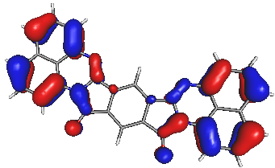 | 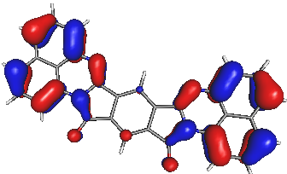 | 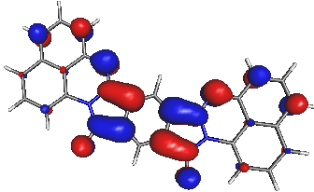 | 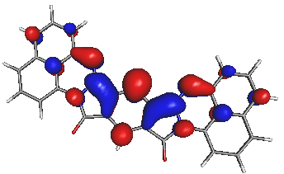
syn-1 | -5.46 | -5.34 | -2.94 | -1.82
anti-1 | 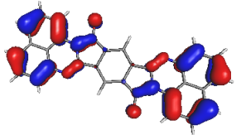 | 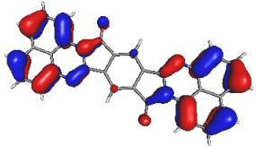 | 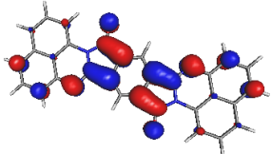 | 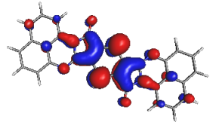
anti-1 | -5.47 | -5.33 | -2.94 | -1.81
syn-2 | 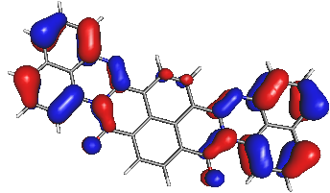 | 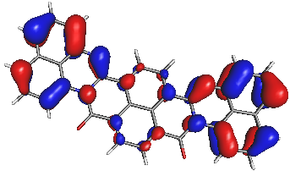 | 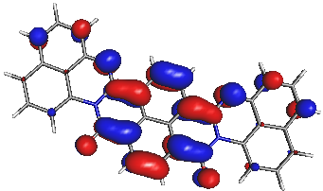 | 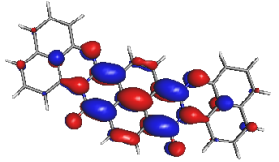
syn-2 | -5.40 | -5.11 | -3.06 | -1.67
anti-2 | 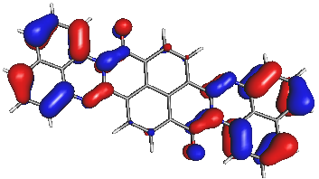 | 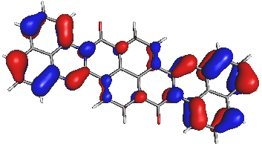 | 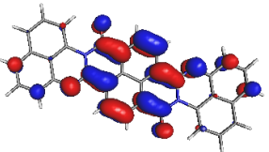 | 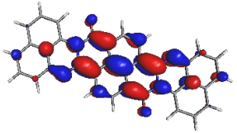
anti-2 | -5.41 | -5.11 | -3.05 | -1.68

Supplementary Table 3 | Spin density of oxidized and reduced monomer 1 and 2 and their syn- and anti-isomer, calculated at B3LYP/3-21G/CPCM(DCM). The isovalue was 0.005 e⁻/au³.
Compound | Diradical dication  (q=2 m=3) | Radical cation (q=1 m=2) | Radical anion (q=-1 m=2) | Diradical dianion  (q=-2 m=3)
syn-1 | 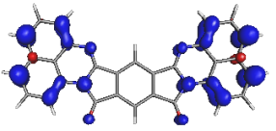 | 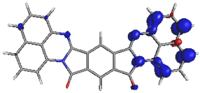 | 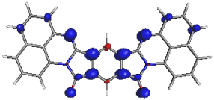 | 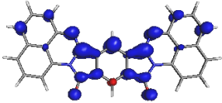
ant-1 | 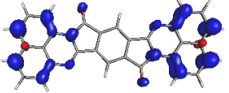 | 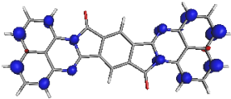 | 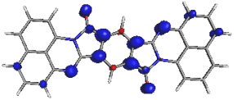 | 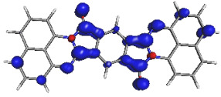
syn-2 | 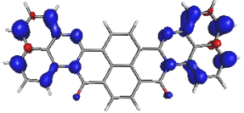 | 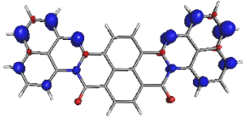 | 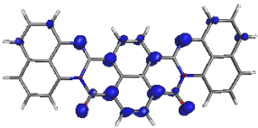 | 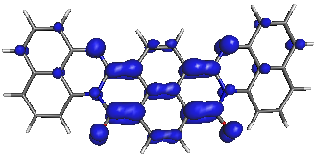
anti-2 | 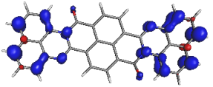 | 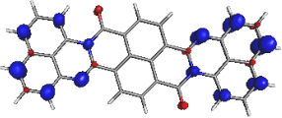 | 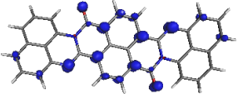 | 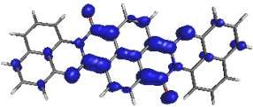

possibilities of bonding in p(2) polymer on the example
of corresponding bonds in its dimers (2)₂ (protonated and neutral)
and oligomers (2)₄, (2)₈

(Table 4-9)
Supplementary Table 4 | Shape of frontier orbitals of dicationic (protonated)
dimer (2)₂ ⁺⁺calculated at B3LYP/3-21G/CPCM(DCM).
The isovalue was 0.03 e⁻/au³ in each case.
(syn-2)+(syn-2) |  | (anti-2)+(anti-2)
(2)₂ ⁺⁺bonded by positions 1,1’
HOMO | LUMO | HOMO | LUMO
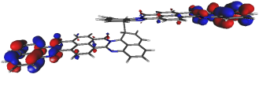 | 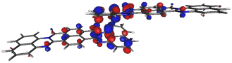 | 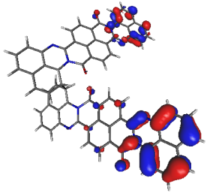 | 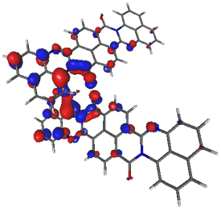
-5.95 eV | -4.74 eV | -5.95 eV | -4.62 eV
(2)₂ ⁺⁺bonded by positions 1,3’
HOMO | LUMO | HOMO | LUMO
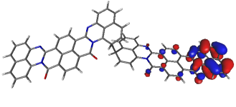 | 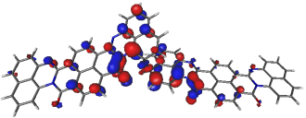 | 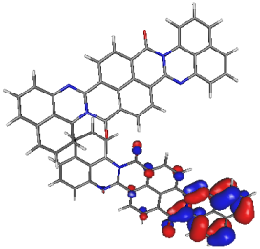 | 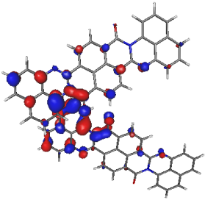
-5.87eV | -4.52eV | -5.91 eV | -4.69 eV
(2)₂ ⁺⁺bonded by positions 1,4’
HOMO | LUMO | HOMO | LUMO
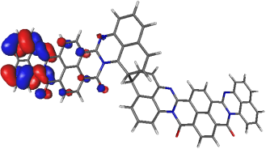 | 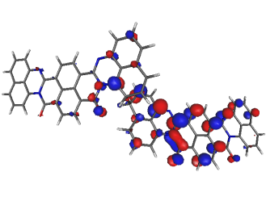 | 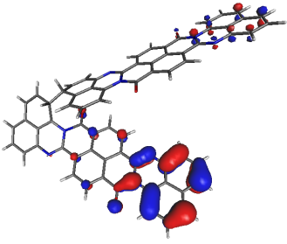 | 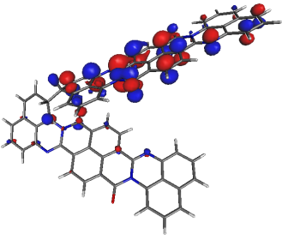
-5.92 eV | -4.57 eV | -5.94 eV | -4.53 eV
(2)₂ ⁺⁺bonded by positions 1,6’
HOMO | LUMO | HOMO | LUMO
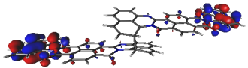 | 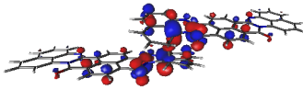 | 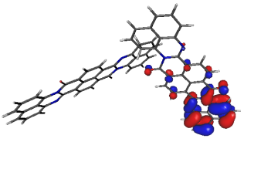 | 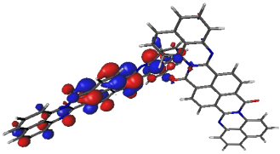
-5.95 eV | -4.73 eV | -5.93 eV | -4.53 eV
(2)₂ ⁺⁺bonded by positions 3,3’
HOMO | LUMO | HOMO | LUMO
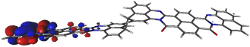 | 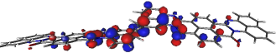 | 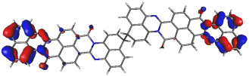 | 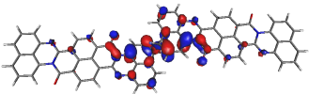
-5.88eV | -4.52 eV | -5.88 eV | -4.54 eV
(2)₂ ⁺⁺bonded by positions 3,4’
HOMO | LUMO | HOMO | LUMO
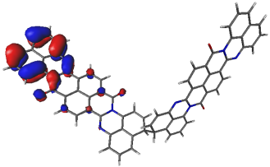 | 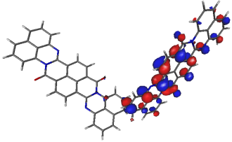 | 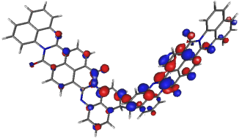 | 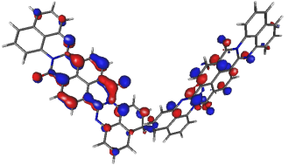
-5.57eV | -4.55 eV | -5.87 eV | -4.55 eV
(2)₂ ⁺⁺bonded by positions 4,4’
HOMO | LUMO | HOMO | LUMO
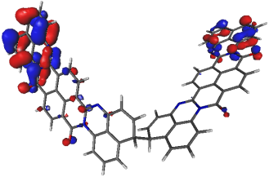 | 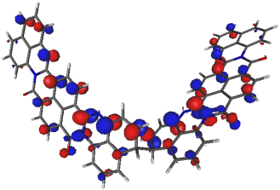 | 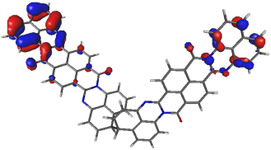 | 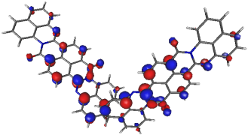
-5.97eV | -4.56eV | -5.96 eV | -4.57 eV
(2)₂ ⁺⁺bonded by positions 3,6’
HOMO | LUMO | HOMO | LUMO
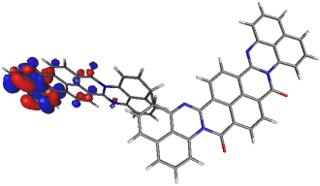 | 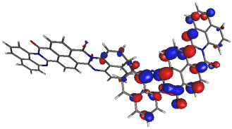 | 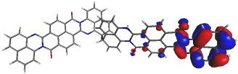 | 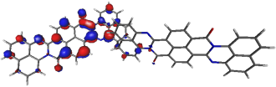
-5.87 eV | -4.57 eV | -5.87 eV | -4.58 eV
(2)₂ ⁺⁺bonded by positions 4,6’
HOMO | LUMO | HOMO | LUMO
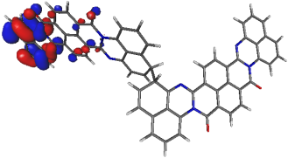 | 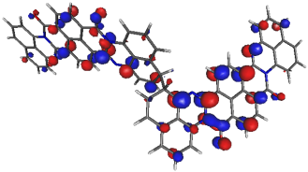 | 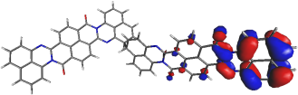 | 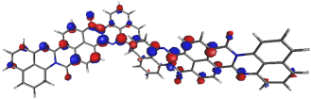
-5.96 eV | -4.56 eV | -5.96 eV | -4.56 eV
(2)₂ ⁺⁺bonded bypositions 6,6’
HOMO | LUMO | HOMO | LUMO
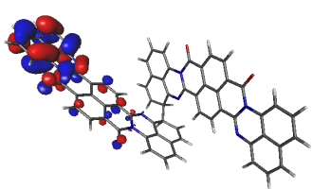 | 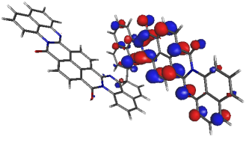 | 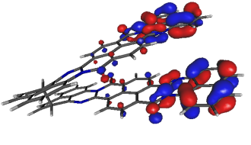 | 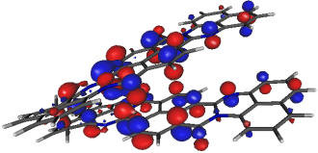
-6.10 eV | -4.67 eV | -6.09 eV | -4.75 eV

Supplementary Table 5 | The shape of frontier orbitals of deprotonated neutral dimer (2)₂, calculated at B3LYP/3-21G/CPCM(DCM). The isovalue was 0.03 e⁻/au³ in each case.
(syn-2)+(syn-2) |  | (anti-2)+(anti-2)
(2)₂bonded by 1,1’ positions
HOMO | LUMO | HOMO | LUMO
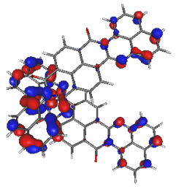 | 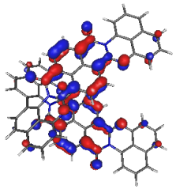 | 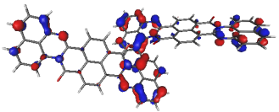 | 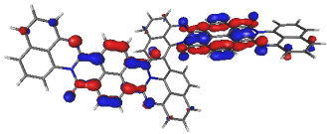
-5.26eV | -3.17eV | -5.23eV | -3.18eV
(2)₂bonded by 1,3’ positions
HOMO | LUMO | HOMO | LUMO
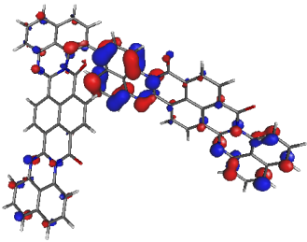 | 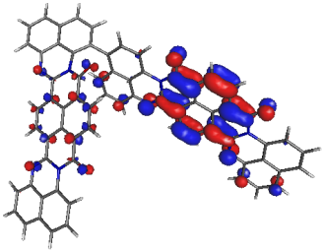 | 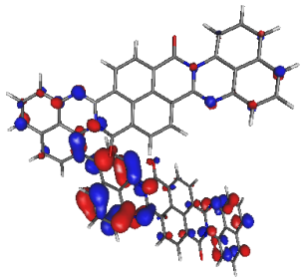 | 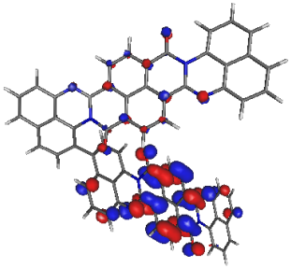
-5.23 eV | -3.21 eV | -5.22 eV | -3.20 eV
(2)₂bonded by 1,4’ positions
HOMO | LUMO | HOMO | LUMO
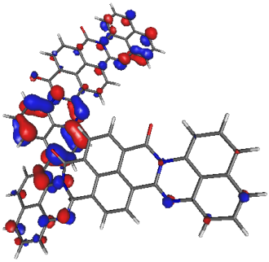 | 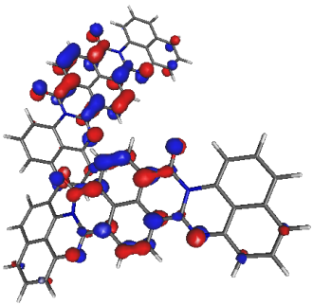 | 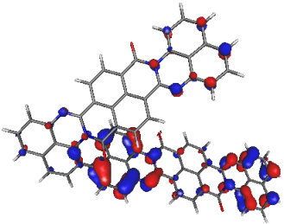 | 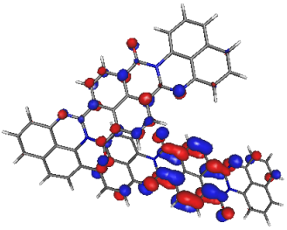
-5.22eV | -3.23 eV | -5.20 eV | -3.21 eV
(2)₂bonded by 1,6’ positions
HOMO | LUMO | HOMO | LUMO
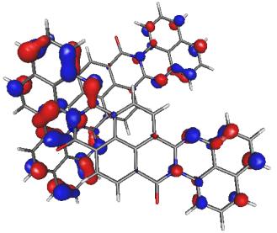 | 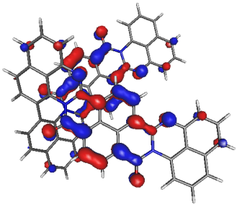 | 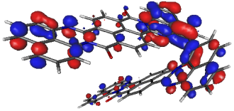 | 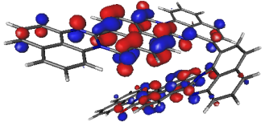
-5.27 eV | -3.17 eV | -5.22 eV | -3.23 eV
(2)₂bonded by 3,3’ positions
HOMO | LUMO | HOMO | LUMO
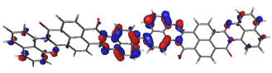 | 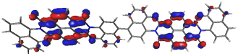 | 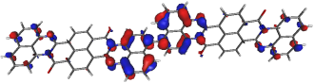 | 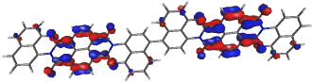
-5.21 eV | -3.21 eV | -5.22 eV | -3.21 eV
(2)₂bonded by 3,4’ positions
HOMO | LUMO | HOMO | LUMO
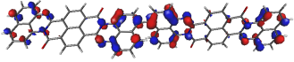 | 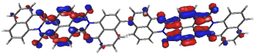 | 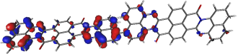 | 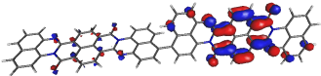
-5.27 eV | -3.22 eV | -5.28 eV | -3.23 eV
(2)₂bonded by 4,4’ positions
HOMO | LUMO | HOMO | LUMO
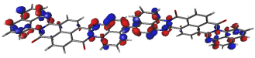 | 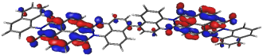 | 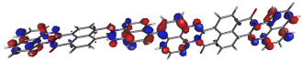 | 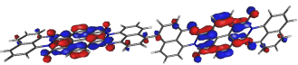
-5.27 eV | -3.23 eV | -5.29 eV | -3.23 eV
(2)₂bonded by 3,6’ positions
HOMO | LUMO | HOMO | LUMO
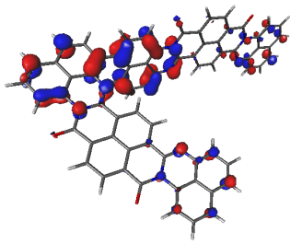 | 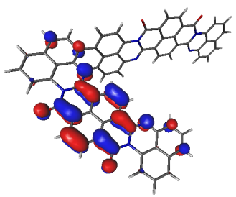 | 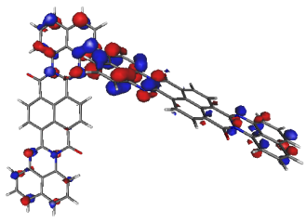 | 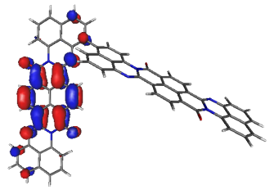
-5.22 eV | -3.21 eV | -5.22 eV | -3.21 eV
(2)₂bonded by 4,6’ positions
HOMO | LUMO | HOMO | LUMO
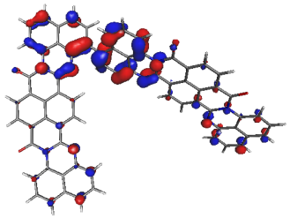 | 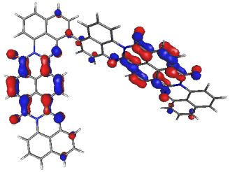 | 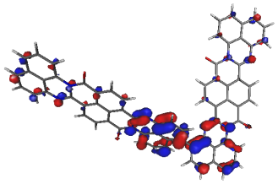 | 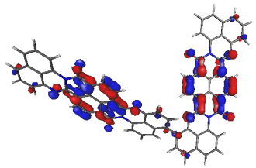
-5.16 eV | -3.26 eV | -5.16 eV | -3.26 eV
(2)₂bonded by 6,6’ positions
HOMO | LUMO | HOMO | LUMO
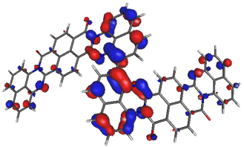 | 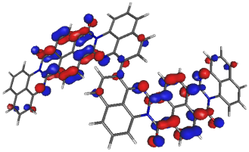 | 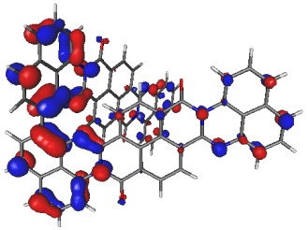 | 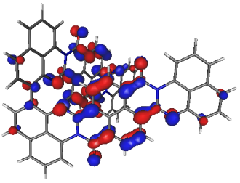
-5.15 eV | -3.26 eV | -5.18 eV | -3.21 eV

Supplementary Table 6 | The shape of frontier orbitals of ladder dimers L(2)₂, calculated at B3LYP/3-21G/CPCM(DCM). The isovalue was 0.03 e⁻/au³ in each case.
(syn-2)+(syn-2)
L(2)₂bonded by 3,4’;4,3’ positions |  | L(2)₂bonded by 3,3’;4,4’ positions
HOMO | LUMO | HOMO | LUMO
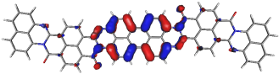 | 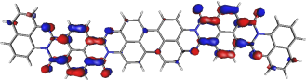 | 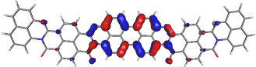 | 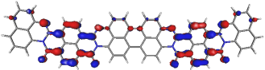
-4.74 eV | -3.35 eV | -4.74 eV | -3.38 eV
(anti-2)+(anti-2)
L(2)₂bonded by 3,4’;4,3’ positions |  | L(2)₂bonded by 3,3’;4,4’ positions
HOMO | LUMO | HOMO | LUMO
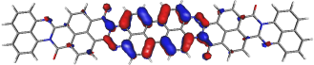 | 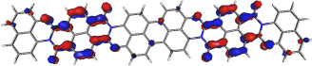 | 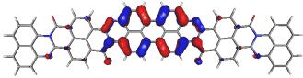 | 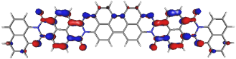
-4.74 eV | -3.35 eV | -4.74 eV | -3.38 eV
(syn-2)+(anti-2)
L(2)₂bonded by 3,4’;4,3’ positions |  | L(2)₂bonded by 3,3’;4,4’ positions
HOMO | LUMO | HOMO | LUMO
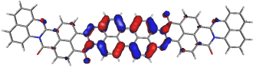 | 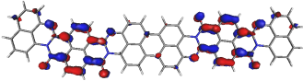 | 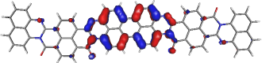 | 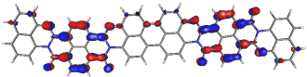
-4.74 eV | -3.35 eV | -4.74 eV | -3.38 eV

Table 7 | Calculated energies ​​of HOMO and LUMO orbitals for monomer 2 and its electrocoupling products.
new bounding positions | isomers | type of compound | HOMO / eV | LUMO / eV
- | (syn-2) | monomer 2 | -5.11 | -3.06
- | (anti-2) | monomer 2 | -5.11 | -3.05
1,1’ | (syn-2)+(syn-2) | protonated dicationic dimer (2)₂⁺⁺ | -5.95 | -4.74
1,1’ | (syn-2)+(syn-2) | neutral dimer (2)₂ | -5.26 | -3.17
1,1’ | (anti-2)+(anti-2) | protonated dicationic dimer (2)₂⁺⁺ | -5.95 | -4.62
1,1’ | (anti-2)+(anti-2) | neutral dimer (2)₂ | -5.23 | -3.18
1,3’ | (syn-2)+(syn-2) | protonated dicationic dimer (2)₂⁺⁺ | -5.87 | -4.52
1,3’ | (syn-2)+(syn-2) | neutral dimer (2)₂ | -5.23 | -3.21
1,3’ | (anti-2)+(anti-2) | protonated dicationic dimer (2)₂⁺⁺ | -5.91 | -4.69
1,3’ | (anti-2)+(anti-2) | neutral dimer (2)₂ | -5.22 | -3.20
1,4’ | (syn-2)+(syn-2) | protonated dicationic dimer (2)₂⁺⁺ | -5.92 | -4.57
1,4’ | (syn-2)+(syn-2) | neutral dimer (2)₂ | -5.22 | -3.23
1,4’ | (anti-2)+(anti-2) | protonated dicationic dimer (2)₂⁺⁺ | -5.94 | -4.57
1,4’ | (anti-2)+(anti-2) | neutral dimer (2)₂ | -5.20 | -3.21
1,6’ | (syn-2)+(syn-2) | protonated dicationic dimer (2)₂⁺⁺ | -5.95 | -4.73
1,6’ | (syn-2)+(syn-2) | neutral dimer (2)₂ | -5.27 | -3.17
1,6’ | (anti-2)+(anti-2) | protonated dicationic dimer (2)₂⁺⁺ | -5.93 | -4.53
1,6’ | (anti-2)+(anti-2) | neutral dimer (2)₂ | -5.22 | -3.23
3,3’ | (syn-2)+(syn-2) | protonated dicationic dimer (2)₂⁺⁺ | -5.88 | -4.52
3,3’ | (syn-2)+(syn-2) | neutral dimer (2)₂ | -5.21 | -3.21
3,3’ | (anti-2)+(anti-2) | protonated dicationic dimer (2)₂⁺⁺ | -5.88 | -4.54
3,3’ | (anti-2)+(anti-2) | neutral dimer (2)₂ | -5.22 | -3.21
3,4’ | (syn-2)+(syn-2) | protonated dicationic dimer (2)₂⁺⁺ | -5.57 | -4.55
3,4’ | (syn-2)+(syn-2) | neutral dimer (2)₂ | -5.27 | -3.22
3,4’ | (anti-2)+(anti-2) | protonated dicationic dimer (2)₂⁺⁺ | -5.87 | -4.55
3,4’ | (anti-2)+(anti-2) | neutral dimer (2)₂ | -5.18 | -3.26
4,4’ | (syn-2)+(syn-2) | protonated dicationic dimer (2)₂⁺⁺ | -5.97 | -4.56
4,4’ | (syn-2)+(syn-2) | neutral dimer (2)₂ | -5.27 | -3.23
4,4’ | (anti-2)+(anti-2) | protonated dicationic dimer (2)₂⁺⁺ | -5.96 | -4.57
4,4’ | (anti-2)+(anti-2) | neutral dimer (2)₂ | -5.29 | -3.23
3,6’ | (syn-2)+(syn-2) | protonated dicationic dimer (2)₂⁺⁺ | -5.89 | -4.57
3,6’ | (syn-2)+(syn-2) | neutral dimer (2)₂ | -5.22 | -3.21
3,6’ | (anti-2)+(anti-2) | protonated dicationic dimer (2)₂⁺⁺ | -5.87 | -4.58
3,6’ | (anti-2)+(anti-2) | neutral dimer (2)₂ | -5.16 | -3.26
4,6’ | (syn-2)+(syn-2) | protonated dicationic dimer (2)₂⁺⁺ | -5.96 | -4.56
4,6’ | (syn-2)+(syn-2) | neutral dimer (2)₂ | -5.16 | -3.26
4,6’ | (anti-2)+(anti-2) | protonated dicationic dimer (2)₂⁺⁺ | -5.96 | -4.56
4,6’ | (anti-2)+(anti-2) | neutral dimer (2)₂ | -5.16 | -3.26
6,6’ | (syn-2)+(syn-2) | protonated dicationic dimer (2)₂⁺⁺ | -6.10 | -4.67
6,6’ | (syn-2)+(syn-2) | neutral dimer (2)₂ | -5.15 | -3.26
6,6’ | (anti-2)+(anti-2) | protonated dicationic dimer (2)₂⁺⁺ | -6.09 | -4.75
6,6’ | (anti-2)+(anti-2) | neutral dimer (2)₂ | -5.18 | -3.21
3,3’/4,4’ | (syn-2)+(syn-2) | neutral lader dimer L(2)₂ | -4.74 | -3.38
3,3’/4,4’ | (anti-2)+(anti-2) | neutral lader dimer L(2)₂ | -4.74 | -3.38
3,3’/4,4’ | (syn-2)+(syn-2) | neutral lader dimer L(2)₂ | -4.74 | -3.38
3,4’/3,4’ | (syn-2)+(syn-2) | neutral lader dimer L(2)₂ | -4.74 | -3.35
3,4’/3,4’ | (anti-2)+(anti-2) | neutral lader dimer L(2)₂ | -4.74 | -3.35
3,4’/3,4’ | (syn-2)+(anti-2) | neutral lader dimer L(2)₂ | -4.74 | -3.35

Supplementary Table 8 | Orbital shapes calculated at B3LYP/3-21G/CPCM(DCM) for total deprotonated ladder tetramers L(2)₄ bonded at different positions. The isovalue was 0.03 e⁻/au³ in each case.
syn-isomers bonded by 3,4’;4,3’+3,4’;4,3’+3,4’;4,3’ positions
HOMO = -4.63 eV
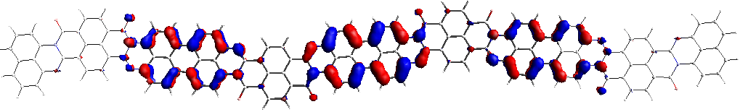
LUMO = -3.45 eV
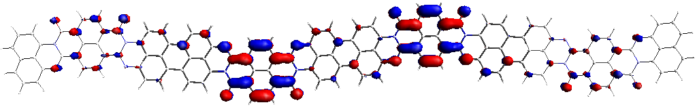
syn- and anti-isomers bonded by 3,3’;4,4’ positions
HOMO = -4.62 eV
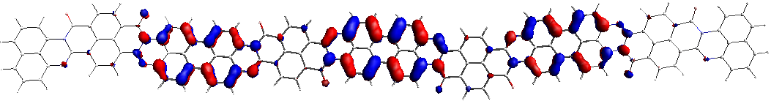
LUMO = -3.50 eV
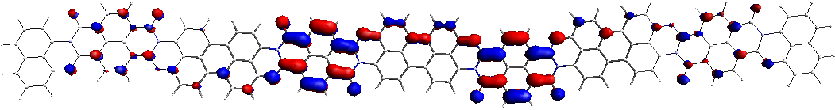
syn- and anti-isomers bonded by 3,4’;4,3’ positions
HOMO = -4.63 eV
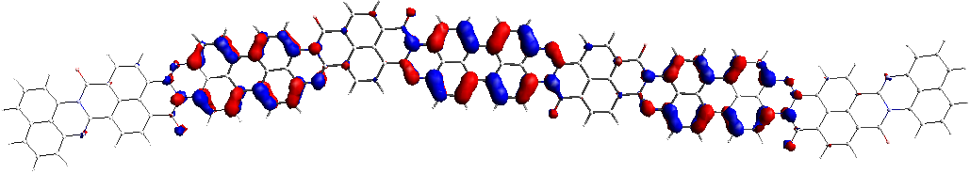
LUMO = -3.45 eV
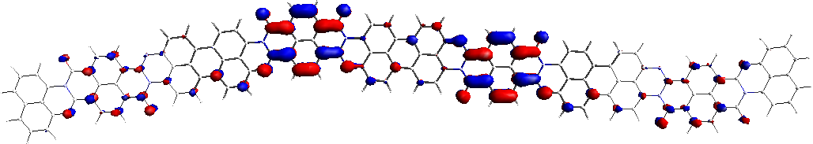
anti- and anti-isomers bonded by 3,4’;4,3’ positions
HOMO = -4.62 eV
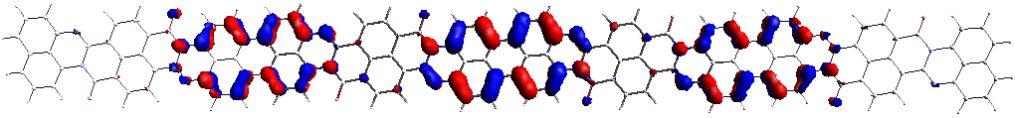
LUMO = -3.45 eV
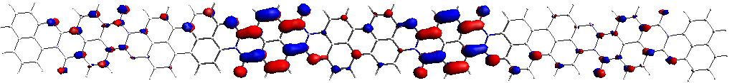

Supplementary Table 9 | Orbital shapes calculated at B3LYP/3-21G/CPCM(DCM) for total deprotonated ladder octamers L(2)₈ bonded at different positions. The isovalue was 0.03 e⁻/au³ in each case.
syn-isomers bonded by 3,4’/4,3’ positions
HOMO = -4.59 eV
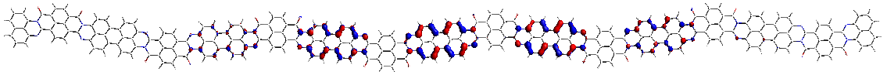
LUMO = -3.49 eV
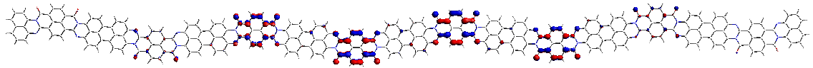
syn-isomers bonded by 3,3’/4,4’ positions
HOMO = -4.57 eV
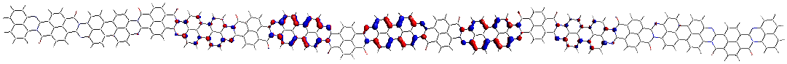
LUMO = -3.55 eV
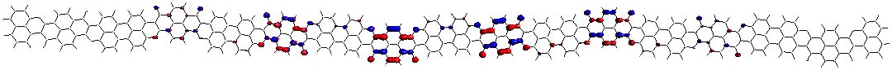
syn- and anti-isomers bonded by 3,3’/4,4’ positions
HOMO = -4.59 eV
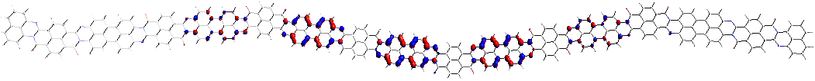
LUMO = -3.49 eV
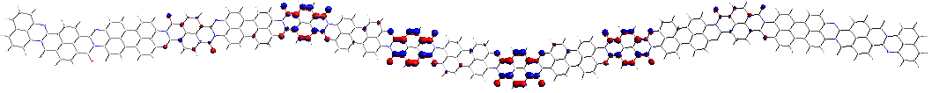
anti-isomers bonded by 3,4’/4,3’ positions
HOMO = -4.58 eV
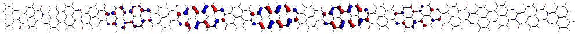
LUMO = -3.48 eV
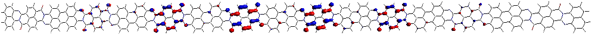

Table 10 | Calculated energies of HOMO, LUMO orbitals, and band gap E_{g} of monomer 2 and its non-ladder dimer (2)₂ and ladder products.
new bounding positions | type of isomer | ladder products | HOMO / eV | LUMO / eV | E_{g} / eV
- | (syn-2) | monomer 2 | -5.11 | -3.06 | 2.05
- | (anti-2) | monomer 2 | -5.11 | -3.05 | 2.06
3,3’;4,4’ | (syn-2)₂ | L(2)₂ | -4.74 | -3.38 | 1.36
3,3’;4,4’ | (anti-2)₂ | L(2)₂ | -4.74 | -3.38 | 1.36
3,3’;4,4’ | (syn-2)+(anti-2) | L(2)₂ | -4.74 | -3.38 | 1.36
3,4’;3,4’ | (syn-2)₂ | L(2)₂ | -4.74 | -3.35 | 1.39
3,4’;3,4’ | (syn-2)+(anti-2) | L(2)₂ | -4.74 | -3.35 | 1.39
3,4’;3,4’ | (syn-2)+(anti-2) | L(2)₂ | -4.74 | -3.35 | 1.39
3,4’;3,4’ | (syn-2)₂ | L(2)₄ | -4.63 | -3.45 | 1.18
3,3’;4,4’ | [(syn-2)+(anti-2)]₄ | L(2)₄ | -4.62 | -3.50 | 1.12
3,4’;3,4’ | [(syn-2)+(anti-2)]₄ | L(2)₄ | -4.63 | -3.45 | 1.18
3,4’;3,4’ | (anti-2)₄ | L(2)₄ | -4.62 | -3.45 | 1.17
3,4’;3,4’ | (syn-2)₂ | L(2)₈ | -4.59 | -3.49 | 1.10
3,3’;4,4’ | [(syn-2)+(anti-2)]₈ | L(2)₈ | -4.57 | -3.55 | 1.02
3,4’;3,4’ | [(syn-2)+(anti-2)]₈ | L(2)₈ | -4.59 | -3.49 | 1.10
3,4’;3,4’ | (anti-2)₈ | L(2)₈ | -4.58 | -3.48 | 1.10

Supplementary Figure 6 | CV of perylene. The concentration was 1 mM, in 0.1 M Bu₄NBF₄/DCM electrolyte.

(a) (b)
Supplementary Figure 7 | Determination of the minimum of band gap for [(syn-2)+(anti-2)]_{n} p2 via 3,4;3,4 bonds (a). (b) Extension of the designated function for one million mers, revealing a small effect of only intramolecular electron delocalization on E_{g} narrowing.

Supplementary Figure 8 | Mechanism of less-efficient electropolymerization
of monomer 1.

Supplementary Figure 9 | Mechanism of efficient electropolymerization
of monomer 2 as a subject of our discussion.
Supplementary Figure 10 | The band gap estimated from CV technique
for p2 deposited with 15 CV cycles.

