Earthquake-induced soil landslides: volume estimates and uncertainties with the existing scaling exponents
Ali P. Yunus¹, Chen Xinyu², Filippo Catani³, Srikrishnan Siva Subramanian⁴, Xuanmei Fan⁵, Dou Jie⁶, K.S. Sajinkumar⁷, Ankita Gupta², Ram Avtar^{2*}
¹Department of Earth and Environmental Sciences, Indian Institute of science education and Research Mohali, Punjab 140-306, India yunusp@iisermohali.ac.in
²Faculty of Environmental Earth Science, Hokkaido University, Sapporo 060-0810, Japan chen@eis.hokudai.ac.jp; ram@ees.hokudai.ac.jp; ankita.gupta.x8@elms.hokudai.ac.jp
³Department of Geosciences, University of Padova, 35131 Padova, Italy filippo.catani@unipd.it
⁴Centre of Excellence in Disaster Mitigation and Management, Indian Institute of Technology Roorkee, Roorkee, Uttarakhand – 247667, India srikrishnan@dm.iitr.ac.in
⁵State Key Laboratory of Geohazard Prevention and Geoenvironment Protection, Chengdu University of Technology, Chengdu, China fxm_cdut@qq.com
⁶Three Gorges Research Center for Geohazards, The China University of Geosciences Wuhan,430074, P.R. China doujie@cug.edu.cn
⁷Department of Geology, University of Kerala, Thiruvananthapuram 695 581, Kerala, India, sajinks@keralauniversity.ac.in
Corresponding author: Ram Avtar (ram@ees.hokudai.ac.jp)

Contents of this file

Figures S1 to S7

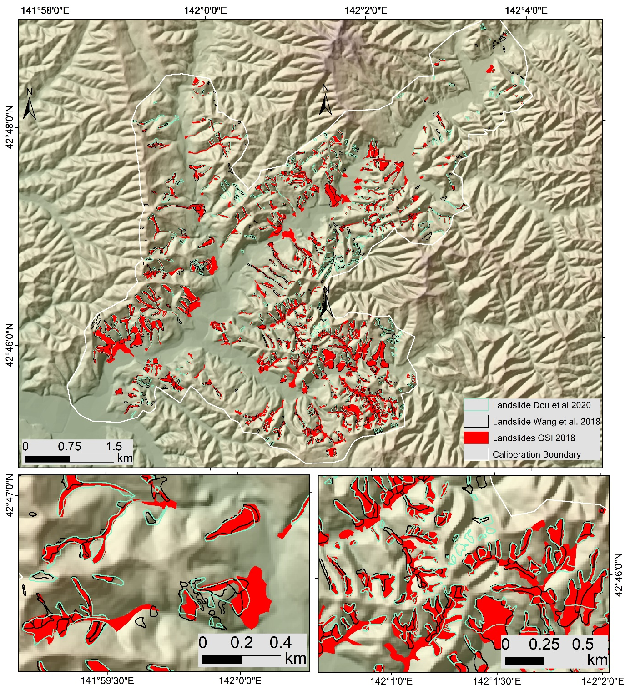Figure S1. Landslides mapped by GSI (2018), Wang et al. (2019) and Dou et al. (2020).
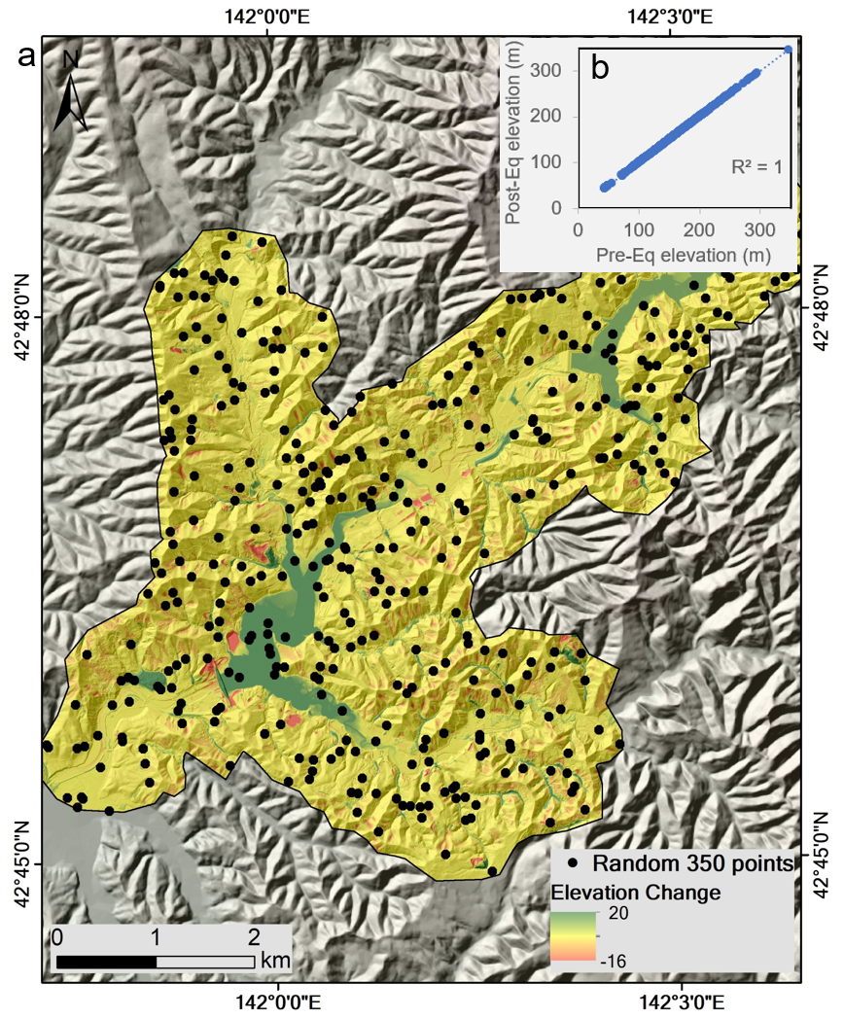
Figure S2. (a) Random non-landslide points (350 numbers; black dots) used for DEM quality check. (b) in inset shows the correlation plot of elevations values for 350 random points obtained from pre-post DEMs (R² = 1).

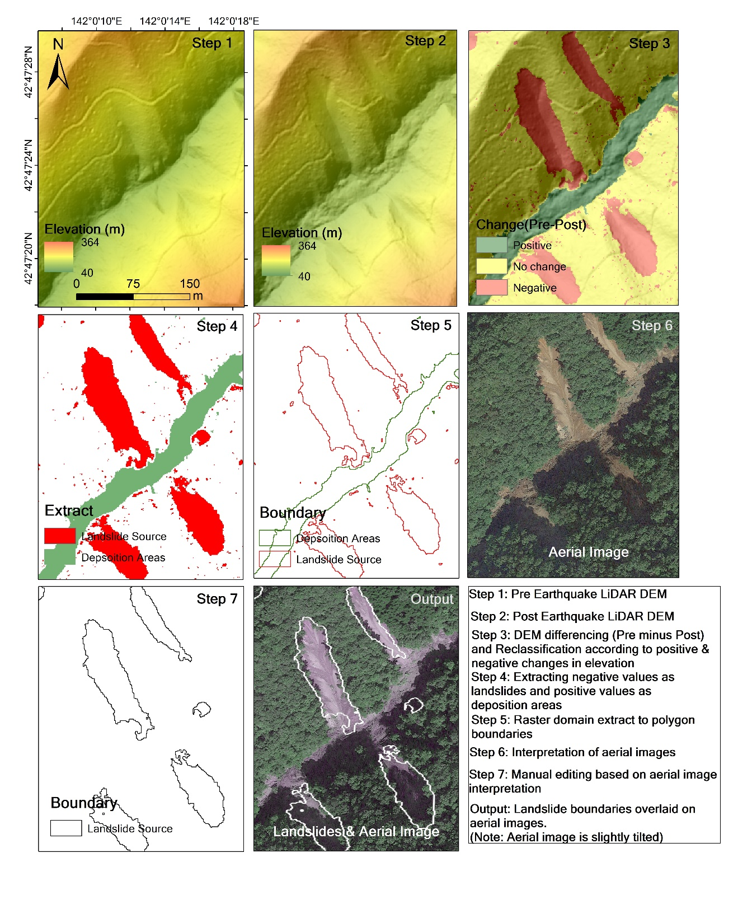

Figure S3. Steps involved in automatic extraction of landslide boundaries from DEM subtraction method.

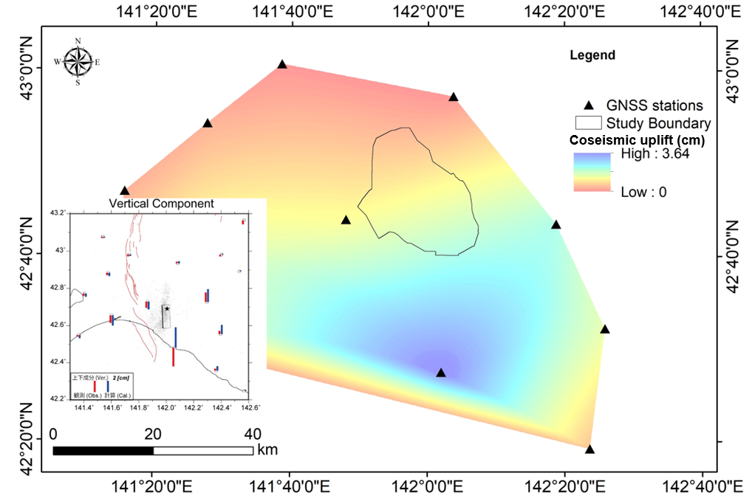
Figure S4. GNSS stations and interpolated uplift values for each pixels using inverse distance weighted (IDW) technique. Black polygon represents the boundary of the present study. Black triangle represents the location of GNSS stations. Vertical component maps are presented in the inset (GSI, 2018).
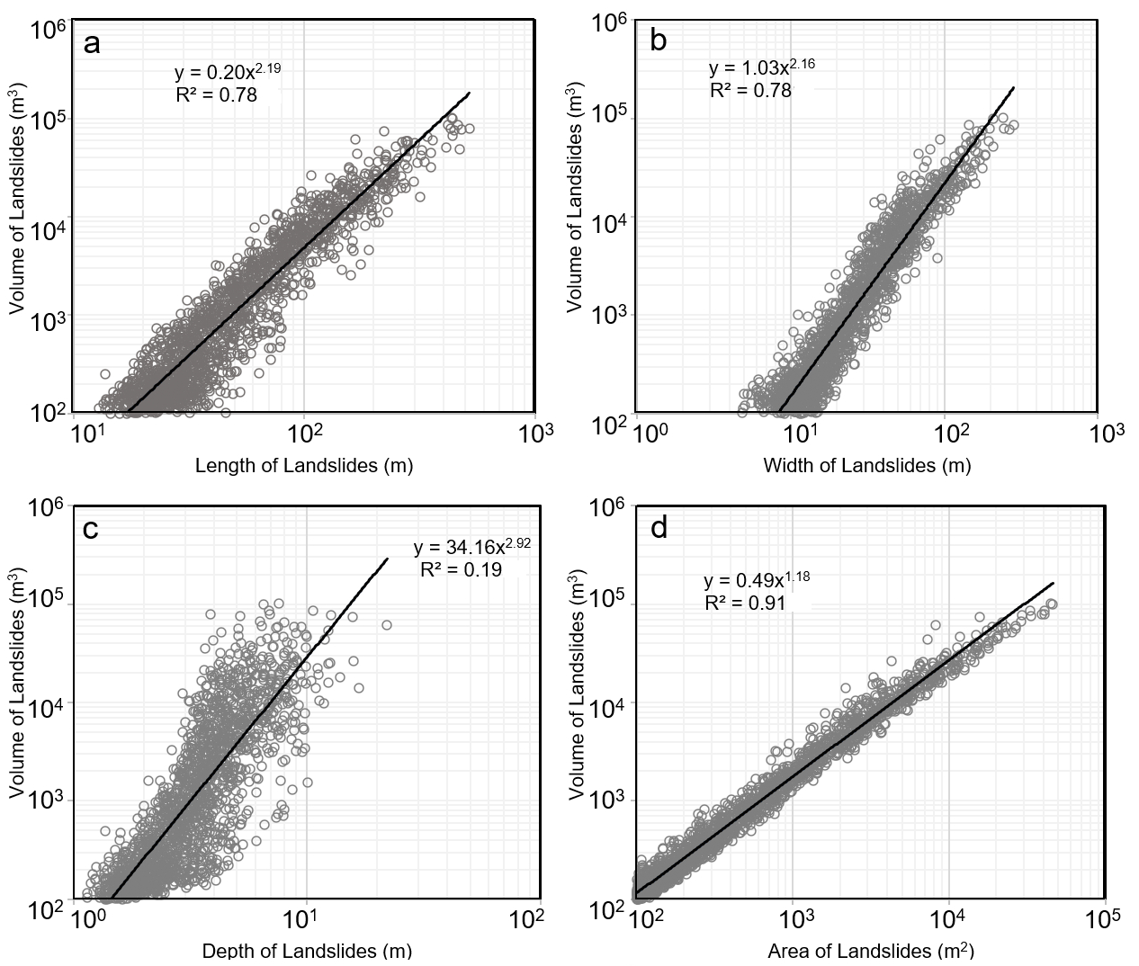

Figure S5. Correlations between (a) length of landslides and landslide volume, (b) width of landslides and landslide volume, (c) mean depth of landslides and landside volume, and (d) area of landslides and landslide volume for all 1719 landslides mapped in the calibration area.

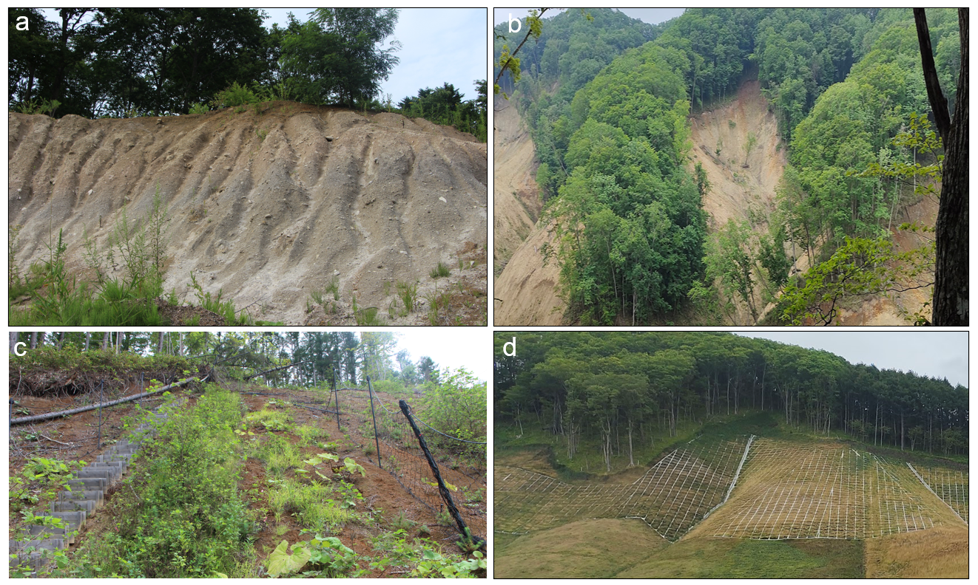
Figure S6. (a) landslide exposing the thick tephra deposits, (b) multiple soil landslides in same slope-aspect, (c) vegetation growth (natural) in soil debris within the first year, and (d) revegetated (artificial) slope within two years.

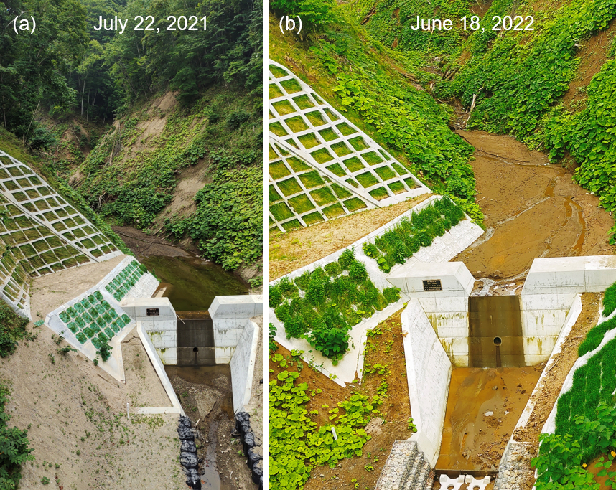
Figure S7. Check dam filled with sediments (a) photograph taken on July 2021, and (b) photograph taken on June 2022.
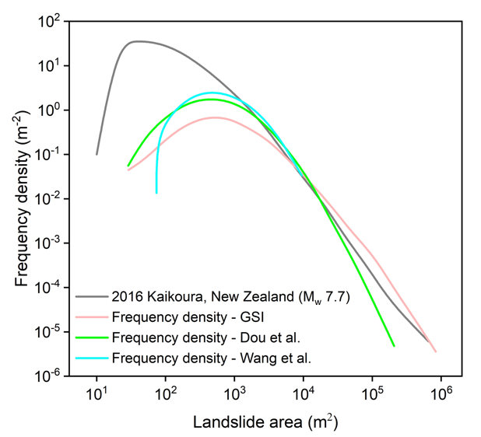
Figure S8. Comparison of frequency density – landslide area plot of Mw 7.7 Kaikoura earthquake induced landslides and Mw 6.6 Hokkaido earthquake induced landslides.

