Extended Data Fig. 1 Characterization of the mechanical fingerprint of the hairpin unfolding in the cRGD-S module using AFM. (a) Typical force-extension (FE) curves between integrin-functionalized tip with surface modified with no cRGD conjugated S (nRGD-S), cRGD-S and cRGD-S with absent hairpin structure (cRGD-S-h⁻). For multiple pulling experiments, the hairpin was allowed to refold after one pulling cycle for 5 min, followed by the next pulling cycle. Red and blue peaks represent hairpin unfolding and cantilever unbinding, respectively. (b) Left: quantitative analysis for cantilever unbinding probabilities. Right: quantitative analysis for hairpin unfolding probabilities relative to FE curves with the specific unbinding peak. Data were measured from ≥ 126 curves.
Extended Data Fig. 2 Worm-like chain (WLC) model analysis. (a) A typical FE curve (blue) and its theoretical fitting curve (red) based on the WLC model. (b) Table of the values of the fitted persistence length L_{p} and calculated total free energy (ΔG). The persistence length p was fitted using WLC model from ≥ 60 curves and presented as mean ± s.e.m. for 3 independent experiments.
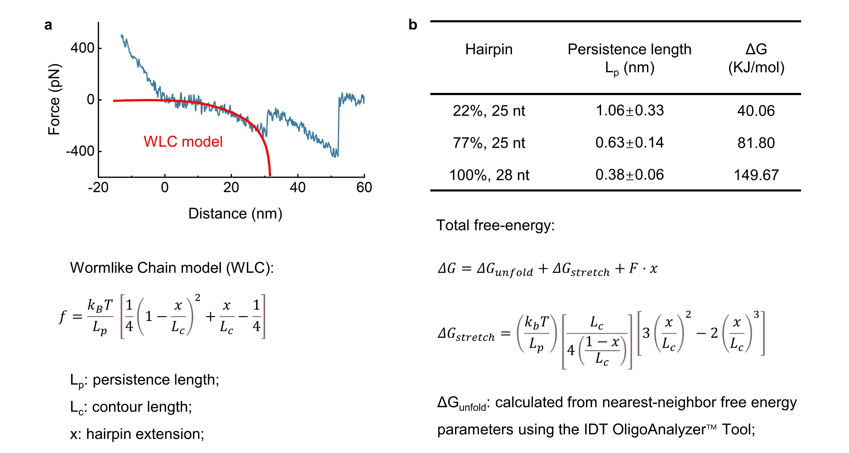

Extended Data Fig. 3 Characterization of force-triggered toehold-mediated strand displacement reaction (F-TSDR) by AFM. (a) Typical FE curves between the integrin-functionalized tip and cRGD-S modified surface in the presence of excess soluble free T modules or the control T modules with mutated engaging sequence (mTe). The contact between the integrin-functionalized tip and Sh/Te duplex-modified surface, the expected product of F-TSDR, was set as a positive control event. (b) Quantitative analysis for hairpin unfolding probabilities relative to FE curves with the specific unbinding peak. Blue bars represent the hairpin unfolding probabilities for the cRGD-S-modified surface. Fuchsia bars represent the hairpin unfolding probabilities of the cRGD-S-modified surface in the presence or absence of T and mTe modules. At least 10 curves from three independent experiments were analysed in each situation.
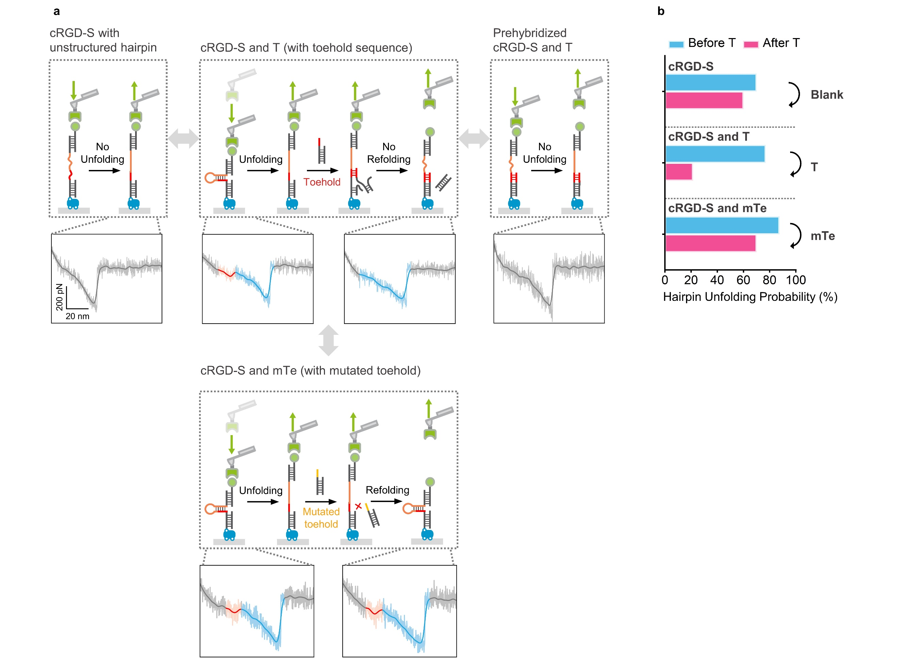

Extended Data Fig. 4 Schematic and in vitro fluorescence test of F-TSDR. (a) Schematic illustration of the cascaded F-TSDR. The transition of the hairpin structure S from the folded state (state A) to unfolded state (state B) is separated by an energy barrier. This energy barrier is contributed by the free energy of base-pair stacking and hydrogen bonding in the stem and the free energy for stretching the ssDNA released by unzipping. Without the application of forces, the unfolding state is kinetically and thermodynamically unfavourable due to the high activation barrier (ΔG). The application of force dampens the energy landscape by changing the free energy between folded and unfolded states, thus affording mechanoselectivity. Initial binding of Te to opened Sh incurs a free energy penalty due to the reduction in the entropy caused by lost translational and orientational degrees of freedom. For the subsequent states, Te progressively base-pairs (zips-up) with the toehold bases of Sh such that the system's free energy decreases until all toehold bases are paired (state C). Beyond the toehold domain, subsequent strand displacement (branch migration) displaces the incumbent Sb and Tb. The initiation of the displacement process requires an additional free-energetic penalty due to the formation of an additional ssDNA overhang. Te-Sh base pairs can only be formed by breaking both the Sh-Sb and Te-Tb base pairs such that no net free energy change occurs. The final state D involves the dissociation of the Sb and Tb followed by the formation of the final base pair between Sh and Te. Dissociation provides a free-energy gain in which the initial costs of the Te association are liberated. (b) In vitro fluorescence assay to explore the mechano-sensitive reaction between the S module and T module. The mechanical selectivity of the toehold sequence binding to unfolded hairpins over folded ones was characterized by comparing the differential hybridization of T to folded S at rest to that of an unstructured sequence. The unstructured sequence provides a model for the unfolded hairpin structure. Hybridization was monitored using the TAMRA fluorescence released from the displacement between S and T/Tb. The hybridization of T to the unstructured sequence saturated within 20 minutes, while the hybridization to the folded hairpin structure did not saturate after 2-hour incubation. We assumed that the dynamic hybridization reactions followed pseudo-first-order binding kinetics and fitted the data by the equation:
$$\begin{aligned}H_{t}=H_{e}\left(1-exp\left(-kt\right)\right)\#(1)\end{aligned}$$
where H_{t} is the amount of hybridization yield at time t, H_{e} is the hybridization yield at equilibrium and k is the pseudo-first-order rate constant. The rate constants were estimated to be k = 1.36×10⁻¹ ± 3.24×10⁻³ s⁻¹ and 7.32×10⁻² ± 1.94×10⁻³ s⁻¹ (mean ± SD) for the unstructured and hairpin probes, respectively. This represents at least one order of magnitude difference in reaction rates, thus providing an estimate of selectively toehold binding between unfolded and folded hairpin structures. Data represent mean ± s.e.m. for 3 independent experiments.
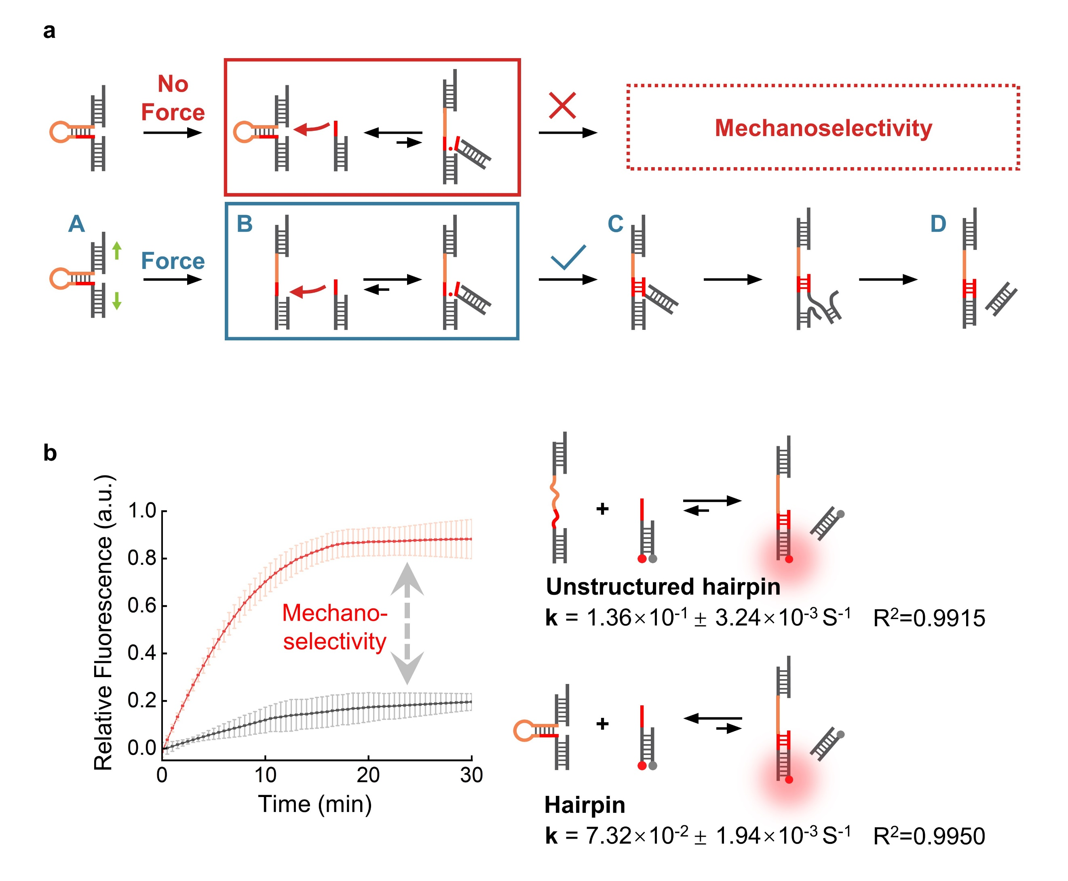

Extended Data Fig. 5 Time-lapsed imaging of intercellular force signal with competition with excess free cRGD peptide or integrin αvβ3 protein. (a) NIH3T3 cells were incubated with 1 µM cholesterol-conjugated cRGD-S and T modules for 30 min followed by treatments with 100 µM soluble cRGDfk peptide or 1 µM integrin αvβ3 protein. Fluorescence images were collected at 0, 4, 10 and 16 min under CLSM. Scale bar, 10 µm. (b) Quantitative analysis for fluorescent intensities between cell-cell junctions at different durations. The intercellular force-sensing signal was greatly inhibited under the competition with cRGDfk peptide or integrin protein, confirming that the tensile force is mediated by integrins. Three distinct cell-cell junctions were imaged for each time point, and the mean intensity was plotted with time. Data represent mean ± s.e.m. for 3 independent experiments.
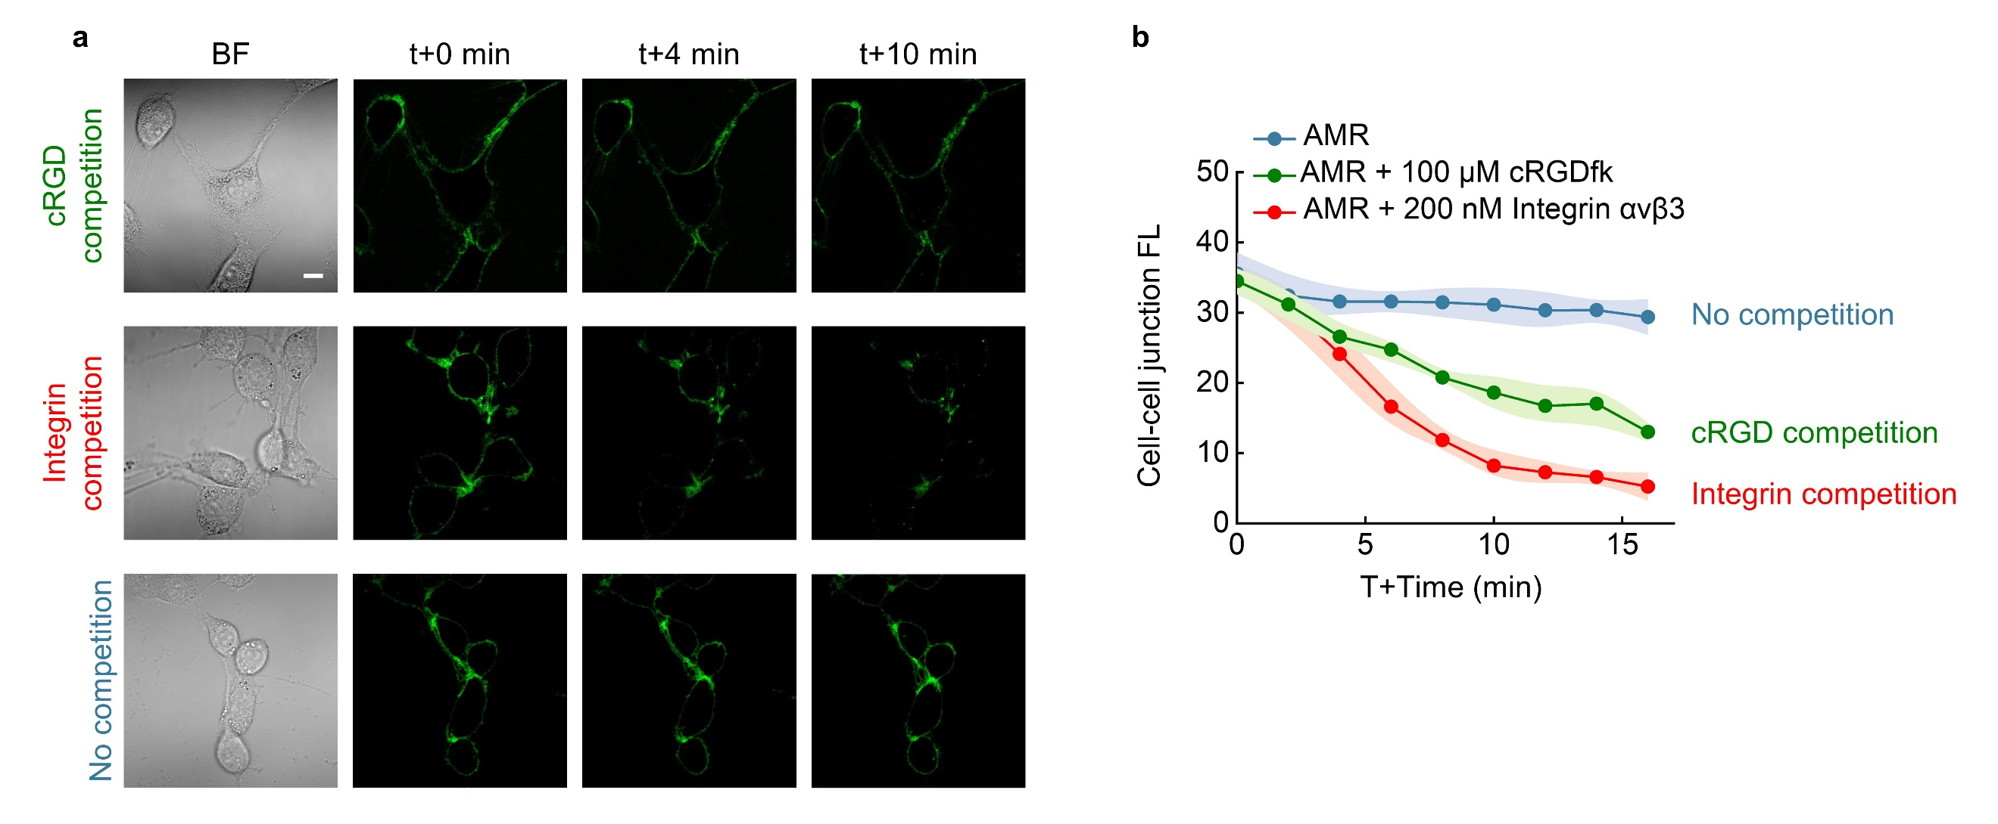

Extended Data Fig. 6 Visualization of cRGD-AMR-c-Met system upon sensing and transmitting integrin-mediated intercellular force on Hela cells. (a) Representative images of brightfield, FAM and TAMRA channels for the Hela cells treated with no cRGD conjugated AMR (nRGD-AMR) and cRGD-AMR (400 nM). For the actomyosin inhibition, Hela cells were pre-treated with blebbistatin (15 µM) for 10 min before the addition of cRGD-AMR-c-Met. Scale bar, 10 µm. (b) Quantification of junctional fluorescence in TAMRA channels to characterize the F-TSDR at cell-cell junctions. Data represent mean ± S.D. (n = 10). ***P < 0.001 (unpaired two-tailed Student’s t-test).
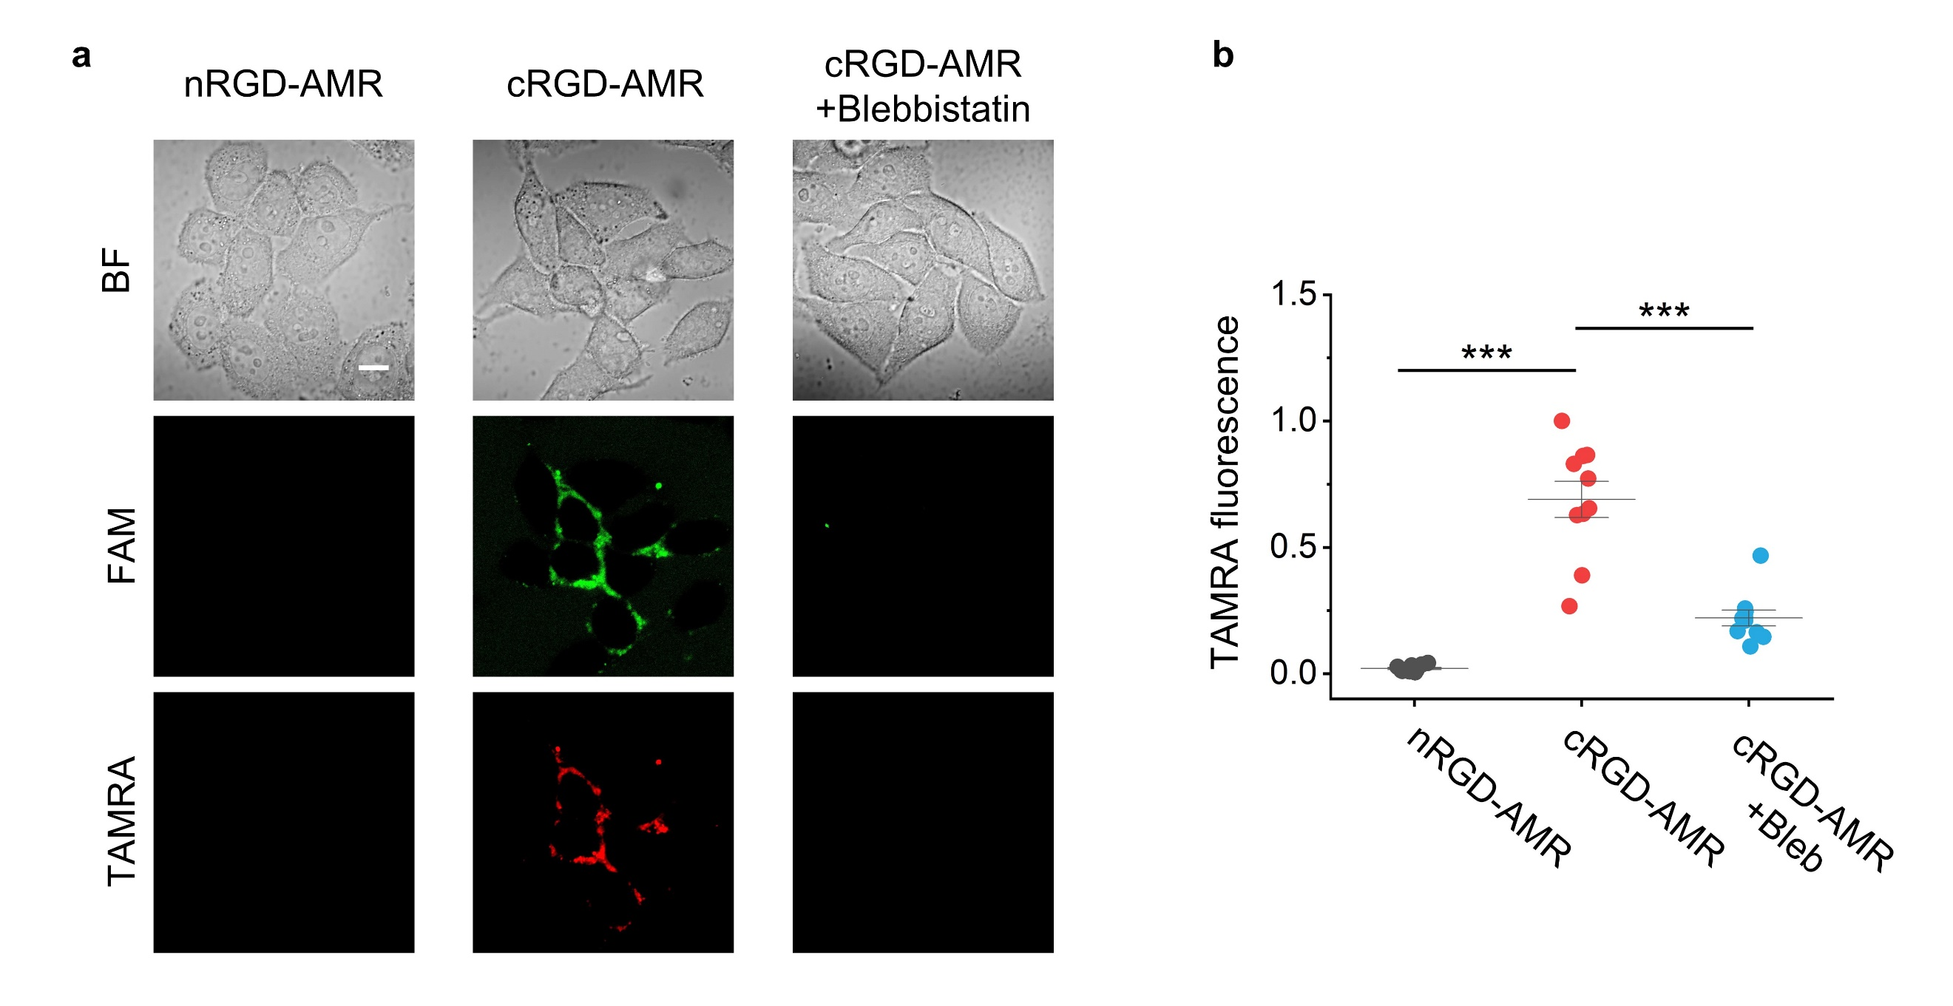

Extended Data Fig. 7 Visualization of F-TSDR and ERK response activity of living cells. Hela cells were transfected with ERK-KTR for 24 h, followed by treatment of cRGD-AMR-c-Met (400 nM) or HGF (2 nM). Cells were pre-treated with 100 nM foretinib for 2 h to inhibit the kinase activity of c-Met. Time-lapsed images were collected to track the ERK-KTR translocation and TAMRA fluorescence change. The white arrows indicate the cells experiencing nucleus-to-cytosol translocation of ERK-KTR. Scale bar, 10 µm.
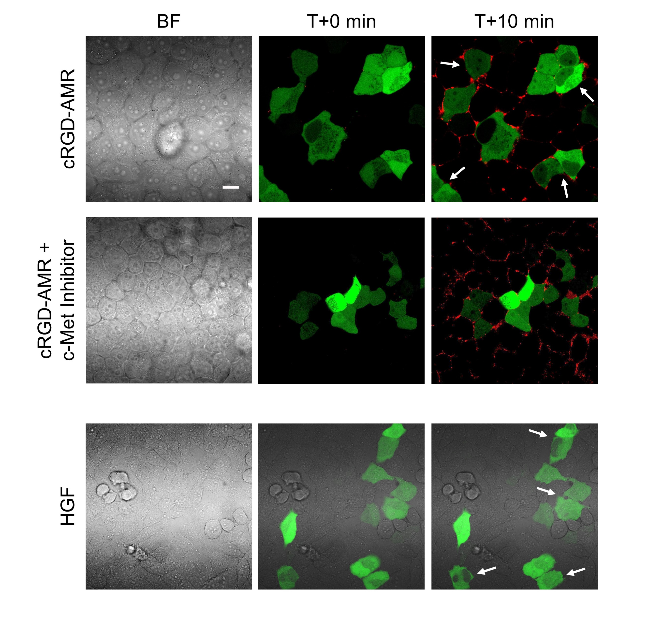
Extended Data Fig. 8 Customized AMR with responsiveness to the E-cadherin-mediated force input. Western blotting showed the c-Met phosphorylation (Tyr1234/Tyr1235) and ERK phosphorylation (Thr202/Tyr204) in the lysates of Hela cells with indicated treatments. The α-tubulin was used as an internal reference. E-cad-AMR-S represent the control in the absence of AMR-T.
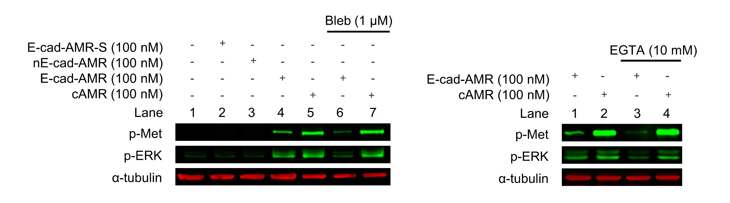

Extended Data Fig. 9 Customized AMR responding to CI-M6PR endocytosis force input. (a) Representative images for the Hela cells engineered with nCI-M6PR-AMR-c-Met (nC-AMR), random sequence-AMR-c-Met (C-AMR with random ligand), and CI-M6PR-AMR-c-Met (C-AMR, 400 nM) are shown in brightfield, FAM and TAMRA channels. For the endocytosis inhibition, cells were pre-treated with Pitstop (30 µM) for 10 min before CI-M6PR-AMR-c-Met functionalization (C-AMR + Pitstop). For the ligand competition control, cells were pre-treated with CI-M6PR aptamers (2 µM) for 30 min before CI-M6PR-AMR-c-Met functionalization (C-AMR with ligand competition). Scale bar, 10 µm. (b) Western blotting showed the c-Met phosphorylation (Tyr1234/Tyr1235) and ERK phosphorylation (Thr202/Tyr204) in the lysates of Hela cells with indicated treatments. The α-tubulin was used as an internal reference. C-AMR-S represent the control in the absence of AMR-T.
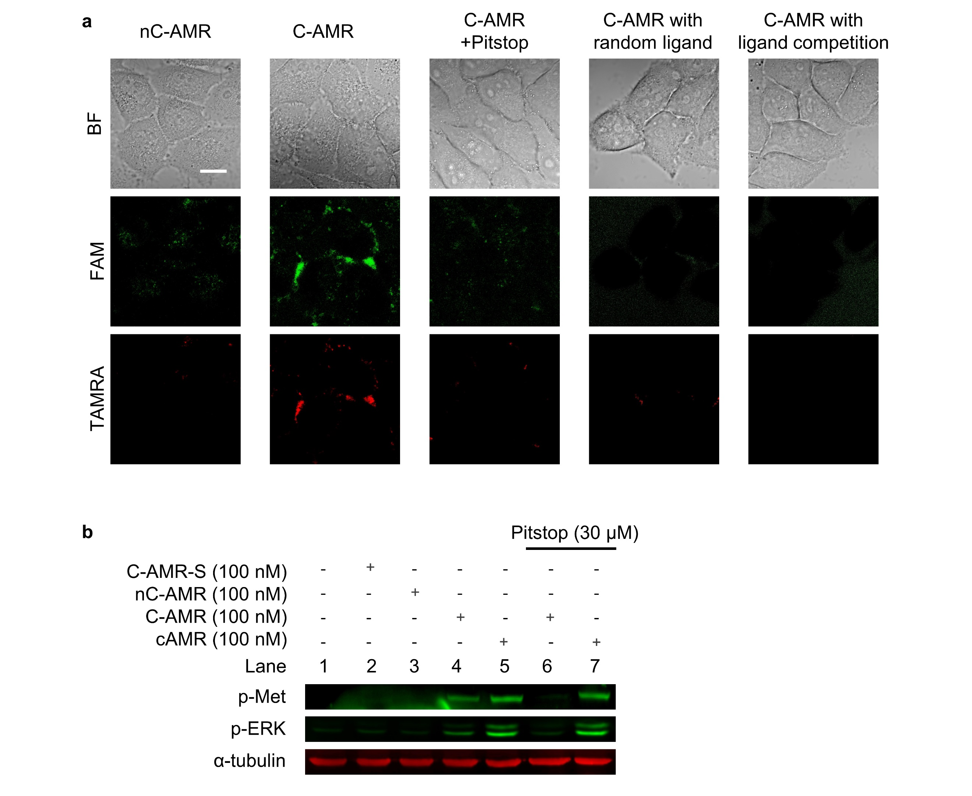

Extended Data Fig. 10 The versatility of AMR for FGFR1 signalling output. (a) Representative images for the NIH3T3 cells engineered with nRGD-AMR-FGFR1 and cRGD-AMR-FGFR1 (400 nM) are shown in brightfield, FAM and TAMRA channels. For actomyosin inhibition, cells were pre-treated with blebbistatin (10 µM) for 10 min before cRGD-AMR-FGFR1 functionalization. Scale bar, 10 µm. (b) Western blotting of FGFR1 phosphorylation (Tyr653/Tyr654) and ERK phosphorylation (Thr202/Tyr204) in the cell lysates of A549 cells with indicated treatments. The α-tubulin was used as an internal reference. cRGD-AMR-F-S represent the control in the absence of AMR-T.
