Supplementary Information for

New insights into the membrane-camouflaged nanoparticles for the treatment of ETX intoxication

This PDF file includes:
1. Figure S1 to S11

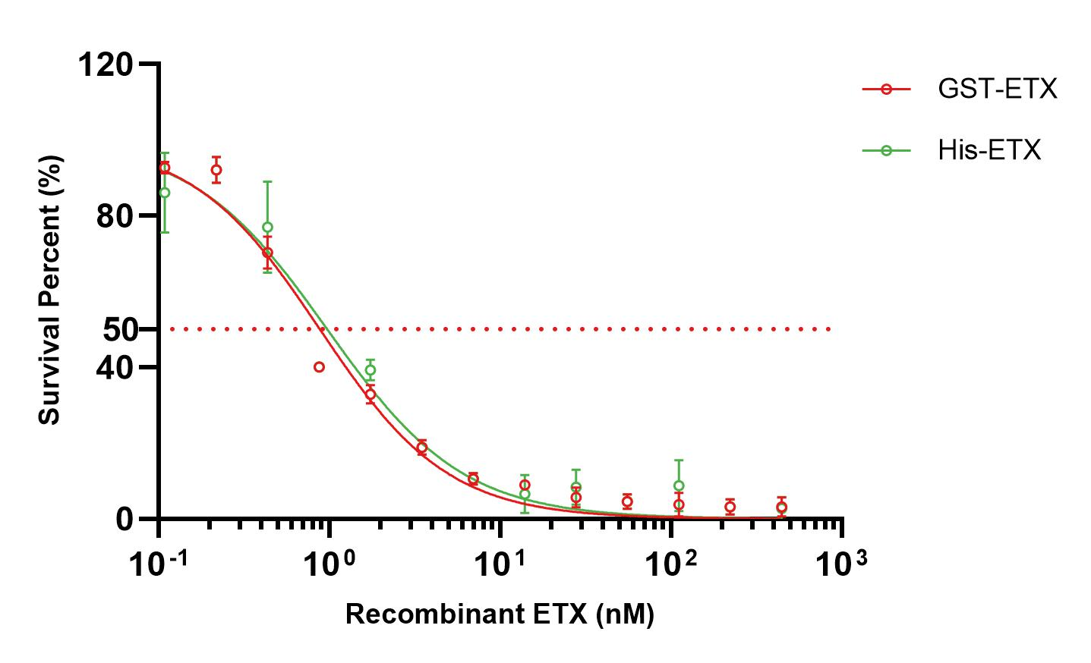
Figure S1. In vitro toxicities of recombinant ETX. ETX with different tags (GST and 6×His) did not significantly differ in toxicities (n=3). Data are presented as the means ± SD.
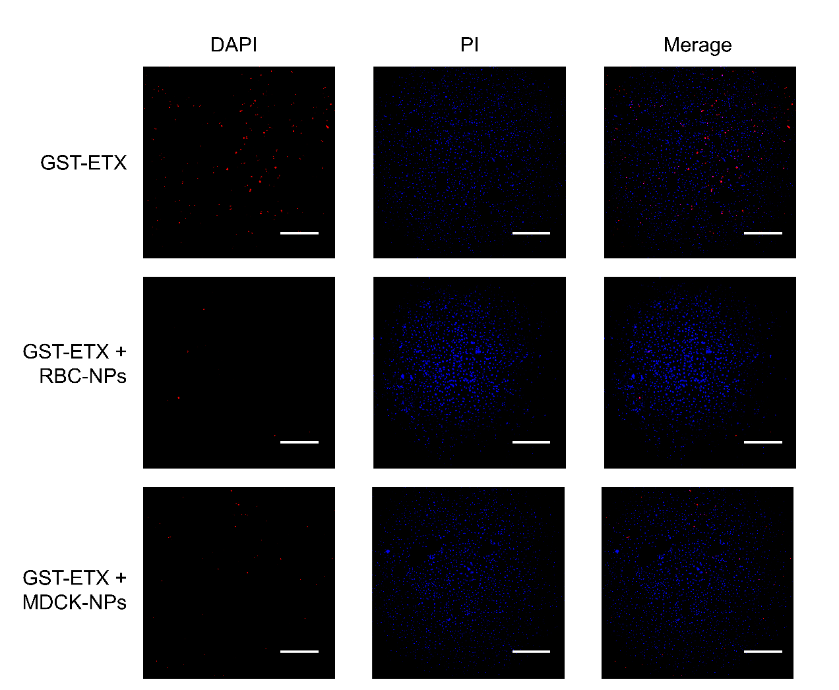
Figure S2. MDCK cells were exposed to 2 mg nanoparticles and 20 nM of GST-ETX for 1h at 37°C. The cells were observed by confocal microscopy. (Scale bar: 1 mm).
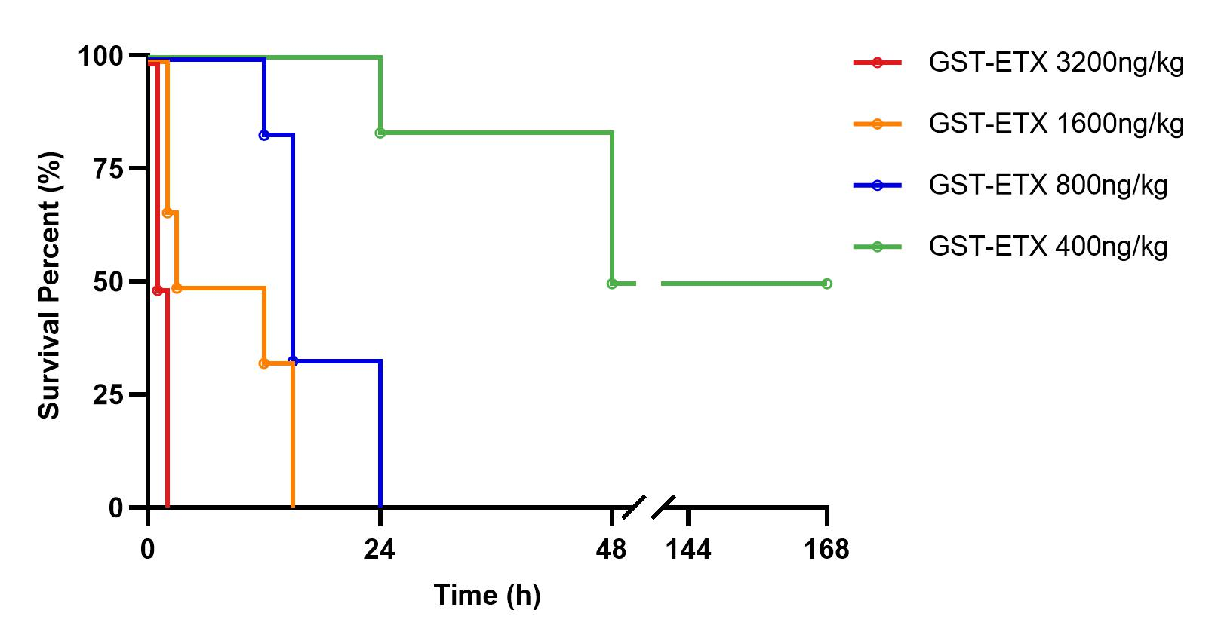
Figure S3. Four groups of eight-week-old female BALB/c mice, were injected with increasing dosages of GST-ETX in intravenous respectively. The survival curves of the mice in the next 7 days (n = 6).
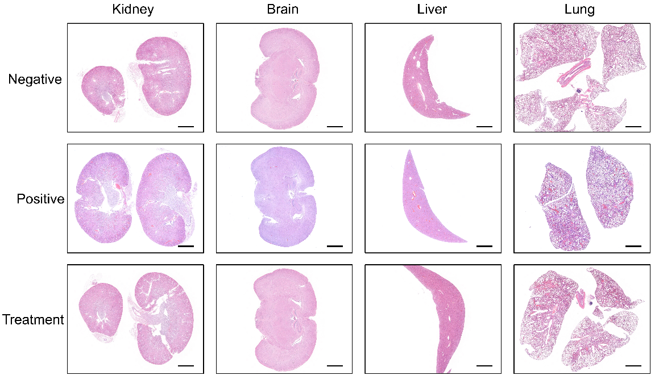
Figure S4. Representative sections made from various organs of experimental mice with intravenous injection, stained with H&E (scale bar: 2 mm).
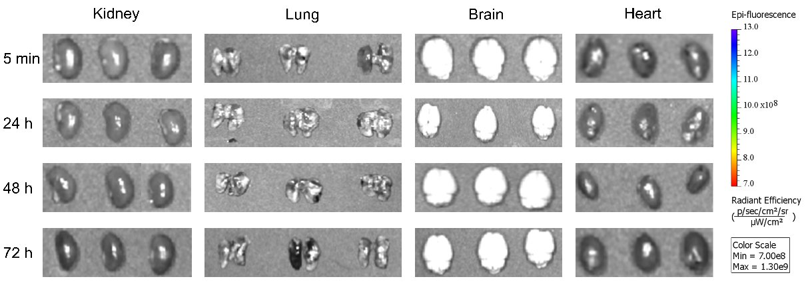
Figure S5. In vitro fluorescence images of DiR in organs of mice which injected intravenously with Cy5.5-ETX and PBS.
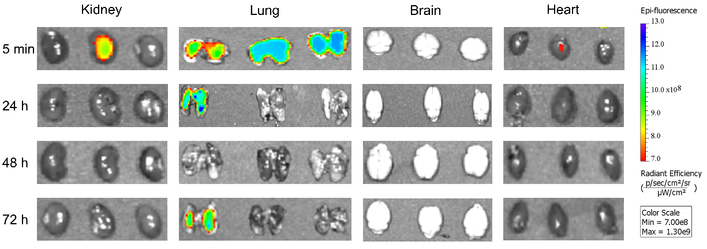
Figure S6. In vitro fluorescence images of DiR in organs of mice which injected intravenously with Cy5.5-ETX and DiR-RNPs.
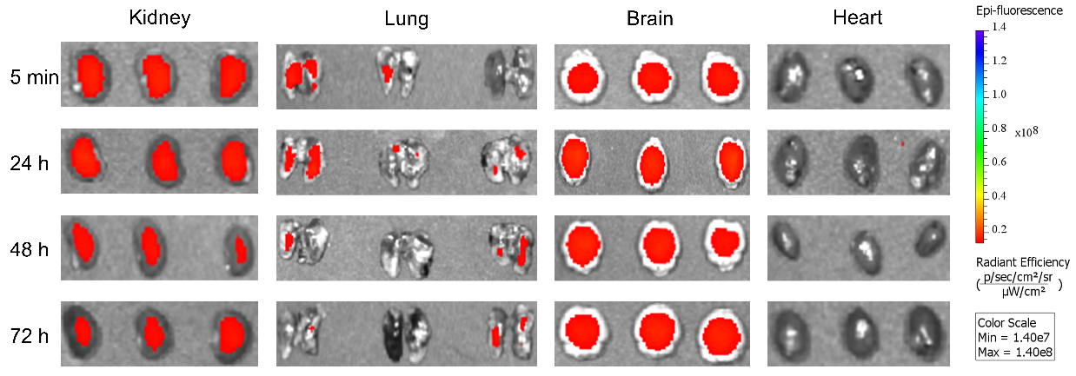
Figure S8. In vitro fluorescence images of Cy5.5 in organs of mice which injected intravenously with Cy5.5-ETX and PBS.
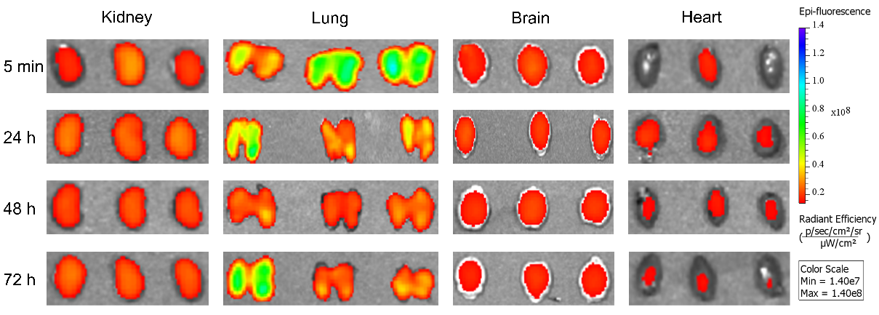
Figure S9. In vitro fluorescence images of Cy5.5 in organs of mice which injected intravenously with Cy5.5-ETX and DiR-RNPs.
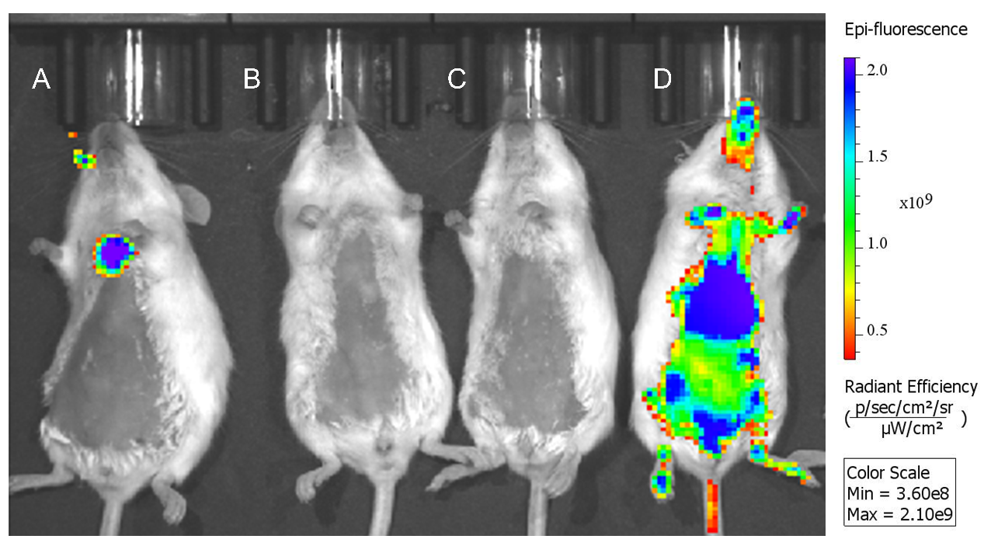
Figure S9. Real-time in vivo fluorescence images of mice after lung delivery or intravenous injection 10 min. (A) Lung delivery DiR-RNPs, DiR-RNPs were evenly dispersed in lung of the mouse but did not escape the lung. Radiant efficiency exceeded 2×10⁹ in the lung. (B) Lung delivery PBS. (C) Intravenous injection PBS. (D) Intravenous injection DiR-RNPs, DiR-RNPs spread throughout the mouse by the bloodstream. The systemic radiation efficiency of mouse was generally low, and the maximum radiation efficiency did not reach 2×10⁹.
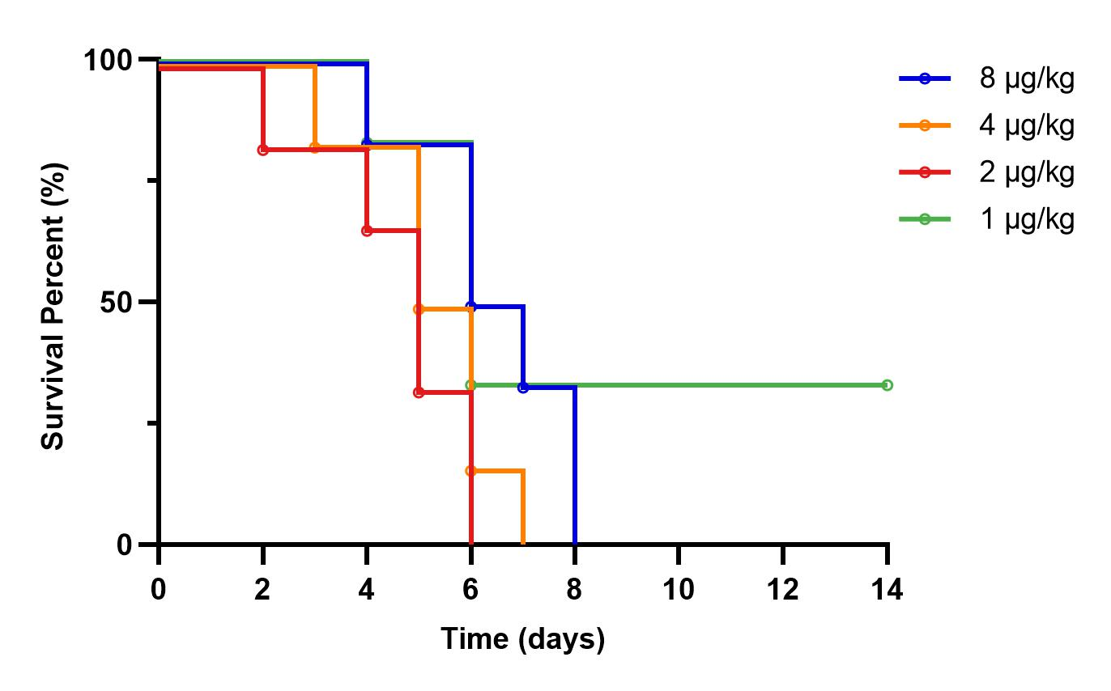
Figure S10. Four groups of eight-week-old female BALB/c mice, were introduced by aerosol into the lungs with increasing dosages of GST-ETX. The survival curves of the mice in the next 14 days (n = 6).
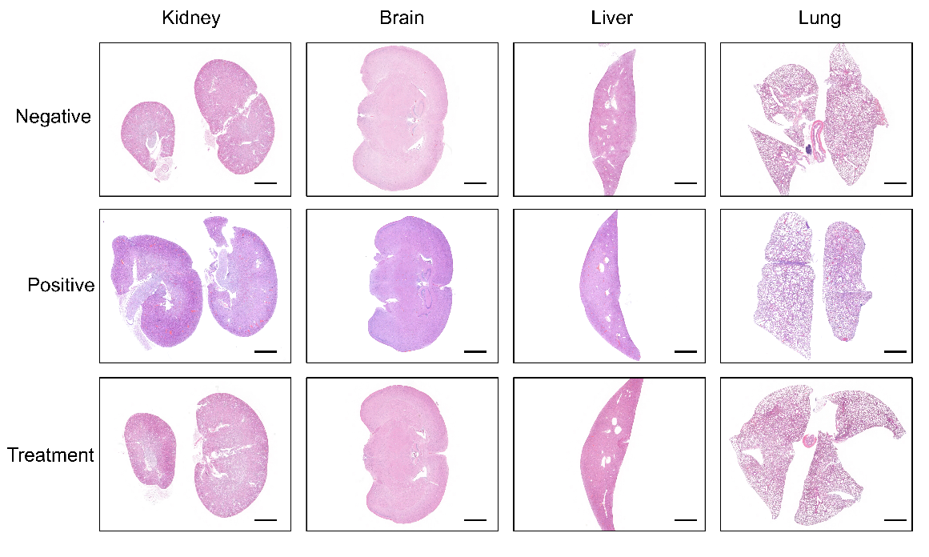
Figure S11. Representative sections made from various organs of experimental mice with lung delivery, stained with H&E (scale bar: 2 mm).

