Additional file 1: Supplemental Figures
Figure S1. The heat map shows the correlation between the three biological repeat transcriptomes for each tissue sample of JH and JL.

Figure S2. Heat map showing the expression profiles of TF family members preferentially expressed in JH and JL varieties during cold treatment.
Figure S3. Expression levels of DEmRNA in 13 pairs of comparative combinations in rice seedling leaves after low temperature treatment Volcano.

Figure S4. Density distribution of each group of lncrna in the leaves of rice seedlings after low temperature treatment.

Figure S5. TopGO enrichment analysis of genes contained in the black module. The enrichment results of biological processes, cellular components and molecular functions are shown from top to bottom.

Figure S6. TopGO enrichment analysis of the genes contained in the green module. The enrichment results of biological processes, cellular components and molecular functions are shown from top to bottom.

Figure S7. The black and green modules share a ceRNA network formed by RNA integration, blue represents lncRNA, pink represents miRNA, and green represents mRNA.

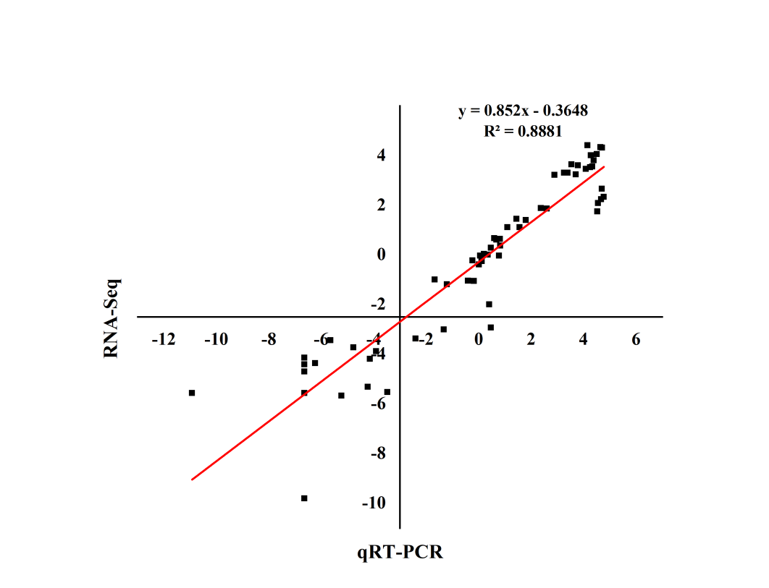
Figure S8. DEGs between RNA-Seq and qRT-PCR.

Figure S9. Sequence difference analysis of OsGLR1.2 in two varieties. Differences in promoter region sequences between JH and JL.

