Supporting information

A technology to reduce ammonia emission via controlling proteolytic bacterial community and physicochemical properties
Ying Huang^{a . .} Yuehong Chen^{a*.} Hongying Huang^{bc.} Jiujun Linª Meiling Yan^{a .}Chengbao Guo^{a .} Xu Xiao ª
(ªNanjing Institute of Agricultural Sciences in Jiangsu Hilly Area, No. 6 Xianyin South Road, Qixia District, Nanjing 210046, Jiangsu Province, China;
^{b}Institute of Agricultural Resources and Environment Jiangsu Academy of Agricultural Sciences, Jiangsu Academy of Agricultural Sciences, No. 50 Zhongling Street,
Xuanwu District, Nanjing, Jiangsu Province 210014, China;
^{c}Jiangsu Collaborative Innovation Center for Solid Organic Waste Resource Utilization, Nanjing, Jiangsu Province 210014, China )

*Correspondence should be addressed to
Yuehong Chen
e-mail address: cyh2007104026@163.com

Main content

Table S1 to Table S3
Figure S1 to Figure S3

Table S1 Biophysicochemical properties
 |  | Physicochemical properties of composts
Treatment | Time | TOC | TN | pH | EC | NH₄⁺-N | NO₃⁻-N | WISN | WSON | DOC
Treatment | (d) | (g/kg) | (g/kg) | pH | (ms/cm) | (mg/kg) | (mg/kg) | (g/kg) | (g/kg) | (mg/kg)
CK | 0 | 379.9±10.8a | 20.4±2.3bc | 8.9±0.1ab | 34.1±0.6 bc | 7160±272 a | 159.1±13.6 a | 9.2±3.4a | 3.0±3.7c | 149.1±47.2bc
 | 20 | 378.8±1.8a | 18.1±0.2d | 8.0±162c | 46.8±3.6 a | 7278±210a | 115.8±11.4 b | 5.3±1.1c | 4.4±2.5e | 183.9±18.9ab
 | 40 | 354.8±30bc | 16.3±0.6d | 8.8±119 b | 36.1±0.5 b | 5951±213 b | 61.8±10.5 e | 4.1±1.4c | 3.1±0.4d | 150.7±62.7b
 | 60 | 275.9±5.3d | 17.6±0.4d | 9.3±194a | 32.3±0.8bc | 1836±477 d | 87.6±2.3 d | 10.0±1.5b | 2.0±0.5b | 102.7±30.8c
HPC | 0 | 380.3±6.3 a | 18.4±0.1cd | 8.8±0.1b | 31.6±0.9c | 6019±273b | 147.8±14.0a | 9.8±1.9b | 3.4±1.4bc | 154.9±10.2b
 | 20 | 367.6±19.7ab | 21.1±2.4b | 8.7±0.2b | 34.4±1.5b | 6435±111b | 107.1±13.8bc | 8.2±0.2c | 4.7±2.3e | 171.5±33.8a
 | 40 | 339.0±5.0 c | 25.1±1.2 a | 9.2±0.1a | 35.2±1.0b | 2905±186c | 84.1±11.7d | 11.9±1.6b | 5.5±3.6bc | 123.8±27.4a
 | 60 | 288.6±9.3 d | 24.4±0.5a | 9.4±0.1a | 31.9±1.3c | 710±163e | 92.3±6.9cd | 14.7±1.1a | 4.1±3.9a | 95.9±28.6c

Table S2 Total N loss as NH₃ from different treatments during composting
Treatments | Initial TN (kg) | Total N after pretreatment (kg) | Total N lost after pretreatment (kg) | Total N at end  (kg) | Total N lost in all (kg) | Total N lost (%) | Total N retained in compost (% of initial N) | NH₃ emission (kg) | Total N lost as NH₃ (% of TN lost)
TC | 1.68±0.05 | 1.68±0.05 | / | 1.13±0.02 | 0.55±0.01 | 32.8±2.5 | 67.2±3.2 | 0.25±0.02 | 45.4±2.1
HPC | 1.68±0.05 | 1.55±0.07 | 0.13±0.01 | 1.40±0.03 | 0.28±0.02 | 16.7±1.1 | 83.3±5.1 | 0.12±0.01 | 21.8±1.5

Abbreviations: TC, traditional composting; HPC, hyperthermophilic pretreatment composting.
Table S3 Illumina amplicon sequencing reads and comparison of α-diversity indices of the bacterial npr and sub communities in the traditional composting (TC) and hyperthermophilic pretreatment composting (HPC). Different letters indicated statistical significance (p < 0.05) based on Newman-Keuls multiple comparison test.

 | Treatment | Number of reads | Richness estimator |  | Diversity estimator
 | Treatment | Filtered data | Observed OTUs | Chao1 | Shannon | Simpson
npr | TC0 | 23705±385 | 36±3.2bc | 42±1.3a | 1.55±0.02ab | 0.29±0.002e
 | TC20 | 21409±1571 | 30±3.0cd | 37±1.7b | 1.59±0.09ab | 0.43±0.018c
 | TC40 | 23548±390 | 40±3.6ab | 36±2.1b | 1.36±0.11b | 0.35±0.012de
 | TC60 | 19832±2466 | 33±2.9bcd | 37±1.8b | 1.66±0.12a | 0.31±0.029e
 | HPC0 | 23748±1030 | 31±2.1cd | 28±0.6d | 0.58±0.19c | 0.77±0.062b
 | HPC20 | 23408±1002 | 20±1.8e | 22±0.7e | 0.45±0.07c | 0.80±0.023a
 | HPC40 | 24029±480 | 28±2.3d | 32±2.7c | 0.56±0.12c | 0.78±0.071ab
 | HPC60 | 24432±526 | 42±3.7a | 44±3.0a | 1.39±0.03b | 0.39±0.033cd
 | Total sequences | 184114
sub | TC0 | 22924±1020 | 129±4.5b | 132±6.2b | 3.06±0.18a | 0.10±0.01b
 | TC20 | 21336±3712 | 34±2.0d | 34±0.17de | 1.09±0.11c | 0.47±0.02a
 | TC40 | 18723±1054 | 32±0.7d | 35±3.1de | 0.81±0.07d | 0.65±0.05a
 | TC60 | 19920±1959 | 49±4.2c | 56±4.2c | 1.18±0.02c | 0.46±0.05a
 | HPC0 | 23519±1959 | 144±3.5a | 145±12.0a | 2.78±0.01b | 0.15±0.05b
 | HPC20 | 22455±500 | 25±2.1e | 26±1.1e | 1.04±0.12cd | 0.50±0.03a
 | HPC40 | 19060±4642 | 33±1.4d | 40±2.5de | 1.12±0.04c | 0.46±0.03a
 | HPC60 | 21385±7557 | 36±1.0d | 44±1.4cd | 1.11±0.09c | 0.47±0.01a
 | Total sequences | 169325

FIGURE LEGENDS
Fig. S1 Temperature profiles of two composting treatments over 60 days. TC, traditional composting; HPC, hyperthermophilic pretreatment composting.
Fig. S2 The protease activity (a) and ammonification rate (b) of two composting treatments over 60 days. TC, traditional composting; HPC, hyperthermophilic pretreatment composting.
Fig. S3 Taxonomic classification at the genus level of abundant (> 1%) npr and sub gene sequences in the samples during the traditional composting (a) and hyperthermophilic pretreatment composting (b) by day 0, 20, 40 and 60. The prefix“Un.”represented unclassified species.

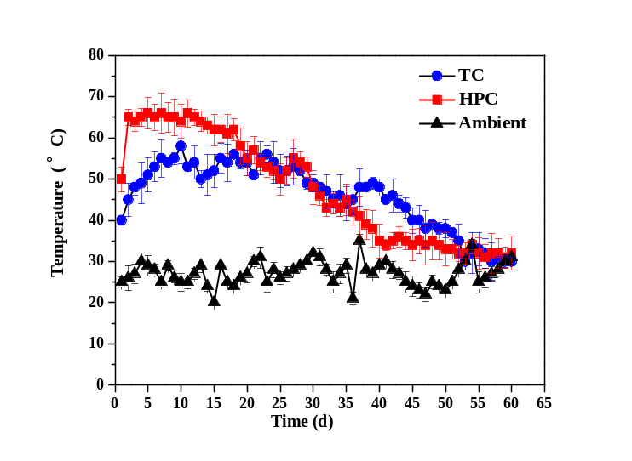
Figure S1 Temperature profiles of two composting treatments over 60 days.
TC, traditional composting; HPC, hyperthermophilic pretreatment composting.

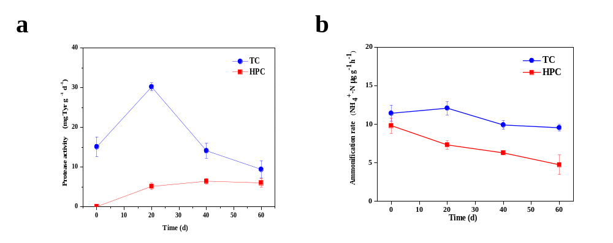
Figure S2 The protease activity (a) and ammonification rate (b) of two composting treatments over 60 days.
TC, traditional composting; HPC, hyperthermophilic pretreatment composting.

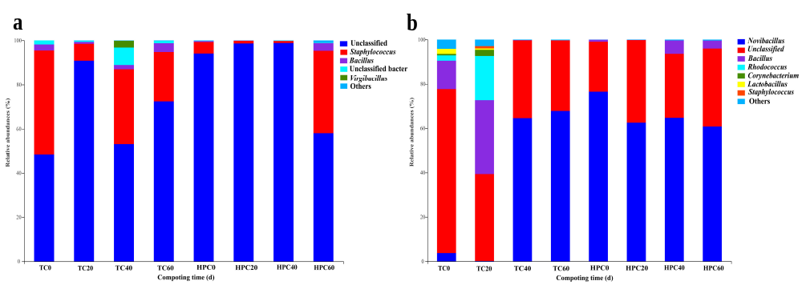
Figure S3 Taxonomic classification at the genus level of abundant (> 1%) npr and sub gene sequences in the samples during the traditional composting (a) and hyperthermophilic pretreatment composting (b) by day 0, 20, 40 and 60. The prefix“Un.”represented unclassified species.

