Supporting Information

A Multi-Material 3D Printing-Assisted Micropatterning

Sayli Jambhulkar, Dharneedar Ravichandran, Varunkumar Thippanna, Dhanush Patil, Kenan Song *

S. Jambhulkar, D. Ravichandran, V. Thippanna, D. Patil
Systems Engineering, The School of Manufacturing Systems and Networks (MSN), Ira A. Fulton Schools of Engineering, Arizona State University (ASU), Mesa, AZ, USA 85212

K. Song
The School of Manufacturing Systems and Networks (MSN), Ira A. Fulton Schools of Engineering, Arizona State University (ASU), Mesa, AZ, USA 85212
Email: kenan.song@asu.edu

Table of contents:

S1. Ink rheology and 3D printing processability 6
S2. Etching Dynamics 13
S3. Thermal Dissipation Demonstration 17

List of Fig.s:

Fig. S1. The microstructure of printed <32> multilayer film for a-a₁) PVA20-W/E, b-b₁) CAB22-A/E, c-c₁) PEG30-H/E system as alternating sublayers before (left column) and after solvent etching (right column) (all scale bars 1200 µm), showing the disrupted layers after etching 8
Fig. S2. Contact angle measurements for printing materials of a) PEG, b) E-BN25, and c) PEI (θ_{PEG-glass}= 35.89°, θ_{E-BN25-glass}=44.17°, θ_{PEI-glass}=63.43°) on glass substrates 8
Fig. S3. TGA analysis for E-BN composite inks to confirm the concentration of the BNs 9
Fig. S4. BNs surface morphology with particle size varying from 300 nm to 1 μm 9
Fig. S5. Theoretical shear rate experienced in multipliers as a function of different layer numbers <n>=<32>, <64>, and <128> (i.e., with different numbers of layer multipliers) in MDIW printhead 10
Fig. S6. Storage modulus (G’) and loss modulus (G") as a function of shear stress for a) E-BN inks at a varying concentration of BNs and b) PEI at room temperature (RT) and 50°C 10
Fig. S7. The optical micrograph shows the printing difficulties observed for <32> sublayers with a) E-BN20 showing overlapped sublayers due to spreading of ink and b) E-BN30 showing discontinued printing due to clogging of the nozzle (both scale-bars 1200 μm) 11
Fig. S8. Thixotropic properties of E-BN25 ink, simulating the printing condition with alternating high and low shear rates 11
Fig. S9. The optical image showing the interfacial phenomena at the polymer/polymer interface between a) E/PEG30-H (diffusion) and b) E/PEI (no diffusion) (scale bars 500 μm) 11
Fig. S10. Digital photograph of PEI and E-BN25 inks interfaces captured after 12 hr of contact demonstrating long-term interfacial stability 12
Fig. S11. The CFD simulation of E-BN25 and PEI-50 inks showing layer multiplication for <32> sublayers within the MDIW printhead 12
Fig. S12. PEI dissolution (%) at different etching times in IPA, water, and ethanol etchant for a) <64> and b) <128> sublayers at RT 14
Fig. S13. The measured contact angle between 3D printing inks PEI and E-BN25 with different etching solvents, such as IPA, ethanol, and water (i.e., θ_{IPA-PEI}= 21.61°, θ_{IPA-E-BN25}=77.43°, θ_{ethanol-PEI}=13.51°, θ_{ethanol-E-BN25}=83.98°, θ_{water-PEI}=16.67°, θ_{water-E-BN25}=91.04°) 14
Fig. S14. Multilayer micropatterns surface morphology for <32>, <64>, <128> samples after etching in IPA, water, and ethanol for 15 minutes showing mechanical debonding with the glass substrate for water and ethanol etchants (all scale bars are 1200 μm) 15
Fig. S15. The average surface roughness (S_{a}) of the MDIW micropatterns was measured using an optical profilometer after etching in IPA (RT) as a function of etching periods (min) 15
Fig. S16. PEI dissolution percentage (%) of multilayer samples in a) ethanol and b) water at 35°C as a function of the etching period 16
Fig. S17. Fitting of the diffusion kinetics for the PEI dissolution (%) of multilayer samples for the etching in a) ethanol and b) water at RT ≈25 °C for 15 min 16
Fig. S18. Fitting of the diffusion kinetics for the PEI dissolution (%) of multilayer samples for etching in a) ethanol and b) water at 35°C for 15 min 16
Fig. S19. Temperature distribution of the etched micropattern surfaces for a-a₁) <64> and b-b₁) <128> sublayers after heating up to 80°C with air and water confined microchannels 19

List of tables:

Table S1. Comparison of the printing speed for different 3D Printing techniques 5
Table S2. Material property used for fluidic simulations 12
Table S3. Solubility parameters (i.e., dispersive interactions (δD), polar interactions (δP), hydrogen bonds (δH), polymer radius of interaction (R₀)) for PEI, epoxy, and etching solvents 16
Table S4. Thermophysical properties of E-BN25 composite ink at RT 18
Table S5. The average a) surface temperature and b) heat flux measured from ANSYS simulations for etched micropatterns 18
Table S6. The average a) surface temperature and b) heat flux measured from ANSYS simulations for ideal micropatterning surfaces 19
Table S1. Comparison of the printing speed for different 3D Printing techniques
Method | Speed (≈mm/s) | Feature resolution (≈μm) | Ref.
FDM | 20-100 | 50-200 | [1–3]
E-jet | 500-1500 | 0.1-20 | [4–6]
EHD | 0.001-0.1 | 0.08–50 | [7–9]
DIW | 0.01-0.1 | 50-500 | [3],[7],[8]
Inkjet | 1-100 | 50-150 | [1],[8],[9]
MDIW | 16 | 50 | This work
3D printing terminology:
FDM, fused deposition modeling;
E-jet, electrojet;
EHD, electrohydrodynamic jet;
DIW, direct ink writing;
MDIW, multiphase direct ink writing in this work

S1. Ink rheology and 3D printing processability

Polyvinyl alcohol (Grade Kuraray Moviol 40-88) with M_{w} ≈205k and 98–99% degree of hydrolysis was purchased from Kuraray, America. Cellulose acetate butyrate (CAB) with (M_{n} ≈70k, density 1.25 g/cm³, CAS number 9004-36-8) was purchased from Sigma Aldrich. Polyethylene glycol (PEG) (M_{n} 570-630, density 1.13 g/cm³, CAS number 25322-68-3) was purchased from Sigma Aldrich. Halloysite nanotubes with particle lengths of ~0.5-3 μm and diameters of ~50-70 nm were purchased from Applied Minerals (Product name Dragonite). The transparent acrylic epoxy (Loctite AA3494, product number 235070) was purchased from Krayden, Inc., USA. All materials were used as received and without treatment.
For the preparation of the polymer solution, the desired weight of PVA powder was added to water (in the ratio of 20 wt% of PVA/water) at 80°C with mechanical stirring until the powder was dissolved, followed by vacuum degassing. Next, the CAB powder was added to acetone to dissolve (in the ratio of 22 wt% of CAB/acetone) in RT with mechanical stirring, followed by vacuum degassing. Finally, 30 wt% Halloysite NPs were added in 50 ml liquid PEG at 40°C to form composite inks.

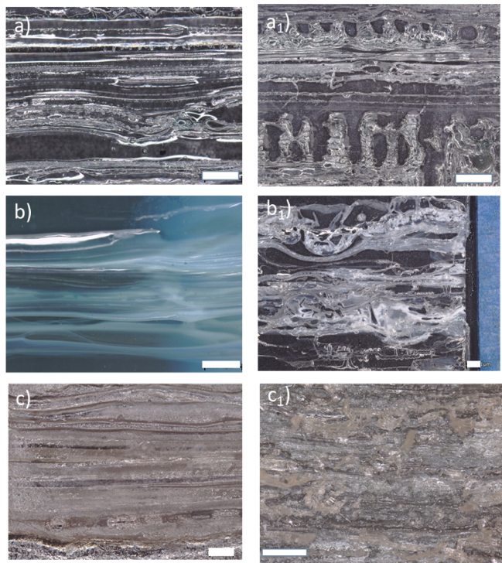
Fig. S1. The microstructure of printed <32> multilayer film for a-a₁) PVA20-W/E, b-b₁) CAB22-A/E, c-c₁) PEG30-H/E system as alternating sublayers before (left column) and after solvent etching (right column) (all scale bars 1200 µm), showing the disrupted layers after etching

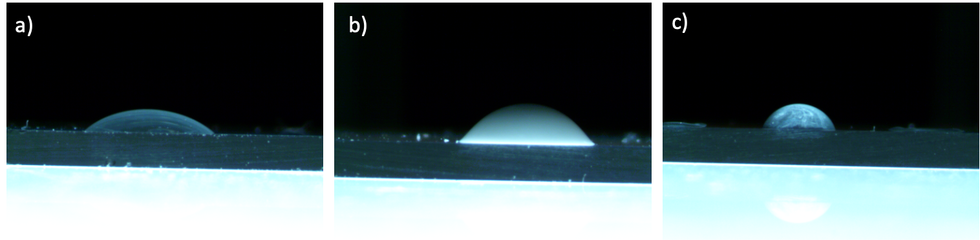
Fig. S2. Contact angle measurements for printing materials of a) PEG, b) E-BN25, and c) PEI (θ_{PEG-glass}= 35.89°, θ_{E-BN25-glass}=44.17°, θ_{PEI-glass}=63.43°) on glass substrates

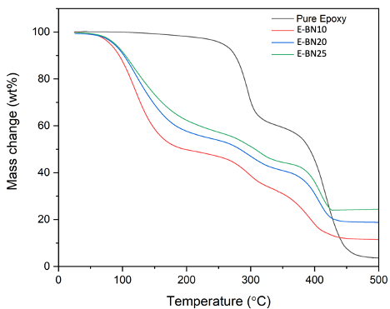
Fig. S3. TGA analysis for E-BN composite inks to confirm the concentration of the BNs

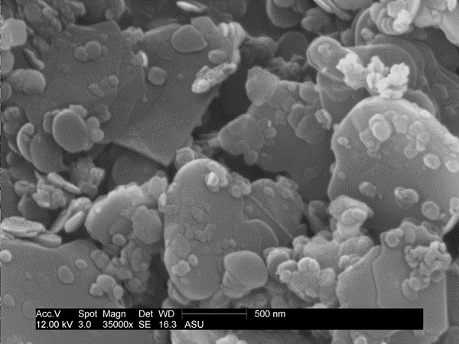
Fig. S4. BNs surface morphology with particle size varying from 300 nm to 1 μm

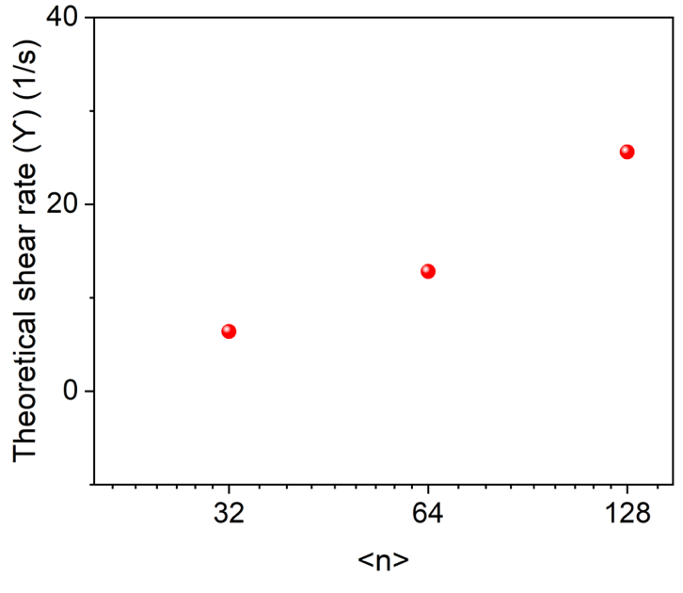
Fig. S5. Theoretical shear rate experienced in multipliers as a function of different layer numbers <n>=<32>, <64>, and <128> (i.e., with different numbers of layer multipliers) in MDIW printhead

Fig. S6. Storage modulus (G’) and loss modulus (G") as a function of shear stress for a) E-BN inks at a varying concentration of BNs and b) PEI at room temperature (RT) and 50°C

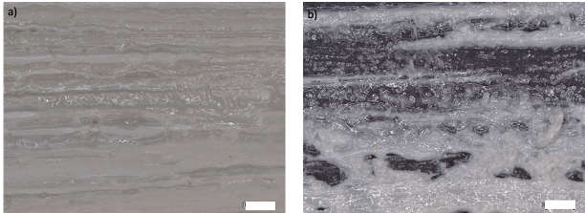
Fig. S7. The optical micrograph shows the printing difficulties observed for <32> sublayers with a) E-BN20 showing overlapped sublayers due to spreading of ink and b) E-BN30 showing discontinued printing due to clogging of the nozzle (both scale-bars 1200 μm)

Fig. S8. Thixotropic properties of E-BN25 ink, simulating the printing condition with alternating high and low shear rates

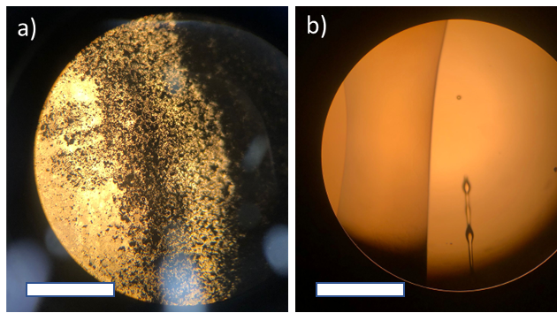
Fig. S9. The optical image showing the interfacial phenomena at the polymer/polymer interface between a) E/PEG30-H (diffusion) and b) E/PEI (no diffusion) (scale bars 500 μm)

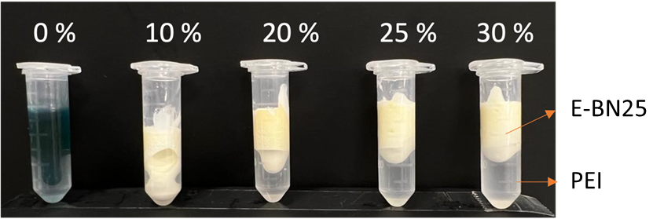
Fig. S10. Digital photograph of PEI and E-BN25 inks interfaces captured after 12 hr of contact demonstrating long-term interfacial stability

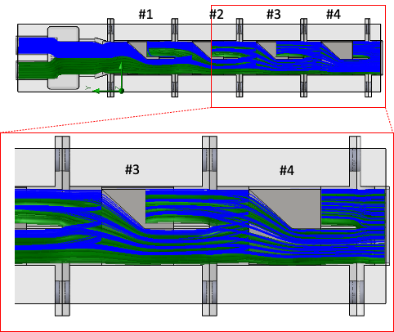
Fig. S11. The CFD simulation of E-BN25 and PEI-50 inks showing layer multiplication for <32> sublayers within the MDIW printhead

A flow simulation was done using the SolidWorks flow simulator to understand the layer formability. The obtained viscosity of the feedstocks PEI-50 (≈17 Pa.s) and E-BN25 (≈20 Pa.s) was used as inputs along with other solution properties, such as density, thermal conductivity, and specific heat (Table S2). The constant flow velocity (i.e., 1.5 ml/min) was set to achieve the predicted shear rate through rheology studies. Fig. S11 shows the layer formability of <32> sublayers through different layer multipliers #n (i.e., n multipliers lead to 2^{n+1} sublayers). The high number of layers was difficult to simulate due to the higher computational time and resolution limit of the software.
Table S2. Material property used for fluidic simulations
 | E-BN25 | PEI
Density (g/cm³) | 1.29 | 1.08[10]
Specific heat (J/gK) | 1.590 | 1.7[11]
Thermal conductivity (W/mK) | 0.419 | 0.17[12]
Viscosity (Pa.s) | 20 | 17
Note: The properties of E-BN25 are experimentally measured.

S2. Etching Dynamics

Fig. S12. PEI dissolution (%) at different etching times in IPA, water, and ethanol etchant for a) <64> and b) <128> sublayers at RT

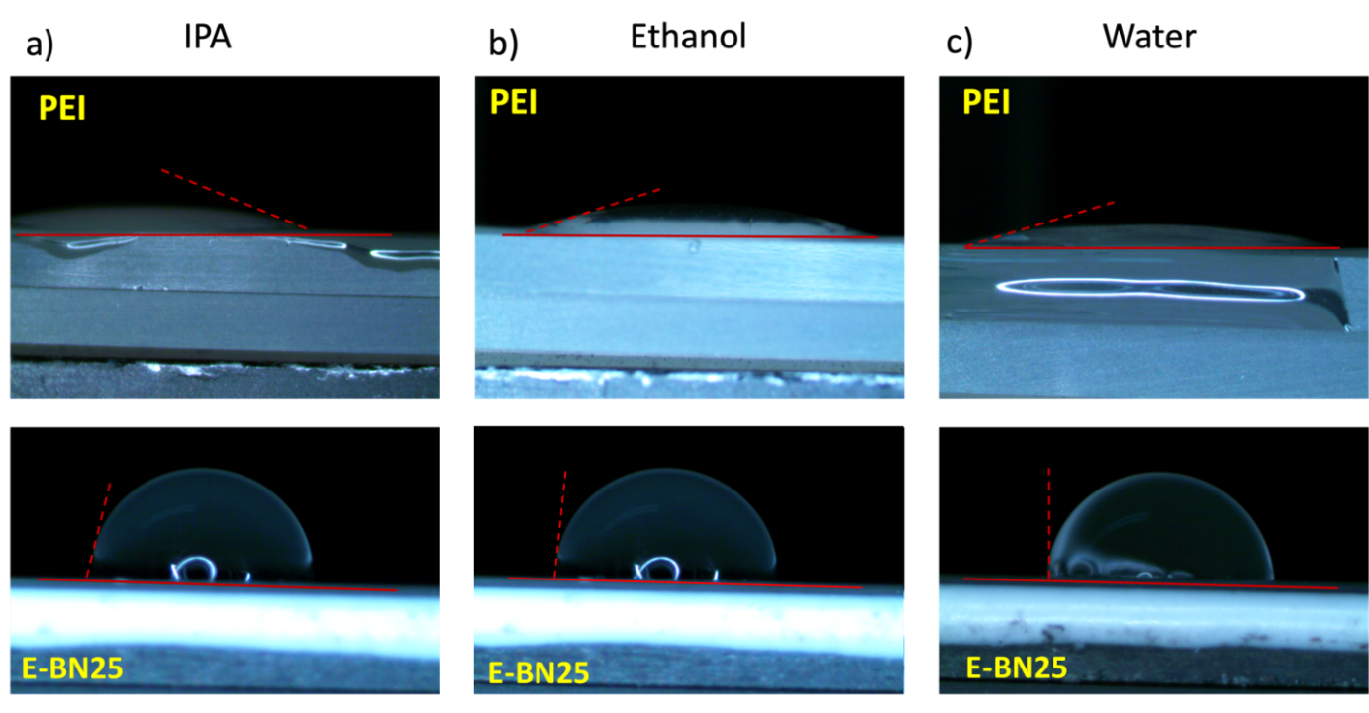
Fig. S13. The measured contact angle between 3D printing inks PEI and E-BN25 with different etching solvents, such as IPA, ethanol, and water (i.e., θ_{IPA-PEI}= 21.61°, θ_{IPA-E-BN25}=77.43°, θ_{ethanol-PEI}=13.51°, θ_{ethanol-E-BN25}=83.98°, θ_{water-PEI}=16.67°, θ_{water-E-BN25}=91.04°)

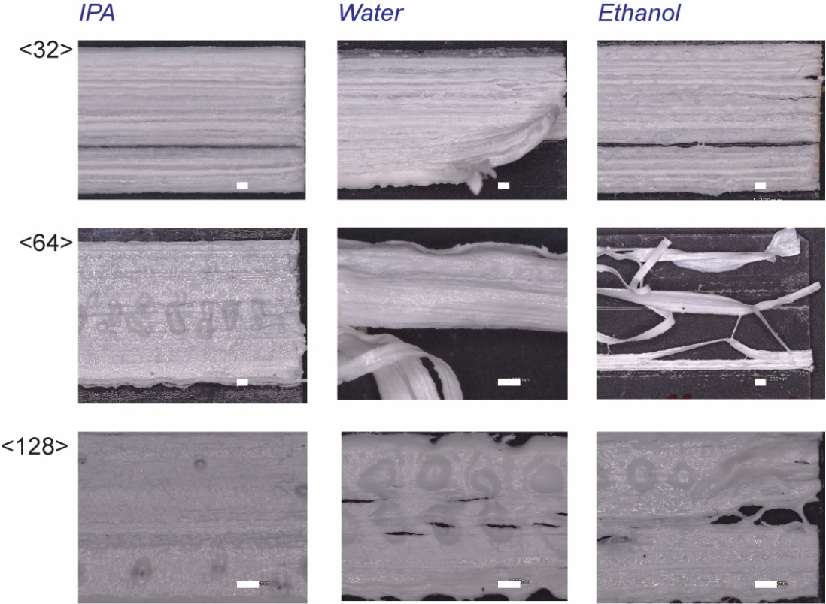
Fig. S14. Multilayer micropatterns surface morphology for <32>, <64>, <128> samples after etching in IPA, water, and ethanol for 15 minutes showing mechanical debonding with the glass substrate for water and ethanol etchants (all scale bars are 1200 μm)

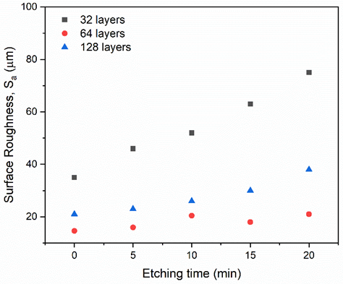
Fig. S15. The average surface roughness (S_{a}) of the MDIW micropatterns was measured using an optical profilometer after etching in IPA (RT) as a function of etching periods (min)
Fig. S16. PEI dissolution percentage (%) of multilayer samples in a) ethanol and b) water at 35°C as a function of the etching period

Fig. S17. Fitting of the diffusion kinetics for the PEI dissolution (%) of multilayer samples for the etching in a) ethanol and b) water at RT ≈25 °C for 15 min

Fig. S18. Fitting of the diffusion kinetics for the PEI dissolution (%) of multilayer samples for etching in a) ethanol and b) water at 35°C for 15 min

Table S3. Solubility parameters (i.e., dispersive interactions (δD), polar interactions (δP), hydrogen bonds (δH), polymer radius of interaction (R₀)) for PEI, epoxy, and etching solvents
 | $$δ_{D}$$ | $$δ_{P}$$ | $$δ_{H}$$ | $$R_{0}$$ | Ref
PEI | 18.6 | 9.8 | 7.7 | 12 | [13, 14]
Epoxy | 20 | 10 | 8 | 9 | [15]
IPA | 15.8 | 6.1 | 16.4 | - | [13]
Ethanol | 15.8 | 8.8 | 19.4 | - | [13]
Water | 15.5 | 16 | 42.3 | - | [13]

S3. Thermal Dissipation Demonstration

Microelectronic devices generate heat that must be dissipated to improve their performance and lifetime. Thus, the etched micropattern structures consisting of grooves can be used as microscale cooling systems by confining heat transfer liquids for more efficient heat transfer.[16] Localized heat accumulation could lead to rapid heat diffusion and catastrophic damage to some electronic components. Thus, it is critical to dissipate heat along guided paths.
To investigate the thermal heat dissipation performance of the micropatterns, we conducted a thermal simulation study using the Steady State Thermal Analysis tool in the ANSYS Workbench platform from ANSYS Student 2021 R1. Since the work compares different geometries, each geometry was modeled using SolidWorks 2021 to closely match the printed geometries. There were, in total, three micropattern samples with ascending layer multiplication: <32>, <64>, and <128>. In addition, the results were matched against a planar substrate to highlight the enhancement post-introduction of micropattern channels. Every geometry was assigned the same material properties defined in Table S4. Also, the boundary constraints were set to seek the temperature distribution caused by the heat dissipation due to convection. The set boundary constraints are heat flux (bottom face), insulated heat flow (side faces), and convective heat flow (top faces). Since the sample contact surface was exposed to the operating temperature, it was set at 80°C. In addition, the modeled sample walls were insulated, as the model represented only a section of the entire printed sample. To facilitate convection, the channels were simulated to contain air, oil, water, and liquid metal (Ga-In-Sn) with convective coefficients of 100, 1000, 500, and 5000 W/m²K¹, respectively. This setup was used to obtain and analyze the average heat flux, average surface temperature, and temperature distribution, as mentioned, through the temperature contours.

Table S4. Thermophysical properties of E-BN25 composite ink at RT
Property | E-BN25
Density (g/cm³) | 1.29
Specific Heat (J/gK) | 1.59
Thermal Conductivity (W/mK) | 0.42

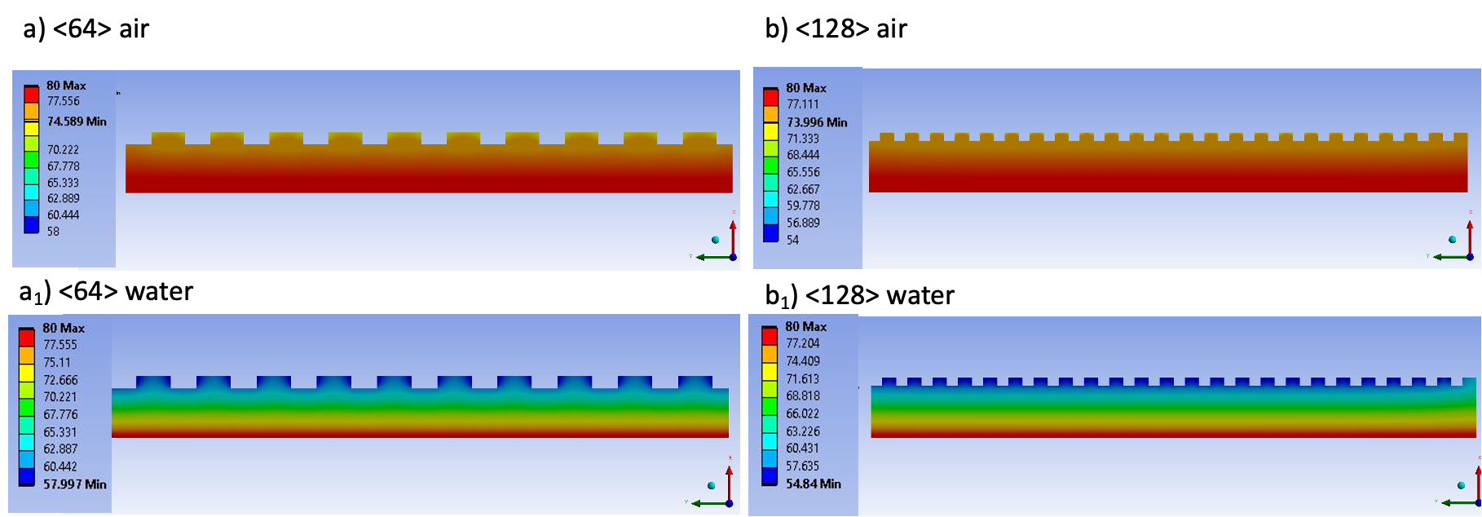
Fig. S19. Temperature distribution of the etched micropattern surfaces for a-a₁) <64> and b-b₁) <128> sublayers after heating up to 80°C with air and water confined microchannels

Table S5. The average a) surface temperature and b) heat flux measured from ANSYS simulations for etched micropatterns

Property | Experimental system
Property | <64> |  | <128>
Property | Air | Water | Air | Water
T_{avg} (°C) | 77.43 | 68.89 | 77.19 | 67.71
Q_{avg} (W m⁻²) | 7074 | 30127 | 8045.5 | 34788

Our technique demonstrates a new class of micropatterned structures with high thermal conductivity and electrical insulation with potential use in diverse applications, from dissipating heat in electronics packages to creating patterned thermal pathways to move heat from hotspots within the electronics circuit. However, our current patterning did not show high consistency in layer dimensions that we will target in our future research. For example, microchannels with uniform layer etchability (width and depth) and higher layer density can improve the thermal conduction of the <128> composite to be 19.73 (for air) and 85.22 kW m⁻² (for coolant), with better thermal management properties (Table S6). We aim to focus on printing resolution consistency in our future work.

Table S6. The average a) surface temperature and b) heat flux measured from ANSYS simulations for ideal micropatterning surfaces
Property | Perfect system
Property | <32> |  | <64> |  | <128>
Property | Air | Water | Air | Water | Air | Water
T_{avg} (°C) | 75.97 | 63.25 | 67.46 | 58.19 | 72.24 | 53.56
Q_{avg} (W m⁻²) | 10962 | 47515 | 34989 | 56396 | 19722 | 65526

REFERENCES:

1. Wallin TJ, Pikul J, Shepherd RF (2018) 3D printing of soft robotic systems. Nat Rev Mater 3:84–100. https://doi.org/10.1038/s41578-018-0002-2
2. Deomore SA, Raykar SJ (2021) Multi-criteria decision making paradigm for selection of best printing parameters of fused deposition modeling. Materials Today: Proceedings 44:2562–2565. https://doi.org/10.1016/j.matpr.2020.12.632
3. Elder B, Neupane R, Tokita E, et al (2020) Nanomaterial Patterning in 3D Printing. Adv Mater 32:1907142. https://doi.org/10.1002/adma.201907142
4. Plog J, Jiang Y, Pan Y, Yarin AL (2021) Electrostatically-assisted direct ink writing for additive manufacturing. Additive Manufacturing 39:101644. https://doi.org/10.1016/j.addma.2020.101644
5. Liashenko I, Rosell-Llompart J, Cabot A (2020) Ultrafast 3D printing with submicrometer features using electrostatic jet deflection. Nat Commun 11:753. https://doi.org/10.1038/s41467-020-14557-w
6. Nagy ZK, Balogh A, Démuth B, et al (2015) High speed electrospinning for scaled-up production of amorphous solid dispersion of itraconazole. International Journal of Pharmaceutics 480:137–142. https://doi.org/10.1016/j.ijpharm.2015.01.025
7. Hirt L, Reiser A, Spolenak R, Zambelli T (2017) Additive Manufacturing of Metal Structures at the Micrometer Scale. Adv Mater 29:1604211. https://doi.org/10.1002/adma.201604211
8. Xu W, Jambhulkar S, Ravichandran D, et al (2021) 3D Printing‐Enabled Nanoparticle Alignment: A Review of Mechanisms and Applications. Small 17:2100817. https://doi.org/10.1002/smll.202100817
9. Kim S, Sojoudi H, Zhao H, et al (2016) Ultrathin high-resolution flexographic printing using nanoporous stamps. Sci Adv 2:e1601660. https://doi.org/10.1126/sciadv.1601660
10. Ahmed S, Ramli A, Yusup S (2017) Development of polyethylenimine-functionalized mesoporous Si-MCM-41 for CO2 adsorption. Fuel Processing Technology 167:622–630. https://doi.org/10.1016/j.fuproc.2017.07.036
11. Zhang W, Liu H, Sun C, et al (2014) Performance of polyethyleneimine–silica adsorbent for post-combustion CO2 capture in a bubbling fluidized bed. Chemical Engineering Journal 251:293–303. https://doi.org/10.1016/j.cej.2014.04.063
12. Wu B, Liu F-Q, Luo S-W, et al (2021) Carbonaceous materials-supported polyethylenimine with high thermal conductivity: A promising adsorbent for CO2 capture. Composites Science and Technology 208:108781. https://doi.org/10.1016/j.compscitech.2021.108781
13. Hansen CM (2007) Hansen solubility parameters: a user’s handbook, 2nd ed. CRC Press, Boca Raton
14. Sehlleier YH, Dobrowolny S, Xiao L, et al (2017) Micrometer-sized nano-structured silicon/carbon composites for lithium-ion battery anodes synthesized based on a three-step Hansen solubility parameter (HSP) concept. Journal of Industrial and Engineering Chemistry 52:305–313. https://doi.org/10.1016/j.jiec.2017.04.001
15. Launay H, Hansen CM, Almdal K (2007) Hansen solubility parameters for a carbon fiber/epoxy composite. Carbon 45:2859–2865. https://doi.org/10.1016/j.carbon.2007.10.011
16. Hajmohammadi MR, Alipour P, Parsa H (2018) Microfluidic effects on the heat transfer enhancement and optimal design of microchannels heat sinks. International Journal of Heat and Mass Transfer 126:808–815. https://doi.org/10.1016/j.ijheatmasstransfer.2018.06.037

