Extended Data Figures and Tables

Extended Data Table 1. Hazard ratios, 95% confidence intervals, and -log10(P-Values) for having at least one Post-acute Sequelae of SARS-CoV-2 Infection (PASC), INSIGHT cohort, March 2020 to November 2021.
Covariate | Univariate HR (95% CI) | Univariate -log10 (P-Value) | Fully adjusted HR (95% CI) | Fully adjusted -log10 (P-Value)
The severity of acute infection
Not hospitalized | 1.00 (ref) |  | 1.00 (ref)
Hospitalized | 1.48 (1.43-1.52) | 141.6 | 1.29 (1.24-1.33) | 46.4
ICU | 1.46 (1.38-1.56) | 34.3 | 1.40 (1.32-1.49) | 25.9
Age group
20-39 years | 0.78 (0.75-0.81) | 31.8 | 0.88 (0.84-0.92) | 7.0
40-54 years | 0.93 (0.90-0.97) | 2.9 | 0.99 (0.95-1.03) | 0.2
55-64 years | 1.00 (ref) |  | 1.00 (ref)
65-74 years | 1.12 (1.07-1.17) | 6.5 | 1.06 (1.01-1.11) | 1.8
≥ 75 years | 1.28 (1.22-1.34) | 25.9 | 1.14 (1.09-1.20) | 6.7
Sex
Male | 1.00 (ref) |  | 1.00 (ref)
Female | 0.97 (0.94-1.00) | 1.4 | 1.04 (1.01-1.07) | 1.9
Race
White | 1.00 (ref) |  | 1.00 (ref)
Asian | 0.91 (0.85-0.98) | 2.0 | 0.95 (0.89-1.02) | 0.7
Black | 1.09 (1.05-1.13) | 4.9 | 1.05 (1.01-1.09) | 1.6
Other | 1.11 (1.07-1.15) | 8.3 | 1.01 (0.97-1.05) | 0.2
Missing | 0.90 (0.86-0.95) | 4.0 | 1.00 (0.95-1.06) | 0.0
Ethnic group
Not Hispanic | 1.00 (ref) |  | 1.00 (ref)
Hispanic: Yes | 1.11 (1.08-1.15) | 10.8 | 1.09 (1.05-1.14) | 4.4
Other or missing | 0.76 (0.73-0.81) | 23.4 | 0.86 (0.81-0.91) | 6.9
No. of hospital visits in the past 3 yrs
Inpatient 0 | 1.00 (ref) |  | 1.00 (ref)
Inpatient 1-2 | 1.16 (1.12-1.20) | 15.3 | 0.96 (0.92-1.00) | 1.3
Inpatient ≥ 3 | 1.17 (1.11-1.23) | 8.6 | 0.87 (0.82-0.93) | 4.1
Outpatient 0 | 1.00 (ref) |  | 1.00 (ref)
Outpatient 1-2 | 0.71 (0.66-0.76) | 20.3 | 0.80 (0.74-0.86) | 9.0
Outpatient ≥ 3 | 0.62 (0.58-0.66) | 57.7 | 0.64 (0.60-0.68) | 47.1
Emergency 0 | 1.00 (ref) |  | 1.00 (ref)
Emergency 1-2 | 1.17 (1.13-1.21) | 19.3 | 1.05 (1.01-1.08) | 1.9
Emergency ≥ 3 | 1.17 (1.12-1.22) | 13.6 | 1.02 (0.97-1.07) | 0.4
Median Area Deprivation Index (rank)
ADI1-19 (least deprived) | 1.00 (ref) |  | 1.00 (ref)
ADI20-39 | 0.99 (0.96-1.03) | 0.2 | 0.97 (0.93-1.00) | 1.2
ADI40-59 | 0.97 (0.89-1.05) | 0.4 | 0.96 (0.89-1.05) | 0.4
ADI80-100 | 1.09 (0.96-1.22) | 0.8 | 0.98 (0.87-1.10) | 0.1
Body Mass Index (kg/m²)
BMI: 18.5-<25 normal | 1.00 (ref) |  | 1.00 (ref)
BMI: <18.5 underweight | 1.18 (1.13-1.24) | 13.3 | 1.17 (1.12-1.23) | 10.8
BMI: 25-<30 overweight | 0.97 (0.93-1.01) | 0.9 | 0.97 (0.93-1.01) | 0.8
BMI: ≥30 obese | 0.98 (0.94-1.02) | 0.4 | 0.98 (0.93-1.02) | 0.6
BMI: missing | 0.69 (0.65-0.73) | 40.4 | 0.82 (0.77-0.87) | 11.1
Smoking
Smoker: never | 1.00 (ref) |  | 1.00 (ref)
Smoker: current | 1.02 (0.91-1.14) | 0.1 | 0.90 (0.80-1.01) | 1.1
Smoker: former | 0.99 (0.88-1.10) | 0.1 | 0.90 (0.81-1.01) | 1.1
Smoker: missing | 1.02 (0.96-1.09) | 0.3 | 0.96 (0.90-1.03) | 0.6
Infection Period
03/20-06/20 | 1.00 (ref) |  | 1.00 (ref)
07/20-10/20 | 0.95 (0.89-1.01) | 1.1 | 0.98 (0.92-1.05) | 0.2
11/20-02/21 | 0.95 (0.92-0.98) | 3.1 | 0.99 (0.96-1.03) | 0.1
03/21-06/21 | 1.07 (1.02-1.11) | 2.5 | 1.07 (1.02-1.12) | 2.5
07/21-11/21 | 1.42 (1.30-1.54) | 14.8 | 1.55 (1.42-1.69) | 21.5
No. of pre-existing conditions
No comorbidity | 1.00 (ref) |  | 1.00 (ref)
1 comorbidity | 1.15 (1.10-1.20) | 9.3 | 1.07 (1.02-1.12) | 2.1
2 comorbidities | 1.19 (1.13-1.25) | 10.2 | 1.04 (0.98-1.10) | 0.7
3 comorbidities | 1.24 (1.17-1.31) | 13.6 | 1.03 (0.97-1.10) | 0.5
4 comorbidities | 1.34 (1.26-1.42) | 21.7 | 1.08 (1.01-1.16) | 1.6
≥5 comorbidities | 1.43 (1.38-1.48) | 78.6 | 1.05 (0.97-1.13) | 0.6
Pre-existing conditions
Alcohol Abuse | 1.18 (1.09-1.28) | 4.0 | 0.96 (0.88-1.05) | 0.4
Anemia | 1.21 (1.16-1.26) | 18.6 | 1.00 (0.95-1.05) | 0.0
Arrythmia | 1.28 (1.23-1.33) | 33.7 | 0.98 (0.93-1.02) | 0.5
Asthma | 1.16 (1.11-1.21) | 10.1 | 1.05 (0.98-1.12) | 0.7
Cancer | 1.25 (1.19-1.31) | 20.7 | 1.13 (1.07-1.18) | 6.0
Chronic Kidney Disease | 1.31 (1.26-1.36) | 39.6 | 1.05 (1.00-1.10) | 1.1
Chronic Pulmonary Disorders | 1.23 (1.18-1.27) | 26.7 | 1.03 (0.96-1.10) | 0.4
Cirrhosis | 1.43 (1.29-1.58) | 11.1 | 1.22 (1.10-1.35) | 3.6
Coagulopathy | 1.34 (1.27-1.41) | 26.5 | 1.07 (1.01-1.14) | 1.9
Congestive Heart Failure | 1.32 (1.26-1.38) | 32.6 | 1.04 (0.98-1.09) | 0.8
COPD | 1.29 (1.22-1.38) | 15.0 | 0.98 (0.90-1.05) | 0.3
Coronary Artery Disease | 1.24 (1.19-1.29) | 23.3 | 0.99 (0.94-1.04) | 0.2
Dementia | 1.46 (1.37-1.56) | 27.3 | 1.03 (0.96-1.11) | 0.4
Diabetes Type 1 | 1.22 (1.07-1.38) | 2.7 | 1.11 (0.98-1.25) | 0.9
Diabetes Type 2 | 1.23 (1.18-1.27) | 30.4 | 0.99 (0.93-1.06) | 0.1
End Stage Renal Disease on Dialysis | 1.23 (1.15-1.31) | 8.9 | 1.03 (0.96-1.11) | 0.4
Hemiplegia | 1.20 (1.06-1.36) | 2.5 | 0.96 (0.85-1.09) | 0.3
Herpes Zoster | 0.99 (0.83-1.17) | 0.0 | 0.89 (0.75-1.05) | 0.8
HIV | 1.03 (0.92-1.16) | 0.2 | 0.93 (0.83-1.04) | 0.7
Hypertension | 1.28 (1.24-1.31) | 57.2 | 1.01 (0.97-1.06) | 0.3
Hypertension and Type 1/2 Diabetes | 1.23 (1.19-1.28) | 28.9 | 0.97 (0.90-1.04) | 0.4
Inflammatory Bowel Disorder | 0.99 (0.86-1.15) | 0.0 | 0.99 (0.86-1.14) | 0.1
Lupus or Systemic Lupus Erythematosus | 1.04 (0.89-1.21) | 0.2 | 0.94 (0.81-1.10) | 0.4
Mental Health Disorders | 1.24 (1.19-1.30) | 20.4 | 1.08 (1.03-1.13) | 2.5
Multiple Sclerosis | 1.04 (0.85-1.27) | 0.2 | 1.03 (0.85-1.25) | 0.1
Obstructive sleep apnea | 1.09 (1.03-1.16) | 2.5 | 0.98 (0.92-1.04) | 0.3
Other Substance Abuse | 1.19 (1.12-1.26) | 8.5 | 1.06 (1.00-1.14) | 1.2
Parkinson's Disease | 1.15 (0.96-1.37) | 0.9 | 0.90 (0.75-1.07) | 0.7
Peripheral vascular disorders | 1.23 (1.16-1.30) | 13.3 | 0.99 (0.93-1.05) | 0.1
Pregnant | 0.70 (0.65-0.77) | 15.5 | 0.79 (0.72-0.86) | 6.7
Pulmonary Circulation Disorder | 1.39 (1.30-1.49) | 19.7 | 1.09 (1.01-1.18) | 1.6
Rheumatoid Arthritis | 1.15 (1.03-1.29) | 1.9 | 1.04 (0.93-1.17) | 0.3
Seizure/Epilepsy | 1.22 (1.11-1.34) | 4.6 | 1.05 (0.96-1.16) | 0.6
Severe Obesity (BMI≥40 kg/m²) | 1.09 (1.03-1.15) | 2.5 | 1.02 (0.96-1.08) | 0.2
Sickle Cell | 1.07 (0.90-1.26) | 0.3 | 1.01 (0.85-1.20) | 0.0
Weight Loss | 1.38 (1.29-1.47) | 21.5 | 1.09 (1.02-1.17) | 1.8
Corticosteroids drugs | 1.09 (1.05-1.14) | 4.5 | 0.98 (0.94-1.03) | 0.3
Immunosuppressant drugs | 1.01 (0.95-1.07) | 0.1 | 0.91 (0.85-0.97) | 2.4
Ref, reference group; 95% CI, 95% Confidence Interval. Risks in each categorical class were compared to the reference.
-log10 (p-Value), the larger, the more significant. Two reference values are -log10(0.05)=1.3, -log10(0.01)=2.
See our PASC list in the method section.
See the adjusted covariates in the method section.
Pre-existing conditions were ascertained existence if two records in the past 3-years prior to index event. See detailed phenotyping codes in the appendix.

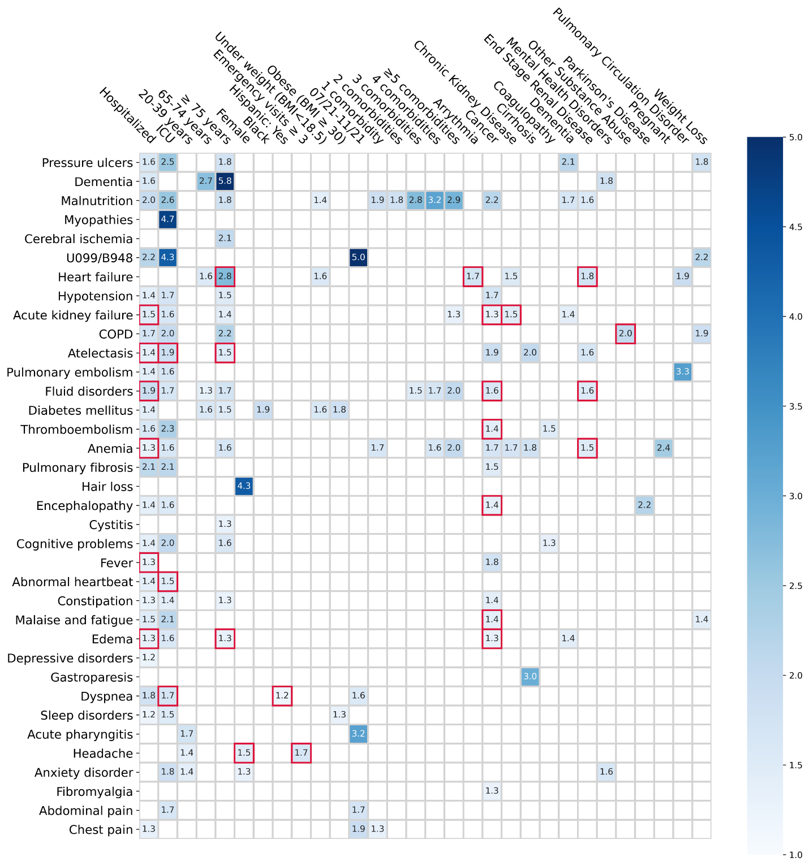Extended Data Fig. 1. Sensitivity analyses of identified risk factors associated with incident PASC conditions, the INSIGHT cohort, March 2020 to November 2021. The associations ruled out by the riskier than control criterion were highlighted in red squares. The adjusted hazard ratios of different factors were reported. The colors represent different risk levels. The risk factors were identified by meeting three criteria: aHR > 1, p-Value < 0.00056, and riskier than in the control group. ICD-10 diagnosis codes B948 (sequelae of other specified infectious and parasitic diseases) and U099 (post-COVID-19 condition, unspecified) were used to capture general post-acute sequelae of SARS-CoV-2 infection.

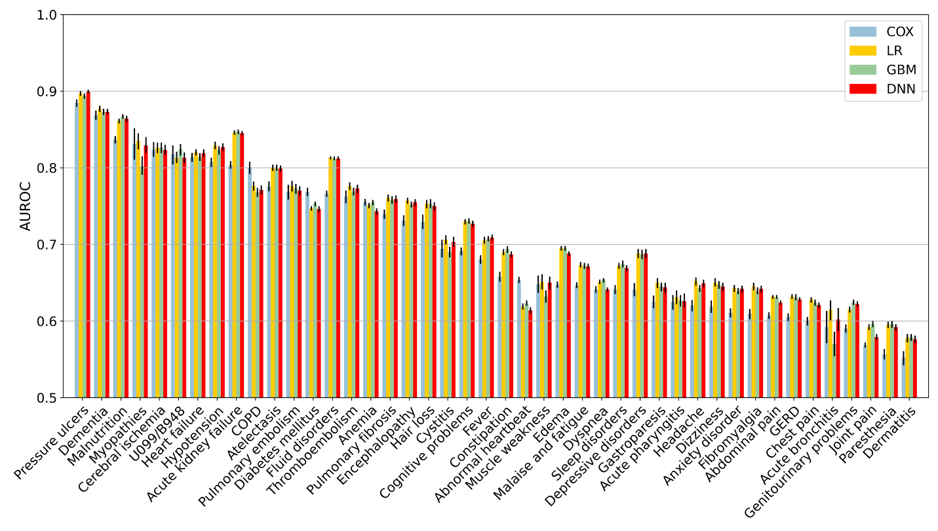Extended Data Fig. 2. Predictive performance of incident post-acute sequelae of SARS-CoV-2 infection (PASC) by different machine learning models, based on the pre-defined baseline covariates and the severity of acute infection, INSIGHT, March 2020 to November 2021. The pre-defined baseline covariates were the same ones used in the risk factor analysis. The COX model was measured by C-index. Regularized logistic regression (LR), gradient boosting machine (GBM), and deep forward neural network (DNN) were measured by the area under the receiver operating characteristic curve (AUROC). The 95% confidence intervals of all measures were reported.

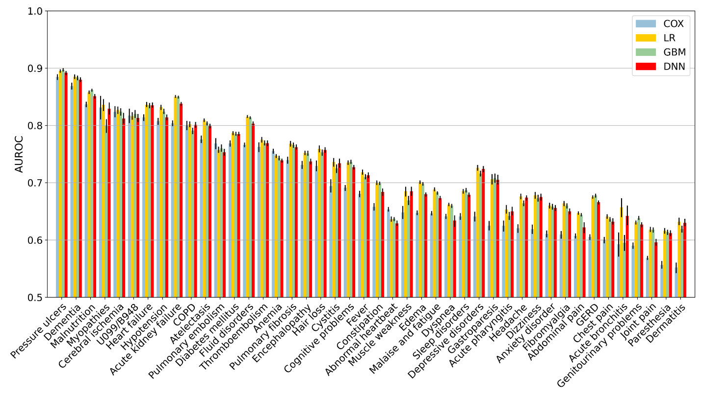Extended Data Fig. 3. Predictive performance of incident post-acute sequelae of SARS-CoV-2 infection (PASC) based on building baseline covariates in a data-driven way, by different machine learning models, INSIGHT, March 2020 to November 2021. The data-driven baseline covariates were selected based on the first 3 digits of ICD-10 codes and prescribed medications at the ingredient level in a data-driven way. The COX model was measured by C-index. Regularized logistic regression (LR), gradient boosting machine (GBM), and deep forward neural network (DNN) were measured by the area under the receiver operating characteristic curve (AUROC). The 95% confidence intervals of all measures were reported.

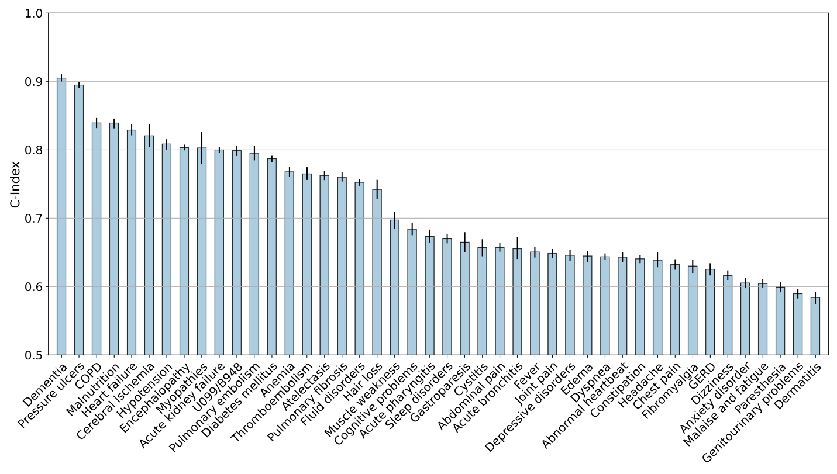Extended Data Fig. 4. Predictive performance of incident post-acute sequelae of SARS-CoV-2 infection (PASC) based on the pre-defined baseline covariates and the severity of acute infection on the OneFlorida+ cohort, March 2020 to November 2021. A c-index with a 95% confidence interval was reported.
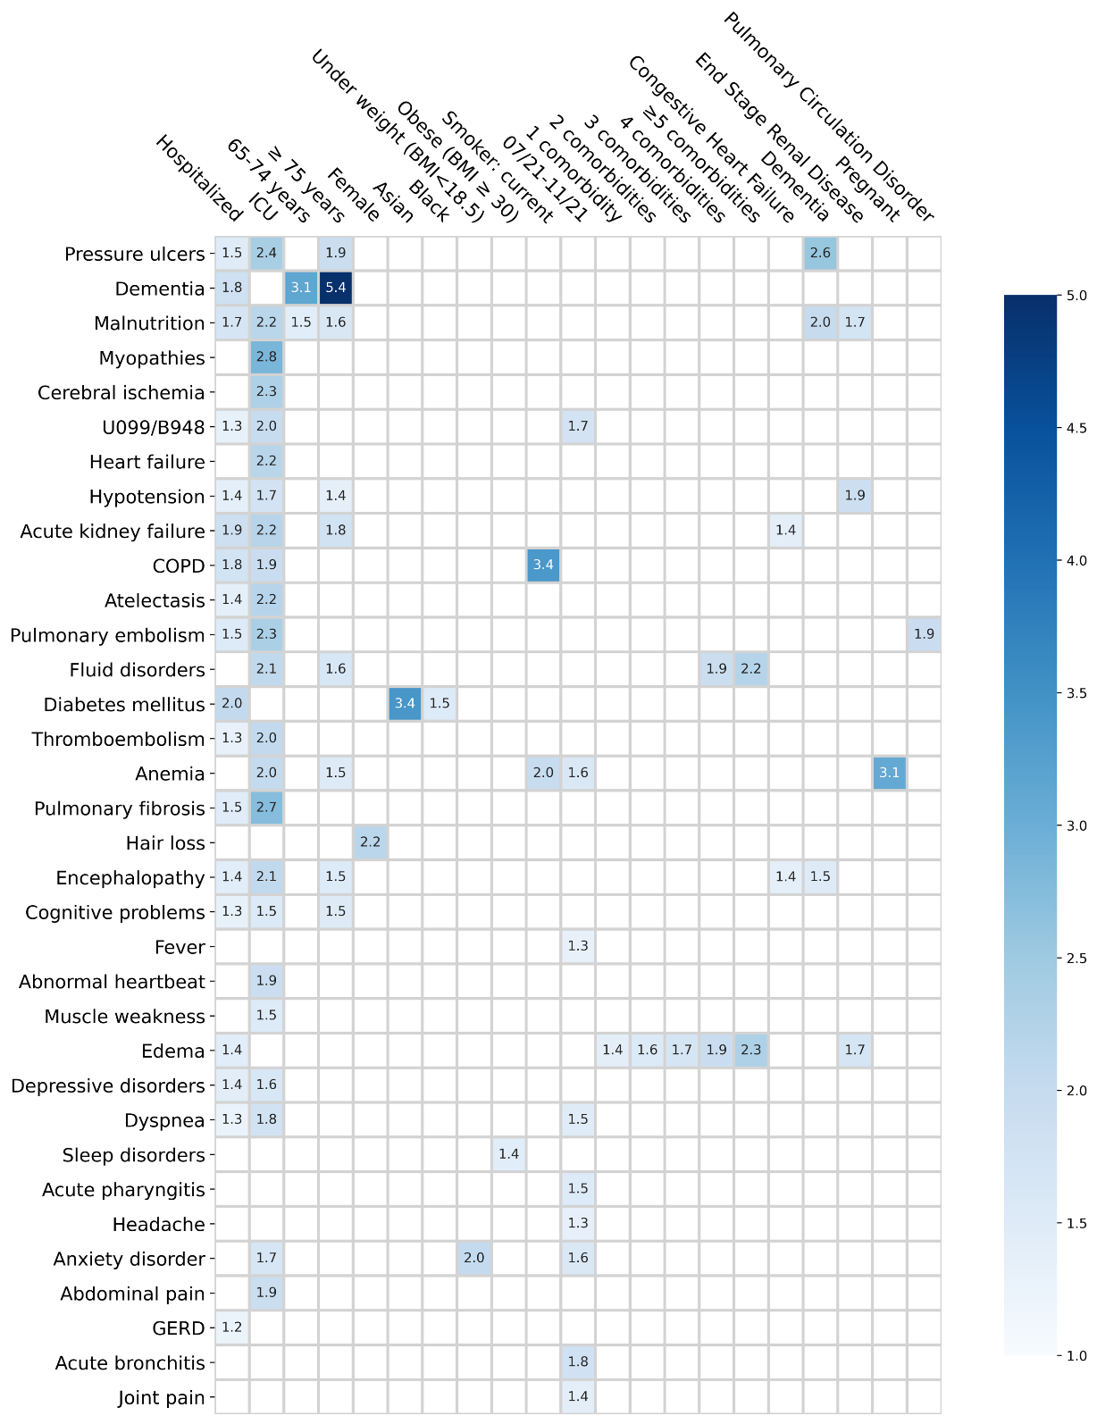

Extended Data Fig. 5. Identified risk factors associated with incident PASC conditions by the OneFlorida+ cohort, March 2020 to November 2021. The adjusted hazard ratios of different factors were reported. The colors represent different risk levels. The risk factors were identified by meeting three criteria: aHR > 1, p-Value < 0.00056, and riskier than in the control group. ICD-10 diagnosis codes B948 (sequelae of other specified infectious and parasitic diseases) and U099 (post COVID-19 condition, unspecified) were used to capture general post-acute sequelae of SARS-CoV-2 infection.

