Supporting Information

Mechanistic Insight into the Hydrogenation of Acetylene on the Pd₂/g-C₃N₄ Catalyst: Effect of Pd clustering on the barrier energy and selectivity
Sayyed Mahdi Hosseiniª, Mehran Ghiaciª, Hossein Farrokhpourª*
ªDepartment of Chemistry, Isfahan University of Technology, Isfahan 84156-83111, Iran
Corresponding Author: Hossein Farrokhpour
E-mail: farrokhphossein@gmail.com; h-farrokh@iut.ac.ir
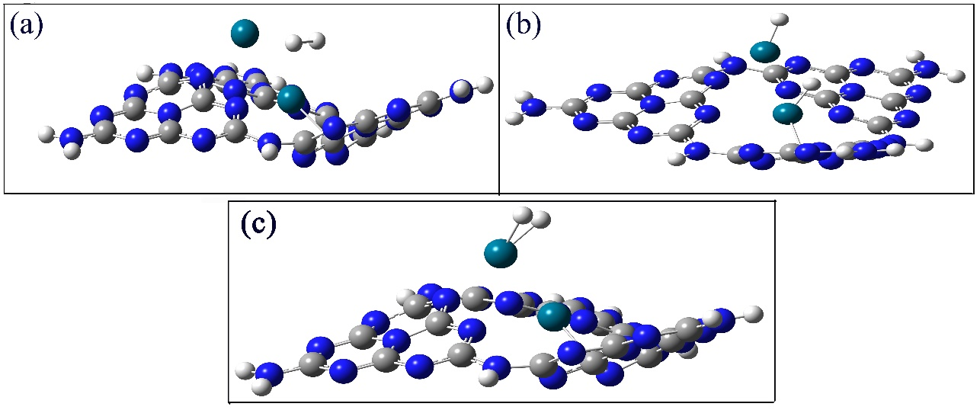
Figure S1. The initial structures for (a) H₂.Pd₂/g-C₃N₄, (b) 2H.Pd₂/g-C₃N₄ and (c) their optimized structure.

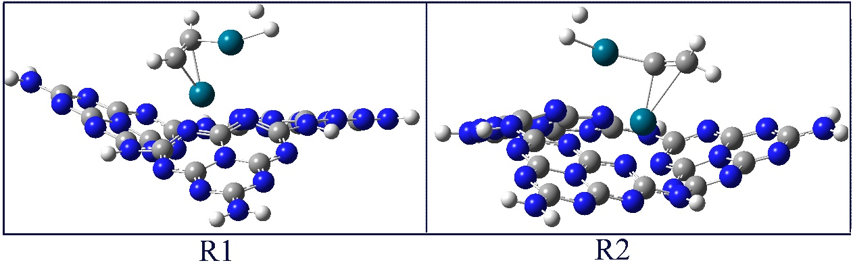
Figure S2. Two proposed structures for the pre-reactant of the hydrogenation reaction (C₂H₂.H₂/g-C₃N₄) ( R1 and R2 ).
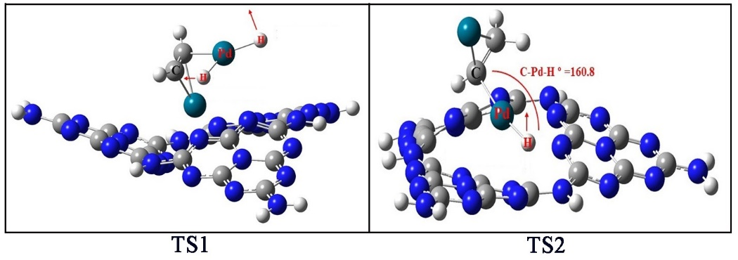
Figure S3. The vibrational modes of the TS1 and TS2 structures with the imaginary frequencies. The arrows show the displacement vector of the atoms.
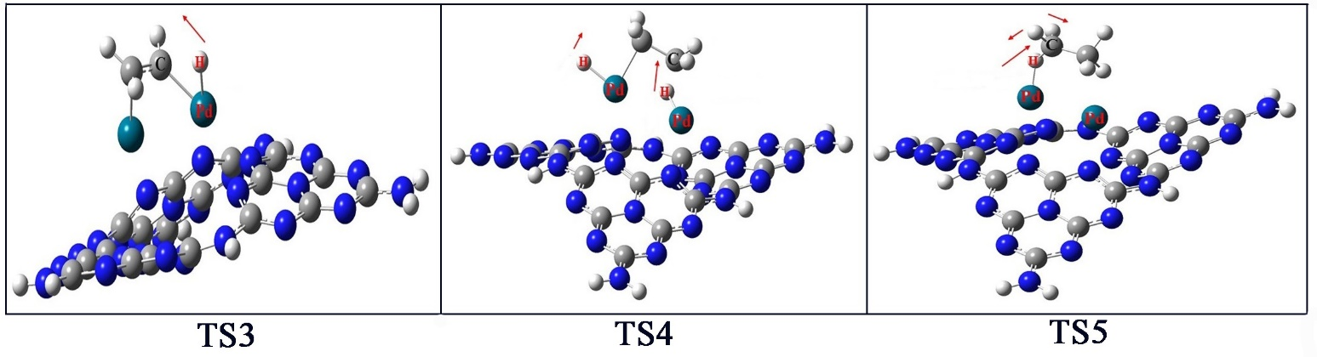
Figure S4. The vibrational modes of the TS3, TS4, and TS5 structures with the imaginary frequencies. The arrows show the displacement vector of the atoms.

