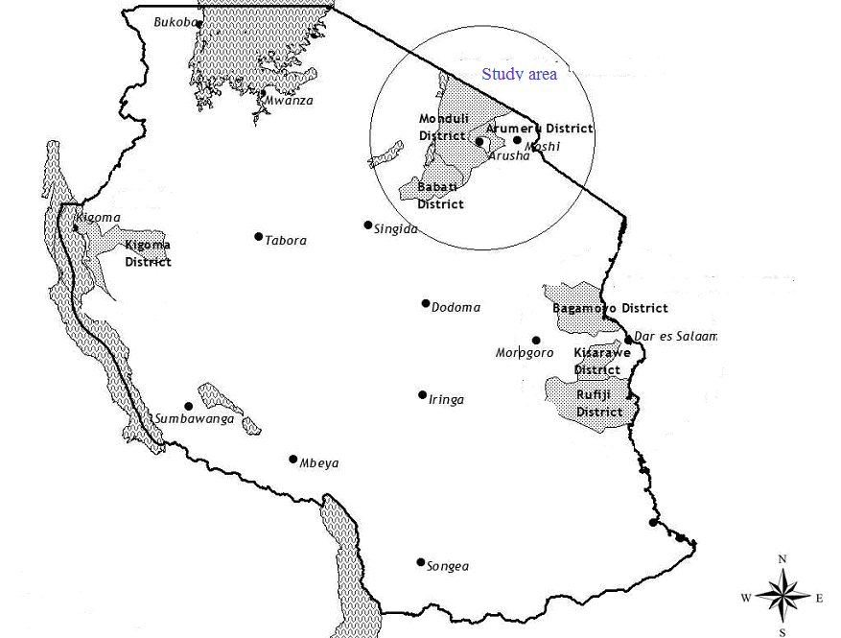
Figure 1: Map of Tanzania showing the study area

Figure 2: The education levels of respondents sampled in Sihakati, Naibili and Leguruki villages

Figure 3: The age classes and percentage of participation in Jatropha cultivation in Sihakati, Naibili and Leguruki villages

Figure 4: The correlation between optimal age and effective participation in Jatropha cultivation

Figure 5: The land allocated for Jatropha cultivation in Sihakati, Naibili and Leguruki villages

Ethics declarations
Ethics approval and consent to participate
Not applicable.
Consent for publication
Not Applicable
Competing interests
All authors have no conflict of interests.
Abbreviations
DAAD Deutscher Akademischer Austauch Dienst
NGOs Non Governmental Organizations
JPTL Jatropha Products Tanzania Limited
KaKuTe Kampuni ya Kusambaza Teknolojia
MAFC Ministry of Agriculture Food security and Cooperation
MEM Ministry of Energy and Minerals
MUCE Mkwawa University College of Education
WWW World Health Organization
SPSS Statistical Package for Social Sciences
TFS Tanzania Forest Services

