supplementary figures

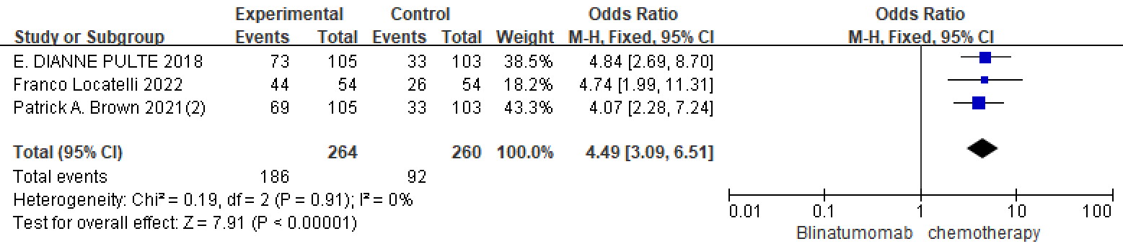
Figure 7.Blinatumomab versus chemotherapy negative for MRD meta analysis forest plots

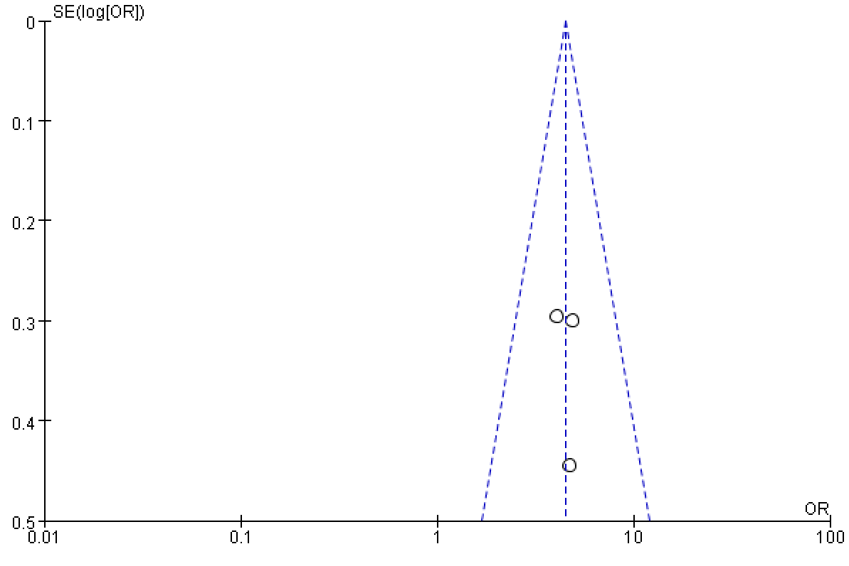
Figure 8.Blinatumomab versus chemotherapy negative for MRD meta analysis funnel plots

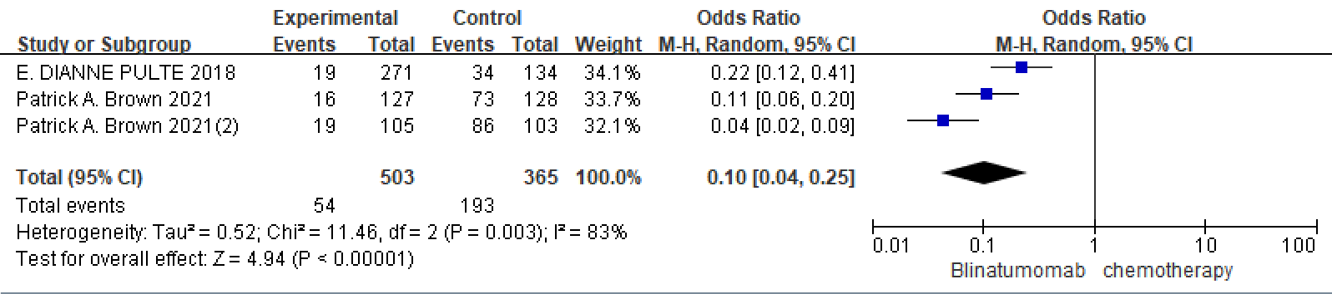
Figure 9.Blinatumomab versus chemotherapy anemia (≧Grade3) meta analysis forest plots

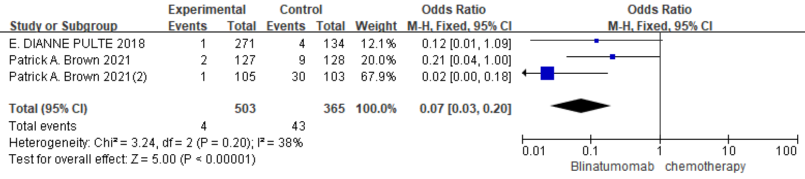
Figure 10.Blinatumomab versus chemotherapy mucositis (≧Grade3) meta analysis forest plots

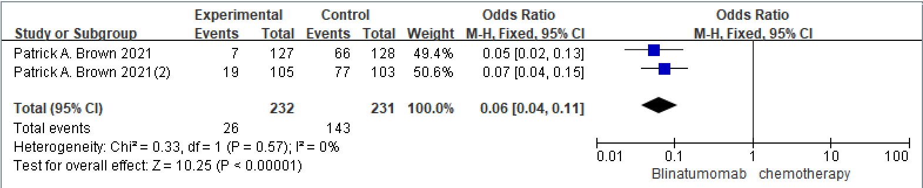
Figure 11.Blinatumomab versus chemotherapy infections(≧Grade3) meta analysis forest plot

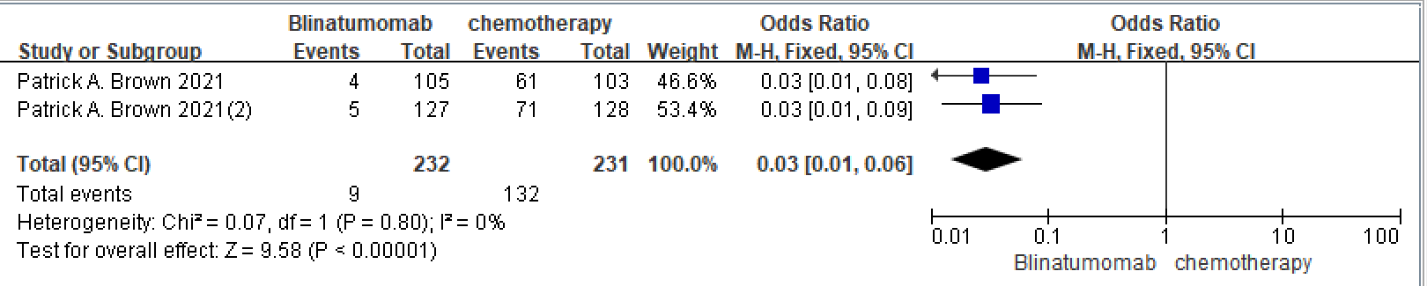
Figure 12.Blinatumomab versus chemotherapy febrile neutropenia(≧Grade3)meta analysis forest plots

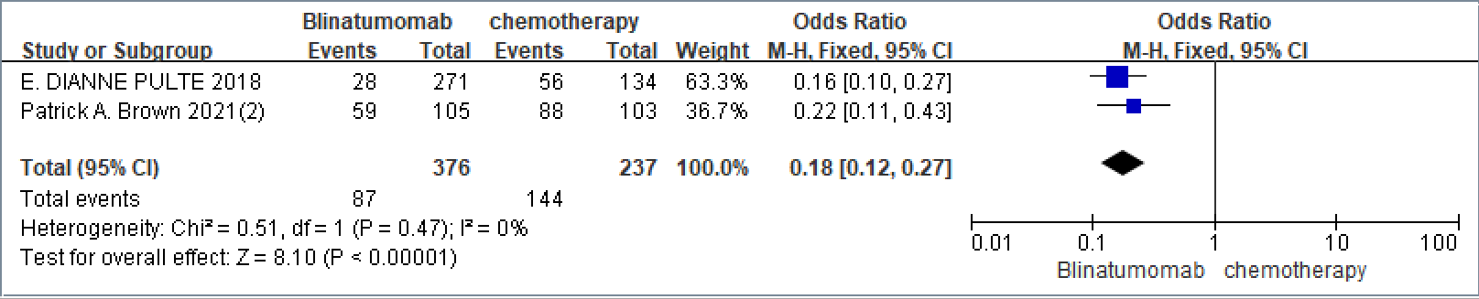
Figure 13.Blinatumomab versus chemotherapy Neutrophil count decreased(≧Grade3) for MRD meta analysis forest plots

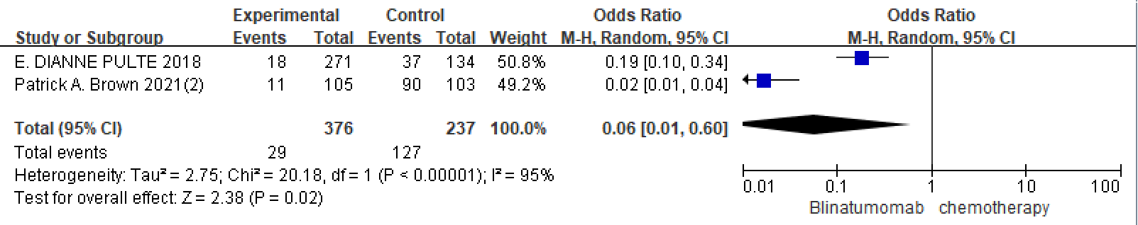

Figure 14.Blinatumomab versus chemotherapy Thrombocytopenia(≧Grade3) meta analysis funnel plots

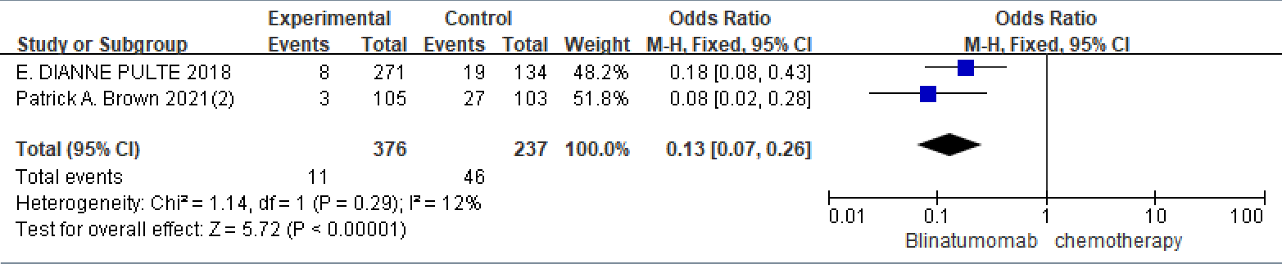
Figure 15.Blinatumomab versus chemotherapy Sepsis(≧Grade3) meta analysis funnel plots

