Supplementary Materials
The supplementary materials include:
Tables S1 to S2
Fig. S1 to S13
Table S1. Lotteries for those who have been vaccinated during the study period
Registration start | Registration end | Company | Prize type | Prize | Total value (HKD) more than | Target population | Vaccinated by | Remark | Source
7/2/2021 | 7/21/2021 | HK GCC Lucky Draw 1 | Shopping rewards | Shopping rewards | 6500000 | Public: Fully vaccinated Hong Kong residents aged 18 or older | 7/21/2021 | 1099 entries were drawn from over 37 organizations | https://www.chamber.org.hk/en/luckydraw/winner1_en.html
 | 8/1/2021 | Towngas | Home & Utilities vouchers | Towngas shopping vouchers | 3000000 | Public: Fully vaccinated Hong Kong residents aged 18 or older | 8/1/2021 |  | https://luckydraw.towngas.com/
7/2/2021 | 8/4/2021 | HK GCC Lucky Draw 2 | Shopping rewards | Shopping rewards | 5900000 | Public: Fully vaccinated Hong Kong residents aged 18 or older | 8/4/2021 | 1005 entries were drawn from over 37 organizations | https://www.chamber.org.hk/en/media/press-releases.aspx?issearch=yes
7/2/2021 | 8/18/2021 | HK GCC Lucky Draw 3 | Shopping rewards | Shopping rewards | 6000000 | Public: Fully vaccinated Hong Kong residents aged 18 or older | 8/18/2021 | 1009 entries were drawn from over 37 organizations | https://www.chamber.org.hk/en/media/press-releases.aspx?issearch=yes
 | 8/29/2021 | K Wah International Holdings | Dining vouchers | Electronic dining vouchers | 1000000 | Public: Fully vaccinated HKID holders who are Marriott Bonvoy members | 8/31/2021 |  | https://kwahcaresvaccination.kwih.com/Home/
6/25/2021 | 8/30/2021 | Sun Hung Kai Properties | Shopping rewards | Daily draws of dining and hotel coupons | 10000000 | Public: Fully vaccinated Hong Kong Permanent Residents aged 18 or older | 8/30/2021 |  | https://www.shkp.com/en-US/media/press-releases/registration-of-shkp-hk10-million-day-day-lucky-draw-starts-on-25-june-a-5g
 | 8/31/2021 | Regina Ip’s New People’s Party | Luxury goods | Rolex, a diamond bracelet, shopping vouchers, etc. | 1000000 | Public: Fully vaccinated Hong Kong residents aged 18 or older | 8/31/2021 |  | https://www.scmp.com/news/hong-kong/politics/article/3136669/hong-kong-politician-regina-ip-puts-diamond-rolex-part-hk1
7/14/2021 | 8/31/2021 | Hong Kong Convention and Exhibition Centre | Dining vouchers | Dining vouchers | 500000 | Public: Fully vaccinated Hong Kong residents aged 18 or older | 8/31/2021 |  | https://luckydraw.hkcec.com/en/index.html
6/21/2021 | 8/31/2021 | China Construction Bank (Asia) | Shopping rewards | Credit card spending reward | 584000 | Public: Fully vaccinated Hong Kong residents aged 18 or older | 8/31/2021 |  | https://www.timeout.com/hong-kong/things-to-do/your-guide-to-vaccine-incentives-and-prizes-in-hong-kong
6/15/2021 | 9/1/2021 | The Sino Group and Chinese Estates Holdings Limited | Apartment | One-bedroom flat at the Grand Central project in Kwun Tong, and other prizes | 21600000 | Public: Fully vaccinated Hong Kong residents and PR aged 18 or older | 9/1/2021 |  | https://www.vaccinationluckydraw.hk/tc/index.html
7/1/2021 | 9/1/2021 | Vision Finance Group | Stocks | SIIC Environment Holdings shares | 1500000 | Public: Fully vaccinated Hong Kong residents aged 18 or older | 9/1/2021 |  | http://www.vfg.hk/upload/article_attachment/2021-07-01_60dc951fa5671.pdf
7/2/2021 | 9/1/2021 | HK GCC Lucky Draw 4 | Shopping rewards | 10000 Swire coupons to 500 people | 5000000 | Public: Fully vaccinated Hong Kong residents aged 18 or older | 9/1/2021 | 500 entries were drawn from over 37 organizations | https://www.chamber.org.hk/en/media/press-releases.aspx?issearch=yes
7/13/2021 | 9/2/2021 | Goodman Hong Kong | Car & shopping rewards | Tesla Model 3, $80,000 Lane Crawford vouchers, $60,000 vouchers from Dairy Farm selected merchants, $90,000 Don Don Donki vouchers, and other prizes. | 1025000 | Public: Fully vaccinated Hong Kong residents aged 18 or older | 8/31/2021 |  | https://www.goodman.com/hk/goodshot-lucky-draw
 | 9/10/2021 | CK Asset Holdings, CK Hutchison Holdings, and Li Ka-shing Foundation | Home & Utilities vouchers | Downpayment coupons for a new CKA apartment, product purchases and services at ParknShop, Watsons, Watsons Wine, Fortress, 3HK, Hutchgo, ESDlife, Harbour Plaza Hotels, and for settling HK Electric fees | 20000000 | Public: Fully vaccinated Hong Kong residents aged 18 or older | 8/31/2021 |  | https://www.ck-lksf-supportvaccine.hk/zh/index.html
7/26/2021 | 9/13/2021 | Hong Kong Association of Banks | Shopping rewards | Shopping vouchers | 100000 | Public: Fully vaccinated Hong Kong residents aged 18 or older | 8/31/2021 |  | https://www.hkabluckydraw.hk/en/application/register
7/2/2021 | 9/15/2021 | HK GCC Lucky Draw 5 | Shopping rewards | MTR annual pass, shopping coupons | 5200000 | Public: Fully vaccinated Hong Kong residents aged 18 or older | 9/15/2021 | 1003 entries were drawn from over 37 organizations | https://www.chamber.org.hk/en/media/press-releases.aspx?issearch=yes
 | 9/15/2021 | 3 Hong Kong | Shopping rewards | iphones and other handsets and data | 10000000 | Public: Fully vaccinated Hong Kong residents aged 18 or older | 9/15/2021 |  | https://go.skimresources.com/
 | 9/18/2021 | Chinese Manufacturers' Association | Shopping rewards | Shopping discounts and a prepaid credit card | 4000000 | Public: Fully vaccinated Hong Kong residents aged 18 or older | 9/18/2021 |  | https://www.cma.org.hk/en/menu/130/content/3088
6/1/2021 | 9/20/2021 | Henderson Land Development | Shopping rewards | Total of 24 Karat gold and over $1 million worth of shopping vouchers that can be used under the company's businesses | 1000000 | Public: Fully vaccinated Hong Kong residents aged 18 or older | 9/20/2021 |  | https://www.scmp.com/business/article/3135632/coronavirus-henderson-land-offers-employees-four-days-support-hong-kongs
7/2/2021 | 9/22/2021 | HK GCC Lucky Draw 6 | Shopping rewards | Mercedes Benz, MTR annual pass, shopping coupons | 6500000 | Public: Fully vaccinated Hong Kong residents aged 18 or older | 9/22/2021 | 1000 entries were drawn from over 37 organizations | https://www.chamber.org.hk/en/media/press-releases.aspx?issearch=yes
7/2/2021 | 9/29/2021 | HK GCC Lucky Draw 7 | Shopping rewards | Shopping rewards | 7780000 | Public: Fully vaccinated Hong Kong residents aged 18 or older | 9/29/2021 | 1177 entries were drawn from over 37 organizations | https://www.chamber.org.hk/en/media/press-releases.aspx?issearch=yes
9/16/2021 | 9/30/2021 | Airport Authority Hong Kong | Travel & Leisure | 50000 air tickets | NA | Public: Fully vaccinated Hong Kong residents aged 18 or older | 9/30/2021 | 50000 entries | https://vaccinationluckydraw.hongkongairport.com/index.html
9/16/2021 | 9/30/2021 | Airport Authority Hong Kong | Travel & Leisure | 10000 air tickets | NA | Airport staff: Fully vaccinated Hong Kong airport staffs or airport staffs are vaccinated with one dose after recovering from COVID-19 | 9/30/2021 | 10000 entries | https://vaccinationluckydraw.hongkongairport.com/index.html
9/1/2021 | 10/24/2021 | Link | Dining vouchers | Dining vouchers from designated restaurants | 2000000 | Public: Fully vaccinated Hong Kong residents aged 18 or older,  Or, those who are vaccinated with one dose after recovering from COVID-19 | 10/24/2021 | 500 entries were drawn | https://vaccinationluckydraw.linkhk.com/Home/Index_en
9/28/2021 | 11/24/2021 | Construction Industry Council | Shopping rewards | Supermarket vouchers | 500000 | Construction workers: At least one dose vaccinated Hong Kong resident construction worker | 11/24/2021 | 500 | https://www.cic.hk/files/press_release/289/en/20210920%20Construction%20Workers%20Vaccination%20Lucky%20Draw_efinal.pdf

Table S2. Exemptions for those who have been vaccinated during the study period
Date | Category | Type | Exemption action | Announce date | Sources
7/8/2021 | Community | bar | Bars or pubs can resume operation if they can fulfil the requirements under the "vaccine bubble". If all staff have received the first dose of COVID-19 vaccine, the maximum number of customers will be relaxed to 75% of the normal seating capacity, and the maximum number of same-table customers will be increased to 4. The opening hours will remain the same - till 2am. If all staff have been fully vaccinated for 14 days, bars and pubs may operate every day from 5am to 3.59am on the subsequent day. The maximum number of customers will be relaxed to 100% of the normal seating capacity, while the maximum number of customers at the same table will be increased to 8. | Announced on 7/7/2021 | https://www.news.gov.hk/eng/2021/07/20210707/20210707_211327_006.html?type=category&name=covid19&tl=t
7/8/2021 | Community | theme park | The total number of visitors in a theme park must not exceed 75% of its overall capacity  Fully vaccinated performers in theme parks can be exempted from wearing masks at outdoor performances | Announced on 7/7/2021 | https://www.news.gov.hk/eng/2021/07/20210707/20210707_211327_006.html?type=category&name=covid19&tl=t
7/22/2021 | Community | bar | Bars or pubs can resume operation if they can fulfil the requirements under the "vaccine bubble". If all staff have received the first dose of COVID-19 vaccine, the maximum number of customers will be relaxed to 75% of the normal seating capacity, and the maximum number of same-table customers will be increased to 4. The opening hours will remain the same - till 2am. If all staff have been fully vaccinated for 14 days, bars and pubs may operate every day from 5am to 3.59am on the subsequent day. The maximum number of customers will be relaxed to 100% of the normal seating capacity, while the maximum number of customers at the same table will be increased to 8. | Announced on 21/7/2021 | https://www.news.gov.hk/eng/2021/07/20210721/20210721_102606_068.html?type=category&name=covid19&tl=t
7/22/2021 | Community | theme park | The total number of visitors in a theme park must not exceed 75% of its overall capacity  Fully vaccinated performers in theme parks can be exempted from wearing masks at outdoor performances | Announced on 21/7/2021 | https://www.news.gov.hk/eng/2021/07/20210721/20210721_102606_068.html?type=category&name=covid19&tl=t
7/25/2021 | Clinical | lab testing | Staff of residential care homes for the elderly (RCHEs), residential care homes for persons with disabilities (RCHDs) and nursing homes, except those vaccinated, must undergo the 21st round of compulsory COVID-19 nucleic acid testing from July 25 to August 3 | Announced on 22/7/2021 | https://www.news.gov.hk/eng/2021/07/20210722/20210722_114435_230.html?type=category&name=covid19&tl=t
8/5/2021 | Community | bar | Bars or pubs can resume operation if they can fulfil the requirements under the "vaccine bubble". If all staff have received the first dose of COVID-19 vaccine, the maximum number of customers will be relaxed to 75% of the normal seating capacity, and the maximum number of same-table customers will be increased to 4. The opening hours will remain the same - till 2am. If all staff have been fully vaccinated for 14 days, bars and pubs may operate every day from 5am to 3.59am on the subsequent day. The maximum number of customers will be relaxed to 100% of the normal seating capacity, while the maximum number of customers at the same table will be increased to 8. | Announced on 2/8/2021 | https://www.info.gov.hk/gia/general/202108/03/P2021080300863.htm?fontSize=1
8/5/2021 | Community | theme park | The total number of visitors in a theme park must not exceed 75% of its overall capacity  Fully vaccinated performers in theme parks can be exempted from wearing masks at outdoor performances | Announced on 2/8/2021 | https://www.info.gov.hk/gia/general/202108/03/P2021080300863.htm?fontSize=1
8/9/2021 | Travel | quarantine | Tighter border control measures set  Only fully vaccinated Hong Kong residents are allowed to board flights for Hong Kong from high-risk places. They must undergo a 21-day compulsory quarantine and will be subject to four tests to be conducted during the period, followed by a seven-day self-monitoring period as well as compulsory testing on the 26th day of arrival in Hong Kong  For medium-risk places, only Hong Kong residents and fully vaccinated non-Hong Kong residents are allowed to board flights for Hong Kong. Fully vaccinated travellers from medium and low-risk places are subject to a shortened quarantine period of 14 days and seven days. Additionally, travellers from medium-risk places who have been fully vaccinated and hold proof of a positive serology antibody test result are also allowed to have a shortened quarantine period of seven days | Announced on 2/8/2021 | https://www.news.gov.hk/eng/2021/08/20210802/20210802_181121_697.html?type=category&name=covid19&tl=t
8/9/2021 | Travel | quarantine | If foreign domestic helpers who are currently in the Philippines and Indonesia had been fully vaccinated in Hong Kong before they left, they can come to work in the city from August 9 | Announced on 6/8/2021 | https://www.news.gov.hk/eng/2021/08/20210806/20210806_121152_203.html?type=category&name=covid19&tl=t
8/11/2021 | Clinical | compulsory lab testing | Staff of residential care homes for the elderly (RCHEs), residential care homes for persons with disabilities (RCHDs) and nursing homes, except those vaccinated, must undergo compulsory COVID-19 nucleic acid testing from August 11 to 17 | Announced on 6/8/2021 | news.gov.hk/eng/2021/08/20210806/20210806_140245_657.html?type=category&name=covid19&tl=t
8/19/2021 | Community | bar | Bars or pubs can resume operation if they can fulfil the requirements under the "vaccine bubble". If all staff have received the first dose of COVID-19 vaccine, the maximum number of customers will be relaxed to 75% of the normal seating capacity, and the maximum number of same-table customers will be increased to 4. The opening hours will remain the same - till 2am. If all staff have been fully vaccinated for 14 days, bars and pubs may operate every day from 5am to 3.59am on the subsequent day. The maximum number of customers will be relaxed to 100% of the normal seating capacity, while the maximum number of customers at the same table will be increased to 8. | Announced on 17/8/2023 | https://www.news.gov.hk/eng/2021/08/20210817/20210817_230156_959.html?type=category&name=covid19&tl=t
8/19/2021 | Community | theme park | The total number of visitors in a theme park must not exceed 75% of its overall capacity  Fully vaccinated performers in theme parks can be exempted from wearing masks at outdoor performances | Announced on 17/8/2027 | https://www.news.gov.hk/eng/2021/08/20210817/20210817_230156_959.html?type=category&name=covid19&tl=t
8/30/2021 | Travel | bar entry | Starting August 30, foreign domestic helpers who were fully vaccinated in Indonesia or the Philippines may come to work in Hong Kong from Group A specified places | Announced on 26/8/2021 | https://www.news.gov.hk/eng/2021/08/20210826/20210826_121014_456.html?type=category&name=covid19&tl=t
9/1/2021 | Travel | vaccine | Rule for vaccinated returnees set  From September 1, Hong Kong residents holding vaccination records issued by the relevant authorities of places such as Indonesia, the Philippines and Turkey can board a flight for Hong Kong from high-risk Group A specified places. | Announced on 30/8/2021 | https://www.news.gov.hk/eng/2021/08/20210830/20210830_194434_174.html?type=category&name=covid19&tl=t
9/2/2021 | Community | bar | Bars or pubs can resume operation if they can fulfil the requirements under the "vaccine bubble". If all staff have received the first dose of COVID-19 vaccine, the maximum number of customers will be relaxed to 75% of the normal seating capacity, and the maximum number of same-table customers will be increased to 4. The opening hours will remain the same - till 2am. If all staff have been fully vaccinated for 14 days, bars and pubs may operate every day from 5am to 3.59am on the subsequent day. The maximum number of customers will be relaxed to 100% of the normal seating capacity, while the maximum number of customers at the same table will be increased to 8. | Announced on 31/8/2023 | https://www.news.gov.hk/eng/2021/08/20210831/20210831_193002_230.html?type=category&name=covid19&tl=t
9/2/2021 | Community | theme park | The total number of visitors in a theme park must not exceed 75% of its overall capacity  Fully vaccinated performers in theme parks can be exempted from wearing masks at outdoor performances | Announced on 31/8/2027 | https://www.news.gov.hk/eng/2021/08/20210831/20210831_193002_230.html?type=category&name=covid19&tl=t
9/16/2021 | Community | theme park | The total number of visitors in a theme park must not exceed 75% of its overall capacity  Fully vaccinated performers in theme parks can be exempted from wearing masks at outdoor performances | Announced on 14/9/2021 | https://www.news.gov.hk/eng/2021/09/20210914/20210914_184657_806.html?type=category&name=covid19&tl=t
9/22/2021 | Clinical | lab testing | Staff of residential care homes for the elderly (RCHEs), residential care homes for persons with disabilities (RCHDs) and nursing homes, except those vaccinated, must undergo compulsory COVID-19 nucleic acid testing from September 22 to 28 | Announced on 17/9/2021 | https://www.news.gov.hk/eng/2021/09/20210917/20210917_121516_496.html?type=category&name=covid19&tl=t
9/30/2021 | Community | theme park | The total number of visitors in a theme park must not exceed 75% of its overall capacity  Fully vaccinated performers in theme parks can be exempted from wearing masks at outdoor performances | Announced on 28/9/2027 | https://www.news.gov.hk/eng/2021/09/20210928/20210928_153745_771.html?type=category&name=covid19&tl=t
10/14/2021 | Community | theme park | The total number of visitors in a theme park must not exceed 75% of its overall capacity  Fully vaccinated performers in theme parks can be exempted from wearing masks at outdoor performances | Announced on 12/10/2021 | https://www.news.gov.hk/eng/2021/10/20211012/20211012_150140_722.html?type=category&name=covid19&tl=t
10/28/2021 | Community | theme park | The total number of visitors in a theme park must not exceed 75% of its overall capacity  Fully vaccinated performers in theme parks can be exempted from wearing masks at outdoor performances | Announced on 27/10/2021 | https://www.news.gov.hk/eng/2021/10/20211027/20211027_202252_350.html?type=category&name=covid19&tl=t
11/11/2021 | Community | theme park | The total number of visitors in a theme park must not exceed 75% of its overall capacity  Fully vaccinated performers in theme parks can be exempted from wearing masks at outdoor performances | Announced on 9/11/2021 | https://www.news.gov.hk/eng/2021/11/20211109/20211109_163835_473.html?type=category&name=covid19&tl=t
11/25/2021 | Community | theme park | The total number of visitors in a theme park must not exceed 75% of its overall capacity  Fully vaccinated performers in theme parks can be exempted from wearing masks at outdoor performances | Announced on 23/11/2021 | https://www.news.gov.hk/eng/2021/11/20211123/20211123_184013_012.html?type=category&name=covid19&tl=t




Fig. S1. Webpages displaying the message “Government” in Traditional Chinese, Simplified Chinese and English.
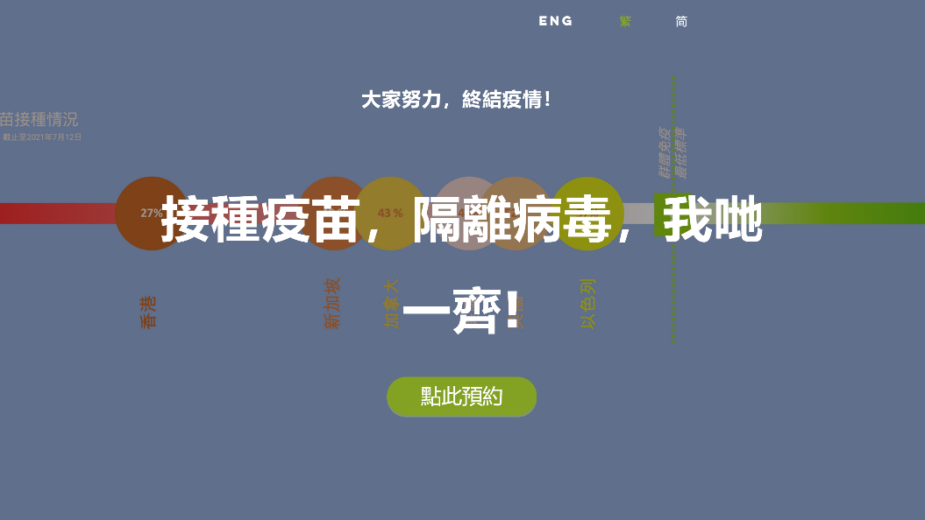
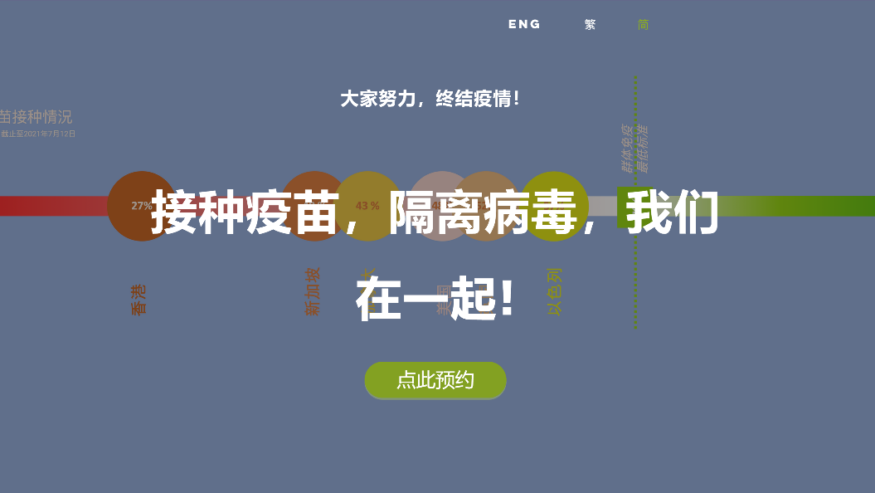
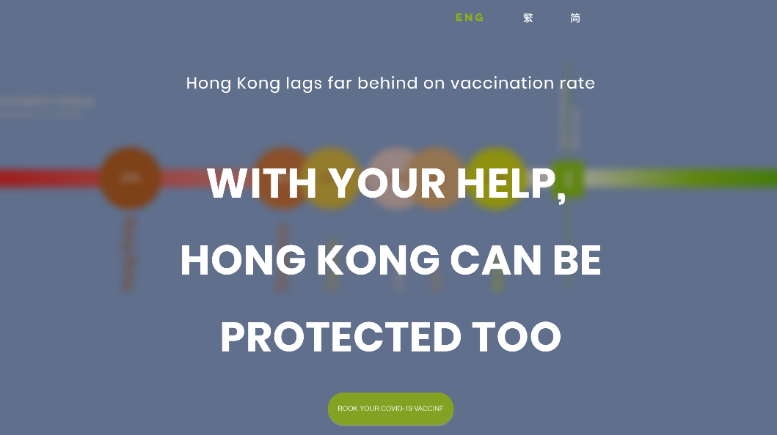
Fig. S2. Webpages displaying the message “Comparison” in Traditional Chinese, Simplified Chinese and English.


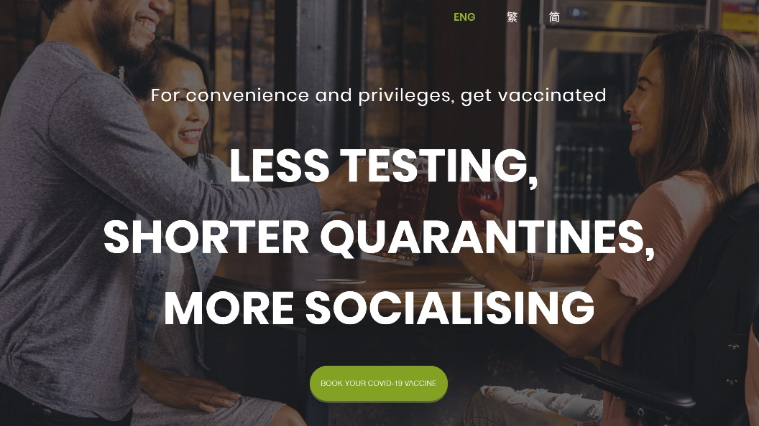
Fig. S3. Webpages displaying the message “Exemption” in Traditional Chinese, Simplified Chinese and English.



Fig. S4. Webpages displaying the message “Family” in Traditional Chinese, Simplified Chinese and English.
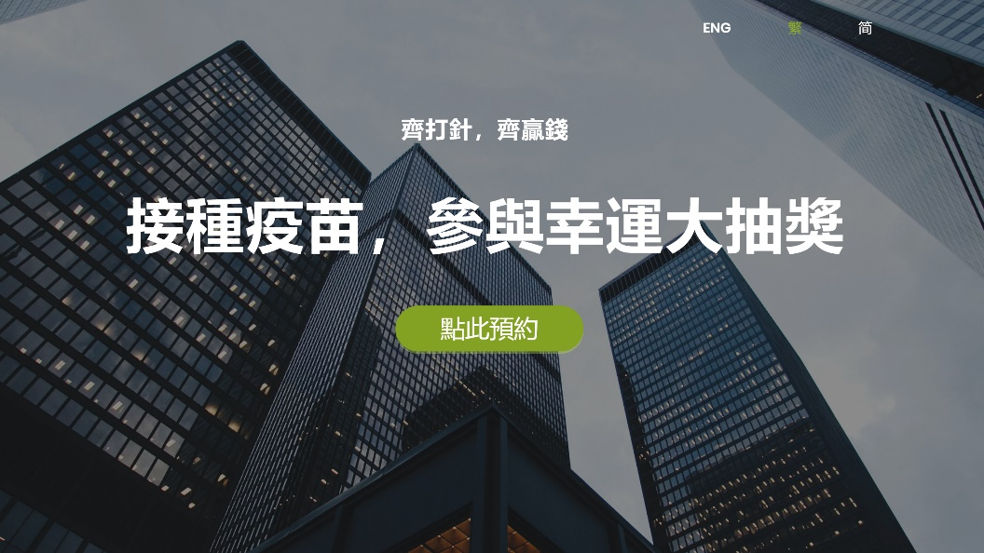
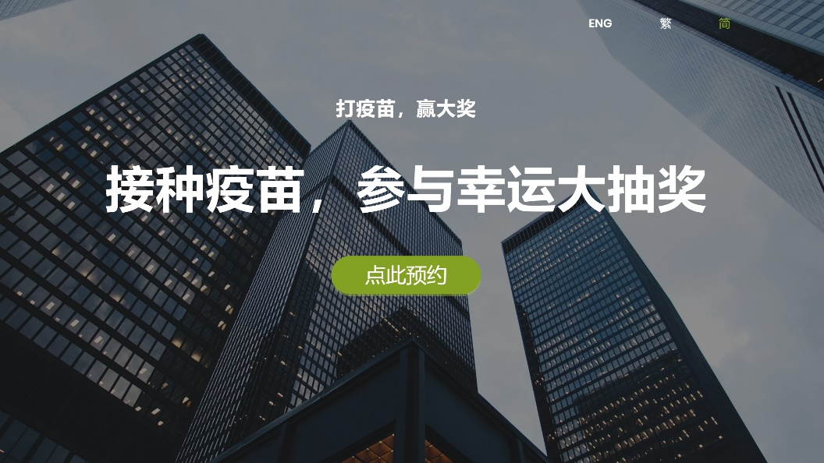
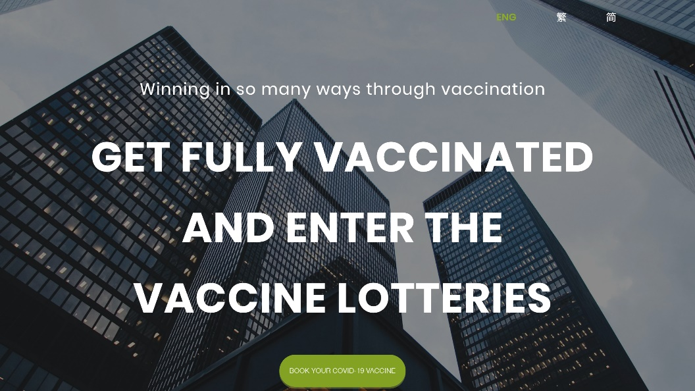
Fig. S5. Webpages displaying the message “Lottery” in Traditional Chinese, Simplified Chinese and English.
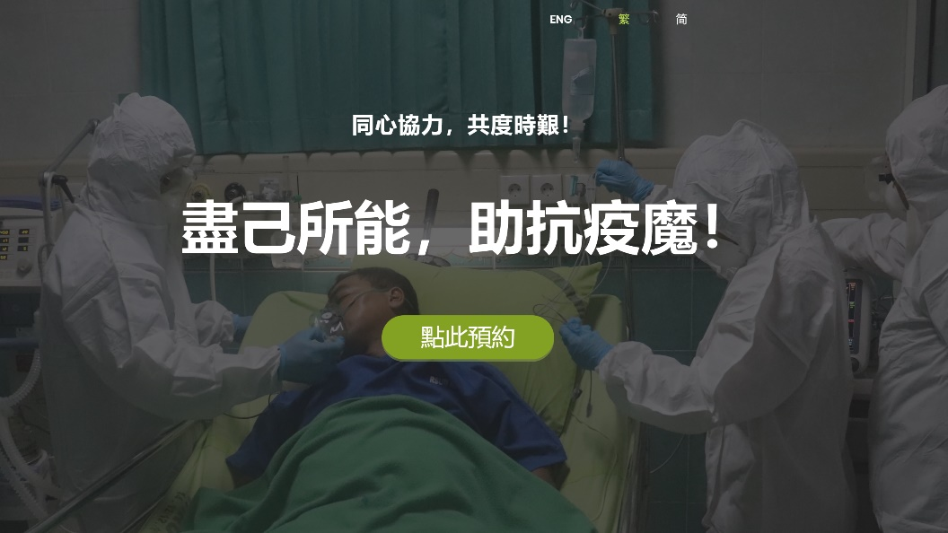
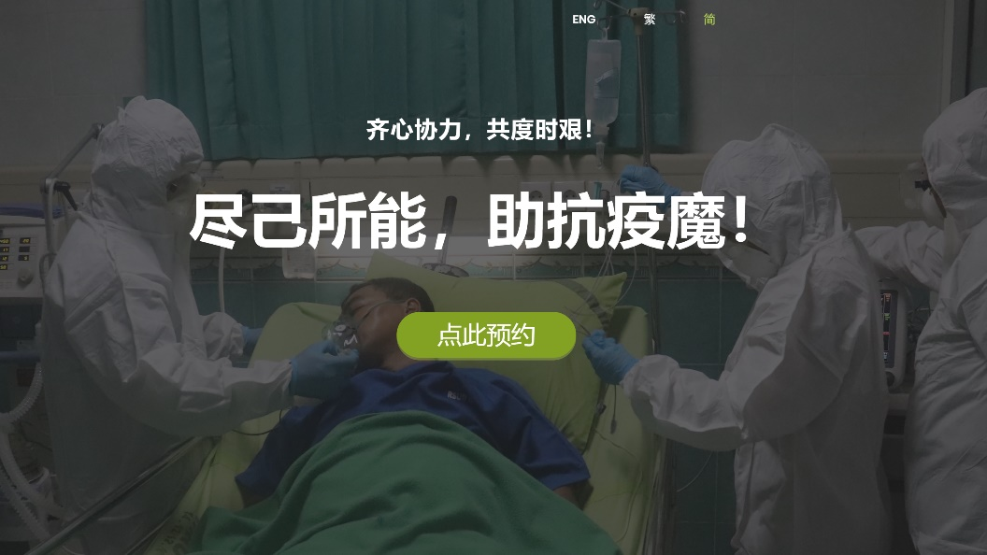
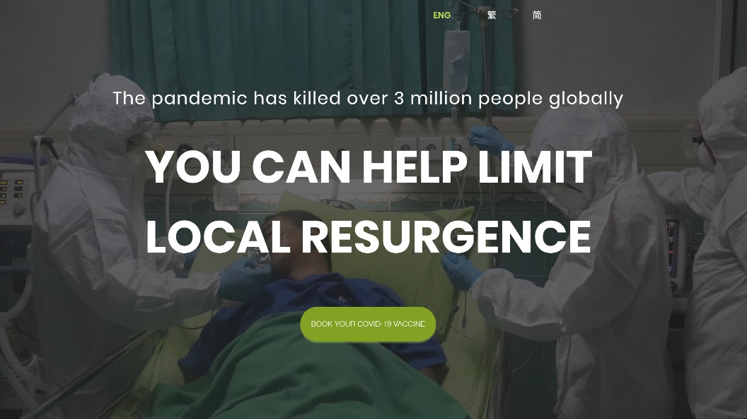
Fig. S6. Webpages displaying the message “Mortality” in Traditional Chinese, Simplified Chinese and English.
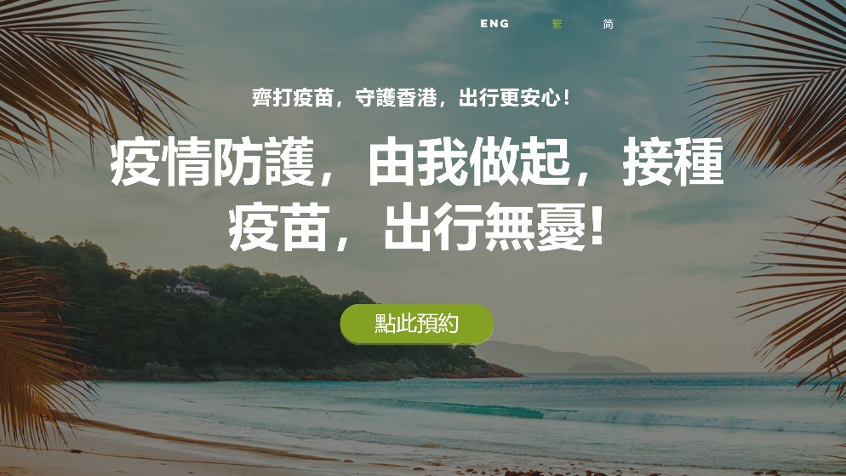
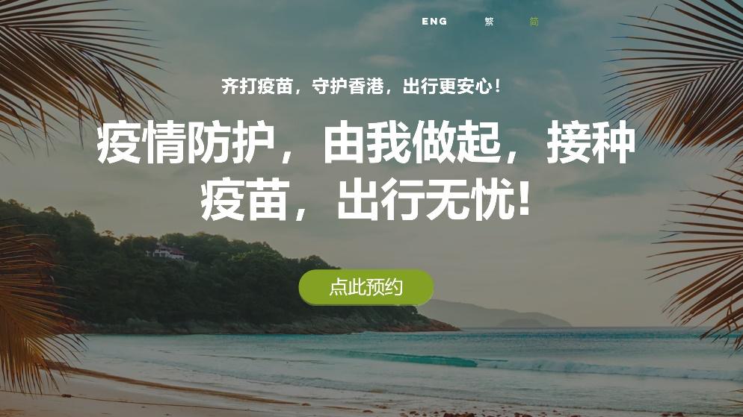
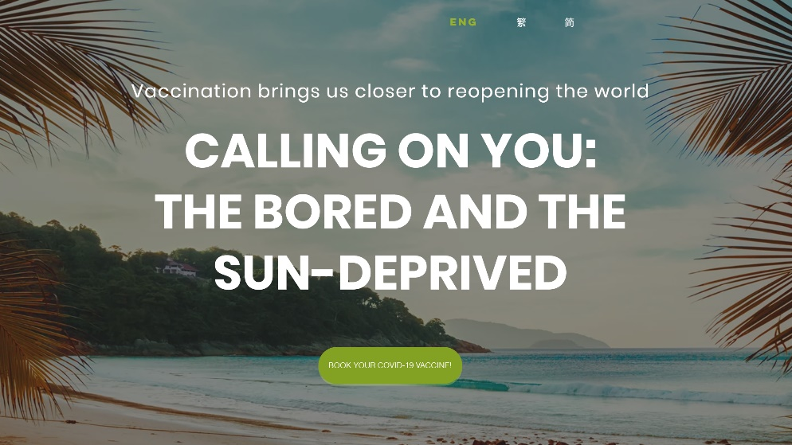
Fig. S7. Webpages displaying the message “Reopen” in Traditional Chinese, Simplified Chinese and English.
Fig. S8. Daily number of page requests and clickthrough rate of our Google Ads and the temporal distribution of nudges administered in our RCT.

Fig. S9. Same as Fig. 3 but with a follow-up period of X = 3 hours.

Fig. S10. Same as Fig. 3 but with a follow-up period of X = 12 hours.

Fig. S11. Same as Fig. 3 but with a washout period of $∆$ = 0.5 day.

Fig. S12. Same as Fig. 3 but with a washout period of $∆$ = 2 day.
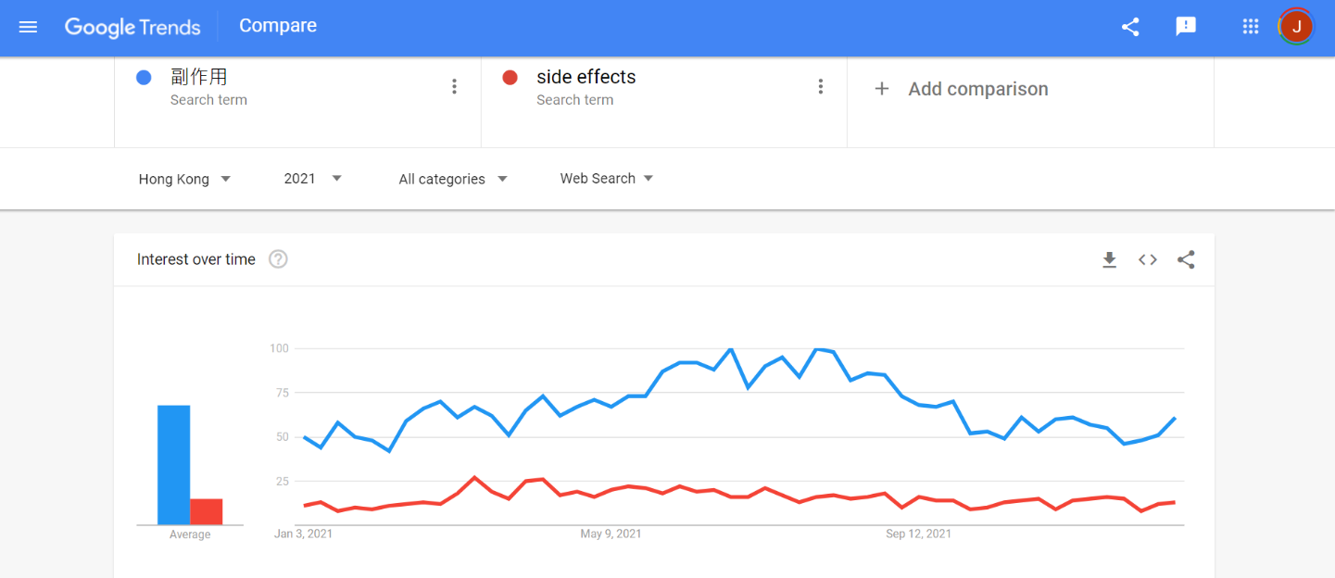
Fig. S13. Google Trends of the search term “side effects” in Traditional/Simplified Chinese and English in Hong Kong during 2021.

