Supplementary Material
The effect of UV₃₆₅/Fenton process on the removal of gaseous ethylbenzene in the bubble column reactor
Yan Wang ª, Yanchen Sun ª, Zhen Wang ª, Qingduan Kong ^{b}, Bo Wu ª, Junfeng Wan ª, Weiwei Guo ^{a, b,} *
ª School of Ecology and Environment, Zhengzhou University, Zhengzhou 450001, PR China
^{b} Henan Xinanli Security Technology Co., Ltd., Zhengzhou 450000, PR China

This file contained seven figures and one table.

*Corresponding author: guoweiwei@zzu.edu.cn (Weiwei. Guo)
Captions of Figures and Tables
Fig. S1. Effect of main experimental parameters on CO₂ selectivity………………....3
Fig. S2. Effect of UV power on the removal efficiency and CO₂ selectivity in the UV₂₅₄/Fenton process ……………………………………………………………....5
Fig. S3. Changes of the lump and intermittent dosing of H₂O₂.....……………………..……………………………………………………….....6
Fig. S4. Effect of lump and intermittent dosing of H₂O₂ on CO₂ selectivity......………………………………………………………………………......7
Fig. S5. The profiles of Fe²⁺ and Fe³⁺ in the UV₃₆₅/Fenton process.…………………..8
Fig. S6. Changes of the carbon concentration with time………………………………9
Fig. S7. GC-MS chromatograms of liquid intermediates and CH₂Cl₂ in the UV₃₆₅/Fenton process.………………...………....…………………….................…..10
Table S1. The intermediates of gaseous ethylbenzene degradation in the UV₃₆₅/Fenton process.………....……........…….....…….....……......……......…......…........…...…..11

Fig. S1. Effect of main experimental parameters on CO₂ selectivity of gaseous ethylbenzene: (a) H₂O₂ concentration; (b) pH; (c) [H₂O₂]/[Fe²⁺]; (d) UV power; (e) gaseous ethylbenzene concentration and (f) gas flow rate. Reaction conditions: H₂O₂ concentration, 100 mM; pH, 3.0; [H₂O₂]/[Fe²⁺], 4; UV wavelength, 365 nm; UV power, 5 W and 10 W; gaseous ethylbenzene concentration, 30 ppm; gas flow rate, 900 mL·min⁻¹; temperature, 30 ℃ (unless specified).

Fig. S2. Effect of UV power on the removal efficiency (a) and CO₂ selectivity (b) in the UV₂₅₄/Fenton process. Reaction conditions: H₂O₂ concentration, 100 mM; pH, 3.0; [H₂O₂]/[Fe²⁺], 4; UV wavelength, 254 nm; UV power, 15 W and 30 W; gaseous ethylbenzene concentration, 30 ppm; gas flow rate, 900 mL·min⁻¹; temperature, 30 ℃.
Fig. S3. Changes of the lump and intermittent dosing of H₂O₂: (a) lump dosing of 100 mM H₂O₂; (b) and (c) intermittent dosing of 16.67 mM and 100 mM H₂O₂, respectively. Reaction conditions: Fe²⁺ concentration, 25 mM; pH, 3.0; UV wavelength, 365 nm; UV power, 5 W; gaseous ethylbenzene concentration, 30 ppm; gas flow rate, 900 mL·min⁻¹; temperature, 30 ℃.

Fig. S4. Effect of lump and intermittent dosing of H₂O₂ on CO₂ selectivity: (a) lump dosing of 100 mM H₂O₂; (b) and (c) intermittent dosing of 16.67 mM and 100 mM H₂O₂, respectively. Reaction conditions: Fe²⁺ concentration, 25 mM; pH, 3.0; UV wavelength, 365 nm; UV power, 5 W; gaseous ethylbenzene concentration, 30 ppm; gas flow rate, 900 mL·min⁻¹; temperature, 30 ℃.

Fig. S5. The profiles of Fe²⁺ and Fe³⁺ in the UV₃₆₅/Fenton process. Conditions: H₂O₂ concentration, 100 mM; pH, 3.0; [H₂O₂]/[Fe²⁺], 4; UV wavelength, 365 nm; UV power, 5 W; gaseous ethylbenzene concentration, 30 ppm; gas flow rate, 900 mL·min⁻¹; temperature, 30 ℃.

Fig. S6. Changes of the carbon concentration with time. Conditions: H₂O₂ concentration, 100 mM; pH, 3.0; [H₂O₂]/[Fe²⁺], 4; UV wavelength, 365 nm; UV power, 5 W; gaseous ethylbenzene concentration, 30 ppm; gas flow rate, 900 mL·min⁻¹; temperature, 30 ℃.
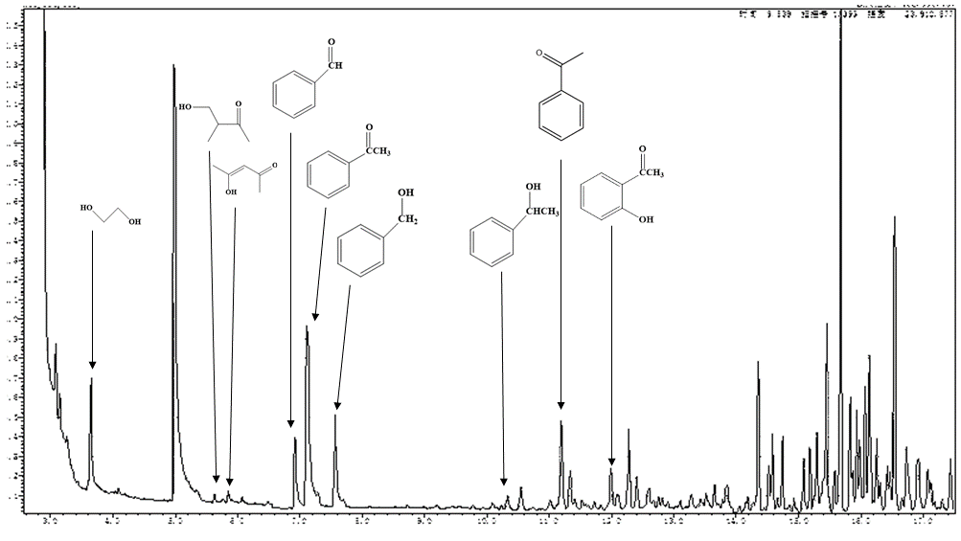
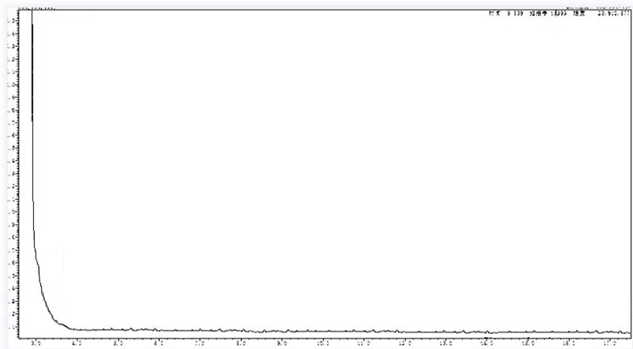
Fig. S7. GC-MS chromatograms of liquid intermediates and CH₂Cl₂ in the UV₃₆₅/Fenton process.
Table S1. The intermediates of ethylbenzene degradation in the UV₃₆₅/Fenton process.
No. | Intermediates | Structures | CAS
1 | Benzyl alcohol | 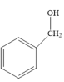 | 100-51-6
2 | Benzaldehyde | 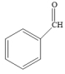 | 100-52-7
3 | Phenylethyl alcohol | 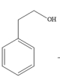 | 60-12-8
4 | Phenylethanol | 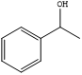 | 1321-27-3
5 | Acetophenone | 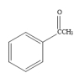 | 98-86-2
6 | 2-Hydroxy acetophenone | 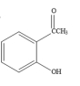 | 118-93-4
7 | 1,2-Ethanediol | 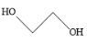 | 107-21-1
8 | 4-Hydroxy-3-methyl-2-butanone | 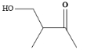 | 3393-64-4
9 | Acetylacetone | 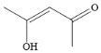 | 1522-20-9
10 | Benzeneacetic acid, octyl ester | 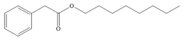 | 122-45-2
11 | 1-Octanol | 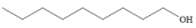 | 111-87-5
12 | Hexadecane |  | 544-76-3

