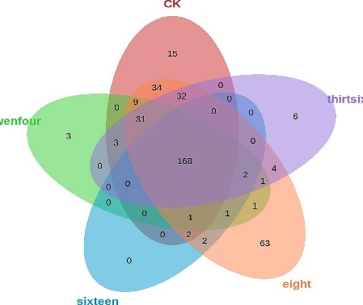
Supplementary fig. 1 Species Venn diagram.The ovals represent different periods of fermentation of the concentrate by the enhanced bacteria, overlapping areas between ovals indicate common species during fermentation, and non-overlapping areas indicate unique species during different periods of fermentation.
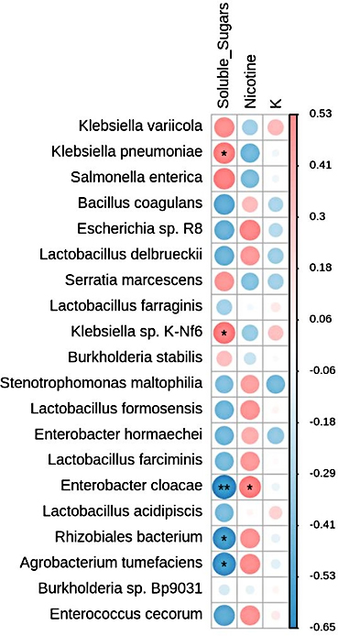
Supplementary fig. 2 Correlation diagram between conventional chemical components and microorganisms.
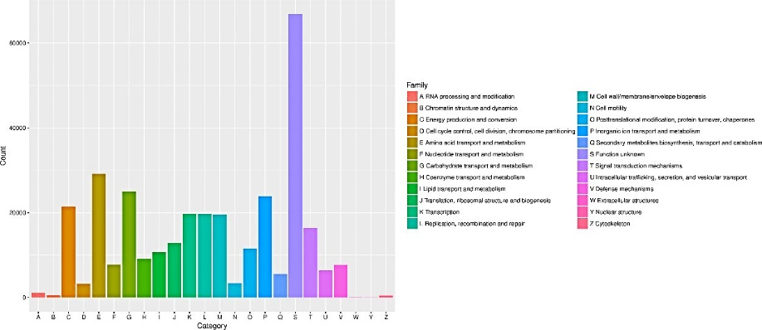
Supplementary fig. 3 Statistical chart of eggnog functional group annotation results. The abscissa corresponds to 25 gene functional groups of eggNOG, and the ordinate is the number of eggNOG functional groups annotated to the corresponding classification.
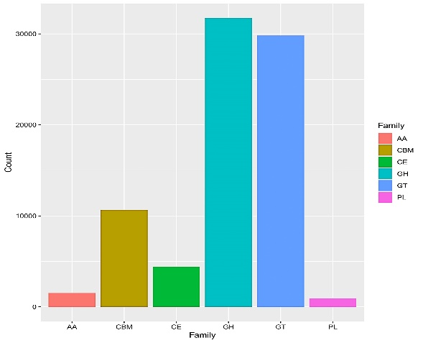
Supplementary fig. 4 Statistical chart of cazy enzyme function module annotation results. The abscissa corresponds to each CAZy enzyme function module, and the ordinate is the number of protein families annotated to the corresponding module.

