Supplementary Information
Inhibition of multipotent ILC2s by JAK3 inhibitor attenuates steroid-resistant asthma
Running title: JAK3i inhibits multipotent ILC2s in steroid-resistant asthma

Jihyun Kim et al.

Supplementary Figures
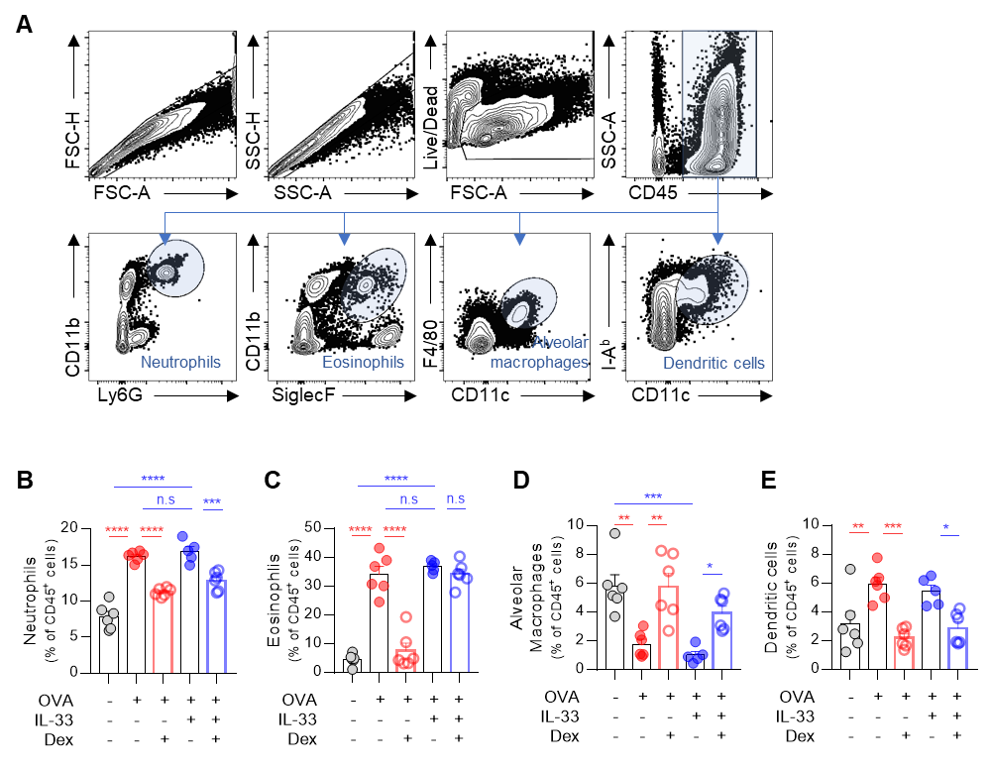
Supplementary Figure 1. Changes of myeloid cells in OVA/IL-33 model after dexamethasone treatment in vivo. A. Gating strategy of myeloid cells in lungs. Neutrophils were gated as CD45⁺CD11b⁺Ly6G⁺ cells. Eosinophils were gated as CD45⁺CD11b⁺SiglecF⁺ cells. Alveolar macrophages were gated as CD45⁺CD11c⁺F4/80⁺ cells. Dendritic cells were gated as CD45⁺CD11c⁺I-A^{b+} cells. B-E. Frequency of neutrophils (B), eosinophils (C), alveolar macrophages (D), and dendritic cells (E) in OVA-alone and OVA/IL-33 models with or without dexamethasone (Dex) treatment. n.s; not significant, *P ≤ 0.05, **P ≤ 0.01, ***P ≤ 0.001, and ****P ≤ 0.0001, by one-way ANOVA followed by Bonferroni’s post-test. The data are representative of 2–3 independent experiments and are presented as mean ± SEM.
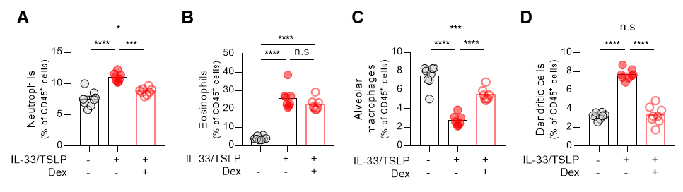
Supplementary Figure 2. Changes of myeloid cells in IL-33/TSLP model after dexamethasone treatment in vivo. A-D. Frequency of neutrophils (A), eosinophils (B), alveolar macrophages (C), and dendritic cells (D) in IL-33/TSLP model with and without Dex treatment. n.s; not significant, *P ≤ 0.05, ***P ≤ 0.001, and ****P ≤ 0.0001, by one-way ANOVA followed by Bonferroni’s post-test. The data are representative of 2–3 independent experiments and are presented as mean ± SEM.

Supplementary Figure 3. The proliferation of Th2 cells and ILC2s after dexamethasone treatment in vitro. A, B. Ki67 expression by the murine ILC2s (A) and Th2 cells (B). C, D. Murine ILC2s were stimulated with IL-2/7 alone, IL-33 alone, or all three together. The frequencies of Annexin V⁺ ILC2s were determined. A representative dot plot is shown in left plot and the cell frequencies were presented in the right plot (C). The frequencies of IL-5⁺ or IL-13⁺ ILC2s were determined. A representative dot plot is shown in left plot and the cell frequencies were presented in the right plot (D). n.s; not significant, **P ≤ 0.01, and ****P ≤ 0.0001 by unpaired t-test (A and B) and two-way ANOVA followed by Tukey's multiple comparisons test (C and D). The data are representative of 2–3 independent experiments and are presented as mean ± SEM.
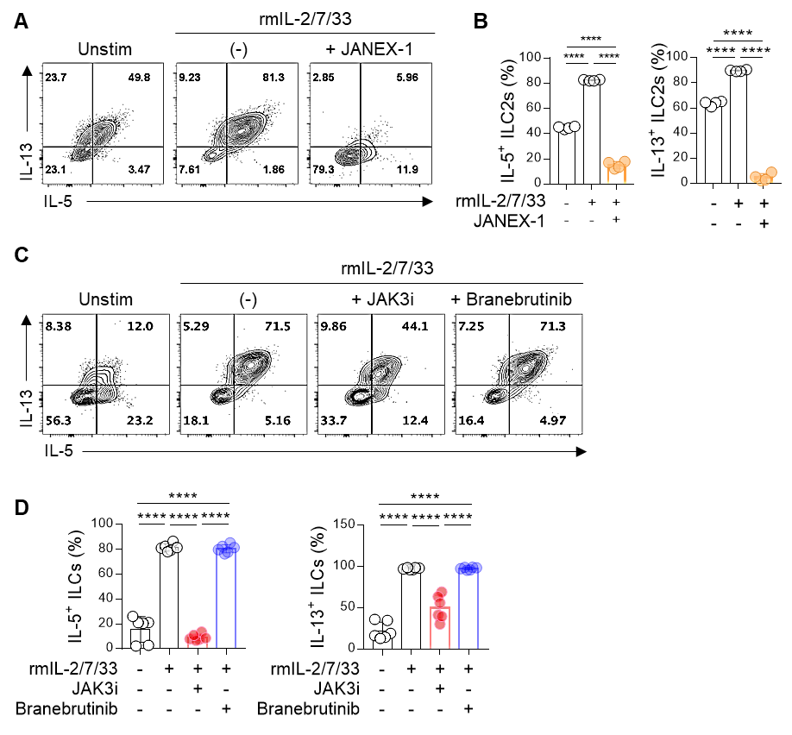
Supplementary Figure 4. Cytokine expression from ILC2s after JANEX-1 or Branebrutinib treatment in vitro. A, B. Effect of JANEX-1 treatment on IL-2/7/33-stimulated murine lung ILC2s. Their frequencies of IL-5- and IL-13-producing murine ILC2s are shown by representative dot plots (A) and plots (B). C, D. Effect of JAK3i (PF06651600) or Branerutinib treatment on IL-2/7/33-stimulated murine lung ILC2s. Their frequencies of IL-5- and IL-13-producing murine ILC2s are shown by representative dot plots (C) and plots (D). ****P ≤ 0.0001, by one-way ANOVA followed by Bonferroni’s post-test. The data are representative of 2–3 independent experiments and are presented as mean ± SEM.

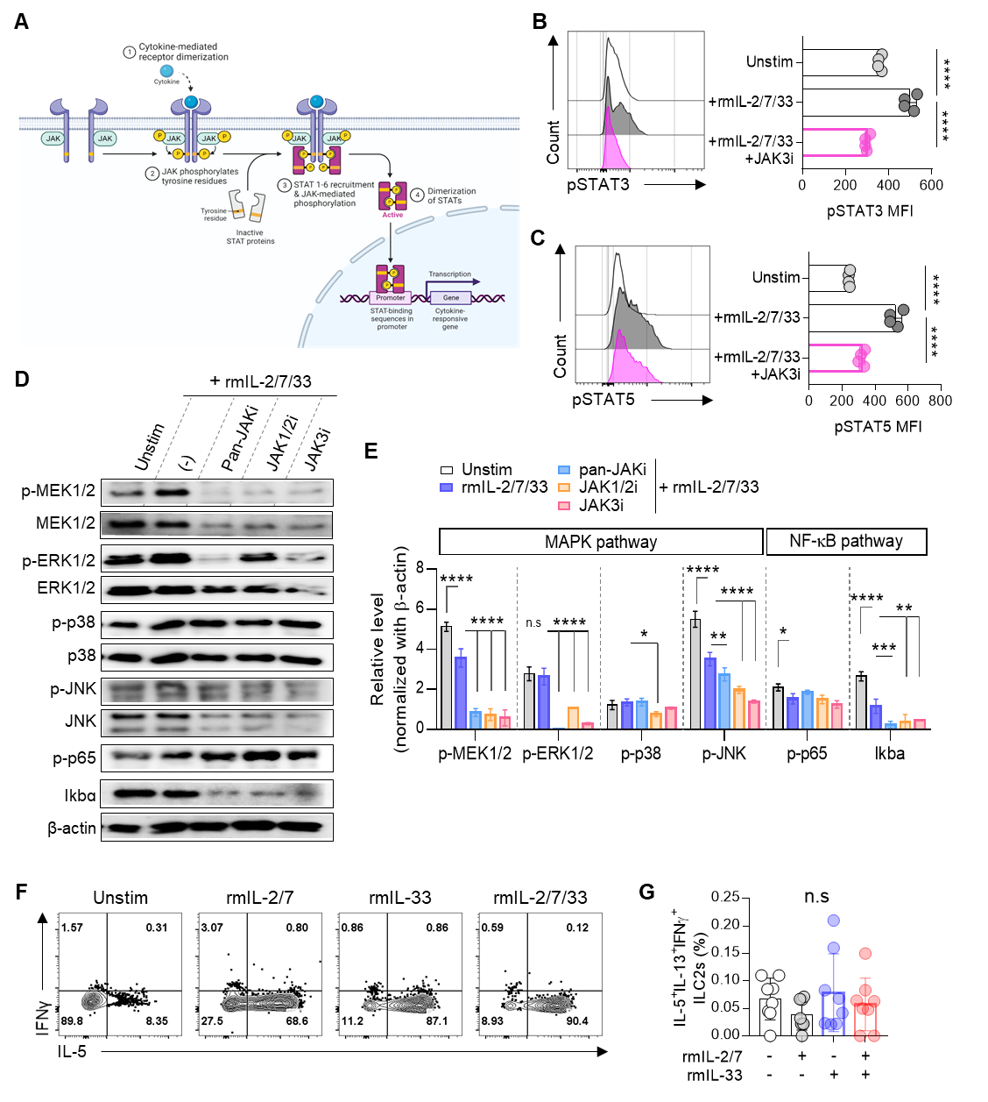
Supplementary Figure 5. Changes in phosphorylation of proteins of MAPK and NF-𝜅B signaling. A. JAK/STAT signaling pathway transduced by cytokines. B, C. Effect of JAK3i treatment on IL-2/7/33-stimulated murine lung ILC2s. Their phosphorylated STAT3 (pSTAT3) (B) and pSTAT5 (C) expression are shown. D, E. Western blot analysis of the phosphorylated form and protein of MAPK and NF-𝜅B in murine IL-2/3/33-stimulated ILC2s that were treated with a pan-JAK inhibitor (Tofacitinib; Pan-JAKi), a JAK1/JAK2 dual inhibitor (AZD1480; JAK1/2i), or a JAK3-selective inhibitor (PF06651600; JAK3i). A representative blot is shown in (D) and the relative phosphorylated protein levels are plotted in (E). F, G. Murine ILC2s were stimulated with IL-2/7 alone, IL-33 alone, or all three together. The frequencies of IL-5⁺IL-13⁺IFNγ⁺ ILC2s were determined. A representative dot plot is shown in (F) and the cell frequencies were presented in (G). n.s; not significant, *P ≤ 0.05, **P ≤ 0.01, ***P ≤ 0.001, and ****P ≤ 0.0001, by one-way ANOVA followed by Bonferroni’s post-test. The data are representative of 2–3 independent experiments and are presented as mean ± SEM.

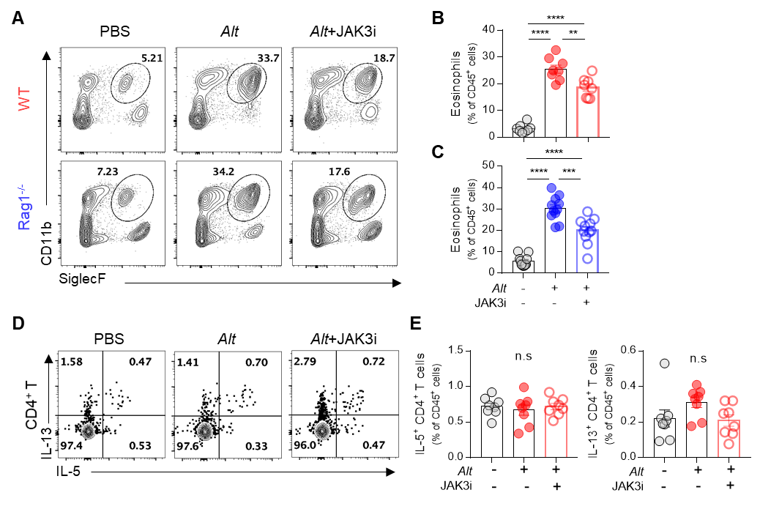
Supplementary Figure 6. Changes of eosinophils in Alt extract-induced asthma model after JAK3i treatment in vivo. A–C. Frequencies of eosinophils (gated as CD45⁺CD11b⁺SiglecF⁺ cells). Representative dot plots are shown in (A) and the frequencies in WT (B) and Rag1^{-/-} (C) mice are plotted. D, E. Frequencies of IL-5- and IL-13-producing CD4⁺ T cells (gated as CD45⁺Lineage⁺CD4⁺ cells). Representative dot plots are shown in (D) and the frequencies are plotted in (E). n.s; not significant, **P ≤ 0.01, ***P ≤ 0.001, and ****P ≤ 0.0001, by one-way ANOVA followed by Bonferroni’s post-test. The data are representative of 2–3 independent experiments and are presented as mean ± SEM.

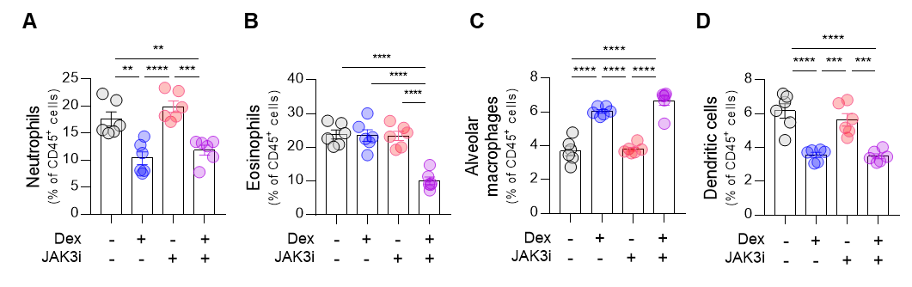
Supplementary Figure 7. Changes of myeloid cells in OVA/IL-33 model after dexamethasone or JAK3i treatment in vivo. A-D. Frequency of neutrophils (A), eosinophils (B), alveolar macrophages (C), and dendritic cells (D) in OVA/IL-33 model with Dex and/or JAK3i treatment. **P ≤ 0.01, ***P ≤ 0.001, and ****P ≤ 0.0001, by one-way ANOVA followed by Bonferroni’s post-test. The data are representative of 2–3 independent experiments and are presented as mean ± SEM.

