Molecular structures, chemical descriptors and pancreatic lipase (1LPB) inhibition by natural products: A DFT investigation and molecular docking prediction
Hamza Allal^{1,3,*} Hacene Nemdili¹, Mohamed Amine Zerizer^{1,2}, Bachir Zouchoune^{1,2,*}

¹Unité de Recherche de Chimie de l’Environnement et Moléculaire Structurale, Université de Constantine-1 (Mentouri), 25000 Constantine, Algeria.
²Laboratoire de Chimie Appliquée et Technologie des Matériaux, Université Larbi Ben M’hidi Oum el Bouaghi, 04000 Oum El Bouaghi, Algeria.
³Département de technologie, Faculté de technologie, Université 20 Août 1955 de Skikda, Route El Hadaik, Skikda 21000, Algeria.

Hamza Allal: hamzaallal.univ@gmail.com, http://orcid.org/0000-0002-8095-7421
Bachir Zouchoune: bzouchoune@gmail.com, http://orcid.org/0000-0002-0181-6058

Content

Figure S1. Corresponds to the isosurface Fukui maps for Eug 1, Ging 2, AA 3 and Oleu 4 ligands.
Table S1-S9 of condensed Fukui functions ($f_{k}^{+}$, $f_{k}^{-}$), Local electrophilicity ($ω_{k}^{+}$, $ω_{k}^{-}$) and Local softness ($δ_{k}^{+}$, $δ_{k}^{-}$) of the Eug1, Ging 2, AA 3, Oleu 4, Pip 5, Hesp 6, Quer 7, Lut 8 and Cur 9 compounds.
Table S10: corresponds to the Amino acids involved in interactions for Eug 1, Ging 2, AA 3 and Oleu 4 ligands at Human pancreatic lipase 1LPB protein.
Fig. S2-S5 correspond to the 3D visual representations of Eug1@1LPB, Ging2@1LPB, AA3@1LPB and Oleu4@1LPB complexes, respectively, (a) best binding mode in the protein pocket, (b) amino acid residues involved in the interaction.

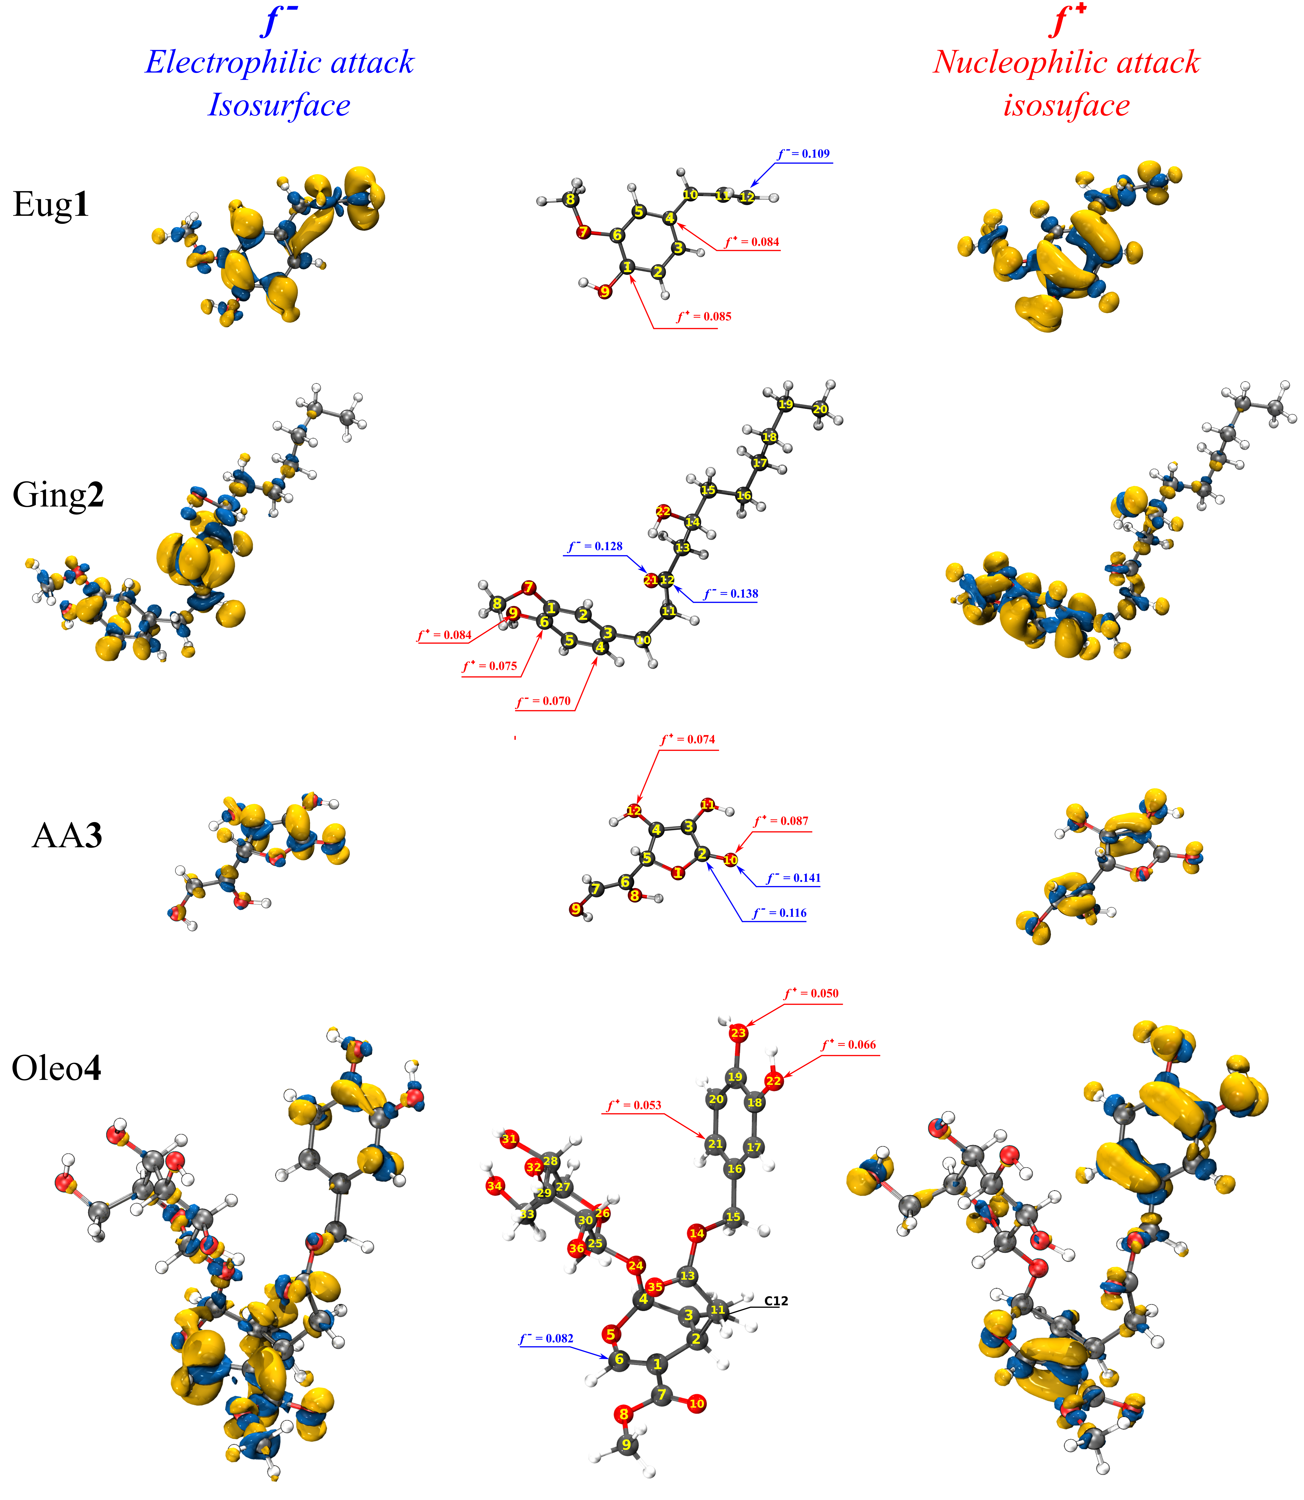
Fig. S1. Isosurface Fukui maps of electrophilic attack $f_{k}^{-}$ (left), nucleophilic attack $f_{k}^{+}$ (right) and high values of Fukui functions $f_{k}^{-}$ and $f_{k}^{+}$ (center) for Eug 1, Ging 2, AA 3 and Oleo 4 ligands.

Table S1
Condensed Fukui functions ($f_{k}^{+}$, $f_{k}^{-}$), Local electrophilicity ($ω_{k}^{+}$, $ω_{k}^{-}$) and Local softness ($δ_{k}^{+}$, $δ_{k}^{-}$) of the Eug1molecule.
Atms | $$f_{k}^{+}$$ | $$f_{k}^{-}$$ | Δf | $$ω_{k}^{+}$$ | $$ω_{k}^{-}$$ | $$δ_{k}^{+}$$ | $$δ_{k}^{-}$$
C1 | 0.085 | 0.050 | 0.035 | 0.172 | 0.102 | 0.035 | 0.021
C2 | 0.050 | 0.089 | -0.039 | 0.100 | 0.179 | 0.020 | 0.036
C3 | 0.080 | 0.037 | 0.043 | 0.161 | 0.075 | 0.033 | 0.015
C4 | 0.084 | 0.030 | 0.054 | 0.170 | 0.061 | 0.035 | 0.012
C5 | 0.034 | 0.082 | -0.049 | 0.068 | 0.166 | 0.014 | 0.034
C6 | 0.069 | 0.050 | 0.019 | 0.139 | 0.101 | 0.028 | 0.021
O7 | 0.062 | 0.025 | 0.037 | 0.125 | 0.050 | 0.025 | 0.010
C8 | 0.023 | 0.015 | 0.007 | 0.045 | 0.031 | 0.009 | 0.006
O9 | 0.106 | 0.042 | 0.065 | 0.215 | 0.084 | 0.044 | 0.017
C10 | 0.016 | 0.019 | -0.003 | 0.032 | 0.039 | 0.007 | 0.008
C11 | 0.006 | 0.066 | -0.060 | 0.012 | 0.133 | 0.003 | 0.027
C12 | 0.054 | 0.109 | -0.055 | 0.109 | 0.220 | 0.022 | 0.045

Table S2
Condensed Fukui functions ($f_{k}^{+}$, $f_{k}^{-}$), Local electrophilicity ($ω_{k}^{+}$, $ω_{k}^{-}$) and Local softness ($δ_{k}^{+}$, $δ_{k}^{-}$) of the Ging 2 molecule.
Atms | $$f_{k}^{+}$$ | $$f_{k}^{-}$$ | Δf | $$ω_{k}^{+}$$ | $$ω_{k}^{-}$$ | $$δ_{k}^{+}$$ | $$δ_{k}^{-}$$
C1 | 0.061 | 0.035 | 0.026 | 0.169 | 0.097 | 0.024 | 0.014
C2 | 0.028 | 0.030 | -0.003 | 0.078 | 0.085 | 0.011 | 0.012
C3 | 0.071 | 0.004 | 0.067 | 0.198 | 0.011 | 0.029 | 0.002
C4 | 0.070 | 0.037 | 0.033 | 0.195 | 0.103 | 0.028 | 0.015
C5 | 0.043 | 0.052 | -0.010 | 0.118 | 0.145 | 0.017 | 0.021
C6 | 0.075 | 0.025 | 0.049 | 0.208 | 0.071 | 0.030 | 0.010
O7 | 0.051 | 0.013 | 0.037 | 0.141 | 0.037 | 0.020 | 0.005
C8 | 0.020 | 0.012 | 0.007 | 0.055 | 0.034 | 0.008 | 0.005
O9 | 0.084 | 0.024 | 0.060 | 0.233 | 0.067 | 0.034 | 0.010
C10 | 0.015 | 0.011 | 0.004 | 0.041 | 0.031 | 0.006 | 0.004
C11 | 0.015 | 0.025 | -0.010 | 0.042 | 0.069 | 0.006 | 0.010
C12 | 0.007 | 0.138 | -0.131 | 0.019 | 0.382 | 0.003 | 0.055
C13 | 0.012 | 0.020 | -0.008 | 0.033 | 0.056 | 0.005 | 0.008
C14 | 0.009 | 0.005 | 0.005 | 0.026 | 0.013 | 0.004 | 0.002
C15 | 0.003 | 0.005 | -0.002 | 0.010 | 0.015 | 0.001 | 0.002
C16 | 0.001 | 0.001 | 0.000 | 0.004 | 0.003 | 0.001 | 0.000
C19 | 0.002 | 0.003 | 0.000 | 0.006 | 0.007 | 0.001 | 0.001
C18 | 0.001 | 0.001 | 0.000 | 0.002 | 0.003 | 0.000 | 0.000
C19 | 0.002 | 0.002 | -0.001 | 0.005 | 0.006 | 0.001 | 0.001
C20 | 0.002 | 0.002 | 0.000 | 0.006 | 0.007 | 0.001 | 0.001
O21 | 0.024 | 0.128 | -0.104 | 0.066 | 0.355 | 0.010 | 0.051
O22 | 0.053 | 0.022 | 0.031 | 0.147 | 0.060 | 0.021 | 0.009

Table S3
Condensed Fukui functions ($f_{k}^{+}$, $f_{k}^{-}$), Local electrophilicity ($ω_{k}^{+}$, $ω_{k}^{-}$) and Local softness ($δ_{k}^{+}$, $δ_{k}^{-}$) of the AA 3 molecule.
Atms | $$f_{k}^{+}$$ | $$f_{k}^{-}$$ | Δf | $$ω_{k}^{+}$$ | $$ω_{k}^{-}$$ | $$δ_{k}^{+}$$ | $$δ_{k}^{-}$$
O1 | 0.038 | 0.049 | -0.010 | 0.131 | 0.167 | 0.015 | 0.020
C2 | 0.028 | 0.116 | -0.089 | 0.094 | 0.398 | 0.011 | 0.047
C3 | 0.080 | 0.067 | 0.013 | 0.274 | 0.231 | 0.032 | 0.027
C4 | 0.064 | 0.098 | -0.035 | 0.217 | 0.336 | 0.026 | 0.040
C5 | 0.016 | 0.023 | -0.008 | 0.053 | 0.080 | 0.006 | 0.009
C6 | 0.067 | 0.005 | 0.062 | 0.229 | 0.016 | 0.027 | 0.002
C7 | 0.090 | 0.049 | 0.041 | 0.306 | 0.168 | 0.036 | 0.020
O8 | 0.057 | 0.030 | 0.028 | 0.196 | 0.102 | 0.023 | 0.012
O9 | 0.101 | 0.048 | 0.052 | 0.344 | 0.166 | 0.041 | 0.020
O10 | 0.087 | 0.141 | -0.054 | 0.298 | 0.482 | 0.035 | 0.057
O11 | 0.101 | 0.057 | 0.044 | 0.344 | 0.194 | 0.041 | 0.023
O12 | 0.074 | 0.072 | 0.002 | 0.252 | 0.246 | 0.030 | 0.029

Table S4
Condensed Fukui functions ($f_{k}^{+}$, $f_{k}^{-}$), Local electrophilicity ($ω_{k}^{+}$, $ω_{k}^{-}$) and Local softness ($δ_{k}^{+}$, $δ_{k}^{-}$) of the Oleu 4 molecule.
Atms | $$f_{k}^{+}$$ | $$f_{k}^{-}$$ | Δf | $$ω_{k}^{+}$$ | $$ω_{k}^{-}$$ | $$δ_{k}^{+}$$ | $$δ_{k}^{-}$$
C1 | 0.043 | 0.030 | 0.013 | 0.171 | 0.118 | 0.020 | 0.014
C2 | 0.005 | 0.007 | -0.002 | 0.019 | 0.029 | 0.002 | 0.003
C3 | -0.005 | 0.018 | -0.023 | -0.019 | 0.074 | -0.002 | 0.009
C4 | 0.003 | 0.009 | -0.007 | 0.011 | 0.038 | 0.001 | 0.004
O5 | 0.034 | 0.031 | 0.004 | 0.138 | 0.123 | 0.016 | 0.014
C6 | 0.035 | 0.082 | -0.047 | 0.140 | 0.328 | 0.016 | 0.038
C7 | 0.006 | 0.044 | -0.038 | 0.026 | 0.176 | 0.003 | 0.021
O8 | 0.010 | 0.018 | -0.008 | 0.039 | 0.070 | 0.005 | 0.008
C9 | 0.009 | 0.013 | -0.005 | 0.035 | 0.053 | 0.004 | 0.006
O10 | 0.025 | 0.057 | -0.032 | 0.100 | 0.227 | 0.012 | 0.026
C11 | 0.008 | 0.012 | -0.004 | 0.031 | 0.048 | 0.004 | 0.006
C12 | 0.019 | 0.057 | -0.038 | 0.077 | 0.227 | 0.009 | 0.027
C13 | 0.007 | 0.025 | -0.017 | 0.030 | 0.100 | 0.003 | 0.012
O14 | 0.007 | 0.016 | -0.009 | 0.027 | 0.064 | 0.003 | 0.007
C15 | 0.007 | 0.012 | -0.004 | 0.030 | 0.047 | 0.003 | 0.005
C16 | 0.039 | 0.015 | 0.025 | 0.157 | 0.058 | 0.018 | 0.007
C17 | 0.026 | 0.036 | -0.011 | 0.103 | 0.145 | 0.012 | 0.017
C18 | 0.049 | 0.020 | 0.029 | 0.196 | 0.080 | 0.023 | 0.009
C19 | 0.049 | 0.032 | 0.017 | 0.195 | 0.127 | 0.023 | 0.015
C20 | 0.025 | 0.036 | -0.011 | 0.101 | 0.145 | 0.012 | 0.017
C21 | 0.053 | 0.012 | 0.042 | 0.213 | 0.046 | 0.025 | 0.005
O22 | 0.066 | 0.020 | 0.047 | 0.266 | 0.078 | 0.031 | 0.009
O23 | 0.050 | 0.023 | 0.027 | 0.201 | 0.092 | 0.023 | 0.011
O24 | -0.002 | 0.000 | -0.003 | -0.009 | 0.002 | -0.001 | 0.000
C25 | 0.002 | 0.001 | 0.001 | 0.009 | 0.003 | 0.001 | 0.000
O26 | 0.015 | -0.001 | 0.017 | 0.061 | -0.005 | 0.007 | -0.001
C27 | 0.005 | 0.002 | 0.003 | 0.020 | 0.006 | 0.002 | 0.001
C28 | 0.001 | 0.001 | 0.000 | 0.004 | 0.003 | 0.001 | 0.000
C29 | 0.001 | 0.002 | -0.001 | 0.004 | 0.007 | 0.000 | 0.001
C30 | 0.001 | 0.000 | 0.001 | 0.003 | -0.001 | 0.000 | 0.000
O31 | 0.008 | 0.008 | 0.000 | 0.033 | 0.033 | 0.004 | 0.004
O32 | 0.008 | 0.008 | 0.000 | 0.032 | 0.034 | 0.004 | 0.004
C33 | 0.009 | 0.001 | 0.008 | 0.038 | 0.004 | 0.004 | 0.000
O34 | 0.043 | 0.011 | 0.032 | 0.172 | 0.044 | 0.020 | 0.005
O35 | 0.026 | 0.026 | 0.001 | 0.106 | 0.103 | 0.012 | 0.012
O36 | 0.012 | 0.005 | 0.007 | 0.050 | 0.021 | 0.006 | 0.002

Table S5
Condensed Fukui functions ($f_{k}^{+}$, $f_{k}^{-}$), Local electrophilicity ($ω_{k}^{+}$, $ω_{k}^{-}$) and Local softness ($δ_{k}^{+}$, $δ_{k}^{-}$) of the Hesp 5 molecule.
Atms | $$f_{k}^{+}$$ | $$f_{k}^{-}$$ | Δf | $$ω_{k}^{+}$$ | $$ω_{k}^{-}$$ | $$δ_{k}^{+}$$ | $$δ_{k}^{-}$$
C1 | 0.051 | 0.016 | 0.036 | 0.206 | 0.062 | 0.024 | 0.007
C2 | 0.052 | 0.013 | 0.039 | 0.207 | 0.052 | 0.024 | 0.006
C3 | 0.024 | 0.002 | 0.022 | 0.098 | 0.010 | 0.011 | 0.001
C4 | 0.045 | -0.010 | 0.055 | 0.180 | -0.039 | 0.021 | -0.005
C5 | 0.053 | 0.002 | 0.051 | 0.213 | 0.010 | 0.025 | 0.001
C6 | 0.029 | 0.012 | 0.017 | 0.116 | 0.047 | 0.013 | 0.006
O7 | 0.063 | 0.012 | 0.051 | 0.254 | 0.048 | 0.030 | 0.006
C8 | 0.018 | 0.006 | 0.012 | 0.072 | 0.023 | 0.008 | 0.003
O9 | 0.065 | 0.016 | 0.048 | 0.259 | 0.065 | 0.030 | 0.008
C10 | 0.008 | 0.008 | 0.000 | 0.031 | 0.031 | 0.004 | 0.004
O11 | 0.017 | 0.025 | -0.008 | 0.068 | 0.100 | 0.008 | 0.012
C12 | 0.016 | 0.046 | -0.030 | 0.064 | 0.183 | 0.007 | 0.021
C13 | 0.045 | 0.033 | 0.012 | 0.181 | 0.134 | 0.021 | 0.016
C14 | 0.018 | 0.072 | -0.054 | 0.070 | 0.288 | 0.008 | 0.034
C15 | 0.046 | 0.037 | 0.009 | 0.185 | 0.148 | 0.022 | 0.017
C16 | 0.026 | 0.042 | -0.017 | 0.104 | 0.170 | 0.012 | 0.020
C17 | 0.008 | 0.025 | -0.017 | 0.030 | 0.098 | 0.004 | 0.011
C18 | 0.008 | 0.122 | -0.114 | 0.033 | 0.490 | 0.004 | 0.057
C19 | 0.009 | 0.021 | -0.012 | 0.038 | 0.085 | 0.004 | 0.010
O20 | 0.032 | 0.125 | -0.093 | 0.128 | 0.502 | 0.015 | 0.059
O21 | 0.046 | 0.046 | 0.000 | 0.185 | 0.184 | 0.022 | 0.021
O22 | 0.013 | 0.028 | -0.015 | 0.053 | 0.112 | 0.006 | 0.013
C32 | 0.001 | 0.006 | -0.005 | 0.003 | 0.022 | 0.000 | 0.003
C33 | 0.001 | 0.002 | -0.001 | 0.006 | 0.009 | 0.001 | 0.001
C34 | 0.001 | 0.002 | -0.001 | 0.005 | 0.008 | 0.001 | 0.001
C35 | 0.001 | 0.001 | 0.000 | 0.005 | 0.006 | 0.001 | 0.001
C36 | 0.000 | 0.002 | -0.002 | 0.002 | 0.009 | 0.000 | 0.001
O37 | -0.002 | -0.004 | 0.002 | -0.006 | -0.015 | -0.001 | -0.002
O38 | 0.006 | 0.007 | -0.001 | 0.024 | 0.029 | 0.003 | 0.003
O39 | 0.009 | 0.012 | -0.003 | 0.036 | 0.048 | 0.004 | 0.006
O40 | 0.008 | 0.011 | -0.003 | 0.032 | 0.042 | 0.004 | 0.005
C41 | 0.001 | 0.002 | -0.001 | 0.005 | 0.007 | 0.001 | 0.001
O42 | -0.007 | -0.009 | 0.002 | -0.028 | -0.035 | -0.003 | -0.004
C43 | 0.001 | 0.000 | 0.000 | 0.003 | 0.001 | 0.000 | 0.000
C44 | 0.000 | -0.002 | 0.001 | -0.001 | -0.007 | 0.000 | -0.001
C45 | -0.002 | -0.002 | 0.000 | -0.008 | -0.008 | -0.001 | -0.001
C46 | 0.001 | 0.002 | 0.000 | 0.005 | 0.006 | 0.001 | 0.001
C47 | 0.000 | 0.000 | 0.000 | 0.001 | 0.000 | 0.000 | 0.000
O48 | 0.006 | 0.006 | 0.000 | 0.025 | 0.024 | 0.003 | 0.003
O49 | 0.005 | 0.007 | -0.002 | 0.021 | 0.027 | 0.002 | 0.003
O50 | -0.001 | 0.004 | -0.005 | -0.004 | 0.016 | 0.000 | 0.002
O51 | -0.003 | 0.003 | -0.007 | -0.014 | 0.013 | -0.002 | 0.002
C52 | 0.003 | 0.003 | 0.000 | 0.010 | 0.012 | 0.001 | 0.001

Table S6
Condensed Fukui functions ($f_{k}^{+}$, $f_{k}^{-}$), Local electrophilicity ($ω_{k}^{+}$, $ω_{k}^{-}$) and Local softness ($δ_{k}^{+}$, $δ_{k}^{-}$) of the Pip 6 molecule.
Atms | $$f_{k}^{+}$$ | $$f_{k}^{-}$$ | Δf | $$ω_{k}^{+}$$ | $$ω_{k}^{-}$$ | $$δ_{k}^{+}$$ | $$δ_{k}^{-}$$
N1 | 0.029 | 0.019 | 0.010 | 0.164 | 0.108 | 0.019 | 0.012
C2 | 0.005 | 0.005 | 0.000 | 0.027 | 0.027 | 0.003 | 0.003
C3 | 0.005 | 0.004 | 0.001 | 0.030 | 0.024 | 0.003 | 0.003
C4 | 0.005 | 0.005 | 0.000 | 0.027 | 0.029 | 0.003 | 0.003
C5 | 0.006 | 0.005 | 0.000 | 0.033 | 0.030 | 0.004 | 0.003
C6 | 0.008 | 0.008 | 0.000 | 0.048 | 0.047 | 0.005 | 0.005
O8 | 0.046 | 0.052 | -0.007 | 0.257 | 0.296 | 0.030 | 0.034
C7 | 0.012 | 0.037 | -0.026 | 0.066 | 0.211 | 0.008 | 0.024
C9 | 0.077 | 0.083 | -0.006 | 0.433 | 0.466 | 0.050 | 0.054
C10 | 0.028 | 0.057 | -0.029 | 0.158 | 0.320 | 0.018 | 0.037
C11 | 0.058 | 0.056 | 0.002 | 0.328 | 0.314 | 0.038 | 0.036
C12 | 0.045 | 0.083 | -0.037 | 0.257 | 0.468 | 0.030 | 0.054
C13 | 0.038 | 0.020 | 0.018 | 0.216 | 0.116 | 0.025 | 0.013
C14 | 0.020 | 0.036 | -0.017 | 0.110 | 0.205 | 0.013 | 0.024
C15 | 0.034 | 0.023 | 0.011 | 0.191 | 0.131 | 0.022 | 0.015
C16 | 0.056 | 0.050 | 0.007 | 0.319 | 0.281 | 0.037 | 0.032
O17 | 0.044 | 0.019 | 0.025 | 0.248 | 0.108 | 0.028 | 0.012
C18 | 0.020 | 0.013 | 0.007 | 0.114 | 0.073 | 0.013 | 0.008
O19 | 0.064 | 0.033 | 0.030 | 0.361 | 0.189 | 0.041 | 0.022
C20 | 0.056 | 0.033 | 0.023 | 0.314 | 0.186 | 0.036 | 0.021
C21 | 0.037 | 0.035 | 0.003 | 0.211 | 0.197 | 0.024 | 0.023

Table S7
Condensed Fukui functions ($f_{k}^{+}$, $f_{k}^{-}$), Local electrophilicity ($ω_{k}^{+}$, $ω_{k}^{-}$) and Local softness ($δ_{k}^{+}$, $δ_{k}^{-}$) of the Quer7 molecule.
Atms | $$f_{k}^{+}$$ | $$f_{k}^{-}$$ | Δf | $$ω_{k}^{+}$$ | $$ω_{k}^{-}$$ | $$δ_{k}^{+}$$ | $$δ_{k}^{-}$$
O1 | 0.019 | 0.033 | -0.014 | 0.093 | 0.162 | 0.010 | 0.018
C2 | 0.039 | 0.067 | -0.029 | 0.192 | 0.334 | 0.021 | 0.037
C3 | 0.065 | 0.029 | 0.037 | 0.324 | 0.142 | 0.036 | 0.016
C4 | 0.014 | 0.082 | -0.068 | 0.070 | 0.408 | 0.008 | 0.045
C5 | 0.019 | 0.011 | 0.007 | 0.092 | 0.055 | 0.010 | 0.006
C6 | 0.027 | 0.033 | -0.006 | 0.136 | 0.166 | 0.015 | 0.018
C7 | 0.032 | 0.033 | -0.001 | 0.156 | 0.162 | 0.017 | 0.018
C8 | 0.029 | 0.043 | -0.013 | 0.145 | 0.211 | 0.016 | 0.023
C9 | 0.049 | 0.025 | 0.023 | 0.241 | 0.125 | 0.027 | 0.014
C10 | 0.006 | 0.018 | -0.012 | 0.031 | 0.090 | 0.003 | 0.010
O11 | 0.066 | 0.029 | 0.037 | 0.327 | 0.142 | 0.036 | 0.016
O12 | 0.040 | 0.087 | -0.047 | 0.196 | 0.431 | 0.022 | 0.048
O13 | 0.051 | 0.041 | 0.010 | 0.251 | 0.203 | 0.028 | 0.023
O14 | 0.037 | 0.037 | 0.000 | 0.184 | 0.185 | 0.020 | 0.021
C15 | 0.029 | 0.015 | 0.013 | 0.142 | 0.077 | 0.016 | 0.009
C16 | 0.046 | 0.035 | 0.011 | 0.229 | 0.172 | 0.025 | 0.019
C17 | 0.032 | 0.028 | 0.004 | 0.159 | 0.137 | 0.018 | 0.015
C18 | 0.055 | 0.047 | 0.007 | 0.270 | 0.235 | 0.030 | 0.026
C19 | 0.032 | 0.024 | 0.008 | 0.160 | 0.118 | 0.018 | 0.013
C20 | 0.017 | 0.032 | -0.016 | 0.084 | 0.161 | 0.009 | 0.018
O21 | 0.041 | 0.025 | 0.016 | 0.204 | 0.123 | 0.023 | 0.014
O22 | 0.053 | 0.034 | 0.019 | 0.263 | 0.170 | 0.029 | 0.019

Table S8
Condensed Fukui functions ($f_{k}^{+}$, $f_{k}^{-}$), Local electrophilicity ($ω_{k}^{+}$, $ω_{k}^{-}$) and Local softness ($δ_{k}^{+}$, $δ_{k}^{-}$) of the Lut 8 molecule.
Atms | $$f_{k}^{+}$$ | $$f_{k}^{-}$$ | Δf | $$ω_{k}^{+}$$ | $$ω_{k}^{-}$$ | $$δ_{k}^{+}$$ | $$δ_{k}^{-}$$
O1 | 0.017 | 0.031 | -0.014 | 0.083 | 0.151 | 0.009 | 0.016
C2 | 0.022 | 0.076 | -0.054 | 0.106 | 0.367 | 0.011 | 0.038
C3 | 0.069 | 0.048 | 0.020 | 0.333 | 0.234 | 0.035 | 0.024
C4 | 0.014 | 0.068 | -0.054 | 0.067 | 0.328 | 0.007 | 0.034
C5 | 0.031 | 0.008 | 0.023 | 0.148 | 0.038 | 0.015 | 0.004
C6 | 0.035 | 0.027 | 0.008 | 0.171 | 0.130 | 0.018 | 0.014
C7 | 0.039 | 0.031 | 0.008 | 0.191 | 0.150 | 0.020 | 0.016
C8 | 0.029 | 0.033 | -0.005 | 0.138 | 0.162 | 0.014 | 0.017
C9 | 0.070 | 0.022 | 0.048 | 0.339 | 0.108 | 0.035 | 0.011
C10 | 0.012 | 0.010 | 0.002 | 0.057 | 0.048 | 0.006 | 0.005
O11 | 0.041 | 0.084 | -0.043 | 0.197 | 0.407 | 0.020 | 0.042
O12 | 0.075 | 0.038 | 0.037 | 0.362 | 0.184 | 0.038 | 0.019
O13 | 0.038 | 0.032 | 0.006 | 0.184 | 0.155 | 0.019 | 0.016
C14 | 0.030 | 0.023 | 0.008 | 0.147 | 0.110 | 0.015 | 0.011
C15 | 0.036 | 0.037 | -0.002 | 0.172 | 0.180 | 0.018 | 0.019
C16 | 0.030 | 0.033 | -0.002 | 0.147 | 0.159 | 0.015 | 0.017
C17 | 0.048 | 0.056 | -0.007 | 0.234 | 0.270 | 0.024 | 0.028
C18 | 0.037 | 0.026 | 0.011 | 0.177 | 0.124 | 0.018 | 0.013
C19 | 0.017 | 0.042 | -0.025 | 0.081 | 0.204 | 0.008 | 0.021
O20 | 0.061 | 0.045 | 0.016 | 0.293 | 0.217 | 0.031 | 0.023
O21 | 0.038 | 0.025 | 0.013 | 0.183 | 0.121 | 0.019 | 0.013

Table S9
Condensed Fukui functions ($f_{k}^{+}$, $f_{k}^{-}$), Local electrophilicity ($ω_{k}^{+}$, $ω_{k}^{-}$) and Local softness ($δ_{k}^{+}$, $δ_{k}^{-}$) of the Cur 9 molecule.
Atms | $$f_{k}^{+}$$ | $$f_{k}^{-}$$ | Δf | $$ω_{k}^{+}$$ | $$ω_{k}^{-}$$ | $$δ_{k}^{+}$$ | $$δ_{k}^{-}$$
C1 | 0.023 | 0.006 | 0.017 | 0.131 | 0.032 | 0.015 | 0.004
C2 | 0.013 | 0.021 | -0.008 | 0.073 | 0.117 | 0.009 | 0.014
C3 | 0.021 | 0.016 | 0.005 | 0.119 | 0.090 | 0.014 | 0.010
C4 | 0.040 | 0.037 | 0.002 | 0.225 | 0.212 | 0.026 | 0.025
C5 | 0.025 | 0.021 | 0.004 | 0.143 | 0.119 | 0.017 | 0.014
C6 | 0.032 | 0.027 | 0.005 | 0.180 | 0.150 | 0.021 | 0.018
O7 | 0.017 | 0.011 | 0.006 | 0.098 | 0.064 | 0.011 | 0.007
C8 | 0.008 | 0.006 | 0.002 | 0.045 | 0.036 | 0.005 | 0.004
O9 | 0.045 | 0.032 | 0.013 | 0.255 | 0.180 | 0.030 | 0.021
C10 | 0.032 | 0.065 | -0.033 | 0.182 | 0.367 | 0.021 | 0.043
C11 | 0.031 | 0.025 | 0.006 | 0.178 | 0.143 | 0.021 | 0.017
C12 | 0.018 | 0.051 | -0.033 | 0.103 | 0.288 | 0.012 | 0.034
C13 | 0.065 | 0.017 | 0.048 | 0.368 | 0.095 | 0.043 | 0.011
C14 | 0.009 | 0.058 | -0.048 | 0.052 | 0.325 | 0.006 | 0.038
C15 | 0.037 | 0.020 | 0.017 | 0.212 | 0.116 | 0.025 | 0.014
C16 | 0.026 | 0.066 | -0.040 | 0.150 | 0.374 | 0.017 | 0.044
O17 | 0.024 | 0.043 | -0.020 | 0.133 | 0.243 | 0.016 | 0.028
O18 | 0.016 | 0.056 | -0.040 | 0.089 | 0.316 | 0.010 | 0.037
C19 | 0.031 | 0.002 | 0.028 | 0.174 | 0.013 | 0.020 | 0.002
C20 | 0.029 | 0.018 | 0.011 | 0.164 | 0.104 | 0.019 | 0.012
C21 | 0.023 | 0.017 | 0.006 | 0.129 | 0.094 | 0.015 | 0.011
C22 | 0.041 | 0.035 | 0.007 | 0.234 | 0.195 | 0.027 | 0.023
C23 | 0.028 | 0.017 | 0.011 | 0.156 | 0.095 | 0.018 | 0.011
C24 | 0.017 | 0.022 | -0.005 | 0.094 | 0.123 | 0.011 | 0.014
O25 | 0.048 | 0.030 | 0.018 | 0.269 | 0.169 | 0.031 | 0.020
O26 | 0.022 | 0.011 | 0.011 | 0.124 | 0.062 | 0.014 | 0.007
C27 | 0.010 | 0.007 | 0.003 | 0.055 | 0.039 | 0.006 | 0.005

Table S10
Amino acids involved in interactions of Eug 1, Ging 2, AA 3, Oleu 4, Quer 7 and Cur 9 ligands at Human pancreatic lipase 1LPB protein.
Rece. | Amino acid involved in interaction (Interaction site) | Distances (Å)
Eug1@1LPB | Lys239(B), Asp331(B), Arg265(B), Gln244(B), Cys261(B), Asp257(B) & Asp247(B). | Lig−Lys239(B) (2.34, 2.55, 1.85, 4.98)  Lig−Asp331(B) (2.19)  Lig−Arg265(B) (1.92, 4.01)  Lig−Gln244(B) (2.79)  Lig−Cys261(B) (4.06)  Lig−Asp257(B) (2.90)  Lig−Asp247(B) (3.27)
Ging2@1LPB | Glu253(B), Asp257(B), Asp247(B), Arg265(B), Lys268(B) & Ile248(B). | Lig−Glu253(B) (1.96)  Lig−Asp257(B) (2.05, 3.00)  Lig−Asp247(B) (3.22)  Lig−Arg265(B) (4.24)  Lig−Lys268(B) (4.55, 4.74)  Lig−Ile248(B) (5.43)
AA3@1LPB | Asp272(B), Ser333(B) & Asp249(B). | Lig−Asp272 (2.26)  Lig−Ser333 (2.01)  Lig−Asp249 (1.92; 2.15)
Oleu4@1LPB | Arg265(B), Asp257(B), Glu253(B), Asp272(B), Asn92(B), Lys95(B), Ser333(B) & Lys268(B). | Lig−Arg265(B) (2.26)  Lig−Asp257(B) (2.44)  Lig−Glu253(B) (2.21, 2.31)  Lig−Asp272(B) (3.18)  Lig−Asn92(B) (2.07, 2.11)  Lig−Lys95(B) (2.43)  Lig−Ser333(B) (2.68, 2.71, 3.18)  Lig− Lys268(B) (4.50)

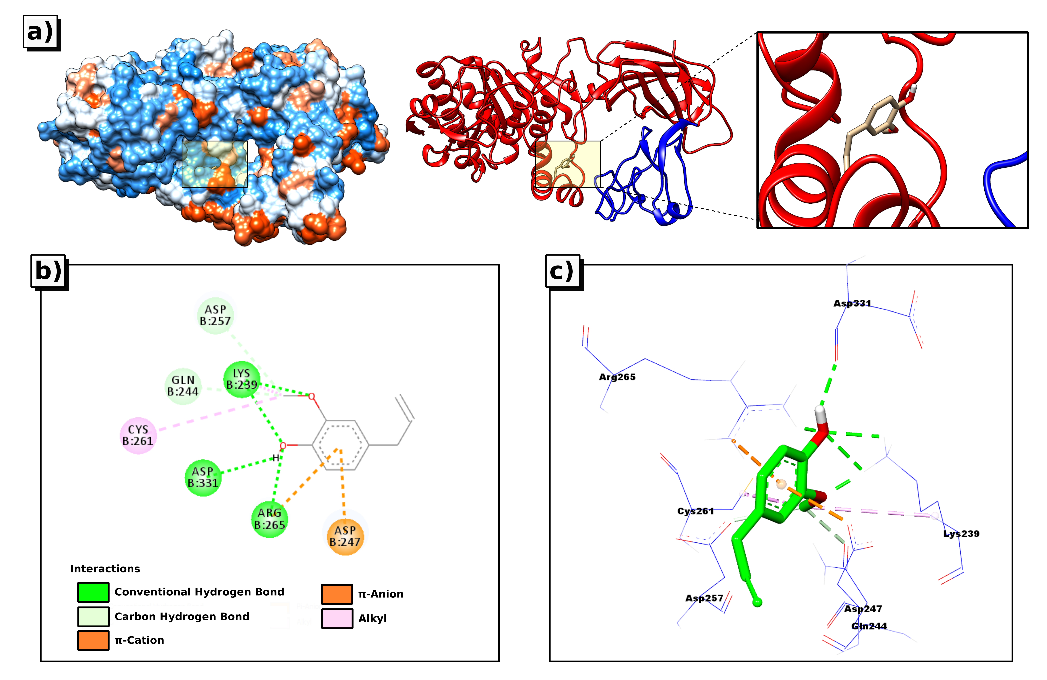
Fig. S2. 3D visual representations of Eug1@1LPB complex; (a) best binding mode in the protein pocket, (b) amino acid residues involved in the interaction.

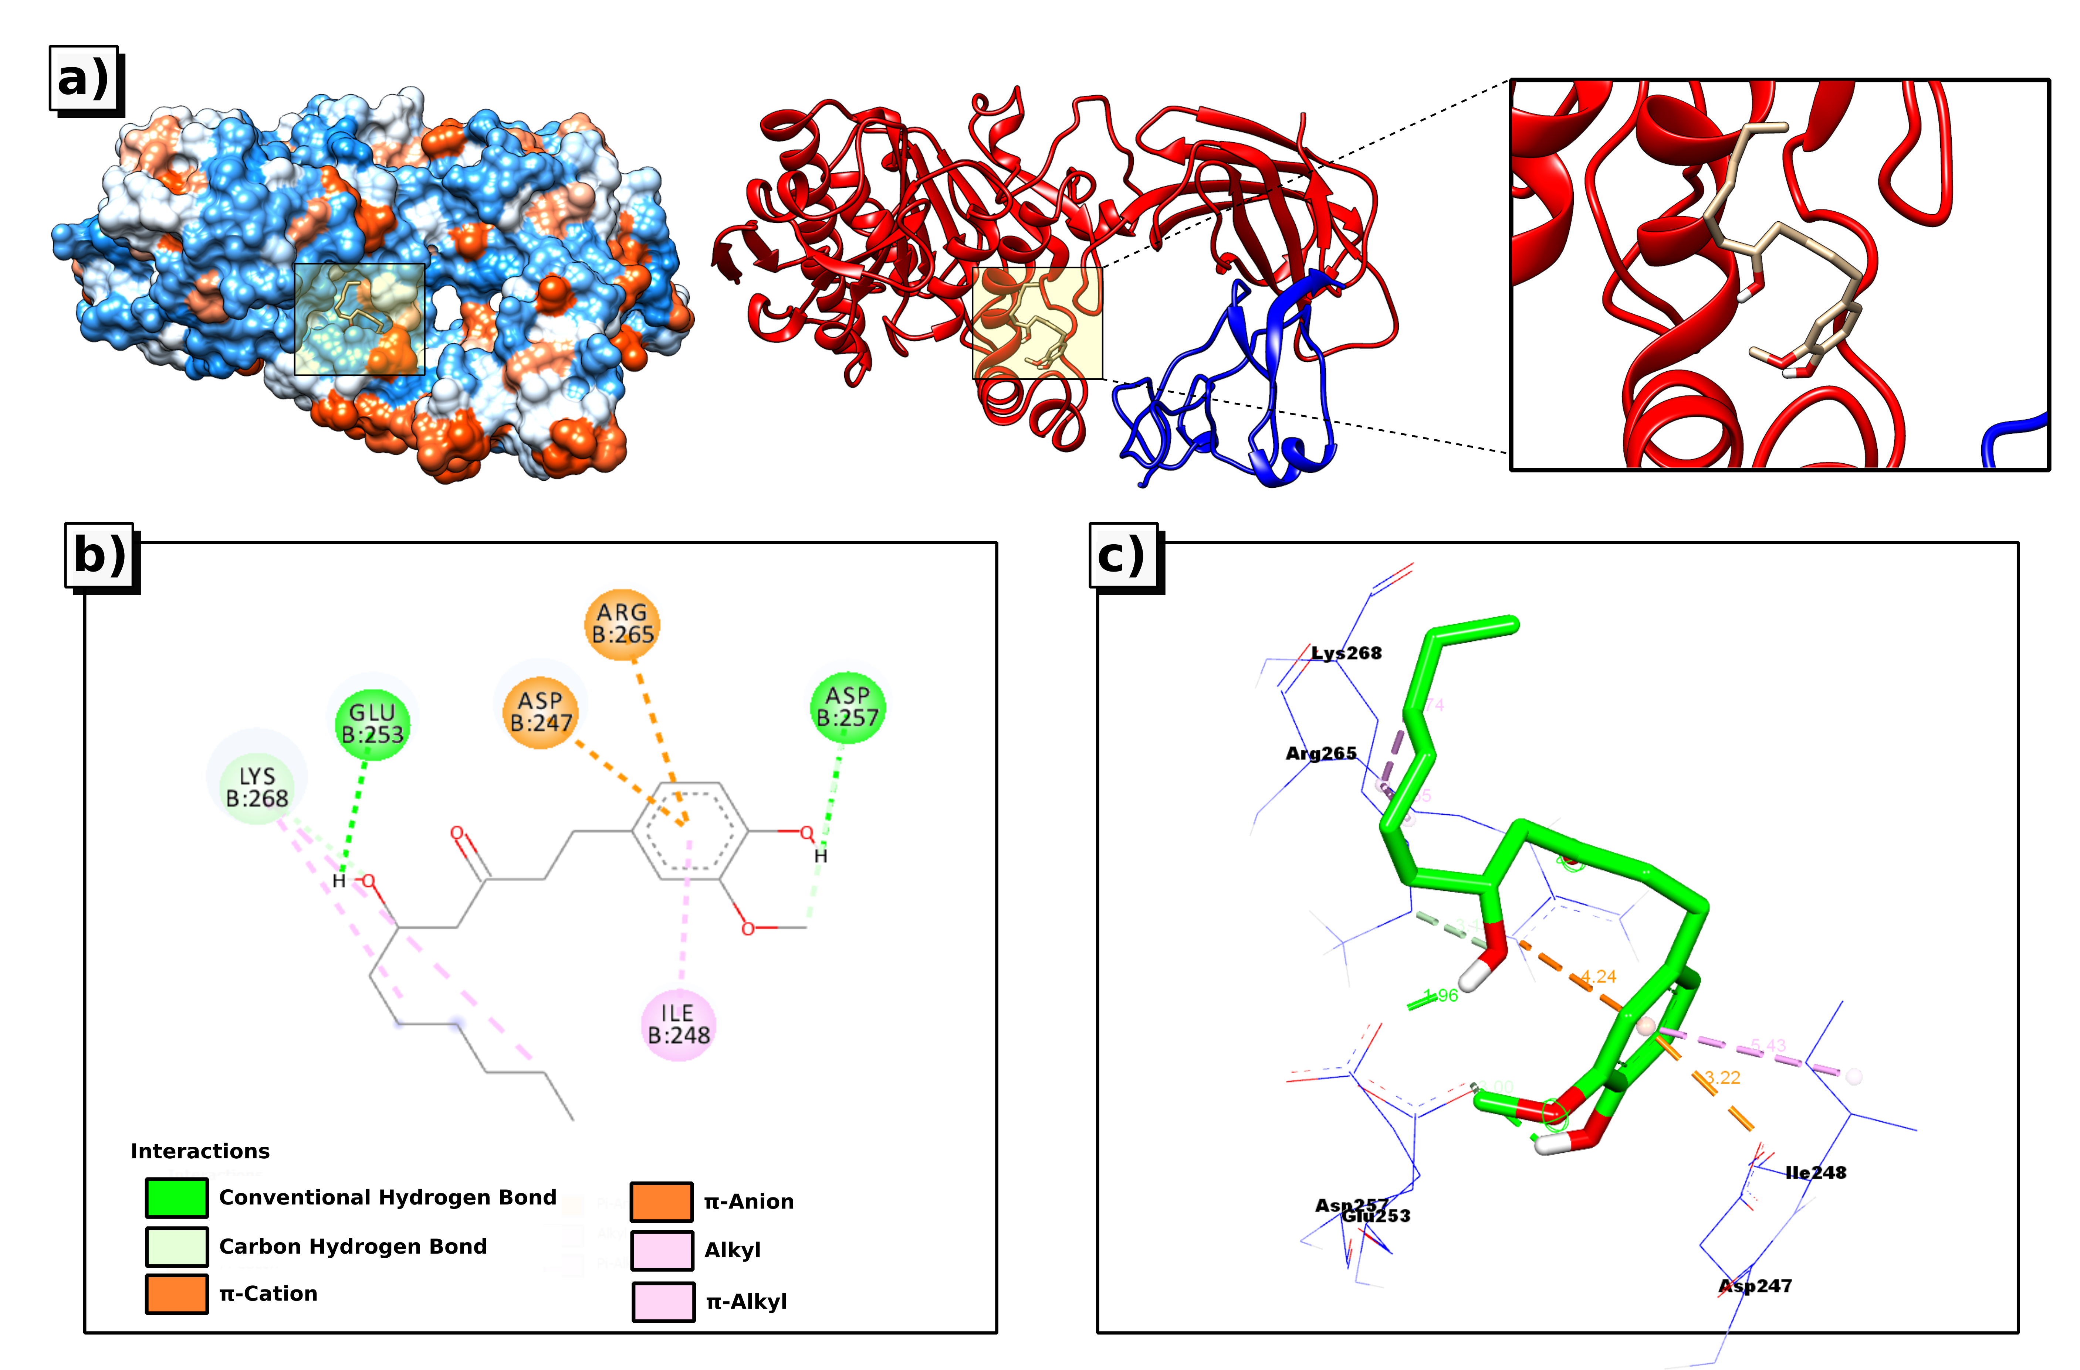
Fig. S3. 3D visual representations of Ging2@1LPB complex; (a) best binding mode in the protein pocket, (b) amino acid residues involved in the interaction.

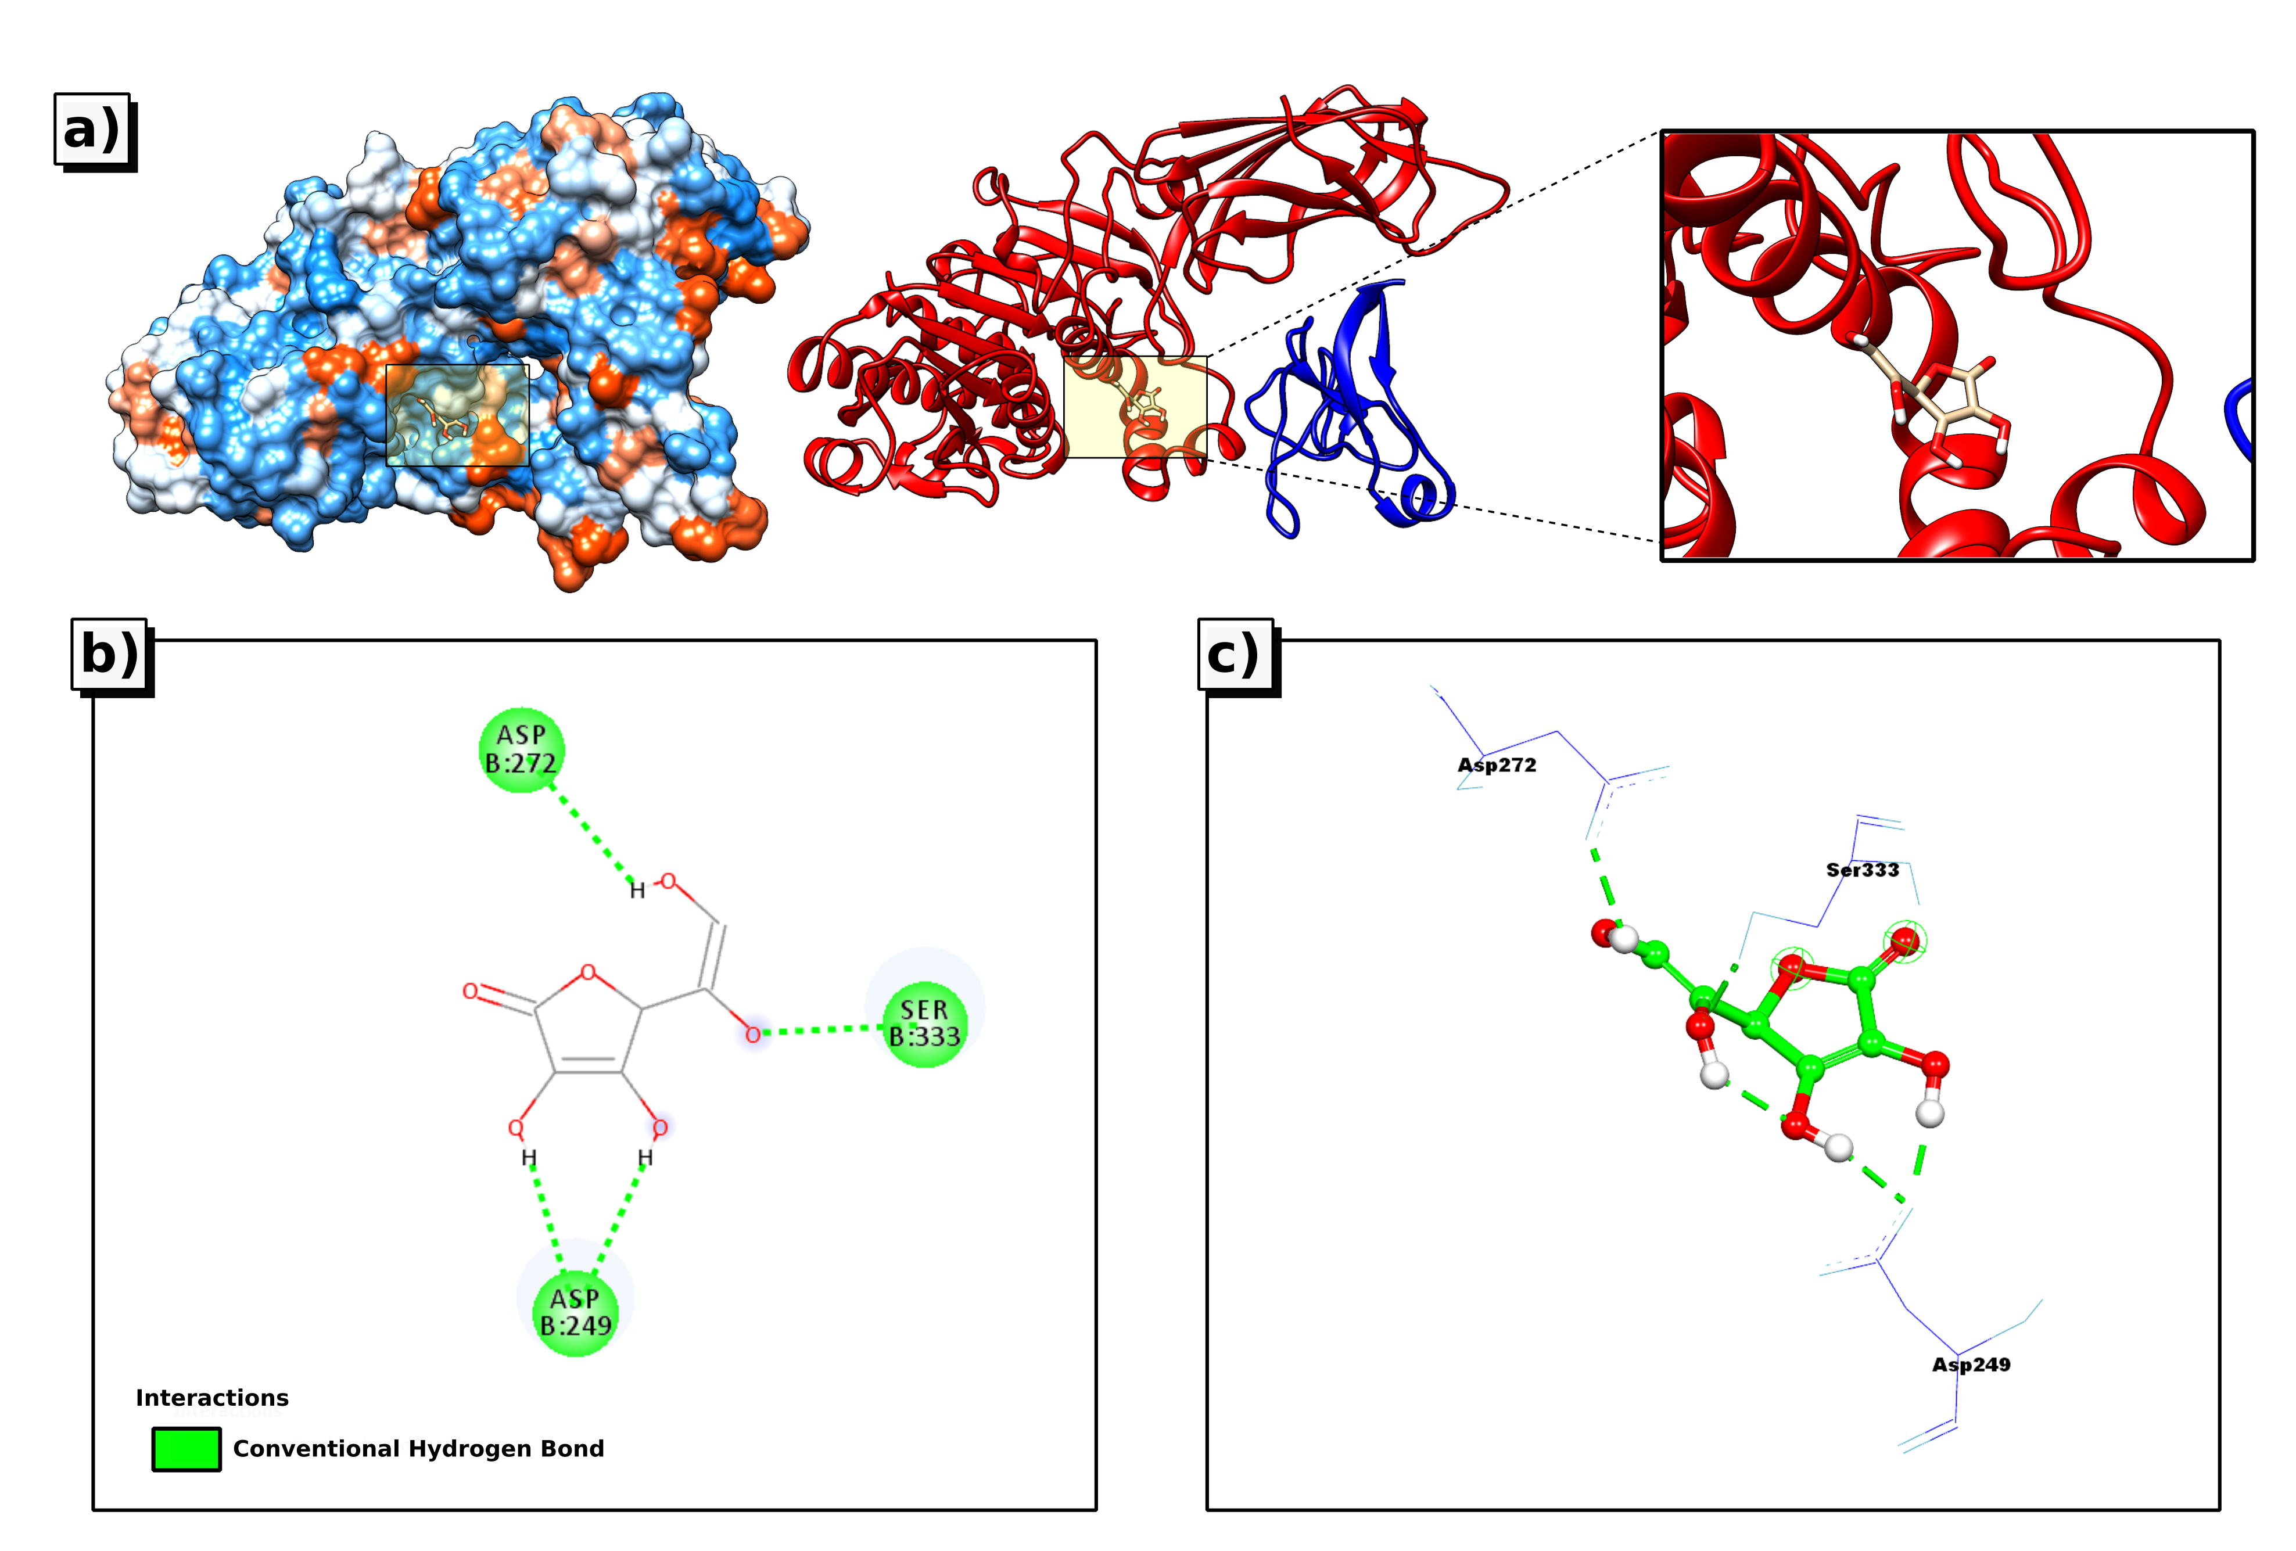
Fig. S4. 3D visual representations of AA3@1LPB complex; (a) best binding mode in the protein pocket, (b) amino acid residues involved in the interaction.

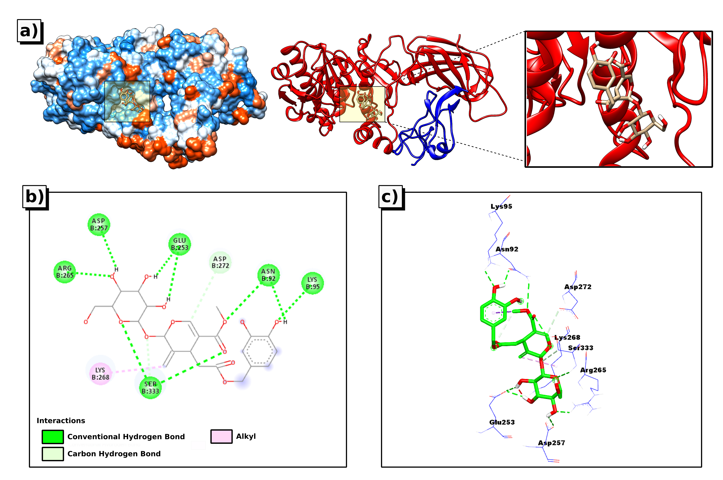
Fig. S5. 3D visual representations of Oleu4@1LPB complex; (a) best binding mode in the protein pocket, (b) amino acid residues involved in the interaction.

