Supplementary Material for
Reversible Elastomer-Fluid Transitions for Metamorphosic Robots

The PDF file includes:

Section S1. SEM images and optical microscope captured images
Section S2. Material setup for MIMMs
Section S3. Stretch results and experimental setup of VSM tests
Section S4. Supplementary introduction of RF heat tests
Section S5. MFR and viscosity results
Section S6. Stiffness-tuning fluid soft actuator
Section S7. Ex-vivo biomedical demonstrations
Fig. S1. SEM and sample used in this work
Figs. S2-S10. Raw SEM images
Figs. S11-S15. Raw OM images
Fig. S16. Part of material preparations for stretch, OM, VSM, and SEM
Fig. S17. Equipment setup of the conducted stretch tests
Figs. S18-S31. Stretch results
Fig. S32. Illustrations of fracture stretch results
Fig. S33. Equipment setup of the VSM tests: installation, equipment, and control platform
Fig. S34. Experimental setup of the fixed-location RF heating tests
Fig. S35. Experimental setup of the location-varied RF heating tests
Fig. S36. Experimental setup of the viscosity tests
Fig. S37. Experimental setup of MFR tests
Fig. S38. The structure of the stiffness-varied fluidic soft actuator. (A) The hollowed elastic shell cannot be magnetically actuated. (B) With MIMMs, the fluidic soft actuator can be therefore actuated, and stiffness is varied by the elastomer-fluid transition.
Fig. S39. The maximum bending performances of the different stiffness-distributed soft actuators. (A) The left-side distributed soft actuator performs delicate bending. (B) Both sides of distributed soft actuators perform central-concentrated bending. (C) The right-side distributed soft actuator performs large-scale bending
Fig. S39. The maximum bending performances of different stiffness-distributed soft actuators. (A) The left-side distributed soft actuator performs delicate bending. (B) Both sides distributed the soft actuator perform central-concentrated bending. (C) The right-side distributed soft actuator performs large-scale bending
Fig. S40. Locally stiffness adjustable fluidic soft actuator. (A) Constraining the tip, stiffness at the center of the actuator is tested at the ambient temperature. (B) In the elastomer state, the center of the actuator is tested with large stiffness (~10 MPa), where maximum bending curvatures are found at low-stiffness (~2 MPa) regions. (C) Constraining the tip, the fluid-stated actuator is tested. (D) The curvature at the studied region is larger than that in the elastomer state
Fig. S41. The ex-vivo trachea was dissected from a pig lung
Fig. S42. The actuator can navigate itself for intubation
Fig. S43. The actuator can move in a pig intestine with friction
Fig. S44. An oropharyngeal phantom was applied to demonstrate Fig. 5E in the main text
Table. S1. Case table for prepared MIMMs
Table S2. Viscosity results
Table S3. MFR results

Other Supplementary Material for this manuscript includes the following:

Movie S1. Elastomer-fluid transitions of MIMMs responding to RF heating
Movie S2. Self-healing enabled by the elastomer-fluid transition
Movie S3. Additive manufacturing by MIMMs
Movie S4. “Let’s collaborate!”-collaboration to repair fractured structures
Movie S5. “Symbiosis”-gain new motion functions by interacting with external objects
Movie S6. “Field explorer!”-flow through a narrow terrain
Movie S7. “Varied stiffness”- soft actuator with varied-stiffness distributions
Movie S8. “Reach and grab out”-field exploration
Movie S9. In situ drug delivery/treatment
Movie S10. Intubation navigation
Movie S11. Electrical wire connection and insulation
Movie S12. Endoscope transportation through a narrow hole

Section 1. SEM images and optical microscope captured images.
All captured SEM images and OM images are provided here for reference.
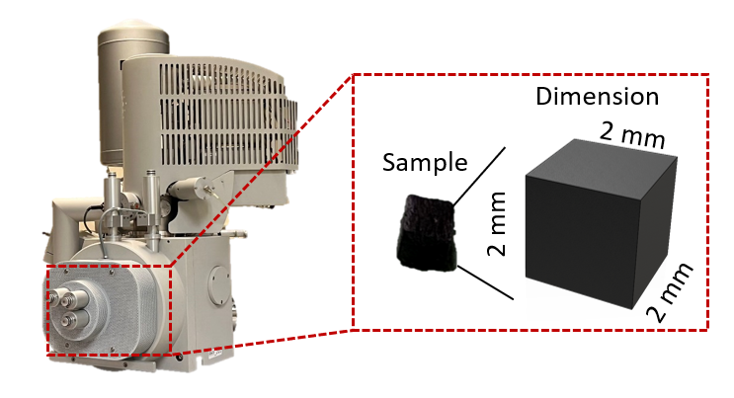
Fig. S1. SEM and sample used in this work.
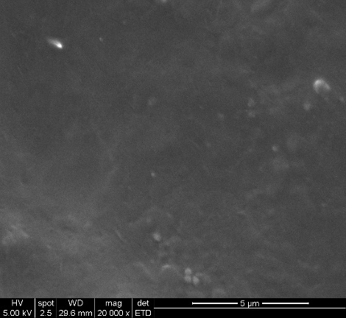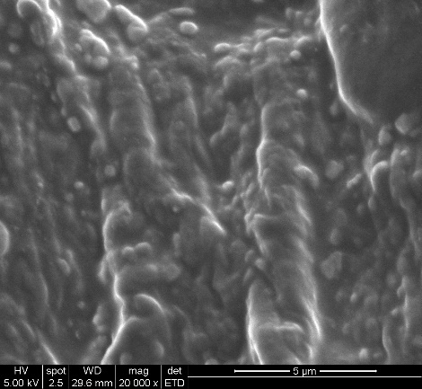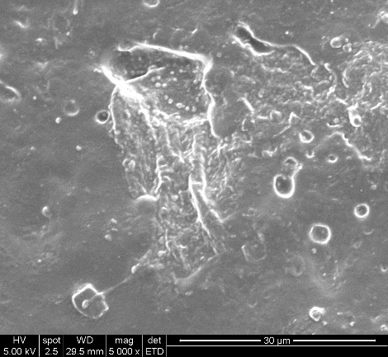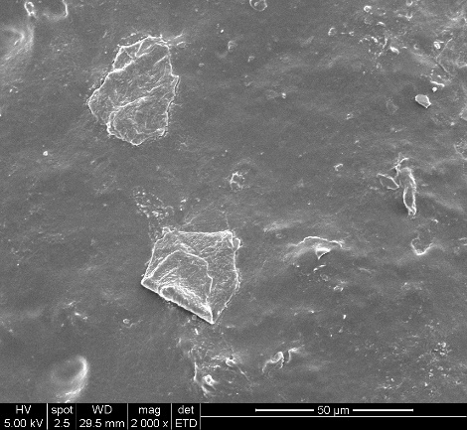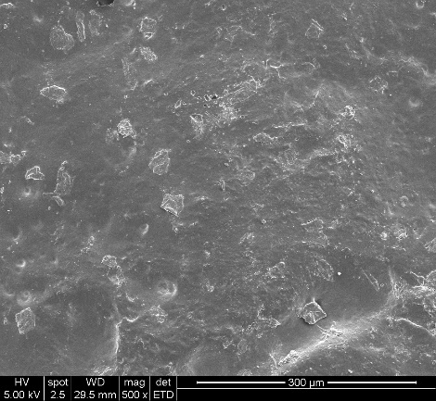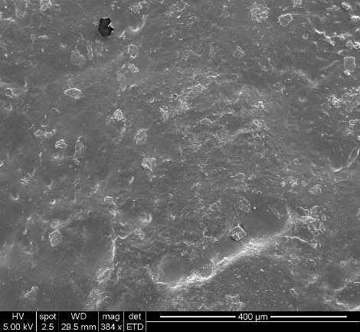
Fig. S2. SEM images of 10 g Fe₃O₄+ 10 g HMA.
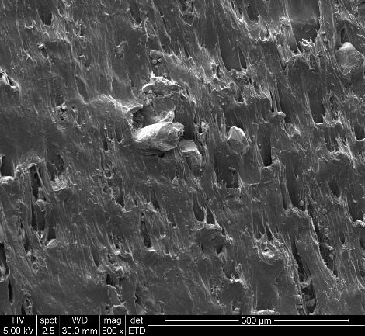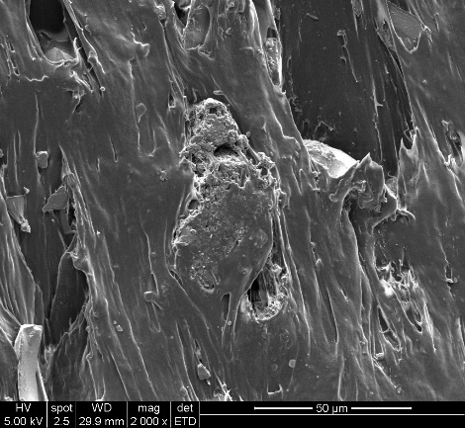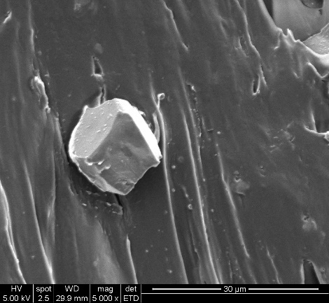
Fig. S3. SEM images of 10 g Fe₃O₄+ 10 g HMA+ 1.2 g wax.
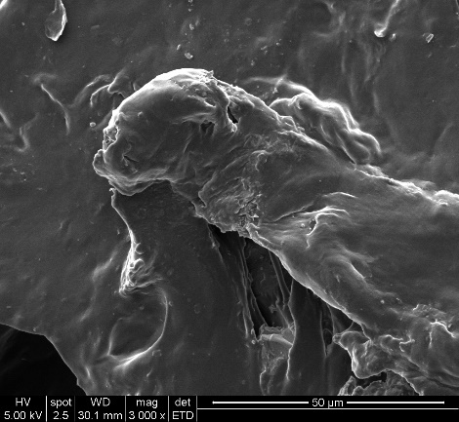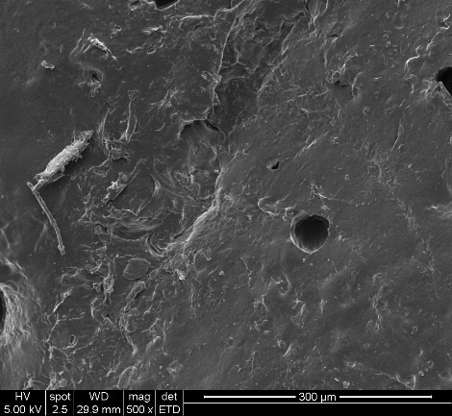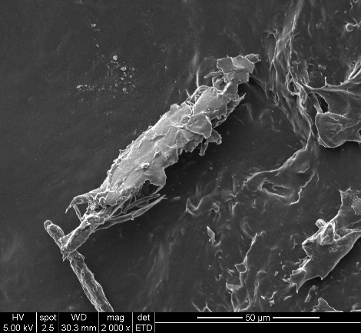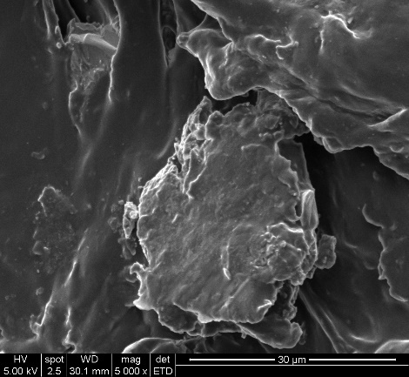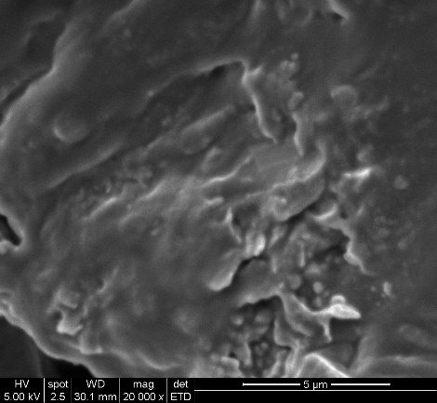
Fig. S4. SEM images of 10 g Fe₃O₄+ 10 g HMA+ 0.3 g graphene.
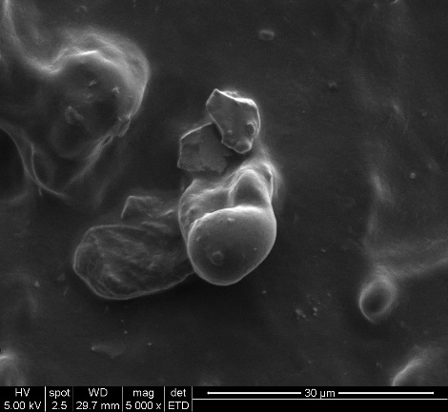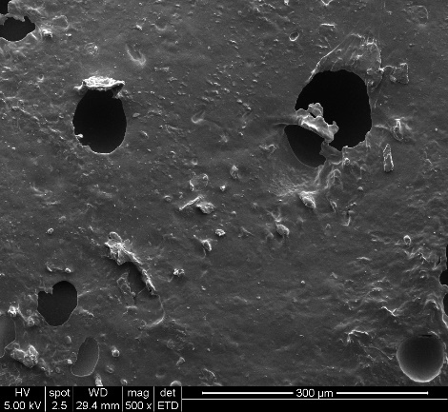
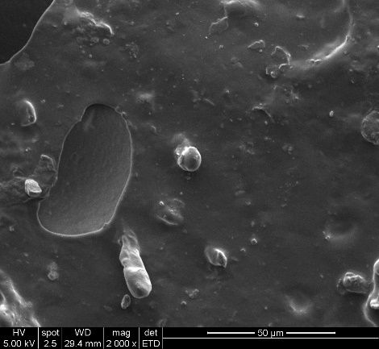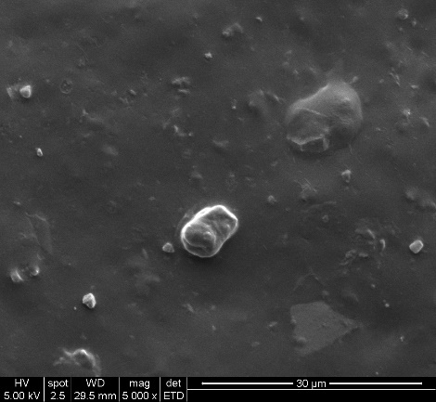
Fig. S5. SEM images of 10 g NdFeB + 10 g HMA.
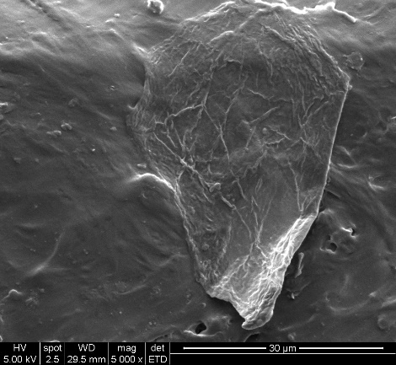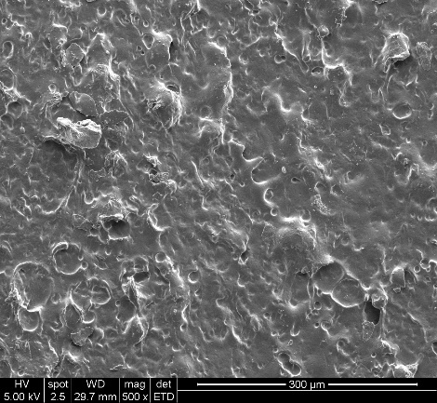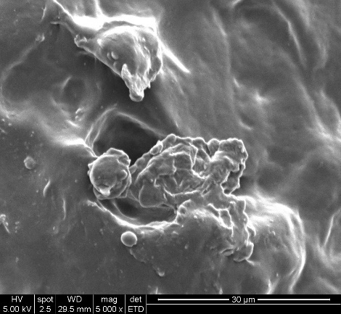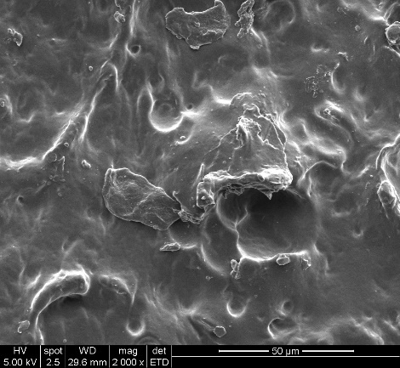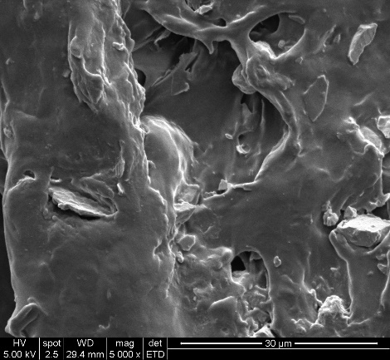
Fig. S6. SEM images of 5 g Fe₃O₄+5 g NdFeB+0.2 g graphene.
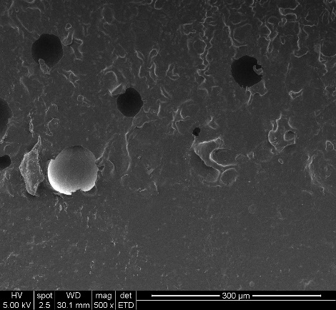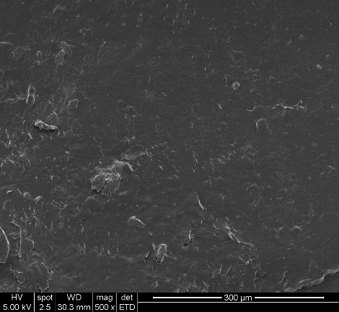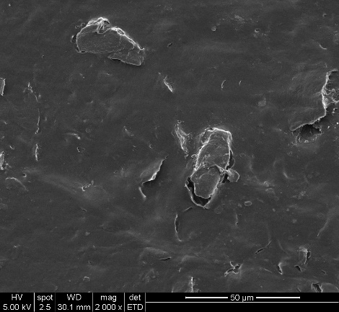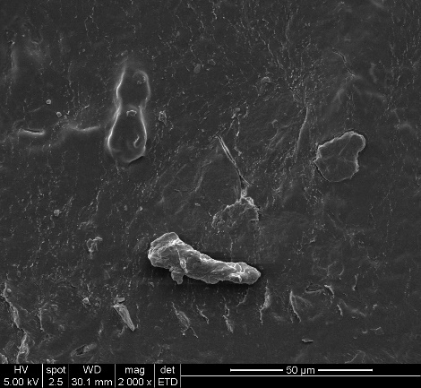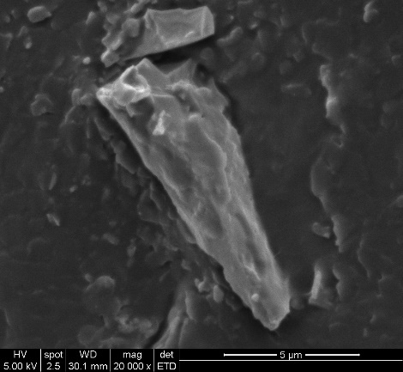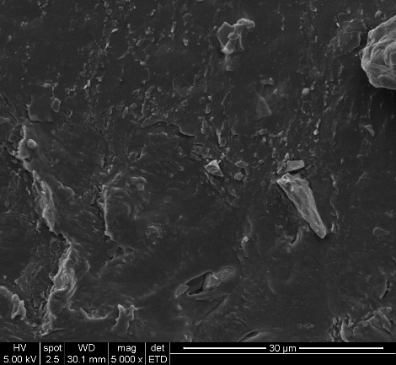
Fig. S7. SEM images of 5 g Fe₃O₄+5 g NdFeB+0.6 g wax+10 g HMA.
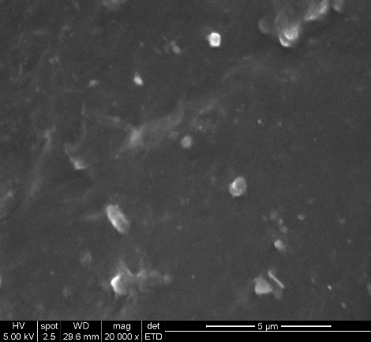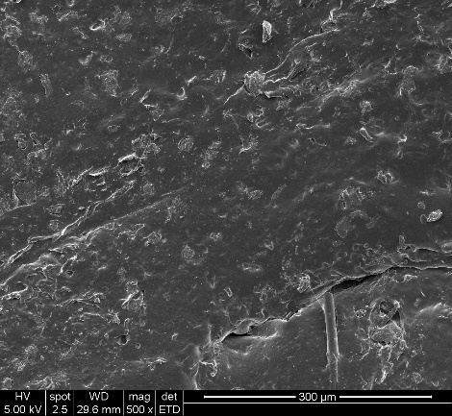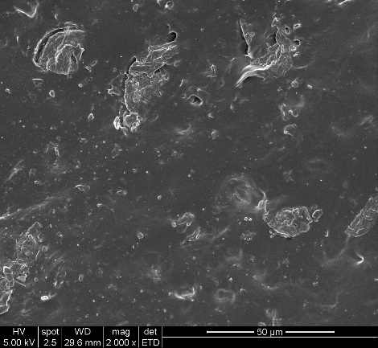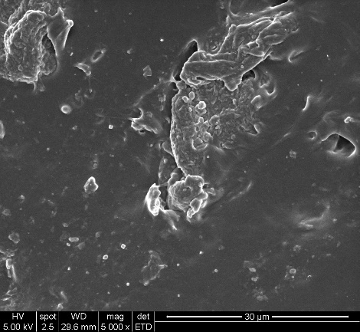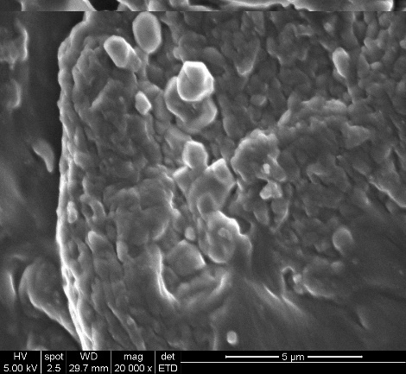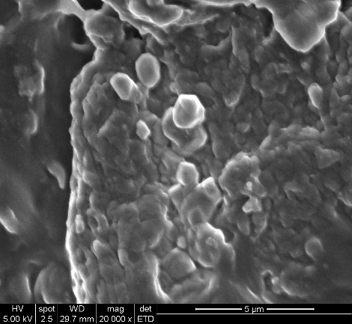
Fig. S8. SEM images of 10 g Fe₃O₄+10 g EVA.
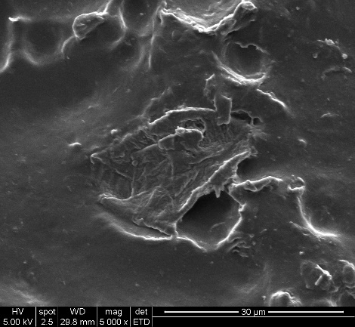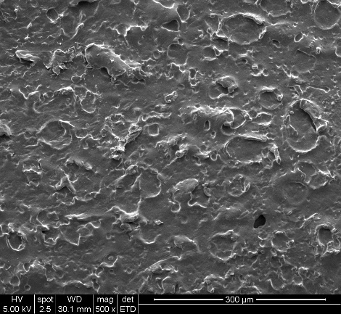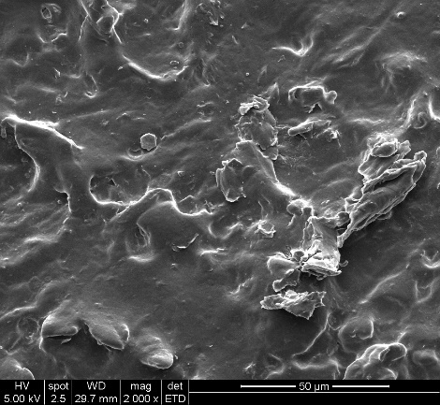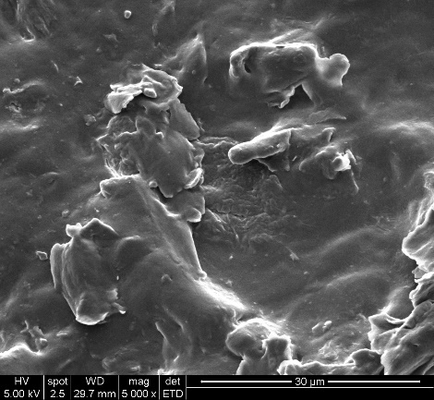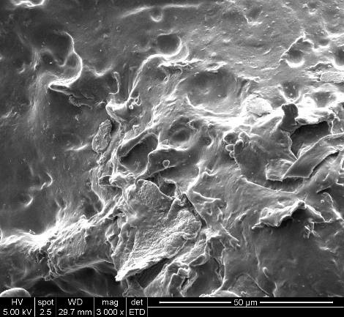
Fig. S9. SEM images of 5 g Fe₃O₄+5 g NdFeB+0.6 g wax+10 g EVA.
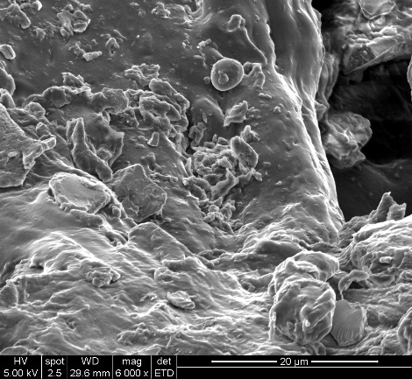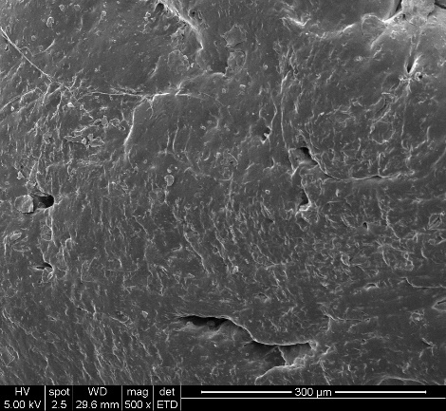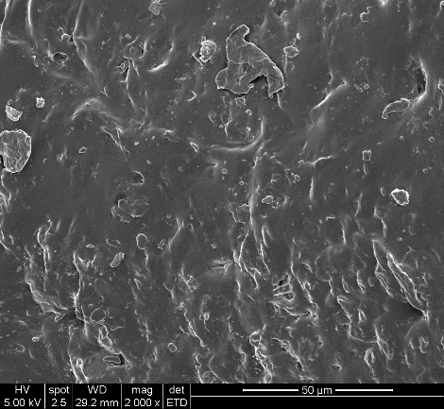
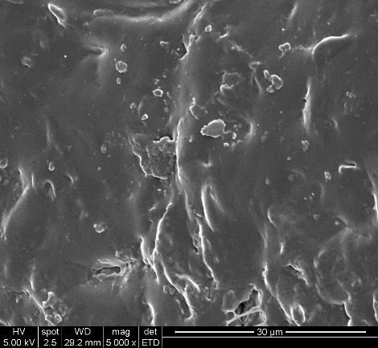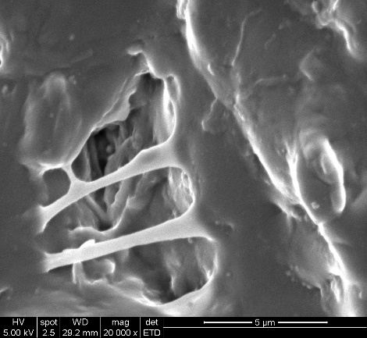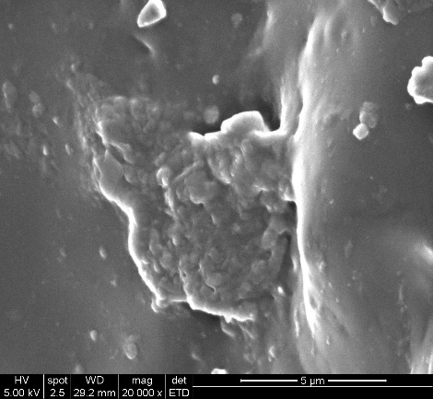
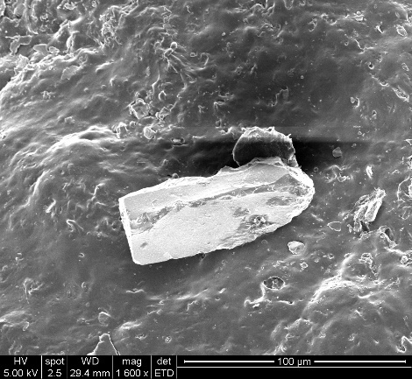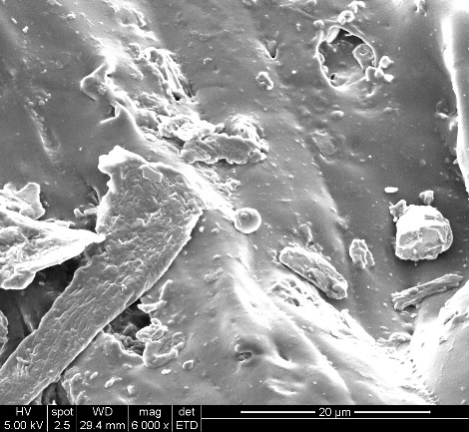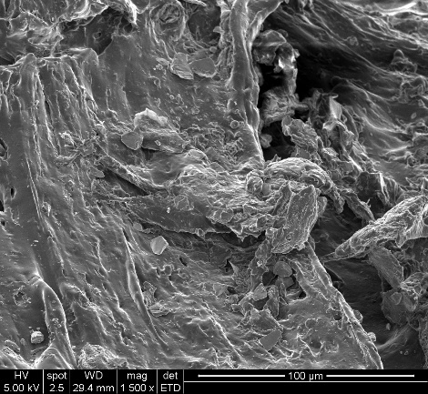
Fig. S10. SEM images of 5 g Fe₃O₄+5 g NdFeB+0.6 g wax+10 g PCL.
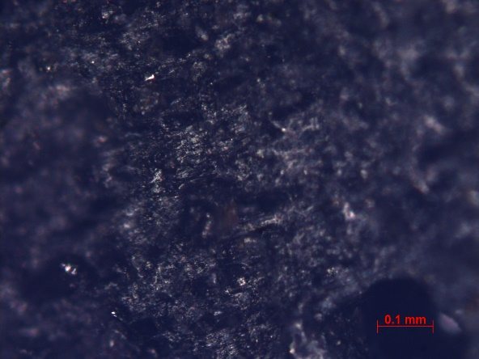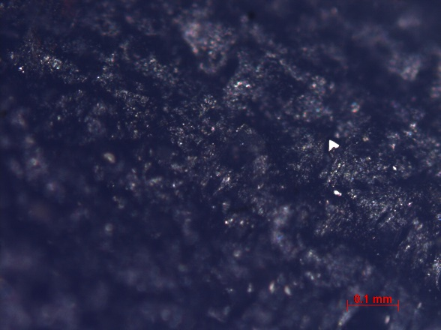
Fig. S11. OM image of 10 g Fe₃O₄+ 10 g HMA. Fig. S12. OM image of 10 g Fe₃O₄+ 10 g HMA+ 0.3 g graphene.
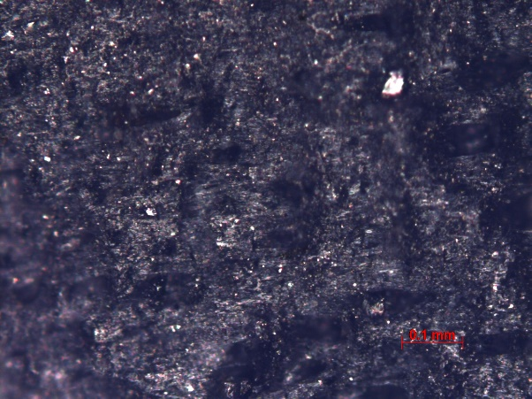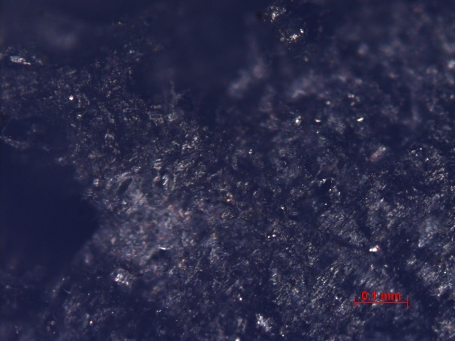
Fig. S13. OM image of 5 g Fe₃O₄+5 g NdFeB+10 g HMA Fig. S14. OM image of 10 g Fe₃O₄+10 g EVA
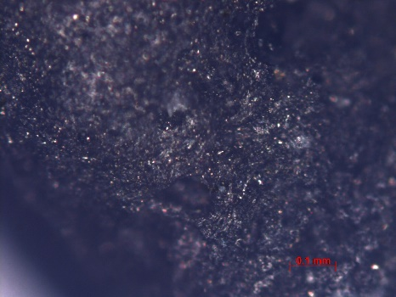
Fig. S15. OM image of 5 g Fe₃O₄+5 g NdFeB+0.6 g wax+10 g PCL
Section 2. Material setup for MIMMs
The case table to prepare the 35 types of MIMMs below for reference.
Table S1. Case table for prepared MIMMs
No. | Base Material | Base Material Mass (g) | Fe3O4  (g) | NdFeB  (g) | Wax  (g) | Graphene  (g)
1 | HMA | 10 | 15 | - | - | -
2 | HMA | 10 | 10 | - | - | -
3 | HMA | 10 | 5 | - | - | -
4 | HMA | 10 | 10 | - | 0.3 | -
5 | HMA | 10 | 10 | - | 0.6 | -
6 | HMA | 10 | 10 | - | 1.2 | -
7 | HMA | 10 | 10 | - | - | 0.1
8 | HMA | 10 | 10 | - | - | 0.2
9 | HMA | 10 | 10 | - | - | 0.3
10 | HMA | 10 | - | 15 | - | -
11 | HMA | 10 | - | 10 | - | -
12 | HMA | 10 | - | 5 | - | -
13 | HMA | 10 | - | 10 | 0.3 | -
14 | HMA | 10 | - | 10 | 0.6 | -
15 | HMA | 10 | - | 10 | 1.2 | -
16 | HMA | 10 | - | 10 | - | 0.1
17 | HMA | 10 | - | 10 | - | 0.2
18 | HMA | 10 | - | 10 | - | 0.3
19 | HMA | 10 | 5 | 5 | - | -
20 | HMA | 10 | 2 | 8 | - | -
21 | HMA | 10 | 8 | 2 | - | -
22 | HMA | 10 | 5 | 5 | - | 0.2
23 | HMA | 10 | 5 | 5 | 0.6 | -
24 | EVA | 10 | 10 | - | - | -
25 | EVA | 10 | 10 | - | 1.2 | -
26 | EVA | 10 | 10 | - | - | 0.3
27 | EVA | 10 | - | 10 | - | -
28 | EVA | 10 | 5 | 5 | - | 0.2
29 | EVA | 10 | 5 | 5 | 0.6 | -
30 | PCL | 10 | 10 | - | - | -
31 | PCL | 10 | 10 | - | 1.2 | -
32 | PCL | 10 | 10 | - | - | 0.3
33 | PCL | 10 | - | 10 | - | -
34 | PCL | 10 | 5 | 5 | - | 0.2
35 | PCL | 10 | 5 | 5 | 0.6 | -

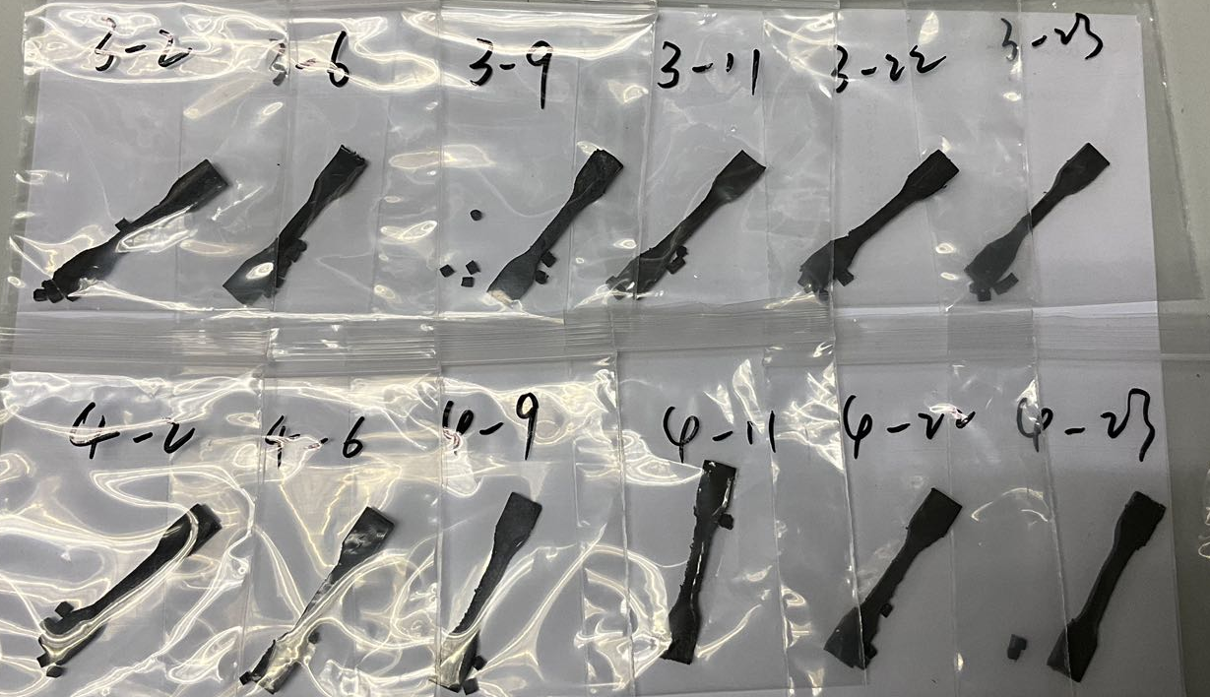
Fig. S16. Part of material preparations for stretch, OM, VSM, and SEM.

Section 3. Stretch results and experimental setup of VSM tests
Stretch tests were conducted by a mechanical test machine (see Fig. S17).
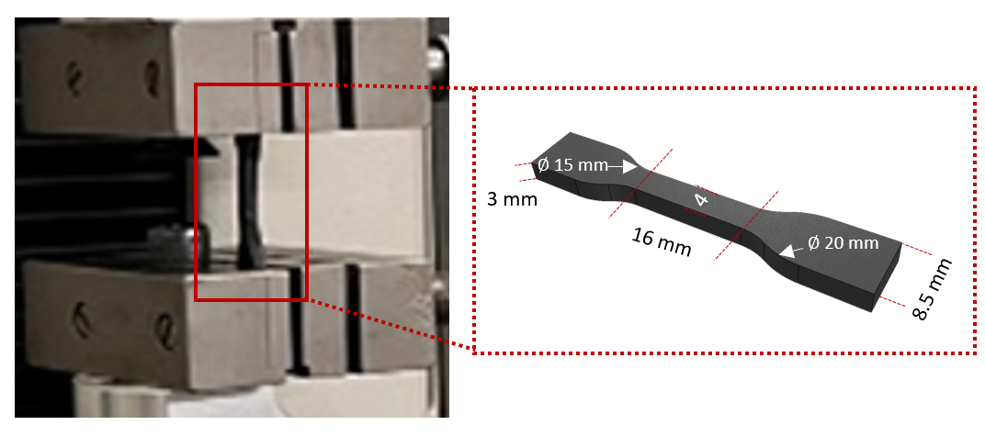
Fig. S17. Equipment setup of the conducted stretch tests.
Fig. S18. Stretch results of Fe₃O₄-HMA Fig. S19. Stretch results of wax-Fe₃O₄-HMA
Fig. S20. Stretch results of graphene-Fe₃O₄-HMA Fig. S21. Stretch results of NdFeB-HMA
Fig. S22. Stretch results of wax-NdFeB-HMA Fig. S23. Stretch results of graphene-NdFeB-HMA
Fig. S24. Stretch results of Fe₃O₄-NdFeB-HMA Fig. S25. Stretch results of wax-graphene-Fe₃O₄-NdFeB-HMA
Fig. S26. Stretch results of Fe₃O₄-HMA/EVA/PCL Fig. S27. Stretch results of wax-Fe₃O₄-HMA/EVA/PCL

Fig. S28. Stretch results of graphene-Fe₃O₄-HMA/EVA/PCL Fig. S29. Stretch results of NdFeB-HMA/EVA/PCL
Fig. S30. Stretch results of graphene-Fe₃O₄-NdFeB-HMA/EVA/PCL
Fig. S31. Stretch results of wax-Fe₃O₄-NdFeB-HMA/EVA/PCL

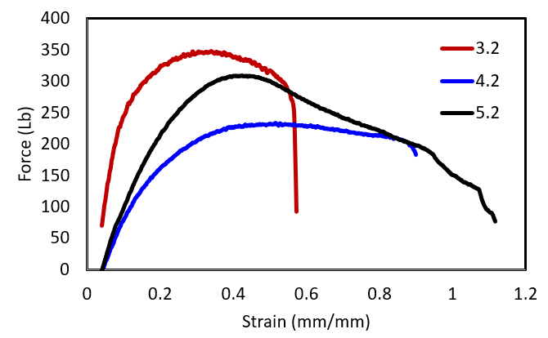
Fig. S32. Fracture stretches results of Fe₃O₄-HMA/EVA/PCL

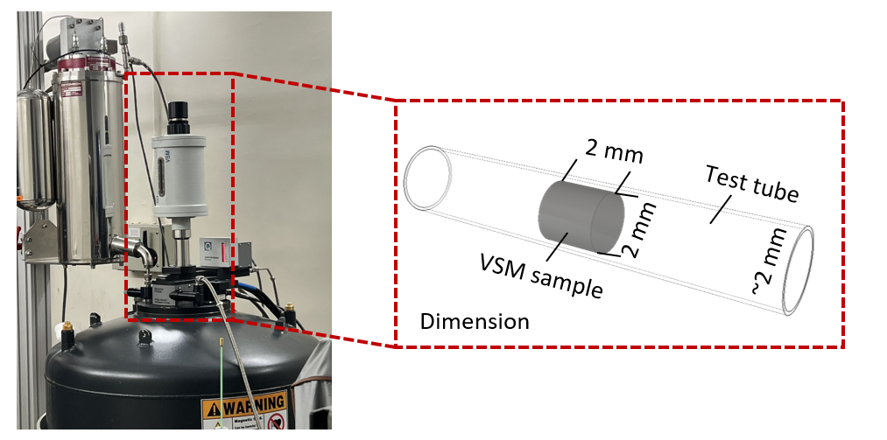
Fig. S33. Equipment setup of the VSM tests: installation, equipment, and control platform.

Section 4. Supplementary introduction of RF heat tests
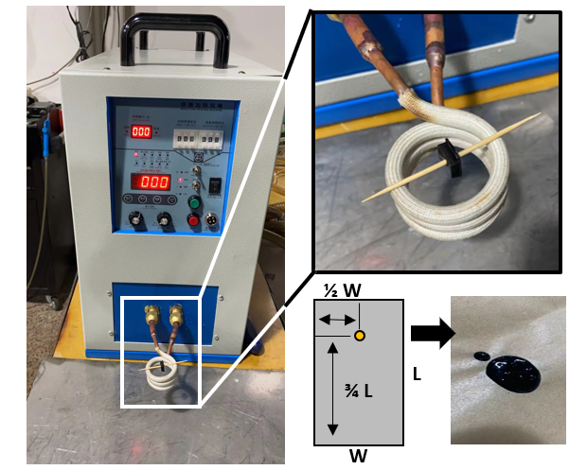
Fig. S34. Experimental setup of the fixed-location RF heating tests.
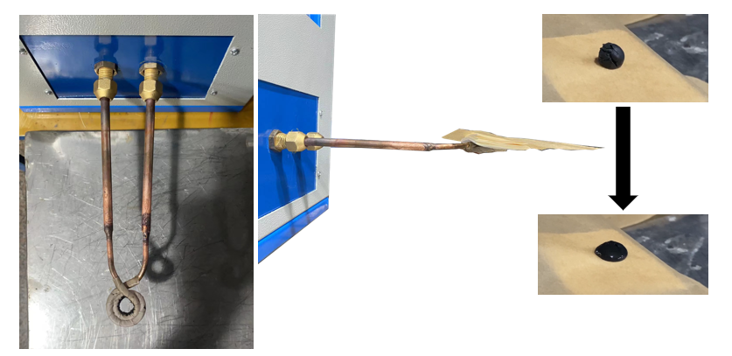
Fig. 35. Experimental setup of the location-varied RF heating tests.

Experimental setups of two RF heating tests are shown in Figs. S34 and S35. To quantitatively conduct experiments for fixed location heating (Fig. S34), a wooden stick was applied to pierce the sample for positioning. Due to the RF non-responsibility and heat resistance, the wooden stick was selected instead of resin-based or metal-based materials. The time was recorded when the first MIMM droplet fell on the ground. Regarding the second RF heating test (location vs. melt time, shown in Fig. S35), a planar coil was applied to perform vertically intense inductions. The time was recorded when the sample height was half the original height.

Section 5. MFR and viscosity results
Experimental setups and raw test data are provided below for reference.
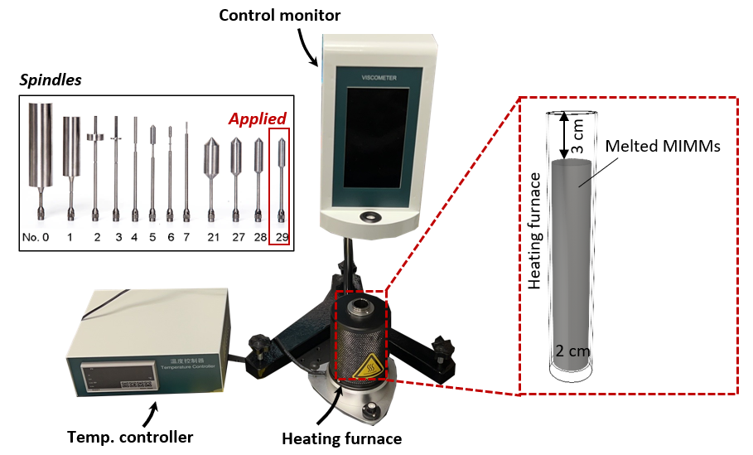
Fig. S36. Experimental setup of the viscosity tests.

Table S2. Viscosity results
Material No. | Temp. ($℃$) | RPM | Cut rate | Viscosity (MPa*s) | Cut pressure (MPa)
2 | 140 | 5 | 1.2 | 361410.1 | 451762.7
2 | 140 | 6 | 1.5 | 342579.6 | 513869.4
2 | 140 | 7 | 1.7 | 327832.8 | 573707.4
2 | 140 | 8 | 2 | 305712.6 | 611425.2
2 | 140 | 9 | 2.2 | 312581.8 | 703309.2
2 | 145 | 5 | 1.2 | 331916.5 | 414895.6
2 | 145 | 6 | 1.5 | 306468.8 | 459703.3
2 | 145 | 7 | 1.7 | 287157.5 | 502525.7
2 | 145 | 8 | 2 | 275368.2 | 550736.4
2 | 145 | 9 | 2.2 | 280945.5 | 632127.5
2 | 150 | 5 | 1.2 | 290852.3 | 363565.4
2 | 150 | 6 | 1.5 | 265820.6 | 398730.9
2 | 150 | 7 | 1.7 | 231411.4 | 404969.9
2 | 150 | 8 | 2 | 234105.5 | 468211
2 | 150 | 9 | 2.2 | 224983.3 | 506212.4
2 | 155 | 5 | 1.2 | 249561.3 | 311951.6
2 | 155 | 6 | 1.5 | 229520.8 | 344281.2
2 | 155 | 7 | 1.7 | 218771.2 | 382849.7
2 | 155 | 8 | 2 | 213261.4 | 426522.9
2 | 155 | 9 | 2.2 | 204060.5 | 459136.1
2 | 160 | 5 | 1.2 | 228462 | 285577.5
2 | 160 | 6 | 1.5 | 199838.1 | 299757.1
2 | 160 | 7 | 1.7 | 204672.6 | 358177.2
2 | 160 | 8 | 2 | 196245.9 | 392491.8
2 | 160 | 9 | 2.2 | 203556.3 | 458001.7
5 | 140 | 5 | 1.2 | 338042.1 | 422552.7
5 | 140 | 6 | 1.5 | 310817.2 | 466225.9
5 | 140 | 7 | 1.7 | 310493.1 | 543363
5 | 140 | 8 | 2 | 307839.5 | 615679.1
5 | 140 | 9 | 2.2 | 275525.7 | 619933
5 | 145 | 5 | 1.2 | 321934.1 | 402417.6
5 | 145 | 6 | 1.5 | 302309.5 | 453464.3
5 | 145 | 7 | 1.7 | 274679.5 | 480689.1
5 | 145 | 8 | 2 | 259345.2 | 518690.5
5 | 145 | 9 | 2.2 | 251704 | 566334
5 | 150 | 5 | 1.2 | 306052.9 | 382566.1
5 | 150 | 6 | 1.5 | 283025.2 | 424539.8
5 | 150 | 7 | 1.7 | 265766.6 | 465091.5
5 | 150 | 8 | 2 | 251830 | 503660.1
5 | 150 | 9 | 2.2 | 239730.1 | 539392.8
5 | 155 | 5 | 1.2 | 294028.6 | 367535.7
5 | 155 | 6 | 1.5 | 266955 | 400432.4
5 | 155 | 7 | 1.7 | 247778.7 | 433612.7
5 | 155 | 8 | 2 | 229709.8 | 459419.7
5 | 155 | 9 | 2.2 | 221454.1 | 498271.8
5 | 160 | 5 | 1.2 | 266123.1 | 332653.8
5 | 160 | 6 | 1.5 | 241998.8 | 362998.2
5 | 160 | 7 | 1.7 | 224767.2 | 393342.6
5 | 160 | 8 | 2 | 207589.6 | 415179.2
5 | 160 | 9 | 2.2 | 190215 | 436704.8
8 | 140 | 5 | 1.2 | 396802.4 | 496003.1
8 | 140 | 6 | 1.5 | 383038.8 | 574558.2
8 | 140 | 7 | 1.7 | 360567.4 | 630993.1
8 | 140 | 8 | 2 | 348109.6 | 696219.3
8 | 140 | 9 | 2.2 | 339176.5 | 763147.2
8 | 145 | 5 | 1.2 | 394328.3 | 497555.3
8 | 145 | 6 | 1.5 | 370749.8 | 566124.7
8 | 145 | 7 | 1.7 | 354733.5 | 620783.7
8 | 145 | 8 | 2 | 340736.2 | 681472.5
8 | 145 | 9 | 2.2 | 329345.2 | 741026.9
8 | 150 | 5 | 1.2 | 376610.7 | 470763.3
8 | 150 | 6 | 1.5 | 346549.9 | 519824.9
8 | 150 | 7 | 1.7 | 327670.7 | 573423.8
8 | 150 | 8 | 2 | 321168.3 | 642336.7
8 | 150 | 9 | 2.2 | 312455.8 | 703025.6
8 | 155 | 5 | 1.2 | 377518.2 | 471897.7
8 | 155 | 6 | 1.5 | 343524.9 | 515287.4
8 | 155 | 7 | 1.7 | 328465.2 | 576543.3
8 | 155 | 8 | 2 | 318899.6 | 637799.3
8 | 155 | 9 | 2.2 | 295440.2 | 664740.6
8 | 160 | 5 | 1.2 | 309682.9 | 387103.6
8 | 160 | 6 | 1.5 | 260337.8 | 390506.7
8 | 160 | 7 | 1.7 | 274355.3 | 480121.9
8 | 160 | 8 | 2 | 246441.8 | 492883.6
8 | 160 | 9 | 2.2 | 235192.6 | 529183.5
11 | 140 | 5 | 1.2 | 115025 | 143781.3
11 | 140 | 6 | 1.5 | 111735.4 | 167603.1
11 | 140 | 7 | 1.7 | 111168.2 | 194544.4
11 | 140 | 8 | 2 | 110884.6 | 221769.2
11 | 140 | 9 | 2.2 | 110538 | 248710.5
11 | 145 | 5 | 1.2 | 94833.3 | 118541.6
11 | 145 | 6 | 1.5 | 95097.9 | 142646.9
11 | 145 | 7 | 1.7 | 93666.5 | 163916.4
11 | 145 | 8 | 2 | 93443.6 | 186887.3
11 | 145 | 9 | 2.2 | 93144.3 | 209574.7
11 | 150 | 5 | 1.2 | 85077.7 | 106347.1
11 | 150 | 6 | 1.5 | 81674.6 | 122511.9
11 | 150 | 7 | 1.7 | 80054 | 140094.6
11 | 150 | 8 | 2 | 79405.8 | 158811.7
11 | 150 | 9 | 2.2 | 79027.7 | 177812.4
11 | 155 | 5 | 1.2 | 69423.4 | 86779.2
11 | 155 | 6 | 1.5 | 68251.2 | 102376.8
11 | 155 | 7 | 1.7 | 67738 | 118541.6
11 | 155 | 8 | 2 | 67353.1 | 134706.3
11 | 155 | 9 | 2.2 | 67305.9 | 151438.3
11 | 160 | 5 | 1.2 | 60121.5 | 75151.9
11 | 160 | 6 | 1.5 | 58798.1 | 88197.2
11 | 160 | 7 | 1.7 | 58663.1 | 102660.4
11 | 160 | 8 | 2 | 58420 | 116840
11 | 160 | 9 | 2.2 | 58230.9 | 131019.6
24 | 180 | 5 | 1.2 | 442404.2 | 553005.2
24 | 180 | 6 | 1.5 | 413288.6 | 619932.9
24 | 180 | 7 | 1.7 | 391681.6 | 685442.8
24 | 180 | 8 | 2 | 372356.8 | 744713.6
24 | 180 | 9 | 2.2 | 354553.5 | 797745.4
24 | 190 | 5 | 1.2 | 333958.4 | 417448
24 | 190 | 6 | 1.5 | 339365.4 | 509048.4
24 | 190 | 7 | 1.7 | 316651.1 | 554139.5
24 | 190 | 8 | 2 | 292383.7 | 584767.5
24 | 190 | 9 | 2.2 | 276282 | 621634.5
24 | 200 | 5 | 1.2 | 326698.4 | 408373
24 | 200 | 6 | 1.5 | 306847 | 460270.5
24 | 200 | 7 | 1.7 | 290884.7 | 509048.3
24 | 200 | 8 | 2 | 284584.9 | 569169.9
24 | 200 | 9 | 2.2 | 270862.2 | 609440.1
24 | 210 | 5 | 1.2 | 298566 | 373207.6
24 | 210 | 6 | 1.5 | 267333.1 | 400999.6
24 | 210 | 7 | 1.7 | 241782.7 | 423119.8
24 | 210 | 8 | 2 | 221627.4 | 443254.9
24 | 210 | 9 | 2.2 | 222084.3 | 499689.8
24 | 220 | 5 | 1.2 | 227100.7 | 283875.9
24 | 220 | 6 | 1.5 | 221769.2 | 332653.8
24 | 220 | 7 | 1.7 | 230439 | 403268.4
24 | 220 | 8 | 2 | 207123.6 | 406945.6
24 | 220 | 9 | 2.2 | 183263.7 | 412343.4

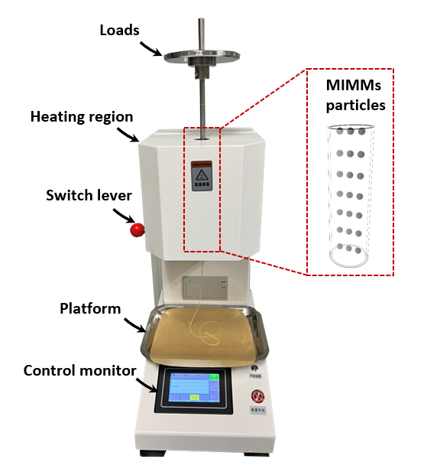
Fig. S37. Experimental setup of MFR tests.

Table S3. MFR results
No. | Load  (kg) | T  ($℃$) | W-1  (g) | W-2  (g) | W-3  (g) | W-4  (g) | W-5  (g) | W-6  (g) | W-ave  (g) | MFR  (g/10 min) | Uni-MFR  (g/10 min)
25 | 1.2 | 100 | 0.113 | 0.114 | 0.114 | 0.114 | 0.114 | 0.1 | 0.1115 | 2.23 | 1.858333
25 | 1.2 | 110 | 0.189 | 0.189 | 0.19 | 0.189 | 0.19 | 0.19 | 0.1895 | 3.79 | 3.158333
25 | 1.2 | 120 | 0.287 | 0.284 | 0.284 | 0.284 | 0.284 | 0.284 | 0.2845 | 5.69 | 4.741667
25 | 1.2 | 130 | 0.468 | 0.468 | 0.466 | 0.479 | 0.468 | 0.483 | 0.472 | 9.44 | 7.866667
25 | 1.2 | 140 | 0.668 | 0.682 | 0.678 | 0.694 | - | - | 0.6805 | 13.61 | 11.34167
25 | 1.2 | 160 | 1.266 | 1.249 | 1.154 | - | - | - | 1.223 | 24.46 | 20.38333
30 | 10 | 100 | 0.051 | 0.053 | 0.051 | 0.045 | 0.051 | 0.054 | 0.050833 | 1.016667 | 0.101667
30 | 10 | 110 | 0.684 | 0.689 | 0.652 | 0.684 | 0.637 | 0.637 | 0.663833 | 13.27667 | 1.327667
30 | 5 | 120 | 0.787 | 0.764 | 0.768 | 0.79 | 0.794 | 0.794 | 0.782833 | 15.65667 | 3.131333
30 | 2.16 | 130 | 0.465 | 0.465 | 0.465 | 0.465 | 0.465 | 0.465 | 0.465 | 9.3 | 4.305556
30 | 2.16 | 140 | 0.695 | 0.728 | 0.741 | 0.741 | 0.741 | 0.741 | 0.731167 | 14.62333 | 6.770062
2 | 1.2 | 100 | 0.469 | 0.45 | 0.483 | 0.49 | 0.51 | 0.49 | 0.482 | 9.64 | 8.033333
2 | 1.2 | 110 | 0.783 | 0.839 | 0.848 | 0.865 | 0.865 | 0.865 | 0.844167 | 16.88333 | 14.06944
2 | 1.2 | 120 | 1.37 | 1.33 | - | - | - | - | 1.35 | 27 | 22.5
2 | 0.325 | 130 | 0.463 | 0.444 | 0.444 | 0.41 | 0.415 | 0.412 | 0.431333 | 8.626667 | 26.54359
2 | 0.325 | 140 | 0.658 | 0.636 | 0.646 | - | - | - | 0.646667 | 12.93333 | 39.79487
2 | 0.325 | 150 | 0.804 | 0.746 | 0.878 | 0.854 | - | - | 0.8205 | 16.41 | 50.49231
2 | 0.325 | 160 | 1.015 | 1.143 | 0.906 | - | - | - | 1.021333 | 20.42667 | 62.85128
5 | 0.325 | 100 | 0.548 | 0.548 | 0.53 | 0.534 | - | - | 0.54 | 10.8 | 33.23077
5 | 0.325 | 110 | 0.739 | 0.791 | 0.779 | - | - | - | 0.769667 | 15.39333 | 47.3641
5 | 0.325 | 120 | 1.215 | 1.33 | - | - | - | - | 1.2725 | 25.45 | 78.30769
8 | 0.325 | 100 | 0.078 | 0.078 | 0.095 | 0.089 | 0.089 | 0.095 | 0.087333 | 1.746667 | 5.374359
8 | 0.325 | 110 | 0.146 | 0.146 | 0.146 | 0.146 | 0.146 | 0.146 | 0.146 | 2.92 | 8.984615
8 | 0.325 | 120 | 0.188 | 0.188 | 0.188 | 0.188 | 0.188 | 0.188 | 0.188 | 3.76 | 11.56923
8 | 0.325 | 130 | 0.33 | 0.34 | 0.336 | 0.344 | 0.344 | - | 0.3388 | 6.776 | 20.84923
8 | 0.325 | 140 | 0.542 | 0.575 | 0.566 | 0.537 | 0.537 | 0.537 | 0.549 | 10.98 | 33.78462
8 | 0.325 | 150 | 0.732 | 0.72 | 0.76 | 0.8 | - | - | 0.753 | 15.06 | 46.33846
8 | 0.325 | 160 | 0.906 | 1 | 1.04 | - | - | - | 0.982 | 19.64 | 60.43077
11 | 0.325 | 100 | 0.175 | 0.176 | 0.175 | 0.178 | 0.178 | 0.167 | 0.174833 | 3.496667 | 10.75897
11 | 0.325 | 110 | 0.317 | 0.317 | 0.31 | 0.3 | 0.305 | - | 0.3098 | 6.196 | 19.06462
11 | 0.325 | 120 | 0.444 | 0.444 | 0.444 | 0.42 | 0.42 | 0.42 | 0.432 | 8.64 | 26.58462
11 | 0.325 | 130 | 0.729 | 0.729 | 0.707 | 0.7 | - | - | 0.71625 | 14.325 | 44.07692
11 | 0.325 | 140 | 0.898 | 0.903 | - | - | - | - | 0.9005 | 18.01 | 55.41538
11 | 0.325 | 150 | 1.384 | 1.264 | - | - | - | - | 1.324 | 26.48 | 81.47692

Section 6. Stiffness-varied fluid soft actuator
The experimental setup and results are presented below in figure form for reference.
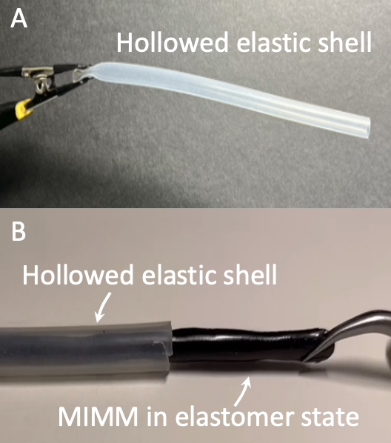
Fig. S38. The structure of the stiffness-varied fluidic soft actuator. (A) The hollowed elastic shell cannot be magnetically actuated. (B) With MIMMs, the fluidic soft actuator can be therefore actuated, and stiffness is varied by the elastomer-fluid transition.

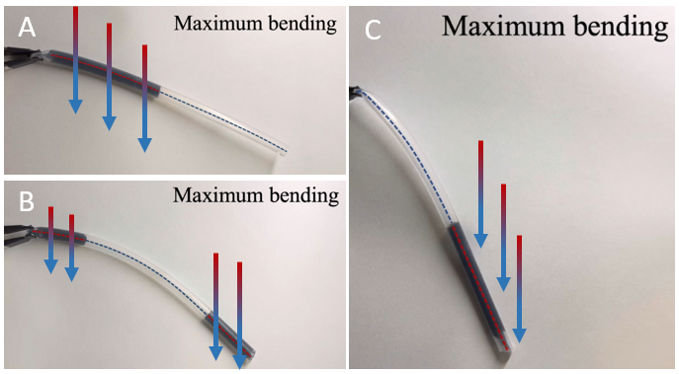
Fig. S39. The maximum bending performances of different stiffness-distributed soft actuators. (A) The left-side distributed soft actuator performs delicate bending. (B) Both sides distributed the soft actuator perform central-concentrated bending. (C) The right-side distributed soft actuator performs large-scale bending.
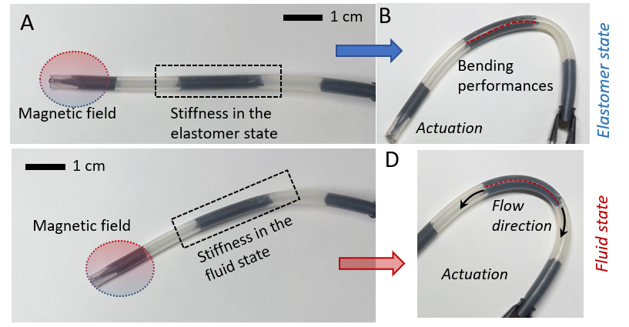
Fig. S40. Locally stiffness adjustable fluidic soft actuator. (A) Constraining the tip, stiffness at the center of the actuator is tested at the ambient temperature. (B) In the elastomer state, the center of the actuator is tested with large stiffness (~10 MPa), where maximum bending curvatures are found at low-stiffness (~2 MPa) regions. (C) Constraining the tip, the fluid-stated actuator is tested. (D) The curvature at the studied region is larger than that in the elastomer state.

Section 7. Ex-vivo biomedical demonstrations
Experimental setups are presented below for reference.
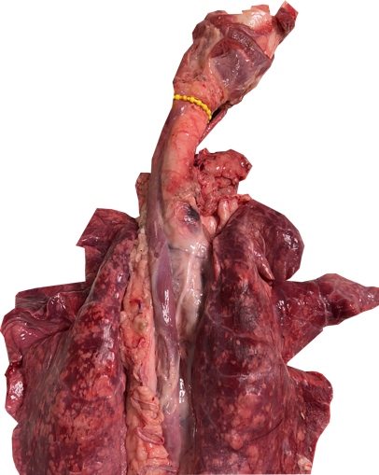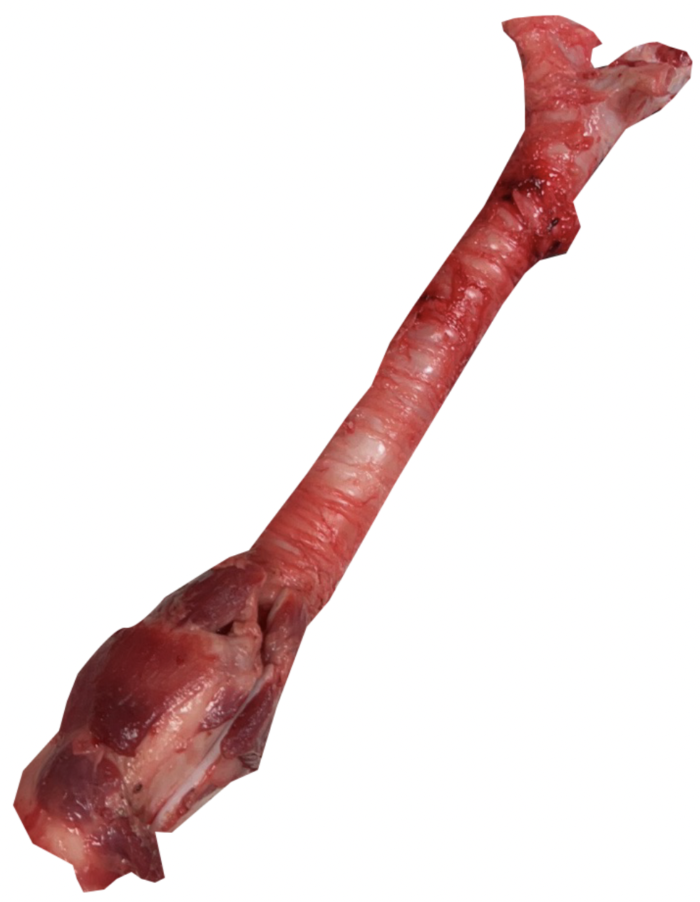
Fig. S41. The ex-vivo trachea was dissected from a pig lung.
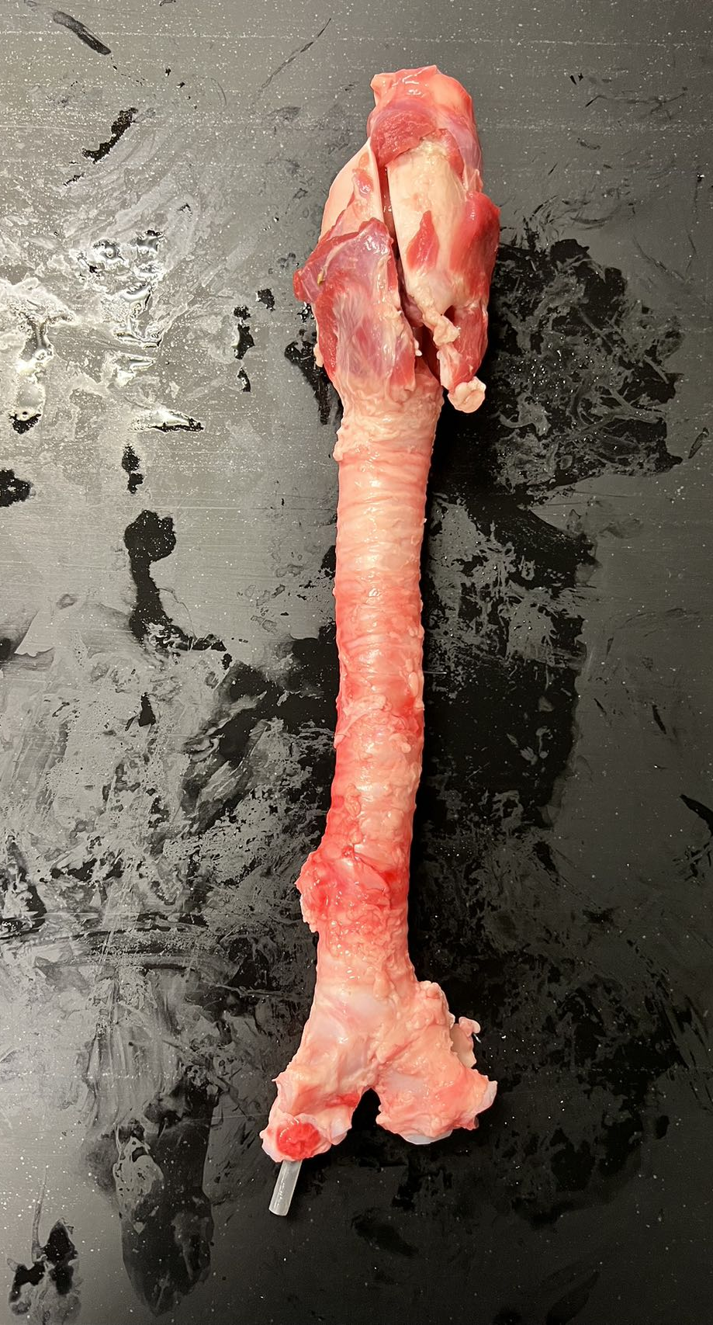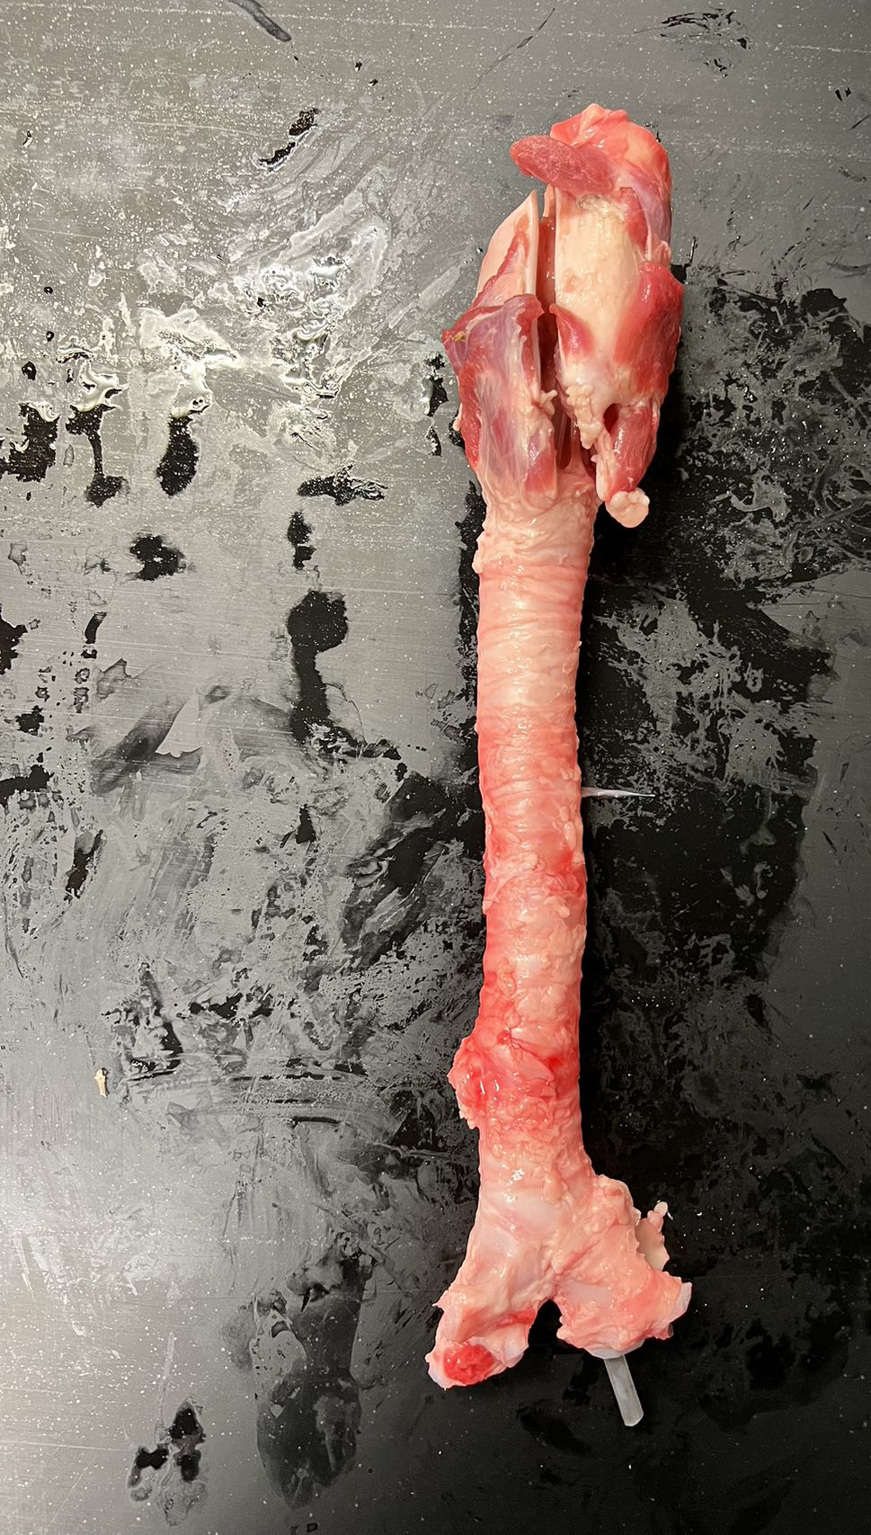
Fig. S42. The actuator can navigate itself for intubation.
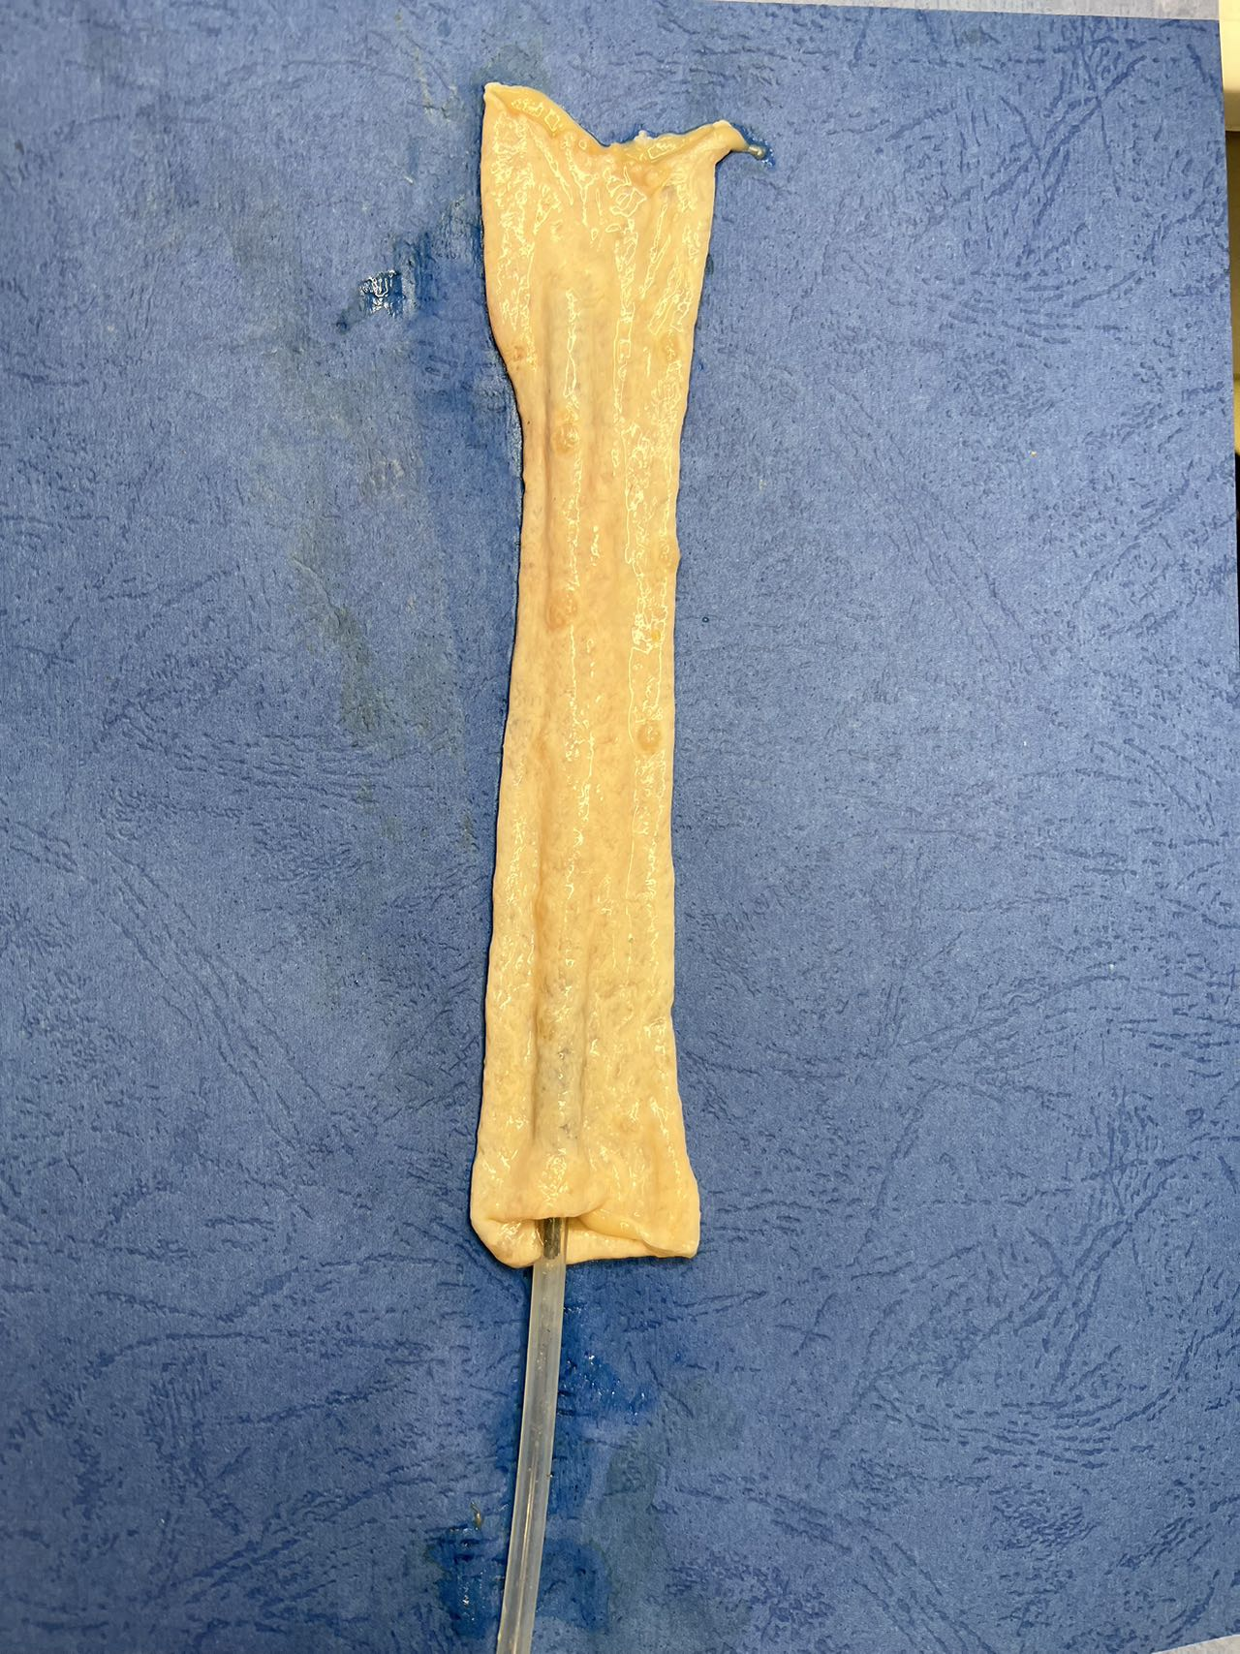
Fig. S43. The actuator can move in a pig intestine with friction.

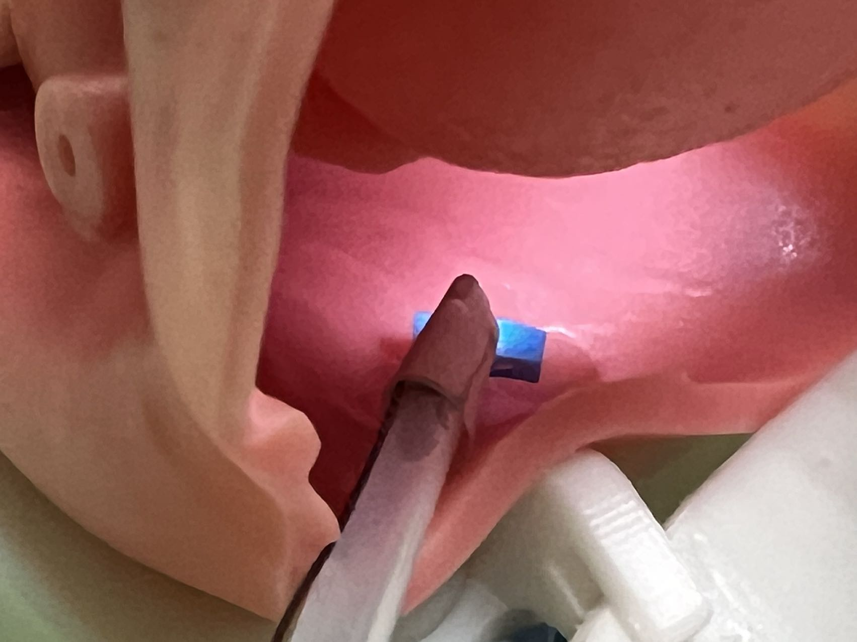
Fig. S44. An oropharyngeal phantom was applied to demonstrate Fig. 5E in the main text.

