Supporting Information
Repolarization of inflammation-associated macrophages by multifunctional dual drug-loaded liposome with antibacterial capacity for acute lung sepsis synergistic therapy
Qing Zhang^{a, b}, Lin Zhangª, Yuhan Zhangª, Yi Wang^{b}, Rong Juª, Guoqing Wei*ª

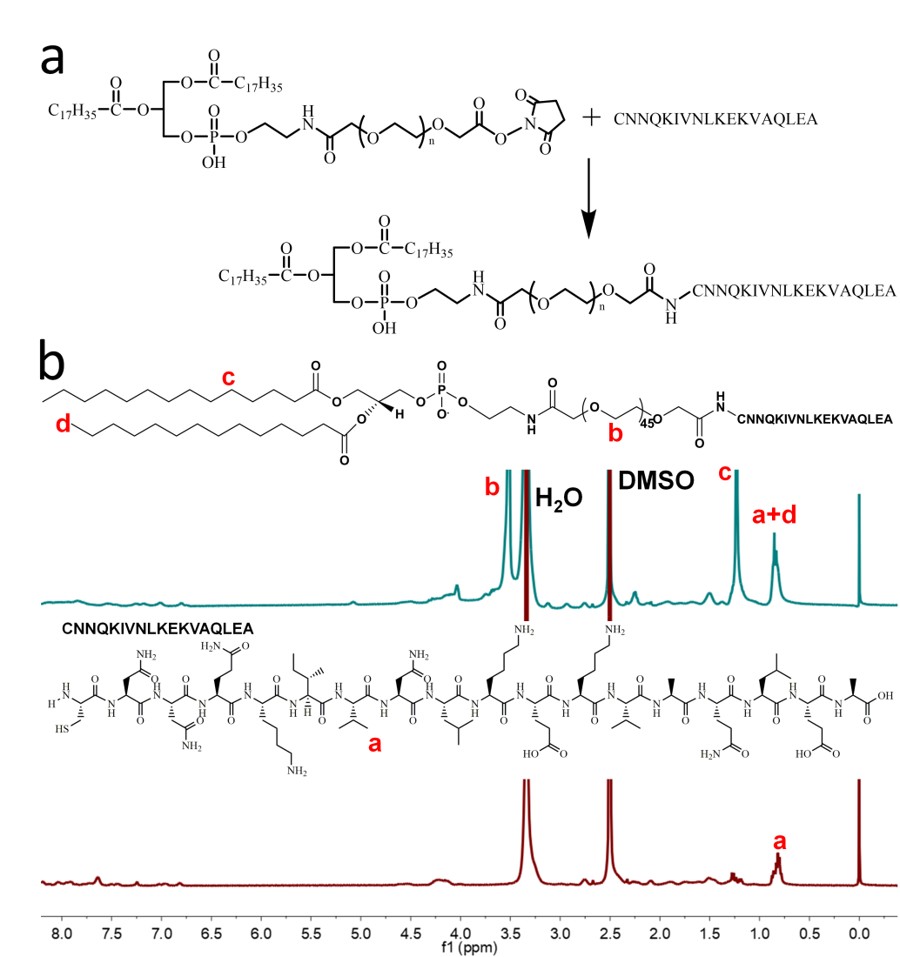
Figure S1 Synthetic routes (a) and (b) ¹H NMR spectrum of the DSPE-PEG2000-γ3.

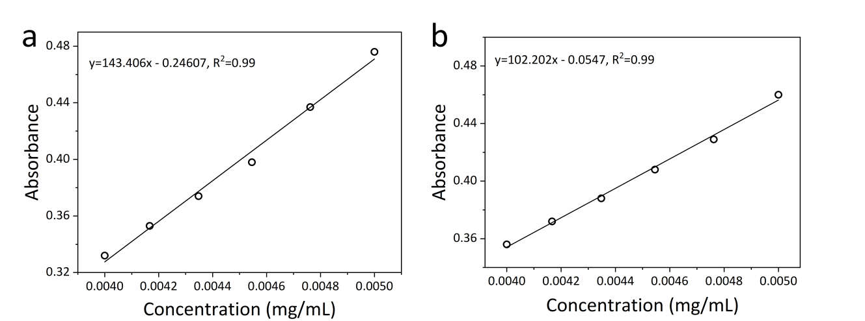
Figure S2 Grafting rate at λ = 276 nm of Cip·HCl (a) and Cur (b) by UV-vis spectrophotometer.
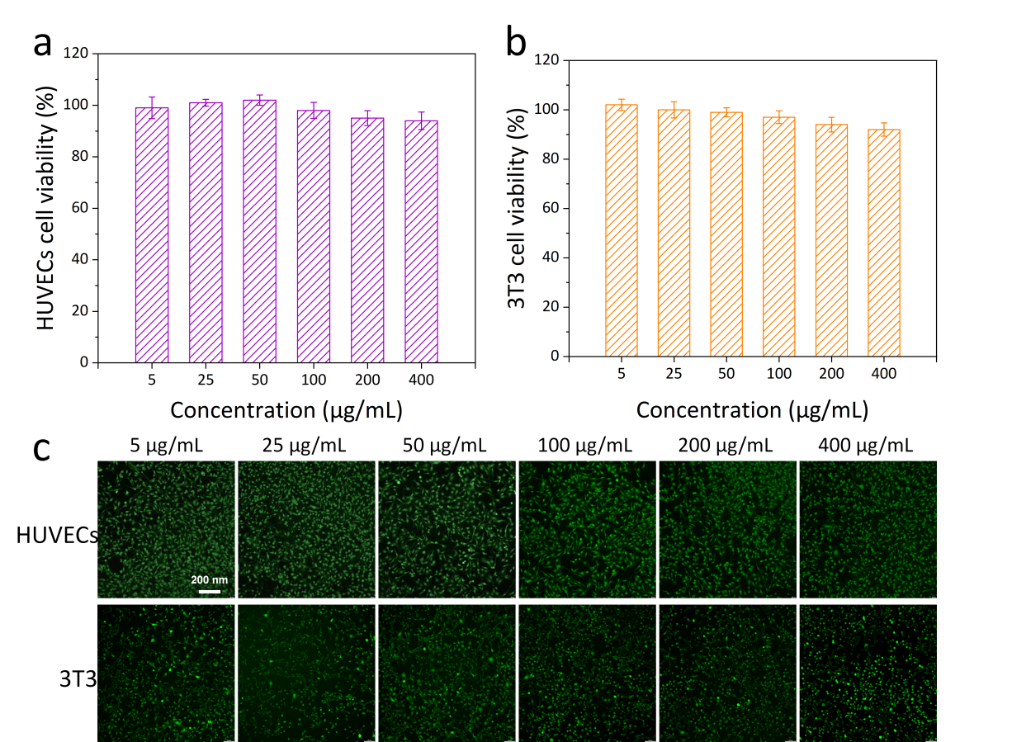
Figure S3 Cytotoxicity of the Cip.HCl/Cur@Lip-γ3 to HUVECs (a) and 3T3 cells (b) in vitro. (n=5). (c) Calcein AM/PI staining showing the viability of HUVECs and 3T3 cells following treatment with different concentrations of the Cip.HCl/Cur@Lip-γ3.

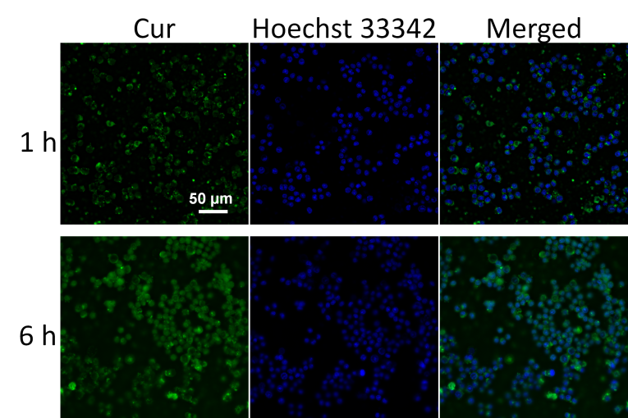
Figure S4 Microscopy images of activated RAW264.7 cells after incubation with Cur@Lip-γ3 at 37 °C for 1 and 6 h. The blue and the green color indicate Hoechst 33342 and Cur, respectively.

Figure S5 The quantitative analysis of M1 (a) and (b) M2 percentages in different treatment groups (n=3).

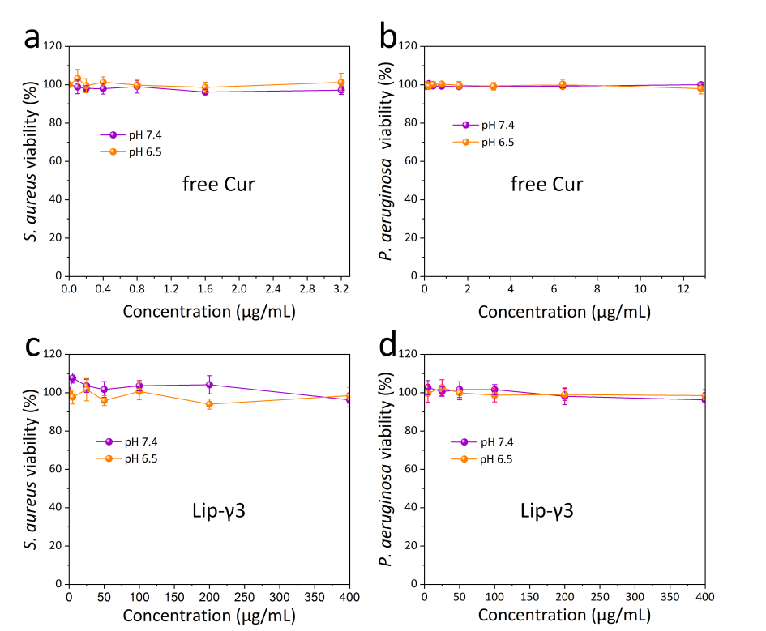
Figure S6 Antibacterial effect of different samples in vitro. Bacterial viability of different concentrations of Lip-γ3 cultured with S. aureus (a) and P. aeruginosa (b). Bacterial viability of different concentrations of Cur cultured with S. aureus (c) and P. aeruginosa (d). (n = 3).

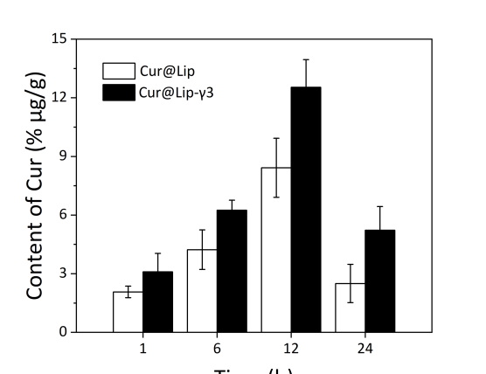
Figure S7 Biodistribution of Cur in major organs of ALS mice at 1, 6, 12 h and 24 h post-administration of Cur@Lip and Cur@Lip-γ3. (n = 3).

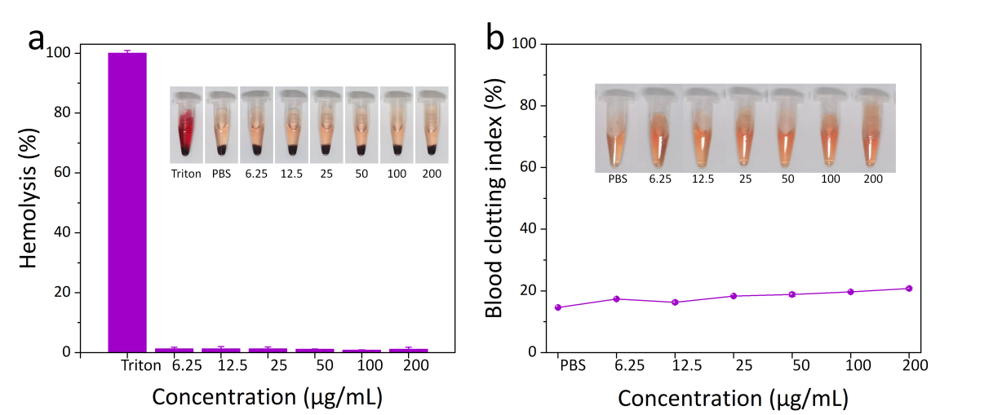
Figure S8 (a) Hemolytic percent of RBCs incubated with Cip.HCl/Cur@PL-γ3 at various concentrations, using Triton X-100 (0.1%) and PBS as positive and negative controls, respectively. Inset: Photographs for direct observation of hemolysis, suggesting that Cip.HCl/Cur@PL-γ3 exhibits good biocompatibility. (n = 3). (b) Blood clotting index changes of Cip.HCl/Cur@PL-γ3 with various concentrations. DI water and PBS are used as positive and negative controls, respectively. Inset: Photographs showing the supernatant of Cip.HCl/Cur@PL-γ3 with various concentrations. (n = 3).

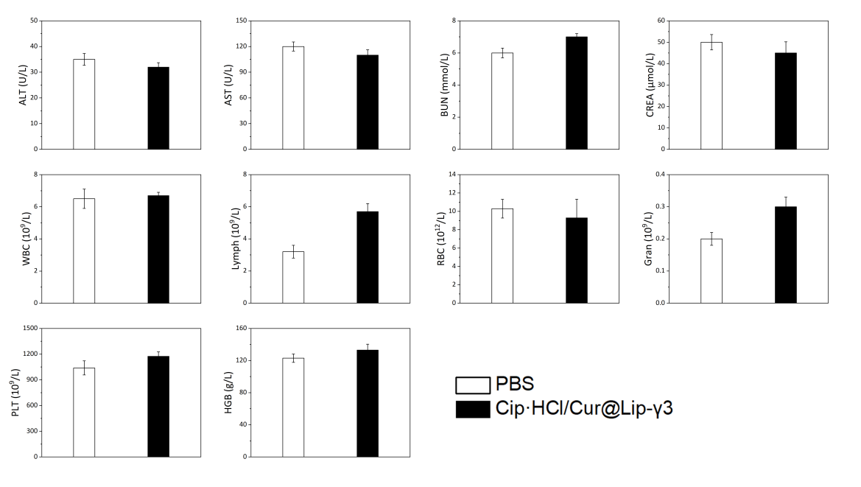
Figure S9 Blood biochemical indexes and hematology parameters of the mice treated with PBS and Cip·HCl/Cur@Lip-γ3. (n = 3).

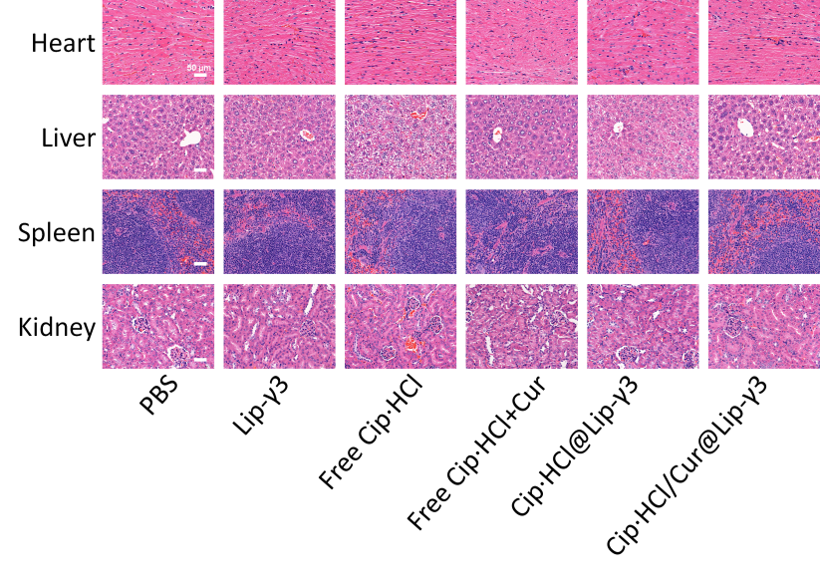
Figure S10 H&E staining of tissue sections from normal organs harvested from P. aeruginosa-infected mice on the 72 h day treated with PBS, Lip-γ3, free Cip·HCl, free Cip·HCl+Cur, Cip·HCl@Lip-γ3 and Cip·HCl/Cur@Lip-γ3.

Table S1 Properties of blank liposome and drug-loaded liposomes.
Entry | liposome | Size (nm) | PDIa | Zeta potential (mv) | Cip·HCl |  | Cur
 |  |  |  |  | LC^{b} (%) | EE^{c} (%) | LC^{b} (%) | EEc (%)
1 | Lip-γ3 | 90 | 0.18 | -32.28 | - | - | - | -
2 | Cip·HCl@Lip-γ3 | 94 | 0.18 | -39.24 | 6.0 | 67 | - | -
3 | Cur@Lip-γ3 | 91 | 0.17 | -35.32 | - | - | 5.8 | 60
4 | Cip·HCl/Cur@Lip-γ3 | 93 | 0.19 | -28.37 | 5.0 | 56 | 5.8 | 60
ª Polydispersity index (PDI).
^{b} Loading content (LC).
^{c} Encapsulation efficiency (EE).

