Table1 Construction process: Steps,Methods,Remaks
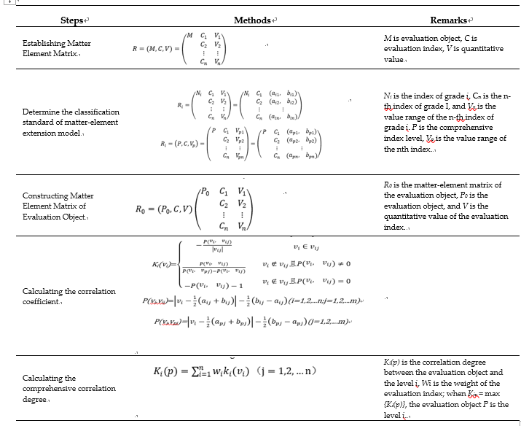

Table 2 Evaluation index weight determination
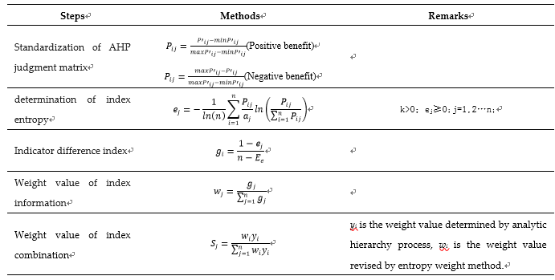
Table 3. Land consolidation index

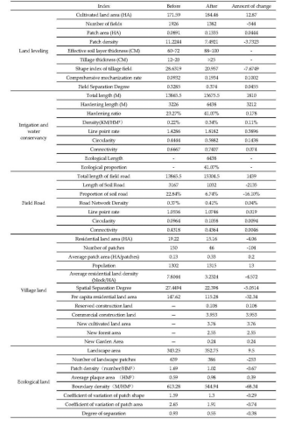
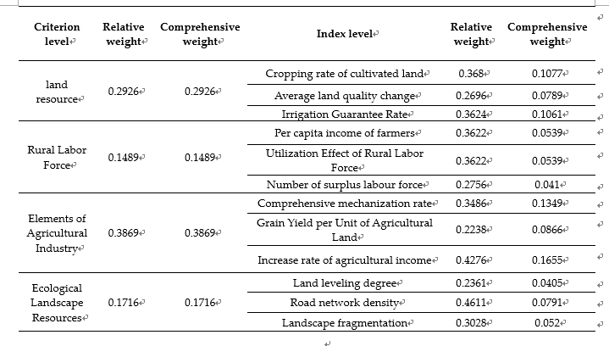
Table 4 Table of Analytic weights of analytic hierarchy process and entropy weight method

Table 5 Table of Canonical and local matter matrix
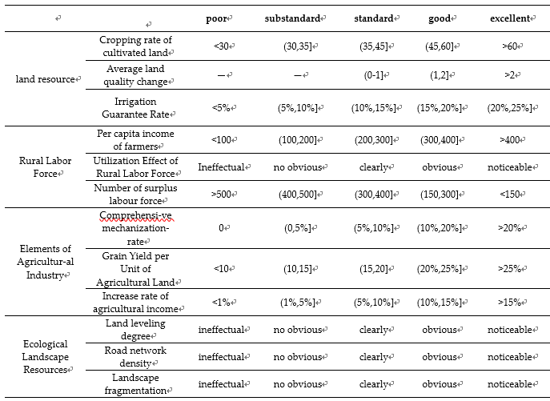

Table 6 Table of Canonical and local matter matrix
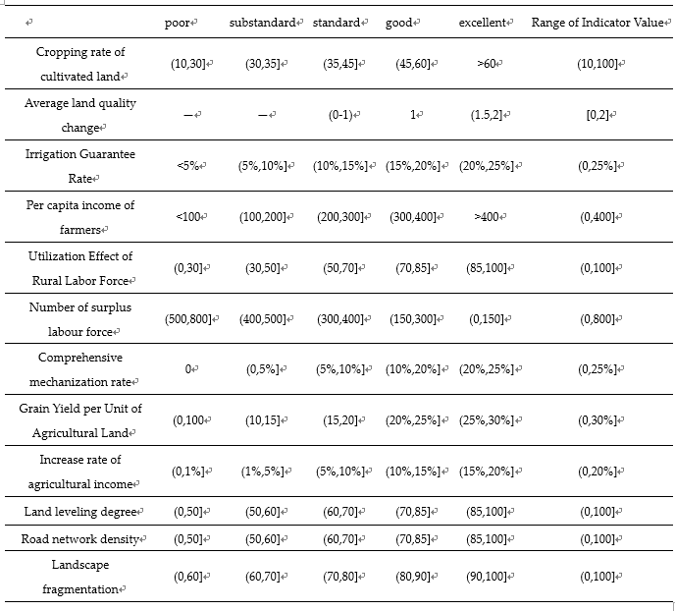

Table 7. Table of Indicator benefit
