Supplementary Materials

Electric Field Sensing of Etchless Lithium Niobate Heterostructure with Low Driving Voltage based on Quasibound States in the Continuum
Zhijin Huang^{1, *}, Junzhong Wang¹, Lifang Yuan¹, Kaixiang Shen¹, Qianqian Li¹
¹School of Electronics and Communication, Guangdong Mechanical and Electrical Polytechnic, Guangzhou 510550, China.
*Corresponding author

S1. The bandstructures of hybrid coupled-grating system without 100nm-thick gold film
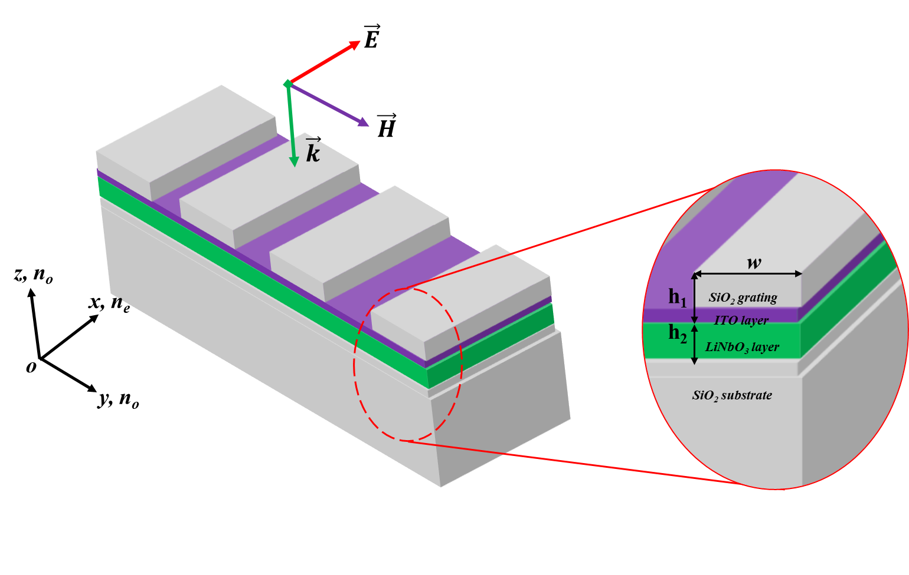
Figure. S1 The schematic of hybrid coupled-grating system. The gold film is not taken into consideration here.
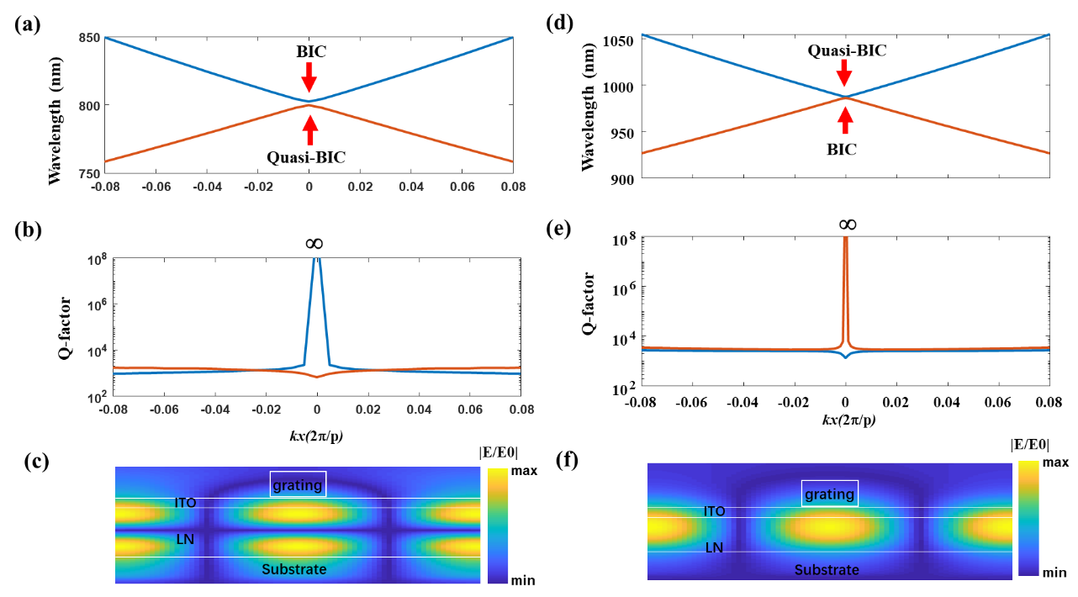
Figure S2. (a, d) and (b, e) The bandstructures and Q factors calculated with COMSOL Multiphysics, respectively. (c-f) are the electric field profiles at kx=0.
Here, we study all-dielectric structure with the same geometrical parameters in the main text. Both have the similar bandstructures as shown in Fig S2(a, d). The two modes are degenerate at Γ point and separate immediately once deviating from the Γ point. The Q factor of BIC reaches to infinite with a low Q leaky mode as shown in Fig S2(b, e). However, both are located above the light cone, that is, the continuum. Therefore, it can be called quasi-BIC with finite Q factor. The electric field profiles at Γ point indicate that the modes supported by the all-dielectric structure is confined inside the LN material, which is also like that of the structure with 100nm-thick gold film.
S2. The detailed comparison of reflectance spectra.
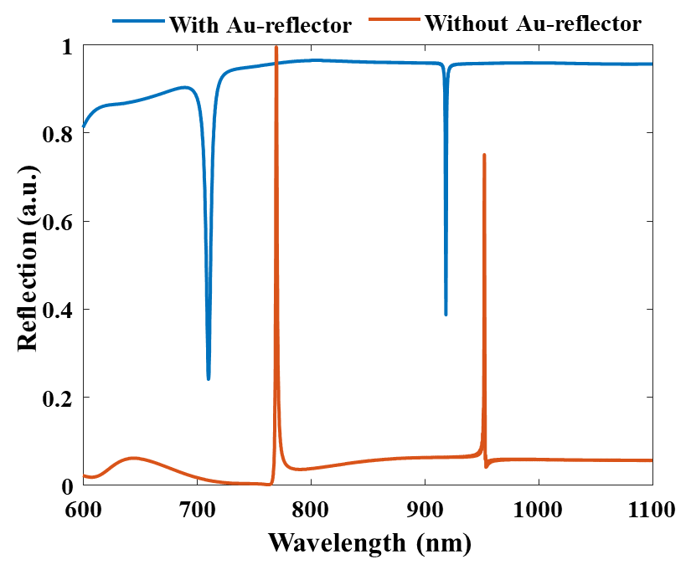
Figure S3. The reflectance spectra of the structure with 100nm-thick gold film (our proposed E-field sensor) and the all-dielectric structures. The simulation is carried out with TE-polarized normal incident light.

