Light-oriented 3D printing of 4'-pentyl-4-cyanobiphenyl (5CB) liquid crystal/photocurable resins and its in-situ enhancement of mechanical performance
Xiaolu Sun ^{1,2,3,4,✝} ,Shaoyun Chen ^{1,3,4,✝}*, Bo Qu ^{1,3,4,} , Rui Wang ^{1,3,4},Yanyu Zheng ^{1,3,4}, Xiaoying Liu^{1,3,4}, Wenjie Li ^{1,3,4}, Jianhong Gao^{1,3,4}, Qinhui Chen ²*, Dongxian Zhuo ^{1,2,3,4}*.
¹College of Chemical Engineering and Materials Science, Quanzhou Normal University, Quanzhou, Fujian, 362000, P. R. China;
²College of Chemistry and Materials Science, Fujian Normal University, Fuzhou, Fujian, 350007, P. R. China;
³Fujian University Engineering Research Center of Polymer Functional Coating based Graphene, Fujian, 362000, P. R. China;
⁴Fujian Key Laboratory of New Materials for Light Textile and Chemical Industry, Fujian, 362000, P. R. China.
*Correspondence: chshaoy@qztc.edu.cn; chenqh@fjnu.edu.cn; dxzhuo@qztc.edu.cn;
✝ Co-first authors

Table S1 Different commercial printing formulations with 3% content of 5CB
Figure S1 Stress-strain curves of different commercial printing formulations with 3% content of 5CB
Figure S2 Polarizing optical microscopy (POM) at 0º and 45º of different commercial printing formulations with 3% content of 5CB

Table S1 Different commercial printing formulations with 3% content of 5CB
F1 | Aliphatic polyether acrylates | CN991 | HPMA | TPO
F1 | 46 | 5 | 46 | 3
F2 | Aliphatic polyether acrylates | CN991 | HEMA | HPMA | TPO
F2 | 36 | 5 | 20 | 36 | 3
F3 | CN9010 | CN991 | HEMA | HPMA | TPO
F3 | 40 | 32 | 15 | 10 | 3

Figure S1 Stress-strain curves of different commercial printing formulations with 3% content of 5CB

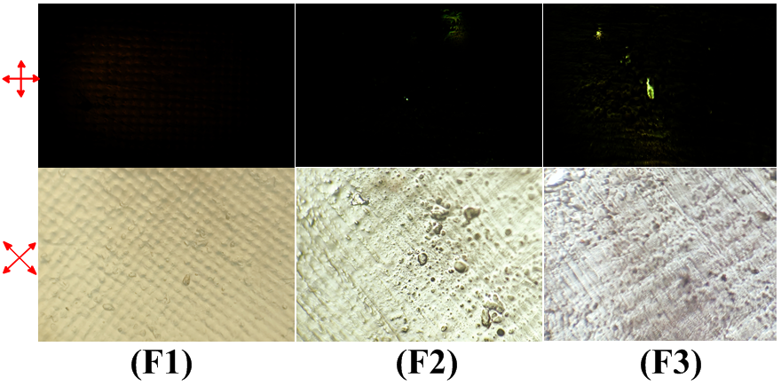
Figure S2 Polarizing optical microscopy (POM) at 0º and 45º of different commercial printing formulations with 3% content of 5CB

