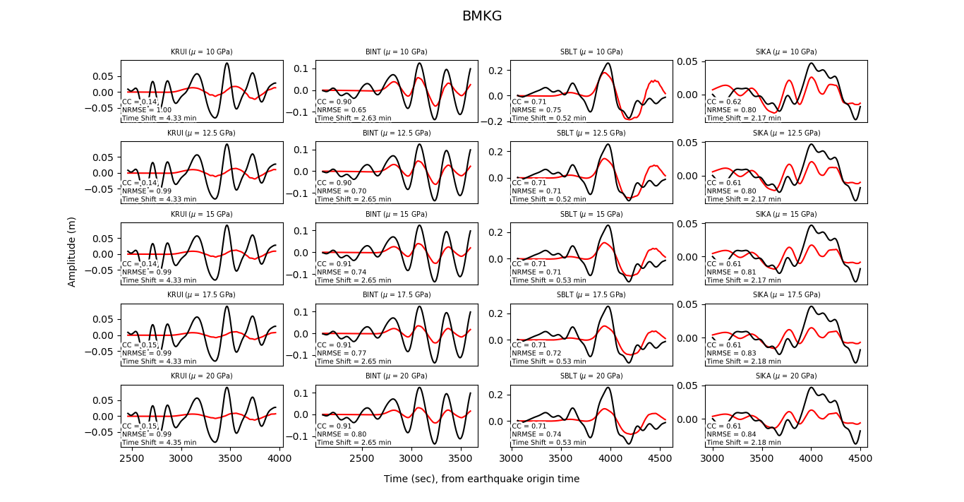
Fig S1 Comparison of observed (black line) and simulated (red line) waveform that generated by source model from BMKG at four tide gauges. The first, second, third, fourth, and fifth row represent the BMKG01, BMKG02, BMKG03, BMKG04, and BMKG05 scenario, respectively. The correlation coefficient (CC), NRMSE, and the time shifting are shown in each trace.

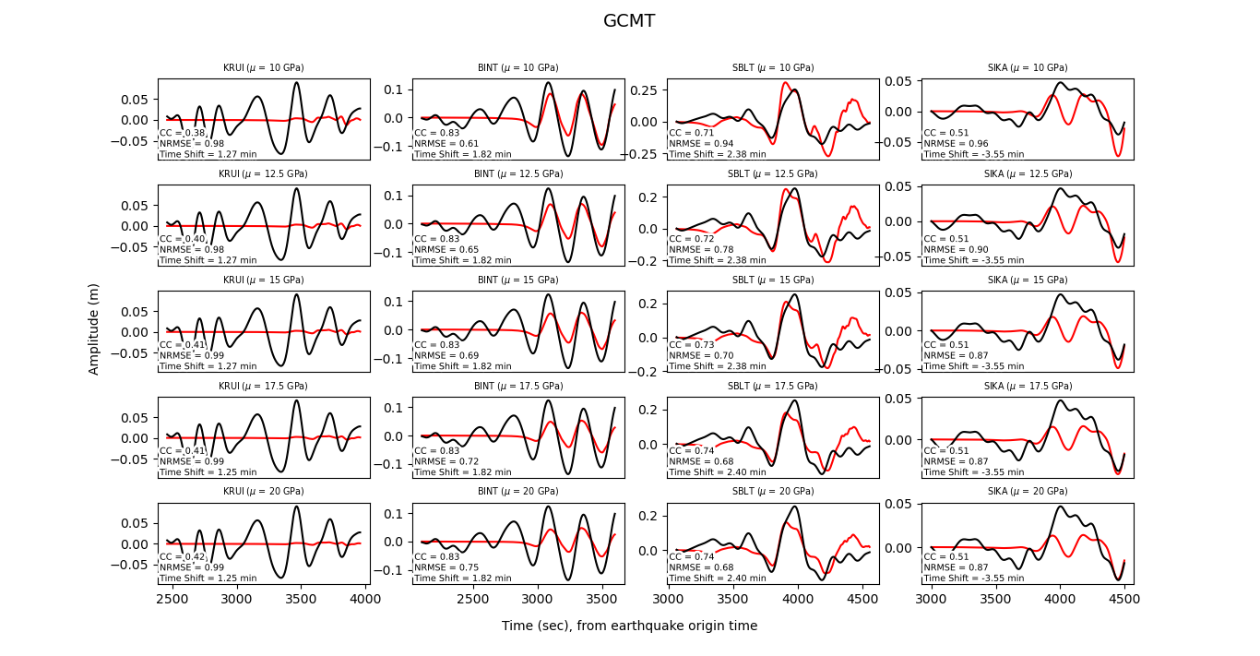
Fig S2 As in Figure S1 but for simulated waveform that generated by source model from GCMT.
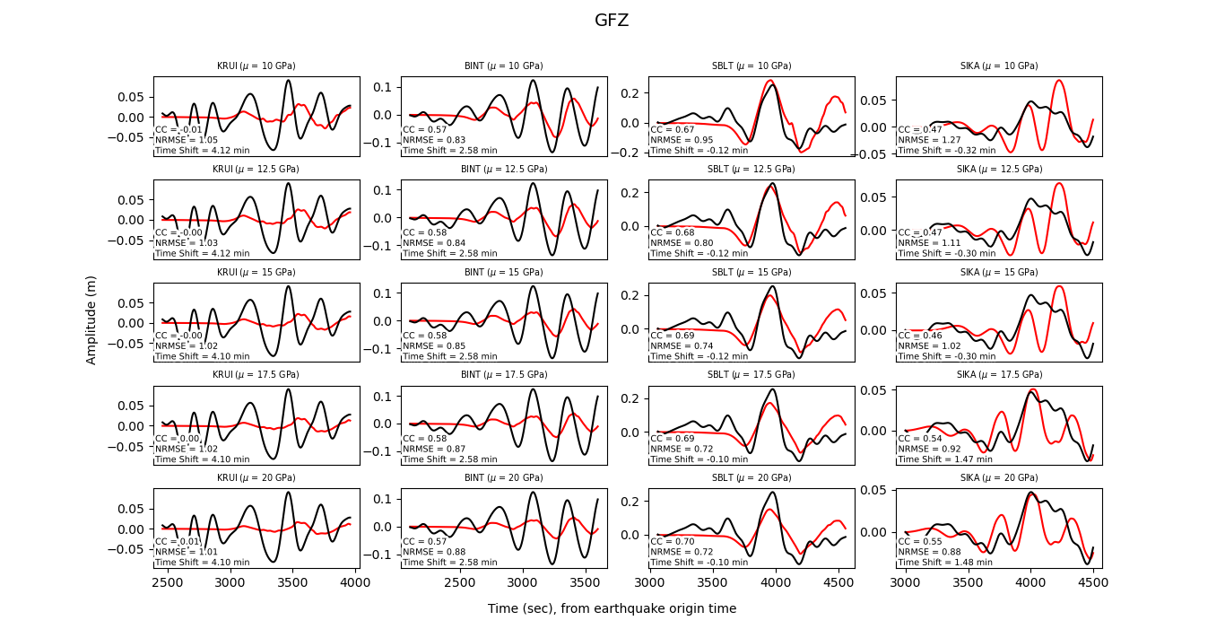
Fig S3 As in Figure S1 but for simulated waveform that generated by source model from GFZ.

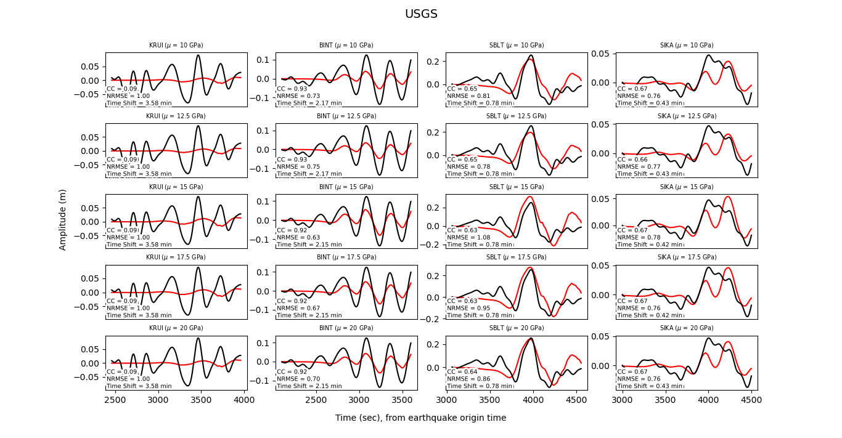
Fig S4 As in Figure S1 but for simulated waveform that generated by source model from USGS.

