Supplementary Information

Terrain Effect of Hainan Island during Intensification of Typhoon Son-Tinh (2012)
Shumin Chen, Mingsen Zhou*, Weibiao Li*, Chaoyong Tu, Aoqi Zhang, Yilun Chen
* Corresponding authors:
Mingsen Zhou: zhoums@gd121.cn; Weibiao Li: eeslwb@mail.sysu.edu.cn.

Supplementary Methods

Detailed parameters of the control (CTL) simulation
In CTL simulation, the boundary conditions of Domain 1 were assigned the value from the GFS-ANL data every six model hours, and obtained at every time step for Domain 2 from values in Domain 1 in the same region. The sea surface temperature (SST) was fixed during model integration. The WRF Single-Moment 6-Class microphysics scheme, Rapid Radiative Transfer Model longwave radiation scheme, Dudhia shortwave radiation scheme, Monin–Obukhov scheme, Noah land surface process scheme, and Yonsei University planetary boundary layer scheme were adopted in both domains. The Kain–Fritsch cumulus parameterization scheme was used only in Domain 1; no cumulus parameterization scheme was employed in Domain 2.

Calculation of vertical wind shear, relative and potential vorticity
The vertical wind shear calculated as
$vertical wind shear=\sqrt{{（u_{200}−u_{850}）}^{2}+{（v_{200}−v_{850}）}^{2}}$,
where $u_{200}$/$v_{200}$ and $u_{850}$/$v_{850}$ means the meridional/zonal winds at 200 and 850 hPa, respectively. The relative vorticity was calculated as
$relative vorticity=\frac{∂v}{∂x}−\frac{∂u}{∂y}$,
where $u$/$v$ means the meridional/zonal winds.
Potential vorticity in the plane of the z-axis was calculated as follows:
$potential vorticity={(\frac{∂w}{∂y}−\frac{∂v}{∂z})∙\frac{∂θ}{∂x}}/ρ+{(\frac{∂u}{∂z}−\frac{∂w}{∂x})∙\frac{∂θ}{∂y}}/ρ+{(\frac{∂v}{∂x}−\frac{∂u}{∂y}+f)∙\frac{∂θ}{∂z}}/ρ$,
where $w$, $θ$, $ρ$, and $f$ are vertical wind speed, potential temperature, dry air density, and Coriolis coefficient, respectively.

Calculation of the percentage of the difference relative to the CTL simulation
The percentage of the difference between the sensitivity and CTL experiments relative to CTL for variable X was calculated as follows:
$Precentage=\frac{X_{ST}−X_{CTL}}{X_{CTL}}×100\%$,
where $X_{ST}$ is the value of variable X from the sensitivity experiment, and $X_{CTL}$ is the value of variable X from the CTL simulation.

Normalization of relative and potential vorticities
Normalized relative or potential vorticity ($X$) were calculated as follow:
$$X_{N}=\frac{X−\overline{X}}{\overline{X'}}$$
where $X_{N}$ is the normalized value of the estimated variable ($X$), $\overline{X}$ is the mean value of $X$, and $\overline{X'}$ is the standard deviation of $X$.

Supplementary Figures and Tables

Supplementary Figures

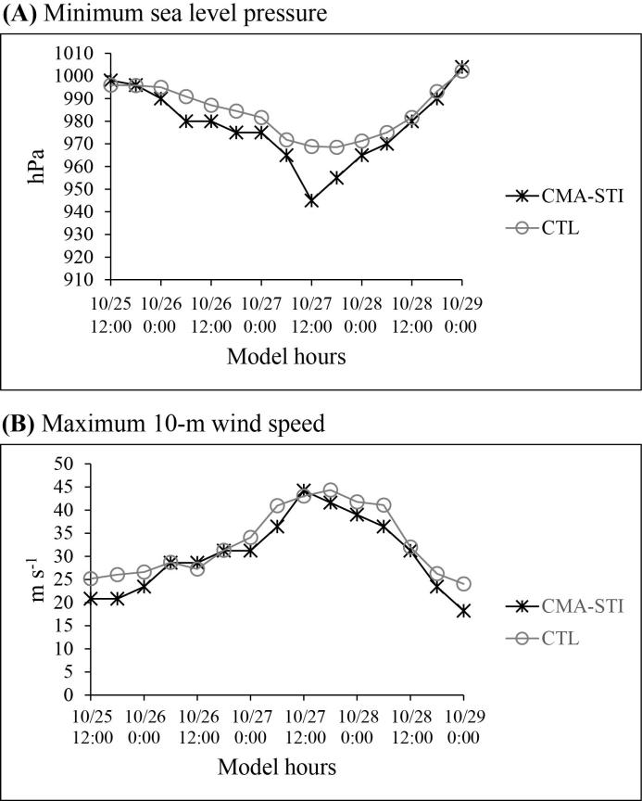
Supplementary Figure 1. Tropical cyclone (TC) intensity at 6-h intervals from the Shanghai Typhoon Institute of the China Meteorological Administration (CMA-STI) best-track dataset (black line) and the control (CTL) experiment (gray line). (A) minimum sea level pressure (unit: hPa) and (B) maximum 10-m wind speed (unit: m s⁻¹) of Typhoon Son-Tinh (2012).

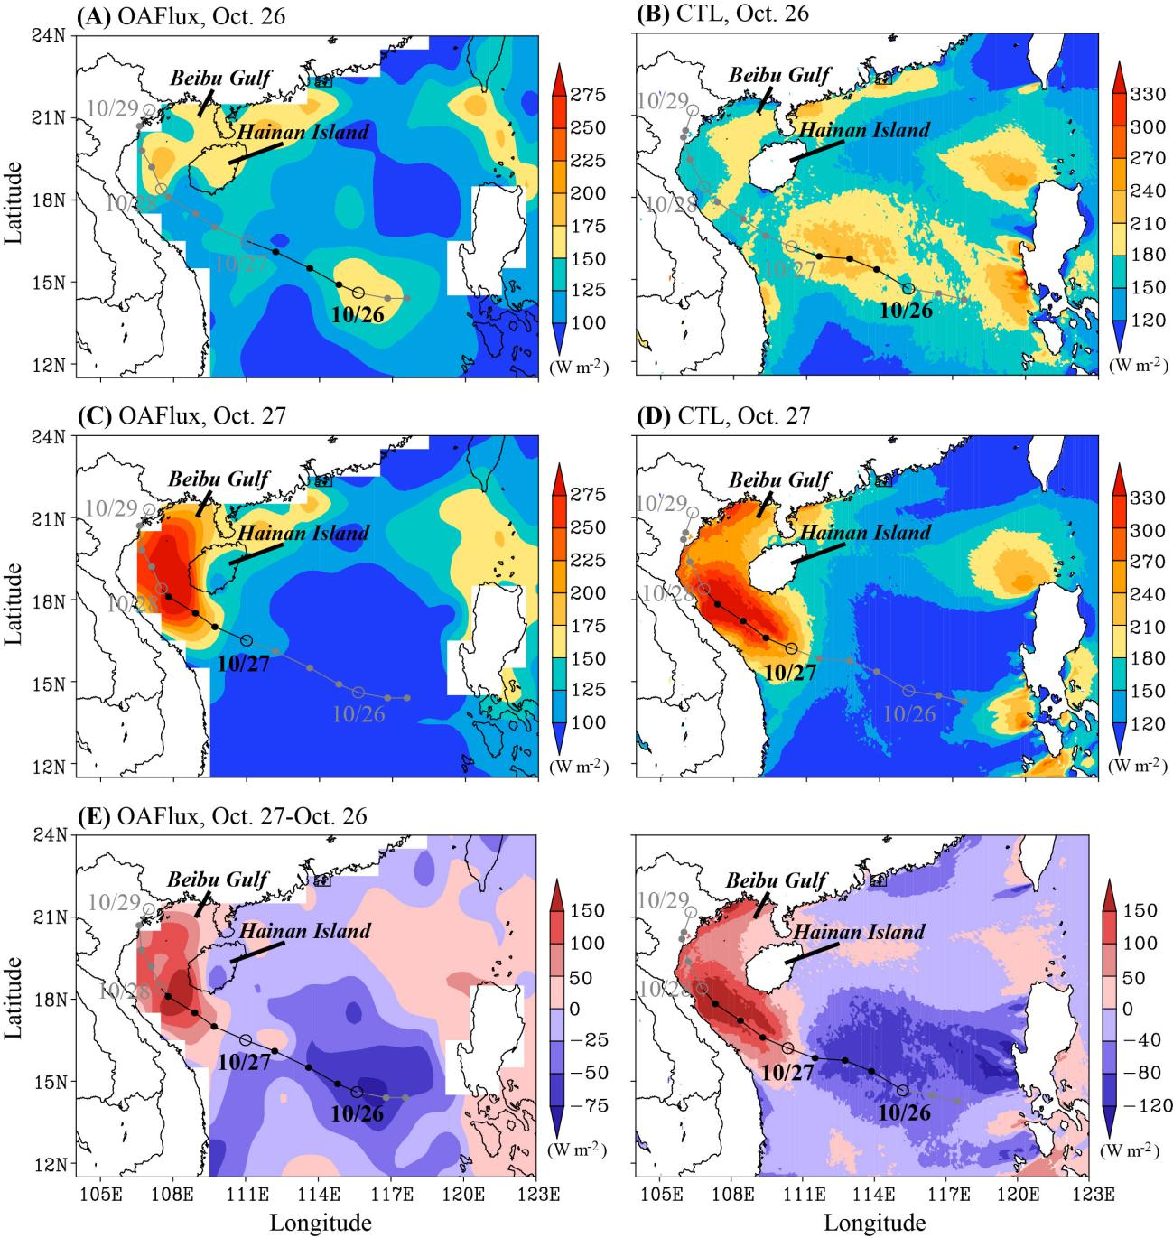
Supplementary Figure 2. Air–sea latent heat flux from (left column) the Objectively Analyzed air–sea Fluxes for the global oceans (OAFlux) dataset and (right column) the control (CTL) simulation. (A) and (B) show averaged values for Oct. 26 2012; (C) and (D) show averaged values for Oct. 27 2012; (E) and (F) show the difference between Oct. 27 and 26. Tropical cyclone (TC) track is indicated by black and gray lines with circles; black segments indicate TC tracks during the analysis period.

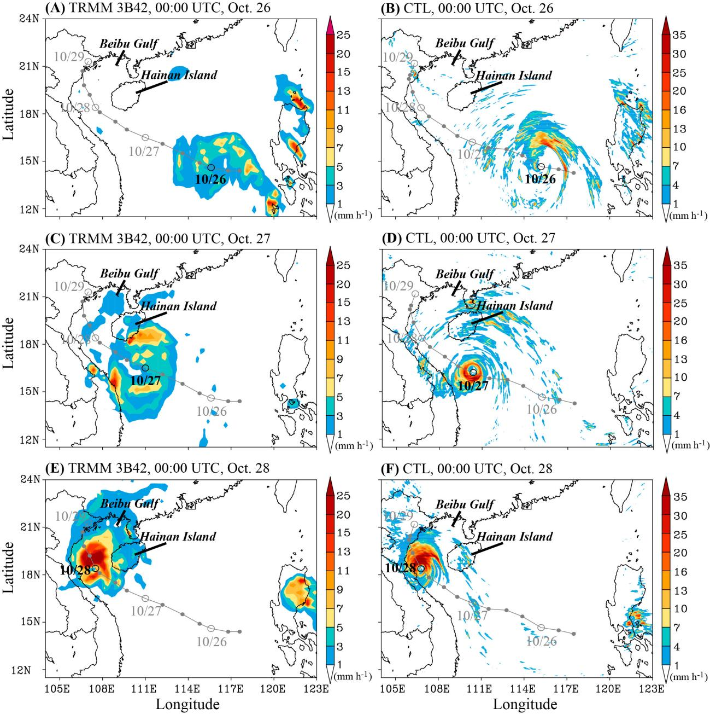
Supplementary Figure 3. Precipitation from (left column) the Tropical Rainfall Measuring Mission (TRMM) Multi-Satellite Precipitation Analysis (TMPA) 3B42 dataset and (right column) the control (CTL) simulation for 00:00 UTC on (A) and (B) Oct. 26 2012, (C) and (D) Oct. 27 2012, and (E) and (F) Oct. 28 2012. Locations of the tropical cyclone (TC) at these times are indicated by black circles on the TC track in (A)–(F).

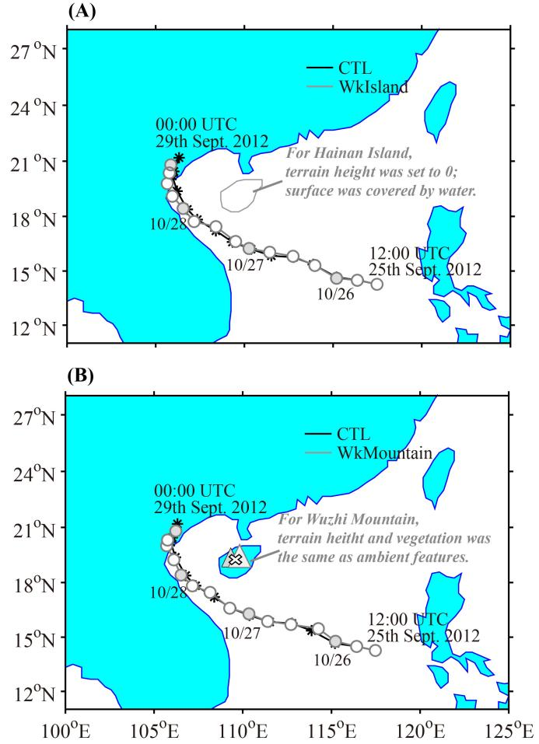
Supplementary Figure 4. General model configuration for the sensitivity experiments of (A) WkIsland and (B) WkMountain. Black lines indicate the track of Typhoon Son-Tinh (2012) in the control (CTL) simulation.

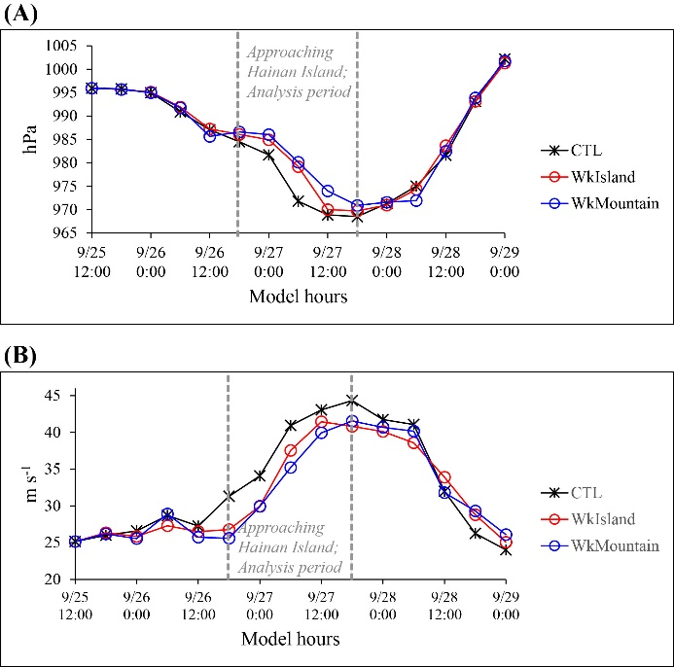
Supplementary Figure 5. Tropical cyclone (TC) intensity at 6-h intervals from the CTL (black), WkIsland (red), and WkMountain (blue) experiments. (A) minimum sea level pressure (unit: hPa) and (B) maximum 10-m wind speed (unit: m s⁻¹) of Typhoon Son-Tinh (2012). In between the gray dashed lines is the detailed analysis period during which Typhoon Son-Tinh (2012) was intensifying rapidly and approaching Hainan Island.

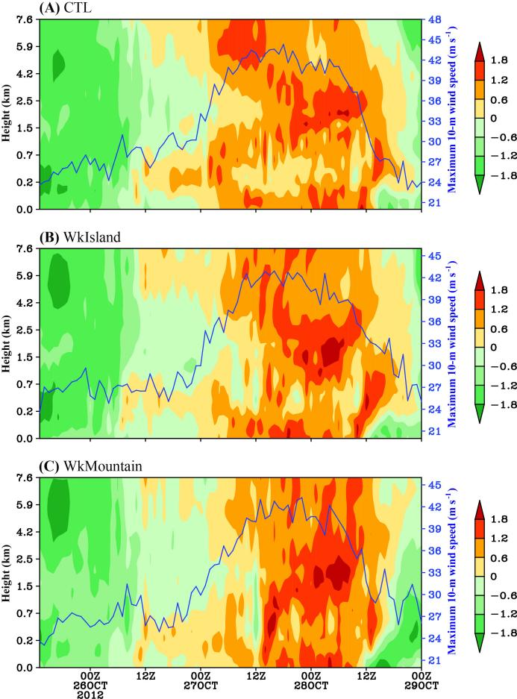
Supplementary Figure 6. Maximum 10-m wind speed (blue line; unit: m s⁻¹) and variation of spatially averaged normalized potential vorticity with height in the analysis region from (A) CTL, (B) WkIsland, and (C) WkMountain experiments. Analysis regions are defined in Section 2.2.2. Normalization of vorticities is explained in Supplementary Section 1.4.
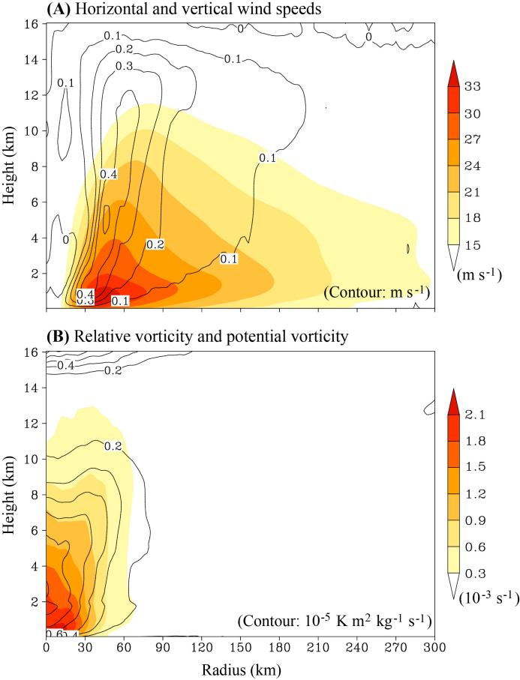
Supplementary Figure 7. Radius–height distribution of azimuthally averaged (A) horizontal (shading) and vertical wind speeds (contour; unit: ms⁻¹) and (B) relative (shading; unit: 10⁻³ s⁻¹) and potential vorticities (contour; 10⁻⁵ K m⁻² kg⁻¹ s⁻¹) of Typhoon Son-Tinh (2012) in the control (CTL) simulation.

Supplementary Tables
Supplementary Table 1. Changes of the values of different variables in the control (CTL) simulation over the 24-h analysis period (18:00 UTC October 26 to 18:00 UTC October 27, 2012)
Variable | Changes during the 24 hours period
Maximum 10-m wind speed (m s-1) | 14.32
Lant heat flux (1012 W) | -6.06
Sensible heat flux (1012 W) | -1.96
Vertical wind shear (m s-1) | 12.85
Relative vorticity (10-4 s-1) | 3.64
Potential vorticity (10-5 K m-2 kg-1 s-1) | 1.27

Supplementary Table 2. Values of variables used to calculate the percentages of the differences relative to the CTL simulation, which are shown in Figure 3*.
Variable (unit) | CTL | WkIsland | WkMountain
Intensed maximum 10-m wind speed (m s⁻¹) | 37.89 | 36.20 | 35.46
Mean lant heat flux (10¹⁴ W) | 5.55 | 5.39 | 5.51
Mean sensible heat flux (10¹³ W) | 4.10 | 4.02 | 4.20
Mean vertical wind shear (m s⁻¹) | 10.37 | 10.09 | 10.17
Mean relative vorticity (10⁻³ s⁻¹) | 1.17 | 1.08 | 1.02
Mean potential vorticity (10⁻⁶ K m⁻² kg⁻¹ s⁻¹) | 1.93 | 1.55 | 1.30
* Values were averaged over the 24-h analysis period (18:00 UTC October 26 to 18:00 UTC October 27, 2012).

