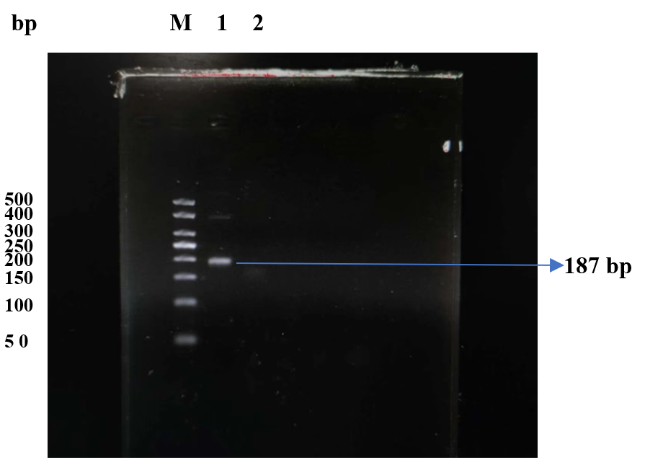
Figure S1 Cas12a Cutting Activity Verification M: Marker；1: The system does not contain Cas12a protein；2-4: Three independent replicates containing Cas12a protein in the system.

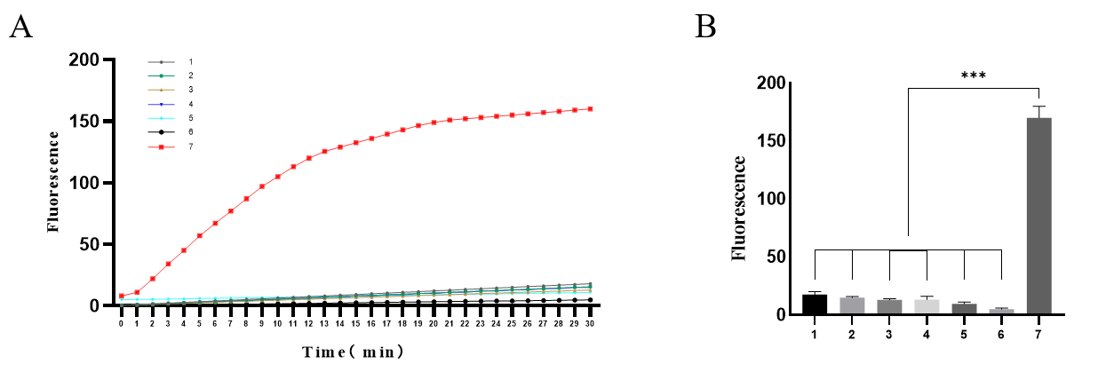
Figure S2 Integrity verification of CRISPR/Cas12a detection system (A) Fluorescence curve1: LbCas12a+ target+ FQ; 2: gRNA+ target+ FQ; 3: LbCas12a+ target+ gRNA; 4: LbCas12a+ gRNA + FQ; 5: LbCas12a+ target(IS6110)+ FQ+ gRNA(IS1081-gRNA2); 6: LbCas12a+ target(IS1081)+ FQ+ gRNA(IS6110-gRNA2); 7: LbCas12a+ target(IS6110)+ FQ+ gRNA(IS6110-gRNA2); (B) Histogram of fluorescence value ;***: P<0.001.

Table S1 Integrity verification of CRISPR/Cas12a detection system
Component | 1 | 2 | 3 | 4 | 5 | 6 | 7
LbCas12a | + | - | + | + | + | + | +
gRNA（IS6110-1） | - | + | + | + | - | + | +
gRNA（IS1081-1） | - | - | - | - | + | - | -
Target DNA（IS6110） | + | + | + | - | + | - | +
Target DNA（IS1081） | - | - | - | - | - | + | -
ssDNA-FQ | + | + | - | + | + | + | +
Buffer | + | + | + | + | + | + | +
H₂O | + | + | + | + | + | + | +
Note: +: add this component; -: lack of this component
Table S2 Specificity and Sensitivity by Sample Type
Type | BACTEC 960 | TB-CRISPR assay |  |  | Total | Specificity | Sensitivity
Type | BACTEC 960 | Positive | Negative |  | Total | Specificity | Sensitivity
Sputum | Positive | 66 | 10 |  | 217 | 0.936 | 0.868
Sputum | Negative | 9 | 132 |  | 217 | 0.936 | 0.868
Bronchoalveolar lavage fluid | Positive | 33 | 4 |  | 194 | 0.968 | 0.892
Bronchoalveolar lavage fluid | Negative | 5 |  | 152 | 194 | 0.968 | 0.892
Hydrothorax | Positive | 5 |  | 0 | 54 | 0.857 | 1
Hydrothorax | Negative | 7 |  | 42 | 54 | 0.857 | 1
Tissue | Positive | 1 |  | 0 | 17 | 1 | 1
Tissue | Negative | 0 |  | 16 | 17 | 1 | 1
Urine | Positive | 1 |  | 0 | 10 | 0.9 | -
Urine | Negative | 0 |  | 9 | 10 | 0.9 | -
Puncture fluid | Positive | 0 |  | 0 | 4 | 1 | -
Puncture fluid | Negative | 0 |  | 4 | 4 | 1 | -
Cerebrospinal fluid | Positive | 0 |  | 0 | 3 | 1 | -
Cerebrospinal fluid | Negative | 0 |  | 3 | 3 | 1 | -
Ascites | Positive | 0 |  | 0 | 2 | 1 | -
Ascites | Negative | 0 |  | 2 | 2 | 1 | -
Pus | Positive | 0 |  | 0 | 2 | 0.5 | -
Pus | Negative | 1 |  | 1 | 2 | 0.5 | -
Lung puncture tissue | Positive | 1 |  | 0 | 1 | - | 1
Lung puncture tissue | Negative | 0 |  | 0 | 1 | - | 1
Other  (Containing Tissue, Urine, Puncture fluid, Cerebrospinal fluid, Ascites, Pus) | Positive | 3 |  | 0 | 39 | 0.972 | 1
 | Negative | 1 |  | 35 | 39 | 0.972 | 1

