Supplementary Information

Assessment of microplastics in a municipal wastewater treatment plant with tertiary treatment: Removal efficiencies and loading per day into the environment

Javier Bayo *, Sonia Olmos, Joaquín López-Castellanos

Department of Chemical and Environmental Engineering, Technical University of Cartagena, Paseo Alfonso XIII 44, E-30203 Cartagena, Spain

* Corresponding author: javier.bayo@upct.es (J. Bayo)

Table S1. Description of sewage treatment stages and working parameters.
DESIGNED FLOWS
Daily average flow |  | Hourly average flow | Peak hourly flow | Maximum hourly flow
6,500 m³ d⁻¹ |  | 271 m³ h⁻¹ | 677 m³ h⁻¹ | 1,354 m³ h⁻¹
CONVENTIONAL TREATMENT LINE (ACTIVATED SLUDGE PROCESS)
Coarse solids | Concrete casting box for coarse solids removal with a volume of 22.79 m³. Extraction by means of a 250 L amphibious clamshell grab moved by 1,000 kg electric hoist.
Pretreatment | Initial screening with a 50 mm mesh for rough solids, 3 automatic screens with a 12 mm pitch and 3 self-cleaning sieves (3 mm clearance for fine solids).
Grit and grease | Aeration using 2+1 double speed blowers of 213/105 m³ h and  4.90/3.20 kW.
Phosphorus removal | Biological removal of phosphorus through anaerobic chambers of 1,160 m³, divided into 4 chambers per line and one shaker per chamber to promote agitation and avoid sedimentation.
Biological reactor | Two full-scale Carrousel oxidation ditch systems with prolonged aeration (8,502 m³ each), 182 membrane diffusers, and three 4.0 kW current accelerators per line. They are equipped with an internal pre-anoxic zone for nitrogen removal.
Secondary clarifiers and sludge treatment | Two circular gravity clarifiers (21 m inner Ø). Settled sludge is collected and partially pumped to the biological reactor by means of 2+1 submersible centrifugal pumps. Secondary sludge in excess is thickened by a gravity thickener (12 m inner Ø) and dewatered by means of 2 centrifuges (10 m³/h) with prior addition of polyelectrolyte.
Tertiary treatment and UV disinfection | Three parallel rapid sand filters with high purity siliceous sand (85% minimum content of silica, 20.5 tons/filter) and two units per filter, with a total surface of 62.18 m². Other parameters:  - Effective grain size (mm) 1.2 ± 0.05  - Sand bulk density (g ml⁻¹) 2.5  - Uniformity coefficient (d10/d60) 1.5  Ultraviolet disinfection performance in an open-channel with a maximum operating power of 34.60 kW.
Table S2. Physicochemical and biological parameters.
RAW WASTEWATER
Parameter | Concentration (daily load)
BOD₅ | 650 mg l⁻¹ (4,225 kg d⁻¹)
TSS | 500 mg l⁻¹ (3,250 kg d⁻¹)
TN | 60 mg l⁻¹ (390 kg d⁻¹)
TP | 15 mg l⁻¹ (98 kg d⁻¹)
EFFLUENT
Parameter | Concentration
BOD₅ | ≤ 25 mg l⁻¹
TSS | ≤ 35 mg l⁻¹
TN | ≤ 15 mg l⁻¹
TP | ≤ 2 mg l⁻¹
TC | 2.2 cfu 100 ml⁻¹
T | 2 NTU
NE | 1 egg l⁻¹
BOD₅: Biochemical oxygen demand-5 days; TSS: Total suspended solids; TP: Total phosphorus; TN: Total nitrogen; TC: Total coliforms (colony-forming units); T: Turbidity (nephelometric turbidity units); NE: Nematode eggs.

Table S3. Samples and volumes collected in “La Aljorra” WWTP for this study.

DATE | VOLUME (L)
DATE | INF | EFF | TOTAL
Feb 28th, 2019 | 4.500 | 7.320 | 11.82
Mar 20th, 2019 | 4.725 | 4.830 | 9.555
Apr 25th, 2019 | 3.610 | 3.000 | 6.610
May 30th, 2019 | 4.500 | 4.480 | 8.980
Jul 3rd, 2019 | 4.500 | 4.810 | 9.310
Aug 1st, 2019 | 2.400 | 7.740 | 10.140
Sep 19th, 2019 | 4.650 | 8.890 | 13.540
Oct 17th, 2019 | 3.820 | 5.210 | 9.030
Nov 21st, 2019 | 3.650 | 6.820 | 10.470
Dec 19th, 2019 | 3.450 | 6.780 | 10.230
Jan 23rd, 2020 | 4.850 | 7.270 | 12.120
Feb 20th, 2020 | 6.230 | 7.500 | 13.730
Mar 12th, 2020 | 4.500 | 5.720 | 10.220
May 20th, 2020 | 4.500 | 6.470 | 10.970
JAN 22/2018 | 3.320 | 3.500 | 3.460
FEB 08/2018 | 2.950 | 3.050 | 1.375
FEB 22/2018 | 3.270 | 3.250 | 3.220
MAR 15/2018 | 3.100 | 3.190 | 3.000
APR 18/2018 | 3.220 | 3.300 | 3.120
TOTAL | 59.885 | 86.840 | 146.725

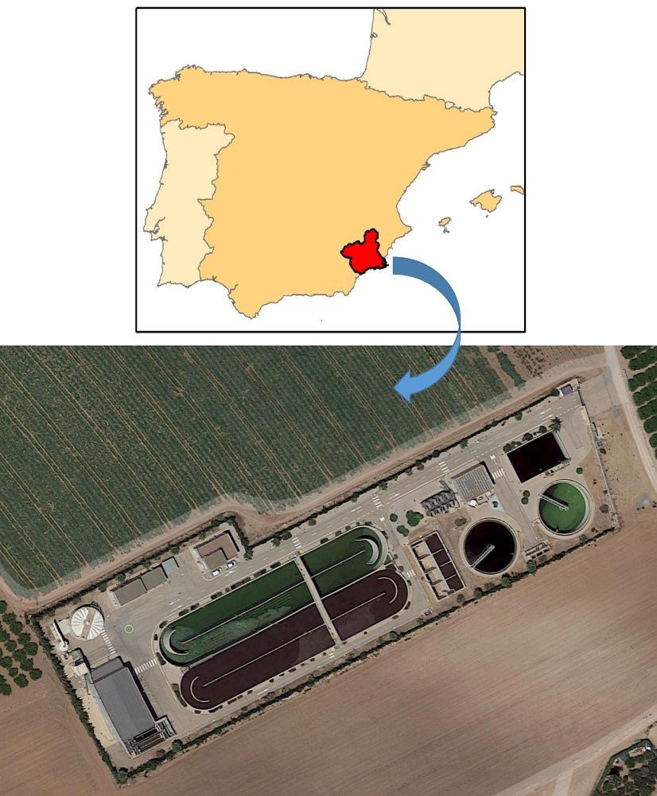

Fig. S1. Location of “La Aljorra” WWTP (37º41’16’’N, 01º03’13’’W).

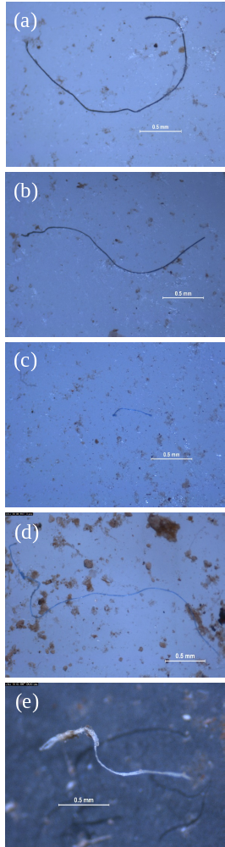
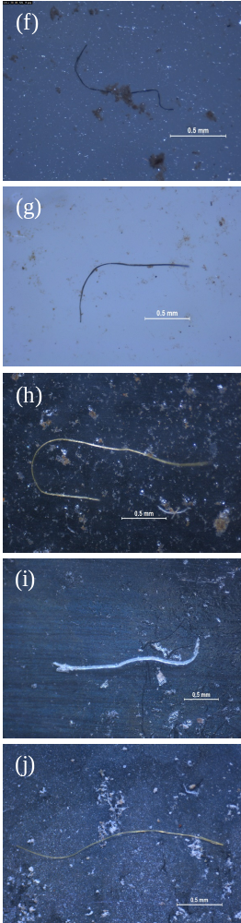

Fig. S2. Unidentified fibers from “la Aljorra” WWTP: (a-e) INF and (f-j) EFF.

