 | - Azocasein Agar | - Casein Agar | - Gelatin Agar | - Colloidal Chitin Agar
Winter wheat extract | 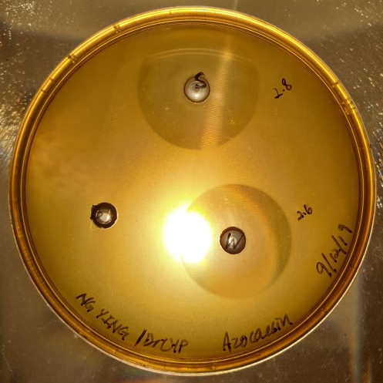  P  S  N | 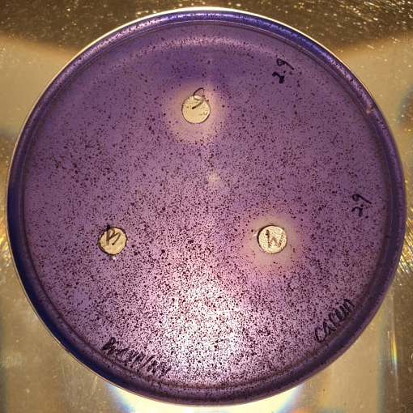  S  P  N | 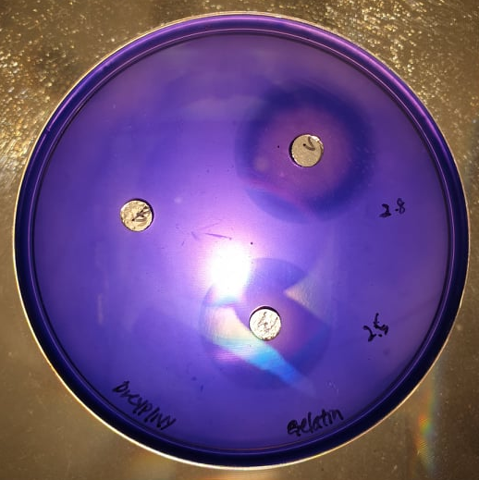  S  P  N | 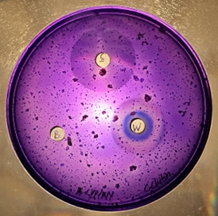  S  P  N
Buckwheat extract | 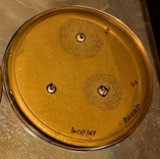  S  P  N | 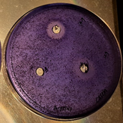  S  P  N | 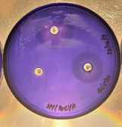  S  P  N | 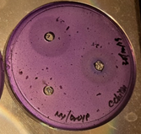  S  P  N

Figure 1. Protease detection from germinated winter wheat extract and buckwheat extract on the agar of (a) azocasein; (b) casein; (c) gelatin and chitinase detection on the colloidal chitin agar. (N: Negative control; P: Positive control: S: Sample)

