Supporting Information

Surface Grafting of a Zwitterionic Copolymer onto a Cellulose Nanofiber Membrane for Oil/Water Separation

Dongwan Son,^{1,a}, Seungjun Kim,^{1,a} Jinhyeong Kim,¹ Myungwoong Kim,^{1,*} Hoik Lee^{2,*}

¹Department of Chemistry and Chemical Engineering, Inha University, Incheon 22212, Republic of Korea
²Advanced Textile R&D Department, Research Institute of Convergence Technology, Korea Institute of Industrial Technology (KITECH), 143 Hanggaulro, Sangnok-gu, Ansan-si, Gyeonggi-do 15588, Republic of Korea

* To whom correspondence should be addressed:
Myungwoong Kim (mkim233@inha.ac.kr)
Hoik Lee (hoik@kitech.re.kr)

ªD.S. and S.K. contributed equally to this work.

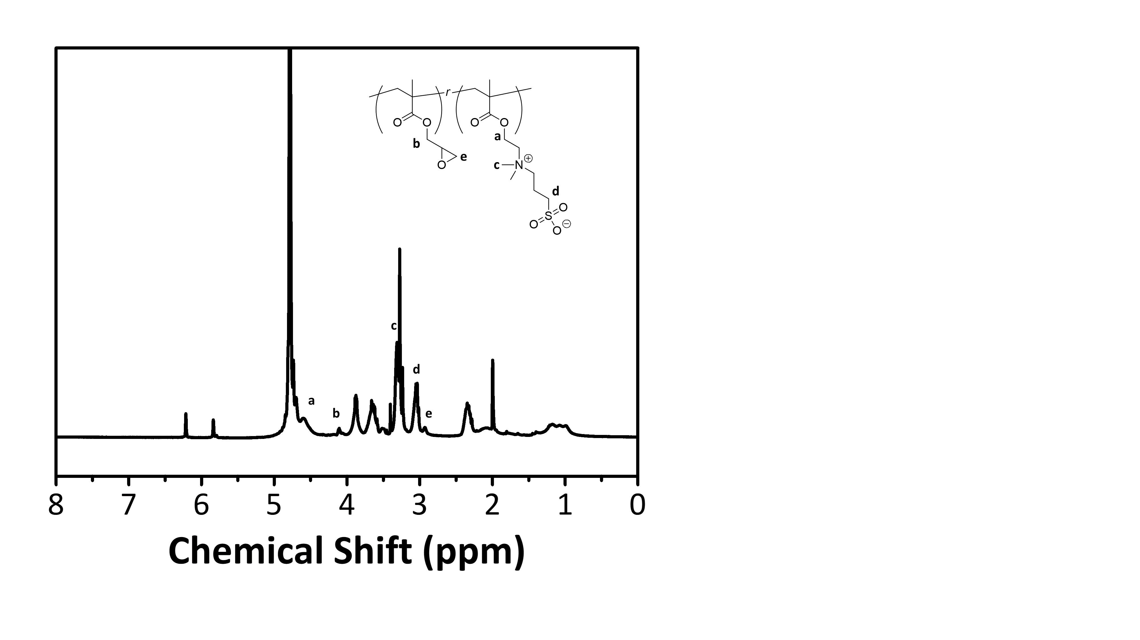
Fig. S1 ¹H NMR spectrum of synthesized poly(SBMA-r-GMA) (solvent: D₂O)

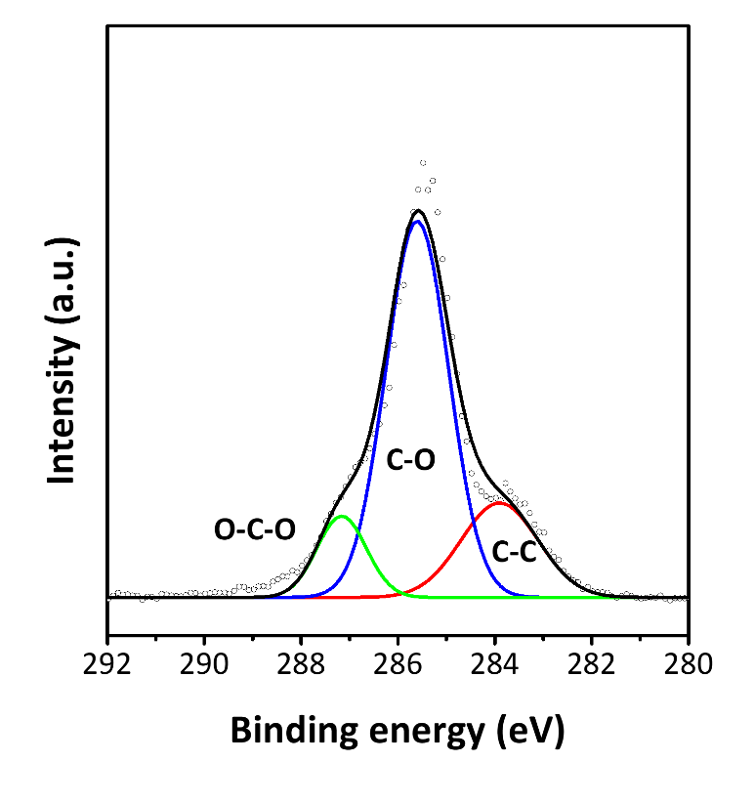
Fig. 2 XPS multiplex spectrum of cellulose nanofiber membrane for C_{1s} at 280-292 eV

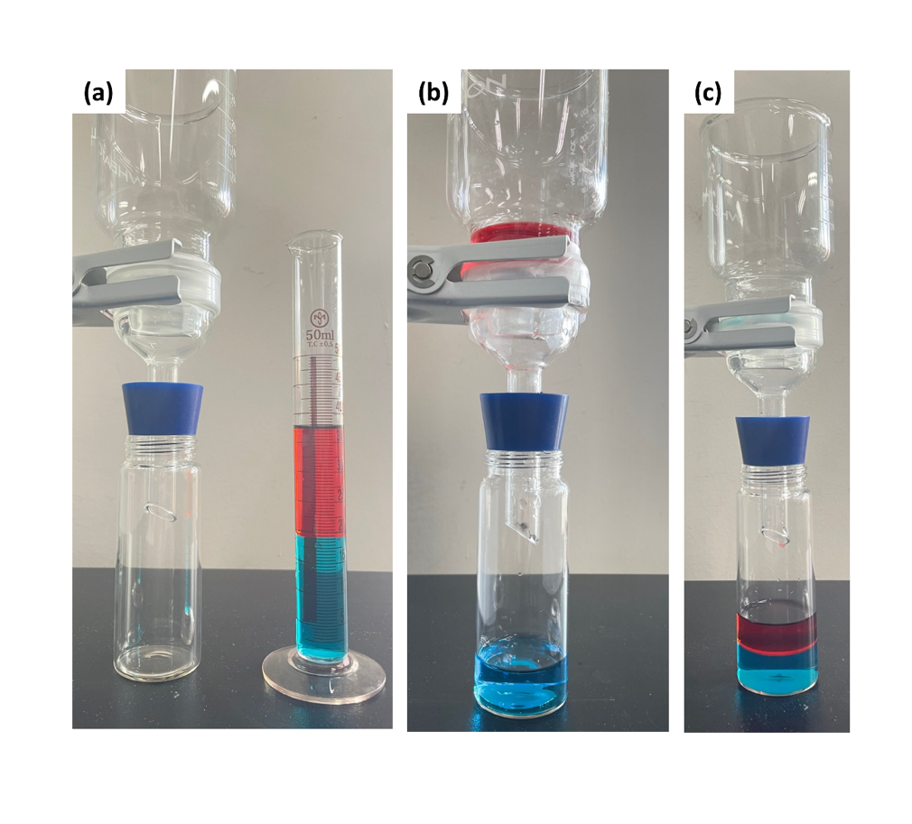
Fig. S3 Photographs showing (a) filtration apparatus equipped with Z-CL nanofiber membrane filter and oil/water mixture, (b) after filtration of the mixture leaving oil phase on top of the membrane, and (c) after filtration of the mixture with pristine cellulose nanofiber membrane

