Supplemental Figures
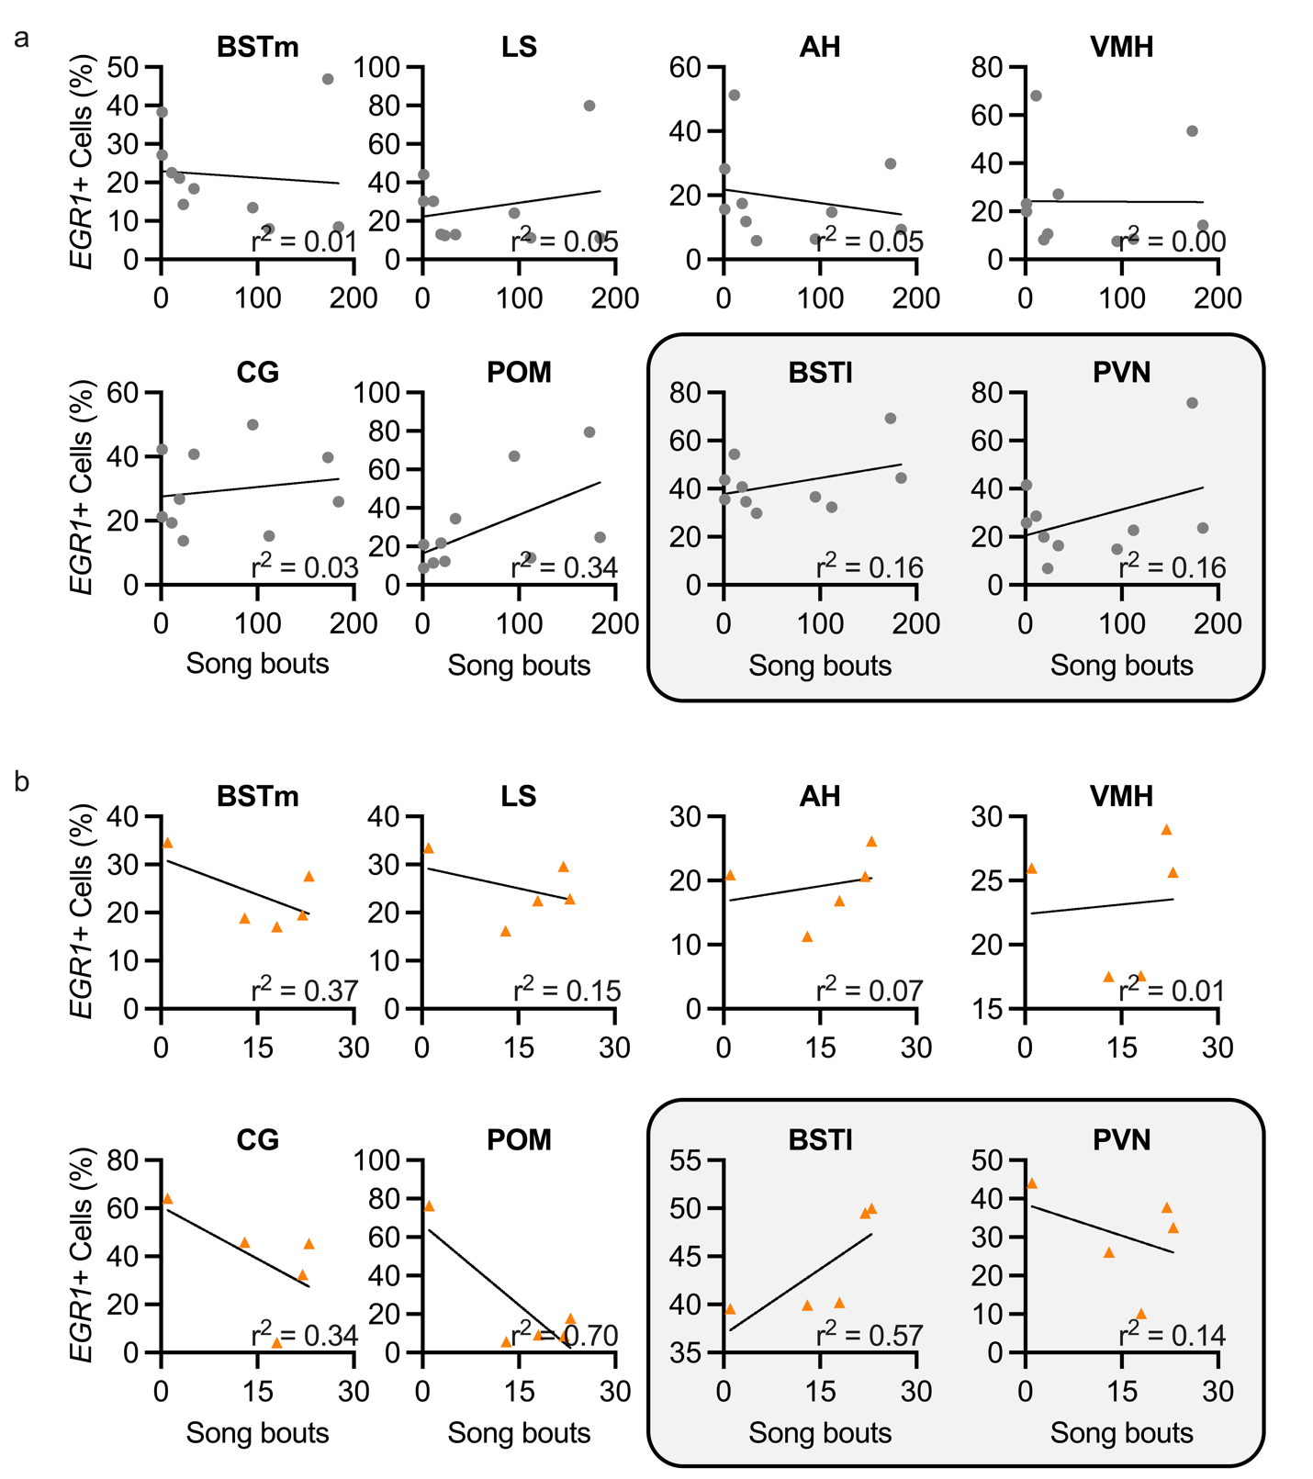
Supplemental Fig 1 Correlations between song bouts produced and percentage of cellular activation in all regions of the social behavior network, BSTl, and PVN in non-social and social conditions. Percentage of cells expressing EGR1 is plotted against the number of song bouts produced for individual animals in non-social undirected (a, gray circles) and social female-directed (b, orange triangles) singing conditions

