Graph 1. Cluster of participants by the Charlson Index modified by age.
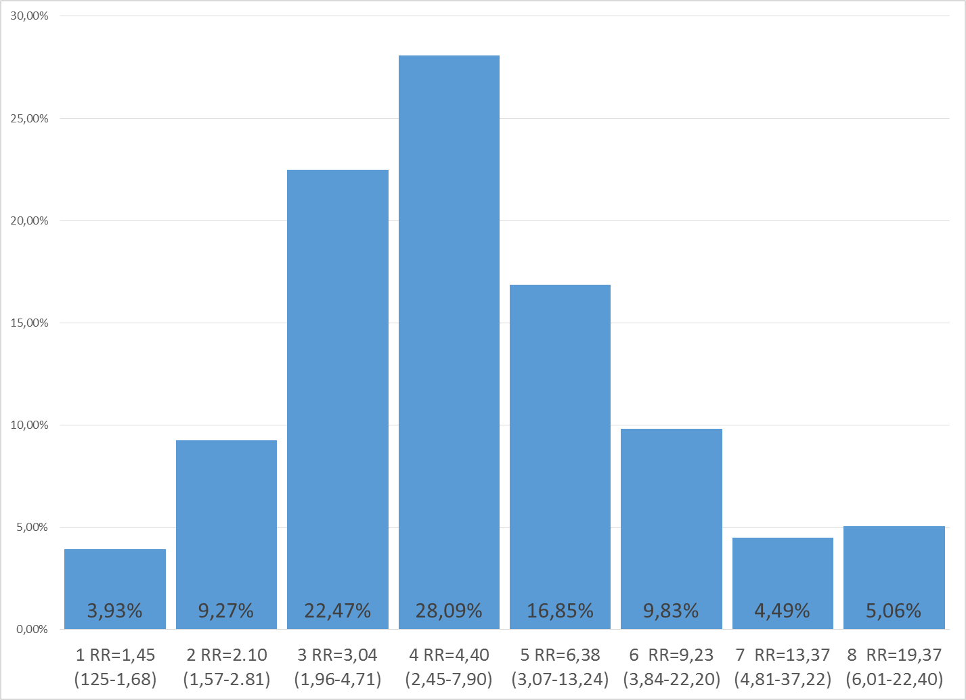
Graph 2. Relationship between polypharmacy and the Orthogeriatric unit (OU)
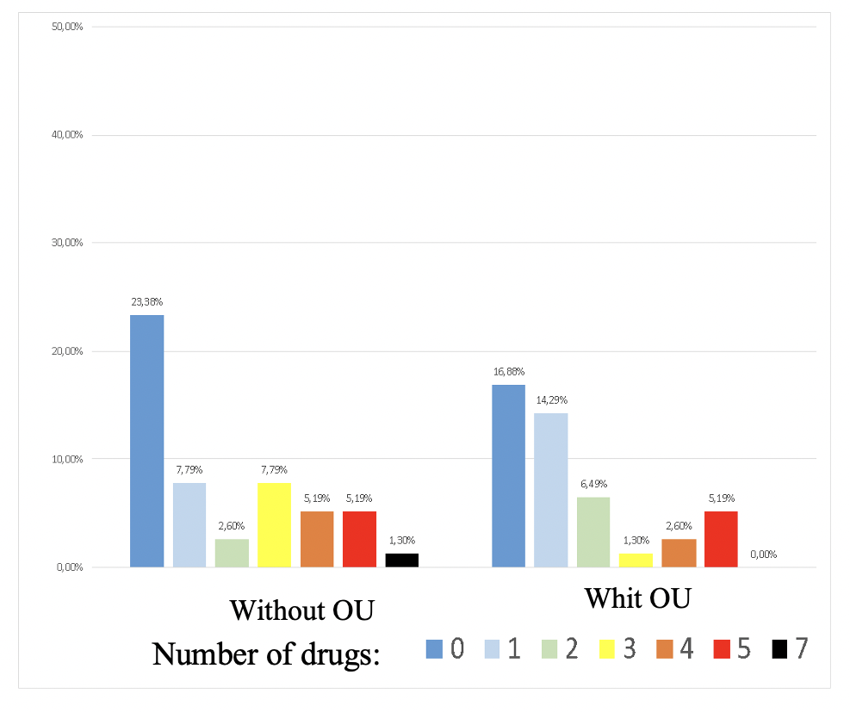
Number of drugs:
Without OU
Whit OU
Graph 3. Average of hospital stay
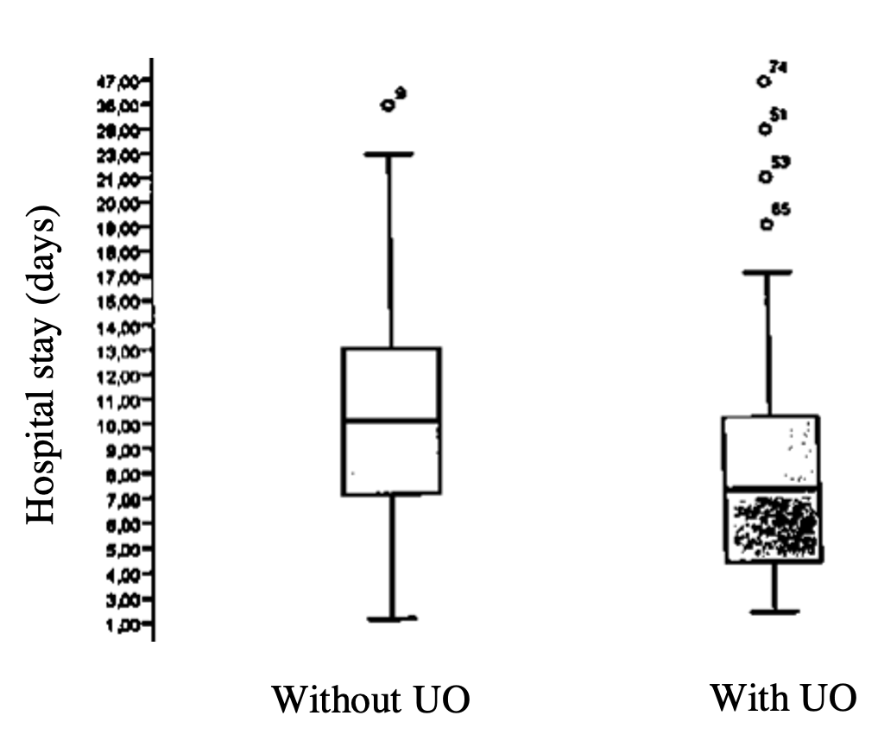

Graph 4. Bed-day cost
