Supplementary Materials:
Impacts of Testing, Vaccination, and Immunity on COVID-19 Cases in Schools

Item | Page Number
Supplementary Table 1. Data Sources | 2
Supplementary Table 2. Biweekly Vaccination and Incidence Rates | 3
Supplementary Table 3. Biweekly total population size that participated in the testing program | 4
Supplementary Table 4. All Schools, Total Test Positivity Rate | 5
Supplementary Table 5. Sensitivity Analysis (First 6 weeks of the program excluded) | 6
Supplementary Table 6. Impact of high versus low vaccination rates in schools during the second half of the academic year (Omicron period), all test results | 7
Supplementary Figure 1. County Incidence Rates | 8
Supplementary Figure 2. Student Consent Rates, In-School Testing and Positivity Rates | 9
Supplementary Figure 3. Unadjusted mean case rates in high schools with low versus high vaccination rates | 10

Supplementary Table 1. Sources of Data
Variable | Data Source
Testing consent rate | CIC data file
Test type (TTS, pooled testing, other) | CIC data file
Test result | CIC data file
Age of person receiving test | CIC data file; estimated based on birth year
School age of student | Estimated based on birth year  Age 5-11: Elementary school  Age 12-14: Middle school  Age 15-19: High school  Age >19: Non-student
School population | DESE, NCES
Community COVID-19 incidence rate | Massachusetts DPH COVID-19 Dashboard
Community COVID-19 vaccination rate | Massachusetts DPH COVID-19 Dashboard
COVID-19 vaccination rate (district-level) | Estimated based on town vaccination rates from the Massachusetts DPH COVID-19 Dashboard  Age 5-11: Elementary school  Age 12-14: Middle school  Age 15-19: High school  Age >19: Non-student
School Type (Public, private, charter, elementary, middle, high, mixed) | DESE data file  NCES data file
School Demographics (E.g., racial distribution of students, %non-Hispanic white, Title I status) | NCES data file
Urban-Rural Index | DESE data file  NCES data file
Pooled testing positivity rate | Calculated variable:  # positive pools/consented population/school/biweekly period  Note: Due to the nature of pooled testing results, which included multiple individuals in one testing run, age of the individual was not available for these tests. For the purposes of the analysis, all positive pools were attributed to cases in students, however, some of the positive pools were likely from staff members.
Total testing positivity rate | Calculated variable:  # positive tests/consented population/school/biweekly period  Note: Reflex testing results excluded from the analysis, as these tests were duplicates to confirm pooled testing positivity rates.  Note: All tests performed in individuals 19 years of age or younger were assumed to be students and all tests performed in individuals older than 19 years of age were assumed to be not students. In cases where the age variable was not available, tests were assumed to have been performed on students.

Supplementary Table 2. Biweekly Vaccination and Incidence Rates and In-School Testing Positivity Rates in all counties
Week | County Vaccination Rate | Mean County COVID-19 Incidence Rate | Sum of County COVID-19 Incidence Rate (per 100,000 residents) | Surveillance Testing Positivity Rate* (%) | Test-to-Stay Positivity Rate* (%) | All Positive Tests | All Tests
9/5/2021 | 0.63 | 293.85 | 4114 | 0.79 | 3.75 | 20 | 1,714
9/19/2021 | 0.64 | 390.73 | 5470 | 0.94 | 0.34 | 129 | 12,473
10/3/2021 | 0.65 | 264.70 | 3706 | 0.80 | 0.33 | 325 | 35,434
10/17/2021 | 0.65 | 233.51 | 3269 | 0.99 | 0.63 | 565 | 50,398
10/31/2021 | 0.66 | 235.73 | 3300 | 0.85 | 0.61 | 845 | 86,392
11/14/2021 | 0.67 | 288.70 | 4042 | 1.36 | 1.00 | 1,436 | 96,763
11/28/2021 | 0.68 | 442.26 | 6192 | 2.18 | 0.95 | 1,870 | 109,547
12/12/2021 | 0.69 | 834.84 | 11688 | 3.02 | 1.00 | 4,205 | 192,792
12/26/2021 | 0.70 | 1098.95 | 15385 | 3.74 | 1.22 | 4,704 | 197,720
1/9/2022 | 0.71 | 3240.52 | 45367 | 18.33 | 5.47 | 13,065 | 96,261
1/23/2022 | 0.71 | 2725.70 | 38160 | 10.86 | 3.66 | 20,975 | 252,845
2/6/2022 | 0.72 | 1031.04 | 14435 | 4.19 | 1.90 | 7,005 | 162,696
2/20/2022 | 0.73 | 339.70 | 4756 | 1.69 | 1.50 | 2,182 | 97,460
3/6/2022 | 0.73 | 222.19 | 3111 | 0.99 | 0.94 | 536 | 40,743
3/20/2022 | 0.73 | 127.25 | 1781 | 0.81 | 1.08 | 771 | 70,284
4/3/2022 | 0.73 | 186.38 | 2609 | 1.28 | 1.94 | 1,273 | 71,478
4/17/2022 | 0.74 | 242.65 | 3397 | 2.10 | 1.65 | 2,006 | 74,867
5/1/2022 | 0.74 | 491.34 | 6879 | 2.41 | 1.49 | 1,396 | 45,913
5/15/2022 | 0.74 | 700.78 | 9811 | 4.43 | 2.41 | 5,392 | 97,867
5/29/2022 | 0.74 | 493.52 | 6909 | 4.50 | 2.25 | 5,048 | 92,671
6/12/2022 | 0.74 | 414.29 | 5800 | 2.76 | 2.62 | 2,440 | 67,630
6/26/2022 | 0.74 | 275.29 | 3854 | 2.49 | 3.16 | 825 | 23,799

*Calculated based on the consented population within a school, not the total school population.

Supplementary Table 3. Biweekly total population size that participated in the testing program, number of total consented students, number of test-to-stay tests performed, number of surveillance pool testing performed, percentage of surveillance positivity rate
Date | Schools Population in the Program* | Consented Students in the Program** | Number of Students Tested | Population Consented (19 and Under) (%) | Test to Stay Tests Performed | Test to Stay Tests Positive (%) | Surveillance Pools Performed | Surveillance Pools Positive (%)
9/5/2021 | 24,999 | 8,140 | 1,233 | 0.38 | 152 | 3.95 | 658 | 1.06
9/19/2021 | 164,432 | 49,890 | 10,057 | 0.36 | 3,122 | 0.35 | 6,273 | 0.92
10/3/2021 | 411,131 | 138,093 | 28,439 | 0.37 | 6,055 | 0.35 | 21,156 | 0.85
10/17/2021 | 647,539 | 225,993 | 40,006 | 0.39 | 10,430 | 0.61 | 27,611 | 0.98
10/31/2021 | 844,894 | 315,554 | 70,618 | 0.42 | 32,692 | 0.63 | 33,864 | 0.83
11/14/2021 | 861,811 | 341,656 | 80,195 | 0.44 | 40,442 | 0.99 | 34,949 | 1.49
11/28/2021 | 930,980 | 381,829 | 92,846 | 0.46 | 64,129 | 0.96 | 23,848 | 2.36
12/12/2021 | 1,002,446 | 446,988 | 165,499 | 0.49 | 112,731 | 1.00 | 42,198 | 3.22
12/26/2021 | 1,001,572 | 480,473 | 169,510 | 0.53 | 128,176 | 1.21 | 31,865 | 3.96
1/9/2022 | 972,873 | 513,201 | 76,449 | 0.58 | 32,886 | 5.63 | 28,627 | 19.26
1/23/2022 | 1,022,493 | 574,316 | 209,195 | 0.61 | 108,793 | 3.73 | 73,819 | 11.29
2/6/2022 | 977,730 | 578,216 | 129,348 | 0.64 | 46,706 | 1.95 | 67,676 | 4.29
2/20/2022 | 870,360 | 521,943 | 72,456 | 0.65 | 8,960 | 1.58 | 55,384 | 1.69
3/6/2022 | 711,810 | 440,458 | 29,446 | 0.67 | 1,178 | 0.68 | 25,234 | 0.91
3/20/2022 | 810,665 | 491,812 | 52,681 | 0.65 | 2,222 | 1.22 | 43,718 | 0.81
4/3/2022 | 799,038 | 492,629 | 53,054 | 0.66 | 2,509 | 1.91 | 42,576 | 1.17
4/17/2022 | 809,691 | 496,686 | 55,979 | 0.66 | 4,639 | 1.53 | 42,533 | 2.01
5/1/2022 | 725,924 | 452,623 | 33,283 | 0.67 | 3,141 | 1.43 | 25,068 | 2.39
5/15/2022 | 884,643 | 540,910 | 74,622 | 0.66 | 11,102 | 2.43 | 46,733 | 4.46
5/29/2022 | 858,695 | 529,924 | 70,700 | 0.67 | 9,160 | 2.33 | 45,673 | 4.51
6/12/2022 | 747,025 | 467,942 | 51,198 | 0.68 | 3,508 | 2.65 | 39,961 | 2.83
6/26/2022 | 467,116 | 305,970 | 17,980 | 0.69 | 1,021 | 3.23 | 14,418 | 2.47

*Population of schools that participate to the program on the corresponding date
** Population of students consented to the program on the corresponding date

 | Supplementary Table 4. All Schools, Total Test Positivity Rate (Random Effects Regression)
 |  | Elementary Schools |  |  |  | Middle Schools |  |  | High Schools |  |  | Multiple Programs
Delta (Until Dec 15) | Cases norm | 0.116 | 0.000 |  | 0.295 |  | 0.000 |  | 0.434 | 0.000 |  | 0.052 | 0.000
Delta (Until Dec 15) | Fully vaccinated | - | - |  | 0.017 |  | 0.000 |  | 0.015 | 0.000 |  | -0.009 | 0.000
Delta (Until Dec 15) | Consent rate | 0.007 | 0.000 |  | 0.012 |  | 0.000 |  | 0.021 | 0.000 |  | 0.004 | 0.000
Delta (Until Dec 15) | Demographics of Students
Delta (Until Dec 15) | African American | -0.000005 | 0.463 |  | -0.00003 |  | 0.059 |  | -0.00004 | 0.142 |  | -0.00001 | 0.462
Delta (Until Dec 15) | Hispanic | -0.00004 | 0.000 |  | -0.0001 |  | 0.000 |  | -0.0001 | 0.000 |  | -0.00003 | 0.000
Delta (Until Dec 15) | White | -0.00001 | 0.239 |  | -0.00005 |  | 0.000 |  | -0.0001 | 0.002 |  | 0.000004 | 0.584
Delta (Until Dec 15) | Other | 0.00002 | 0.001 |  | 0.0001 |  | 0.000 |  | 0.0001 | 0.000 |  | 0.000004 | 0.754
Delta (Until Dec 15) | Demographics of Schools
Delta (Until Dec 15) | Rural Status | 0.001 | 0.000 |  | 0.002 |  | 0.000 |  | 0.006 | 0.000 |  | 0.001 | 0.085
Delta (Until Dec 15) | Title 1 Status | -0.0004 | 0.001 |  | -0.0001 |  | 0.905 |  | -0.002 | 0.025 |  | -0.001 | 0.329
Delta (Until Dec 15) | Charter School | 0.001 | 0.289 |  | 0.006 |  | 0.000 |  | -0.006 | 0.001 |  | -0.0001 | 0.929
Delta (Until Dec 15) | Public School | 0.001 | 0.000 |  | 0.002 |  | 0.002 |  | 0.006 | 0.000 |  | 0.0002 | 0.659
Omicron (Dec 16 to June) | Cases norm | -0.093 | 0.000 |  | -0.023 |  | 0.000 |  | -0.146 | 0.000 |  | -0.235 | 0.000
Omicron (Dec 16 to June) | Fully vaccinated | -0.023 | 0.000 |  | -0.007 |  | 0.000 |  | -0.010 | 0.000 |  | -0.046 | 0.000
Omicron (Dec 16 to June) | Consent rate | -0.006 | 0.000 |  | -0.00003 |  | 0.534 |  | -0.014 | 0.000 |  | -0.003 | 0.028
Omicron (Dec 16 to June) | Demographics of Students
Omicron (Dec 16 to June) | African American | -0.00005 | 0.021 |  | 0.00005 |  | 0.142 |  | 0.0001 | 0.141 |  | 0.00004 | 0.110
Omicron (Dec 16 to June) | Hispanic | -0.00001 | 0.468 |  | 0.00003 |  | 0.417 |  | 0.00002 | 0.510 |  | -0.00003 | 0.159
Omicron (Dec 16 to June) | White | 0.00003 | 0.123 |  | 0.0001 |  | 0.200 |  | 0.00004 | 0.211 |  | -0.0001 | 0.001
Omicron (Dec 16 to June) | Other | 0.0001 | 0.000 |  | 0.002 |  | 0.295 |  | -0.0001 | 0.221 |  | -0.0001 | 0.055
Omicron (Dec 16 to June) | Demographics of Schools
Omicron (Dec 16 to June) | Rural Status | -0.004 | 0.000 |  | -0.0004 |  | 0.690 |  | -0.001 | 0.401 |  | -0.004 | 0.014
Omicron (Dec 16 to June) | Title 1 Status | -0.001 | 0.065 |  | -0.002 |  | 0.649 |  | 0.001 | 0.358 |  | -0.003 | 0.040
Omicron (Dec 16 to June) | Charter School | 0.007 | 0.026 |  | -0.0004 |  | 0.740 |  | 0.005 | 0.082 |  | 0.004 | 0.023
Omicron (Dec 16 to June) | Public School | -0.001 | 0.050 |  | -0.023 |  | 0.000 |  | -0.005 | 0.000 |  | 0.0001 | 0.956
Variables in bold are significant to p<0.05.

Supplementary Table 5. Sensitivity Analysis (First 6 weeks of the program excluded)
 |  | Elementary Schools |  |  | Middle Schools |  |  | High Schools |  |  | Mixed School Age
 | Positivity Rate | β-coefficient | p-value |  | β-coefficient | p-value |  | β-coefficient | p-value |  | β-coefficient | p-value
Delta (Until Dec 15) | County Cumulative Cases per 100,000 residents | 0.508 | 0.000 |  | 0.678 | 0.000 |  | 0.447 | 0.000 |  | 0.466 | 0.000
Delta (Until Dec 15) | Proportion of school-aged children fully vaccinated in the district | - | - |  | 0.037 | 0.000 |  | 0.012 | 0.001 |  | -0.009 | 0.000
Delta (Until Dec 15) | Consent rate | 0.025 | 0.000 |  | 0.019 | 0.000 |  | 0.021 | 0.000 |  | 0.016 | 0.000
Delta (Until Dec 15) | Demographics of Students
Delta (Until Dec 15) | African American | -0.0001 | 0.060 |  | -0.00004 | 0.554 |  | 0.00001 | 0.924 |  | -0.0001 | 0.045
Delta (Until Dec 15) | Hispanic | -0.0002 | 0.000 |  | -0.0001 | 0.168 |  | -0.00005 | 0.278 |  | -0.0001 | 0.000
Delta (Until Dec 15) | White | -0.00003 | 0.505 |  | 0.00003 | 0.654 |  | 0.0001 | 0.191 |  | 0.0001 | 0.002
Delta (Until Dec 15) | Other | 0.0001 | 0.002 |  | 0.0004 | 0.000 |  | 0.0001 | 0.106 |  | 0.00003 | 0.280
Delta (Until Dec 15) | Demographics of Schools
Delta (Until Dec 15) | Rural status | 0.006 | 0.000 |  | 0.005 | 0.126 |  | 0.006 | 0.001 |  | 0.010 | 0.000
Delta (Until Dec 15) | Title1 status | -0.003 | 0.004 |  | -0.001 | 0.616 |  | -0.003 | 0.152 |  | -0.001 | 0.305
Delta (Until Dec 15) | Charter school | 0.013 | 0.011 |  | 0.017 | 0.001 |  | -0.007 | 0.029 |  | 0.003 | 0.052
Delta (Until Dec 15) | Public school | 0.002 | 0.014 |  | 0.004 | 0.035 |  | 0.007 | 0.000 |  | 0.005 | 0.000
Omicron (Dec 16 to June) | County Cumulative Cases per 100,000 residents | -0.402 | 0.000 |  | -0.521 | 0.000 |  | -0.466 | 0.000 |  | -0.434 | 0.000
Omicron (Dec 16 to June) | Proportion of school-aged children fully vaccinated in the district | -0.069 | 0.000 |  | -0.062 | 0.000 |  | -0.021 | 0.001 |  | -0.088 | 0.000
Omicron (Dec 16 to June) | Consent rate | -0.014 | 0.000 |  | -0.015 | 0.001 |  | -0.031 | 0.000 |  | -0.007 | 0.031
Omicron (Dec 16 to June) | Demographics of students
Omicron (Dec 16 to June) | African American | -0.00004 | 0.493 |  | -0.0001 | 0.557 |  | 0.0003 | 0.008 |  | 0.0001 | 0.131
Omicron (Dec 16 to June) | Hispanic | 0.0001 | 0.290 |  | 0.0002 | 0.125 |  | 0.0002 | 0.023 |  | -0.00001 | 0.809
Omicron (Dec 16 to June) | White | 0.0001 | 0.165 |  | -0.0001 | 0.620 |  | 0.00005 | 0.558 |  | -0.0001 | 0.004
Omicron (Dec 16 to June) | Other | 0.0002 | 0.000 |  | -0.0002 | 0.228 |  | -0.00004 | 0.701 |  | -0.00005 | 0.439
Omicron (Dec 16 to June) | Demographics of School
Omicron (Dec 16 to June) | Rural status | -0.011 | 0.000 |  | -0.005 | 0.200 |  | -0.009 | 0.013 |  | -0.001 | 0.711
Omicron (Dec 16 to June) | Title 1 status | -0.002 | 0.210 |  | 0.002 | 0.474 |  | 0.001 | 0.785 |  | 0.000 | 0.915
Omicron (Dec 16 to June) | Charter school | 0.006 | 0.431 |  | -0.023 | 0.013 |  | 0.011 | 0.048 |  | -0.002 | 0.627
Omicron (Dec 16 to June) | Public school | -0.004 | 0.011 |  | -0.006 | 0.074 |  | -0.015 | 0.000 |  | -0.008 | 0.000
Variables in bold are significant to p<0.05
Supplementary Table 6. Impact of high versus low vaccination rates in schools during the second half of the academic year (Omicron period), all test results
 |  | Elementary School |  |  |  | High School
Jan 1st – Feb 28th | Positivity Rate | β-coefficient | p-value | Confidence Interval |  | β-coefficient | p-value | Confidence Interval
Jan 1st – Feb 28th | County Cumulative Cases per 100,000 residents | -1.205 | 0.000 | -1.225 | -1.186 | -1.463 | 0.000 | -1.510 | -1.416
Jan 1st – Feb 28th | Consent rate | -0.055 | 0.000 | -0.060 | -0.051 | -0.056 | 0.000 | -0.064 | -0.047
Jan 1st – Feb 28th | Demographics of students
Jan 1st – Feb 28th | African American | 0.0001 | 0.053 | 0.000 | 0.000 | 0.0004 | 0.000 | 0.000 | 0.001
Jan 1st – Feb 28th | Hispanic | 0.001 | 0.000 | 0.001 | 0.001 | 0.001 | 0.000 | 0.001 | 0.001
Jan 1st – Feb 28th | White | -0.00002 | 0.732 | 0.000 | 0.000 | 0.0004 | 0.000 | 0.000 | 0.001
Jan 1st – Feb 28th | Other | -0.0004 | 0.000 | 0.000 | 0.000 | -0.0003 | 0.009 | -0.001 | 0.000
Jan 1st – Feb 28th | Demographics of school
Jan 1st – Feb 28th | Rural status | -0.011 | 0.000 | -0.015 | -0.008 | -0.018 | 0.000 | -0.027 | -0.010
Jan 1st – Feb 28th | Title 1 status | 0.003 | 0.028 | 0.000 | 0.005 | 0.017 | 0.000 | 0.010 | 0.024
Jan 1st – Feb 28th | Charter school | 0.015 | 0.045 | 0.000 | 0.029 | 0.001 | 0.840 | -0.011 | 0.014
Jan 1st – Feb 28th | Public school | -0.005 | 0.001 | -0.007 | -0.002 | -0.029 | 0.000 | -0.036 | -0.023
Jan 1st – Feb 28th | Low vaccination uptake* (yes/no) | 0.016 | 0.000 | 0.013 | 0.019 | 0.031 | 0.000 | 0.024 | 0.037
Mar 1st – End | County Cumulative Cases per 100,000 residents | 0.209 | 0.000 | 0.199 | 0.219 | 0.437 | 0.000 | 0.406 | 0.468
Mar 1st – End | Consent rate | 0.005 | 0.000 | 0.003 | 0.007 | 0.011 | 0.000 | 0.006 | 0.016
Mar 1st – End | Demographics of students
Mar 1st – End | African American | -0.00001 | 0.951 | 0.000 | 0.000 | -0.0001 | 0.228 | 0.000 | 0.000
Mar 1st – End | Hispanic | -0.0001 | 0.000 | 0.000 | 0.000 | -0.0002 | 0.000 | 0.000 | 0.000
Mar 1st – End | White | 0.00002 | 0.294 | 0.000 | 0.000 | 0.00001 | 0.909 | 0.000 | 0.000
Mar 1st – End | Other | -0.00002 | 0.527 | 0.000 | 0.000 | 0.0001 | 0.026 | 0.000 | 0.000
Mar 1st – End | Demographics of school
Mar 1st – End | Rural status | 0.002 | 0.005 | 0.001 | 0.004 | 0.007 | 0.001 | 0.003 | 0.012
Mar 1st – End | Title1 status | -0.002 | 0.001 | -0.003 | -0.001 | -0.005 | 0.007 | -0.009 | -0.001
Mar 1st – End | Charter school | 0.0002 | 0.927 | -0.005 | 0.006 | -0.0002 | 0.947 | -0.007 | 0.006
Mar 1st – End | Public school | 0.002 | 0.006 | 0.000 | 0.003 | 0.010 | 0.000 | 0.006 | 0.014
Mar 1st – End | Low vaccination uptake* (yes/no) | -0.003 | 0.000 | -0.004 | -0.002 | -0.011 | 0.000 | -0.014 | -0.007
*Defined as <50% of students fully vaccinated against COVID-19 at a town level.
Variables in bold are significant to the p<0.05 level.
Supplementary Figure 1. County Incidence Rates

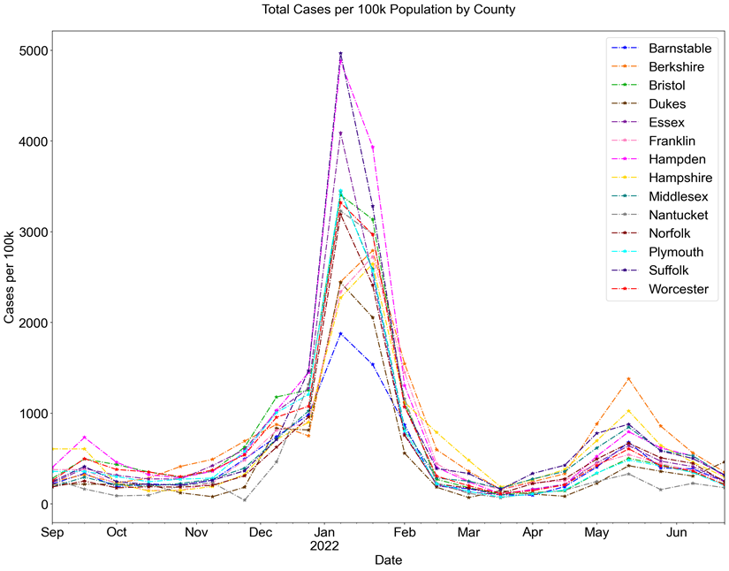

Supplementary Figure 2. Student Consent Rates, In-School Testing and Positivity Rates
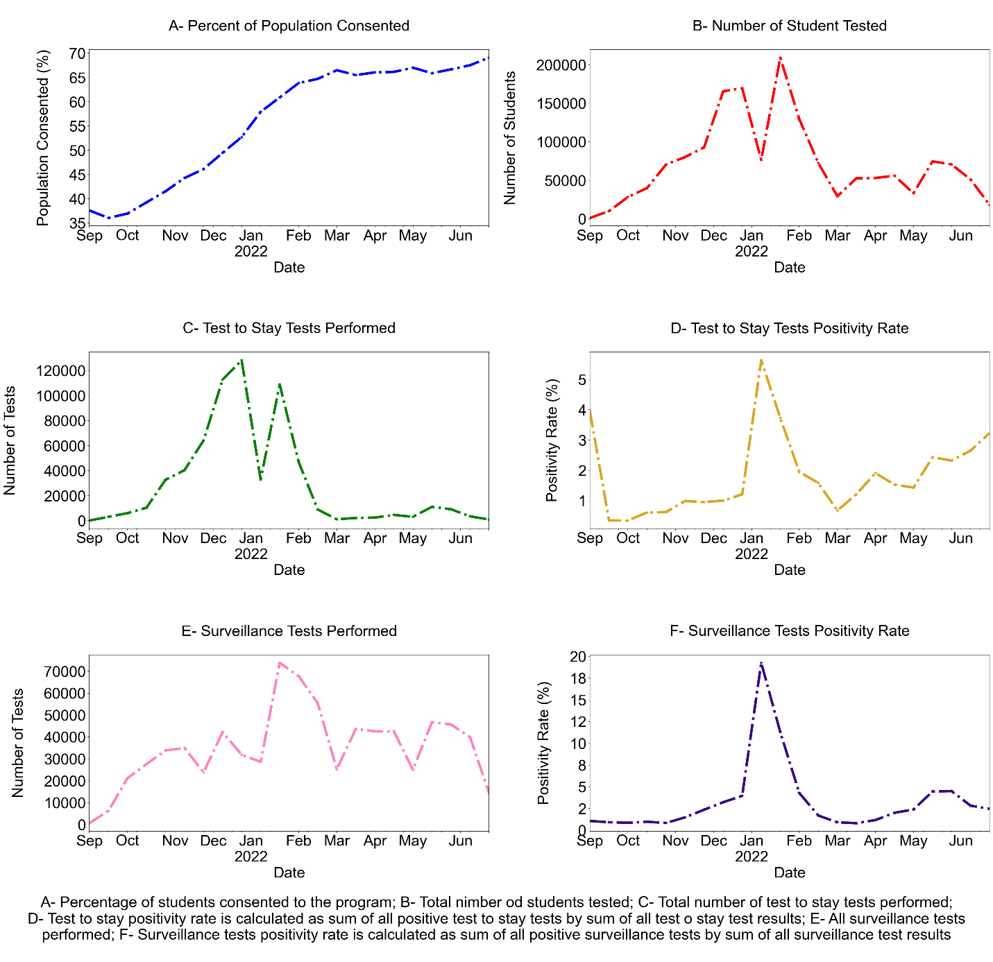

Supplementary Figure 3. Unadjusted mean case rates in high schools with low versus high vaccination rates. Panel A is all test results and Panel B is limited to pooled testing positivity only.

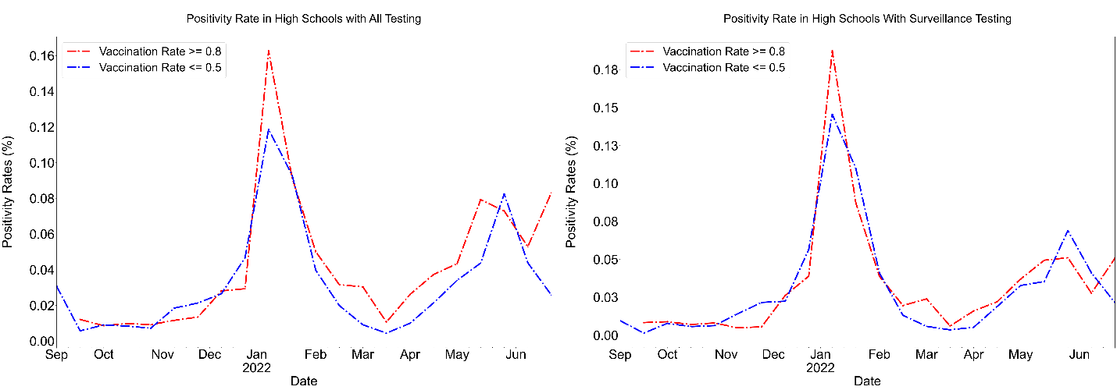
A) Unadjusted means of all tests positivity rate in high schools with low vaccination rate (less than 50%) and high vaccination rate (higher than 80%). (B) Unadjusted means of pooled testing positivity rate in High Schools with low vaccination rate (less than 50%) and high vaccination rate (higher than 80%). The red line represents schools with a ≥ 80% vaccination rate and the blue line represents schools with ≥ 50% vaccination rate.

