Supplementary material for “Weighted Spin Torque Nano-Oscillator System for Neuromorphic Computing”
Multistate weights In order to move from binary weights with two states to higher number of states we increase the number of MRAM elements in series. The WSTNO structure for two states is shown in Fig S1a) and a WSTNO structure with 12 states (11 MRAMs) is shown in Fig S1b). In this structure all MRAM elements are of the same size, but with varying switching fields. Thus, each switching will lead to a resistance jump of around 100 Ω, as shown in Fig. S2, leading to 12 resistance states independent of the order of switching. This scheme is often described as thermometer scale. Alternatively, each MRAM elements can have twice the size of the previous element and be individually switched. This leads to a binary scale with 2^{N} states, where N is the number of MRAM elements. In this scheme the order of switching has to be controlled on an individual device basis. Further optimization is ongoing in order to improve the control and reliability of these multistate devices.
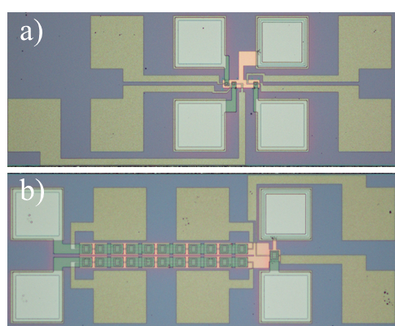
Figure S1. Optical image of the different WSTNO device structures. a) Device structure of the WSTNO including bottom contact, top contact, two MRAMs, STNO and field lines. b) Device structure of the multistate WSTNO including bottom contact, top contact, 22 MRAMs, STNO and field lines.

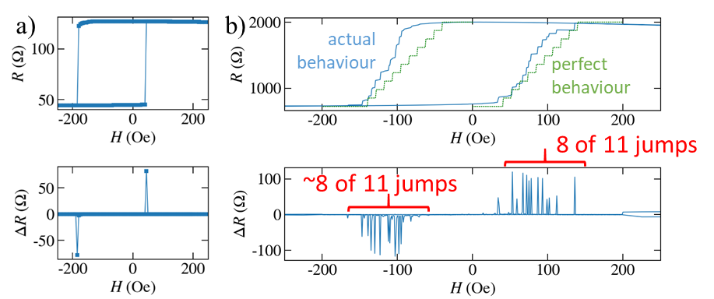
Figure S2. Electric measurement of the switching behavior of the weights in different configurations. a) Resistance and height of the resistance jumps of a single MRAM element as a function of the magnetic field. Two well defined resistance jumps are visible. b) Resistance and height of the resistance jumps of the multistate weights (multiple MRAM elements) as a function of the magnetic field. Multiple resistance jumps are detected. In comparison to the perfect behavior some deviations are visible. The switching fields are not equidistant and the resistance jump amplitude for some devices is smaller than expected. However, the majority of the devices is behaving as expected.
Digital Digit Classification The proposed WSTNO-based neural network is shown in Fig. S3a. In a trained neural network, the same inputs usually trigger the same chain reactions in such a way to fire the same neuron at the output layer. The proposed neural network includes only one layer to classify 10 digits. For this classification task, the input is 4x5 pixels digits pictures (fig. S3b), which are digitized using a 1-bit voltage Digital to Analog Converter (DAC) fed into the network. Therefore, inputs of the network can be either '0' or '1' values. These values represent whether a pixel is gray (‘0’) or blue (‘1’). This binary input is converted to a current value to contribute to the STNO biasing through MRAMs. The whole network includes 10 STNOs with 20 MRAMs as a weighted neuron. Each STNO corresponds to a digit (0-9) and the best weights are found using equation (1) and equation (3) of the main manuscript to guarantee that only one neuron (the corresponding STNO) oscillates or fires for each input pattern. Fig. S3c shows the simulation results obtained using Cadence Virtuoso. As it is seen, only the corresponding neuron fires for the corresponding input.
Figure S3. a) The proposed WSTNO-based neural network with 10 STNO neurons with 20 DC voltages as inputs, b) 10 digit input patterns of the network, and c) the simulation results of the proposed WSTNO-based neural network

