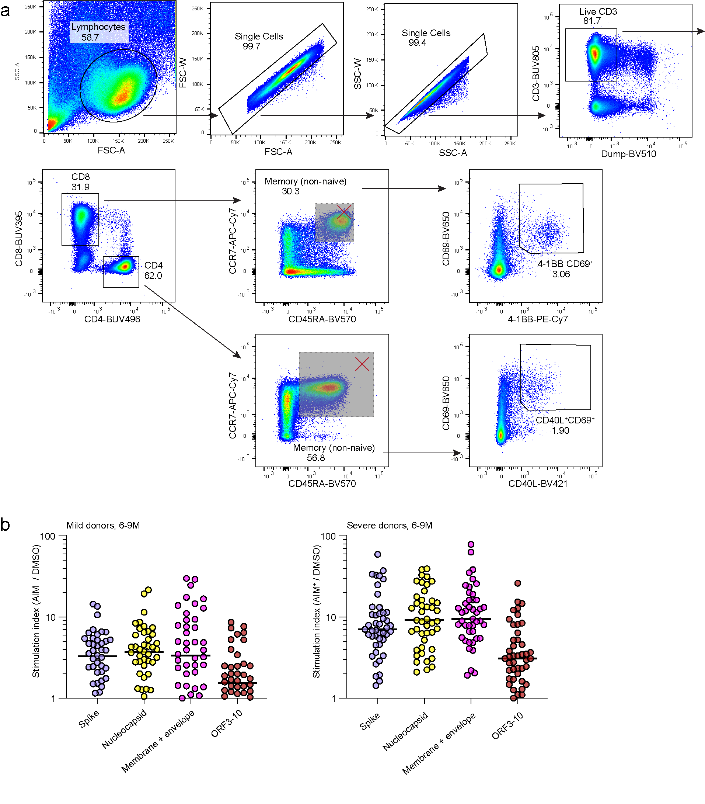
Extended Data Fig. 1: Detection of AIM⁺ T cells. a. Representative gating strategy for the identification of AIM⁺ CD4⁺ and CD8⁺ T cells from flow cytometry of peripheral blood mononuclear cells. b. Stimulation index of individual donor responses from 6M.

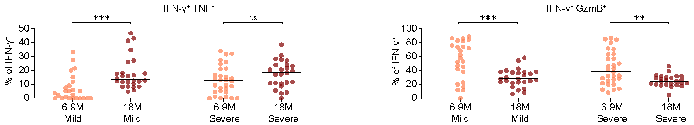
Extended Data Fig. 2: Polyfunctional responses of spike-specific CD8⁺ T cells. The proportion of cells from the total memory CD8⁺ IFNG⁺ subset with co-expression for TNF or granzyme B as measured by intracellular cytokine staining.

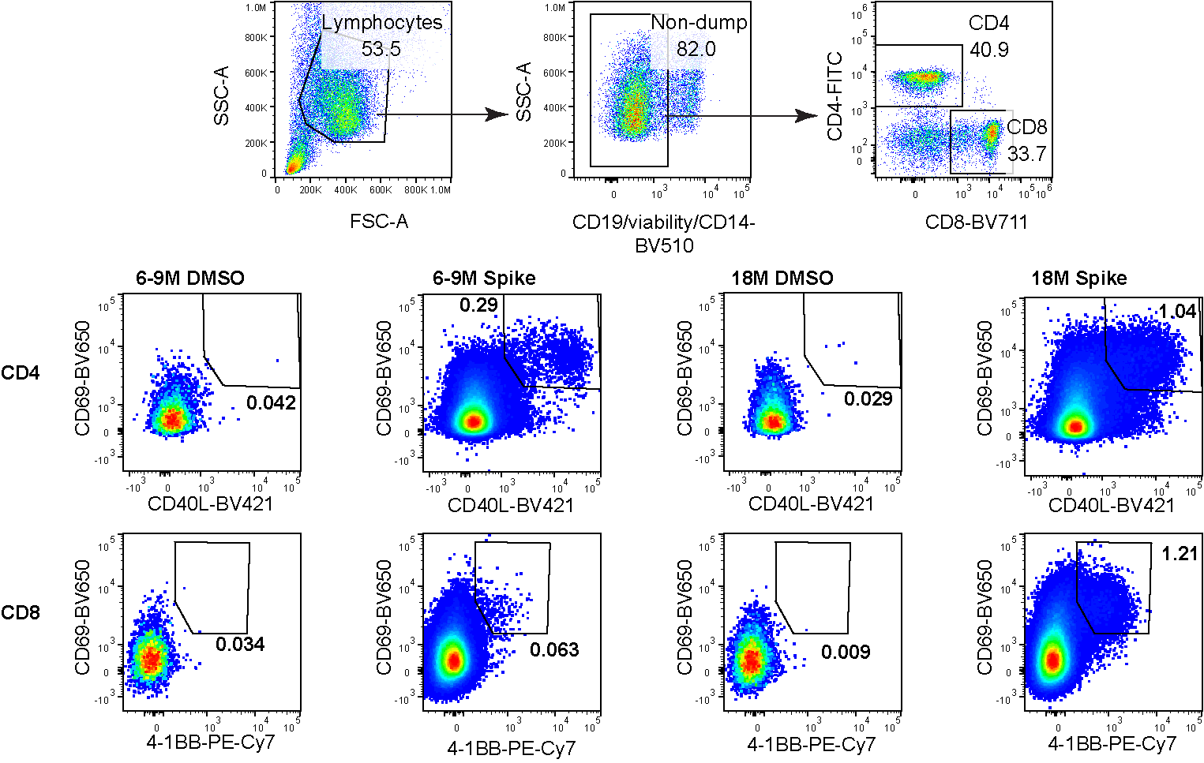
Extended Data Fig. 3: Sorting of AIM⁺ T cell populations for scRNA-seq. Representative gating strategy for the identification and sorting of AIM⁺ CD4⁺ and CD8⁺ T cells for input to scRNA-seq.

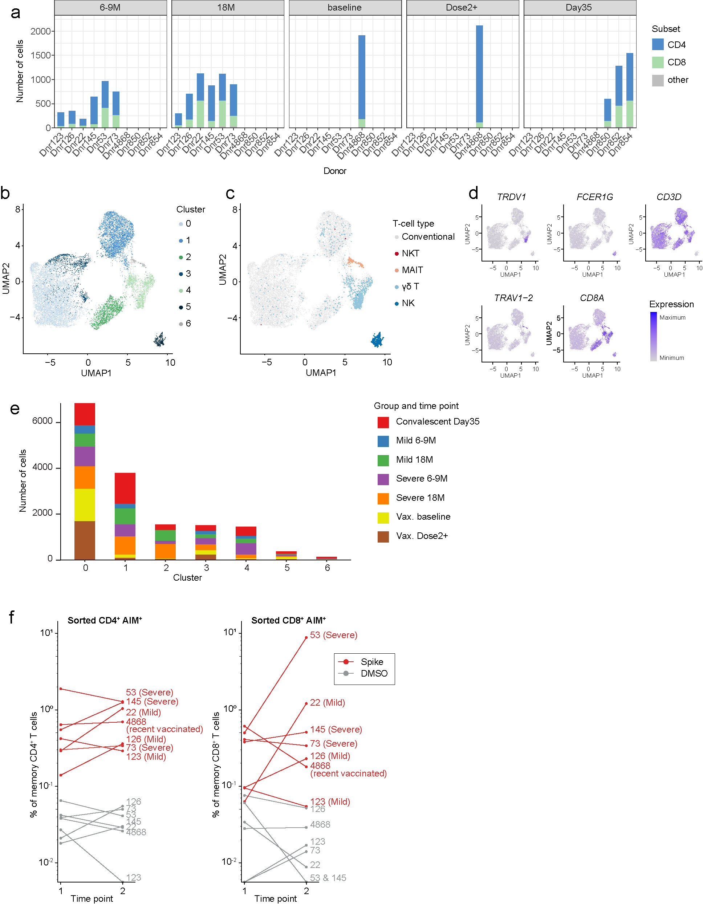
Extended Data Fig. 4: Classification of AIM⁺ populations sorted for scRNA-seq. a. Distribution of cells with CD4 or CD8 protein expression between individual donors and time points. Other includes cells with double positive or double negative CD4/CD8 expression. b. UMAP and clustering of all sorted cells including unconventional T cell subsets. c. Classification of unconventional T cell subsets. d. Expression of transcripts corresponding to conventional and unconventional T cell subsets. e. Distribution of donor groups and time points between each UMAP cluster. f. Frequency of sorted AIM+ populations as determined by flow cytometry. Time points 1 and 2 correspond to pre- and post-vaccination respectively.
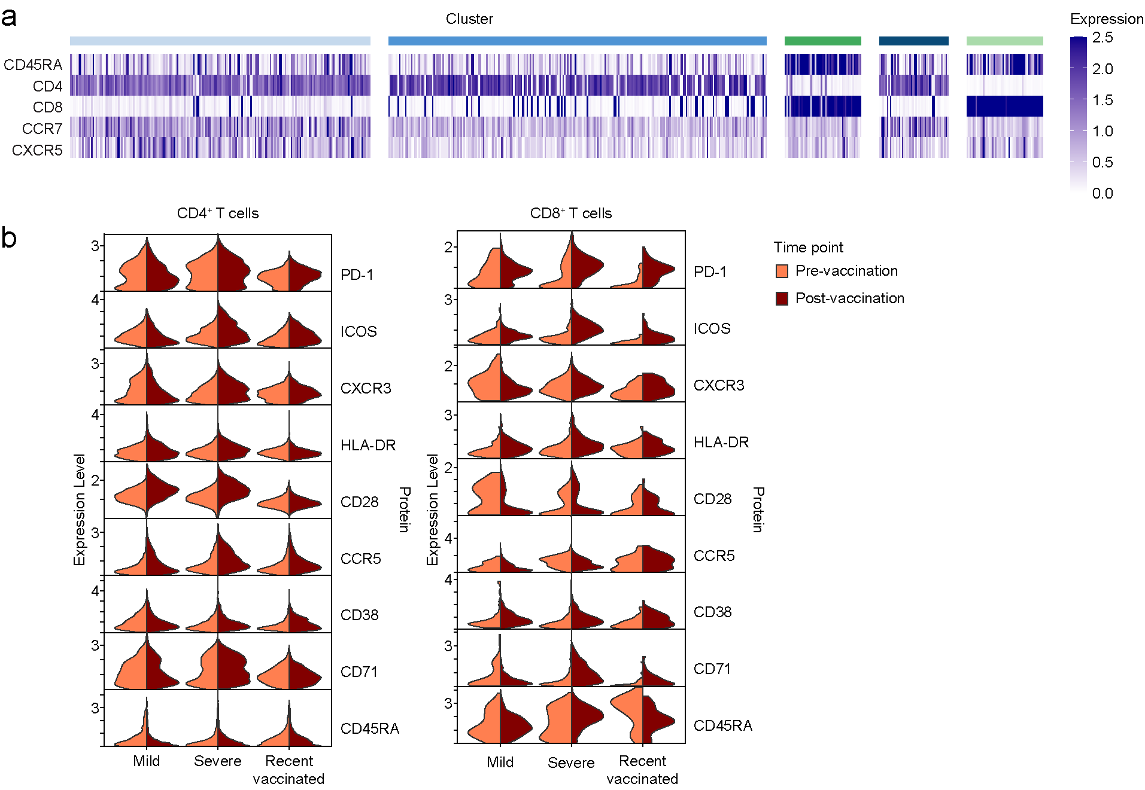
Extended Data Fig. 5: Protein expression of spike-specific T cells from CITE-seq analyses. a. Heatmap of protein expression measured by nucleotide-conjugated antibodies for convalescent donors at Day 35 using a reduced panel of markers. b. Violin plots of expression for activation markers separated by donor groups and split by time point.

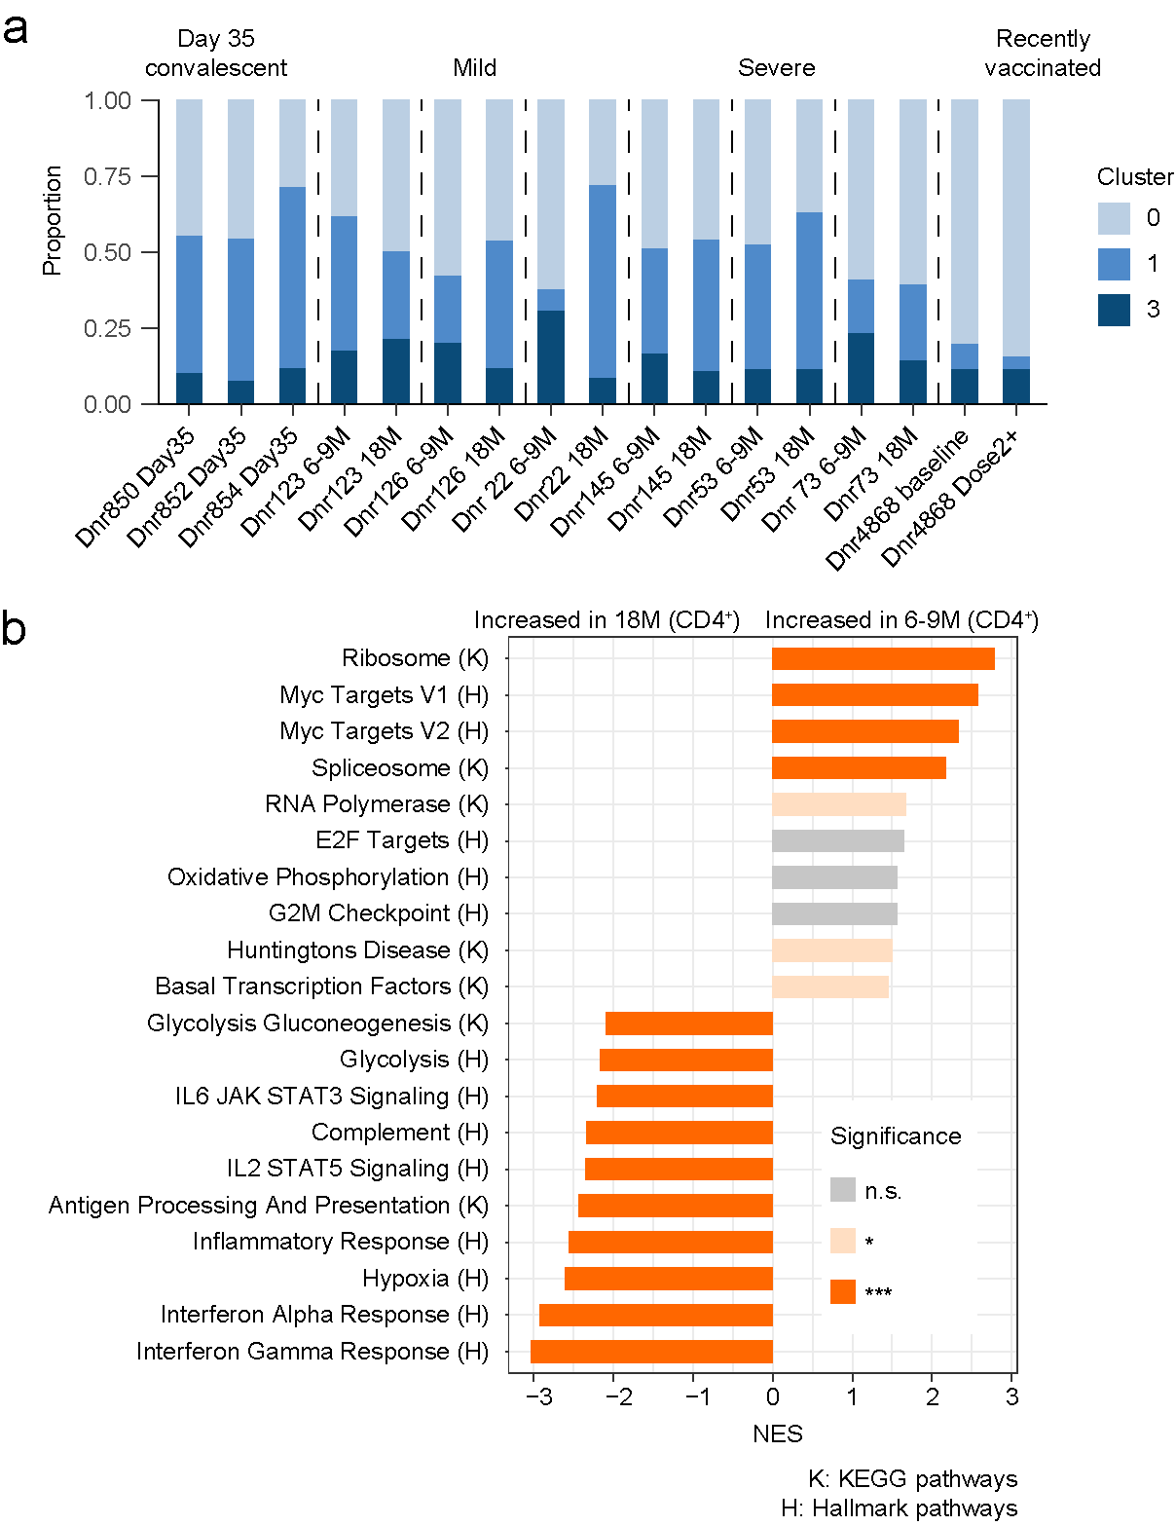
Extended Data Fig. 6: Comparison of pre- and post-vaccination spike-specific CD4⁺ T cell responses. a. Proportion of sequenced CD4⁺ T cells belonging to each CD4⁺ T cell cluster, shown at the individual donor and time point level. b. GSEA summary of differentially expressed genes between CD4⁺ T cells from 6-9M and 18M.

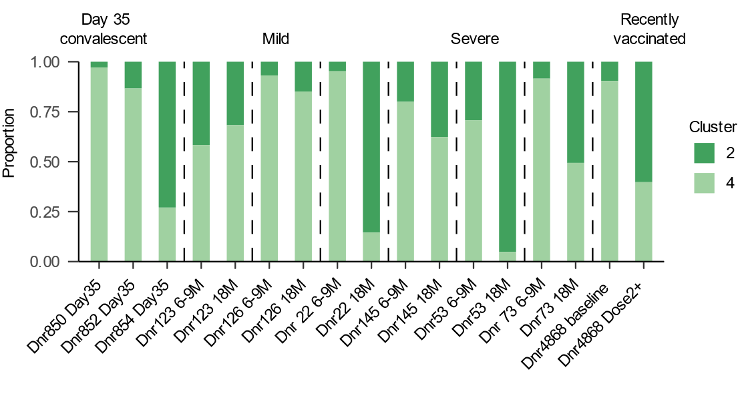
Extended Data Fig. 7: Comparison of pre- and post-vaccination spike-specific CD8⁺ T cell responses. Proportion of sequenced CD8⁺ T cells belonging to each CD8⁺ T cell cluster, shown at the individual donor and time point level.

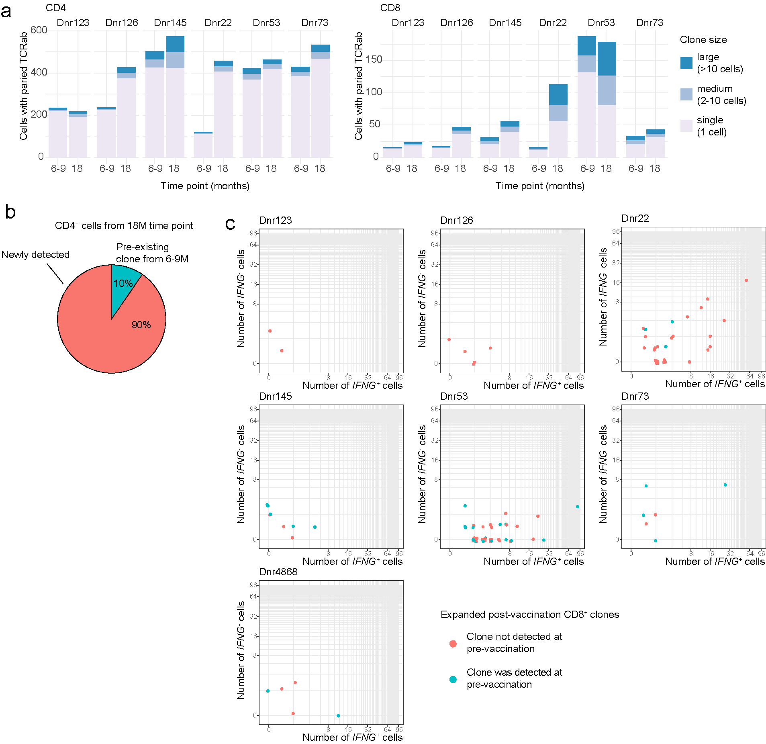
Extended Data Fig. 8: Clonal characterization of spike-specific CD4⁺ and CD8⁺ T cells. a. Proportion of cells from the CD4⁺ and CD8⁺ T cell subsets classified according to their degree of clonal expansion. b. Proportion of CD4⁺ T cells with paired TCR clonotype information from the 18M time point detected or not detected from the 6-9M time point dataset. c. Expanded CD8⁺ T cell clones from the post-vaccination time point of each donor showing the number of constituent cells with positive IFNG expression. Clones were colored based on whether they were detected in the pre-vaccination time point.

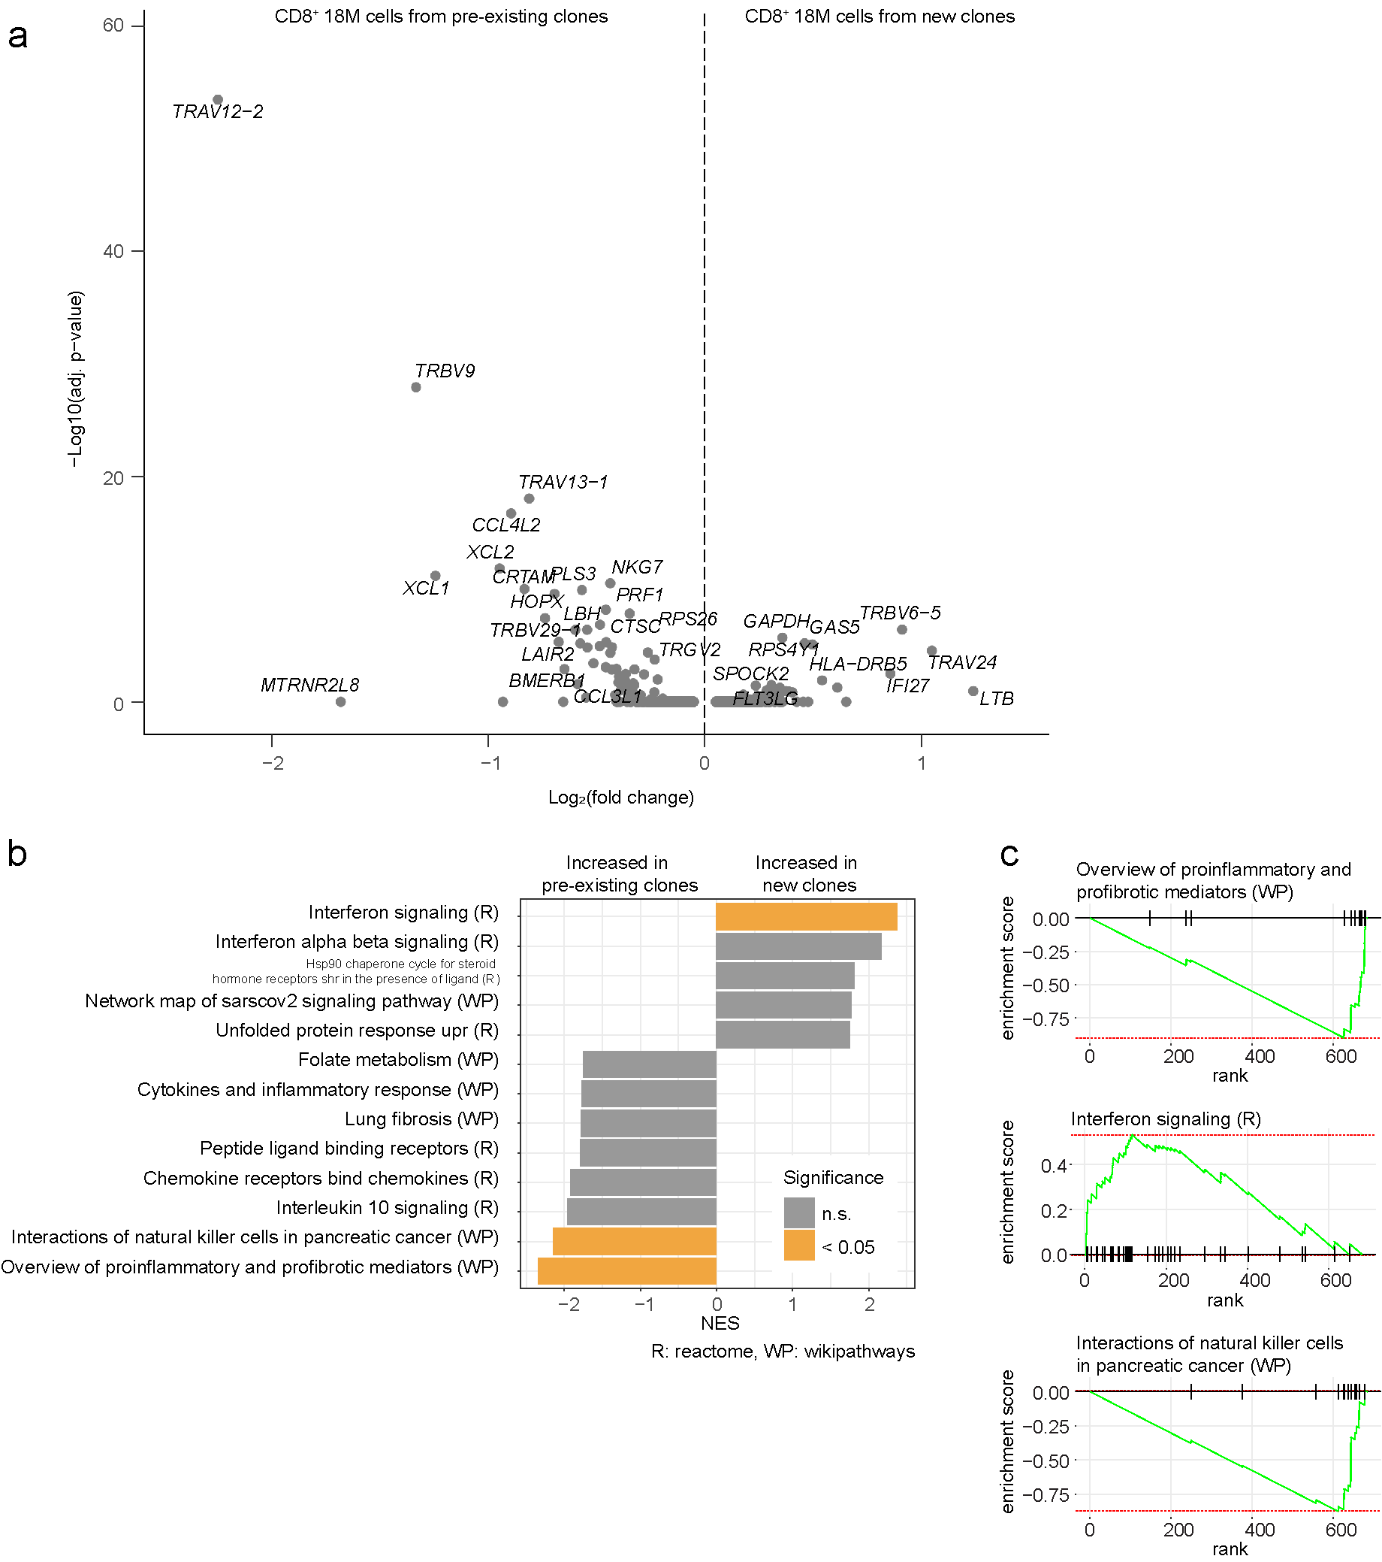
Extended Data Fig. 9: Transcriptomic signatures of pre-existing and newly detected CD8⁺ T cell clones at post-vaccination timepoints. a. Volcano plot of differentially expressed genes between 18M pre-existing and newly detected clones. b. GSEA summary of differentially expressed genes between18M pre-existing and newly detected clones. c. GSEA enrichment plot of statistically significant pathways.

