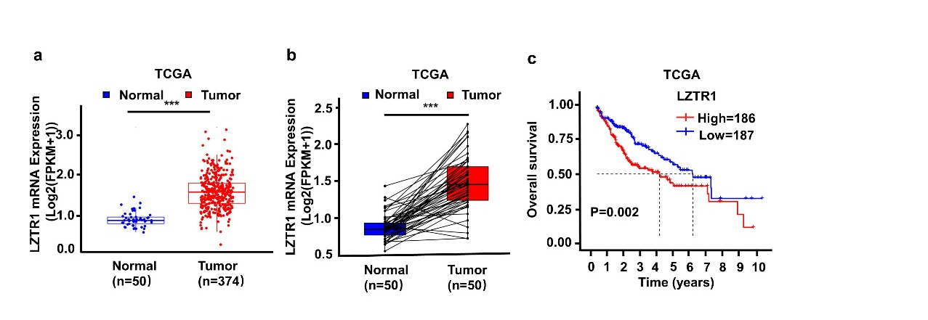
Fig. S1 High expression of LZTR1 mRNA expression is related to the worse outcome of HCC patients. a-b Differential expression analysis of LZTR1 mRNA levels in HCC tissues and adjacent normal tissues from TCGA database using R software. c Association between LZTR1 mRNA expression and overall survival in HCC patients from TCGA database using R software. Asterisk represents the significant difference. *P < 0.05, **P < 0.01, ***P < 0.001.

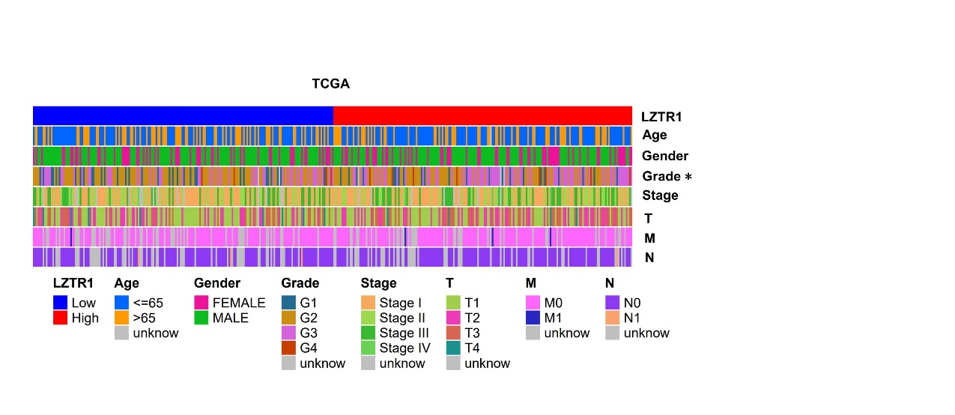

Fig. S2 A heatmap depicting the relationship between the clinicopathological characteristics and LZTR1 mRNA expression from TCGA database using R software. Asterisk represents the significant difference. *P < 0.05, **P < 0.01, ***P < 0.001.

