Supporting Information for
Design of nitrobenzene vapor sensor based on PCN-224
Luyu Wangª*, Jia Song^{b}*, Yuhang Wu^{c}, Chunyang Yu^{d}
ª College of Artificial Intelligence and E-Commerce, Zhejiang Gongshang University Hangzhou College of Commerce, Hangzhou, 311599, China
^{b} School of Nuclear Science and Engineering, Shanghai Jiao Tong University, Shanghai, 200240, China
^{c} Department of Industrial Design, Zhejiang University City College, Hangzhou, 310015, China
^{d} Design-AI Laboratory, China Academy of Art, Hangzhou 310009, China
*Corresponding Author
Luyu Wang: Dr.Luyu-Wang@hotmail.com
Jia Song: songjia111@sjtu.edu.cn
Keywords: Gas sensor; Quartz crystal microbalance; PCN-224; nitrobenzene
1. Chemicals and Materials
The organic linker 5,10,15,20-tetrakis (4-carboxyphenyl) porphyrin was purchased from J&K Scientific Co. Ltd. (China). Zirconium (IV) chloride (ZrCl₄, 99.95%) was provided by Strem Chemicals, Inc. Benzoic acid (BA, 99.5%) and N,N-dimethylformamide (DMF, 99.5%) were obtained from Tianjin Chemical Plant (China). All the chemical reagents were directly used as obtained from commercial sources without further purification.
2. Synthesis of PCN-224
A mixture of 25 mg 5,10,15,20-tetrakis (4-carboxyphenyl) porphyrin, 39 mg ZrCl₄ and 1350 mg BA were homogeneously dissolved with 4 mL DMF under sonication in a 10mL Pyrex vial, which was then tightly sealed and heated at 120°C for 48 h in an oven. After the Pyrex vial was naturally cooled to ambient temperature, cubic dark purple crystals were collected by filtration and washed with fresh DMF and acetone. Then, we soaked the as-synthesized PCN-224 in 30 mL acetone for 24 h, in which process solvent-exchange with fresh acetone was carried out every 8 h. Finally, the acetone was decanted, and the activated sample of PCN-224 was obtained by filtration and vacuum drying at 150 °C for 8 h.
2. Characterization
Powder X-ray diffraction data were obtained on a Panalytical X'Pert'3 Powder advance diffractometer with a graphite-monochromatized Cu Ka radiation. Brunauer-tmmett-teller (BET) method was used to calculate the specific surface areas. The N₂ adsorption-desorption isotherms at 77 K were measured on a Micrometrics ASAP 2460 system to evaluate their pore structures. The surface morphologies of the materials were observed by Zeiss Sigma300 scanning electron microscope (SEM). For the characterization of the functional groups, we employed Fourier-transform infrared spectroscope (FTIR, Thermo Scientific Nicolet iS20, Thermo Fisher Scientific).
3. Fabrication and Test Methods of the QCM Sensor
The absolute ethanol dispersion of the synthesized materials after ultrasonic processing was drop-casted onto QCM surface, and the as-fabricated sensor was dried in an infrared box for evaporating of ethanol. According to Sauerbrey equation (ΔF = -2.2×10⁻⁶ f² Δm/ A), the frequency shift of QCM resonator (ΔF) is proportionate with the increased mass on silver electrode (Δm) [1]. As shown in Figure S1, QCM chip was vertically suspended inside a sealed chamber with gas inlet/outlet. The air (15 sccm) generated by an air generator was used as the carrier gas. Because the evaporation point of nitrobenzene is relatively high, a heater is indispensable. All tests were conducted at ambient temperature and relative humidity (RH) of 50%. Two running fans can accelerate the dispersion of gaseous nitrobenzene homogeneously. As a typical process, QCM sensor was flushed with air until a steady fundamental frequency was obtained. Then, the liquid nitrobenzene analyte with calculated volume was introduced to the chamber by a microliter syringe. The exact volume of the injected nitrobenzene analyte liquid was concretely calculated in μl based on the following equation: Vl=cVM10⁻⁶/22.4dp, where Vl represents the volume of liquid in μl, c is the liquid concentration in ppm, M represents the molecular weight, d is the liquid density, and p represents the degree of purity. Then, following the sensing test, a frequency shift to analyte would be obtained after a period of time. The frequency shift was living measured by a digital controller and recorded by a desk top computer. At the end of each testing cycle, continuous air would wash away the analyte to re-establish the fundamental frequency.

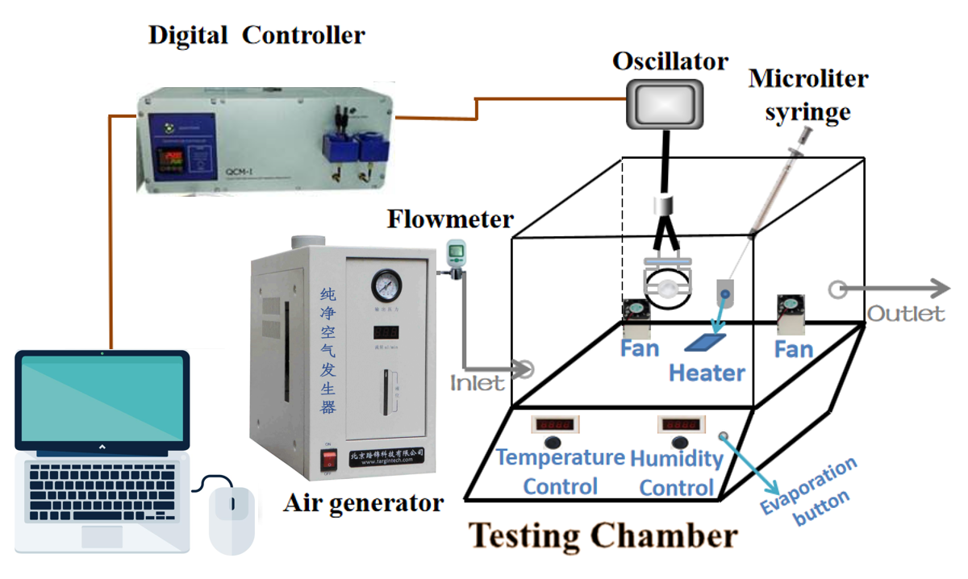
Figure S1. Schematic of the sensing testing system.

References
[1] L. Wang, Z. Wang, Q. Xiang, Y. Chen, Z. Duan, J. Xu, Sensors and Actuators B-Chemical, 248, 820-828 (2017)

