Topological barrier to Cas12a activation by circular DNA nanostructures
facilitates autocatalysis
Yi Li ^{a.b,#,}*, Biyao Yang ^{a.b,#}, Fei Deng ^{a.b,}*, Ewa M. Goldys ^{a.b,}*
ª Graduate School of Biomedical Engineering, Faculty of Engineering, University of New South Wales, Sydney 2052, Australia
^{b} ARC Centre of Excellence for Nanoscale Biophotonics, University of New South Wales, Sydney 2052, Australia
# These authors contributed equally to this work.
* Correspondence: e.goldys@unsw.edu.au; fei.deng@unsw.edu.au; yi.li6@unsw.edu.au;

List of abbreviations
AutoCAR | Autocatalytic CRISPR/Cas12a Amplification Reaction
c-DNA | Complementary DNA
Cir-ssDNA | circular single strand DNA
dsDNA | double strand DNA
FRET | fluorescence resonance energy transfer assay
gRNA | guiding RNA or presenting the crRNA (CRISPR RNA), sgRNA (single guiding RNA)
L-dsDNA | linear double strand DNA
L-ssDNA | linear single strand DNA
PAM | protospacer adjacent motif
RNP | ribonucleoprotein
ssDNA | single strand DNA

Supplementary Figures

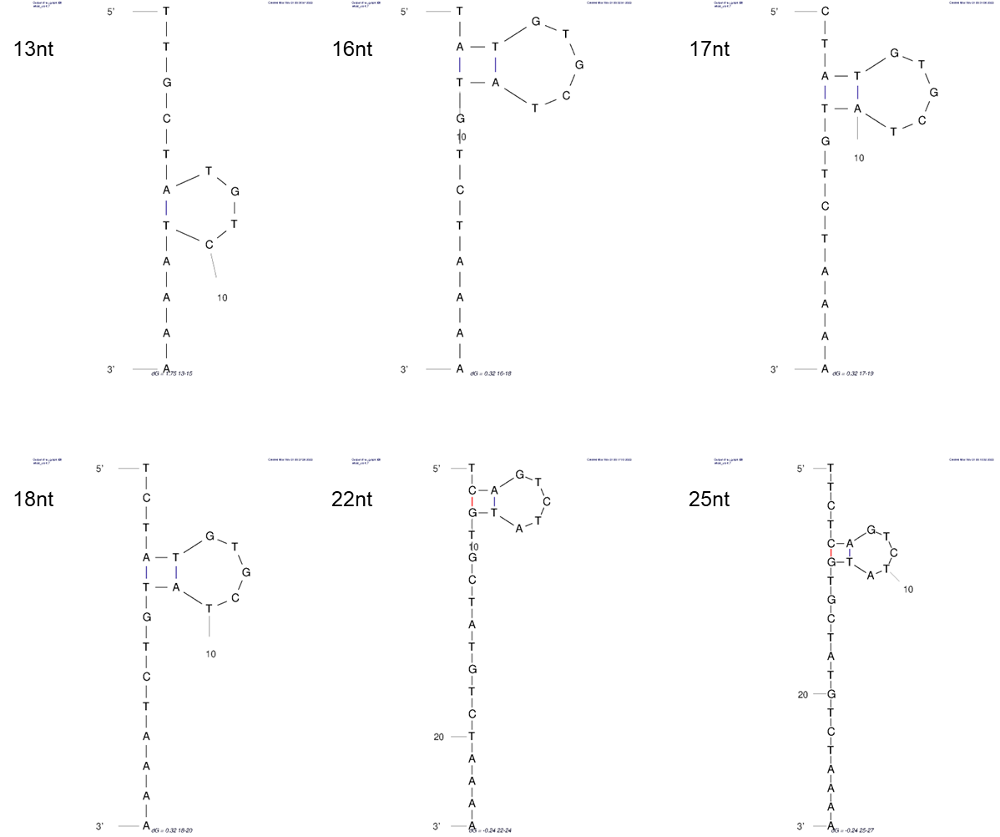
Figure S1. UNAFold simulations show that no complex secondary structures are formed for the triggering ssDNA at different lengths ^{1, 2}. Simulation conditions: 25℃, 50mM NaCl, 10mM MgCl₂, which is correlated with the 1X NEBuffer 2.1 reaction conditions.

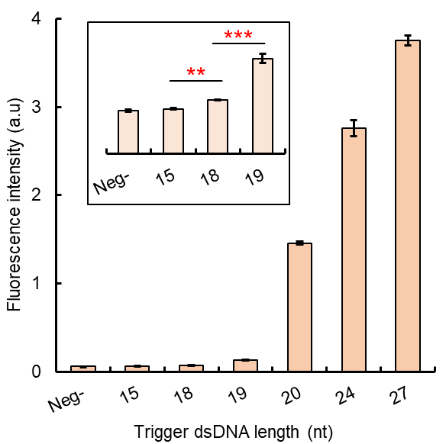
Figure S2. The activation efficiency of Cas12a triggered by L-dsDNA oligos at different lengths. Similar to the corresponding L-ssDNA oligos, with the dsDNA length decreased from 27 nt to 15 nt, the activation efficiency of Cas12a trans-cleavage decreased as well. The L-dsDNA oligo of 19 nt length showed only ~8.8% activity compared to 20 nt oligo L-dsDNA. The oligos with less than 18 nt length showed no significant difference of the fluorescence signal compared with negative controls, which has no trigger L-dsDNA presented (Method 4.5).

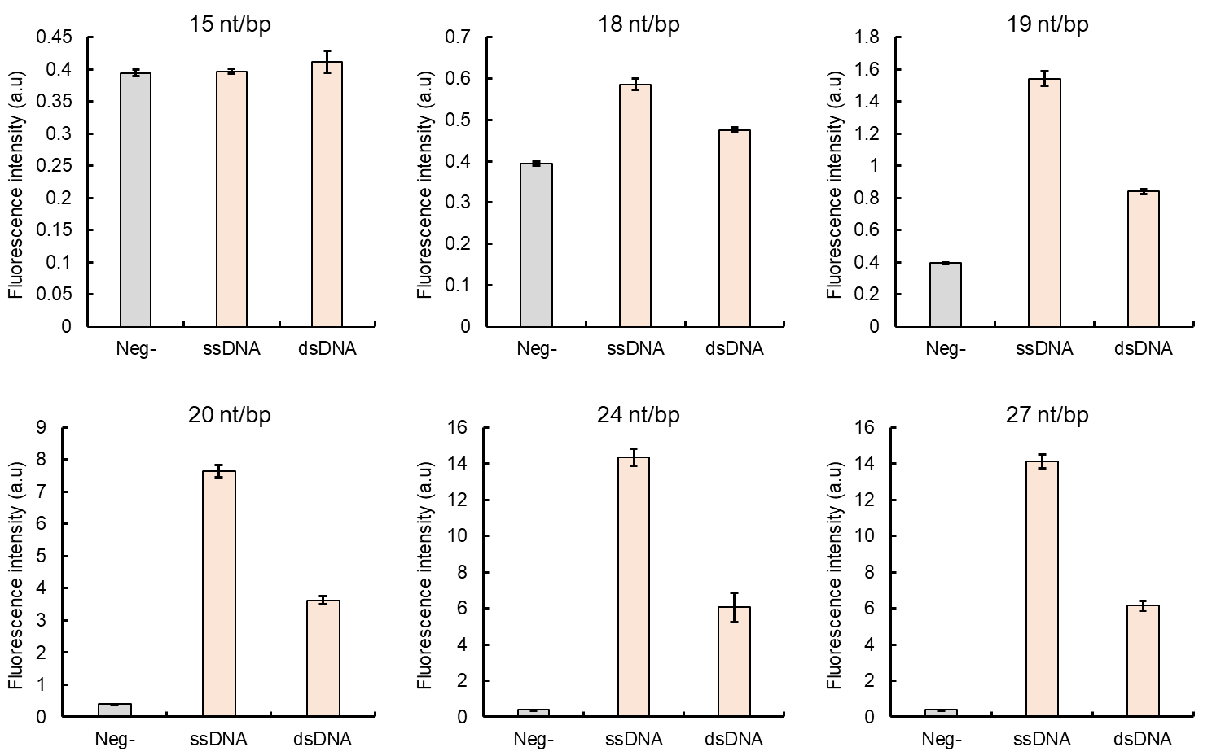
Figure S3. Comparison of Cas12a activation efficiencies between ssDNA and dsDNA. When comparing the activation efficiency for the sequence used in this study, in general, dsDNAs have higher Cas12a activation efficiency compared to their corresponding ssDNA oligos. But, only the trigger DNA length > 19 nt/bp generated the increase of fluorescence signal higher than at least 3 times for both ssDNA and dsDNA triggers (Method 4.5).

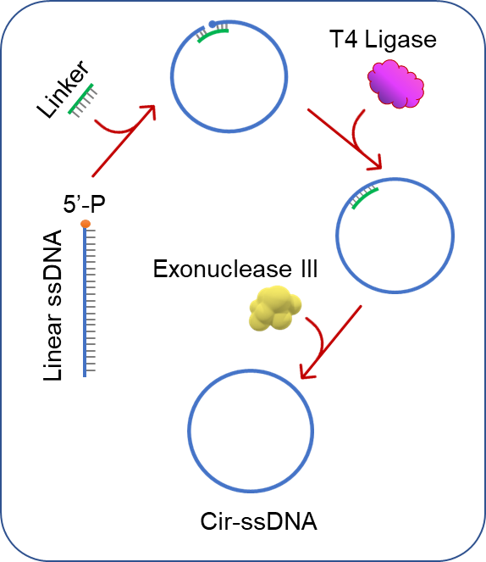
Figure S4. The scheme of T4 DNA ligase-based circular ssDNA (Cir-ssDNA) synthesis. Cir-ssDNA was synthesized in a three-step protocol. Firstly, a 5’-P linear ssDNA oligo with a complementary sequence to the guide RNA of Cas12a RNP (or the target strand), was pulled into a circular shape with the help of a short ssDNA linker, which had complementary sequences to both ends of the linear ssDNA. Then, the break locus was ligated by T4 ligase to form a circular ssDNA structure. Exonuclease III was then applied to remove the excessive linear ssDNA and linker oligos in the reaction system. The synthesized Cir-ssDNA was stored at 4ºC for further study. (Method 4.2)

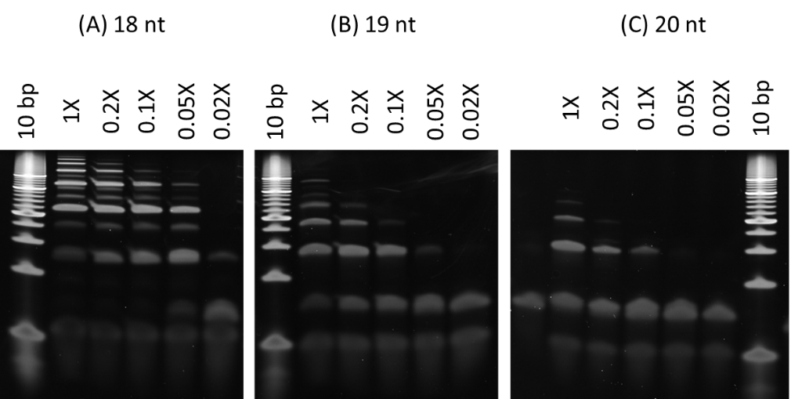
Figure S5. Urea-PAGE electrophoresis verifies the formation of Cir-ssDNA for different length of ssDNA oligos (Methods 4.4, S1). (A) 18 nt 5’-P ssDNA oligo for Cir-ssDNA synthesis. (B) 19 nt 5’-P ssDNA oligo for Cir-ssDNA synthesis. (C) 20 nt 5’-P ssDNA oligo for Cir-ssDNA synthesis. 10 bp = 10 bp DNA ladder, 1X = 1X T4 ligation buffer, 0.2X = 5 times diluted 1X T4 ligation buffer, 0.1X = 10 times diluted 1X T4 ligation buffer, 0.05X = 20 times diluted 1X T4 ligation buffer, 0.02X = 50 times diluted 1X T4 ligation buffer. In agreement with a previous study ³, our data showing that, for different length of ssDNA oligos, increasing the dilution times of the 1X T4 ligation buffer during synthesis helps to increase the amount of formed circular ssDNA. However, dilution times higher than 20 times lead to a decrease of the overall circular ssDNA synthesis efficiency. Hence, 5 – 10 times buffer dilution is optimal for our T4 ligase-based Cir-ssDNA synthesis method.

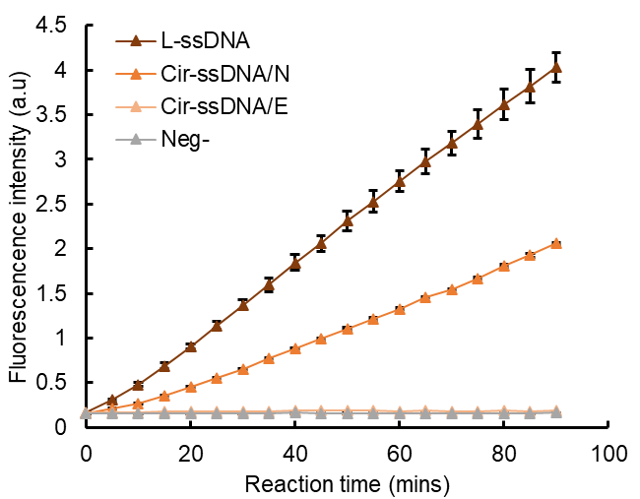
Figure S6. Verifying Cas12a trans-cleavage activation by synthesized Cir-mediators. The synthesized Cir-ssDNA structure, without (Cir-ssDNA/N) or with (Cir-ssDNA/E) or exonuclease III treatment, was used as the trigger to activate the Cas12a trans-cleavage. The data indicated that the ligation efficiency of L-ssDNA to form circular ssDNA nanostructure does not reach 100%, as the remaining L-ssDNA continues to be able to cause activation of Cas12a RNP. However, exonuclease III treated Cir-ssDNA/E show a significantly reduced activation efficiency as all extraneous L-ssDNA has been digested. Hence, exonuclease III treatment is necessary to remove the L-ssDNA residues. (Method S2)

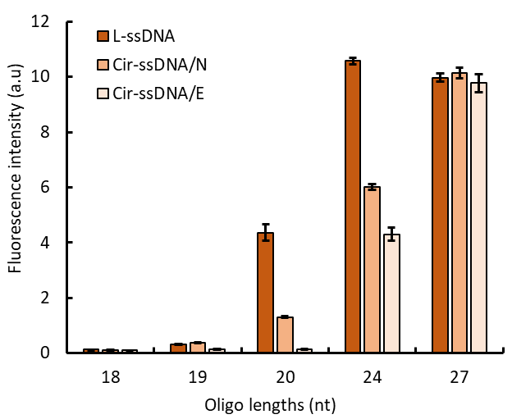
Figure S7. Comparison of Cas12a activation patterns with synthesized Cir-ssDNA of different lengths with and without exonuclease III treatment. In comparison to the respective L-ssDNA, the activation efficiency of synthesized Cir-ssDNA oligos, including exonuclease III treated Cir-ssDNA/E and Cir-ssDNA/N (no exonuclease III treatment) show a significant decreased signal intensity with the length of oligos decreased from 27 nt to 20 nt. All types of oligos shorter than 20 nt produce limited Cas12a RNP activation. For 20 nt oligos, the Cir-ssDNA/E showed a >90% decreased Cas12aRNP activation comparing to its linear form. This oligo length produced the highest difference of the Cas12a RNP activation efficiency changes, hence, 20 nt is used for further study. (Method S2)

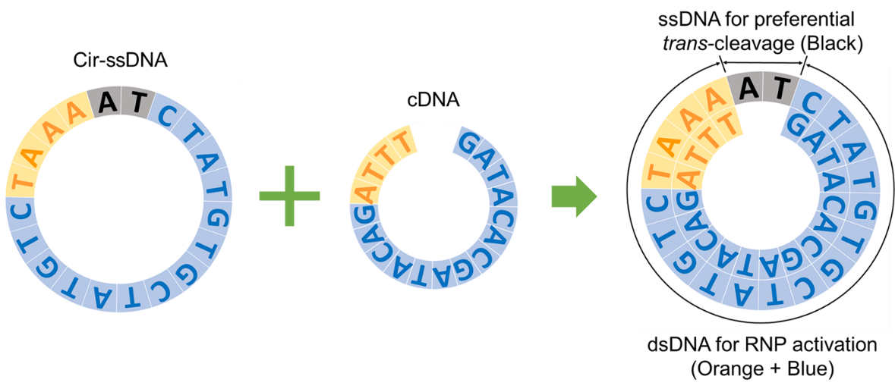
Figure S8. Schematics for combining Cir-ssDNA with cDNA to form the Cir-mediator DNA nanostructure. To form the final Cir-mediator DNA nanostructure, a slightly shorter complementary ssDNA (cDNA) oligo was added to the Cir-ssDNA. The cDNA covers the PAM region (orange) and also the Cas12a RNP2 targeting sequence (blue) to form the partial dsDNA structure on the Cir-mediator. The remaining single strand region (black) allow the activated Cas12a to easily break and open the circle through trans-cleavage.

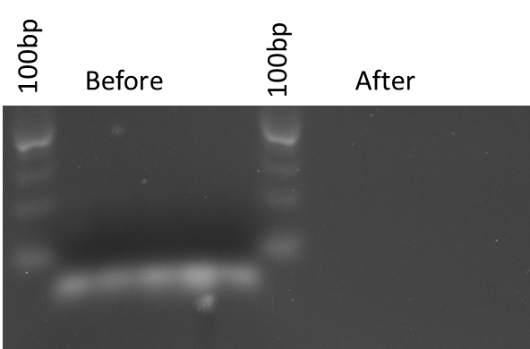
Figure S9. Cir-ssDNA treated with pre-activated Cas12a RNP. Five different batches of Cir-ssDNA were synthesized using same synthesis protocol, and then they were treated with pre-activated Cas12a RNPs for 60 mins at room temperature (Method S3). The results show no visually identifiable fragments on the gel with molecular weight under the lowest band of 100 bp DNA ladder. This indicates the necessity to protect the Cir-ssDNA structure from complete degradation by these RNPs which we accomplished by its integration with c-DNA and formation of Cir-mediator.

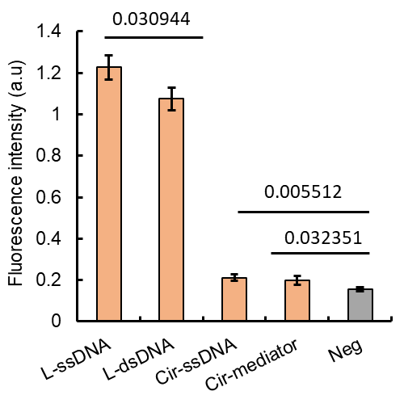
Figure S10. Comparison of Cas12a activation for different DNA molecular structures prepared from 20 nt L-ssDNA. The results show that compared to the linear formations (L-ssDNA or L-dsDNA), the circular DNA structures (Cir-ssDNA or Cir-mediator) have significantly lower Cas12a trans-cleavage activation efficiency. By adding the cDNA to Cir-ssDNA to form the Cir-mediator DNA nanostructure, a similar restriction of Cas12a activation can be observed. (Method 4.5)

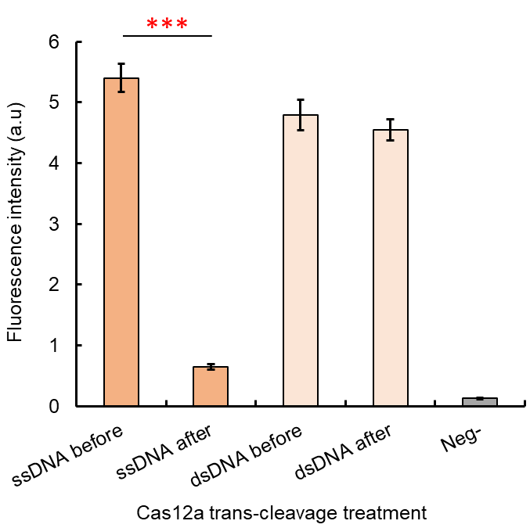
Figure S11. The Cas12a activation efficiency of oligos after their treatment with pre-activated Cas12aRNPs capable of trans-cleavage. Compared to the trigger ssDNA oligos which produce a significantly decreased fluorescence signal intensity after Cas12a trans-cleavage treatment, the trigger dsDNA oligos do not produce significant changes of the assay signal in the same conditions. (Method S3)

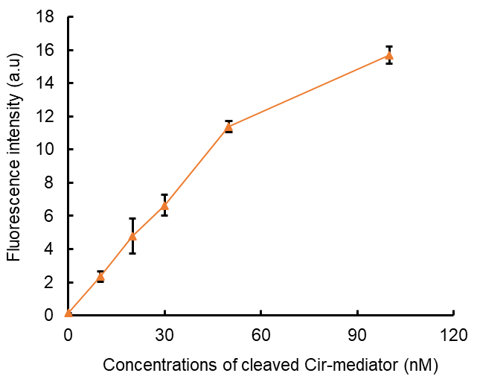
Figure S12. Testing different concentrations of trans-cleavage treated Cir-mediator for downstream Cas12a RNP2 activation. Different concentrations of Cir-mediators have been exposed to pre-activated Cas12a RNPs for re-linearization. Afterwards, the same amount of cleavage product was used for further Cas12a RNP2 activations. The results indicated that with the increased number of re-linearized Cir-mediators, the downstream Cas12a activation also increased correspondingly. (Method S4)

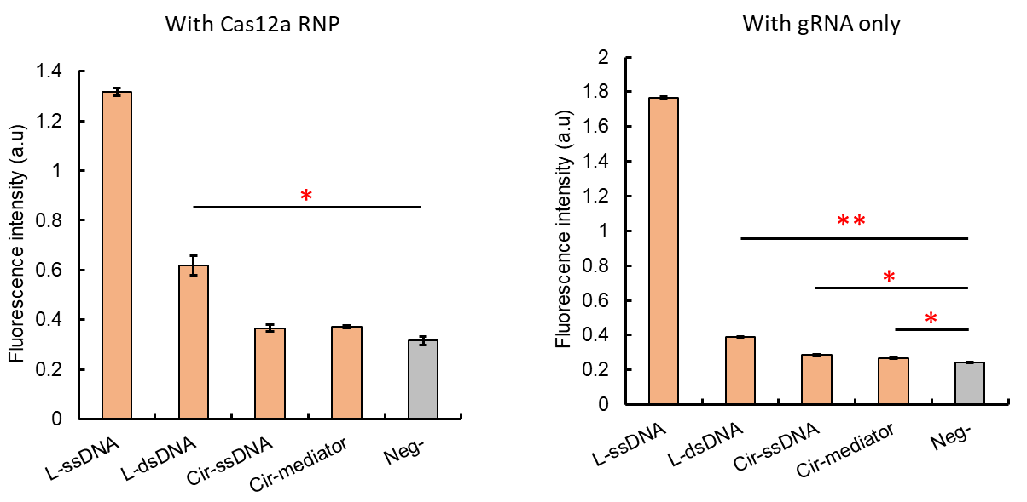
Figure S13. The results of the FRET test for the interaction of different DNA molecular structures. The FRET results indicated that for all 4 different DNA structures (L-ssDNA, L-dsDNA, Cir-ssDNA and Cir-dsDNA) with the sequence targeted by the Cas12a RNP, the binding affinity to its corresponding Cas12a RNP has a similar trend, with the affinities of L-ssDNA> L-dsDNA > Cir-ssDNA ≈ Cir-dsDNA, regardless of the presence of Cas12a RNP. (Method 4.10)

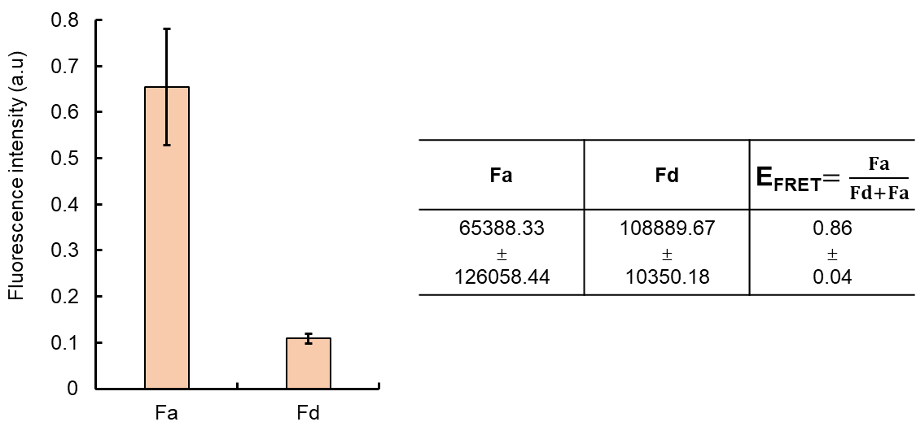
Figure S14. The FRET efficiency for the Cy3-Cy5 pair used in this study. Based on the FRET efficiency equation, E_{FRET}=Fa/(Fd+Fa), where Fa is the acceptor (Cy5) , and Fd is the donor (Cy3) emission signal, the measured fluorescence intensities of the Cy3-Cy5 solution at Em= 520 nm and Ex= 560 nm was used as Fd, and the fluorescence intensities of the Cy3-Cy5 solution at Em= 520 nm and Ex= 666 nm was used as Fa. The calculated E_{FRET} is 0.86 ± 0.04. (Method S5)

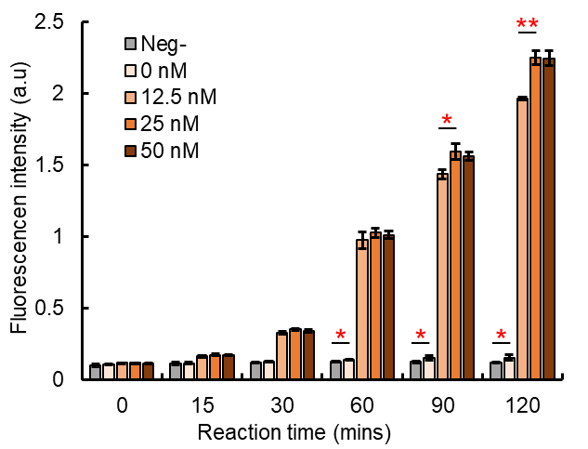
Figure S15. The trans-cleavage activity levels of AutoCAR system with different concentration of Cir-mediators. Compared with the CRISPR/Cas12a reaction without the presence of Cir-mediators (0 nM), all the AutoCAR reactions with different concentrations of Cir-mediators (12.5 nM, 25 nM, 50 nM) showed an increased fluorescence signal, which indicated elevated trans-cleavage activity. “Neg-” represents the reaction mixture without trigger DNA and Cir-mediator, while with same concentration of reporter. In addition, as shown in the figure, the trans-cleavage activity of AutoCAR is also significantly increased with increasing Cir-mediator concentration. (Method S6)

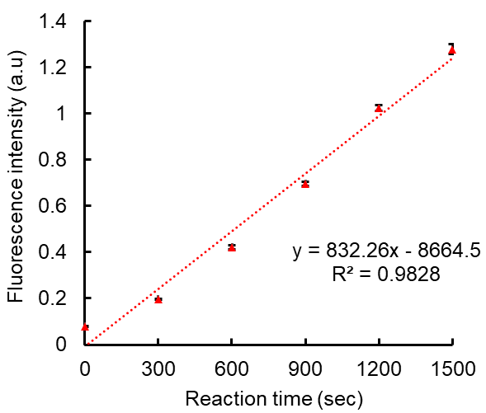
Figure S16. Standard CRISPR/Cas12a trans-cleavage reaction pattern. In a standard CRISPR/Cas12a trans-cleavage reaction (Method 4.5), the fluorescence intensity produced by cleaved reporters shows a positive linear correlation with increasing reaction time (linear fit also shown, R² = 0.9828, n=3).

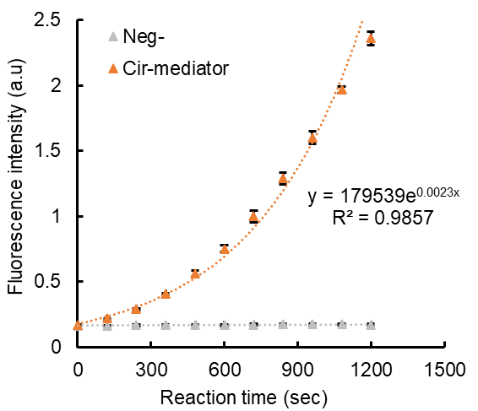
Figure S17. AutoCAR trans-cleavage pattern. After the autocatalysis loop of AutoCAR has been activated, the fluorescence signal intensity showed a strong increase with the reaction time, with a non-linear growth pattern. “Neg-” represents the inactive AutoCAR reaction mixture without the presence of trigger DNA. (Method 4.8)

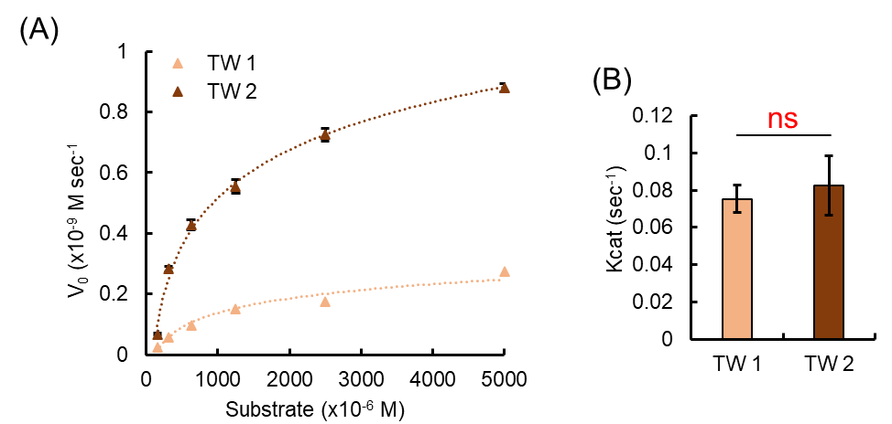
Figure S18. Michaelis-Menten analysis of the AutoCAR trans-cleavage pattern in defined short reaction windows. This approach represents an approximation the reaction rate is a nonlinear function of time, but in short time windows it can be approximated as linear. (A) Michaelis-Menten kinetics plot for the trans-cleavage activities of AutoCAR with different concentrations of ssDNA reporters (Substrates) and using a ssDNA trigger (n = 3). V₀ = the number of cleaved substrates per second, TW 1 = time window 1 (0-6 mins), TW 2 = time window 2 (20-30 mins). (B) Comparison of the approximate K_{cat} values of AutoCAR in different reaction time windows. The data show no significant difference of the K_{cat} values which indicates the increased total trans-cleavage rate of AutoCAR system is not attributed to the change of a single Cas12a RNP trans-cleavage rate. (Methods 4.9, S13)

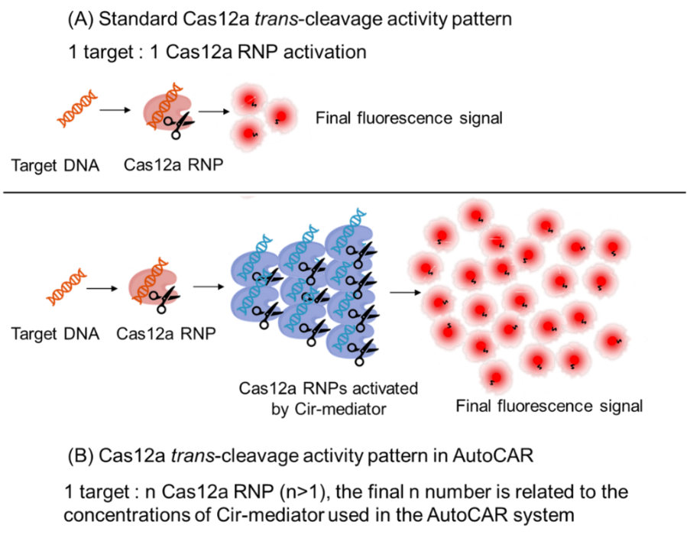
Figure S19. Schematics contrasting the reaction patterns for standard Cas12a RNP trans-cleavage (top) and the trans-cleavage pattern of the AutoCAR system (bottom).

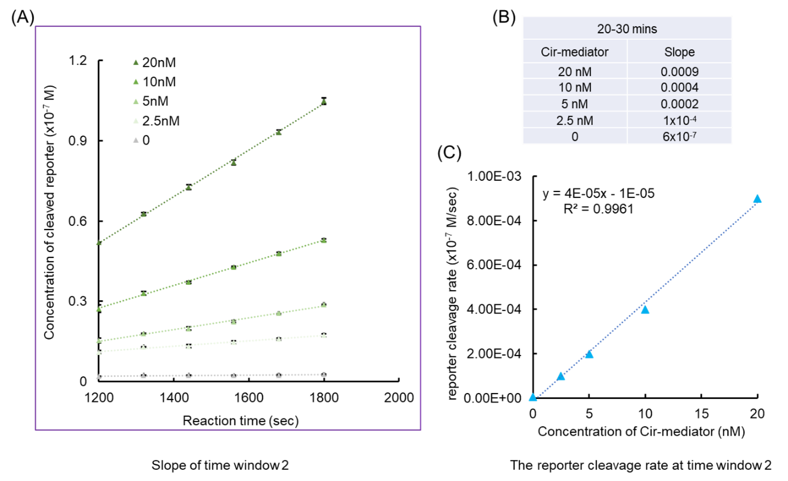
Figure S20. Reporter cleavage rate patterns for AutoCAR in a specific short reaction time window. (A) We used the time window 2 in Figure 4F, where a near linear signal trend with reaction time was found for different concentrations of Cir-mediators. (B) These reaction rates (slopes of linear lines in A) were used to estimate R_{Cas12a/target} value of the AutoCAR system. (C) The linear correlation between concentration of Cir-mediator to the reporter cleavage rate. (Method 4.10).

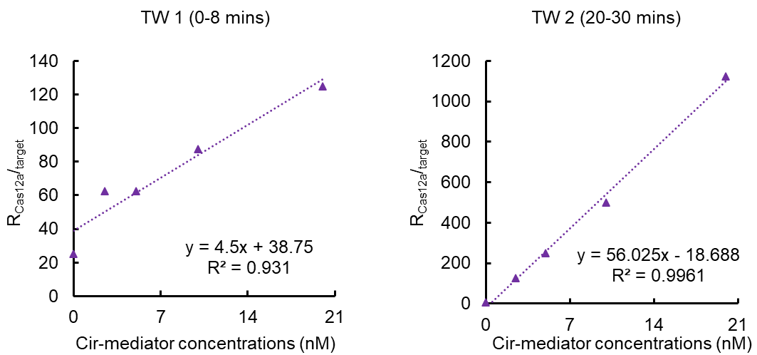
Figure S21. The correlation between the R_{Cas12a/target} value (the number of overall activated Cas12a RNPs per a single trigger ssDNA) to the change of Cir-mediator concentrations in the AutoCAR system. The results shown that both for the reaction time window 1 (TW 1, 0-8 mins) and time window 2 (TW 2, 20-30 mins), a positive linear correlation can be identified between the R_{Cas12a/target} value and the Cir-mediator concentrations in AutoCAR system. This indicated that the overall level of activated Cas12a RNP level is increased with the higher concentration of Cir-mediator in the system, and its linear correlation confirmed an increased level of Cas12a RNP activation in AutoCAR system. (Methods 4.10)

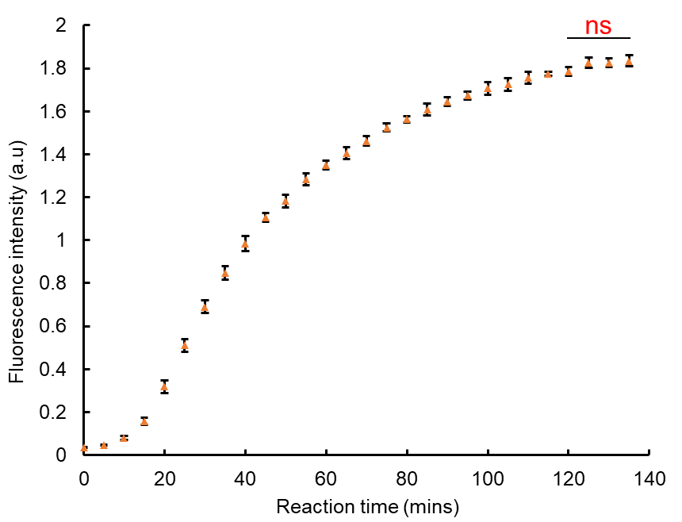
Figure S22. Depletion of reporters leads to saturation of the fluorescence signal. Illustration of signal trends in an AutoCAR reaction with a comparatively low ssDNA-linked fluorescence-quenched reporter. As Cas12a trans-cleavage continues over time, the fluorescence intensity level appears to saturate, with no significant changes after 120 mins (Methods 4.8, with the reporter concentration reduced to 39 nM).

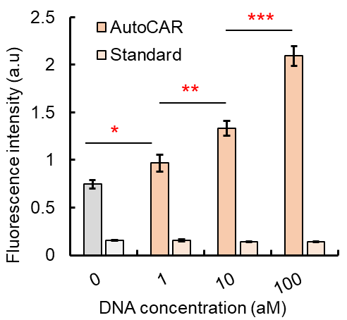
Figure S23. AutoCAR system makes it possible for Cas12a RNP to reveal the presence of specific DNA sequence in the attomolar concentration range, down to 1 aM. While the standard CRISPR/Cas12a system without additional amplification strategy has no detectable signal differences between the same target concentration ranges (* P<0.05, ** P<0.005, *** P<0.001, Methods S7).

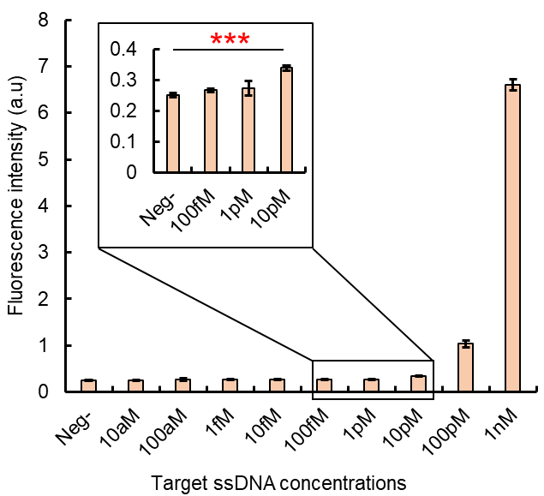
Figure S24. Standard CRISPR/Cas12a for direct DNA detection without the use of Cir-mediator autocatalysis (Method 4.5). The sensitivity is 10pM based on the statistical difference using two-tailed t-test. (* P<0.05, ** P<0.005, *** P<0.001).

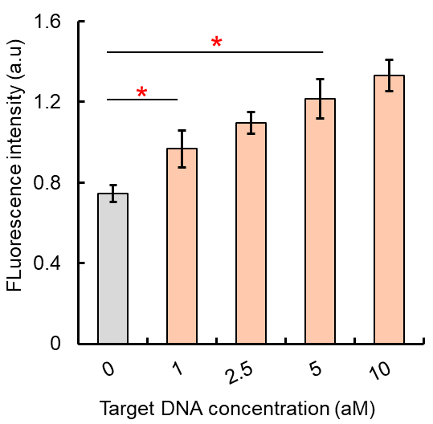
Figure S25. The performance of AutoCAR for DNA detection at low concentration levels (Method S7). AutoCAR system showing the capability to differentiate even a small target concentration changes under extra low concentration level, here between 1 aM to 5 aM target DNA. (* P<0.05, ** P<0.005, *** P<0.001).

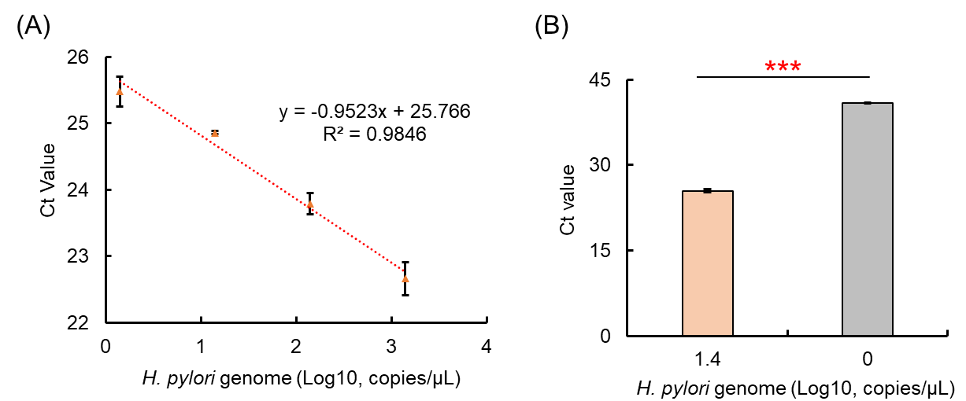
Figure S26. Quantitative PCR (qPCR) for H. pylori glm gene detection (Methods S8). A negative 3 logs linear correlation have been identified for samples containing 1.4 to 1400 copies/μL H. pylori genome DNA, and qPCR is able to differentiate the difference between negative sample and the presence of 1.4 copies/μL H. pylori genome DNA.

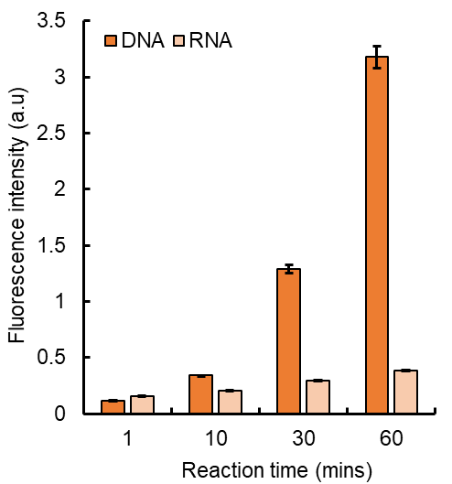
Figure S27. Difference of CRISPR/Cas12a trans-cleavage efficiency between DNA and RNA triggers detected by a standard CRISPR/Cas12a reaction without additional amplification strategy (Method 4.5). The results shown, comparing to DNA (ssDNA) which showing a rapidly increased fluorescence signal after Cas12a activation, RNA (ssRNA) activates the Cas12a RNP at a significantly lower level.

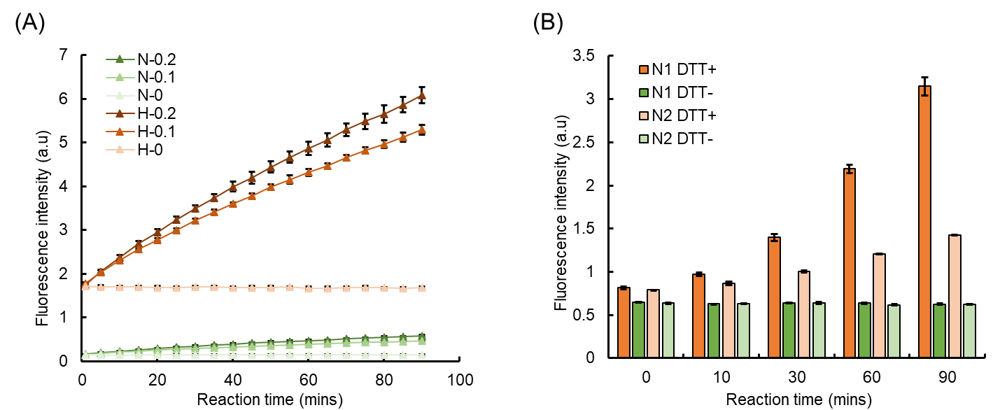
Figure S28. Optimization of the CRISPR/Cas12a trans-cleavage conditions for improved fluorescence signal generation in response to RNA trigger (Method S9). (A) CRISPR/Cas12a trans-cleavage patter for RNA trigger (0, 0.1, 0.2 μM) with different reporter concentrations (N = normal reporter concentration, H = 10 times higher reporter concentration). (B) CRISPR/Cas12a trans-cleavage patter for RNA trigger with or without the use of DTT. N1 and N2 represent the different Cas12a targeting sequences, and the results indicated that the adding of 10mM DTT into the standard CRISPR/Cas12a reaction can significantly increase the signal output level responding to RNA target, and the differences of targeted RNA sequence can also lead to the reaction intensity level changes.

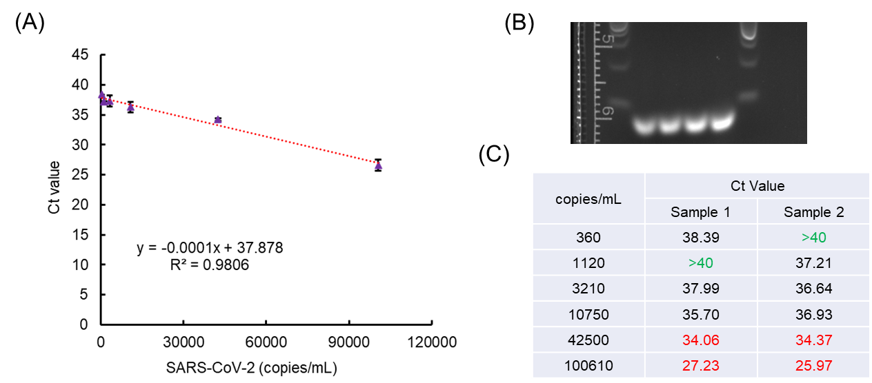
Figure S29. Standard RT-qPCR method for SARS-CoV-2 genome RNA detection (Methods S10, S11). (A) The results shown a typical RT-qPCR can present a linear correlation between the target RNA concentration and the Ct value. (B) Gel electrophoresis assay for RT-qPCR amplicon to verify no non-specific amplification in the RT-PCR reaction system (Method 4.3). (C) The Ct value for different concentrations of SARS-CoV-2 genome RNA. In general, the cut-off Ct value for representing a positive Covid-19 infection is between 35 to 40, and Ct value higher than 40 can be considered as negative. The results show the RT-qPCR performed here has the sensitivity between 360 and 3210 copies/mL, which is 0.36 ~ 3.21 copies/μL.

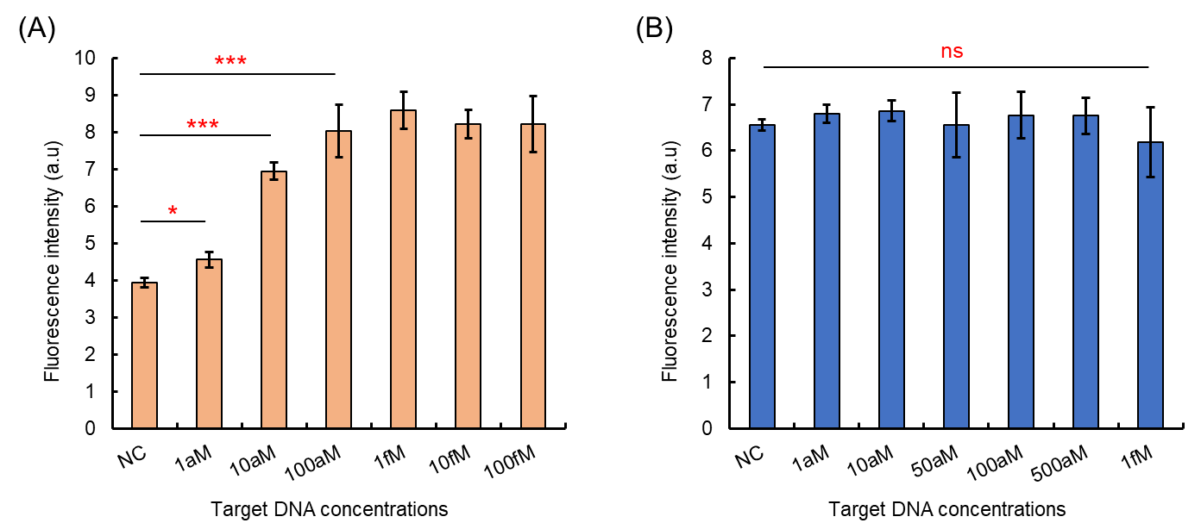
Figure S30. Performing AutoCAR for ultra-sensitive DNA detection on a qPCR system (Methods S12). (A) AutoCAR system to detect target DNA on qPCR machine, the results indicated that the AutoCAR system can differentiate the signal changes between negative sample (NC) to samples with target DNA concentration between 1 aM to 100 aM. (B) Standard CRISPR/Cas12a reaction (without additional amplification strategy) to detect target DNA on qPCR machine, the results shown no significant differences for the signal between negative sample (NC) to any of the samples with target DNA between 1 aM to 1 fM on qPCR system.

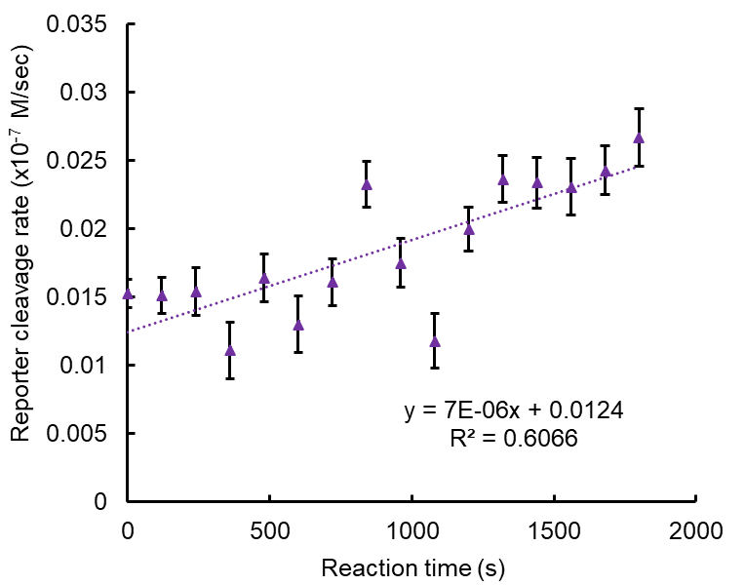
Figure S31. Reporter cleavage rate for standard CRISPR/Cas12a reaction without additional amplification response to 1 pM target DNA (Methods 4.5).

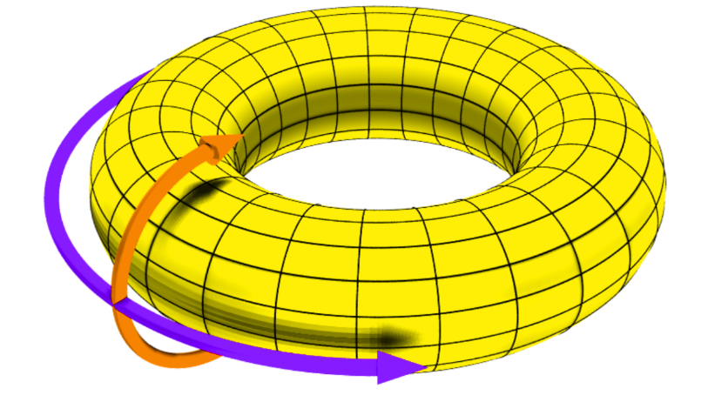
Figure S32. Idealised toroidal geometry of the Cir-mediator. Real Cir-mediator molecules are strictly speaking not toroidal, but represent deformed toroids. Purple line indicates the direction along the length of the circle. The radius of curvature of the purple line is small because the entire length of the Cir-mediator molecule along the purple line is ~ 7 nm. Orange line represents the “perpendicular” direction - this is the direction of rotation needed for releasing torsional stress during unwinding. This rotation is topologically constrained because the ends of the Cir-mediator molecule are joined together.

Supplementary Tables

Table S1. Michaelis-Menten calculation for the trans-cleavage rates for AutoCAR system at defined reaction time windows (Methods S15).
Cleavage status | K_{cat} (sec⁻¹) | Km (M⁻¹) | K_{cat}/km  (sec⁻¹ M⁻¹) | V_{max}
Time window 1* | 0.08 ± 0.01 | 2.05 ± 0.55 x 10⁻⁷ | 3.67 x10⁵ | 0.38 ± 0.04
Time window 2# | 0.08 ± 0.02 | 1.87 ± 0.71 x 10⁻⁷ | 4.40 x10⁵ | 1.24 ± 0.24
* Time window 1 equals to 0-6 mins of the reaction time.
# Time window 2 equals to 20-30 mins of the reaction time.

Table S2. The R_{Cas12a/trigger} value (number of activated Cas12a RNP per target) of AutoCAR
Standard CRISPR/Cas12a without amplification (30 mins) * |  | Cir-mediator (nM) | AutoCAR at time windows (20-30 mins)
Cleavage rate (x10⁻⁷M/s) | R_{Cas12a/trigger} | Cir-mediator (nM) | Cleavage rate (x10⁻⁷M/s) | R_{Cas12a/trigger}
7 x 10⁻⁶ | 0.86 | 20 | 0.0009 | 1125
7 x 10⁻⁶ | 0.86 | 10 | 0.0004 | 500
7 x 10⁻⁶ | 0.86 | 5 | 0.0002 | 250
7 x 10⁻⁶ | 0.86 | 2.5 | 0.0001 | 125
* As the standard CRISPR/Cas12a without amplification for 1 pM generated slightly increased fluorescence signal after 30 mins reaction, with shown a linear fitting with only R² = 0.61. Addition results (from Figure S16, S31) for standard CRISPR/Cas12a reactions without amplification have been applied to verify the R_{Cas12a/trigger} for standard CRISPR/Cas12a reaction, which has R_{Cas12a/trigger} = 0.5.

Table S3. DNA and RNA oligos used in this study (Synthesized and modified by Sangon Ltd.)
Name | Oligo type | Sequence 5’-3’ | Modification
5’-P 15nt ssDNA | ssDNA | GTGCTATGTCTAAAA | 5’- phosphorylation
5’-P 18nt ssDNA | ssDNA | T ATG TGC TAT GTC TAAA A | 5’- phosphorylation
5’-P 19nt ssDNA | ssDNA | CT ATG TGC TAT GTC TAAA A | 5’- phosphorylation
5’-P 20nt ssDNA | ssDNA | TCT ATG TGC TAT GTC TAAA A | 5’- phosphorylation
5’-P 24nt ssDNA | ssDNA | TCAGTCTATGTGCTATGTCTAAAA | 5’- phosphorylation
5’-P 27nt ssDNA | ssDNA | TTCTCAGTCTATGTGCTATGTCTAAAA | 5’- phosphorylation
15nt cDNA | ssDNA | TTTAGACATAGCA | N/A
18nt cDNA | ssDNA | TTTAGACATAGCACAT | N/A
19nt cDNA | ssDNA | TTTAGACATAGCACATA | N/A
20nt cDNA | ssDNA | TTTAGACATAGCACATAG | N/A
24nt cDNA | ssDNA | TTTAGACATAGCACATAGACTG | N/A
27nt cDNA | ssDNA | TTTAGACATAGCACATAGACTGAGA | N/A
15nt linker ssDNA | ssDNA | ATAGCACTTTTA | N/A
18nt linker ssDNA | ssDNA | GCACATATTTTAG | N/A
19nt linker ssDNA | ssDNA | GCACATAGTTTTAG | N/A
20nt linker ssDNA | ssDNA | GCACATAGATTTTAG | N/A
24nt linker ssDNA | ssDNA | AGACTGATTTTAG | N/A
27nt linker ssDNA | ssDNA | CTGAGAATTTTAG | N/A
20nt ssDNA 3-Cy5 | ssDNA | TCT ATG TGC TAT GTC TAAA A | 5’- phosphorylation  Int Cy5-dT
Trigger ssDNA | ssDNA | GAA GAC ACC CTA CCA ACC CCC CCC | N/A
ssDNA reporter | ssDNA | TTATT | 5’-Texa Red; 3’-BHQ2
HP glm FW | ssDNA | TCC TTT TAG CGC TAC CGA CG | N/A
HP glm RV | ssDNA | CGA GCC ACA ACC CTT TTG AAG | N/A
CoV N FW | ssDNA | CAGAATGGAGAACGCAGTG | N/A
CoV N RV | ssDNA | GTGAACCAAGACGCAGTATT | N/A
Cir-T-strand gRNA | ssRNA | UAA UUU CUA CUA AGU GUA GAU GAC AUA GCA CAU AGA CUG AGA CUG | N/A
gRNA for FRET | ssRNA | UAA UUU CUA CUA AGU GUA GAU GAC AUA GCA CAU AGA CUG AGA CUG | 5’- Cy3
Trigger ssDNA gRNA | ssRNA | UAA UUU CUA CUA AGU GUA GAU GGG GGG GGU UGG UAG GGU GUC | N/A
Cas12a direct-N1 gRNA | ssRNA | UAA UUU CUA CUA AGU GUA GAU ACG UUG UUU UGA UCG CGC CCC | N/A
Cas12a direct-N2 gRNA | ssRNA | UAA UUU CUA CUA AGU GUA GAU AUU GGG UAA ACC UUG GGG CCG A | N/A
CoV-N-target | ssRNA | CAGAA UGGAG AACGC AGUGG GGCGC GAUCA AAACA ACGUC GGCCC CAAGG UUUAC CCAAU AAUAC UGCGU CUUGG UUCAC | N/A

Supplementary methods
Method S1. Synthesis of Cir-ssDNA with diluted ligase buffer at different rates
Firstly, 43 µL of DNase/RNase free water was mixed with different volumes (5, 1, 0.5, 0.25, 0.1 µL) of 10X T4 ligase buffer to form the final dilution times (including 1X, 0.2X, 0.1X, 0.05X and 0.02X), and followed with the adding of 2 µL of the linear ssDNA oligo (100 µM), 4 µL of linker ssDNA oligo (100 µM) and 2.5 µL of T4 ligase (NEB) to form a final 50 µL reaction mixture. The cyclization reaction was then allowed to proceed at 16℃ for 12 hours and then deactivated at 65℃ for 10min. The products were stored at 4℃ before downstream applications.
Method S2. Removing residual linear ssDNA from Cir-ssDNA synthesis product
After the Cir-ssDNA has been synthesized, the un-ligated linear ssDNA and the linker ssDNA was depredated with a mixture containing 1.5 µL of exonuclease III, 10 µL of Cir-ssDNA product in 40 µL of 1×NEBuffer 2.1 buffer, and incubation at 37℃ for 100 mins followed with deactivation of exonuclease III at 75℃ for 30 mins.
Method S3. Validation of Cas12a trans-cleavage for ssDNA and dsDNA degradation following activation of Cas12a RNP2
1 μL of 100 μM LbaCas12a endonuclease (NEB, M0653T) and 5 μL of 20 μM gRNA was mixed at 3.6 mL 1× NEBuffer 2.1, and followed with the adding of 1 μM L-ssDNA or L-dsDNA. Then, 10 μL of 1 μM trigger ssDNA was mixed with 90 μL of the prepared standard CRISPR/Cas12a reaction mixture. The reaction was set at room temperature, and each of 10 μL cleavage product from 0, 10, 20, 30, 40, 50, 60 mins was mixed with 2 μL 6X DNA gel loading dye, and then loaded onto 4% agarose gel for electrophoresis at a constant voltage of 80V for 60 min. Gel images were visualized by using Gel Doc + XR image system (Bio-Rad Laboratories Inc., USA).
Method S4. Using different concentrations of trans-cleaved Cir-mediator for Cas12a RNP2 detection
1 μL of 100 μM LbaCas12a endonuclease (NEB, M0653T) and 5 μL of 20 μM gRNA was mixed at 3.6 mL 1× NEBuffer 2.1, and followed with the adding of 100 nM of prepared DNA oligo (linear dsDNA, linear ssDNA, Cir-ssDNA or Cir-mediator). Then, 1 μM of trigger ssDNA oligo was added to activate Cas12a trans-cleavage for 60 mins at room temperature. Subsequently, heat all the reaction solutions at 65 ℃ for 10min to deactivated Cas12a RNP1. Afterwards, 10 μL of the trans-cleavage product was transferred into 90 μL of the standard CRISPR/Cas12a reaction mixture with gRNA for Cir-mediator, and set at room temperature for 60 mins. The fluorescence intensity at Ex/Em of 570/615 nm was determined by using a plate reader (iD5 Spectramax, Molecular Devices, USA).
Method S5. The FRET efficiency test for the Cy3-Cy5 pair used in this study
The Cy5 labelled ssDNA oligo was firstly mixed with its cDNA to form dsDNA, then 5 μL 1 μM of the prepared DNA oligo was mixed with 95 μL of 1×NEBuffer 2.1 containing Cy3 labelled gRNA loaded Cas12a RNP to a final concentration of 50 nM for both the DNA oligo and Cas12a RNP. The fluorescence signals were then collected by using a plate reader (iD5 Spectramax, Molecular Devices, USA) as Em= 520 nm and Ex= 560 nm for acquiring Fd, and Em= 520 nm and Ex= 666 nm for acquiring Fa.
Method S6. Exploring the AutoCAR reaction signal intensity with Cir-mediator concentration changes
3 μL of 100 μM LbaCas12a endonuclease (NEB, M0653T), 5 μL of 20 μM gRNA1 (for trigger DNA/RNA) and 10 μL of 20 μM gRNA2 (for Cir-mediator) was mixed at 3.6 mL 1× NEBuffer 2.1 and followed with the adding of 12 μL of 100 μM Texas Red quenched reporter. Afterwards, the Cir-mediator solution was mixed to a final concentration of 0, 5, 12.5, 25 and 50 nM. Then, 10 μL 10 pM trigger ssDNA was mixed with 90 μL of the prepared final AutoCAR reaction mixture to initiate the reaction. The reaction was set at room temperature and the fluorescence intensity at Ex/Em of 570/615 nm was determined by using a plate reader (iD5 Spectramax, Molecular Devices, USA).
Method S7. Investigations of AutoCAR sensitivity
3 μL of 100 μM LbaCas12a endonuclease (NEB, M0653T), 5 μL of 20 μM gRNA1 (for trigger DNA/RNA) and 10 μL of 20 μM gRNA2 (for Cir-mediator) was mixed at 3.6 mL 1× NEBuffer 2.1 and followed with the adding of 12 μL of 100 μM Texas Red quenched reporter. Afterwards, the prepared Cir-mediator solution was mixed to a final concentration of 50 nM before use to form the final AUTOCAR reaction mixture. Then, 10 μL different concentrations of trigger DNA with a complementary sequence to gRNA was mixed with 90 μL of the prepared final AUTOCAR reaction mixture to initiate the reaction. The reaction was set at room temperature and the fluorescence intensity at Ex/Em of 570/615 nm was determined by using a plate reader (iD5 Spectramax, Molecular Devices, USA).
Method S8. qPCR reaction for H.pylori glm gene detection
The manufacturer’s instruction of QuantiNova SYBR Green PCR kit (QIAGEN, 208052) was used for the qPCR reactions. Briefly, for each 20 μL reaction mixture, 10 μL 2X SYBR master mixture, 2 μL 10 μM Forward-primer and 2 μL 10 μM Reverse-primer were mixed with 4 μL of DNase/RNase free water. Then, 2 μL of sample with difference concentrations of H.pylori genome DNA (0, 1.4, 14, 140, 1400, 14000 copies/μL) was added to form the final 20 μL reaction mixture. Then qPCR reaction was set on a CFX96 Touch Real-Time PCR Detection System (Bio-Rad Laboratories Inc., USA) at the conditions of 95℃ 2 mins, and followed with 35 cycles of amplification at 95℃ 10 sec and 60℃ 20 sec. The default melting curve analysis was also added for validation of the RT-qPCR.
Method S9. Optimization of CRISPR/Cas12a RNP response to RNA trigger for higher signal generation
1 μL of 100 μM LbaCas12a endonuclease (NEB, M0653T) and 5 μL of 20 μM gRNA was mixed at 3.6 mL 1× NEBuffer 2.1, and followed by adding of 6 μL or 60 μL of 100 μM Texas Red quenched reporter. In addition, the reaction mixture can be prepared with or without adding of DTT to a final concentration of 10 mM. For each CRISPR/Cas12a trans-cleavage activation reaction, 10 μL different concentrations of RNA with complementary sequence of gRNA was added into 90 μL prepared reaction buffer. The reaction was set at room temperature, and the fluorescence intensity at Ex/Em of 570/615 nm was determined by using a plate reader (iD5 Spectramax, Molecular Devices, USA).
Method S10. RNA extraction from SARS-CoV-2 viral particle
The PureLink Viral RNA/RNA Mini Kit was used to extract the genome RNA of SARS-CoV-2 viral particles (Certified Reference Materials from National Measurement Institute) following the manufacturer’s instruction. Briefly, 200 μL of viral sample was mixed with 25 μL Proteinase K (included with the kit), and followed with the adding of 200 μL Lysis Buffer containing 5.6 μg Carrier RNA (included with the kit). The mixture was then incubated at 56℃ for 15 mins. After a briefly centrifuge, 250 μL 100% ethanol was added to the mixture and vortexing for 15 sec. The mixture was incubated at room temperature for 5 mins and then transferred onto the Viral Spin Column for centrifugation at 6800 x g for 1 min. The flow-through was discard, and followed with 2 times of washing with 500 μL prepared Wash Buffer and centrifugation at 6800 x g for 1 min. Afterwards, Centrifuge the column at maximum speed for 1 mins to dry the membrane completely. Then, 25 μL of Sterile, RNase free water was loaded onto the centre of the membrane and incubate at room temperature for 1 min. After centrifugation again at maximum speed again for 1 min, the eluted purified RNA was stored at -20℃ immediately until the downstream application.
Method S11. RT-qPCR reaction for SARS-CoV-2 RNA N-gene detection
The manufacturer’s instruction of QuantiNova SYBR Green RT-PCR kit (QIAGEN, 208152) was used for the RT-qPCR reactions. Briefly, for each 20 μL reaction mixture, 10 μL 2X SYBR mixture, 0.2 μL reverse transcription mixture, 1 μL 10 μM Forward-primer and 1 μL 10 μM Reverse-primer were mixed with 5.8 μL of DNase/RNase free water. Then, 2 μL of sample with different concentrations of extracted SARS-CoV-2 genome RNA (0, 360, 1120, 3210, 10750, 42500, 100610 copies/mL, Method S11) was added to form the final 20 μL reaction mixture. The RT-qPCR reaction was set on a CFX96 Touch Real-Time PCR Detection System (Bio-Rad Laboratories Inc., USA) at the conditions of 50℃ 10mins and 95℃ 3 mins, and followed by 40 cycles of amplification at 95℃ 10 sec and 60℃ 20 sec. The default melting curve analysis was also added for validation of the RT-qPCR.
Method S12. Using AutoCAR for DNA diagnostics on a qPCR thermocycler
6 μL 100 μM of LbaCas12a endonuclease (NEB, M0653T) was mixed with 30 μL 20 μM of gRNA1 (for target DNA) and 30 μL 20 μM of gRNA2 (for Cir-mediator) within 1.2 mL of 1×NEB2.1 buffer. Then, 2.4 μL 100 μM of Texas Red reporters was added. Before the DNA detection test, 5 μL of 500nM Cir-mediator solution were firstly mixed with 40 μL of the prepared reaction mixture, and 5 μL samples were added containing different concentrations of the target DNA sequence. The reaction was then set at 37℃ on a CFX96 Touch Real-Time PCR Detection System (Bio-Rad Laboratories Inc., USA). Then fluorescence intensity was determined by the selection of the Texas Red channel of the thermocycler in 30 sec intervals.
Method S13. Calculation of trans-cleavage rates for AutoCAR system at defined reaction time windows
Based on the results from Figure 4E, the reaction of AutoCAR with difference concentration of reporters (156 nM to 5 uM) can be treat as two reaction time windows, the first window (0-6 mins) where the reaction begin with limited Cir-mediator has been prelinearized, and the second time window where majority of Cir-mediator has been depleted. For these two time windows, an approximately linear correlation can be acquired (Figure 4E), therefore, this supports the application of basic Michaelis-Menten theory in these defined two time windows to estimate the observed trans-cleavage rates using the previously published method ⁴.

Supplementary Note (Kinetics)
In order to understand the kinetics of the Cir-mediator system discussed here, we extend and adapt the model outlined in Ref 1 ⁴, broadly following their notation to facilitate comparisons. We then create approximate models and find solutions which suit specific experimental conditions.
Enzyme kinetics is described by a set of nonlinear ordinary differential equations for which there are generally no closed form solutions. A common approach to deal with this problem is model reduction where simplified model equations are proposed for which solutions can be more easily obtained and analysed. The Briggs-Haldane approximation commonly adopted in the field of enzyme kinetics achieves this model reduction by forcing certain rates to be zero which replaces some of the differential equations of the model by algebraic equations. This then allows to derive the well-established Michaelis-Menten equation, which is in close agreement with many experiments. However, the understanding of reasons for this agreement require quite refined mathematical analysis ⁵. It is now established that the Briggs-Haldane approximation represents the so-called singular perturbation ⁵. The solutions to the original model of enzyme kinetics converge to the solutions of the reduced model satisfying the Briggs-Haldane conditions) when the ratio of enzyme to substrate concentration tends to zero ⁵.
Inspired by this work, our model follows the conventional Briggs-Haldane approach and Michaelis-Menten analysis for slowly varying active enzyme and other concentrations. We obtain tractable solutions for the reduced model of AutoCAR kinetics. We emphasize that these do not represent the solutions of the actual AutoCAR model. However, as in the case of conventional Michaelis-Menten kinetics, these solutions are close to the AutoCAR solutions and they converge to them if the concentration ratio of enzyme(s) to the substrate(s) tend to zero. Therefore, as long as these ratios are small, the solutions of the reduced model are close to the experimental observables and allow to predict their trends.
Our core model describes the time evolution of molecular concentrations$\left[X\right]$ of all relevant constituents described below and highlighted in bold. Their time-dependence $\left(\left[X\right]=\left[X\right]\left(t\right)\right)$ is mostly omitted for clarity. The model based on coupled non-linear differential equations assumes the presence of two types of Cas12 RNPs, RNP1 and RNP2, with two different guides. It describes the evolution of targets and Cir-mediators in their two forms: original circular form and “linearized” form. References to Cir-mediators without any descriptor imply that they are in a circular form. RNP1 is bound to gRNA which matches the target sequence, while RNP2 is bound to gRNA matching the Cir-mediator dsDNA sequence. The binding of RNP1 to a target or the binding of RNP2 to a linearized Cir-mediator changes the RNP from “inactive” to “activated”, a condition where the RNP becomes capable of trans-cleavage. Such activated RNPs cleave Cir-mediators transforming them to a linearized form. Activated RNPs are also able to cleave another molecular species we supply to the system called reporters. These reporters, like Cir-mediators have two states: they can be either uncleaved or cleaved by activated RNPs (both by RNP1 and by RNP2). The quantity observed in the experiment is the amount or the rate of increase of cleaved reporters, so our formalism is aimed at deriving and revealing the time evolution of cleaved reporter rate.
Our notation takes into consideration different roles the enzyme and substrate molecules and the reaction intermediates play in catalysis, so each molecular species will have different symbols as its role in the catalysis process changes. Correspondingly, our kinetic equations are grouped according to the stage of the catalysis process. These stages are: (1) activation of each of the two RNPs, (2) catalytic interaction of RNPs, separately with two different substrates, (3) formation of the reaction intermediates, separately for each substrate, and (4) cleavage of each of the two substrates, one of which produces linearized Cir-mediators capable of RNP2 activation.
We denote:
$\left[U\right]$- concentration of inactive Cas RNP1,
${[U}_{cir}]$ - concentration of inactive Cas RNP2,
${[E}_{1}]$ - concentration of activated RNP1 which are not complexed with reaction intermediates,
[E_{1T}] - concentration of activated RNP1,
${[E}_{2}]$ - concentration of activated RNP2 which are not complexed with reaction intermediates,
[E_{2T}] - concentration of activated RNP2,
$\left[E\right]$ - total concentration of all activated RNPs which are not complexed with reaction intermediates,
[E_{T}] – total concentration of activated RNP1 and RNP2,
$\left[T\right]$ - concentration of targets,
${[S}_{cir}]$- concentration of Cir-mediators in their circular form (the symbol is “S_{cir}” because they are a catalytic substrate),
$\left[S\right]$ - concentration of uncleaved reporters (the symbol is “S” because they are a catalytic substrate),
${[P}_{cir}]$ - concentration of linearized (cleaved) Cir-mediators (the symbol is “P_{cir}” because they are a catalytic product),
$\left[P\right]$ - concentration of cleaved reporters (the symbol is “P” because they are a catalytic product),
$\left[C_{cir}\right]$ - concentration of reaction intermediate 1 – activated RNP (RNP1 or RNP2) and Cir-mediator complex (Cir-mediator in their circular, uncleaved form),
$\left[C\right]$ - concentration of reaction intermediate 2 – activated RNP (RNP1 or RNP2) and uncleaved reporter complex.
The species conservation rules are as follows:
${[E}_{1T}]+ {[E}_{2T}]=[E_{T}]$ (activated RNP1 + activated RNP2 = total activated RNPs).
$\left[E_{T}\right]=\left[E\right]+\left[C\right]+[C_{cir}]$ (total activated RNPs = total activated uncomplexed RNPs+ concentration of both complexes)
$T_{0}- \left[T\right]=\left[E_{1T}\right]$ (initial targets – unbound targets = activated RNP1). Similar simple condition can not be written for ${[E}_{2T}]$ because Cir-mediators do not only activate RNP2 but also take part in catalysis.
$\left[C\right]\left(t\right)+\left[S\right]\left(t\right)+\left[P\right]\left(t\right)=S_{0}$ (reporters complexed with RNPs + uncleaved reporters+ cleaved reporters = initial concentration of reporters)
$\left[C_{cir}\right]\left(t\right)+\left[S_{cir}\right]\left(t\right)+\left[P_{cir}\right]\left(t\right)=S_{cir0}$ (Cir-mediators complexed with RNPs + uncleaved Cir-mediators (in their circular form) + cleaved (linearized) Cir-mediators = initial concentration of supplied Cir-mediators in their circular form)
We note here that unlike in Ref. 1 the species conservation condition for activated RNPs is invalid in our problem, as these concentrations are varying in autocatalysis.
The initial conditions are:
${[E}_{1T}]\left(0\right)= {[E}_{2T}]\left(0\right)=0$ - initial concentrations of activated RNPs expressing no initial RNP activation,
$U_{0}$ - initial concentration of RNP1,
$U_{cir0}$ - initial concentration of RNP2,
$S_{cir0}$- initial concentration of Cir-mediators in their circular form,
$S_{0}$ - initial concentration of uncleaved reporters,
$P_{cir0}$ = 0 - initial concentration of linearized (cleaved) Cir-mediators,
$P_{0}$ = 0 - initial concentration of cleaved reporters.
We also denote:
$C_{0}$ – a constant describing the concentration of the reaction intermediate for RNPs with uncleaved reporters according to the Briggs-Haldane approximation.
$C_{cir0}$ - a constant describing the concentration of the reaction intermediate for RNPs with uncleaved Cir-mediators according to the Briggs-Haldane approximation.
Other constants, especially those resulting from integration and symbols used to facilitate algebra are defined in the text.
The reactions describing the activation of the two RNPs can be modelled as:
$U+T ↔E_{1T}$ with bimolecular association and dissociation rate constants $k_{on}, k_{off}$
$U_{cir}+P_{cir} ↔E_{2T}$ with are bimolecular association and dissociation rate constants $k_{on}, k_{off}$
The rate equations for RNP activation are:
$\frac{d{[E}_{1T}]}{dt}= k_{on}\left[U\right]\left[T\right]- k_{off}\left[E_{1T}\right]$ /1/
$\frac{d\left[E_{2T}\right]}{dt}= k_{on}\left[U_{cir}\right]\left[P_{cir}\right]{ - k}_{off}\left[E_{2T}\right]$ /2/
where the first term on the right describes the rate of RNP-target complex formation (which leads to activation, hence + sign) and the second term describes the decomposition of the complex (and deactivation). We assume here that the on and off reaction rates are identical for targets and Cir-mediators.
The catalytic reactions are modelled following the approach in Ref 1. The catalytic reaction of reporter cleavage is modelled as:
${{(k}_{f}{,k}_{r}) (k}_{cat})$
$E+S ↔ C → E+P$ /3/
The catalytic reaction of Cir-mediator cleavage (linearisation) is modelled as:
$${{(k}_{f}{,k}_{r}) (k}_{cat})$$
$E+S_{cir} ↔ C_{cir} → E+P_{cir}$ /4/
Here, ${(k}_{f}{,k}_{r})$ are bimolecular association and dissociation rate constants for the reaction between activated RNP, uncleaved reporters and Cir-mediators in circular form, while $k_{cat}$ is the cleavage rate of reporters and Cir-mediators. As a first approximation, we assume that these rates are the same for reporters and Cir-mediators although the nucleic acid sequences differ. (The literature reports these rates to be somewhat sequence - dependent).
The Cir-mediator system is described by the following system of nonlinear differential equations:
The “catalysis” equations:
$\frac{d\left[E\right]}{dt}= - k_{f}\left[E\right]\left[S\right]- k_{f}\left[E\right]\left[S_{cir}\right]+ k_{r}\left[C\right]+k_{r}\left[C_{cir}\right]+k_{cat}\left[C\right]+k_{cat}\left[C_{cir}\right]$ /5/
where
$\left[E\right]={[E}_{1}]+{[E}_{2}]$ /6/
In Equation /5/ the first term on the right has a minus sign because the formation of the RNP-substrate complex decreases the concentration of RNP available for further complex formation.
The “substrate” equations are, correspondingly:
$\frac{d\left[S\right]}{dt}= - k_{f}\left[E\right]\left[S\right]+ k_{r}\left[C\right]$ /7/
$\frac{d\left[S_{cir}\right]}{dt}= - k_{f}\left[E\right]\left[S_{cir}\right]+ k_{r}\left[C_{cir}\right]$ /8/
The equations describing how the reaction intermediates are formed are given by:
$\frac{d\left[C\right]}{dt}= k_{f}\left[E\right]\left[S\right]- k_{r}\left[C\right]-k_{cat}\left[C\right]$ /9/
$\frac{d\left[C_{cir}\right]}{dt}= k_{f}\left[E\right]\left[S_{cir}\right]- k_{r}\left[C_{cir}\right]-k_{cat}\left[C_{cir}\right]$ /10/
The “product” equations are:
$\frac{d\left[P\right]}{dt}= k_{cat}\left[C\right]$ /11/
$\frac{d\left[P_{cir}\right]}{dt}= k_{cat}\left[C_{cir}\right]$ /12/
These equations, together with species conservation conditions and initial conditions, allow to predict all relevant concentrations in this problem.
We now analyse the results derived from these equations from a number of important perspectives, and in practically relevant cases. As usual in catalysis, the ratios of substrates to the relevant enzymes cleaving those substrates are particularly significant, but in this specific case of catalysis mediated by Cir-mediators, other ratios including the ratio of targets to Cir-mediators are also important. In the below, in all sections of our analysis, we will generally assume that the concentrations of reporters is much higher than the initial concentration of both RNPs. We will also assume that initial concentrations of both RNPs are high compared with the concentration of the respective activated RNPs. In some instances, the time-dependence of these concentrations may be ignored and the concentrations replaced by the initial values $\left(\left[S\right]= S_{0}, \left[U\right]= U_{0}, \left[U_{cir}\right]= U_{cir0}\right)$.
In the below the cleaved reporter rate $\frac{d\left[P\right]}{dt}$is referred to as the “experimental observable”.
Result 1: The experimental observable reflects the concentration of activated RNPs in the Briggs-Haldane approximation.
Derivation:
We apply the Briggs-Haldane approximation to the reporters and to Cir-mediators. This approximation says that the concentrations of reaction intermediates are constant ($\left[C\right]=$ const, $\left[C_{cir}\right]=$ const). We should emphasise here that the Briggs-Haldane approximation is strictly not applicable to the very initiation of catalysis because the concentration of reaction intermediates (in this case $\left[C\right])$ at $t=0$ is zero.
We equate $\frac{d(\left[C\right])}{dt}$ and $\frac{d(\left[C_{cir}\right])}{dt}$ to zero in Equations /9/ and /10/ and add these two equations to get:
$\frac{d(\left[C\right]+\left[C_{cir}\right])}{dt}=0= k_{f}\left[E\right]\left(\left[S\right]+\left[S_{cir}\right]\right)- {(k}_{r}+ k_{cat})(\left[C\right]+{[C}_{cir}])$ /13/
By adding Equation /11/ and Equation /12/ we get the expression for the rate of product formation for the reporters and for Cir-mediators, the first of which contains the experimental observable.
$\frac{d(\left[P\right]+\left[P_{cir}\right])}{dt}= k_{cat}\left(\left[C\right]+\left[C_{cir}\right]\right)$ /14/
Equation /13/ leads to the familiar form of the Michaelis-Menten equation, in the following way:
$k_{f}\left[E\right]\left(\left[S\right]+\left[S_{cir}\right]\right)= {(k}_{r}+ k_{cat})(\left[C\right]+{[C}_{cir}])$ /15/
We remind that
$\left[E_{T}\right]=\left[E\right]+\left[C\right]+\left[C_{cir}\right]$ /16/
so we can now substitute
$\left[E\right]= \left[E_{T}\right]-\left(\left[C\right]+\left[C_{cir}\right]\right)$ /17/
producing
$k_{f}(\left[E_{T}\right]-(\left[C\right]+\left[C_{cir}\right])\left(\left[S\right]+\left[S_{cir}\right]\right)= {(k}_{r}+ k_{cat})(\left[C\right]+{[C}_{cir}])$ /18/
So
$k_{f}\left[E_{T}\right]\left(\left[S\right]+\left[S_{cir}\right]\right)- k_{f}(\left[C\right]+\left[C_{cir}\right])\left(\left[S\right]+\left[S_{cir}\right]\right)= {(k}_{r}+ k_{cat})(\left[C\right]+{[C}_{cir}])$/19/
And
$k_{f}\left[E_{T}\right]\left(\left[S\right]+\left[S_{cir}\right]\right)= {(k}_{r}+ k_{cat})(\left[C\right]+{[C}_{cir}])+ k_{f}(\left[C\right]+\left[C_{cir}\right])\left(\left[S\right]+\left[S_{cir}\right]\right)$ /20/
which means that
$\left[C\right]+{[C}_{cir}]= \frac{k_{f}\left[E_{T}\right]\left(\left[S\right]+\left[S_{cir}\right]\right)}{k_{r}+ k_{cat}+ k_{f}\left(\left[S\right]+\left[S_{cir}\right]\right)}$ /21/
Hence from Equation /14/ and Equation/21/ the rate $\frac{d(\left[P\right]+\left[P_{cir}\right])}{dt}$can be expressed as:
$\frac{d(\left[P\right]+\left[P_{cir}\right])}{dt}= k_{cat}\left(\left[C\right]+\left[C_{cir}\right]\right)= \frac{k_{cat}k_{f}\left[E_{T}\right]\left(\left[S\right]+\left[S_{cir}\right]\right)}{k_{r}+ k_{cat}+ k_{f}\left(\left[S\right]+\left[S_{cir}\right]\right)}$ /22/
which can be expressed using the Michaelis-Menten constant $K_{M}=\frac{{(k}_{r}+ k_{cat})}{k_{f}}$ as
$\frac{d(\left[P\right]+\left[P_{cir}\right])}{dt}= \frac{k_{cat}\left[E_{T}\right]\left(\left[S\right]+\left[S_{cir}\right]\right)}{K_{M}+ \left(\left[S\right]+\left[S_{cir}\right]\right)}$ /23/
In conditions when $\frac{d\left[P_{cir}\right]}{dt} ≪ \frac{d\left[P\right]}{dt}$, for example when the concentration of Cir-mediators is much lower than the concentration of reporters, or Cir-mediators are close to being depleted and $\frac{d\left[P_{cir}\right]}{dt}$ is approximately zero, we get the following approximate expression for the experimental observable:
$\frac{d\left[P\right]}{dt}= \frac{k_{cat}\left[E_{T}\right]\left(\left[S\right]+\left[S_{cir}\right]\right)}{K_{M}+ \left(\left[S\right]+\left[S_{cir}\right]\right)}$ /24/
This means that the experimental observable follows the time-varying concentration of active RNPs, in analogy with standard CRISPR/Cas reaction without autocatalysis. Furthermore, in conditions when the Cir-mediators are close to being depleted, the reaction kinetics returns to a linear trend with reaction time, as in a standard CRISPR/Cas reaction system and the experimental observable is then proportional to the total concentration of RNPs successfully activated by targets and linearized Cir-mediators.
Result 2: When the RNP2 and Cir-mediators are sufficiently abundant, much more abundant than targets, and if RNP2 and Cir-mediators do not get noticeably depleted, then the experimental observable increases approximately exponentially.
Derivation:
Cir-mediators sufficiently abundant means that $\left[S_{cir}\right]= S_{cir0}$, and we are also assuming that $S_{cir0} ≫\left[T\right].$ Sufficiently abundant RNP2 means that $\left[U_{cir}\right]$ can be approximated by $U_{cir0}$.
The relevant activation equation in our approximation where we have many more Cir-mediators than targets is Equation /2/ where we now replace $\left[E_{2T}\right]$ by $\left[E_{T}\right].$
$\frac{d\left[E_{T}\right]}{dt}= k_{on}U_{cir0}\left[P_{cir}\right]{ - k}_{off}\left[E_{T}\right]$ /25/
We now apply the Briggs -Haldane approximation to the Cir-mediators in Equation /10/. We obtain:
$\frac{d\left[C_{cir}\right]}{dt}=0= k_{f}\left[E\right]\left[S_{cir}\right]- k_{r}\left[C_{cir}\right]-k_{cat}\left[C_{cir}\right]$ /26/
Hence
$\left[C_{cir}\right]= {k_{f}\left[E\right]\left[S_{cir}\right]}/{\left(k_{r}+k_{cat} \right)}$ /27/
The above Equation /27/ and Equation/12/ lead to a simple expression for the rate of product formation for the reporters (which represent the experimental observable).
$\frac{d\left[P_{cir}\right]}{dt}= k_{cat}\left[C_{cir}\right]= {k_{cat}k_{f}\left[E\right]\left[S_{cir}\right]}/{\left(k_{r}+k_{cat} \right)}$ /28/
In our special case
$\frac{d\left[P_{cir}\right]}{dt}= k_{cat}\left[C_{cir}\right]= {k_{cat}k_{f}\left[E\right] S_{cir0}}/{\left(k_{r}+k_{cat} \right)}$ /29/
We now substitute one of the species conservation rules, which in Briggs-Haldane approximation says that $\left[E_{T}\right]=\left[E\right]+\left(C_{0}+C_{cir0}\right)$. From Equation /28/ we get:
$\frac{d\left[P_{cir}\right]}{dt}=$ ${{k_{cat}k}_{f}\left[E\right]S_{cir0}}/{\left(k_{r}+k_{cat} \right)}=\frac{{k_{cat}k}_{f} S_{cir0}}{\left(k_{r}+k_{cat} \right)}*(\left[E_{T}\right]-\left(C_{0}+C_{cir0}\right))$ /30/
For brevity, we denote $C_{0}+C_{cir0}=C_{1}$. Formally Equations /25/ and /30/ have the form:
$\frac{d\left[E_{T}\right]}{dt}= p\left[P_{cir}\right]-k_{off}\left[E_{T}\right]$ /31/
$\frac{d\left[P_{cir}\right]}{dt}=q(\left[E_{T}\right]$-${ C}_{1})$ /32/
where ${p= k}_{on} U_{cir0}$ and$q= {{k_{cat}k}_{f}S_{cir0}}/{\left(k_{r}+k_{cat} \right)}$.
From Equations /31/ and /32/ we get:
$\frac{d^{2}\left[E_{T}\right]}{{dt}^{2}}+k_{off}\frac{d\left[E_{T}\right]}{dt}-pq\left[E_{T}\right]+pqC_{1}=0$ /33/
The solution is a sum of a general solution of a homogeneous equation and a specific solution of an inhomogeneous equation. We can guess that specific solution by noticing that a constant $E_{s}$can satisfy the inhomogeneous equation as long as:
$-pqE_{s}+pqC_{1}=0$ /34/
so
$E_{s}=C_{1}$ /35/
Consequently,
$\left[E_{T}\right]=A\exp{{(λ}_{1}}t)+B \exp{{(λ}_{2}}t)+C_{1}$ /36/
where $λ_{1}=\frac{-k_{off}+ \sqrt{{k_{off}}^{2}+4pq}}{2}$ and $λ_{2}=\frac{-k_{off}- \sqrt{{k_{off}}^{2}+4pq}}{2}$ and $A,B$ are constants obtained from the initial conditions ( $\left[E_{T}\right]\left(0\right)=0$, and $\frac{d\left[E_{T}\right]}{dt}\left(0\right)=0$).
In this solution, the first exponentially increasing term dominates at increasing times.
The total cleavage rates of linearised Cir-mediators and reporters are proportional to their concentrations. Therefore if the concentration of linearized Cir-mediators is much lower than the concentration of cleaved reporters, Equation /24/ leads to a following approximate expression for the experimental observable:
$\frac{d\left[P\right]}{dt}= \frac{k_{cat}\left[E_{T}\right]\left(\left[S\right]+\left[S_{cir}\right]\right)}{K_{M}+ \left(\left[S\right]+\left[S_{cir}\right]\right)}= \frac{k_{cat}\left(\left[S\right]+\left[S_{cir}\right]\right)}{(K_{M}+ \left(\left[S\right]+\left[S_{cir}\right]\right))} * \left(A\exp{{(λ}_{1}}t)+B \exp{{(λ}_{2}}t)+C_{1}\right)$ /37/
Hence at increasing times under the above experimental conditions we should observe the fluorescence rates increasing approximately exponentially. The fluorescence signal is proportional to the integral of fluorescence rate. Exponentially increasing rate produces a signal exponentially increasing with time.

References:

1. Zuker, M. Mfold web server for nucleic acid folding and hybridization prediction. Nucleic Acids Res 31, 3406-3415 (2003).
2. Turner, D.H. & Mathews, D.H. NNDB: the nearest neighbor parameter database for predicting stability of nucleic acid secondary structure. Nucleic Acids Res 38, D280-D282 (2010).
3. An, R. et al. Highly efficient preparation of single-stranded DNA rings by T4 ligase at abnormally low Mg(II) concentration. Nucleic Acids Res 45 (2017).
4. Ramachandran, A. & Santiago, J.G. CRISPR Enzyme Kinetics for Molecular Diagnostics. Anal Chem 93, 7456-7464 (2021).
5. Heineken, F.G., Tsuchiya, H.M. & Aris, R. On the mathematical status of the pseudo-steady state hypothesis of biochemical kinetics. Mathematical Biosciences 1, 95-113 (1967).

