Supporting Information

Novel quinoxaline core-conjugated microporous polymer coating for highly sensitive solid-phase microextraction of phthalate esters in liquid food samples

Gang Xiang^{a,b}*,WenzhuoLi^{c}, QiuxiangNongª, XiansenHe^{d}, CuizhongZhang^{a,b}, ZhengfaZhang^{a,b}, Wei Huang ^{a,b}, Jinyun Peng ^{a,b}, JiangfenXu^{c}, Yiqiu Tanª*and Jing Sun^{e}

ª College of Chemical and Biological Engineering, Guangxi MinZu Normal University, Chongzuo 532200, China
^{b}Photochemical Sensing and Regional Environmental Analysis Laboratory, Guangxi MinZuNormal University, Chongzuo 532200, China
^{c} Institute for Food and Drug Control of ChongZuo, Chongzuo 532200, China
^{d} School of Pharmacy, Henan University of Traditional Chinese Medicine, Zhengzhou 450046, China
^{e}College of Economics and Management, Guangxi MinZu Normal University, Chongzuo 532200, China

*Corresponding author.
E-mail address: xgshmily@163.com (G. Xiang); 170079911@qq.com (Y. q. Tan);

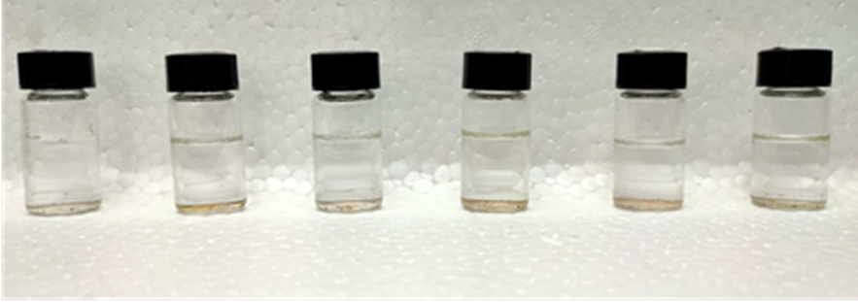
Figure S1 Chemical stability of CMP materials in various organic solvents and in strong acid and alkaline solutions
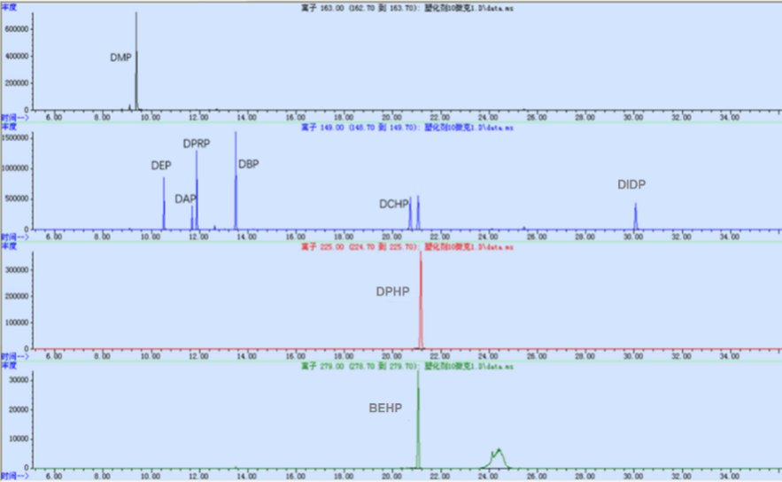

Figure S2 Ion chromatogram of extraction of nine PAEs

Figure S3 Standard curves of 9 PAEs
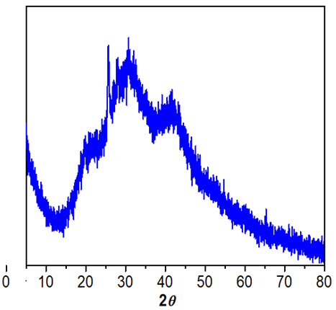

Figure S4 X-ray diffraction pattern of polymer BPQ-CMPs

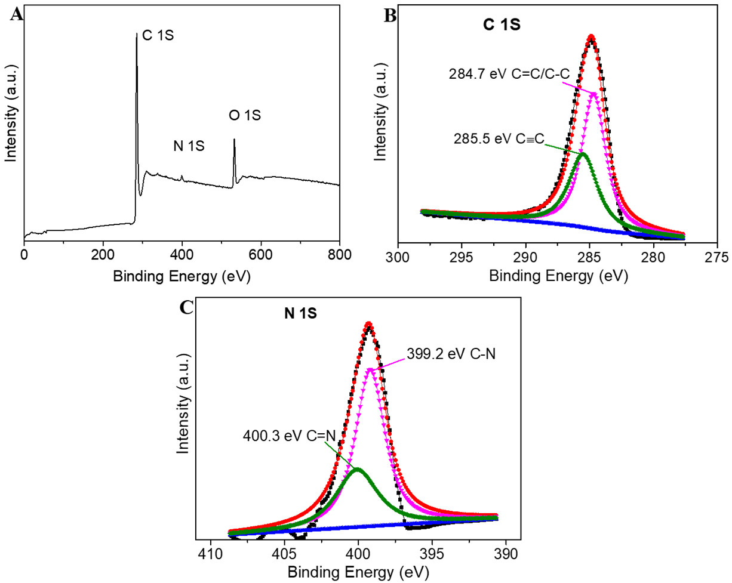

Figure S5 (A) XPS survey spectrum, (B) C 1s and (C) N 1s spectrum of BPQ-CMPs

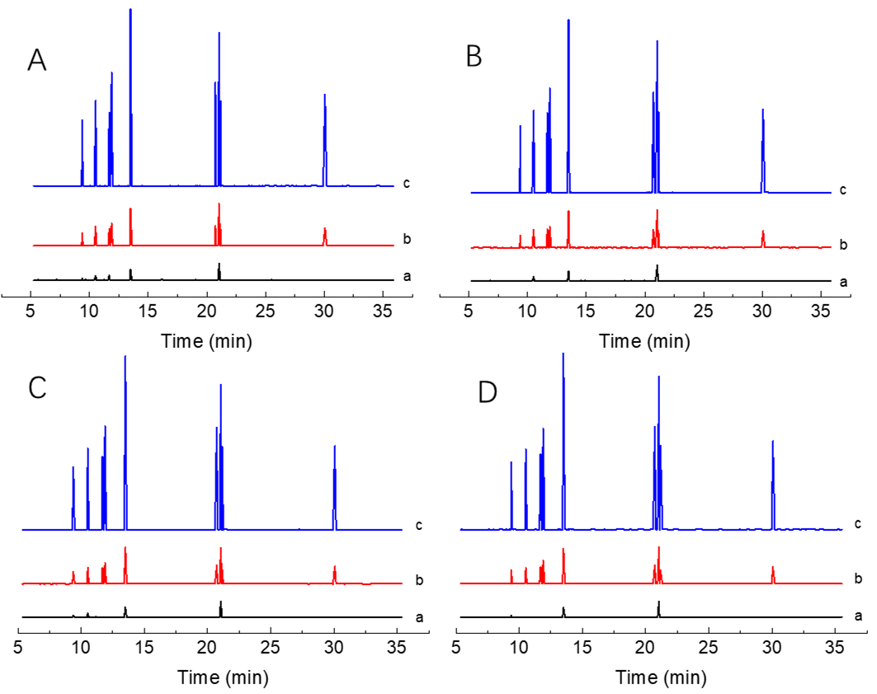

Figure S6 Chromatograms of PAEs by the developed method for (a) samples (the black line); (b) spiked with 1.0 μg L⁻¹ PAEs (the red line) and (c) spiked with 5.0 μg L⁻¹ PAEs (the blue line). (A) peach juice, (B) cooking wine, (C)soy sauce, (D)blending oil
(1) DMP; (2) DEP; (3) DAP; (4) DPRP; (5) DBP; (6) DCHP; (7) BEHP; (8) DPHP; (9) DIDP

Table S1 Pore properties of polymer BPQ-CMPs
Material | Sample weight (g) | BET  (m²/g) | Slope  (g/cm) | Y-Intercept (g/cm) | C | Qm  (cm³/g) | Correlation Coefficient
CMPs | 0.0366 | 601.6196 ± 4.8935 | 0.007235 ± 0.000059 | 0.000000 ± 0.000005 | 31444.84402 | 138.2214 | 0.9998028

Table S2 Extraction performance evaluation
 | DMP | DEP | DAP | DPRP | DBP | DCHP | BEHP | DPHP | DIDP
LogKow | 1.61 | 2.38 | 3.20 | 3.27 | 4.83 | 5.60 | 6.43 | 4.50 | 11.2
EFs | 66±12 | 103±24 | 139±39 | 208±9 | 210±15 | 120±9 | 286±38 | 63±22 | 348±9

Table S3 Binding energy (BE) and inhibitor constant of BPQ-CMP towards PAEs
Compounds | BE (kcal mol⁻¹) | Inhibitor constant
DMP | -3.92 | 1.33
DEP | -3.99 | 1.19
DAP | -4.22 | 803.57
DPRP | -4.41 | 917.64
DBP | -3.95 | 1.27
DCHP | -5.98 | 41.09
BEHP | -4.31 | 695.13
DPHP | -5.98 | 41.46
DIDP | -3.76 | 1.74

