Table S1 Distributions of urine metals and lung function parameters in the study population.
 |  |  |  | Percentiles
 | %>LOD | GM | min | P5 | P25 | P50 | P75 | P95 | max
Metals (μg/g creatinine)
As | 98.2 | 7.023 | 0.765 | 2.420 | 4.104 | 6.073 | 10.212 | 10.225 | 396.97
Ba | 99.4 | 1.600 | 0.100 | 0.388 | 0.919 | 1.639 | 2.856 | 5.679 | 612.000
Cd | 65.3 | 0.076 | 0.009 | 0.027 | 0.050 | 0.077 | 0.115 | 0.210 | 1.604
Co | 99.7 | 0.466 | 0.058 | 0.190 | 0.315 | 0.456 | 0.669 | 1.276 | 5.706
Cs | 100 | 4.367 | 0.401 | 1.982 | 3.232 | 4.455 | 6.014 | 9.008 | 32.474
Hg | 95.6 | 0.333 | 0.025 | 0.101 | 0.179 | 0.292 | 0.580 | 1.681 | 12.973
Mo | 100 | 63.077 | 3.394 | 22.215 | 41.980 | 62.896 | 94.247 | 184.045 | 747.368
Pb | 96.1 | 0.420 | 0.036 | 0.140 | 0.252 | 0.402 | 0.660 | 1.525 | 30.450
Sb | 78.2 | 0.073 | 0.007 | 0.027 | 0.050 | 0.070 | 0.104 | 0.215 | 2.330
Tl | 99.5 | 0.174 | 0.017 | 0.079 | 0.123 | 0.175 | 0.247 | 0.376 | 2.568
Tu | 95.6 | 0.145 | 0.007 | 0.038 | 0.082 | 0.138 | 0.248 | 0.667 | 9.029
Ur | 88.5 | 0.008 | 0.001 | 0.002 | 0.005 | 0.007 | 0.012 | 0.032 | 7.529
Lung function
FEV₁ | 100 | 2406.095 | 900 | 1276.6 | 1796. 0 | 2454.00 | 3242 | 4365.1 | 5580
FVC | 100 | 2800.374 | 1025 | 1491.5 | 2088.0 | 2860.0 | 3781.5 | 5107.9 | 6535
FEF_{25-75%} | 100 | 2651.859 | 635 | 1304.0 | 1960.0 | 2676.0 | 3661.5 | 5196.5 | 8834
PEF | 100 | 5604.348 | 1643 | 3075.5 | 4245.0 | 5763.0 | 7478.5 | 7478.5 | 13437
Abbreviations: LOD, limit of detection; GM, geometric means; As, Arsenic; Ba, Barium; Cd, Cadmium; Cs, Cesium; Co, Cobalt; Hg, Mercury; Mo, Molybdenum; Mn, Manganese; Pb, Lead; Sb, Antimony; Tl, Thallium; Tu, Tungsten Ur, Uranium; FEV₁, forced expiratory volume in one second; FVC, forced vital capacity; FEF_{25–75%}: forced expiratory flow between 25% and 75% of vital capacity; PEF, peak expiratory flow.
Table S2 Posterior inclusion probabilities (PIPs) of BKMR model
Analytes | FEV₁ | FVC | FEF_{25-75%} | PEF
As | 0.6476 | 0.4416 | 0.5954 | 0.1492
Ba | 0.9466 | 0.9576 | 0.7148 | 0.1410
Cd | 0.9976 | 0.9986 | 0.9266 | 0.8546
Co | 0.8006 | 0.5986 | 0.7376 | 0.5554
Cs | 0.6660 | 0.5856 | 0.6100 | 0.3664
Hg | 0.5574 | 0.4178 | 0.6018 | 0.1898
Mo | 0.7248 | 0.7010 | 0.6080 | 0.2034
Pb | 1.0000 | 1.0000 | 1.0000 | 0.9966
Sb | 0.6482 | 0.5628 | 0.6052 | 0.2514
Tl | 0.6482 | 0.6308 | 0.6896 | 0.5892
Tu | 0.8964 | 0.8112 | 0.6230 | 0.2798
Ur | 0.7036 | 0.4476 | 0.6610 | 0.1328
Abbreviations: As, Arsenic; Ba, Barium; Cd, Cadmium; Cs, Cesium; Co, Cobalt; Hg, Mercury; Mo, Molybdenum; Mn, Manganese; Pb, Lead; Sb, Antimony; Tl, Thallium; Tu, Tungsten Ur, Uranium; FEV₁, forced expiratory volume in one second; FVC, forced vital capacity; FEF_{25–75%}: forced expiratory flow between 25% and 75% of vital capacity; PEF, peak expiratory flow.

Table S3 The association between urinary metals and lung function parameters with sampling weights (β, 95%CI)
 | FEV₁ | p | FVC | p | FEF_{25-75%} | p | PEF | p
Univariate Single Metal Models
As | -317.974  (-412.972, -222.977) | <0.001 | -366.981  (-470.618, -263.343) | <0.001 | -363.784  (-485.336, -242.233) | <0.001 | -622.278  (-809.674, -434.882) | <0.001
Ba | -83.872  (-161.842, -5.903) | 0.036 | -94.443  (-186.377, -2.509) | 0.044 | -106.928  (-196.142, -17.713) | 0.020 | -247.322  (-424.157, -70.488) | 0.007
Cd | -215.525  (-330.041, -101.010) | <0.001 | -270.843  (-389.226, -152.460) | <0.001 | -148.388  (-323.305, 26.529) | 0.095 | -380.858 -647.614 -114.102 | 0.006
Co | -466.187  (-591.447, -340.926) | <0.001 | -541.192  (-676.908, -405.476) | <0.001 | -503.814  (-674.148, -333.480) | <0.001 | -993.973  (-1285.531, -702.416) | <0.001
Cs | -939.947  (-1146.767, -733.128) | <0.001 | -1077.219  (-1309.420, -845.018) | <0.001 | -1043.561  (-1294.600, -792.523) | <0.001 | -1972.716  (-2410.164, -1535.267) | <0.001
Hg | -226.792  (-322.201, -131.382) | <0.001 | -284.015  (-390.523, -177.507) | <0.001 | -200.100  (-326.106 -74.095) | 0.002 | -437.318  (-622.121, -252.516) | <0.001
Mo | -669.218  (-789.916, -548.520) | <0.001 | -771.643  (-907.176, -636.110) | <0.001 | -715.696  (-866.447, -564.944) | <0.001 | -1389.173  (-1617.125,-1161.221) | <0.001
Pb | -631.823  (-741.407, -522.239) | <0.001 | -733.421  (-857.056, -609.786) | <0.001 | -662.081  (-797.902, -526.260) | <0.001 | -1280.932  (-1500.644, -1061.221 | <0.001
Sb | -456.462  (-581.207, -331.717) | <0.001 | -540.703  (-673.831, -407.574) | <0.001 | -462.491  (-640.572, -284.410) | <0.001 | -895.771  (-1183.938, -607.605) | <0.001
Tl | -681.560  (-839.735, -523.384) | <0.001 | -772.632  (-947.642, -597.622) | <0.001 | -773.228  (-974.086, -572.370) | <0.001 | -1431.507  (-1775.504,-1087.510) | <0.001
Tu | -397.940  (-479.255, -316.625) | <0.001 | -460.153  (-555.733, -364.573) | <0.001 | -424.294  (-521.405, -327.184) | <0.001 | -800.501  (-970.850, -630.153 | <0.001
Ur | -110.391  (-194.266, -26.517) | 0.011 | -130.979  (-224.350, -37.608) | 0.007 | -111.425  (-220.010, -2.839) | 0.045 | -249.853  (-413.951, -85.754) | 0.004
Covariate-Adjusted Single Toxicant Models ª
As | -29.869  (-83.487, 23.750) | 0.267 | -26.239  (-80.797, 28.318) | 0.336 | -72.117  (-160.136, 15.901) | 0.105 | -50.555  (-157.200, 56.090) | 0.343
Ba | 4.744  (-39.851, 49.339) | 0.831 | 7.135  (-43.585, 57.855) | 0.777 | -3.189  (-65.333, 58.955) | 0.918 | -40.683  (-141.381, 60.015) | 0.419
Cd | -90.138  (-157.689, -22.587) | 0.010 | -112.727  (-175.117, -50.336) | 0.001 | -39.558  (-176.028, 96.913) | 0.561 | -146.845  (-291.047, -2.643) | 0.046
Co | -104.445  (-170.386, -38.503) | 0.003 | -106.461  (-181.100, -31.821) | 0.006 | -138.344  (-243.328, -33.360) | 0.011 | -239.048  (-394.878, -83.218) | 0.004
Cs | -127.419  (-209.900, -44.938) | 0.003 | -130.215  (-228.303, -32.128) | 0.011 | -189.017  (-335.251, -42.783) | 0.013 | -329.899  (-503.379, -156.420) | <0.001
Hg | -43.417  (-100.183, 13.349) | 0.130 | -62.097  (-126.989, 2.794) | 0.060 | -23.288  (-112.220, 65.645) | 0.599 | -75.995  (-178.725, 26.734) | 0.143
Mo | -91.329  (-173.720, -8.937) | 0.031 | -100.033  (-186.855, -13.210) | 0.025 | -94.845  (-209.400, 19.710) | 0.102 | -186.585  (-347.308, 25.861) | 0.024
Pb | -168.667  (-217.980, -119.353) | <0.001 | -192.154  (-249.686, -134.622) | <0.001 | -180.275  (-252.896,-107.653) | <0.001 | -302.868  (-399.520, -206.216) | <0.001
Sb | -83.950  (-133.453, -34.447) | 0.001 | -111.898  (-162.458, -61.339) | <0.001 | -64.024  (-165.780, 37.733) | 0.211 | -118.291  (-256.139, 19.556) | 0.090
Tl | -95.170  (-166.794, -23.545) | 0.011 | -99.459  (-178.670, -20.248) | 0.015 | -139.481  (-262.960, -16.003) | 0.028 | -247.325  (-422.040, -72.610) | 0.007
Tu | -78.428  (-126.590, -30.266) | 0.002 | -87.978  (-145.825, -30.131) | 0.004 | -86.068  (-158.044, -14.091) | 0.020 | -137.408  (-261.084, -13.732) | 0.030
Ur | -16.511  (-59.888, 26.867) | 0.446 | -22.336  (-74.740, 30.069) | 0.394 | -12.904  (-77.823, 52.015) | 0.690 | -54.278  (-140.391, 31.834) | 0.210
Covariate-Adjusted Multiple-Toxicant Models ^{b}
As | -0.952  (-58.802, 56.899) | 0.973 | 10.855  (-47.903, 69.614) | 0.708 | -52.748  (-143.704, 38.208) | 0.244 | 7.693  (-106.366, 121.752) | 0.891
Ba | 63.847  (11.036, 116.658) | 0.020 | 72.250  (12.420, 132.081) | 0.020 | 66.353  (-22.450, 155.156) | 0.137 | 69.201  (-58.835, 197.236) | 0.277
Cd | -52.124  (-118.413, 14.166) | 0.118 | -66.516  (-127.509, -5.522) | 0.034 | 7.626  (-133.447, 148.699) | 0.913 | -70.081  (-216.716, 76.555) | 0.335
Co | -60.119  (-133.358, 13.120) | 0.104 | -59.343  (-143.061, 24.374) | 0.157 | -86.268  (-204.060, 31.523) | 0.145 | -128.214  (-328.772, 72.344) | 0.201
Cs | -19.601  (-153.536, 114.335) | 0.766 | -10.106  (-174.706, 154.495) | 0.901 | -55.670  (-264.050, 152.709) | 0.588 | -99.742  (-397.418, 197.933) | 0.498
Hg | -0.265  (-68.699, 68.169) | 0.994 | -16.698  (-94.080, 60.685) | 0.661 | 29.951  (-79.905, 139.808) | 0.580 | 0.564  (-118.746, 119.874) | 0.992
Mo | 8.834  (-81.815, 99.483) | 0.843 | 8.554  (-88.438, 105.546) | 0.858 | 39.783  (-100.208, 179.773) | 0.565 | 11.429  (-157.529, 180.386) | 0.891
Pb | -152.611  (-222.591, -82.631) | <0.001 | -170.604  (-253.942, -87.267) | <0.001 | -166.850  (-264.896, -68.804) | 0.002 | -245.813  (-371.416, -120.210) | <0.001
Sb | -11.326  (-78.193, 55.542) | 0.731 | -33.452  (-99.627, 32.724) | 0.309 | 17.429  (-113.722, 148.581) | 0.787 | 33.284  (-130.299, 196.867) | 0.680
Tl | -9.903  (-103.688, 83.882) | 0.830 | -4.703  (-114.380, 104.974) | 0.931 | -50.131  (-191.176, 90.914) | 0.472 | -73.141  (-335.387, 189.105) | 0.572
Tu | -57.438  (-120.844, 5.967) | 0.074 | -58.298  (-134.470, 17.875) | 0.128 | -76.226  (-184.766, 32.313) | 0.161 | -86.824  (-234.937, 61.288) | 0.239
Ur | 42.243  (-8.430, 92.916) | 0.099 | 47.531  (-12.646, 107.708) | 0.117 | 42.454  (-34.673, 119.582) | 0.269 | 46.552  (-57.426, 150.529) | 0.366
Abbreviations: CI, Confidence interval; As, Arsenic; Ba, Barium; Cd, Cadmium; Cs, Cesium; Co, Cobalt; Hg, Mercury; Mo, Molybdenum; Mn, Manganese; Pb, Lead; Sb, Antimony; Tl, Thallium; Tu, Tungsten Ur, Uranium; FEV₁, forced expiratory volume in one second; FVC, forced vital capacity; FEF_{25–75%}: forced expiratory flow between 25% and 75% of vital capacity; PEF, peak expiratory flow.
ª Model adjusted for NHANES cycles, age, gender, race, PIR, wheeze, cotinine, BMI.
^{b} Model adjusted for all the covariates and analytic metals

Table S4 The association between urinary metals and lung function parameters among children without current wheezing (β, 95%CI)
 | FEV₁ | p | FVC | p | FEF_{25-75%} | p | PEF | p
Univariate Single Metal Models
As | -330.445  (-396.275, -264.615) | <0.001 | -390.396  (-466.080, -314.711) | <0.001 | -348.012  (-432.266, -263.757) | <0.001 | -683.497  (-828.023, -538.972) | <0.001
Ba | -74.292  (-140.642, -7.943) | 0.028 | -81.663  (-158.136, -5.190) | 0.037 | -86.223  (-170.031, -2.415) | 0.044 | -236.833  (-381.454, -92.211) | 0.001
Cd | -211.272  (-301.560, -120.984) | <0.001 | -271.506  (-375.300, -167.712) | <0.001 | -136.237  (-251.064, -21.410) | 0.020 | 435.491  (-633.002, -237.980) | <0.001
Co | -434.063  (-530.356, -337.770) | <0.001 | -500.856  (-611.808, -389.904) | <0.001 | -484.170  (-606.724, -361.617) | <0.001 | -992.926  (-1202.614, -783.239) | <0.001
Cs | -899.078  (-1008.758, -789.399) | <0.001 | -1031.165  (-1157.696, -904.634) | <0.001 | -997.993  (-1140.212, -855.774) | <0.001 | -1963.936  (-2203.631, -1724.240) | <0.001
Hg | -226.024  (-289.106, -162.942) | <0.001 | -275.166  (-347.664, -202.668) | <0.001 | -205.638  (-286.165, -125.112) | <0.001 | -477.377  (-615.432, -339.321 | <0.001
Mo | -600.681  (-679.634, -521.727) | <0.001 | -684.598  (-775.785, -593.412) | <0.001 | -663.309  (-765.399, -561.219) | <0.001 | 1310.396  (-1482.987, -1137.805) | <0.001
Pb | -598.869  (-664.331, -533.407) | <0.001 | -687.329  (-762.854, -611.804) | <0.001 | -637.575  (-723.732, -551.418) | <0.001 | -1274.588  (-1418.732, -1130.445) | <0.001
Sb | -487.535  (-572.755, -402.315) | <0.001 | -561.515  (-659.723, -463.306) | <0.001 | -519.538  (-628.940, -410.136) | <0.001 | -1011.646  (-1198.937, -824.354) | <0.001
Tl | -620.197  (-726.142, -514.251) | <0.001 | -709.282  (-831.480, -587.084) | <0.001 | -694.342  (-829.859, -558.826) | <0.001 | -1381.742  (-1612.696, -1150.789) | <0.001
Tu | -384.612  (-445.959, -323.265) | <0.001 | -435.894  (-506.748, -365.039 | <0.001 | -431.595  (-510.192, -352.997) | <0.001 | -813.923  (-948.563, -679.283) | <0.001
Ur | -115.435  (-182.030, -48.839) | 0.001 | -125.225  (-202.012, -48.437) | 0.001 | -136.532  (-220.676, -52.388) | 0.002 | -298.690  (-443.900, -153.480) | <0.001
Covariate-Adjusted Single Toxicant Models ª
As | -48.198  (-86.218, -10.179 | 0.013 | -57.780  (-100.231, -15.329) | 0.008 | -61.397  (-125.618, 2.824) | 0.061 | -105.092  (-193.476, -16.707) | 0.020
Ba | 13.252  (-21.588, 48.092) | 0.456 | 16.004  (-22.913, 54.920) | 0.420 | 16.139  (-42.646, 74.923) | 0.591 | -39.792  (-120.742, 41.159) | 0.336
Cd | -87.044  (-134.834, -39.255) | <0.001 | -114.812  (-168.069, -61.554) | <0.001 | -29.214  (-110.300, 51.872) | 0.480 | -192.003  (-303.128, -80.877 | 0.001
Co | -56.356  (-110.414, -2.298) | 0.041 | -51.301  (-111.725, 9.124) | 0.096 | -101.233  (-192.408, -10.058) | 0.030 | -197.347  (-322.659, -72.034) | 0.002
Cs | -93.232  (-168.162, -18.302) | 0.015 | -90.552  (-174.233, -6.871) | 0.034 | -158.577  (-285.133, -32.020) | 0.014 | -278.255  (-452.294, -104.216) | 0.002
Hg | -39.181  (-73.720, -4.641) | 0.026 | -52.129  (-90.674, -13.585) | 0.008 | -20.650  (-79.042, 37.742) | 0.488 | -94.441  (-174.694, -14.189) | 0.021
Mo | -32.827  (-84.823, 19.169) | 0.216 | -23.339  (-81.446, 34.768) | 0.431 | -61.323  (-149.030, 26.384) | 0.171 | -116.896  (-237.614, 3.822) | 0.058
Pb | -121.704  (-167.228, -76.179) | <0.001 | -131.644  (-182.538, -80.750) | <0.001 | -134.089  (-211.457, -56.722) | 0.001 | -260.894  (-366.892, -154.897) | <0.001
Sb | -81.930  (-131.296, -32.565) | 0.001 | -94.464  (-149.590, -39.339) | 0.001 | -83.790  (-167.333, -0.246) | 0.050 | -147.660  (-262.608, -32.713) | 0.012
Tl | -75.800  (-138.876, -12.724) | 0.019 | -84.999  (-155.456, -14.541) | 0.018 | -98.825  (-205.350, 7.700) | 0.069 | -239.454  (-385.714, -93.194) | 0.001
Tu | -64.312  (-100.808, -27.816) | 0.001 | -64.046  (-104.861, -23.232) | 0.002 | -90.292  (-151.969, -28.615) | 0.004 | -135.804  (-220.700, -50.907) | 0.002
Ur | -14.652  (-49.740, 20.435) | 0.413 | -11.306  (-50.507, 27.895) | 0.572 | -26.277  (-85.469, 32.915) | 0.384 | -80.930  (-162.351, 0.491) | 0.052
Covariate-Adjusted Multiple-Toxicant Models ^{b}
As | -33.595  (-73.378, 6.188) | 0.098 | -39.817  (-84.186, 4.552) | 0.079 | -53.469  (-121.489, 14.552) | 0.124 | -61.009  (-154.041, 32.022) | 0.199
Ba | 49.476  (9.606, 89.346) | 0.015 | 49.555  (5.088, 94.021) | 0.029 | 77.787  (9.617, 145.957) | 0.026 | 49.210  (-44.025, 142.446) | 0.301
Cd | -55.744  (-107.160, -4.329) | 0.034 | -81.039  (-138.382, -23.696) | 0.006 | 14.387  (-73.524, 102.297) | 0.748 | -111.249  (-231.483, 8.985) | 0.070
Co | -35.792  (-99.293, 27.710) | 0.270 | -31.189  (-102.012, 39.633) | 0.388 | -82.670  (-191.244, 25.905) | 0.136 | -110.477  (-258.974, 38.020) | 0.145
Cs | 4.320  (-100.554, 109.194) | 0.936 | 14.560  (-102.404, 131.524) | 0.807 | -34.860  (-214.173, 144.453) | 0.703 | -7.091  (-252.336, 238.155) | 0.955
Hg | -4.814  (-42.879, 33.250) | 0.804 | -15.624  (-58.077, 26.828) | 0.471 | 22.511  (-42.571, 87.594) | 0.498 | -21.078  (-110.090, 67.935) | 0.643
Mo | 63.036  (-0.802, 126.873) | 0.053 | 81.736  (10.539, 152.933) | 0.025 | 62.497  (-46.653, 171.646) | 0.262 | 94.415  (-54.868, 243.698) | 0.215
Pb | -102.806  (-156.986, -48.626) | <0.001 | -109.550  (-169.976, -49.124) | <0.001 | -111.354  (-203.991, -18.718) | 0.019 | -180.019  (-306.718, -53.320) | 0.005
Sb | -21.567  (-77.944, 34.811) | 0.454 | -29.872  (-92.749, 33.005) | 0.352 | -17.997  (-114.391, 78.397) | 0.714 | 11.737  (-120.101, 143.575) | 0.862
Tl | -30.409  (-113.285, 52.467) | 0.472 | -38.216  (-130.646, 54.215) | 0.418 | -38.346  (-180.047, 103.355) | 0.596 | -130.263  (-324.066, 63.541) | 0.188
Tu | -72.457  (-118.901, -26.013) | 0.002 | -76.998  (-128.796, -25.200) | 0.004 | -94.352  (-173.762, -14.942) | 0.020 | -119.064  (-227.672, -10.455) | 0.032
Ur | 27.528  (-11.773, 66.830) | 0.170 | 38.454  (-5.378, 82.286) | 0.086 | 10.339  (-56.858, 77.536) | 0.763 | 7.016  (-84.889, 98.921) | 0.881
Abbreviations: CI, Confidence interval; As, Arsenic; Ba, Barium; Cd, Cadmium; Cs, Cesium; Co, Cobalt; Hg, Mercury; Mo, Molybdenum; Mn, Manganese; Pb, Lead; Sb, Antimony; Tl, Thallium; Tu, Tungsten Ur, Uranium; FEV₁, forced expiratory volume in one second; FVC, forced vital capacity; FEF_{25–75%}: forced expiratory flow between 25% and 75% of vital capacity; PEF, peak expiratory flow.
ª Model adjusted for NHANES cycles, age, gender, race, PIR, cotinine, BMI.
^{b} Model adjusted for all the covariates and analytic metals

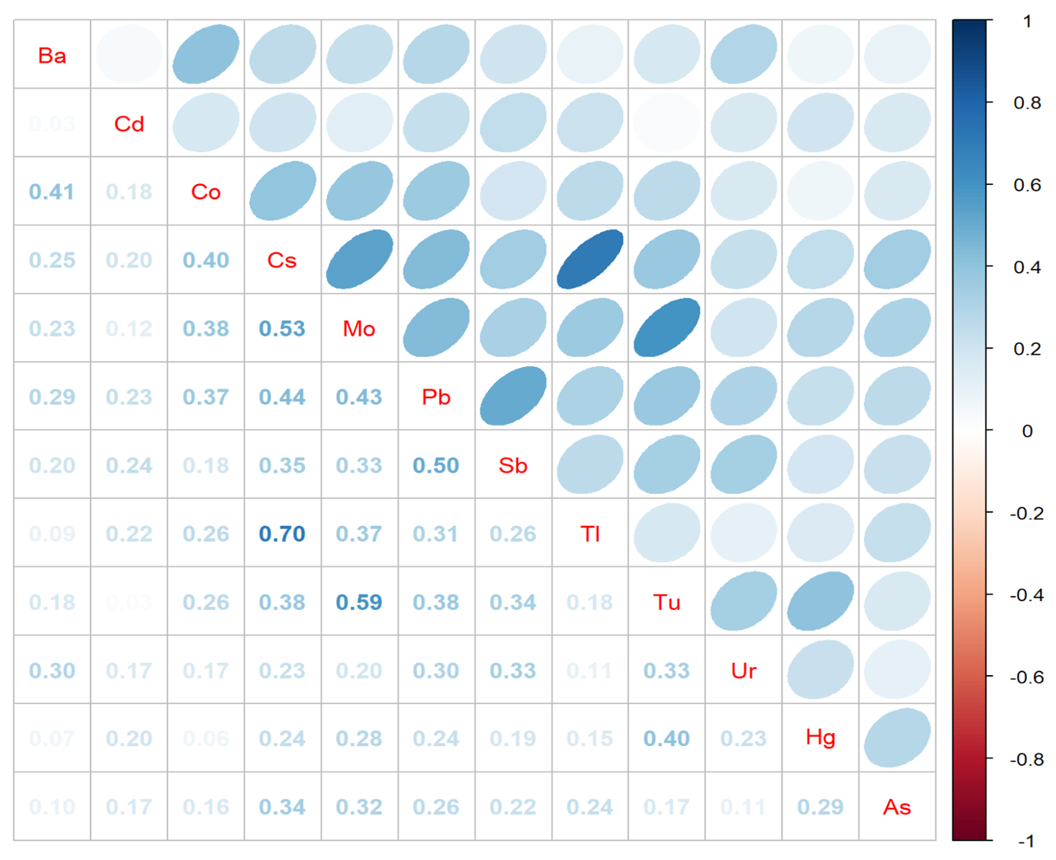
Fig. S1. Spearman correlation matrix for log-transformed urinary metals in the study population.
Abbreviation: As, Arsenic; Ba, Barium; Cd, Cadmium; Cs, Cesium; Co, Cobalt; Hg, Mercury; Mo, Molybdenum; Mn, Manganese; Pb, Lead; Sb, Antimony; Tl, Thallium; Tu, Tungsten Ur, Uranium.

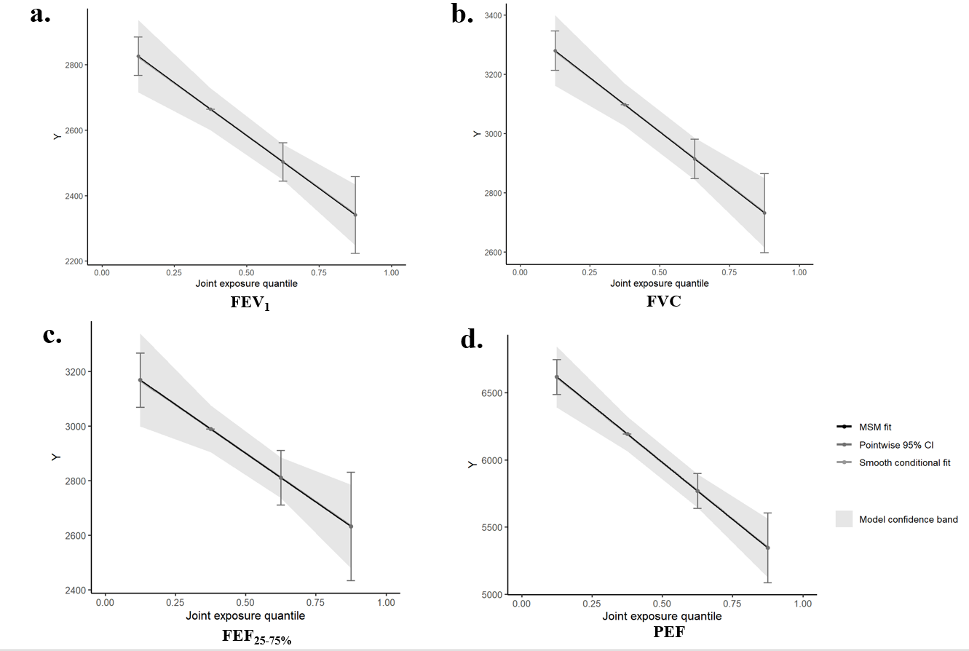
Fig. S2. Weights representing the proportion of the positive or negative partial effect in the quantile g-computation models for each urinary metal in the association with a. FEV₁, b. FVC, c. FEF_{25-75%}, and d. PEF level. Models were adjusted for all covariates.
Abbreviations: CI, confidence interval; FEV₁, forced expiratory volume in one second; FVC, forced vital capacity; FEF_{25–75%}: forced expiratory flow between 25% and 75% of vital capacity; PEF, peak expiratory flow.

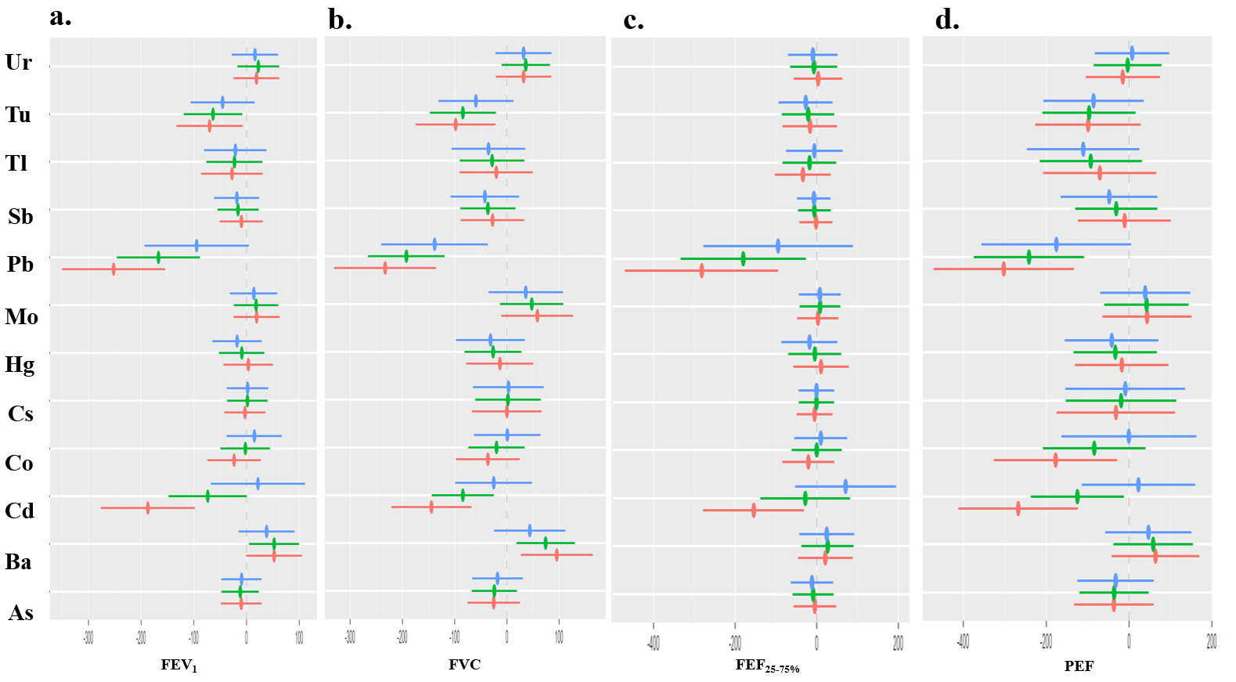
Fig. S3. Single metal effect on a. FEV₁, b. FVC, c. FEF_{25-75%}, and d. PEF comparing the upper quartile to the lower quartile level of a particular urinary metal exposure while fixing the other metals at the 25th (red line), 50th (green line), and 75th (blue line) percentile. Models were adjusted for all covariates.
Abbreviations: As, Arsenic; Ba, Barium; Cd, Cadmium; Cs, Cesium; Co, Cobalt; Hg, Mercury; Mo, Molybdenum; Mn, Manganese; Pb, Lead; Sb, Antimony; Tl, Thallium; Tu, Tungsten Ur, Uranium; FEV₁, forced expiratory volume in one second; FVC, forced vital capacity; FEF_{25–75%}: forced expiratory flow between 25% and 75% of vital capacity; PEF, peak expiratory flow.

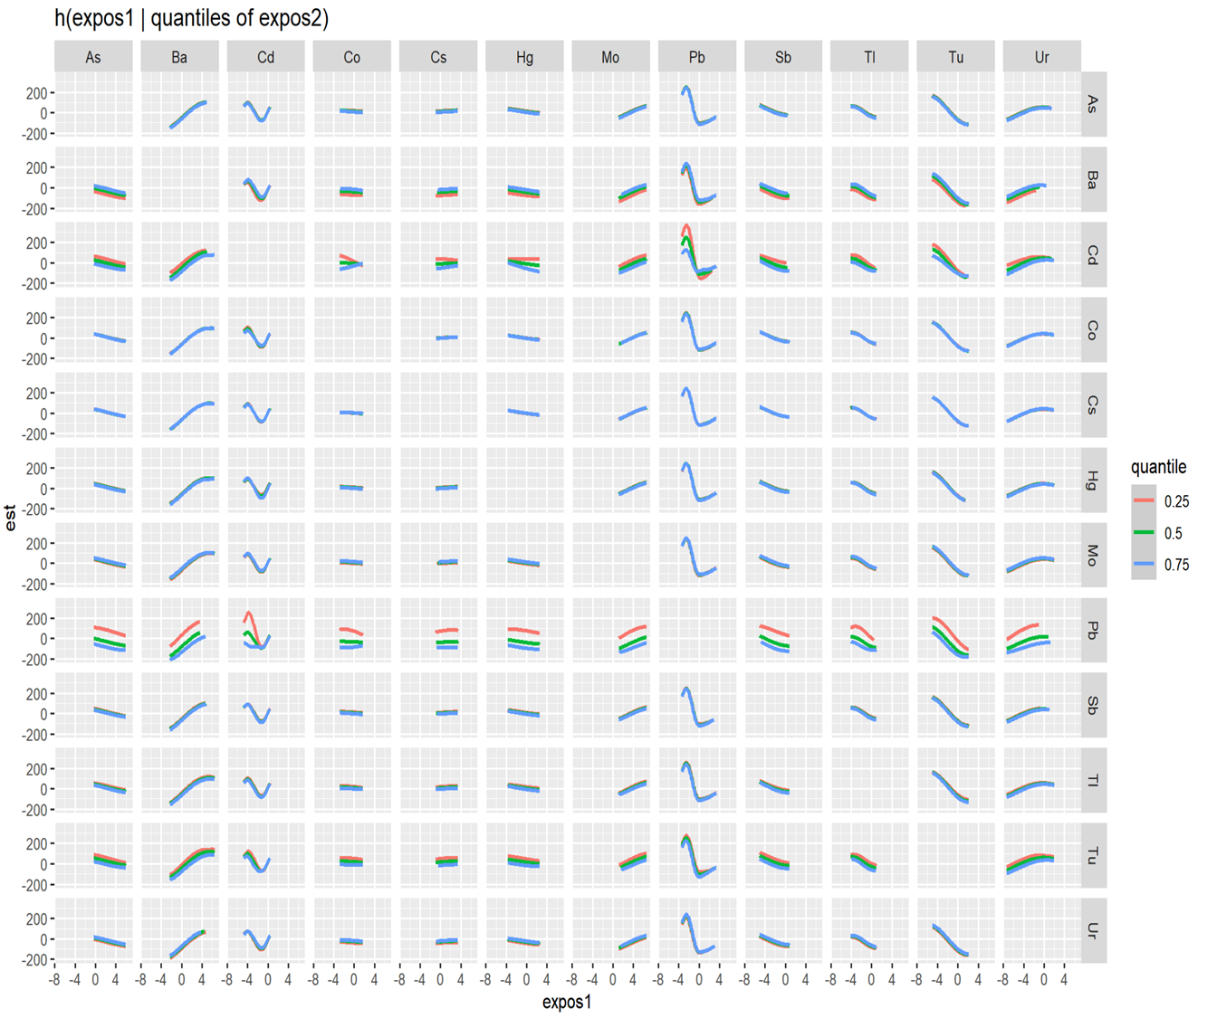
Fig. S4. Bivariate exposure–response functions for FEV₁ and each of the exposure1 metals when exposure2 metals were at their 25th (red line), 50th (green line), and 75th (blue line) percentile, and other chemicals were fixed at their median levels.
Abbreviations: As, Arsenic; Ba, Barium; Cd, Cadmium; Cs, Cesium; Co, Cobalt; Hg, Mercury; Mo, Molybdenum; Mn, Manganese; Pb, Lead; Sb, Antimony; Tl, Thallium; Tu, Tungsten Ur, Uranium; FEV₁, forced expiratory volume in one second.

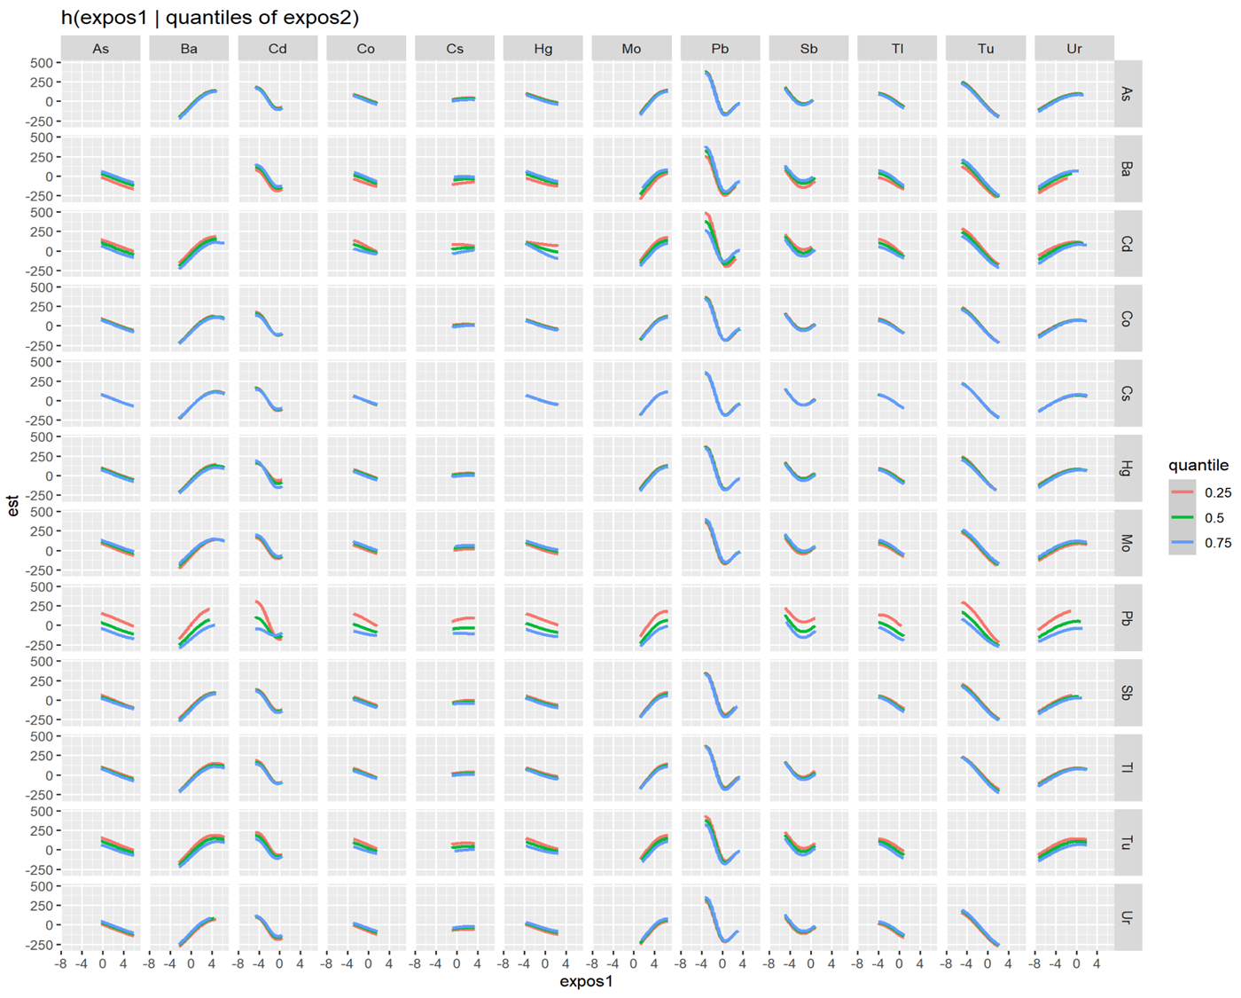
Fig. S5. Bivariate exposure–response functions for FVC and each of the exposure1 metals when exposure2 metals were at their 25th (red line), 50th (green line), and 75th (blue line) percentile, and other chemicals were fixed at their median levels.
Abbreviations: As, Arsenic; Ba, Barium; Cd, Cadmium; Cs, Cesium; Co, Cobalt; Hg, Mercury; Mo, Molybdenum; Mn, Manganese; Pb, Lead; Sb, Antimony; Tl, Thallium; Tu, Tungsten Ur, Uranium; FVC, forced vital capacity.

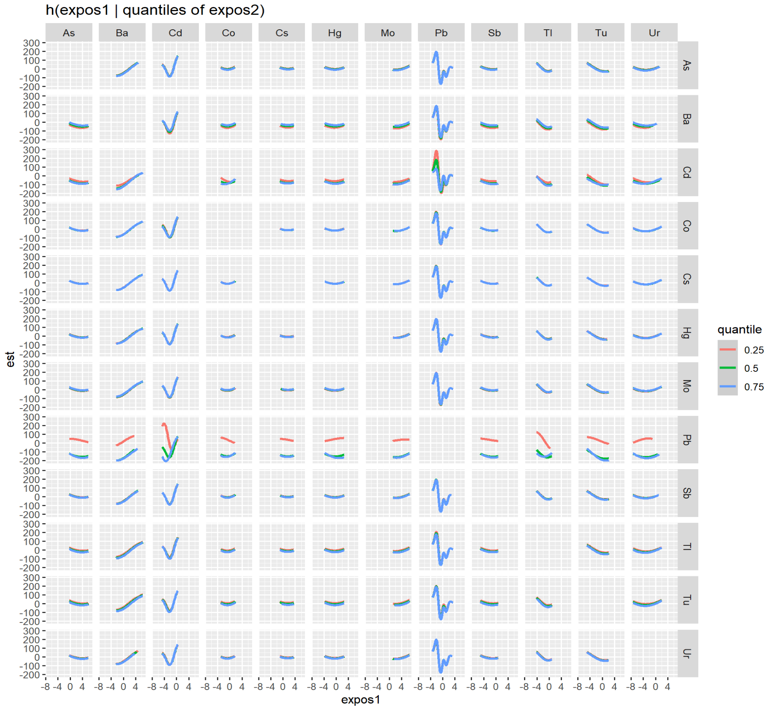
Fig. S6. Bivariate exposure–response functions for FEF_{25-75%} and each of the exposure1 metals when exposure2 metals were at their 25th (red line), 50th (green line), and 75th (blue line) percentile, and other chemicals were fixed at their median levels.
Abbreviations: As, Arsenic; Ba, Barium; Cd, Cadmium; Cs, Cesium; Co, Cobalt; Hg, Mercury; Mo, Molybdenum; Mn, Manganese; Pb, Lead; Sb, Antimony; Tl, Thallium; Tu, Tungsten Ur, Uranium; FEF_{25–75%}: forced expiratory flow between 25% and 75% of vital capacity.

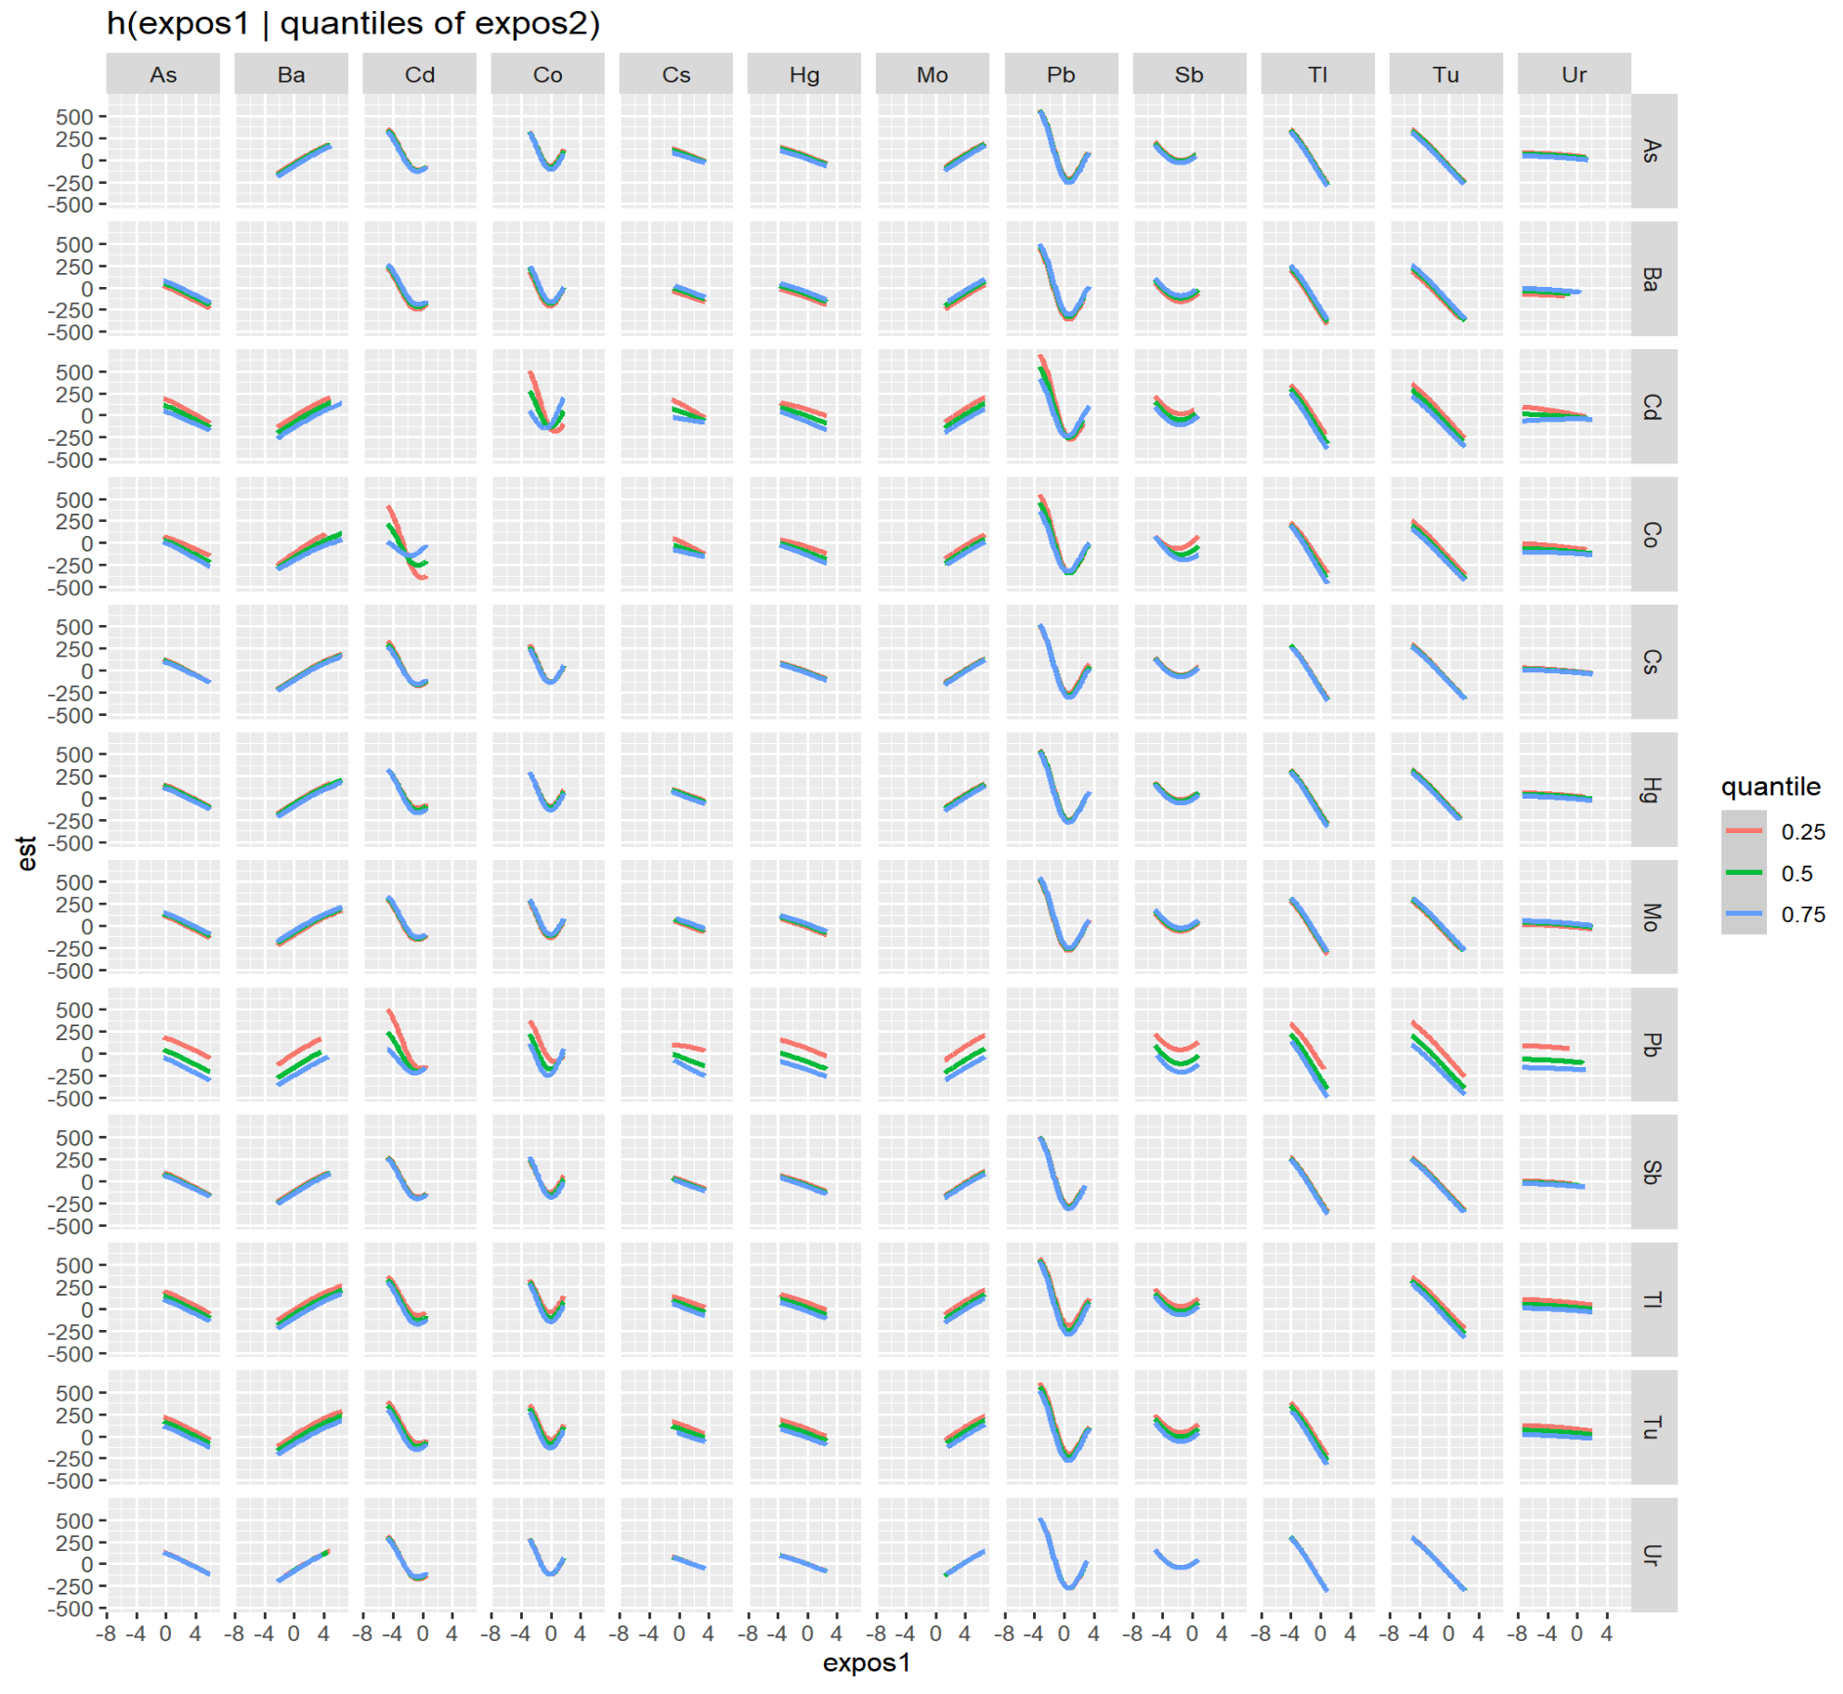
Fig. S7. Bivariate exposure–response functions for PEF and each of the exposure1 metals when exposure2 metals were at their 25th (red line), 50th (green line), and 75th (blue line) percentile, and other chemicals were fixed at their median levels.
Abbreviations: As, Arsenic; Ba, Barium; Cd, Cadmium; Cs, Cesium; Co, Cobalt; Hg, Mercury; Mo, Molybdenum; Mn, Manganese; Pb, Lead; Sb, Antimony; Tl, Thallium; Tu, Tungsten Ur, Uranium; PEF, peak expiratory flow.

