Supplementary information for:
Hogan et al., Profiling cell envelope-antibiotic interactions reveals vulnerabilities to β-lactams in a multidrug-resistant bacterium
Supplementary Tables S1 – S10 are given here
Supplementary Figures S1 – S13 are given here
Supplementary Data S1 is provided as a separate Excel file

Supplementary Table 1 Summary statistics of the randomly barcoded transposon mutant library

Category | K56-2 Library
Number of mutant colonies recovered | ~815, 000
Number of unique barcodes | 338,116
Number of unique insertion positions | 145,585
Protein-coding genes with (or without) central insertions (10-90% of gene) | 6412 (561)
Mean/median strains per interrupted protein-coding gene | 31.9 / 12
Gene and transposon on same strand | 49.9%
Average distance between insertions | 18.7 bp

 |  | MIC (µg/mL) |  | Fold MIC*
Antibiotic | Gene | -Rha | +Rha | Fold MIC*
AMP | NTC | >512 | >512 | -
 | penR | >512 | >512 | -
 | bla_{AmpC} | >512 | >512 | -
 | bla_{PenB} | >512 | 256 | >2
CFD | NTC | 0.125 | 0.125 | 1
 | penR | 0.125 | 0.125 | 1
 | bla_{AmpC} | 0.125 | 0.125 | 1
 | bla_{PenB} | 0.125 | 0.125 | 1
TAZ | NTC | 128 | 128 | 1
 | penR | 128 | 64 | 2
 | bla_{AmpC} | 128 | 128 | 1
 | bla_{PenB} | 128 | 32 | 4
CTT | NTC | 64 | 64 | 1
 | penR | 64 | 16 | 4
 | bla_{AmpC} | 64 | 64 | 1
 | bla_{PenB} | 64 | 64 | 1
Supplementary Table 2. Effect of CRISPRi knockdown of β-lactamase genes on susceptibility to AMP, CFD, TAZ, and CTT. MIC values are the median of three replicates and are reported in µg/mL. Bolded values indicate at least 2-fold change.

*Fold MIC is the ratio of the MIC -Rha to the MIC +Rha

Supplementary Table 3. Susceptibility of Gram-negative panel to AVI combinations (± 8 µg/mL AVI). MICs are the median of three replicates and are reported in µg/mL.
Species | Strain | AZT | AVI/AZT | Ratio | Mero | AVI/MEM | Ratio | CAZ | AVI/CAZ | Ratio | CFD | AVI/CFD | Ratio
A. xylosoxidans | ACH02 | 64 | 64 | 1 | 1 | 1 | 1 | 2 | 2 | 1 | 0.25 | 0.25 | 1
 | ACH03 | 32 | 32 | 1 | 0.25 | 0.25 | 1 | 1 | 1 | 1 | 0.125 | 0.125 | 1
 | ACH09 | 16 | 16 | 1 | 0.125 | 0.125 | 1 | 1 | 1 | 1 | 0.25 | 0.25 | 1
S. maltophilia | D457 | 16 | 2 | 8 | 32 | 32 | 1 | 1 | 1 | 1 | 0.125 | 0.125 | 1
 | K279a | 128 | 1 | 128 | 2 | 2 | 1 | 2 | 1 | 2 | 0.125 | 0.125 | 1
 | 03 T2510 | 256 | 4 | 64 | >64 | >64 | - | 32 | 32 | 1 | 1 | 1 | 1
 | 04 T22674 | 64 | 1 | 64 | 16 | 16 | 1 | 2 | 2 | 1 | 0.5 | 0.5 | 1
 | 05 41846 | 128 | 2 | 64 | >64 | >64 | - | 4 | 4 | 1 | 0.5 | 0.5 | 1
 | 21NE928511 | 256 | 4 | 64 | >64 | >64 | - | >128 | >128 | - | >4 | >4 | -
 | 20NC580771 | 256 | 2 | 128 | >64 | >64 | - | >128 | >128 | - | 0.25 | 0.25 | 1
P. aeruginosa | PAO1 | 4 | 4 | 1 | 0.5 | 0.5 | 1 | 1 | 1 | 1 | 1 | 1 | 1
 | PA14 | 8 | 8 | 1 | 0.5 | 0.25 | 2 | 2 | 2 | 1 | 1 | 1 | 1
 | 70 | 0.25 | 0.25 | 1 | 0.125 | 0.125 | 1 | 0.5 | 0.5 | 1 | 0.5 | 0.5 | 1
 | 71 | 128 | 8 | 16 | 32 | 4 | 8 | >128 | 4 | >32 | 4 | 4 | 1
 | 74 | 128 | 2 | 64 | 16 | 2 | 8 | 128 | 2 | 64 | >4 | >4 | -
 | 20NB681421 | 16 | 16 | 1 | 1 | 0.5 | 2 | 4 | 4 | 1 | 1 | 1 | 1
 | 21NE72623 | 4 | 2 | 2 | 0.5 | 0.125 | 4 | 16 | 2 | 8 | >4 | >4 | -
B. cenocepacia | 110041 | 64 | 16 | 4 | 32 | 4 | 8 | 4 | 4 | 1 | 0.0625 | 0.0625 | 1
 | BC7 | >128 | >128 | - | 16 | 1 | 16 | 16 | 16 | 1 | >4 | >4 | -
 | K56-2 | 256 | 8 | 32 | 16 | 2 | 8 | 32 | 4 | 8 | 0.125 | 0.125 | 1
 | VC10414 | 16 | 8 | 2 | 32 | 2 | 16 | 8 | 4 | 2 | 0.125 | 0.125 | 1
 | VC14488 | 16 | 2 | 8 | 4 | 1 | 4 | 4 | 2 | 2 | 0.25 | 0.25 | 1
 | VC14543 | 256 | 32 | 8 | 16 | 4 | 4 | 8 | 8 | 1 | 0.125 | 0.0625 | 2
 | VC14761 | 8 | 2 | 4 | 4 | 1 | 4 | 2 | 2 | 1 | 0.125 | 0.0625 | 2
 | F4200989-3 | >256 | 64 | >4 | 32 | 4 | 8 | 128 | 32 | 4 | 2 | 1 | 2
 | G11815681 | >256 | 32 | >8 | 32 | 2 | 16 | 16 | 8 | 2 | 2 | 0.5 | 4
 | F3071909 | 256 | 32 | 8 | 16 | 2 | 8 | 32 | 32 | 1 | >4 | >4 | -
 | F9141525 | >256 | 32 | >8 | 32 | 4 | 8 | 128 | 16 | 8 | 0.5 | 0.5 | 1
 | 130723 | 256 | 8 | 32 | 4 | 1 | 4 | 16 | 8 | 2 | 0.5 | 0.25 | 2
 | 134991 | 16 | 16 | 1 | 2 | 2 | 1 | 8 | 8 | 1 | >4 | >4 | -
B. contaminans | LMG23361 | 32 | 2 | 16 | 4 | 0.5 | 8 | 2 | 2 | 1 | 0.125 | 0.125 | 1
 | 21NG609698 | 256 | 8 | 32 | 32 | 8 | 4 | 16 | 4 | 4 | 2 | 2 | 1
 | 21NG595759 | 256 | 8 | 32 | 32 | 8 | 4 | 16 | 8 | 2 | 1 | 2 | 0.5
B. dolosa | CEP021 | 8 | 8 | 1 | 2 | 1 | 2 | 2 | 1 | 2 | 0.5 | 0.5 | 1
 | AU0645 | >256 | 16 | >16 | 16 | 2 | 8 | >128 | 8 | >16 | >4 | >4 | -
 | LM018941 | >256 | 4 | >64 | 16 | 0.5 | 32 | 16 | 2 | 8 | >4 | >4 | -
 | AU2167 | >256 | 16 | >16 | 32 | 1 | 32 | 64 | 4 | 16 | >4 | >4 | -
 | AU6940 | >256 | 8 | >32 | 32 | 2 | 16 | 16 | 16 | 1 | 2 | 2 | 1
B. gladioli | VC14812 | 128 | 32 | 4 | 8 | 8 | 1 | 32 | 16 | 2 | 0.5 | 0.5 | 1
 | VC19233 | 32 | 8 | 4 | 1 | 1 | 1 | 4 | 2 | 2 | 0.25 | 0.25 | 1
 | 113611 | 128 | 32 | 4 | 2 | 2 | 1 | 32 | 32 | 1 | 4 | 4 | 1
 | 132208 | 4 | 4 | 1 | 0.5 | 0.5 | 1 | 2 | 2 | 1 | 0.5 | 0.5 | 1
B. multivorans | 130034 | 16 | 8 | 2 | 8 | 4 | 2 | 8 | 8 | 1 | 0.125 | 0.125 | 1
 | C5393 | 64 | 8 | 8 | 16 | 1 | 16 | 8 | 4 | 2 | 0.25 | 0.25 | 1
 | VC15535 | 256 | 16 | 16 | 16 | 8 | 2 | 32 | 16 | 2 | 0.5 | 0.5 | 1
 | VC15555 | 4 | 4 | 1 | 8 | 4 | 2 | 2 | 2 | 1 | >4 | >4 | -
 | VC19694 | 128 | 4 | 32 | 8 | 4 | 2 | 4 | 1 | 4 | 1 | 1 | 1
 | VC9825 | 8 | 4 | 2 | 2 | 1 | 2 | 2 | 2 | 1 | 0.25 | 0.125 | 2
 | 131077 | 16 | 8 | 2 | 4 | 1 | 4 | 8 | 8 | 1 | 0.125 | 0.125 | 1
 | 134955 | 16 | 4 | 4 | 8 | 1 | 8 | 8 | 8 | 1 | 0.125 | 0.125 | 1
 | F9091687 | 2 | 0.5 | 4 | 0.5 | 0.5 | 1 | 2 | 2 | 1 | 0.25 | 0.25 | 1
 | LM013010 | 64 | 4 | 16 | 8 | 1 | 8 | 4 | 4 | 1 | 0.25 | 0.25 | 1
 | V1120157 | 4 | 4 | 1 | 1 | 1 | 1 | 2 | 2 | 1 | 0.125 | 0.125 | 1
B. vietnamiensis | CEP40 | 4 | 2 | 2 | 1 | 1 | 1 | 4 | 2 | 2 | 0.125 | 0.0625 | 2
 | VC11431 | 256 | 4 | 64 | 16 | 1 | 16 | 32 | 2 | 16 | 1 | 0.125 | 8
 | VC18984 | 256 | 8 | 32 | 8 | 4 | 2 | 16 | 4 | 4 | >4 | >4 | -

Supplementary Table 4. MIC values of other β-lactams in K56-2 with AVI and TAZ. MIC values are the median of three replicates and are reported in µg/mL. Bolded values indicate changes upon β-lactamase addition.
 | β-Lactam Alone | + 8 µg/mL AVI | + 8 µg/mL TAZ
Ceftazidime | 32 | 4 | 32
Cefotaxime | >128 | 16 | >128
Cephalexin | >128 | 128 | >128
Cefmetazole | 128 | 128 | 128
Cefoperazone | >128 | 64 | >128
Ceftriaxone | >128 | 4 | >128
Moxalactam | 128 | 128 | 128

Supplementary Table 5. Susceptibility of CF pathogens and clinical isolates to cefiderocol and ceftazidime in CAMHB and M9+CAA. MIC values (µg/mL) are medians of at least three biological replicates. The ratio is the MIC in M9+CAA divided by the MIC in CAMHB. Bold indicates at least 2-fold difference between medium types.
 |  |  | CFD |  |  | CAZ
Species | Strain | CAMHB | M9+CAA | Ratio | CAMHB | M9+CAA | Ratio
A. xylosoxidans | ACH02 | 0.25 | 0.00781 | 0.03125 | 2 | 2 | 1
 | ACH03 | 0.125 | 0.03125 | 0.25 | 1 | 1 | 1
S. maltophilia | D457 | 0.125 | 0.25 | 2 | 1 | 1 | 1
 | K279a | 0.125 | 0.125 | 1 | 2 | 4 | 2
P. aeruginosa | PAO1 | 1 | 0.0078 | 0.0078 | 1 | 1 | 1
 | PA14 | 1 | 0.0078 | 0.0078 | 2 | 2 | 1
B. cenocepacia | 110041 | 0.0625 | 0.5 | 8 | 4 | 2 | 0.5
 | BC7 | >4 | >4 | N/A | 16 | 16 | 1
 | K56-2 | 0.125 | 1 | 4 | 32 | 32 | 1
 | VC10414 | 0.125 | 0.03125 | 0.25 | 8 | 8 | 1
 | VC14488 | 0.25 | 4 | 16 | 4 | 8 | 2
 | VC14543 | 0.125 | 1 | 8 | 8 | 4 | 0.5
 | VC14761 | 0.125 | 0.125 | 1 | 4 | 8 | 2
B. dolosa | CEP021 | 0.5 | >4 | >8 | 2 | 2 | 1
B. multivorans | 130034 | 0.125 | 0.5 | 4 | 8 | 8 | 1
 | C5393 | 0.25 | 0.5 | 2 | 8 | 8 | 1
 | VC15535 | 0.5 | >8 | >16 | 32 | 32 | 1
 | VC19694 | 1 | 4 | 4 | 4 | 4 | 1
 | VC9825 | 0.25 | 2 | 8 | 2 | 4 | 2
 | ATCC17616 | 4 | 4 | 1 | 8 | 8 | 1
B. vietnamiensis | CEP40 | 0.125 | 2 | 16 | 4 | 4 | 1
 | VC11431 | 1 | 4 | 4 | 32 | 32 | 1
 | VC18984 | >8 | >8 | N/A | 16 | 8 | 0.5
B. thailandensis | E264 | 0.125 | 0.0625 | 0.5 | 8 | 4 | 0.5

Supplementary Table 6. Whole panel of CRISPRi mutants in genes associated with iron uptake from Figure 8 and their susceptibility to cefiderocol and ceftazidime in CAMHB and M9+CAA. MIC values (µg/mL) presented are medians of at least four biological replicates in the presence of 0.5% rhamnose. Bold indicates at least 2-fold difference from the NTC. Gene names are assigned by homology, if known, or else the locus tag is given (preceded by K562_).

Gene Function | CRISPRi  Target | CFD |  | CAZ
Gene Function | CRISPRi  Target | CAMHB | M9+CAA | CAMHB | M9+CAA
N/A | NTC | 0.125 | 1 | 32 | 32
TBDR | piuA (RS21350) | 0.5 | 4 | 32 | 32
(Outer | RS00600 | 0.125 | 1 | 32 | 32
membrane | RS07175 | 0.125 | 1 | 32 | 32
protein) | RS09770 | 0.125 | 1 | 32 | 32
 | RS09805 | 0.125 | 1 | 32 | 32
 | cntO (RS10150)* | 0.25 | 2 | 8 | 16
 | orbA (RS10200) | 0.125 | 1 | 32 | 32
 | fecA (RS11910) | 0.125 | 1 | 32 | 32
 | RS12040 | 0.125 | 1 | 32 | 32
 | RS14405 | 0.125 | 1 | 32 | 32
 | RS19650 | 0.125 | 1 | 32 | 32
 | RS19695 | 0.125 | 1 | 32 | 32
 | RS20035 | 0.125 | 1 | 32 | 32
 | RS20755 | 0.125 | 1 | 32 | 32
 | RS21965 | 0.125 | 1 | 32 | 32
 | RS25090 | 0.125 | 1 | 32 | 32
 | btuB (RS25215) | 0.125 | 1 | 32 | 32
 | RS27300 | 0.125 | 1 | 32 | 32
 | fptA (RS28410) | 0.125 | 1 | 32 | 32
 | RS29155 | 0.125 | 1 | 32 | 32
 | RS29535 | 0.125 | 1 | 32 | 16
 | hmuR (RS30495) | 0.5 | 1 | 32 | 32
 | orbA2 (RS33275) | 0.125 | 1 | 32 | 32
 | RS33410 | 0.125 | 1 | 16 | 16
Regulator | fur (RS16355) | 0.03125 | 0.125 | 8 | 4
Energy | tonB1 (RS20010)** | 0.0625 | 0.25 | 32 | 8
transduction | tonB2 (RS09735) | 0.125 | 1 | 32 | 32
to | tonB3 (RS07120) | 1 | 2 | 32 | 32
TBDRs | tonB4 (RS14515) | 0.125 | 1 | 32 | 16
* K562_RS10150 was assigned as a strong homologue to P. aeruginosa PAO1 cntO but failed reciprocal best-hit BLAST.
** tonB paralogues are assigned based on similarity to the P. aeruginosa PAO1 tonB1
Supplementary Table 7. Bacterial strains and mutants used in this work.
Strain | Features | Source
Achromobacter xylosoxidans ACH02 | Canadian CF isolate; multidrug resistant | H. Adam (Shared Health MB)
A. xylosoxidans ACH03 | Canadian CF isolate; multidrug resistant | H. Adam (Shared Health MB)
A. xylosoxidans ACH09 | Canadian CF isolate; multidrug resistant | H. Adam (Shared Health MB)
B. cenocepacia 110041 | Canadian CF isolate | National Microbiology Lab, MB
B. cenocepacia K56-2 | ET12 lineage CF clinical isolate from Toronto | ¹
B. cenocepacia K56-2::dCas9 | Derived from K56-2; pAH-CTX1rhadCas9 integrated at attB site; clean deletion of plasmid accessory genes | ²
B. cenocepacia BC7 | Canadian CF isolate; epidemic lineage | CBCCRRR
B. cenocepacia VC10414 | Canadian CF isolate | CBCCRRR
B. cenocepacia VC14488 | Canadian CF isolate | CBCCRRR
B. cenocepacia VC14543 | Canadian CF isolate | CBCCRRR
B. cenocepacia VC14761 | Canadian CF isolate | CBCCRRR
B. cenocepacia 110041 | Canadian CF isolate | National Microbiology Lab, Winnipeg, Canada
B. cenocepacia F4200989 | CF isolate from SickKids Hospital, Toronto, Canada | Dr. Valerie Waters
B. cenocepacia G1181568-1 | CF isolate from SickKids Hospital, Toronto, Canada | Dr. Valerie Waters
B. cenocepacia F3071909 | CF isolate from SickKids Hospital, Toronto, Canada | Dr. Valerie Waters
B. cenocepacia F9141525 | CF isolate from SickKids Hospital, Toronto, Canada | Dr. Valerie Waters
B. cenocepacia 130723 | Respiratory isolate from Edmonton, Canada | Canadian Antimicrobial Resistance Alliance
B. cenocepacia 134991 | Respiratory isolate from Halifax, Canada | Canadian Antimicrobial Resistance Alliance
B. cepacia ATCC 25416 | Onion pathogen, reference strain | ATCC
B. contaminans 21NG595759 | Canadian CF isolate | H. Adam (Shared Health MB)
B. contaminans 21NG609698 | Canadian CF isolate | H. Adam (Shared Health MB)
B. contaminans FFH2055 | Cystic fibrosis clinical isolate from Argentina | ³
B. contaminans LMG23361 | Veterinary isolate | BCCM
B. dolosa CEP021 | Cystic fibrosis isolate | Dr. David Speert
B. dolosa AU0645 | CF clinical isolate | Dr. Sarah Kennedy/Dr. Valerie Waters
B. dolosa LM018941 | CF clinical isolate | Dr. Sarah Kennedy/Dr. Valerie Waters
B. dolosa AU2167 | CF clinical isolate | Dr. Sarah Kennedy/Dr. Valerie Waters
B. dolosa AU6940 | CF clinical isolate | Dr. Sarah Kennedy/Dr. Valerie Waters
B. gladioli VC14812 | Canadian CF isolate | CBCCRRR
B. gladioli VC19233 | Canadian CF isolate | CBCCRRR
B. gladioli 113611 | Respiratory isolate from Saskatoon, Canada | Canadian Antimicrobial Resistance Alliance
B. gladioli 132208 | Respiratory isolate from Montréal, Canada | Canadian Antimicrobial Resistance Alliance
B. multivorans 130034 | Canadian CF isolate | National Microbiology Lab, MB
B. multivorans 21NH942533 | Canadian CF isolate | H. Adam (Shared Health MB)
B. multivorans 21NJ503211 | Canadian CF isolate | H. Adam (Shared Health MB)
B. mutlivorans ATCC 17616 | Soil isolate | ATCC
B. multivorans VC15535 | Canadian CF isolate | CBCCRRR
B. multivorans VC15555 | Canadian CF isolate | CBCCRRR
B. multivorans VC19694 | Canadian CF isolate | CBCCRRR
B. multivorans VC9825 | Canadian CF isolate | CBCCRRR
B. multivorans 131077 | Respiratory isolate from Toronto, Canada | Canadian Antimicrobial Resistance Alliance
B. multivorans 134955 | Respiratory isolate from Edmonton, Canada | Canadian Antimicrobial Resistance Alliance
B. multivorans F9091687 | CF clinical isolate | Dr. Sarah Kennedy/Dr. Valerie Waters
B. multivorans LM013010 | CF clinical isolate | Dr. Sarah Kennedy/Dr. Valerie Waters
B. multivorans V1120157 | CF clinical isolate | Dr. Sarah Kennedy/Dr. Valerie Waters
B. multivorans C5393 | CF clinical isolate | Dr. David Speert
B. thailandensis E264 | Rice-field soil sample in Thailand | DSMZ
B. vietnamiensis CEP40 | American cystic fibrosis isolate | ⁴
B. vietnamiensis VC11431 | Canadian cystic fibrosis isolate | CBCCRRR
B. vietnamiensis VC18984 | Canadian cystic fibrosis isolate | CBCCRRR
E. coli DH5α | F⁻ Φ80lacZΔM15 Δ(lacZYAargF) U169 recA1 endA1 hsdR17 (rK⁻, mK⁺) phoA supE44 λ⁻ thi-1 gyrA96 relA1 | Invitrogen
E. coli MM294 | F− φ80 lacZΔM15 endA1 recA1 hsdR17 (rH− mK+) supE44 thi-1 ΔgyrA96 (ΔlacZYA-argF)U169 relA1 | ⁵
E. coli SY327 | F⁻ araD Δ(lac-proAB) argE(Am) recA56 Rifr nalA λpir | ⁶
Pseudomonas. aeruginosa 20NB681421 | Canadian cystic fibrosis isolate | H. Adam (Shared Health MB)
P. aeruginosa 21NE72623 | Canadian cystic fibrosis isolate | H. Adam (Shared Health MB)
P. aeruginosa PAO1 | Lab strain from burn wound | Dr. Ayush Kumar
P. aeruginosa 70 | CF clinical isolate from Montréal, Canada | Dr. Valerie Waters
P. aeruginosa 71 | CF clinical isolate from Montréal, Canada | Dr. Valerie Waters
P. aeruginosa 74 | CF clinical isolate from Montréal, Canada | Dr. Valerie Waters
Stenotrophomonas maltophilia 20NC580771 | Canadian CF isolate | H. Adam (Shared Health MB)
S. maltophilia 21NE928511 | Canadian CF isolate | H. Adam (Shared Health MB)
S. maltophilia D457 | Non-CF respiratory isolate from Spain | ATCC
S. maltophilia K279a | Bloodstream isolate from UK; multidrug resistant | ATCC
S. maltophilia 03 T20510 | CF isolate from SickKids Hospital, Toronto, Canada | Dr. Valerie Waters
S. maltophilia 04 T22674 | CF isolate from SickKids Hospital, Toronto, Canada | Dr. Valerie Waters
S. maltophilia 05 41846 | CF isolate from SickKids Hospital, Toronto, Canada | Dr. Valerie Waters

Supplementary Table 8. Plasmids used in this work.
Plasmid | Features | Source
pDAI-SceI-sacB | pDAI-SceI expressing sacB | ^{7,8}
pGPI-SceI | ori_{R6K} Tmp^{r} mob⁺ carries I-SceI cut site | ⁹
pSCrhaBoutgfp | pTnMod-OTp′, rhaR rhaS P_{rhaB} e-gfp | ¹⁰
pRBrhaBout | pSCrhaboutgfp derivative  ori_{R6K} dhfr rhaR rhaS PrhaB (also called pRB-rham) | ¹¹
pKS1 | pRBrhaBout with NcoI and BamHI restriction sites inserted after dhfr | This study
pRBrha-Barcode | Pool of pKS1 with the random barcode ligated in the NcoI and BamHI sites | This study
pRK2013 | ori_{colE1} RK2 derivative Kan^{r} mob⁺ tra⁺ | ¹²
pSCrhaB2-plus | pSCrhaB2 with rhaI₁-rhaI₁ permutation of rhaS binding sites upstream of P_{rhaBAD} and bacteriophage T7 gene 10 stem loop inserted upstream of native rhaBAD 5′ UTR | ¹³
pSCB2-sgRNAv2 | Template for pgRNA created by inverse PCR; derived from  pSCrhaB2-sgRNA by inverse  PCR to remove rhaS, rhaR, and  PrhaB | ²
pgRNA-non-target | Derived from pSCB2-sgRNA; random 20 nt sequence added as gRNA binding region by inverse PCR | ²
phldD+ | pSCrhaB2plus with K56-2 hldD gene (K562_RS14060) cloned between NdeI and XbaI sites | This study
pwaaL+ | pSCrhaB2plus with K56-2 waaL gene (K562_RS06530) cloned between NdeI and XbaI sites | This study
pwbiI+ | pSCrhaB2plus with K56-2 wbiI gene (K562_RS15035) cloned between NdeI and XbaI sites | This study
pwzm-wzt+ | pSCrhaB2plus with K56-2 wzm and wzt genes (K562_RS15080 and K562_RS15085) cloned between NdeI and XbaI sites | This study
pGPI-SceI-hldD | pGPI-SceI with a fusion of 360 bp regions immediately upstream and downstream of hldD cloned into XbaI and XmaI sites. Enables deletion of the 3’ 796/993 bp of hldD. | This study
pGPI-SceI-waaL | pGPI-SceI with a fusion of 360 bp regions immediately upstream and downstream of waaL cloned into XbaI and XmaI sites. Enables deletion of the 5’ 785/1230 bp of waaL. | This study
pgRNA-32470-1 | pSCB2-sgRNAv2 expressing sgRNA targeting K562_RS32470 | This study
pgRNA-32470-2 | pSCB2-sgRNAv2 expressing sgRNA targeting K562_RS32470 | This study
pgRNA-ampC1 | pSCB2-sgRNAv2 expressing sgRNA targeting ampC | This study
pgRNA-ampC2 | pSCB2-sgRNAv2 expressing sgRNA targeting ampC | This study
pgRNA-ampD1 | pSCB2-sgRNAv2 expressing sgRNA targeting ampD | This study
pgRNA-ampD2 | pSCB2-sgRNAv2 expressing sgRNA targeting ampD | This study
pgRNA-ampG1 | pSCB2-sgRNAv2 expressing sgRNA targeting ampG | This study
pgRNA-ampG2 | pSCB2-sgRNAv2 expressing sgRNA targeting ampG | This study
pgRNA-bacA1 | pSCB2-sgRNAv2 expressing sgRNA targeting bacA | This study
pgRNA-bacA2 | pSCB2-sgRNAv2 expressing sgRNA targeting bacA | This study
pgRNA-hldD1 | pSCB2-sgRNAv2 expressing sgRNA targeting hldD | This study
pgRNA-hldD2 | pSCB2-sgRNAv2 expressing sgRNA targeting hldD | This study
pgRNA-ispDF1 | pSCB2-sgRNAv2 expressing sgRNA targeting ispDF operon | This study
pgRNA-ispDF2 | pSCB2-sgRNAv2 expressing sgRNA targeting ispDF operon | This study
pgRNA-mlaFEDvacJ1 | pSCB2-sgRNAv2 expressing sgRNA targeting the mlaFEDvacJ operon | This study
pgRNA-mlaFEDvacJ2 | pSCB2-sgRNAv2 expressing sgRNA targeting the mlaFEDvacJ operon | This study
pgRNA-mlaCB1 | pSCB2-sgRNAv2 expressing sgRNA targeting the mlaCB operon | This study
pgRNA-mlaCB2 | pSCB2-sgRNAv2 expressing sgRNA targeting the mlaCB operon | This study
pgRNA-ogcABEI1 | pSCB2-sgRNAv2 expressing sgRNA targeting ogcABEI operon | This study
pgRNA-ogcABEI2 | pSCB2-sgRNAv2 expressing sgRNA targeting ogcABEI operon | This study
pgRNA-penB1 | pSCB2-sgRNAv2 expressing sgRNA targeting penB | This study
pgRNA-penB2 | pSCB2-sgRNAv2 expressing sgRNA targeting penB | This study
pgRNA-penR1 | pSCB2-sgRNAv2 expressing sgRNA targeting penR | This study
pgRNA-penR2 | pSCB2-sgRNAv2 expressing sgRNA targeting penR | This study
pgRNA-pglL1 | pSCB2-sgRNAv2 expressing sgRNA targeting pglL | This study
pgRNA-pglL2 | pSCB2-sgRNAv2 expressing sgRNA targeting pglL | This study
pgRNA-piuA1 | pSCB2-sgRNAv2 expressing sgRNA targeting piuA | This study
pgRNA-piuA2 | pSCB2-sgRNAv2 expressing sgRNA targeting piuA | This study
pgRNA-uppS1 | pSCB2-sgRNAv2 expressing sgRNA targeting uppS | This study
pgRNA-uppS2 | pSCB2-sgRNAv2 expressing sgRNA targeting uppS | This study
pgRNA-vio-wbx1 | pSCB2-sgRNAv2 expressing sgRNA targeting vio-wbx operon | This study
pgRNA-vio-wbx2 | pSCB2-sgRNAv2 expressing sgRNA targeting vio-wbx operon | This study
pgRNA-waaL1 | pSCB2-sgRNAv2 expressing sgRNA targeting waaL | This study
pgRNA-waaL2 | pSCB2-sgRNAv2 expressing sgRNA targeting waaL | This study
pgRNA-wabR-P1 | pSCB2-sgRNAv2 expressing sgRNA targeting wabR-P operon | This study
pgRNA-wabR-P2 | pSCB2-sgRNAv2 expressing sgRNA targeting wabR-P operon | This study
pgRNA-wbiFGHI1 | pSCB2-sgRNAv2 expressing sgRNA targeting wbiFGHI operon | This study
pgRNA-wbiFGHI2 | pSCB2-sgRNAv2 expressing sgRNA targeting wbiFGHI operon | This study
pgRNA-wzm-wzt1 | pSCB2-sgRNAv2 expressing sgRNA targeting wzm-wzt operon | This study
pgRNA-wzm-wzt2 | pSCB2-sgRNAv2 expressing sgRNA targeting wzm-wzt operon | This study
pgRNA-00600-1 | pSCB2-sgRNAv2 expressing sgRNA targeting K562_RS00600 | This study
pgRNA-00600-2 | pSCB2-sgRNAv2 expressing sgRNA targeting K562_RS00600 | This study
pgRNA-07175-1 | pSCB2-sgRNAv2 expressing sgRNA targeting K562_RS07175 | This study
pgRNA-07175-2 | pSCB2-sgRNAv2 expressing sgRNA targeting K562_RS07175 | This study
pgRNA-09770-1 | pSCB2-sgRNAv2 expressing sgRNA targeting K562_RS09770 | This study
pgRNA-09770-2 | pSCB2-sgRNAv2 expressing sgRNA targeting K562_RS09770 | This study
pgRNA-09805-1 | pSCB2-sgRNAv2 expressing sgRNA targeting K562_RS09805 | This study
pgRNA-09805-2 | pSCB2-sgRNAv2 expressing sgRNA targeting K562_RS09805 | This study
pgRNA-10150-1 | pSCB2-sgRNAv2 expressing sgRNA targeting K562_RS10150 | This study
pgRNA-10150-2 | pSCB2-sgRNAv2 expressing sgRNA targeting K562_RS0150 | This study
pgRNA-10200-1 | pSCB2-sgRNAv2 expressing sgRNA targeting K562_RS10200 | This study
pgRNA-10200-2 | pSCB2-sgRNAv2 expressing sgRNA targeting K562_RS10200 | This study
pgRNA-11910-1 | pSCB2-sgRNAv2 expressing sgRNA targeting K562_RS11910 | This study
pgRNA-11910-2 | pSCB2-sgRNAv2 expressing sgRNA targeting K562_RS11910 | This study
pgRNA-12040-1 | pSCB2-sgRNAv2 expressing sgRNA targeting K562_RS12040 | This study
pgRNA-12040-2 | pSCB2-sgRNAv2 expressing sgRNA targeting K562_RS12040 | This study
pgRNA-14405-1 | pSCB2-sgRNAv2 expressing sgRNA targeting K562_RS14405 | This study
pgRNA-14405-2 | pSCB2-sgRNAv2 expressing sgRNA targeting K562_RS14405 | This study
pgRNA-19650-1 | pSCB2-sgRNAv2 expressing sgRNA targeting K562_RS19650 | This study
pgRNA-19650-2 | pSCB2-sgRNAv2 expressing sgRNA targeting K562_RS19650 | This study
pgRNA-19695-1 | pSCB2-sgRNAv2 expressing sgRNA targeting K562_RS19695 | This study
pgRNA-19695-2 | pSCB2-sgRNAv2 expressing sgRNA targeting K562_RS19695 | This study
pgRNA-20035-1 | pSCB2-sgRNAv2 expressing sgRNA targeting K562_RS20035 | This study
pgRNA-20035-2 | pSCB2-sgRNAv2 expressing sgRNA targeting K562_RS20035 | This study
pgRNA-20755-1 | pSCB2-sgRNAv2 expressing sgRNA targeting K562_RS20755 | This study
pgRNA-20755-2 | pSCB2-sgRNAv2 expressing sgRNA targeting K562_RS20755 | This study
pgRNA-21965-1 | pSCB2-sgRNAv2 expressing sgRNA targeting K562_RS21965 | This study
pgRNA-21965-2 | pSCB2-sgRNAv2 expressing sgRNA targeting K562_RS21965 | This study
pgRNA-25090-1 | pSCB2-sgRNAv2 expressing sgRNA targeting K562_RS25090 | This study
pgRNA-25090-2 | pSCB2-sgRNAv2 expressing sgRNA targeting K562_RS25090 | This study
pgRNA-25215-1 | pSCB2-sgRNAv2 expressing sgRNA targeting K562_RS25215 | This study
pgRNA-25215-2 | pSCB2-sgRNAv2 expressing sgRNA targeting K562_RS25215 | This study
pgRNA-27300-1 | pSCB2-sgRNAv2 expressing sgRNA targeting K562_RS27300 | This study
pgRNA-27300-2 | pSCB2-sgRNAv2 expressing sgRNA targeting K562_RS27300 | This study
pgRNA-28410-1 | pSCB2-sgRNAv2 expressing sgRNA targeting K562_RS28410 | This study
pgRNA-28410-2 | pSCB2-sgRNAv2 expressing sgRNA targeting K562_RS28410 | This study
pgRNA-29155-1 | pSCB2-sgRNAv2 expressing sgRNA targeting K562_RS29155 | This study
pgRNA-29155-2 | pSCB2-sgRNAv2 expressing sgRNA targeting K562_RS29155 | This study
pgRNA-29535-1 | pSCB2-sgRNAv2 expressing sgRNA targeting K562_RS29535 | This study
pgRNA-29535-2 | pSCB2-sgRNAv2 expressing sgRNA targeting K562_RS29535 | This study
pgRNA-30495-1 | pSCB2-sgRNAv2 expressing sgRNA targeting K562_RS30495 | This study
pgRNA-30495-2 | pSCB2-sgRNAv2 expressing sgRNA targeting K562_RS30495 | This study
pgRNA-33275-1 | pSCB2-sgRNAv2 expressing sgRNA targeting K562_RS33275 | This study
pgRNA-33275-2 | pSCB2-sgRNAv2 expressing sgRNA targeting K562_RS33275 | This study
pgRNA-33410-1 | pSCB2-sgRNAv2 expressing sgRNA targeting K562_RS33410 | This study
pgRNA-33410-2 | pSCB2-sgRNAv2 expressing sgRNA targeting K562_RS33410 | This study
pgRNA-16355-1 | pSCB2-sgRNAv2 expressing sgRNA targeting K562_RS16355 | This study
pgRNA-16355-2 | pSCB2-sgRNAv2 expressing sgRNA targeting K562_RS16355 | This study
pgRNA-20010-1 | pSCB2-sgRNAv2 expressing sgRNA targeting K562_RS20010 | This study
pgRNA-20010-2 | pSCB2-sgRNAv2 expressing sgRNA targeting K562_RS20010 | This study
pgRNA-09735-1 | pSCB2-sgRNAv2 expressing sgRNA targeting K562_RS09735 | This study
pgRNA-09735-2 | pSCB2-sgRNAv2 expressing sgRNA targeting K562_RS09735 | This study
pgRNA-07120-1 | pSCB2-sgRNAv2 expressing sgRNA targeting K562_RS07120 | This study
pgRNA-07120-2 | pSCB2-sgRNAv2 expressing sgRNA targeting K562_RS07120 | This study
pgRNA-14515-1 | pSCB2-sgRNAv2 expressing sgRNA targeting K562_RS14515 | This study
pgRNA-14515-2 | pSCB2-sgRNAv2 expressing sgRNA targeting K562_RS14515 | This study

Supplementary Table 9. Primers used in this work.
Primer | Sequence (restriction sites in lowercase) | Notes
681 | CAAGCAGAAGACGGCATACGAGATTCGCCTTAGTCTCGTGG GCTCGGAGATGTGTATAAGAGACAG | Used for TnSeq circle
682 | CACAAGTGCGGCCGCACTAGTCTAGATTTAAATTACCGTAGTGAGTTCTTCGTCCGAGCCAC | Collector probe for TnSeq-circle
683 | P – CCGTAGTGAGTTCTTCGTCCGAGCCACTCGGAGATGTGTAT AAGAGACAGT | Half of adapter for TnSeq-circle
684 | P – CTGTCTCTTATACACATCTCCGAGTGGCTCGGACGAAGAAC TCACTACGG | Half of adapter for TnSeq-circle
690 | AATGATACGGCGACCACCGAGATCTACACTAGATCGCTCGTCGGCAGCGTCAGATGTGTATAAGAGACAGNNNNAATCTAGACTAGTGCGGCC | Used for TnSeq circle
715 | CAAGCAGAAGACGGCATACGAGATCTAGTACGGTCTCGTGG GCTCGGAGATGTGTATAAGAGACAG | Used for TnSeq circle
717 | CAAGCAGAAGACGGCATACGAGATGCTCAGGAGTCTCGTGG GCTCGGAGATGTGTATAAGAGACAG | Used for TnSeq circle
718 | CAAGCAGAAGACGGCATACGAGATAGGAGTCCGTCTCGTGG GCTCGGAGATGTGTATAAGAGACAG | Used for TnSeq circle
719 | AATGATACGGCGACCACCGAGATCTACACCTCTCTATTCGTCGGCAGCGTCAGATGTGTATAAGAGACAGNNNNAATCTAGACTAGTGCGGCC | Used for TnSeq circle
729 | CAAGCAGAAGACGGCATACGAGATCATGCCTAGTCTCGTGG GCTCGGAGATGTGTATAAGAGACAG | Used for TnSeq circle
781 | TAAGATggatccTCAGTTGGCTTCATCGCTAC | Colony PCR for pSCB2-sgRNA
847 | TTCCTGTCAGTAACGAGAAGG | Colony PCR for plasmids based on pSCrhaB2; used with 1025 to create pSCB2-sgRNA
848 | CCGCCAGGCAAATTCTGTTT | Reverse primer for colony PCR, all gRNAs
964 | CACTTGTGTATAAGAGTCAG | Reverse primer for In-fusion construction of pKS1
965 | CTTATACACAAGTGCccatggGTCTTCAACGAGGCAggatccGGCCGCACTAGTCTAGA | Forward primer for In-fusion construction of pKS1
972 | ATAATACCATGGATGTCCACGAGGTCTCT | Used to amplify the barcode during pRBrha-Barcode construction
973 | AATTAAGGATCCGTCGACCTGCAGCGTACG | Used to amplify the barcode during pRBrha-Barcode construction
1092 | ACTAGTATTATACCTAGGACTGAGCTAGC | Reverse primer, all gRNAs
1093 | GTTTTAGAGCTAGAAATAGCAAGTTAAAATAAGGC | Forward primer, control gRNA
1409 | GGCTTATGTCAACTGGGTTCG | Forward primer for general colony PCR of sgRNA plasmids
1429 | GGATCCGGCCGCACTAGTCTAGATTTAAATTACCGTAGTGAGTTCTTCGTCCGAGCCAC | Collector probe for RB-TnSeq-circle
2163 | CAAGCAGAAGACGGCATACGAGATGCTTACGGACGTCTCGTGGGCTCGGAGATGTGTATAAGAGACAGGTCGACCTGCAGCGTACG | BarSeq primer with i7 index; UDP0089
2164 | CAAGCAGAAGACGGCATACGAGATCGCTTGAAGTGTCTCGTGGGCTCGGAGATGTGTATAAGAGACAGGTCGACCTGCAGCGTACG | BarSeq primer with i7 index; UDP0090
2165 | CAAGCAGAAGACGGCATACGAGATCGCCTTCTGAGTCTCGTGGGCTCGGAGATGTGTATAAGAGACAGGTCGACCTGCAGCGTACG | BarSeq primer with i7 index; UDP0091
2166 | CAAGCAGAAGACGGCATACGAGATCTGGATATGTGTCTCGTGGGCTCGGAGATGTGTATAAGAGACAGGTCGACCTGCAGCGTACG | BarSeq primer with i7 index; UDP0092
2167 | CAAGCAGAAGACGGCATACGAGATATACCAACGCGTCTCGTGGGCTCGGAGATGTGTATAAGAGACAGGTCGACCTGCAGCGTACG | BarSeq primer with i7 index; UDP0093
2168 | CAAGCAGAAGACGGCATACGAGATCAATCTATGAGTCTCGTGGGCTCGGAGATGTGTATAAGAGACAGGTCGACCTGCAGCGTACG | BarSeq primer with i7 index; UDP0094
2169 | CAAGCAGAAGACGGCATACGAGATGGTGGAATACGTCTCGTGGGCTCGGAGATGTGTATAAGAGACAGGTCGACCTGCAGCGTACG | BarSeq primer with i7 index; UDP0095
2170 | CAAGCAGAAGACGGCATACGAGATTGGACGGAGGGTCTCGTGGGCTCGGAGATGTGTATAAGAGACAGGTCGACCTGCAGCGTACG | BarSeq primer with i7 index; UDP0096
2171 | AATGATACGGCGACCACCGAGATCTACACCGTGTATCTTTCGTCGGCAGCGTCAGATGTGTATAAGAGACAGGATGTCCACGAGGTCTCT | BarSeq primer with i5 index; UDP0089
2172 | AATGATACGGCGACCACCGAGATCTACACGAACCATGAATCGTCGGCAGCGTCAGATGTGTATAAGAGACAGGATGTCCACGAGGTCTCT | BarSeq primer with i5 index; UDP0090
2173 | AATGATACGGCGACCACCGAGATCTACACGGCCATCATATCGTCGGCAGCGTCAGATGTGTATAAGAGACAGGATGTCCACGAGGTCTCT | BarSeq primer with i5 index; UDP0091
2174 | AATGATACGGCGACCACCGAGATCTACACACATACTTCCTCGTCGGCAGCGTCAGATGTGTATAAGAGACAGGATGTCCACGAGGTCTCT | BarSeq primer with i5 index; UDP0092
2175 | AATGATACGGCGACCACCGAGATCTACACTATGTGCAATTCGTCGGCAGCGTCAGATGTGTATAAGAGACAGGATGTCCACGAGGTCTCT | BarSeq primer with i5 index; UDP0093
2176 | AATGATACGGCGACCACCGAGATCTACACGATTAAGGTGTCGTCGGCAGCGTCAGATGTGTATAAGAGACAGGATGTCCACGAGGTCTCT | BarSeq primer with i5 index; UDP0094
2177 | AATGATACGGCGACCACCGAGATCTACACATGTAGACAATCGTCGGCAGCGTCAGATGTGTATAAGAGACAGGATGTCCACGAGGTCTCT | BarSeq primer with i5 index; UDP0095
2178 | AATGATACGGCGACCACCGAGATCTACACCACATCGGTGTCGTCGGCAGCGTCAGATGTGTATAAGAGACAGGATGTCCACGAGGTCTCT | BarSeq primer with i5 index; UDP0096
2208 | CAAGCAGAAGACGGCATACGAGATAGACACATTAGTCTCGTGGGCTCGGAGATGTGTATAAGAGACAGGTCGACCTGCAGCGTACG | BarSeq primer with i7 index; UDP0065
2209 | AATGATACGGCGACCACCGAGATCTACACGTAAGGCATATCGTCGGCAGCGTCAGATGTGTATAAGAGACAGGATGTCCACGAGGTCTCT | BarSeq primer with i5 index; UDP0065
2210 | CAAGCAGAAGACGGCATACGAGATGCGTTGGTATGTCTCGTGGGCTCGGAGATGTGTATAAGAGACAGGTCGACCTGCAGCGTACG | BarSeq primer with i7 index; UDP0066
2211 | AATGATACGGCGACCACCGAGATCTACACAATTGCTGCGTCGTCGGCAGCGTCAGATGTGTATAAGAGACAGGATGTCCACGAGGTCTCT | BarSeq primer with i5 index; UDP0066
2212 | CAAGCAGAAGACGGCATACGAGATAGCACATCCTGTCTCGTGGGCTCGGAGATGTGTATAAGAGACAGGTCGACCTGCAGCGTACG | BarSeq primer with i7 index; UDP0067
2213 | AATGATACGGCGACCACCGAGATCTACACTTACAATTCCTCGTCGGCAGCGTCAGATGTGTATAAGAGACAGGATGTCCACGAGGTCTCT | BarSeq primer with i5 index; UDP0067
2214 | CAAGCAGAAGACGGCATACGAGATTTGTTCCGTGGTCTCGTGGGCTCGGAGATGTGTATAAGAGACAGGTCGACCTGCAGCGTACG | BarSeq primer with i7 index; UDP0068
2215 | AATGATACGGCGACCACCGAGATCTACACAACCTAGCACTCGTCGGCAGCGTCAGATGTGTATAAGAGACAGGATGTCCACGAGGTCTCT | BarSeq primer with i5 index; UDP0068
2216 | CAAGCAGAAGACGGCATACGAGATAAGTACTCCAGTCTCGTGGGCTCGGAGATGTGTATAAGAGACAGGTCGACCTGCAGCGTACG | BarSeq primer with i7 index; UDP0069
2217 | AATGATACGGCGACCACCGAGATCTACACTCTGTGTGGATCGTCGGCAGCGTCAGATGTGTATAAGAGACAGGATGTCCACGAGGTCTCT | BarSeq primer with i5 index; UDP0069
2218 | CAAGCAGAAGACGGCATACGAGATACGTCAATACGTCTCGTGGGCTCGGAGATGTGTATAAGAGACAGGTCGACCTGCAGCGTACG | BarSeq primer with i7 index; UDP0070
2219 | AATGATACGGCGACCACCGAGATCTACACGGAATTCCAATCGTCGGCAGCGTCAGATGTGTATAAGAGACAGGATGTCCACGAGGTCTCT | BarSeq primer with i5 index; UDP0070
2220 | CAAGCAGAAGACGGCATACGAGATGGTGTACAAGGTCTCGTGGGCTCGGAGATGTGTATAAGAGACAGGTCGACCTGCAGCGTACG | BarSeq primer with i7 index; UDP0071
2221 | AATGATACGGCGACCACCGAGATCTACACAAGCGCGCTTTCGTCGGCAGCGTCAGATGTGTATAAGAGACAGGATGTCCACGAGGTCTCT | BarSeq primer with i5 index; UDP0071
2222 | CAAGCAGAAGACGGCATACGAGATCCACCTGTGTGTCTCGTGGGCTCGGAGATGTGTATAAGAGACAGGTCGACCTGCAGCGTACG | BarSeq primer with i7 index; UDP0072
2223 | AATGATACGGCGACCACCGAGATCTACACTGAGCGTTGTTCGTCGGCAGCGTCAGATGTGTATAAGAGACAGGATGTCCACGAGGTCTCT | BarSeq primer with i5 index; UDP0072
2224 | CAAGCAGAAGACGGCATACGAGATGTTCCGCAGGGTCTCGTGGGCTCGGAGATGTGTATAAGAGACAGGTCGACCTGCAGCGTACG | BarSeq primer with i7 index; UDP0073
2225 | AATGATACGGCGACCACCGAGATCTACACATCATAGGCTTCGTCGGCAGCGTCAGATGTGTATAAGAGACAGGATGTCCACGAGGTCTCT | BarSeq primer with i5 index; UDP0073
2226 | CAAGCAGAAGACGGCATACGAGATACCTTATGAAGTCTCGTGGGCTCGGAGATGTGTATAAGAGACAGGTCGACCTGCAGCGTACG | BarSeq primer with i7 index; UDP0074
2227 | AATGATACGGCGACCACCGAGATCTACACTGTTAGAAGGTCGTCGGCAGCGTCAGATGTGTATAAGAGACAGGATGTCCACGAGGTCTCT | BarSeq primer with i5 index; UDP0074
2228 | CAAGCAGAAGACGGCATACGAGATCGCTGCAGAGGTCTCGTGGGCTCGGAGATGTGTATAAGAGACAGGTCGACCTGCAGCGTACG | BarSeq primer with i7 index; UDP0075
2229 | AATGATACGGCGACCACCGAGATCTACACGATGGATGTATCGTCGGCAGCGTCAGATGTGTATAAGAGACAGGATGTCCACGAGGTCTCT | BarSeq primer with i5 index; UDP0075
2230 | CAAGCAGAAGACGGCATACGAGATGTAGAGTCAGGTCTCGTGGGCTCGGAGATGTGTATAAGAGACAGGTCGACCTGCAGCGTACG | BarSeq primer with i7 index; UDP0076
2231 | AATGATACGGCGACCACCGAGATCTACACACGGCCGTCATCGTCGGCAGCGTCAGATGTGTATAAGAGACAGGATGTCCACGAGGTCTCT | BarSeq primer with i5 index; UDP0076
2232 | CAAGCAGAAGACGGCATACGAGATGGATACCAGAGTCTCGTGGGCTCGGAGATGTGTATAAGAGACAGGTCGACCTGCAGCGTACG | BarSeq primer with i7 index; UDP0077
2233 | AATGATACGGCGACCACCGAGATCTACACCGTTGCTTACTCGTCGGCAGCGTCAGATGTGTATAAGAGACAGGATGTCCACGAGGTCTCT | BarSeq primer with i5 index; UDP0077
2234 | CAAGCAGAAGACGGCATACGAGATCGCACTAATGGTCTCGTGGGCTCGGAGATGTGTATAAGAGACAGGTCGACCTGCAGCGTACG | BarSeq primer with i7 index; UDP0078
2235 | AATGATACGGCGACCACCGAGATCTACACTGACTACATATCGTCGGCAGCGTCAGATGTGTATAAGAGACAGGATGTCCACGAGGTCTCT | BarSeq primer with i5 index; UDP0078
2236 | CAAGCAGAAGACGGCATACGAGATTCCTGACCGTGTCTCGTGGGCTCGGAGATGTGTATAAGAGACAGGTCGACCTGCAGCGTACG | BarSeq primer with i7 index; UDP0079
2237 | AATGATACGGCGACCACCGAGATCTACACCGGCCTCGTTTCGTCGGCAGCGTCAGATGTGTATAAGAGACAGGATGTCCACGAGGTCTCT | BarSeq primer with i5 index; UDP0079
2238 | CAAGCAGAAGACGGCATACGAGATCTGGCTTGCCGTCTCGTGGGCTCGGAGATGTGTATAAGAGACAGGTCGACCTGCAGCGTACG | BarSeq primer with i7 index; UDP0080
2239 | AATGATACGGCGACCACCGAGATCTACACCAAGCATCCGTCGTCGGCAGCGTCAGATGTGTATAAGAGACAGGATGTCCACGAGGTCTCT | BarSeq primer with i5 index; UDP0080
2240 | CAAGCAGAAGACGGCATACGAGATACCAGCGACAGTCTCGTGGGCTCGGAGATGTGTATAAGAGACAGGTCGACCTGCAGCGTACG | BarSeq primer with i7 index; UDP0081
2241 | AATGATACGGCGACCACCGAGATCTACACTCGTCTGACTTCGTCGGCAGCGTCAGATGTGTATAAGAGACAGGATGTCCACGAGGTCTCT | BarSeq primer with i5 index; UDP0081
2242 | CAAGCAGAAGACGGCATACGAGATTTGTAACGGTGTCTCGTGGGCTCGGAGATGTGTATAAGAGACAGGTCGACCTGCAGCGTACG | BarSeq primer with i7 index; UDP0082
2243 | AATGATACGGCGACCACCGAGATCTACACCTCATAGCGATCGTCGGCAGCGTCAGATGTGTATAAGAGACAGGATGTCCACGAGGTCTCT | BarSeq primer with i5 index; UDP0082
2244 | CAAGCAGAAGACGGCATACGAGATGTAAGGCATAGTCTCGTGGGCTCGGAGATGTGTATAAGAGACAGGTCGACCTGCAGCGTACG | BarSeq primer with i7 index; UDP0083
2245 | AATGATACGGCGACCACCGAGATCTACACAGACACATTATCGTCGGCAGCGTCAGATGTGTATAAGAGACAGGATGTCCACGAGGTCTCT | BarSeq primer with i5 index; UDP0083
2246 | CAAGCAGAAGACGGCATACGAGATGTCCACTTGTGTCTCGTGGGCTCGGAGATGTGTATAAGAGACAGGTCGACCTGCAGCGTACG | BarSeq primer with i7 index; UDP0084
2247 | AATGATACGGCGACCACCGAGATCTACACGCGCGATGTTTCGTCGGCAGCGTCAGATGTGTATAAGAGACAGGATGTCCACGAGGTCTCT | BarSeq primer with i5 index; UDP0084
2248 | CAAGCAGAAGACGGCATACGAGATTTAGGTACCAGTCTCGTGGGCTCGGAGATGTGTATAAGAGACAGGTCGACCTGCAGCGTACG | BarSeq primer with i7 index; UDP0085
2249 | AATGATACGGCGACCACCGAGATCTACACCATGAGTACTTCGTCGGCAGCGTCAGATGTGTATAAGAGACAGGATGTCCACGAGGTCTCT | BarSeq primer with i5 index; UDP0085
2250 | CAAGCAGAAGACGGCATACGAGATGGAATTCCAAGTCTCGTGGGCTCGGAGATGTGTATAAGAGACAGGTCGACCTGCAGCGTACG | BarSeq primer with i7 index; UDP0086
2251 | AATGATACGGCGACCACCGAGATCTACACACGTCAATACTCGTCGGCAGCGTCAGATGTGTATAAGAGACAGGATGTCCACGAGGTCTCT | BarSeq primer with i5 index; UDP0086
2252 | CAAGCAGAAGACGGCATACGAGATCATGTAGAGGGTCTCGTGGGCTCGGAGATGTGTATAAGAGACAGGTCGACCTGCAGCGTACG | BarSeq primer with i7 index; UDP0087
2253 | AATGATACGGCGACCACCGAGATCTACACGATACCTCCTTCGTCGGCAGCGTCAGATGTGTATAAGAGACAGGATGTCCACGAGGTCTCT | BarSeq primer with i5 index; UDP0087
2254 | CAAGCAGAAGACGGCATACGAGATTACACGCTCCGTCTCGTGGGCTCGGAGATGTGTATAAGAGACAGGTCGACCTGCAGCGTACG | BarSeq primer with i7 index; UDP0088
2255 | AATGATACGGCGACCACCGAGATCTACACATCCGTAAGTTCGTCGGCAGCGTCAGATGTGTATAAGAGACAGGATGTCCACGAGGTCTCT | BarSeq primer with i5 index; UDP0088
2421 | GAGCGGGGTCGGGCAAGCAGGTTTTAGAGCTAGAAATAGCAAGTTAAAATAAGGC | Primer containing sgRNA to target ogcABEI operon
2422 | TCGTCGTGCCCGTTGTAGGCGTTTTAGAGCTAGAAATAGCAAGTTAAAATAAGGC | Primer containing sgRNA to target ogcABEI operon
2445 | TGCGGCGACCAGCAGGGTCGGTTTTAGAGCTAGAAATAGCAAGTTAAAATAAGGC | Primer containing sgRNA to target ampC
2446 | TCTGGCGCGTGACGGTGTCGGTTTTAGAGCTAGAAATAGCAAGTTAAAATAAGGC | Primer containing sgRNA to target ampC
2453 | GGCCTCGTCTTGAACTGGGCGTTTTAGAGCTAGAAATAGCAAGTTAAAATAAGGC | Primer containing sgRNA to target piuA
2454 | GTTTCGGCGGAGGCGAGCAGGTTTTAGAGCTAGAAATAGCAAGTTAAAATAAGGC | Primer containing sgRNA to target piuA
2457 | CGTCGCGGCGGCCAGCAACAGTTTTAGAGCTAGAAATAGCAAGTTAAAATAAGGC | Primer containing sgRNA to target penB
2458 | GCGGTGGCGGTGAGAACGAGGTTTTAGAGCTAGAAATAGCAAGTTAAAATAAGGC | Primer containing sgRNA to target penB
2459 | CGTCACGCTCAGCTCGAGGCGTTTTAGAGCTAGAAATAGCAAGTTAAAATAAGGC | Primer containing sgRNA to target penR
2460 | CTGAACGCGTCGCTCAGCACGTTTTAGAGCTAGAAATAGCAAGTTAAAATAAGGC | Primer containing sgRNA to target penR
2461 | GGAATCAGGGCGAAAAGTCGGTTTTAGAGCTAGAAATAGCAAGTTAAAATAAGGC | Primer containing sgRNA to target ispDF operon
2462 | CGTGCCGGCACAGGGAATCAGTTTTAGAGCTAGAAATAGCAAGTTAAAATAAGGC | Primer containing sgRNA to target ispDF operon
2467 | GCCGACGTCAGGCACGCGAAGTTTTAGAGCTAGAAATAGCAAGTTAAAATAAGGC | Primer containing sgRNA to target uppS operon
2468 | ATGATGATCGCGATGTGACGGTTTTAGAGCTAGAAATAGCAAGTTAAAATAAGGC | Primer containing sgRNA to target uppS operon
2469 | GATGTTCGCGCCGATAAAACGTTTTAGAGCTAGAAATAGCAAGTTAAAATAAGGC | Primer containing sgRNA to target hldD
2470 | ATTGCGAAACTTGTCTGCGCGTTTTAGAGCTAGAAATAGCAAGTTAAAATAAGGC | Primer containing sgRNA to target hldD
2477 | TGTTTCGTCGACGGAATGCGGTTTTAGAGCTAGAAATAGCAAGTTAAAATAAGGC | Primer containing sgRNA to target wbiFGHI
2478 | GCGGAGACTGGAGAGCGTCCGTTTTAGAGCTAGAAATAGCAAGTTAAAATAAGGC | Primer containing sgRNA to target wbiFGHI operon
2479 | ATCGGCTTGTCGAATACGTCGTTTTAGAGCTAGAAATAGCAAGTTAAAATAAGGC | Primer containing sgRNA to target vio-wbx operon
2480 | ATTGGCTTGGTCACATAGATGTTTTAGAGCTAGAAATAGCAAGTTAAAATAAGGC | Primer containing sgRNA to target vio-wbx operon
2481 | TGTGGATACGTCCGGGGAAGGTTTTAGAGCTAGAAATAGCAAGTTAAAATAAGGC | Primer containing sgRNA to target wabR-P operon
2482 | AGCGGCTTGAACAGCAATCTGTTTTAGAGCTAGAAATAGCAAGTTAAAATAAGGC | Primer containing sgRNA to target wabR-P operon
2483 | CGCAACGAGCGACAACGAACGTTTTAGAGCTAGAAATAGCAAGTTAAAATAAGGC | Primer containing sgRNA to target pglL
2484 | GTGTGATTCGTGATCGCGTAGTTTTAGAGCTAGAAATAGCAAGTTAAAATAAGGC | Primer containing sgRNA to target pglL
2485 | AGGTGACCGGTGCTCGACACGTTTTAGAGCTAGAAATAGCAAGTTAAAATAAGGC | Primer containing sgRNA to target bacA
2486 | GCCCGCGACGATCAGGTGACGTTTTAGAGCTAGAAATAGCAAGTTAAAATAAGGC | Primer containing sgRNA to target bacA
2619 | ATTAcatatgACCCTCATCGTCACCGG | Used to amplify hldD (K562_RS14060)
2620 | ATTAtctagaGACCCAGTCTATCGATGCAACG | Used to amplify hldD (K562_RS14060)
2627 | ATTAcatatgTTCGCCATCATGTTCGG | Used to amplify waaL (K562_RS06530)
2628 | ATTAtctagaTTCACGATCCGCTCCCC | Used to amplify waaL (K562_RS06530)
2629 | ATTAcatatgTTGCAATCCAGAGCATCTTGG | Used to amplify wbiI (K562_RS15035)
2630 | ATTAtctagaCCTGGAGCCACGTCACCC | Used to amplify wbiI (K562_RS15035)
2631 | ATTAcatatgCGGGATAACATTCAAAGTTCC | Used to amplify wzm-wzt (K562_RS15085-80)
2632 | ATTAtctagaCGTCGACGCTAAACTCATCATC | Used to amplify wzm-wzt (K562_RS15085-80)
2672 | AGGCGGCGATGCCGCCAGAGGTTTTAGAGCTAGAAATAGCAAGTTAAAATAAGGC | Primer containing sgRNA to target wzm-wzt operon
2673 | ATACGGCCAGCAGGAGCAACGTTTTAGAGCTAGAAATAGCAAGTTAAAATAAGGC | Primer containing sgRNA to target wzm-wzt operon
2674 | AACGGCCACCGGAACACCGCGTTTTAGAGCTAGAAATAGCAAGTTAAAATAAGGC | Primer containing sgRNA to target waaL
2675 | TCGGGACGAACAACGGCCACGTTTTAGAGCTAGAAATAGCAAGTTAAAATAAGGC | Primer containing sgRNA to target waaL
2693 | GCTTTGTCGGTTGCGTGA | Colony PCR for hldD deletion
2694 | CACTGTTGCTCACCCGTTC | Colony PCR for hldD deletion
2695 | CGCCGATCTTTGGCATCTCTA | Colony PCR for waaL deletion
2696 | GTCGGTCGGGAAGGCAAC | Colony PCR for waaL deletion
2805 | GCAGGGTCTCGGTAGGAGTGGTTTTAGAGCTAGAAATAGCAAGTTAAAATAAGGC | Primer containing sgRNA to target mlaFEDvacJ operon
2806 | GCGAAGTTCCAGCAGGGTCTGTTTTAGAGCTAGAAATAGCAAGTTAAAATAAGGC | Primer containing sgRNA to target mlaFEDvacJ operon
2807 | TGTTGACGATCGAGATGATGGTTTTAGAGCTAGAAATAGCAAGTTAAAATAAGGC | Primer containing sgRNA to target mlaCB operon
2808 | GTGCGGCGGAAATCGGTGTAGTTTTAGAGCTAGAAATAGCAAGTTAAAATAAGGC | Primer containing sgRNA to target mlaCB operon
2847 | TCGTGAAATCCCCGACACGCGTTTTAGAGCTAGAAATAGCAAGTTAAAATAAGGC | Primer containing sgRNA to target K562_RS32470
2848 | GCGCTGCATCGCGGTAGCGTGTTTTAGAGCTAGAAATAGCAAGTTAAAATAAGGC | Primer containing sgRNA to target K562_RS32470
3018 | CGCGGCGTGGACGGACAGGCGTTTTAGAGCTAGAAATAGCAAGTTAAAATAAGGC | Primer containing sgRNA to targetK562_RS00600
3019 | GTTGAGGGCGGGCAGTACCGGTTTTAGAGCTAGAAATAGCAAGTTAAAATAAGGC | Primer containing sgRNA to targetK562_RS00600
3020 | GGATTCATACGTGGTGCAGCGTTTTAGAGCTAGAAATAGCAAGTTAAAATAAGGC | Primer containing sgRNA to targetK562_RS07120
3021 | ACCGCGACGACGATCACTCGGTTTTAGAGCTAGAAATAGCAAGTTAAAATAAGGC | Primer containing sgRNA to targetK562_RS07120
3022 | ATCGGCGTGAGACGCAGGACGTTTTAGAGCTAGAAATAGCAAGTTAAAATAAGGC | Primer containing sgRNA to targetK562_RS07175
3023 | AGCGCAATGCCGAAGGCAATGTTTTAGAGCTAGAAATAGCAAGTTAAAATAAGGC | Primer containing sgRNA to targetK562_RS07175
3024 | TGCTTCTTGCCGAATTCCCGGTTTTAGAGCTAGAAATAGCAAGTTAAAATAAGGC | Primer containing sgRNA to targetK562_RS09735
3025 | ATGCCGCCGAAACGGCGCACGTTTTAGAGCTAGAAATAGCAAGTTAAAATAAGGC | Primer containing sgRNA to targetK562_RS09735
3026 | GGCTGGCTCTGGGCGAACGCGTTTTAGAGCTAGAAATAGCAAGTTAAAATAAGGC | Primer containing sgRNA to targetK562_RS09770
3027 | TCCGCAATCGATGTGGCGCCGTTTTAGAGCTAGAAATAGCAAGTTAAAATAAGGC | Primer containing sgRNA to targetK562_RS09770
3028 | AGGCGTTGTCTGCGCGTAAGGTTTTAGAGCTAGAAATAGCAAGTTAAAATAAGGC | Primer containing sgRNA to targetK562_RS09805
3029 | GGTCGCGCTGCCGGCTTGCTGTTTTAGAGCTAGAAATAGCAAGTTAAAATAAGGC | Primer containing sgRNA to targetK562_RS09805
3030 | GGCAATCGAGCACAGCGACAGTTTTAGAGCTAGAAATAGCAAGTTAAAATAAGGC | Primer containing sgRNA to targetK562_RS10150
3031 | GGCAGGGCAGGAAGCAACGCGTTTTAGAGCTAGAAATAGCAAGTTAAAATAAGGC | Primer containing sgRNA to targetK562_RS10150
3032 | GTTCATGGCCGGCGCCGTCTGTTTTAGAGCTAGAAATAGCAAGTTAAAATAAGGC | Primer containing sgRNA to targetK562_RS10200
3033 | CAGCGTGCCGTTTTGCGCGCGTTTTAGAGCTAGAAATAGCAAGTTAAAATAAGGC | Primer containing sgRNA to targetK562_RS10200
3034 | GGAAGCCATGATCGGAGAGTGTTTTAGAGCTAGAAATAGCAAGTTAAAATAAGGC | Primer containing sgRNA to targetK562_RS11910
3035 | AGACGGATGGAAGCCATGATGTTTTAGAGCTAGAAATAGCAAGTTAAAATAAGGC | Primer containing sgRNA to targetK562_RS11910
3036 | GTCGGCCGACGCGGACGATGGTTTTAGAGCTAGAAATAGCAAGTTAAAATAAGGC | Primer containing sgRNA to targetK562_RS12040
3037 | AGCCGCGAGCCCGTTTCGAGGTTTTAGAGCTAGAAATAGCAAGTTAAAATAAGGC | Primer containing sgRNA to targetK562_RS12040
3038 | AGCGGCCGGCCATGCGAAAGGTTTTAGAGCTAGAAATAGCAAGTTAAAATAAGGC | Primer containing sgRNA to targetK562_RS14405
3039 | GTCGGTCGAAGCCGCGTGAGGTTTTAGAGCTAGAAATAGCAAGTTAAAATAAGGC | Primer containing sgRNA to targetK562_RS14405
3040 | GATCGTGCACGCGGCAAGCAGTTTTAGAGCTAGAAATAGCAAGTTAAAATAAGGC | Primer containing sgRNA to targetK562_RS14515
3041 | ATTGCGTTCGGCGACACGATGTTTTAGAGCTAGAAATAGCAAGTTAAAATAAGGC | Primer containing sgRNA to targetK562_RS14515
3042 | CCGATATTCTTGAGATCCGTGTTTTAGAGCTAGAAATAGCAAGTTAAAATAAGGC | Primer containing sgRNA to targetK562_RS16355
3043 | GAGAATCTTGAGGCGCGGTAGTTTTAGAGCTAGAAATAGCAAGTTAAAATAAGGC | Primer containing sgRNA to targetK562_RS16355
3044 | TGTGCGTGGGCCTGCCCGGCGTTTTAGAGCTAGAAATAGCAAGTTAAAATAAGGC | Primer containing sgRNA to targetK562_RS19650
3045 | TTCCTGTGCGTGGGCCTGCCGTTTTAGAGCTAGAAATAGCAAGTTAAAATAAGGC | Primer containing sgRNA to targetK562_RS19650
3046 | CGCAAACGAAGTGCGGGCGCGTTTTAGAGCTAGAAATAGCAAGTTAAAATAAGGC | Primer containing sgRNA to targetK562_RS19695
3047 | CGCCTGCGCAAACGAAGTGCGTTTTAGAGCTAGAAATAGCAAGTTAAAATAAGGC | Primer containing sgRNA to targetK562_RS19695
3048 | GACCGACAGCGGTCGCGCCCGTTTTAGAGCTAGAAATAGCAAGTTAAAATAAGGC | Primer containing sgRNA to targetK562_RS20010
3049 | AATTCGACCGTCATCGGCAAGTTTTAGAGCTAGAAATAGCAAGTTAAAATAAGGC | Primer containing sgRNA to targetK562_RS20010
3050 | CGTCAACAGTCCCCCCAGCGGTTTTAGAGCTAGAAATAGCAAGTTAAAATAAGGC | Primer containing sgRNA to targetK562_RS20035
3051 | GCGCCGTCCTCTGCCCACGCGTTTTAGAGCTAGAAATAGCAAGTTAAAATAAGGC | Primer containing sgRNA to targetK562_RS20035
3052 | GGGCGTGTCGCCCTGGGCCGGTTTTAGAGCTAGAAATAGCAAGTTAAAATAAGGC | Primer containing sgRNA to targetK562_RS20755
3053 | CGGCGCGGGCGTGTCGCCCTGTTTTAGAGCTAGAAATAGCAAGTTAAAATAAGGC | Primer containing sgRNA to targetK562_RS20755
3054 | ACGGTGAGTTTCAGCATGCGGTTTTAGAGCTAGAAATAGCAAGTTAAAATAAGGC | Primer containing sgRNA to targetK562_RS21965
3055 | AGCGCGCCGACAGCCAGCGCGTTTTAGAGCTAGAAATAGCAAGTTAAAATAAGGC | Primer containing sgRNA to targetK562_RS21965
3056 | GCCGGACGCGCCCGGTGCATGTTTTAGAGCTAGAAATAGCAAGTTAAAATAAGGC | Primer containing sgRNA to targetK562_RS25090
3057 | AGCGGCGCGGATGCGTTGGCGTTTTAGAGCTAGAAATAGCAAGTTAAAATAAGGC | Primer containing sgRNA to targetK562_RS25090
3058 | GGCGAGCGGGGAAAGCAGCGGTTTTAGAGCTAGAAATAGCAAGTTAAAATAAGGC | Primer containing sgRNA to targetK562_RS25215
3059 | TTCGGGCAGGTGCCGCGTGTGTTTTAGAGCTAGAAATAGCAAGTTAAAATAAGGC | Primer containing sgRNA to targetK562_RS25215
3060 | GAGCTTCAGCTCGTCGGGACGTTTTAGAGCTAGAAATAGCAAGTTAAAATAAGGC | Primer containing sgRNA to targetK562_RS27300
3061 | AGATGGCCTTCGGTGCTGGCGTTTTAGAGCTAGAAATAGCAAGTTAAAATAAGGC | Primer containing sgRNA to targetK562_RS27300
3064 | CGGACGCCAGCGCCCGAAACGTTTTAGAGCTAGAAATAGCAAGTTAAAATAAGGC | Primer containing sgRNA to targetK562_RS28410
3065 | GCATCGGCGAACGCCGCCGCGTTTTAGAGCTAGAAATAGCAAGTTAAAATAAGGC | Primer containing sgRNA to targetK562_RS28410
3066 | CCGCATCGCGCCGTACCACCGTTTTAGAGCTAGAAATAGCAAGTTAAAATAAGGC | Primer containing sgRNA to targetK562_RS29155
3067 | GAACAGCGCCAACGTGCCAAGTTTTAGAGCTAGAAATAGCAAGTTAAAATAAGGC | Primer containing sgRNA to targetK562_RS29155
3068 | GGCACGGCAGGGCGTTCGACGTTTTAGAGCTAGAAATAGCAAGTTAAAATAAGGC | Primer containing sgRNA to targetK562_RS29535
3069 | ACGGACGTGTGGTCCGGGCAGTTTTAGAGCTAGAAATAGCAAGTTAAAATAAGGC | Primer containing sgRNA to targetK562_RS29535
3070 | CCGAACAGTGCGGCACAGATGTTTTAGAGCTAGAAATAGCAAGTTAAAATAAGGC | Primer containing sgRNA to targetK562_RS30495
3071 | GCCGAACGCGCCGAACAGTGGTTTTAGAGCTAGAAATAGCAAGTTAAAATAAGGC | Primer containing sgRNA to targetK562_RS30495
3072 | GGCCACGCACATTGCCCCGCGTTTTAGAGCTAGAAATAGCAAGTTAAAATAAGGC | Primer containing sgRNA to targetK562_RS33275
3073 | GCCGGCCCTCGCACGTCGATGTTTTAGAGCTAGAAATAGCAAGTTAAAATAAGGC | Primer containing sgRNA to targetK562_RS33275
3074 | CGCGTCGGCGCTGCCCATGCGTTTTAGAGCTAGAAATAGCAAGTTAAAATAAGGC | Primer containing sgRNA to targetK562_RS33410
3075 | GTCGATTCACGCGTACGAAAGTTTTAGAGCTAGAAATAGCAAGTTAAAATAAGGC | Primer containing sgRNA to targetK562_RS33410

Supplementary Table 10. gBlock fragments used in this work to delete hldD and waaL (restriction sites are in lowercase)
Name | Sequence (restriction sites in lowercase) | Description
hldD frag | ATTAcccgggATCGTCAAGCCTTCCTGCTGAAGCCGCTCGACGGTGTG  CCCGCCCATGCCCTTCACACGCTTGGCGAGATCGTCCGCATTCCTG  AACGGACCGCGTGCGCCGCGCTCGTCGAGAATCGCCTTCGCGCGTG  CCGGGCCGATGCCCTTGATGCCGACGAGCGCATCCTCGTTCGCGGTG  TTGACGTCGACGGCCGCCCAGGCCGACGCTACTGCGCCGAGCATGA  CCGCTGCGGCAAACCATTCCCTGAACATGTGCTGGATCTCCGAAGAA  AACGGCCGGCGGCTGCCGACCGTGAGACCCAGTCTATCGATGCAAC  GCGCCGGTTTAAACCTGGCCGGATAGCCAACGCACGTAACGATCTTG  TCGAGATAGTCGTCGATCTCGCAATCGACGAGATTGCGAAACTTGTC  TGCGCGGGTCAGGTTGTCGACCGCGATGATGCGCGTCTCGCCGCGC  TCGTTGAGCGCCTTGACGATGTTCGCGCCGATAAAACCGGCTGCGCC  GGTGACGATGAGGGTCATGATCGTCCTGCCTGAAAAGTGCGAGCCC  ACTCGGGCGACGCGCTCGTCGCGCCGCCGAATGCGCTCAGTGAAACA  GTTCGTCGTAATCCACCGTGGCCGTGCCGAGCTTGCCGACCACGATG  CCTGCCGCGCGATTCGCGAGCACCACCGCGTCGACGAGCGGCACCCC  GGCGCCGAGCATCGTCGCGACCGTCGCGATCAtctagaTTA | Enables deletion of the 3' 796bp (of total 993 bp) of hldD
waaL frag | ATTATcccgggTGCCGGACGTTACTGGCGCGACGTTCCGTTCGTCGCC  GTAACGATCGCGGACATGCCATGCCGCGATCAACCGTATATTTTCC  GGCGTCACGTCCAGTGGGTCAGGCGATGCGATCGCGACGCCACGAC  ATGCGTCGCGTGGCACGACGGCTCCGCGGGCTGCATGAGCGGGCT  GTCGGTGGACGCGGTACGTGGCGCACTGAAACACGTTCTGGTGCAA  GTTCGATGACGGCTATTGCGGCGCGTATGGAGCGTCTTCTGTGGATT  GGCTGCCCCGTTCTGATGTTCGCCATCATGTTCGGGCACATGGCGGC  GTTCGTGAATTGCAGCATGGTGCTGGTCGGGATTGCGCTGATCGAA  ACCGGTGCCGGGAATGGCCTACCGCAGCGAGATGCCGCCCGAATTGC  TGGCACTCGAGCCGCAGGCGCTGACGCACGCGCACAATCTTTTCCTG  AATACGTGGCTACAGACCGGGCGCATCGGCCTGGCAATGCAGGCACT  GTTGCTGGCGGCGCTCGTATTCGCGTTCTGGCGACTGCGGAAGGCTG  ACCCGTGGATTGCGGCGGGCGGCATCGCGCTCGTGGTCGGGATGGTC  ACGAAGAACCTGGTGGACGATTTCATGTGGCAGACGACGATCCTGGC  ATTCTGGGCATTTGCCGGGCTGGTGCTCGGGCATGGCGAGCGACGCG  CACGCGTGCGTCGCGCGCAACCGGGGAGCGGATCGTGAAtctagaTTAT | Enables deletion of the 5' 785 bp (of total 1230 bp) of waaL

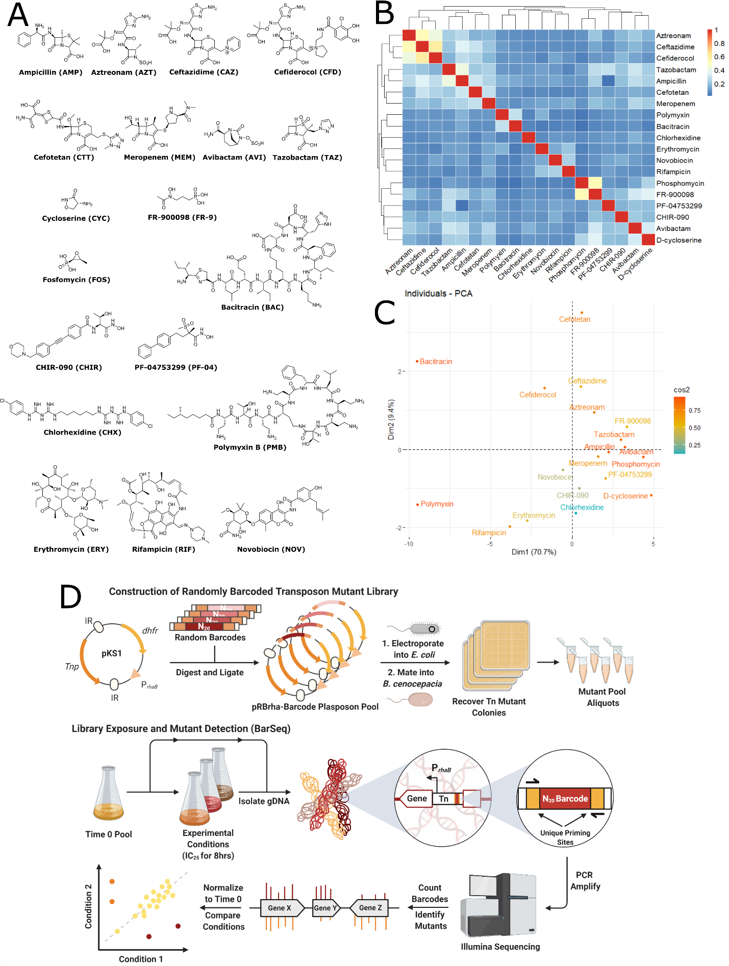

Supplementary Figure 1. Schematic of creating randomly-barcoded transposon mutants and exposure to an antibiotic panel. A) Structure of the antibiotics used in the BarSeq experiment. B) 2-D hierarchical clustering of atom pair Tanimoto similarity scoring from the ChemMine Tools package (Backman et al., 2011). C) Principal component analysis based on chemical properties from the ChemMine Tools package. Warmer colours indicate better representation by the principal components. D). DNA fragments containing random 20 bp barcodes flanked by priming and restriction sites are ligated into the parent plasposon pKS1. The resultant plasposon pool is electroporated into E. coli and then introduced into K56-2 by triparental mating. Mutant colonies are recovered and stored until needed. After growth in a desired condition, genomic DNA is isolated and used as template for one-step PCR to amplify barcodes and add flow cell adapters and sequencing indices. Prepared DNA libraries are then sequenced on an Illumina platform (BarSeq). Barcode abundance is counted and compared between conditions by a bioinformatic pipeline.

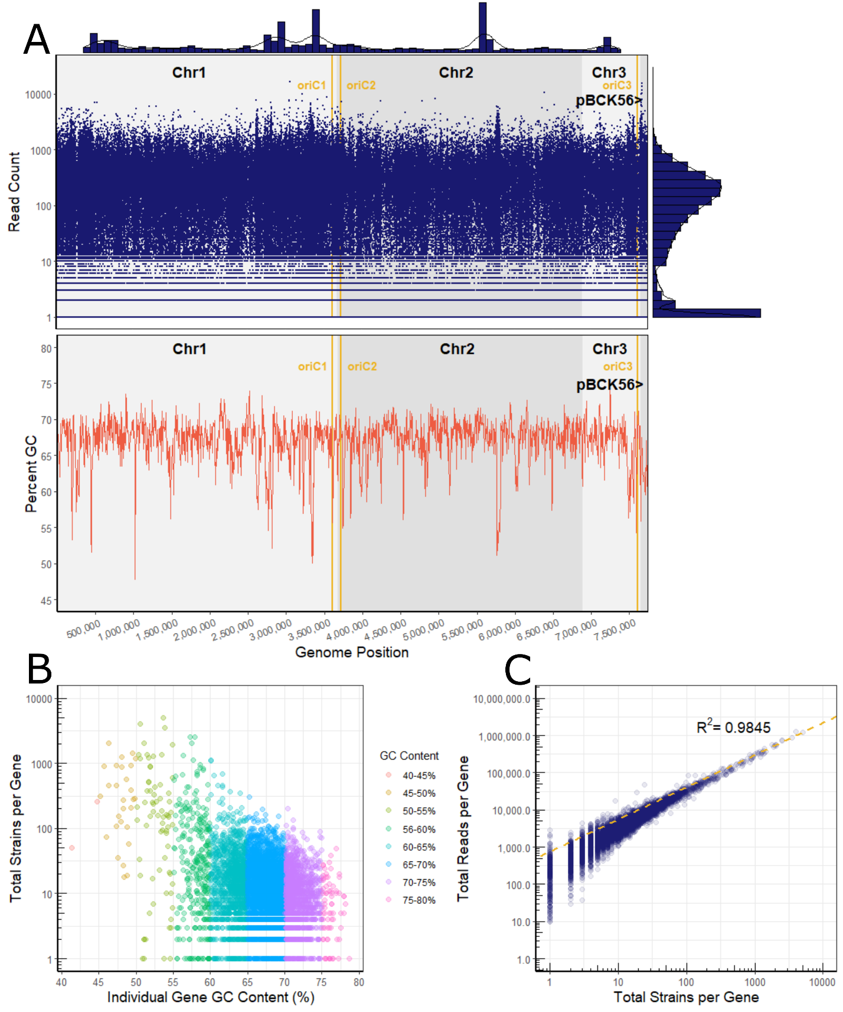

Supplementary Figure 2. Transposon insertion density across the K56-2 genome. A). Each insertion in the library was mapped along with the read count. The marginal histograms represent 1D point density in the x and y dimensions of the plot. The x-marginal histogram has a bin width of 100,000 bp and shows insertion density. The y-marginal histogram splits each log₁₀ into 5 bins and shows read count density. The chromosomal origins (OriC) were identified by homology from B. cenocepacia J2315 using DoriC 10.0 ¹⁴. The GC_content perl script (https://github.com/DamienFr/GC_content_in_sliding_window) was used to calculate GC content with a 5,000 bp window and 5,000 bp step size. B) Gene-level breakdown of the number of strains per gene versus GC content. Each point is coloured by binned GC-content of the gene. C) The number of reads per gene versus the number of strains the gene is represented by in the library. The dashed yellow line is a linear regression showing the relationship between the number of reads and number of strains for each gene.

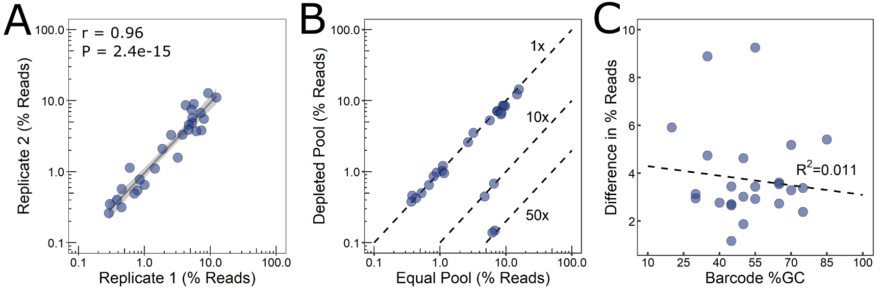

Supplementary Figure 3. Validation of BarSeq to reproducibly and accurately determine barcoded transposon mutant abundance. A) Reproducibility of BarSeq shown between two replicates of artificial equal pools of 30 mutants. The grey line shows a linear regression with 95% confidence interval in lighter grey. The r and P-values are from Pearson’s correlation test. B) Detection of changes in barcode abundance in artificial pools of 30 mutants (equal vs depleted at 10x and 50x). Each point is an average of two replicates. Dashed lines indicate expected mutant abundance in the two pools: 1x, 10x, or 50x. C) Absolute difference between the observed and expected barcode abundance (in percent of reads) for the equal pool replicates as a function of individual barcode GC-content. If truly equal, all barcodes would be present at ~3%. The dashed line shows a linear regression.

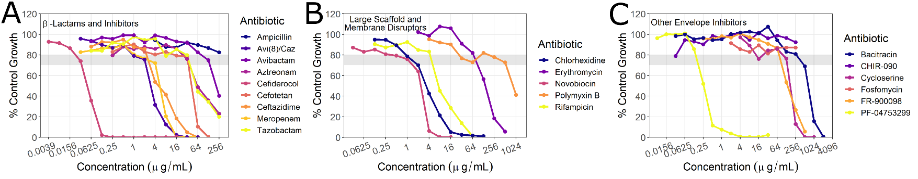

Supplementary Figure 4. Growth dose-response curves of wild-type K56-2 to antibiotics in the panel. The grey box indicates the target region of 20 – 30% growth inhibition relative to the no-antibiotic control. Points are averages of three replicates. Cells were grown in LB to more closely represent conditions of the mutant library exposure.

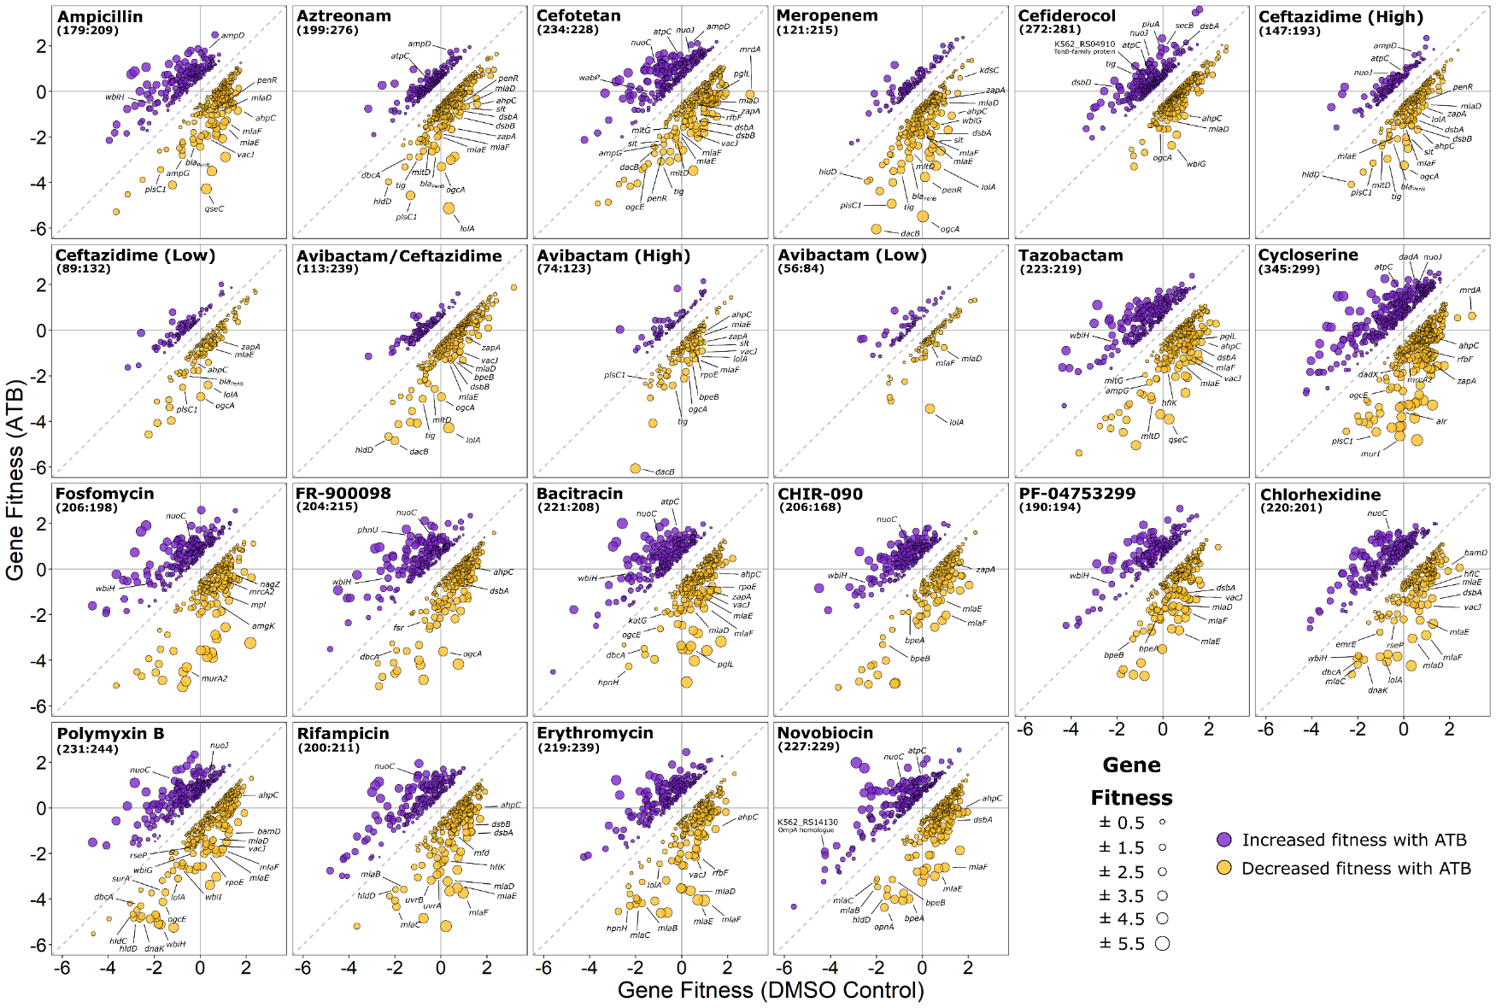
Supplementary Figure 5. Gene fitness profiles of K56-2 transposon mutant library exposed to cell envelope-targeting antibiotic panel. Each point represents a gene that when disrupted by a transposon, affected fitness of the mutant in the presence of an antibiotic versus the DMSO control (two-sided t-test; P < 0.05; only genes with fitness effects greater than 0.5 or less than -0.5 were considered). The points are coloured based on positive (increased fitness; purple) or negative (decreased fitness; gold) interactions between the genes and tested antibiotics. The absolute difference in fitness score for a gene in each condition versus the DMSO control is given by the size of the point. Select genes of interest are indicated and named. The total number of genes in each condition with altered fitness (increased:decreased) is shown.

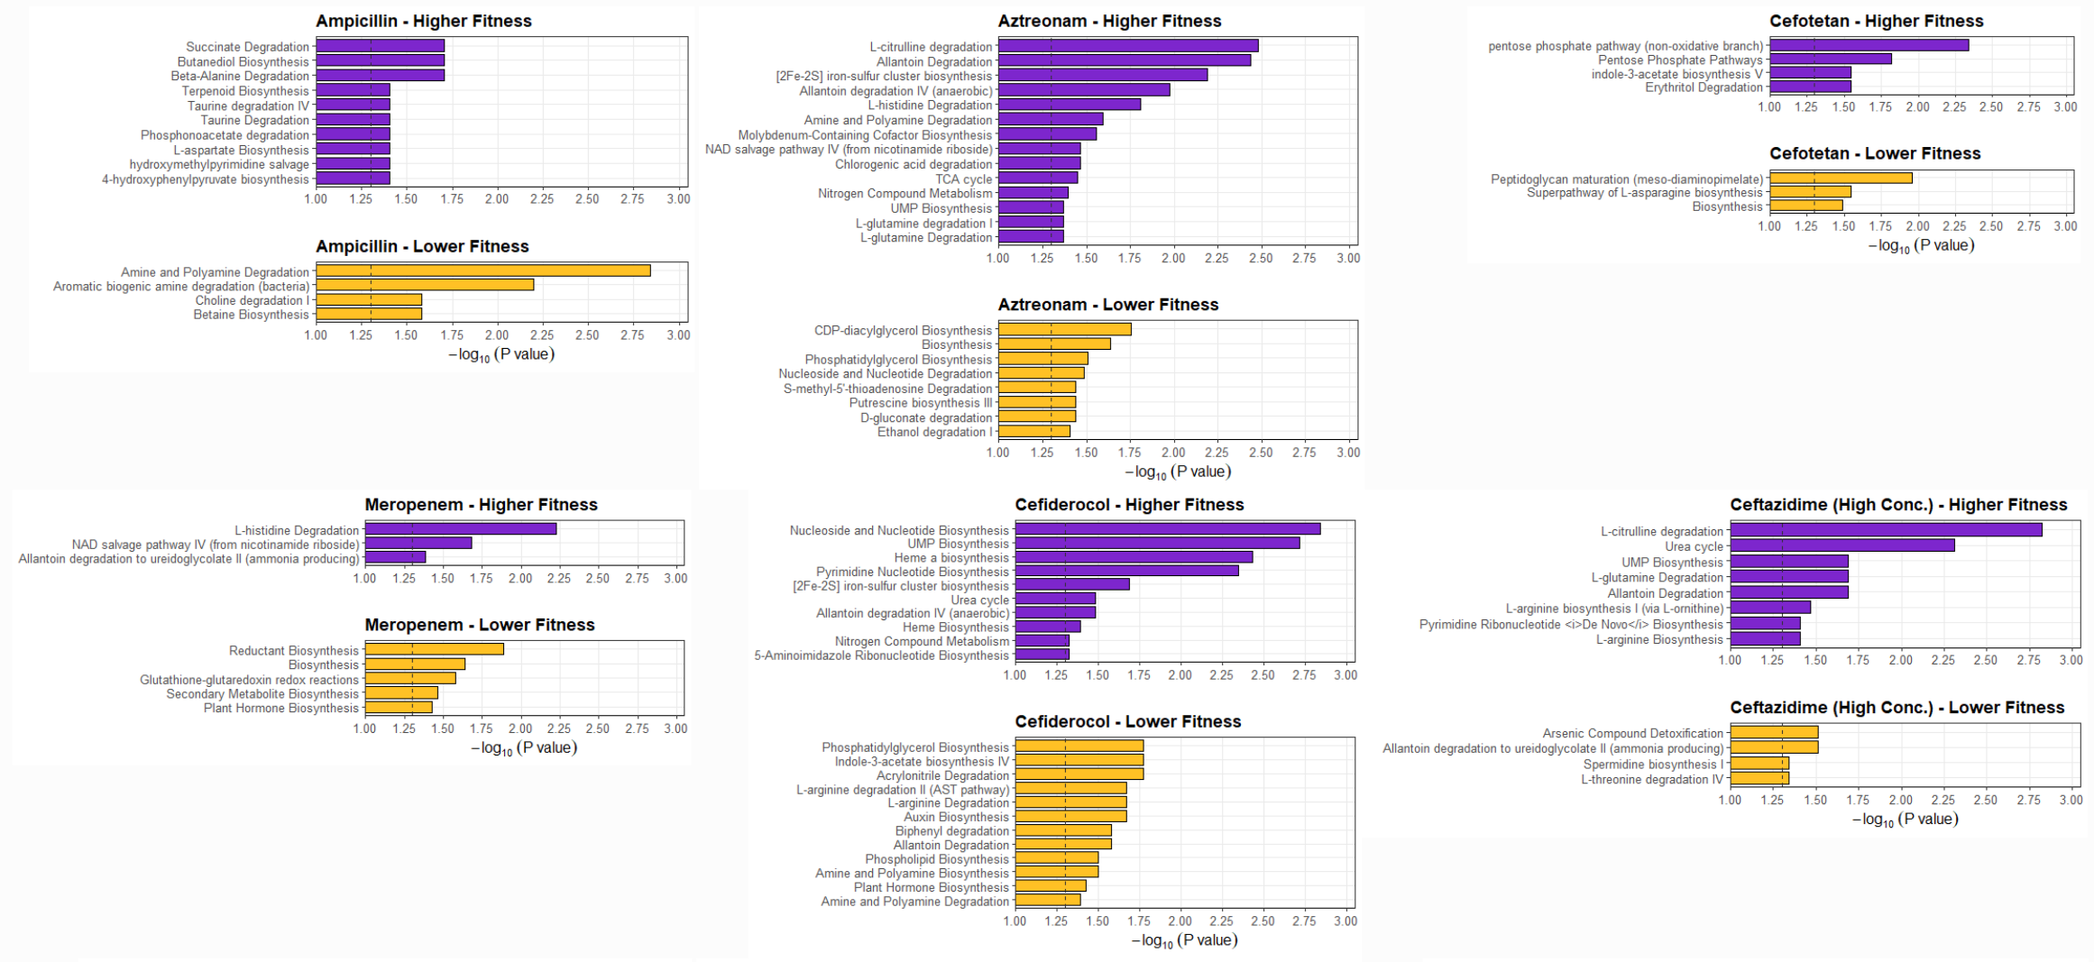

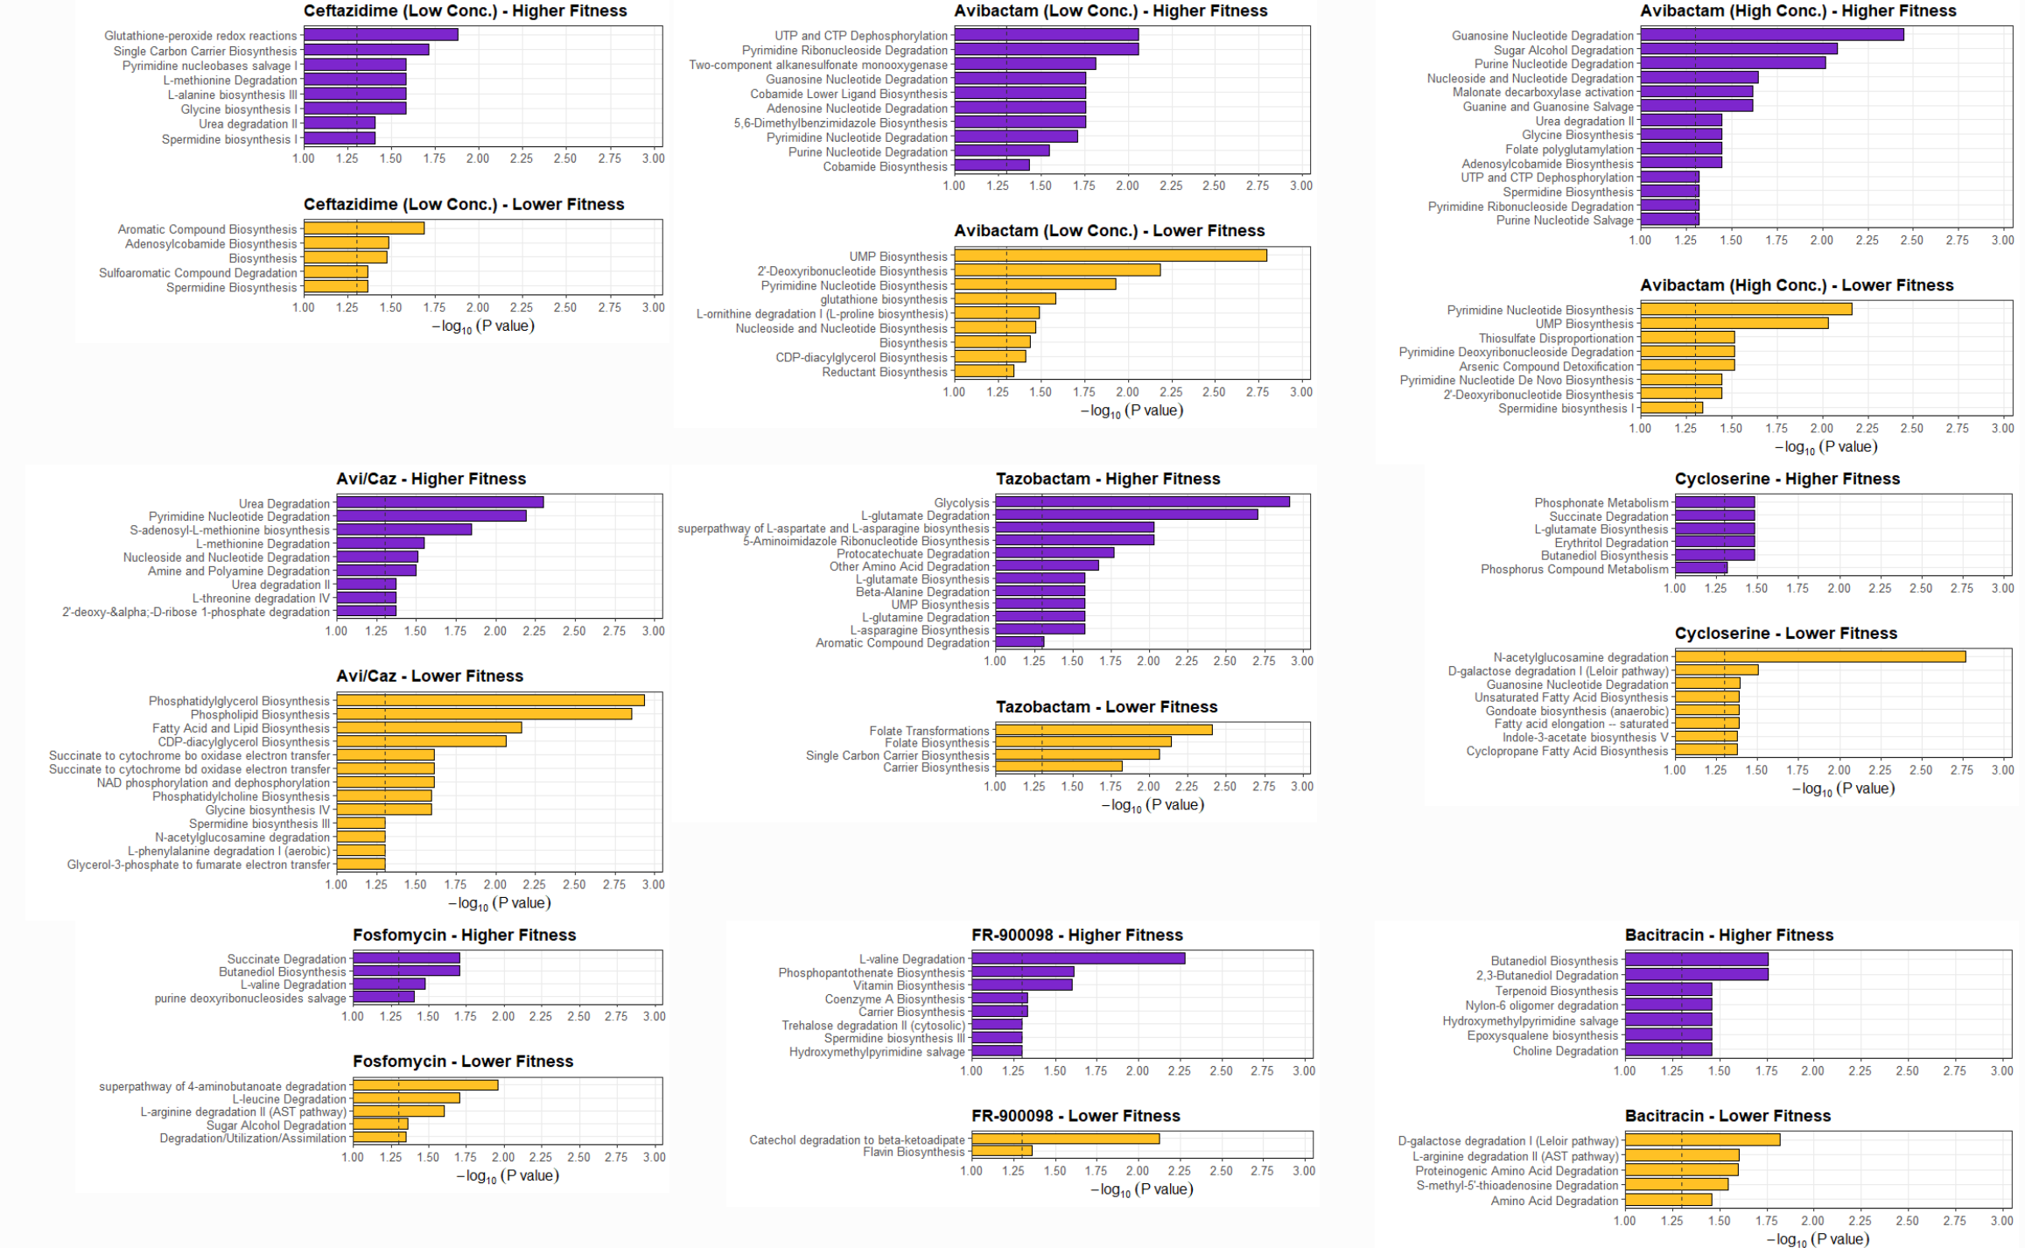
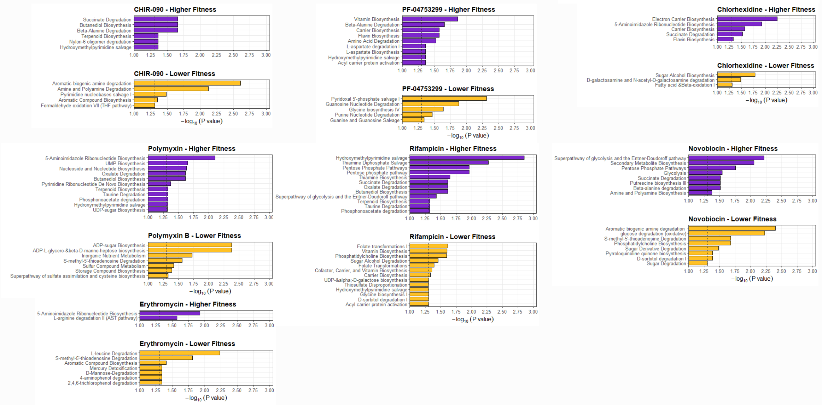
Supplementary Figure 6. BioCyc pathway enrichment of genes affecting fitness in the presence of the antibiotic panel. Genes with fitness scores either above 0.5 or below -0.5 were submitted to BioCyc for enrichment analysis (Fisher exact test without multiple testing correction) (against K56-2 genome from GenBank accession GCA_000333155.2). Enrichments from genes with positive and negative fitness scores are given in purple and gold, respectively. The dashed line indicates P = 0.05.
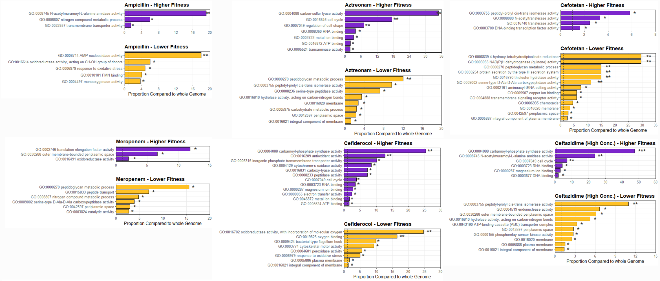

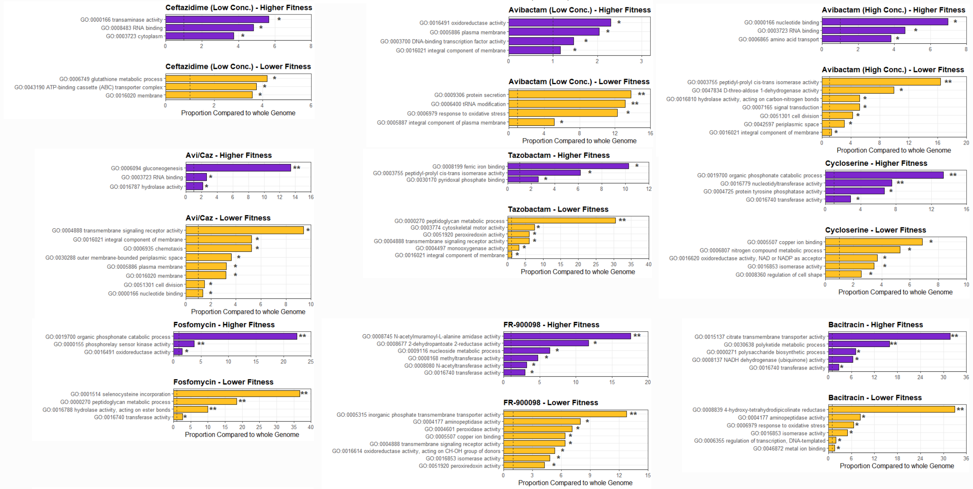

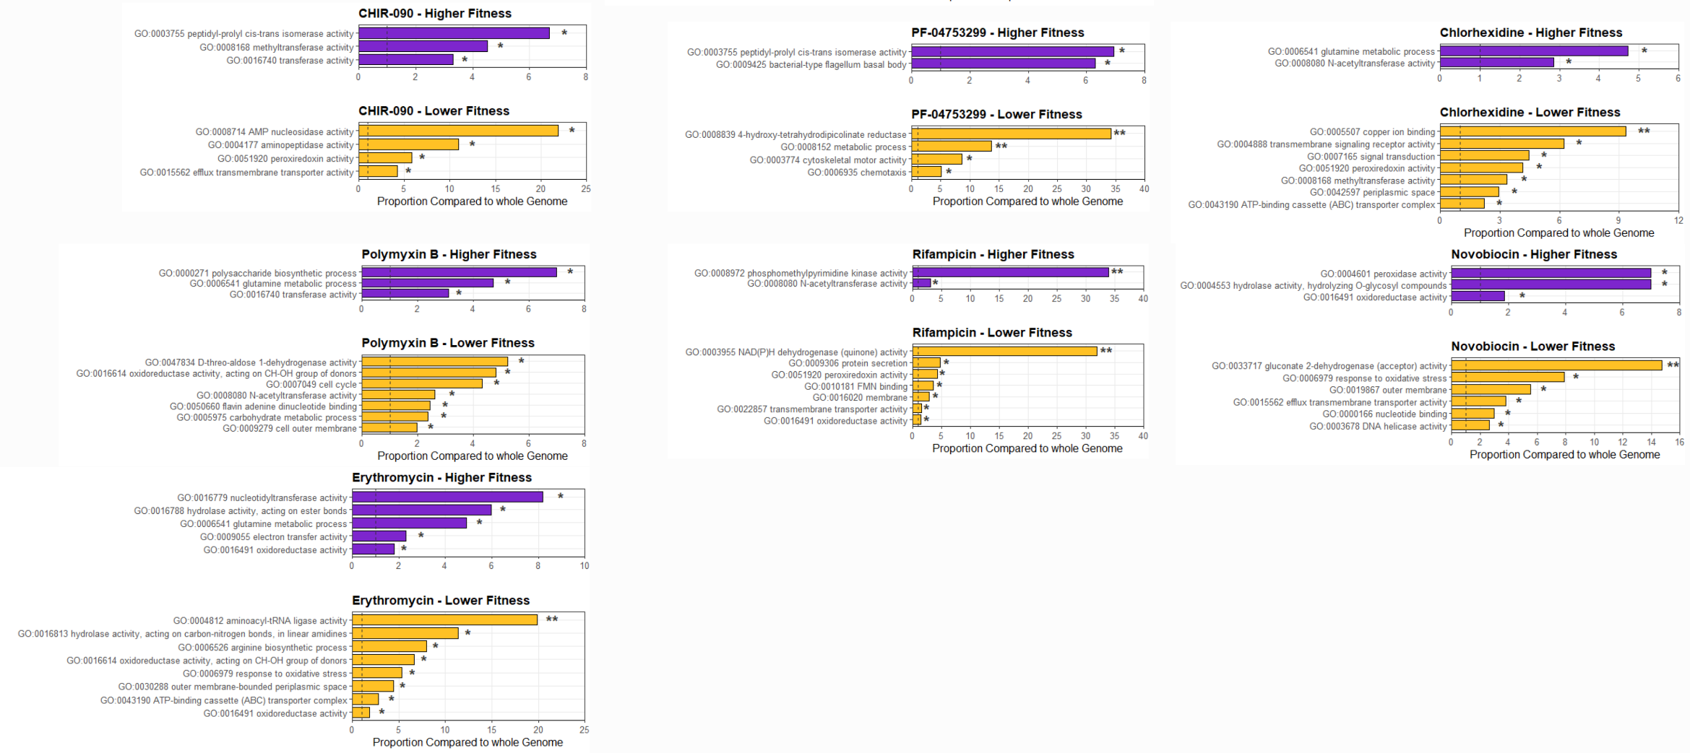
Supplementary Figure 7. GO term enrichment of genes affecting fitness in the presence of the antibiotic panel. Genes with fitness scores either above 0.5 or below -0.5 were used for GO term enrichment relative to the whole K56-2 genome (Hypergeometric test without multiple testing correction) with GeneMerge 1.5 (Castillo-Davis et al. 2003). Enrichments from genes with positive and negative fitness scores are given in purple and gold, respectively. The dashed line indicates equal proportions in the genome and antibiotic condition. * P < 0.05, ** P < 0.01, *** P < 0.001.

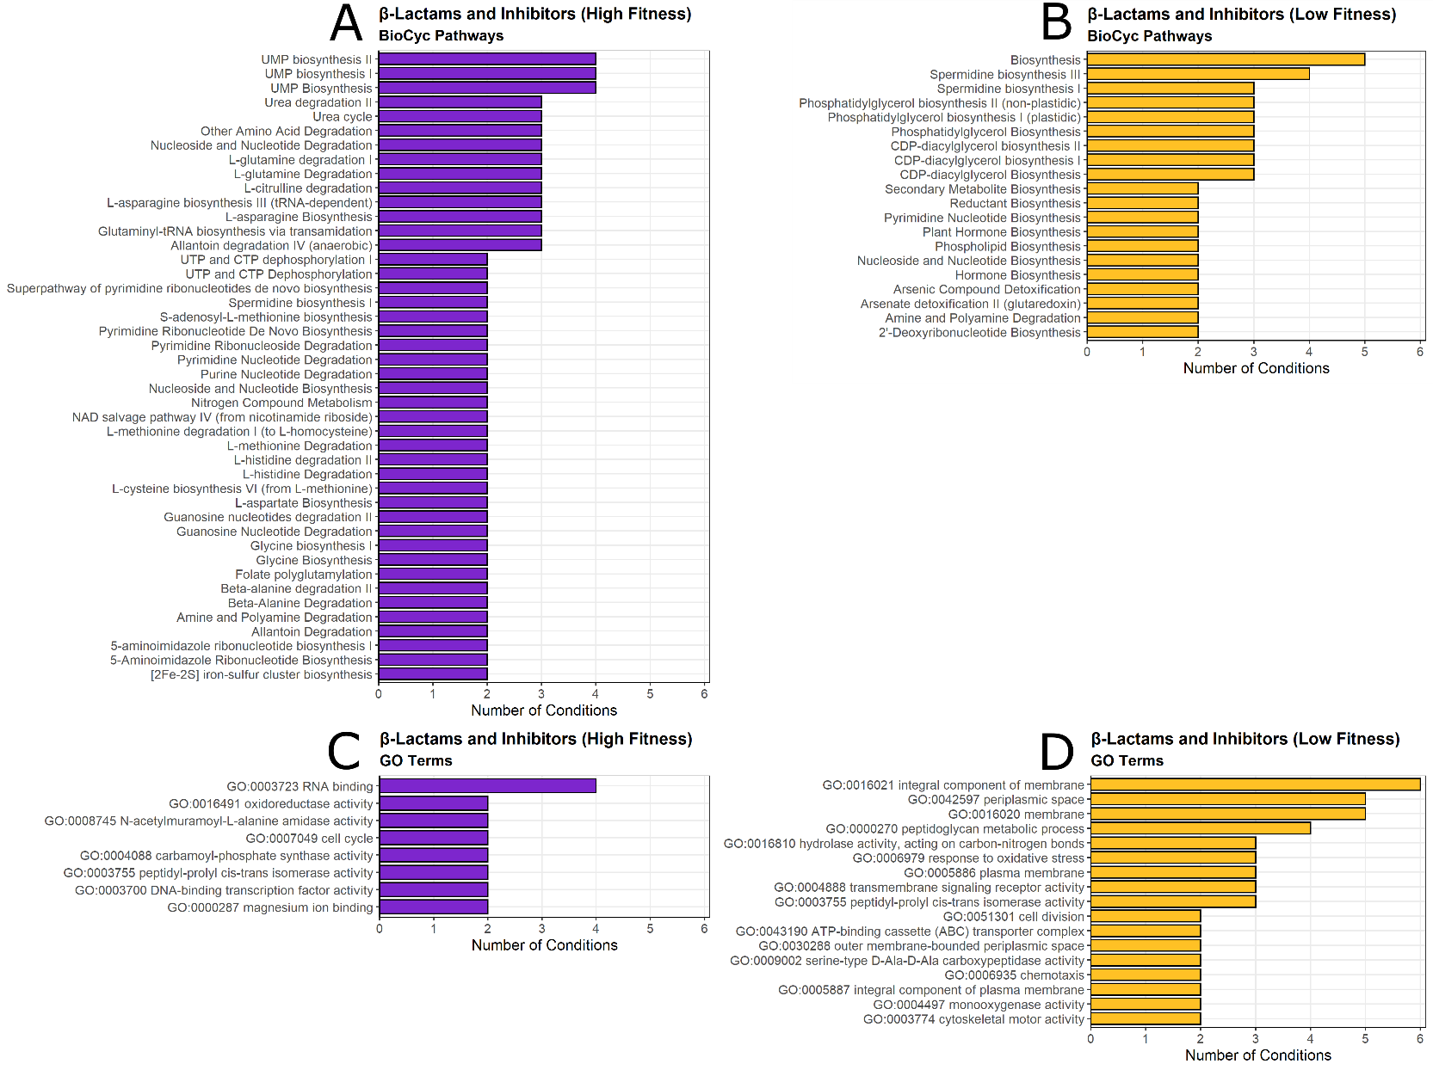

Supplementary Figure 8. Summary of BioCyc pathway and GO term enrichments from gene scores among the β-lactam and β-lactamase inhibitor conditions. Significant enrichments (P < 0.05) from BioCyc pathways and GO terms were pooled from Figures A4 and A5. Only those pathways and terms present in at least two antibiotic conditions are shown.

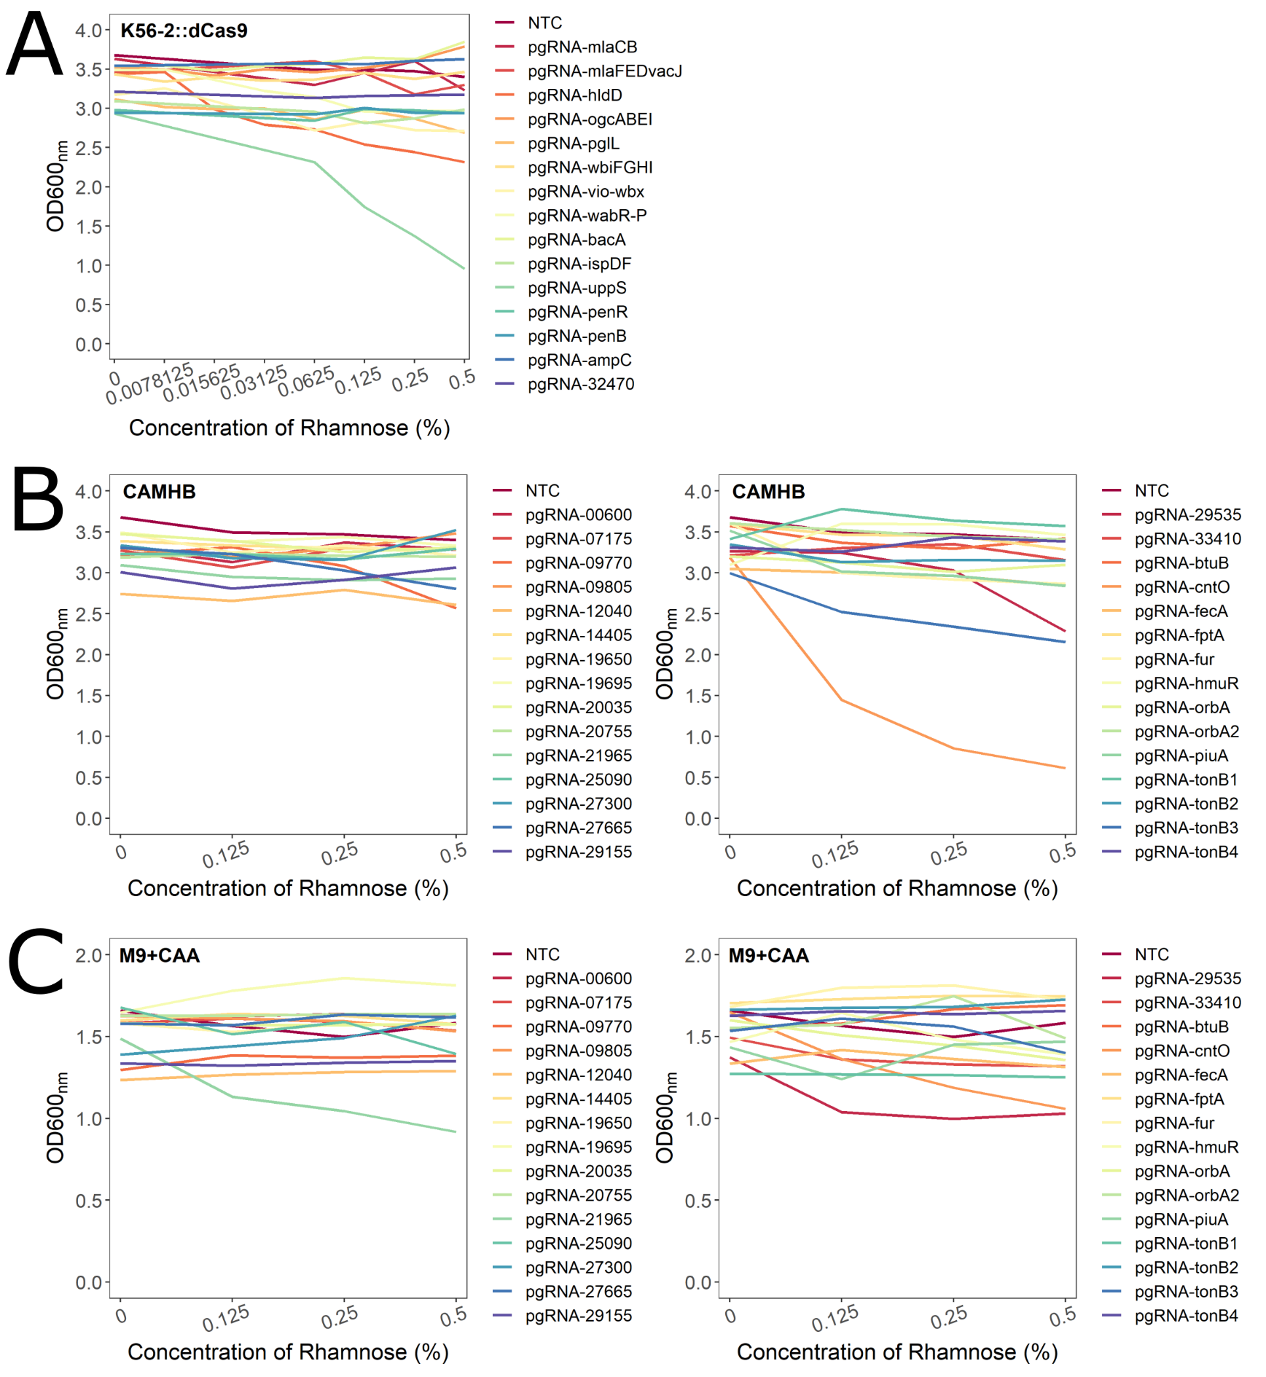
Supplementary Figure 9. Rhamnose dose-responses of select CRISPRi mutants constructed in this study. Cultures were grown with the indicated concentrations of rhamnose in A) LB, B) CAMHB, C) M9+CAA for 16 hours, the time at which the control strains reached the maximum OD₆₀₀, and then OD₆₀₀ values were recorded Each gene was targeted with two sgRNA, and one representative is shown here. If the targeted gene does not have a 4-letter name, the locus tag (preceded by K562_) is given. NTC = non-targeting control sgRNA. Values shown are averages of at least three biological replicates; SD values are omitted for clarity.

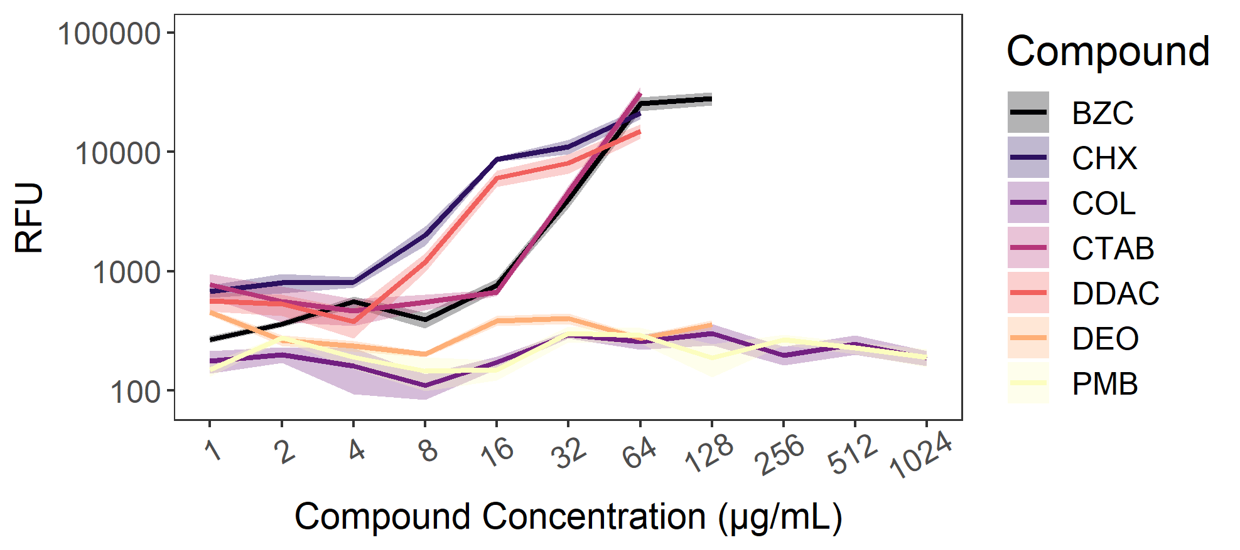

Supplementary Figure 10. Outer membrane permeability of K56-2 is increased by exposure to certain membrane disruptors. Exponential phase K56-2 was incubated with NPN and a concentration gradient of the indicated compounds. BZC = benzethonium chloride; CHX = chlorhexidine; COL = colistin; CTAB = cetrimonium bromide; DDAC = dodecyl dimethylammonium bromide; DEO = sodium deoxycholate; PMB = polymyxin B. Raw fluorescence values were blank corrected. The shading represents means ± SD of three biological replicates.

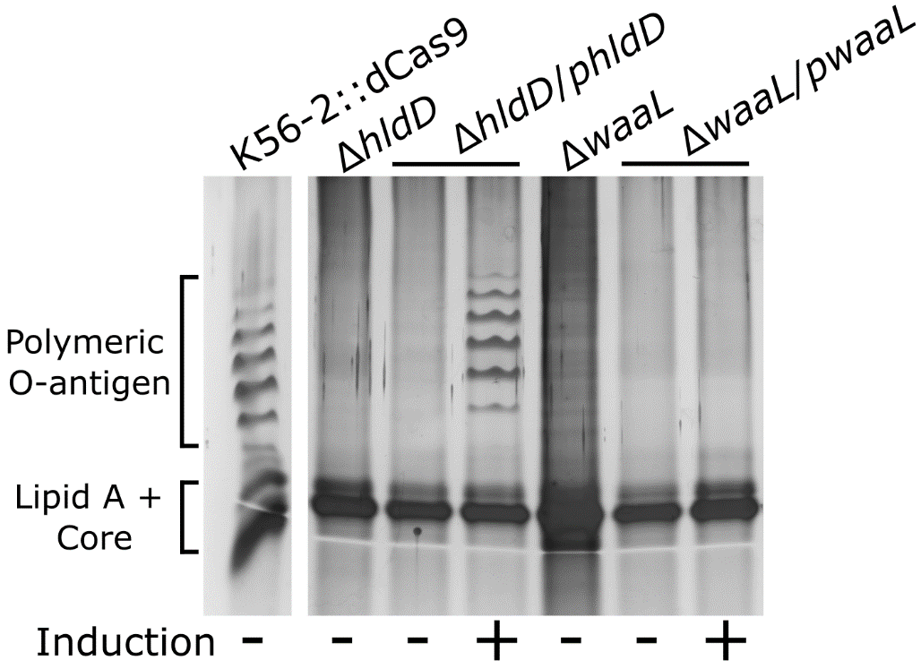

Supplementary Figure 11. Effect of deletion and complementation of hldD and waaL on O-antigen expression. These genes were deleted in the K56-2::dCas9 background. Silver-stained SDS polyacrylamide gels of LPS extracts from mid-exponential phase deletion and complementation mutants grown for 4 hours with or without 0.05% rhamnose. Shown are different lanes from the same gel.

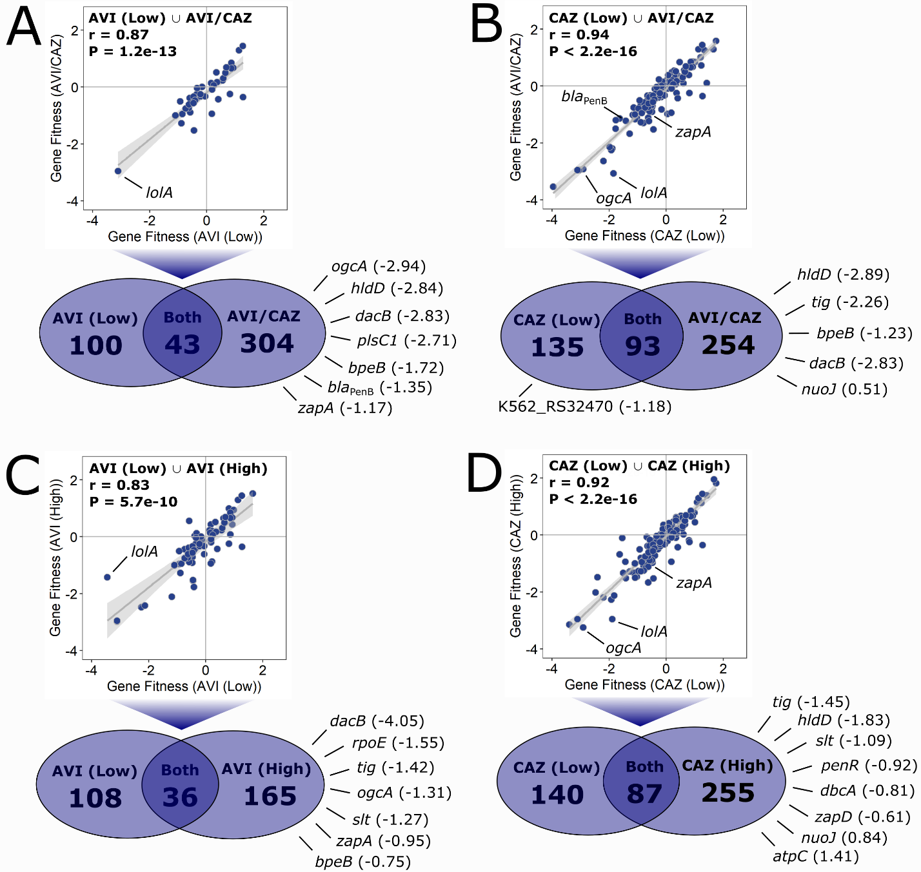

Supplementary Figure 12. Concentration- and combination-dependent chemical-genetic interactions with AVI/CAZ. Comparison gene fitness scores between A) AVI/CAZ to AVI-L, B) AVI/CAZ to CAZ-L, C) AVI-H to AVI-L, and D) CAZ-H to CAZ-L. All genes with significantly different fitness scores greater than 0.5 or less than -0.5 relative to the DMSO control (P < 0.05) were used for comparison. For the genes that were common to both conditions, the scatter plots show a Pearson’s correlation test (with 95% confidence interval in light grey) and associated r and P-values. Fitness scores next to genes are relative to the DMSO control.

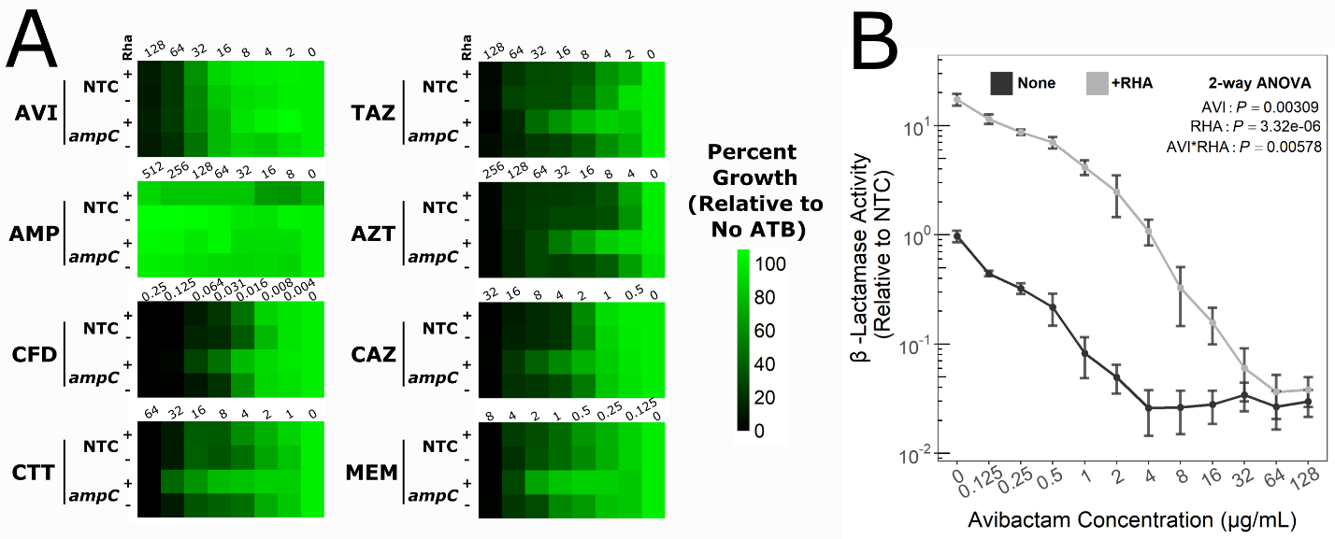
Supplementary Figure 13. Knockdown of bla_{AmpC} reduces β-lactam susceptibility but is still rescued by AVI. A) Antibiotic dose responses (µg/mL) of growth of the indicated mutants with or without CRISPRi induction with 0.5% rhamnose. Values are normalized to the OD₆₀₀ of growth without antibiotic, and are means of three biologica replicates. NTC = non-targeting sgRNA control. B) Nitrocefin hydrolysis assay of the knockdown mutant in bla_{AmpC} incubated with increasing concentrations of AVI with or without CRISPRi induction. Data was normalized to the NTC mutant. Values presented are means of four biological replicates, ± SD. Significance was determined by a two-way ANOVA.

Supplementary References
1. Darling, P., Chan, M., Cox, A. D. & Sokol, P. A. Siderophore production by cystic fibrosis isolates of Burkholderia cepacia. Infection and immunity 66, 874–877 (1998).
2. Hogan, A. M., Rahman, A. S. M. Z., Lightly, T. J. & Cardona, S. T. A broad-host-range CRISPRi toolkit for silencing gene expression in Burkholderia. ACS Synth. Biol. 8, 2372–2384 (2019).
3. Bloodworth, R. A. et al. Draft genome sequences of Burkholderia contaminans, a Burkholderia cepacia complex species that is increasingly recovered from cystic fibrosis patients. Genome announcements 3, 10.1128/genomeA.00766-15 (2015).
4. Mahenthiralingam, E. et al. Diagnostically and experimentally useful panel of strains from the Burkholderia cepacia complex. Journal of clinical microbiology 38, 910–913 (2000).
5. Meselson, M. & Yuan, R. DNA restriction enzyme from E. coli. Nature 217, 1110–1114 (1968).
6. Miller, V. L. & Mekalanos, J. J. A novel suicide vector and its use in construction of insertion mutations: osmoregulation of outer membrane proteins and virulence determinants in Vibrio cholerae requires toxR. Journal of Bacteriology 170, 2575–2583 (1988).
7. Aubert, D. F., Hamad, M. A. & Valvano, M. A. A markerless deletion method for genetic manipulation of Burkholderia cenocepacia and other multidrug-resistant gram-negative bacteria. Methods Mol Biol 1197, 311–327 (2014).
8. Hamad, M. A., Skeldon, A. M. & Valvano, M. A. Construction of aminoglycoside-sensitive Burkholderia cenocepacia strains for use in studies of intracellular bacteria with the gentamicin protection assay. Applied and Environmental Microbiology 76, 3170–3176 (2010).
9. Flannagan, R. S., Linn, T. & Valvano, M. A. A system for the construction of targeted unmarked gene deletions in the genus Burkholderia. Environmental microbiology 10, 1652–1660 (2008).
10. Cardona, S. T., Mueller, C. & Valvano, M. A. Identification of essential operons in Burkholderia cenocepacia with a rhamnose inducible promoter. Applied and Environmental Microbiology. 72, 2547–2555 (2006).
11. Bloodworth, R. A. M., Gislason, A. S. & Cardona, S. T. Burkholderia cenocepacia conditional growth mutant library created by random promoter replacement of essential genes. MicrobiologyOpen 2, 243–258 (2013).
12. Figurski, D. H. & Helinski, D. R. Replication of an origin-containing derivative of plasmid RK2 dependent on a plasmid function provided in trans. Proceedings of the National Academy of Sciences of the United States of America 76, 1648–1652 (1979).
13. Hogan, A. M., Jeffers, K. R., Palacios, A. & Cardona, S. T. Improved dynamic range of a rhamnose-inducible promoter for gene expression in Burkholderia spp. Appl Environ Microbiol 87, e0064721 (2021).
14. Luo, H. & Gao, F. DoriC 10.0: an updated database of replication origins in prokaryotic genomes including chromosomes and plasmids. Nucleic Acids Res 47, D74–D77 (2019).

