Supplementary Material
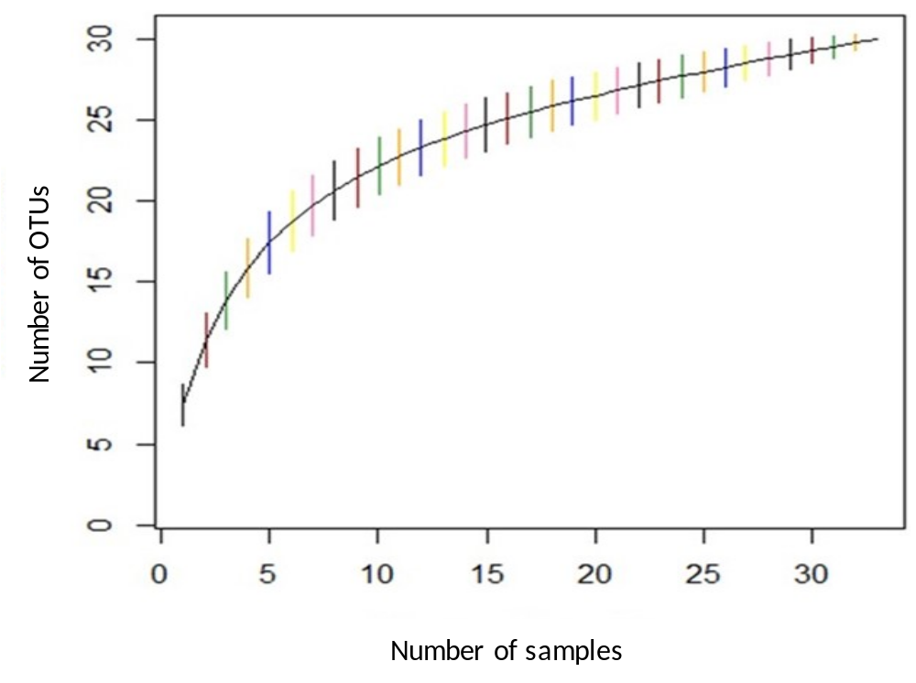
Fig. S1. Rarefaction curves based on the number of samples and showing the degree of saturation of the species richness (OTUs) of AM fungi.
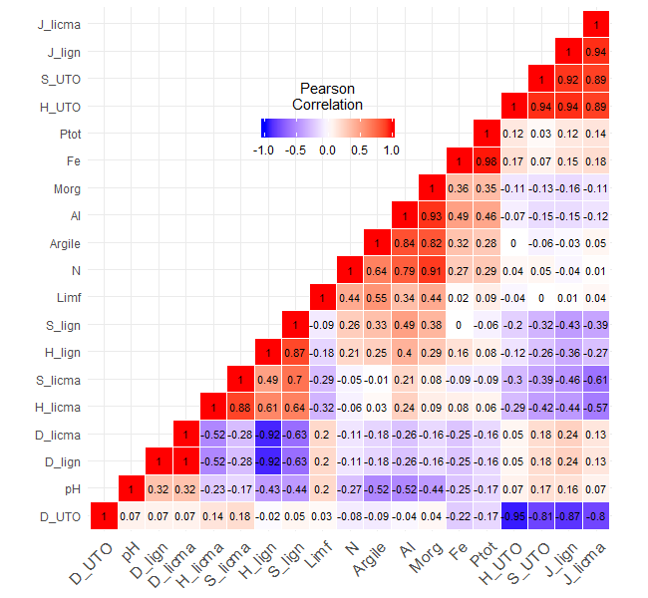
Fig. S2. Pearson correlation matrix between diversity indices of AMF (D_OTU, H_OTU and S_OTU), of all tree and shrub species (ectomycorrhizae and AMF: D_lign, H_lign, J_lign and S_lign) and those colonised only by AMF (D_licma, H_licma, J_licma and S_licma) and physico-chemical variables. D, H, J and S represent Simpson (1-D), Shannon and Pielou diversity indices and species richness, respectively. Values ​​in coloured cells are product-moment correlation coefficients (r). Diagonal elements are correlations of the variables with themselves.
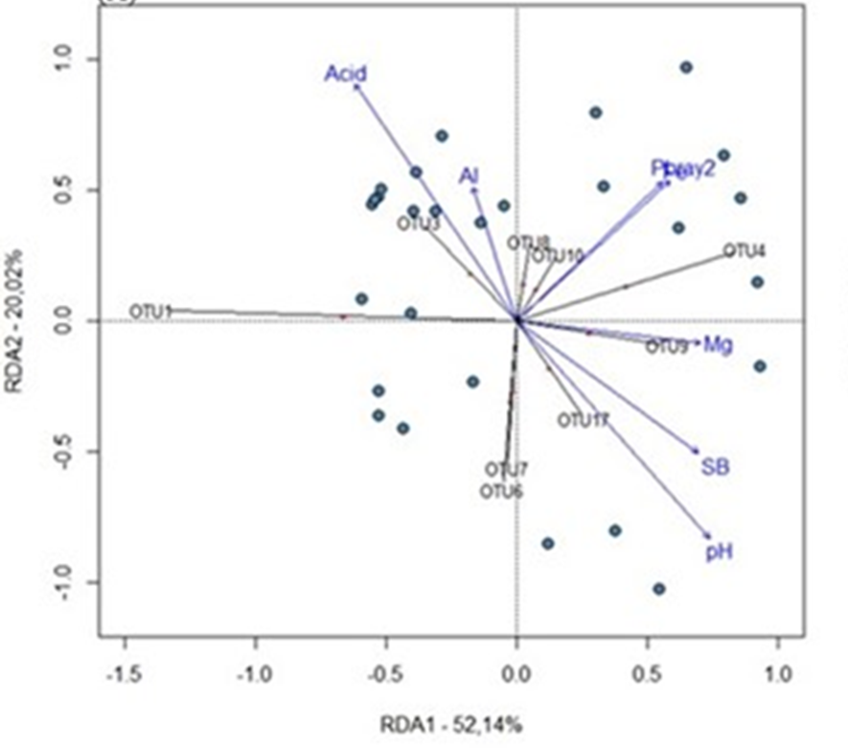
Fig. S3. RDA between indicator OTUs and soil physico-chemical variables (adjusted R² = 0.135). Acid: acidity; Al: aluminium; Fe: iron; Mg: magnesium; pH: soil acidity; Pbray2: bray-extractable phosphorus; SB: base saturation.
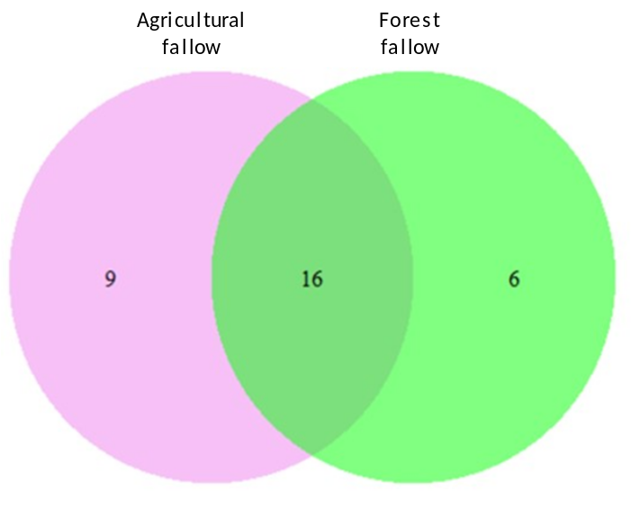
Fig. S4. Venn diagram showing the overlap of AM fungal OTUs identified in the root samples of P. tinctorius growing on agricultural and forest fallow sites.

Table S1. Means and standard errors of non-transformed physico-chemical variables. Within rows, different letters indicate differences between treatments (i.e., sites and land uses) according to Tukey's HSD tests (***p < 0.001; ** p < 0.01; * p < 0.05 and ns p > 0.05 (not significant)).
 | Kasenga |  | Lubumbashi |  | Mulungwishi |  |  | F-value
 | FA | FF | FA | FF | FA | FF |  | Sites | Plots | Sites*Plots
pH H₂O | 5.33±0.04a | 5.27±0.05a | 4.78±0.06b | 4.74±0.04bc | 5.36±0.03a | 4.82±0.07b |  | 26.4*** | 7.99** | 8.8**
Acidity (cmol+/kg) | 0.35±0.01c | 0.39±0.04bc | 1.03±0.04a | 1.06±0.11a | 0.45±0.07b | 0.92±0.08a |  | 78.7*** | 3.12ns | 5.09*
Ca (cmol+/kg) | 0.42±0.05a | 0.2±0.03ab | 0.57±0.12a | 0.09±0.01b | 0.47±0.12a | 0.41±0.05a |  | 8.04** | 5.63* | 9.9***
K (cmol+/kg) | 0.58±0.03a | 0.23±0.01cd | 0.38±0.02b | 0.21±0.01d | 0.26±0.02c | 0.38±0.01b |  | 7.39** | 21.3*** | 125.9***
Mg (cmol+/kg) | 0.63±0.04ab | 0.17±0.04c | 0.42±0.06bc | 0.12±0.02c | 0.91±0.09a | 0.46±0.04ab |  | 12.5*** | 0.03ns | 19.4***
Na (cmol+/kg) | 0.24±0.01d | 0.11±0.02c | 0.11±0.001c | 0.03±0.001a | 0.03±0.003a | 0.06±0.01b |  | 85.1*** | 0.87ns | 64.6***
C (%) | 1.01±0.06ab | 0.49±0.02a | 2.52±0.06d | 1.14±0.08c | 1.47±0.02bc | 1.49±0.12c |  | 46.6*** | 0.87ns | 11.4***
Org. M. (%) | 3.2±0.22ab | 1.9±0.17a | 7.6±0.42d | 4.1±0.28bc | 4.5±0.42c | 5.2±0.36c |  | 44.9*** | 1.1ns | 17.5***
N (%) | 0.05±0.01c | 0.03±0.003c | 0.15±0.004a | 0.08±0.01b | 0.09±0.01ab | 0.09±0.01ab |  | 39.3*** | 1.56ns | 8.12**
S (%) | 0.01±0.001b | 0.01±0.001b | 0.02±0.001a | 0.01±0.001b | 0.012±0.001b | 0.013±0.001b |  | 14.7*** | 0.79ns | 14.33***
CEC (cmol+/kg) | 2.62±0.23ab | 1.11±0.06c | 2.76±0.26ab | 1.72±0.17bc | 3.17±0.42a | 2.53±0.21ab |  | 7.29** | 0.21ns | 12.01***
BS (%) | 85.37±2.81a | 63.63±4.05b | 56.7±4.78bc | 36.21±6.38c | 87.4±4.25a | 62.03±5.33b |  | 18.4*** | 4.31* | 11.5***
P tot (mg/kg) | 110.1±8.58b | 39.81±2.29c | 76.5±11.2b | 7794±10.8b | 113.4±8.93b | 272.8±25.3a |  | 23.8*** | 24.4*** | 7.25**
Pbray2 (ppm) | 11.1±3.66a | 12.9±4.34a | 12.37±0.72a | 4.49±1.01c | 6.05±1.27b | 10.11±1.03a |  | 1.2ns | 1.7ns | 9.03***
Al (mg/kg) | 1790.7±13.03b | 1689.05±18.54a | 5304.2±182.1e | 2961.6±182.2c | 3388.9±251.1cd | 4400.2±172.5de |  | 82.9*** | 0.82ns | 29.9***
Fe (mg/kg) | 1432.8±57.02b | 262.05±18.54a | 1272.4±70.9b | 1619.8±134.3b | 2362.3±218.9bc | 6132.4±474.3c |  | 55.4*** | 31.3*** | 1.87ns
Sand (%) | 54±0.89bc | 77.83±0.49a | 28.8±0.43d | 51.6±0.98bc | 43.26±0.6c | 56.4±1.37b |  | 39.4*** | 7.4* | 56.1***
Clay (%) | 24.6±2.97b | 12.67±0.56c | 35.5±0.99a | 26.17±1.64b | 25.5±1.37b | 29.67±1.58b |  | 27.7*** | 1.85ns | 18.58***
CSilt (%) | 11±0.57bc | 5.83±0.59c | 20±0.75a | 11.33±1.5bc | 15.33±2.13ab | 6±1.2c |  | 14.3*** | 15.5*** | 16.01***
FSilt (%) | 15.4±1.56a | 3.67±0.3c | 14.33±0.73a | 9.33±0.51b | 17.83±0.64a | 9.17±0.55b |  | 14.4*** | 2.26ns | 81.3***
FA: agricultural fallow; FF: forest fallow; pH H₂O: bulk pH in water; Ca: calcium; K: potassium; Mg: magnesium; Na: sodium; C: organic carbon; Org M: organic matter; N: total nitrogen; CEC: cation exchange capacity; S: sulphur; BS: base saturation; P_{tot}: total phosphorus; Pbray2: extractable phosphorus; Al: total aluminium; Fe: total iron; CSilt: coarse silt; FSilt: fine silt.
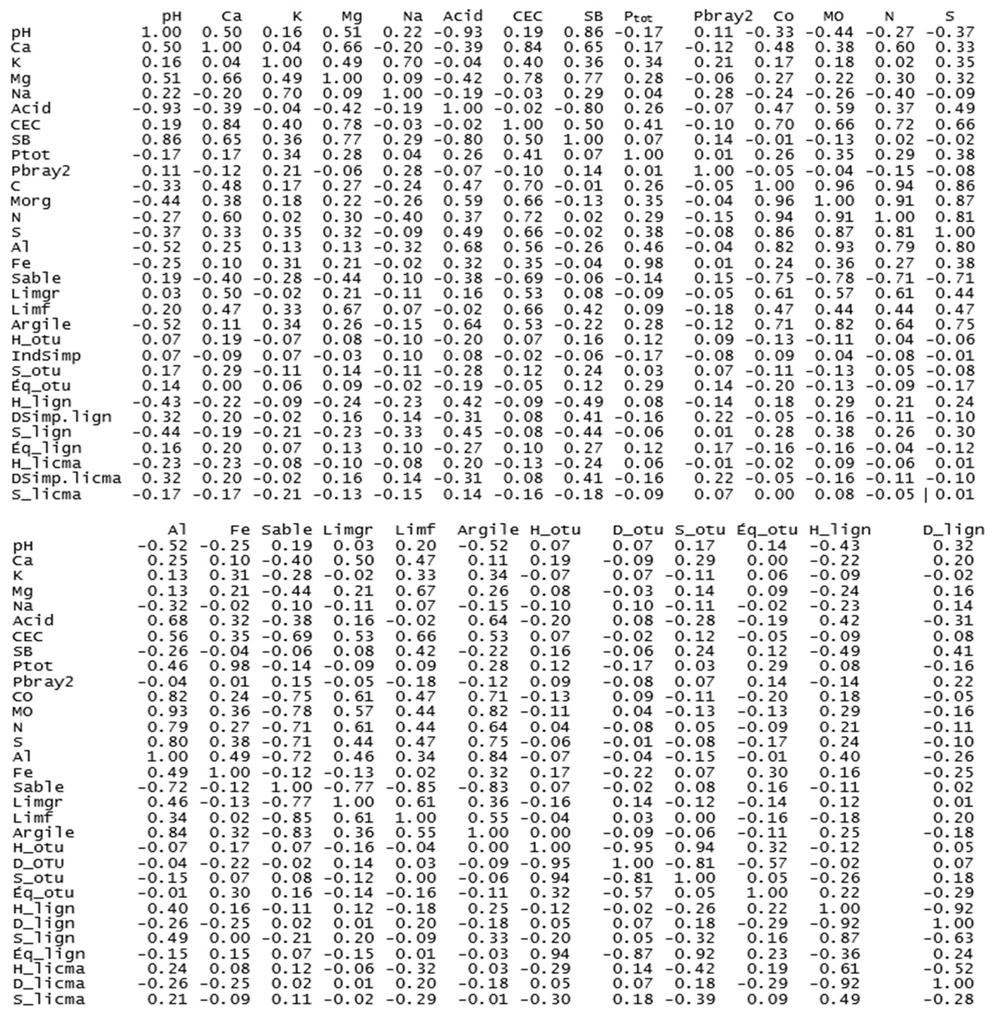
Table S2. Pearson correlations between the AMF diversity indices, woody species diversity indices and physico-chemical variables.
pH: soil acidity; Ca: calcium; CO: organic carbon; K: potassium; Mg: magnesium; Na: sodium; Acid: exchangeable acidity; OM: organic matter; N: total nitrogen; CEC: cation exchange capacity; S: sulphur; SB: base saturation; Ptot: total phosphorus; Pbray2: extractable phosphorus; Al: total aluminium; Fe: total iron; Limgr: coarse silt; Limf: fine silt; D_otu (indsimp): Simpson's index of AMF; H_otu: Shannon's index of AMF; S_otu: specific richness of AMF (or number of OTUs); Eq_otu: Pielou index of AMF; D_lign (DSimp.lign): Simpson index of all woody species; Eq_lign: Pielou index of all woody species; H_lign: Shannon index of all woody species; S_lign: species richness of all woody species; D_licma (Dsimp.licma): Simpson index of woody species colonised by AMF; H_licma: Shannon index of woody species colonised by AMF; and S_licma: species richness of woody species colonised by AMF.
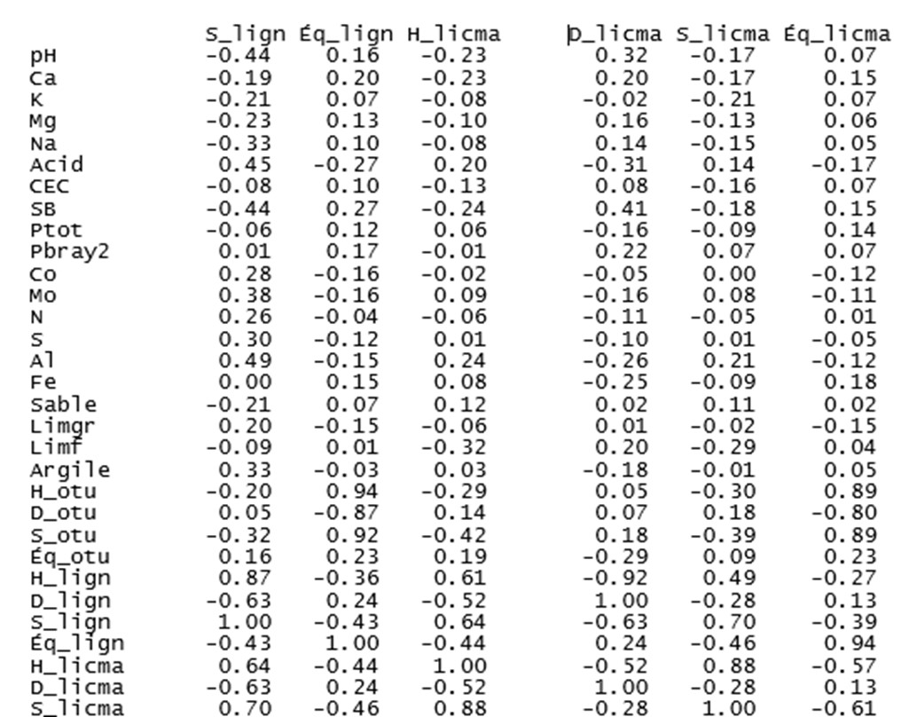
Table S2 (Continued). Pearson correlations between AM fungal diversity indices, woody species diversity indices and physico-chemical variables.

pH: soil acidity; Ca: calcium; CO: organic carbon; K: potassium; Mg: magnesium; Na: sodium; Acid: exchangeable acidity; OM: organic matter; N: total nitrogen; CEC: cation exchange capacity; S: sulphur; SB: base saturation; Ptot: total phosphorus; Pbray2: extractable phosphorus; Al: total aluminium; Fe: total iron; Limgr: coarse silt; Limf: fine silt; D_otu (indsimp): Simpson's index of CMA; H_otu: Shannon's index of AMF; S_otu: specific richness of AMF (or numbers of OTUs); Eq_otu: Pielou's index of AMF; D_lign (DSimp.lign): Simpson index of all woody species; Eq_lign: Pielou index of all woody species; H_lign: Shannon index of all woody species; S_lign: species richness of all woody species; D_licma (Dsimp.licma): Simpson index of woody species colonised by AMF; H_licma: Shannon index of woody species colonised by AMF; and S_licma: species richness of woody species colonised by AMF.
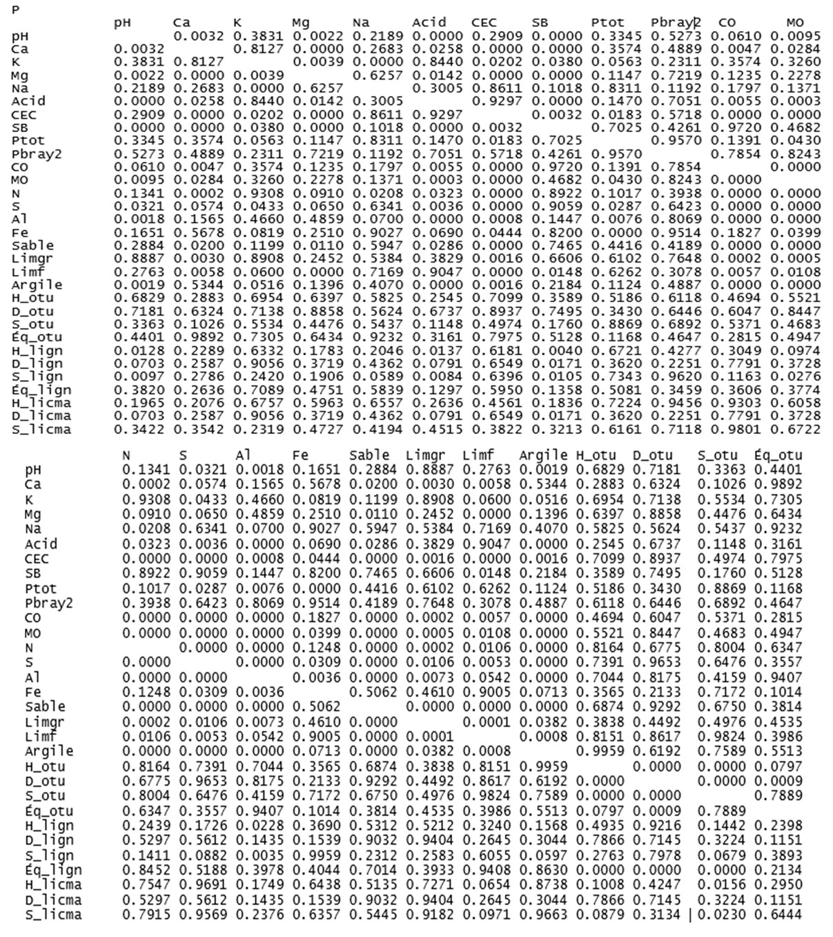
Table S3. P-values for Pearson's correlations between AM fungal diversity indices, woody species diversity indices and soil physico-chemical properties (*** p < 0.001; ** p < 0.01; * p < 0.05 and ns p > 0.05, not significant).
pH: soil acidity; Ca: calcium; CO: organic carbon; K: potassium; Mg: magnesium; Na: sodium; OM: organic matter; N: total nitrogen; CEC: cation exchange capacity: S: sulphur; SB: base saturation; Ptot: total phosphorus; Pbray2: extractable phosphorus; Al: total aluminium; Fe: total iron: Limgr: coarse silt; Limf: fine silt; D_otu (indsimp): Simpson's index of AMF; H_otu: Shannon's index of AMF; S_otu: specific richness of AMF (or number of OTUs): Éq_otu: Pielou’s index of AMF; D_lign (DSimp. lign): Simpson index of all woody species; Eq_lign: Pielou index of all woody species; H_lign: Shannon index of all woody species; S_lign: species richness of all woody species; D_licma (Dsimp.licma): Simpson index of woody species colonised by AMF; H_licma: Shannon index of woody species colonised by AMF; and S_licma: species richness of woody species colonised by AMF.
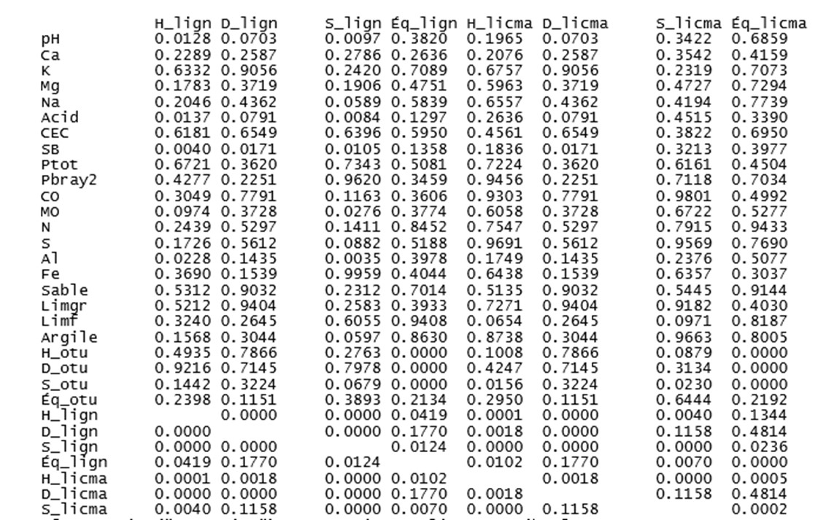
Table S3 (Continued). P-values for Pearson's correlations between AM fungal diversity indices, woody species diversity indices and soil physico-chemical properties (*** p < 0.001; ** p < 0.01; * p < 0.05 and ns p > 0.05, not significant).

pH: soil acidity; Ca: calcium; CO: organic carbon; K: potassium; Mg: magnesium; Na: sodium; OM: organic matter; N: total nitrogen; CEC: cation exchange capacity: S: sulphur; SB: base saturation; Ptot: total phosphorus; Pbray2: extractable phosphorus; Al: total aluminium; Fe: total iron: Limgr: coarse silt; Limf: fine silt; D_otu (indsimp): Simpson's index of AMF; H_otu: Shannon's index of AMF; S_otu: specific richness of AMF (or number of OTUs): Éq_otu: Pielou's index of AMF; D_lign (DSimp. lign): Simpson index of all woody species; Eq_lign: Pielou index of all woody species; H_lign: Shannon index of all woody species; S_lign: species richness of all woody species; D_licma (Dsimp.licma): Simpson index of woody species colonised by AMF; H_licma: Shannon index of woody species colonised by AMF; and S_licma: species richness of woody species colonised by AMF.

Table S4. Indicator values (IndVal) and p-values of AM fungal OTUs identified as indicators.
OTU | IndVal | p-value | Kasenga |  | Lubumbashi |  | Mulungwishi |  | AMF Genus
OTU | IndVal | p-value | FA | FF | FA | FF | FA | FF | AMF Genus
OTU 1 | 0.61 | 0.01 | 18 | 5 | 24 | 22 | 13 | 9 | Rhizophagus
OTU 3 | 0.55 | 0.01 | 3 | 1 | 11 | 7 | 3 | 5 | Rhizophagus
OTU 4 | 0.61 | 0.01 | 1 | 10 | 1 | 3 | 8 | 6 | Rhizophagus
OTU 6 | 0.66 | 0.001 | 1 | 3 | 5 | 4 | 7 | 1 | Rhizophagus
OTU 7 | 1 | 0.04 | 0 | 5 | 5 | 4 | 6 | 1 | Rhizophagus
OTU 8 | 1 | 0.04 | 1 | 0 | 1 | 2 | 6 | 7 | Sclerocystis
OTU 9 | 0.44 | 0.01 | 4 | 5 | 0 | 0 | 2 | 0 | Rhizophagus
OTU 10 | 0.63 | 0.004 | 0 | 0 | 0 | 2 | 1 | 6 | Rhizophagus
OTU 17 | 0.27 | 0.02 | 1 | 1 | 0 | 0 | 4 | 0 | Sclerocystis
Sequence numbers |  |  | 29 | 30 | 47 | 44 | 50 | 35
OTU numbers |  |  | 7 | 7 | 6 | 7 | 9 | 7

Table S5. Distribution of trees and shrubs of woody species that were colonised by AM fungi in the agricultural (FA) and forest (FF) fallows, as defined by Högberg (1982), and Högberg and Piearce (1986).
Code | Tree and shrub species | Kasenga |  | Lubumbashi |  | Mulungwishi
Code | Tree and shrub species | FA | FF | FA | FF | FA | FF
Alad | Albizia adianthifolia | 1 | 0 | 51 | 0 | 0 | 0
Alan | A. antunesiana | 1 | 0 | 1 | 2 | 5 | 1
Anbo | Anisophyllea boehmii | 0 | 0 | 2 | 2 | 0 | 0
Babe | Baphia bequaertii | 1 | 0 | 6 | 0 | 0 | 0
Boma | Bobgunnia madagascariensis | 0 | 0 | 0 | 0 | 1 | 0
Coco | Combretum collinum | 17 | 2 | 0 | 0 | 0 | 13
Coac | C. acutifolium | 5 | 4 | 1 | 0 | 0 | 4
Como | C. molle | 0 | 0 | 1 | 1 | 0 | 0
Dabo | Dalbergia boehmii | 0 | 2 | 21 | 7 | 64 | 3
Dico | Diplorhynchus condylocarpon | 66 | 24 | 9 | 17 | 8 | 23
Eraf | Erythrophleum africanum | 10 | 0 | 1 | 0 | 0 | 0
Ladi | Lannea discolor | 0 | 0 | 0 | 0 | 6 | 5
Pean | Pericopsis angolensis | 1 | 1 | 2 | 4 | 5 | 14
Ptan | Pterocarpus angolensis | 19 | 1 | 1 | 1 | 0 | 2
Ptti | P. tinctorius | 12 | 10 | 20 | 23 | 50 | 29
Stin | Strychnos innocua | 11 | 0 | 0 | 0 | 0 | 11
Psma | Pseudolachnostylis maprouneifolia | 5 | 6 | 0 | 7 | 0 | 6
Sygu | Syzygium guineense | 0 | 0 | 16 | 0 | 3 | 0

