SUPPLEMENTARY MATERIAL

Assessing the gut microbiome and the influence of host genetics on a critically endangered primate, the Northern Muriqui (Brachyteles hypoxanthus)

Naiara Guimarães Sales^{1*}, Mariane da Cruz Kaizer², Samuel S. Browett³, Sofia I. Gabriel^{4,5}, Allan D. McDevitt^{1,6}

 | Page
Table S1: Full list of samples analysed, including sample code and location (Kaizer, 2019). | 2
Table S2: List of 14 microsatellite loci included in this study and respective references. | 3
Figure S1: Accumulation curves obtained for all 55 individuals, showing the sample size and number of ASVs retrieved. | 4
Figure S2: Rarefaction curves of amplicon sequence variants (ASVs). The y-axis shows the number of taxa sampled and the x-axis indicates the number of samples analysed. As the number of samples increases, the number of ASVs also increases. Each curve represents a sample. Accumulation curves obtained before (left) and after (right) rarefaction. | 4
Table S3: Top 3 bacterial Phyla identified per individual including the number of reads and the most abundant phyla found in each sample/individual. | 5
Table S4: Top 3 bacterial Classes identified per individual including the number of reads and the most abundant class found in each sample/individual. | 6
Table S5: Phyla and Classes detected in the analysed samples, with corresponding read counts and overall percentage. | 7
Table S6: Statistical analyses output obtained from the Kruskal-Wallis test for alpha diversity indices. | 7
Table S7: Statistical analyses output obtained for PERMUTEST, PERMANOVA and ANOSIM tests for each of the three analysed beta-diversity distances. | 8
Table S8: Analysis of correlation between microbiome alpha diversity and host genetics (Ho – homozygosity observed, HL – homozygosity by loci). | 8
Table S9: Summary of Mantel test applied to Muriqui social groups, comparing the effects of host genetics (genetic distance) into microbiome communities estimated through three beta diversity distances (Unweighted and weighted UniFrac and Bray-Curtis). | 8

MATERIAL AND METHODS

Table S1: Full list of samples analysed, including sample code and location (Kaizer, 2019).

Sample | Sample Code | Location/Group | Side of the Park
MC10 | VA | Vale do Aleixo | West
MC102 | VA | Vale do Aleixo | West
MC103 | VA | Vale do Aleixo | West
MC104 | VA | Vale do Aleixo | West
MC106 | VA | Vale do Aleixo | West
MC107 | VA | Vale do Aleixo | West
MC108 | VA | Vale do Aleixo | West
MC109 | VA | Vale do Aleixo | West
MC11 | VA | Vale do Aleixo | West
MC110 | VA | Vale do Aleixo | West
MC111 | VA | Vale do Aleixo | West
MC112 | VA | Vale do Aleixo | West
MC113 | VA | Vale do Aleixo | West
MC114 | VA | Vale do Aleixo | West
MC3 | VA | Vale do Aleixo | West
MC38 | VA | Vale do Aleixo | West
MC39 | VA | Vale do Aleixo | West
MC4 | VA | Vale do Aleixo | West
MC5 | VA | Vale do Aleixo | West
MC6 | VA | Vale do Aleixo | West
MC7 | VA | Vale do Aleixo | West
MC78 | VA | Vale do Aleixo | West
MC79 | VA | Vale do Aleixo | West
MC80 | VA | Vale do Aleixo | West
MC81 | VA | Vale do Aleixo | West
MC82 | VA | Vale do Aleixo | West
MC83 | VA | Vale do Aleixo | West
MC84 | VA | Vale do Aleixo | West
MC85 | VA | Vale do Aleixo | West
MC86 | VA | Vale do Aleixo | West
MC87 | VA | Vale do Aleixo | West
MC88 | VA | Vale do Aleixo | West
MC89 | VA | Vale do Aleixo | West
MC9 | VA | Vale do Aleixo | West
MC90 | VA | Vale do Aleixo | West
MC91 | VA | Vale do Aleixo | West
MC92 | VA | Vale do Aleixo | West
MC93 | VA | Vale do Aleixo | West
MC100 | VFP | Vale Facão de Pedra | East
MC95 | VFP | Vale Facão de Pedra | East
MC96 | VFP | Vale Facão de Pedra | East
MC97 | VFP | Vale Facão de Pedra | East
MC98 | VFP | Vale Facão de Pedra | East
MC99 | VFP | Vale Facão de Pedra | East
MC17 | VSM | Vale do Santa Marta | East
MC21 | VSM | Vale do Santa Marta | East
MC22 | VSM | Vale do Santa Marta | East
MC24 | VSM | Vale do Santa Marta | East
MC25 | VSM | Vale do Santa Marta | East
MC32 | VSM | Vale do Santa Marta | East
MC33 | VSM | Vale do Santa Marta | East
MC34 | VSM | Vale do Santa Marta | East
MC35 | VSM | Vale do Santa Marta | East
MC41 | VSM | Vale do Santa Marta | East

Host genotyping

All individuals included in the microbiome analyses were also previously genotyped using a set of 16 nuclear microsatellites loci (see Table S2), Genotyping was conducted using multiplexed reactions through a combination of 2-3 primers. PCR reactions were performed in 2 uL reactions, containing 2uL of DNA extract, 0.4uL of each primer (10 uM), 10uL of Multiplex PCR Master Mix (Qiagen), and H₂O. Thermal cycling conditions for each PCR multiplex were: initial denaturation at 95°C for 15 min, followed by 34 cycles of 94°C for 30s, 55°C for 90s and 72°C for 60 s, with a final extension at 60°C for 30 min. Automated capillary analyses were conducted on an ABI 3730XL DNA Analyser using GeneScan 400HD size standard marker (Applied Biosystems) for allele size estimates (Macrogen Inc., Korea). All samples were replicated 2-3 times to avoid artefacts and minimise genotyping errors due allele dropout and the low quality of DNA in faecal samples.
Automated allele calling was conducted in GeneMapper v.4.1 (Applied Biosystems) and further visually checked for genotype determination. Allele scoring was conducted independently twice (by MCK and NGS) to minimise scoring errors. Homozygote genotypes were accepted if they were scored on all replicates and heterozygote genotypes were accepted if they were scored on at least two replicates. If these criteria were not met, alleles were classified as missing data (Stojak et al., 2016). Micro-Checker (Van Oosterhout et al., 2004) was used to check for the presence of null alleles and scoring errors. After screening the data for putative errors, the 14 loci included in Table S2 were kept for downstream analyses.
Individual identity was estimated in CERVUS v 3.0.7 (Kalinowski et al., 2007). To ensure samples represented different individuals, duplicates were identified by searching for matching genotypes using the probability of identity assuming a full-sibling relationship (PIDsib, < 0.05) and removing genotypes if matched at ten or more loci, without mismatches.

Table S2: List of 14 microsatellite loci included in this study and respective references.
Locus | Reference
SB30 | Bohle UR, Zischler H (2002)
D5S111 | Weber JL, Kwitek AE, May PE (1990)
LL113 | Di Fiore A, Fleischer RC (2004)
SB38 | Bohle UR, Zischler H (2002)
D17S804 | Weissenbach J, et al. (1992)
LL1110 | Di Fiore A, Fleischer RC (2004)
D8S165 | Weber JL, May PE (1989)
LL1118 | Di Fiore A, Fleischer RC (2004)
LL1115 | Di Fiore A, Fleischer RC (2004)
LL157 | Di Fiore A, Fleischer RC (2004)
Leon15 | Perez-Sweeney BM, et al. (2005)
LrP2BH6 | Grativol AD, Ballou JD, Fleischer RC (2001)
AB06 | Goncalves EC, Silva A, Barbosa MSR, Schneider MPC (2004)
Leon21 | Perez-Sweeney BM, et al. (2005)
D13S160 | Weissenbach J, et al. (1992)
D8S260 | Weissenbach J, et al. (1992)
RESULTS
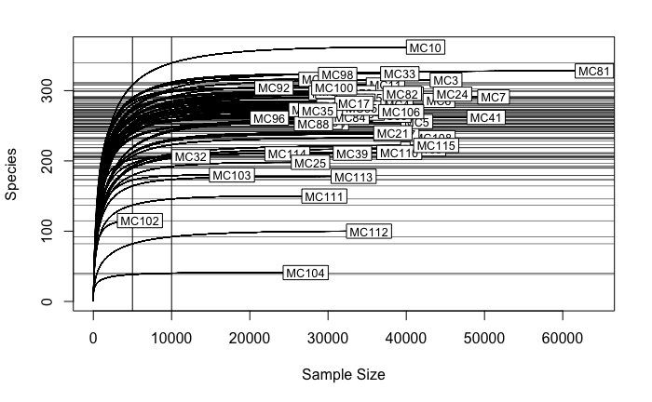

Figure S1: Accumulation curves obtained for all 53 individuals, showing the sample size and number of ASVs retrieved.

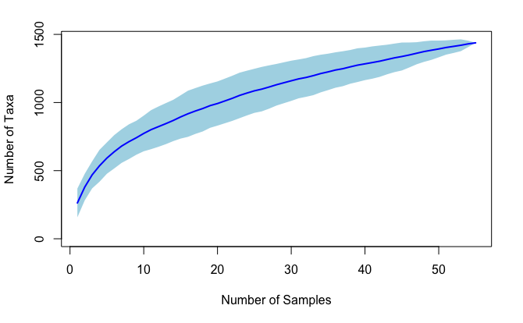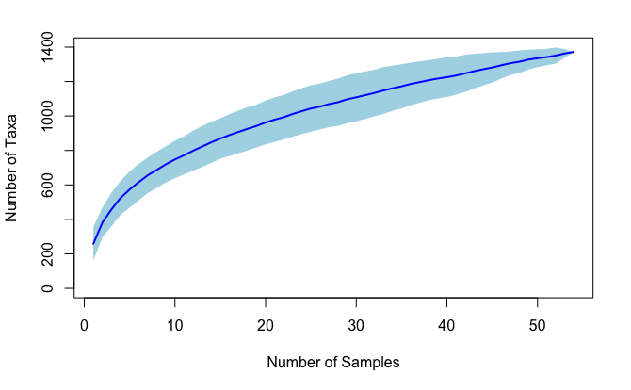

Figure S2: Rarefaction curves of amplicon sequence variants (ASVs). The y-axis shows the number of taxa sampled and the x-axis shows the number of samples analysed. As the number of samples increases, the number of ASVs also increases. Each curve represents a sample. Accumulation curves were obtained before (left) and after (right) rarefaction.

Table S3: Top 3 bacterial Phyla identified per individual including the number of reads and the most abundant Phyla found in each sample/individual.

Sample | Firmicutes | Bacteroidetes | Proteobacteria | Phylum | Total Reads | %
MC10 | 5547 | 2874 | 3015 | Firmicutes | 11436 | 92.98
MC100 | 3402 | 7207 | 773 | Bacteroidetes | 11382 | 92.54
MC103 | 2354 | 8703 | 891 | Bacteroidetes | 11948 | 97.14
MC104 | 0 | 1916 | 10334 | Proteobacteria | 12250 | 99.59
MC106 | 2978 | 8165 | 628 | Bacteroidetes | 11771 | 95.70
MC107 | 2752 | 8901 | 208 | Bacteroidetes | 11861 | 96.43
MC108 | 2682 | 9067 | 181 | Bacteroidetes | 11930 | 96.99
MC109 | 2313 | 9432 | 259 | Bacteroidetes | 12004 | 97.59
MC11 | 2401 | 8356 | 1129 | Bacteroidetes | 11886 | 96.63
MC110 | 2718 | 8781 | 360 | Bacteroidetes | 11859 | 96.41
MC111 | 2366 | 8509 | 1038 | Bacteroidetes | 11913 | 96.85
MC112 | 1 | 1041 | 11197 | Proteobacteria | 12239 | 99.50
MC113 | 2305 | 9348 | 279 | Bacteroidetes | 11932 | 97.01
MC114 | 3400 | 7494 | 249 | Bacteroidetes | 11143 | 90.59
MC17 | 5554 | 5304 | 760 | Firmicutes | 11618 | 94.46
MC21 | 2501 | 9216 | 244 | Bacteroidetes | 11961 | 97.24
MC22 | 4131 | 7390 | 252 | Bacteroidetes | 11773 | 95.72
MC24 | 3248 | 8184 | 404 | Bacteroidetes | 11836 | 96.23
MC25 | 2200 | 9324 | 361 | Bacteroidetes | 11885 | 96.63
MC3 | 3176 | 7691 | 734 | Bacteroidetes | 11601 | 94.32
MC32 | 2619 | 8403 | 256 | Bacteroidetes | 11278 | 91.69
MC33 | 2863 | 7616 | 651 | Bacteroidetes | 11130 | 90.49
MC34 | 2253 | 8762 | 227 | Bacteroidetes | 11242 | 91.40
MC35 | 2955 | 8090 | 324 | Bacteroidetes | 11369 | 92.43
MC38 | 2377 | 8220 | 544 | Bacteroidetes | 11141 | 90.58
MC39 | 1429 | 8964 | 665 | Bacteroidetes | 11058 | 89.90
MC4 | 3735 | 7382 | 156 | Bacteroidetes | 11273 | 91.65
MC41 | 1822 | 6229 | 4041 | Bacteroidetes | 12092 | 98.31
MC5 | 2839 | 8649 | 234 | Bacteroidetes | 11722 | 95.30
MC6 | 2575 | 8653 | 412 | Bacteroidetes | 11640 | 94.63
MC7 | 3242 | 8341 | 95 | Bacteroidetes | 11678 | 94.94
MC78 | 3949 | 5953 | 527 | Bacteroidetes | 10429 | 84.79
MC79 | 3561 | 5962 | 1856 | Bacteroidetes | 11379 | 92.51
MC80 | 4053 | 5498 | 1241 | Bacteroidetes | 10792 | 87.74
MC81 | 3002 | 7503 | 130 | Bacteroidetes | 10635 | 86.46
MC82 | 3869 | 5489 | 2123 | Bacteroidetes | 11481 | 93.34
MC83 | 5372 | 5683 | 472 | Bacteroidetes | 11527 | 93.72
MC84 | 4527 | 5517 | 1337 | Bacteroidetes | 11381 | 92.53
MC85 | 3702 | 6302 | 1595 | Bacteroidetes | 11599 | 94.30
MC86 | 4080 | 6913 | 663 | Bacteroidetes | 11656 | 94.76
MC87 | 4452 | 5265 | 886 | Bacteroidetes | 10603 | 86.20
MC88 | 3994 | 5345 | 1842 | Bacteroidetes | 11181 | 90.90
MC89 | 4017 | 5683 | 1026 | Bacteroidetes | 10726 | 87.20
MC9 | 4507 | 6459 | 564 | Bacteroidetes | 11530 | 93.74
MC90 | 3176 | 6626 | 1826 | Bacteroidetes | 11628 | 94.54
MC91 | 3937 | 6051 | 928 | Bacteroidetes | 10916 | 88.75
MC92 | 4165 | 6174 | 273 | Bacteroidetes | 10612 | 86.28
MC93 | 3738 | 6186 | 931 | Bacteroidetes | 10855 | 88.25
MC95 | 3268 | 7931 | 392 | Bacteroidetes | 11591 | 94.24
MC96 | 3463 | 7112 | 613 | Bacteroidetes | 11188 | 90.96
MC97 | 2084 | 8841 | 617 | Bacteroidetes | 11542 | 93.84
MC98 | 2877 | 7549 | 824 | Bacteroidetes | 11250 | 91.46
MC99 | 2682 | 8317 | 406 | Bacteroidetes | 11405 | 92.72

Table S4: Top 3 bacterial Classes identified per individual including the number of reads and the most abundant class found in each sample/individual.

Sample | Bacilli | Bacteroidia | Gammaproteobacteria | Most abundant Class
MC10 | 4432 | 2873 | 2737 | Bacilli
MC100 | 1 | 7207 | 225 | Bacteroidia
MC103 | 339 | 8703 | 859 | Bacteroidia
MC104 | 0 | 1916 | 10207 | Gammaproteobacteria
MC106 | 186 | 8165 | 586 | Bacteroidia
MC107 | 444 | 8901 | 178 | Bacteroidia
MC108 | 181 | 9067 | 149 | Bacteroidia
MC109 | 5 | 9432 | 237 | Bacteroidia
MC11 | 769 | 8356 | 1086 | Bacteroidia
MC110 | 0 | 8781 | 354 | Bacteroidia
MC111 | 34 | 8509 | 1013 | Bacteroidia
MC112 | 1 | 1041 | 11080 | Gammaproteobacteria
MC113 | 0 | 9348 | 198 | Bacteroidia
MC114 | 5 | 7494 | 148 | Bacteroidia
MC17 | 597 | 5304 | 631 | Bacteroidia
MC21 | 1 | 9216 | 234 | Bacteroidia
MC22 | 0 | 7390 | 219 | Bacteroidia
MC24 | 3 | 8184 | 381 | Bacteroidia
MC25 | 7 | 9324 | 321 | Bacteroidia
MC3 | 0 | 7691 | 633 | Bacteroidia
MC32 | 41 | 8403 | 149 | Bacteroidia
MC33 | 73 | 7616 | 581 | Bacteroidia
MC34 | 10 | 8762 | 170 | Bacteroidia
MC35 | 4 | 8090 | 202 | Bacteroidia
MC38 | 47 | 8220 | 354 | Bacteroidia
MC39 | 0 | 8964 | 501 | Bacteroidia
MC4 | 14 | 7382 | 95 | Bacteroidia
MC41 | 14 | 6229 | 3974 | Bacteroidia
MC5 | 7 | 8649 | 212 | Bacteroidia
MC6 | 144 | 8653 | 356 | Bacteroidia
MC7 | 5 | 8341 | 64 | Bacteroidia
MC78 | 3 | 5953 | 411 | Bacteroidia
MC79 | 35 | 5962 | 1738 | Bacteroidia
MC80 | 180 | 5498 | 1153 | Bacteroidia
MC81 | 17 | 7503 | 87 | Bacteroidia
MC82 | 1 | 5489 | 2026 | Bacteroidia
MC83 | 0 | 5683 | 430 | Bacteroidia
MC84 | 0 | 5517 | 1290 | Bacteroidia
MC85 | 0 | 6302 | 1519 | Bacteroidia
MC86 | 1 | 6913 | 600 | Bacteroidia
MC87 | 1 | 5265 | 828 | Bacteroidia
MC88 | 0 | 5345 | 1719 | Bacteroidia
MC89 | 2 | 5683 | 975 | Bacteroidia
MC9 | 0 | 6459 | 519 | Bacteroidia
MC90 | 3 | 6626 | 1757 | Bacteroidia
MC91 | 9 | 6051 | 883 | Bacteroidia
MC92 | 7 | 6174 | 245 | Bacteroidia
MC93 | 6 | 6186 | 901 | Bacteroidia
MC95 | 0 | 7931 | 346 | Bacteroidia
MC96 | 139 | 7112 | 521 | Bacteroidia
MC97 | 19 | 8841 | 485 | Bacteroidia
MC98 | 327 | 7549 | 288 | Bacteroidia
MC99 | 0 | 8317 | 354 | Bacteroidia

Table S5: Phyla and Classes detected in the analysed samples, with corresponding read counts and overall percentage.
​​
Phylum/Class | Read counts | %
Actinobacteria | 6647 | 1.02
Acidimicrobiia | 2 | 0.03
Actinobacteria | 267 | 4.02
Coriobacteriia | 6377 | 95.94
Thermoleophilia | 1 | 0.02
Bacteroidetes | 378571 | 58.33
Bacteroidia | 378570 | 100.00
Rhodothermia | 1 | 0.00
Cyanobacteria | 12677 | 1.95
Melainabacteria | 12677 | 1.00
Epsilonbacteraeota | 3741 | 0.58
Campylobacteria | 3741 | 1.00
Firmicutes | 167213 | 25.77
Bacilli | 8114 | 4.85
Clostridia | 127468 | 76.23
Erysipelotrichia | 20717 | 12.39
Negativicutes | 10861 | 6.50
Phylum_Firmicutes | 53 | 0.03
Lentisphaerae | 66 | 0.01
Lentisphaeria | 66 | 1.00
Proteobacteria | 61973 | 9.55
Alphaproteobacteria | 1986 | 3.20
Deltaproteobacteria | 2778 | 4.48
Gammaproteobacteria | 57209 | 92.31
Synergistetes | 485 | 0.07
Synergistia | 485 | 1.00
Tenericutes | 17611 | 2.71
Mollicutes | 17611 | 1.00

Table S6: Statistical analyses output obtained from the Kruskal-Wallis test for alpha diversity indices.

Alpha diversity | p-value
Observed | 0.549
Chao1 | 0.517
Shannon | 0.135
Simpson | 0.121
Table S7: Statistical analyses output obtained for PERMUTEST, PERMANOVA and ANOSIM tests for each of the three analysed beta-diversity distances. * Indicates significant values.

 | PERMUTEST | PERMANOVA |  | ANOSIM
 | p-value | Sample data (R2) | Residuals (R2) | p-value | R
Unweighted Unifrac Distance | 0.034* | 0.09178 | 0.90822 | 0.284 | 0.05
Weighted Unifrac Distance | 0.018* | 0.07308 | 0.92692 | 0.534 | -0.01
Bray Distance | 0.006* | 0.09482 | 0.90518 | 0.311 | 0.05

Table S8: Analysis of correlation between microbiome alpha diversity and host genetics (Ho – homozygosity observed, HL – homozygosity by loci).

 | Ho |  | HL
 | p-value | r | p-value | r
Observed | 0.60 | -0.07 | 0.87 | -0.02
Shannon | 0.67 | -0.06 | 0.87 | -0.02
Chao1 | 0.56 | -0.08 | 0.82 | -0.03
Simpson | 0.94 | -0.009 | 0.87 | 0.02

Table S9: Summary of Mantel test applied to Muriqui social groups, comparing the effects of host genetics (genetic distance) into microbiome community estimated through three beta diversity distances (Unweighted and weighted UniFrac and Bray-Curtis).

 | p-value | r
Unweighted UniFrac | 0.04 | 0.13
Weighted UniFrac | 0.002 | 0.25
Bray-Curtis | 0.003 | 0.22

REFERENCES

Strier, K. B., Chaves, P. B., Mendes, S. L., Fagundes, V., & Di, A. (2011). Low paternity skew and the influence of maternal kin in an egalitarian, patrilocal primate. PNAS 108 (47), 18915-18919.
Bohle, U. R., Zischle,r H. (2002). Polymorphic microsatellite loci for the moustached tamarin (Saguinus mystax) and their cross-species amplification in other New World monkeys. Mol Ecol Notes 2:1e3.
Di Fiore, A., Fleischer, R. C. (2004). Microsatellite markers for woolly monkeys (Lagothrix lagotricha) and their amplification in other New World primates (Primates: Platyrrhini). Mol Ecol Notes 4:246e249.
Grativol, A. D., Ballou, J. D., & Fleischer, R. C. (2001). Microsatellite variation within and among recently fragmented populations of the golden lion tamarin (Leontopithecus rosalia). Conservation Genetics, 2(1), 1-9.
Kaizer, M. C. (2019). Non-invasive monitoring for population assessments of a critically endangered Neotropical primate. PhD Thesis. The University of Salford. 169p.
Perez-Sweeney, B. M., Valladares-Padua, C., Burrell, A. S. et al. (2005). Dinucleotide microsatellite primers designed for a critically endangered primate, the black lion tamarin (Leontopithecus chrysopygus). Mol Ecol Notes 5:198–201. doi:10.1111/j.1471-8286.2005.00875.x
Weber, J. L., Kwitek, A. E., May, P. E. (1990.) Dinucleotide repeat polymorphisms at the D5S107, D5S108, D5S111, D5S117 and D5S118 loci. Nucleic Acids Res 18:4035.
Weissenbach, J., Gyapay, G., Dib, C., Vignal, A., Morissette, J., Millasseau, P., Vaysseix, G., Lathrop, M. (1992). A second-generation linkage map of the human genome. Nature. 29;359(6398):794-801. doi: 10.1038/359794a0. PMID: 1436057.

