Supplementary
Adsorption activity of spent coffee ground biochar for the removal of Vivizole Red 3BS dye from aqueous solution
Admasu Adamu ^{a *}, Feleke Zewge ^{a,b}, Yonas Chebude ^{a,b},
ª Africa Center of Excellence for Water Management, Addis Ababa University, Addis Ababa, Ethiopia
^{b} Department of Chemistry, College of Natural and Computational Sciences, Addis Ababa University, Addis Ababa, Ethiopia
S1 Physicochemical characteristics of real wastewater (VR 3BS 150 % dye) of the cotton industry
Parameter Value
pH 12.44
COD (mg O₂ L⁻) 6,885
BOD5 (mg O₂ L⁻) 1,377
Dey concentration (mg/L) 665
Turbidity (NTU) 34.4
Conductivity (µS cm⁻¹) 48.4
TDS (mg/L) 28, 600
TOC (ppm) 319
Total alkalinity (mg/L) 4,400
Chloride Concentration (mg/L) 18, 465
Total Hardness as CaCO₃ (mg/L) 440
NO₃-N (mg/L) 50
SO₄²⁻ (mg/L) 600
PO₄³⁻ (mg/L) 2
NH₃-N (mg/L) 28.5

S2 Actual versus predicted VR 3BS dye removal from aqueous solution by activated SCG biochar
Run | Initial Dye concentration (mg/L) | pH | Dose (g/L) | Contact time (min) | VR 3BS dye removal (%)
 |  |  |  |  | Actual | Predicted
1 | 20 | 6.5 | 7.5 | 90 | 71.6 | 72.53
2 | 40 | 3 | 10 | 120 | 80.65 | 81.87
3 | 40 | 6.5 | 7.5 | 90 | 66.33 | 65.71
4 | 20 | 10 | 5 | 120 | 64.98 | 64.18
5 | 40 | 10 | 5 | 60 | 61.02 | 60.41
6 | 20 | 3 | 10 | 120 | 89.32 | 90.30
7 | 20 | 3 | 10 | 60 | 94.3 | 91.12
8 | 40 | 3 | 5 | 120 | 64.08 | 61.29
9 | 30 | 3 | 7.5 | 90 | 75.7 | 76.91
10 | 30 | 6.5 | 7.5 | 90 | 67.53 | 63.89
11 | 20 | 3 | 5 | 120 | 89.85 | 89.28
12 | 40 | 10 | 10 | 60 | 71.9 | 72.02
13 | 30 | 6.5 | 7.5 | 60 | 71.9 | 70.95
14 | 20 | 10 | 5 | 60 | 67.3 | 65.62
15 | 20 | 10 | 10 | 120 | 61.03 | 60.41
16 | 30 | 6.5 | 7.5 | 90 | 63.9 | 63.89
17 | 20 | 10 | 10 | 60 | 54.5 | 57.67
18 | 30 | 6.5 | 7.5 | 90 | 62.7 | 63.89
19 | 30 | 6.5 | 7.5 | 120 | 69.07 | 70.32
20 | 20 | 3 | 5 | 60 | 92.5 | 94.28
21 | 30 | 6.5 | 5 | 90 | 51.97 | 53.74
22 | 30 | 6.5 | 7.5 | 90 | 60.6 | 63.89
23 | 30 | 6.5 | 10 | 90 | 61.53 | 60.06
24 | 40 | 3 | 5 | 60 | 65.13 | 65.30
25 | 30 | 10 | 7.5 | 90 | 60.43 | 59.52
26 | 40 | 10 | 10 | 120 | 77.15 | 75.75
27 | 30 | 6.5 | 7.5 | 90 | 65.97 | 63.89
28 | 40 | 10 | 5 | 120 | 57.23 | 59.96
29 | 30 | 6.5 | 7.5 | 90 | 63.57 | 63.89
30 | 40 | 3 | 10 | 60 | 80.52 | 81.70

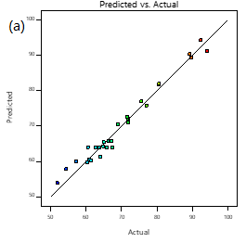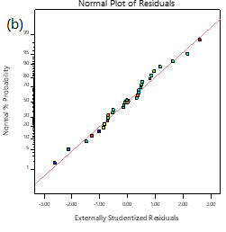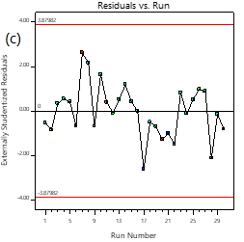
S3 Relationship plot between (a) Predicted versus actual values of response, (b) normal % probability versus externally studentised residuals, (c) residual versus the run

