Electronic Supplementary Material
Mpiliou, M., Kappis, K., Tombros, S., Avgouropoulos, G., Kokkalas, S., Lampropoulou², P., Triantafyllidis, S., Li, H., and Papavasiliou, J.

Corresponding author e-mail, stel@upatras.gr/ and ipapavas@upatras.gr.

Detailed regional, skarn and ore deposits geology
Serifos Island belongs to the Attico-Cycladic Massif which represents a multi-metamorphic terrane in the back-arc region of the Hellenic subduction zone. The Attico-Cycladic Massif (ACM) consists of four Alpine nappes, namely the Cycladic Basement (CB), the Basal Unit, the Cycladic Blueschist Unit (CBU) and the Upper Cyclades Unit (UCU)¹. At Serifos the CB, CBU and UCU are exposed¹. The CB comprises pre-to-Carboniferous schists and gneisses¹, while the CBU consists of a Permo-Carboniferous-to-Cretaceous volcanosedimentary sequence of meta-sedimentary and -igneous rocks, marbles and schists². The CBU at Serifos comprises three subunits (Fig. 1): The lowermost subunit of alternating CB gneisses, intercalated with schists, quartzites and marbles. The middle subunit consists of amphibolites overlain by greenschist and dolomitic marbles, and the uppermost comprises of meta-schists and calcitic marbles which host irregular-shaped ankerite-dolomite-talc-goethite carbonate-replacement orebodies^{2, 3, 4}. The UCU comprises an ophiolite cover with marbles, shales, schists and serpentinites^{2, 3, 4}.
The CBU has experienced at least two stages of Tertiary metamorphism¹. The first episode occurred at eclogite-to-blueschist facies conditions, between ca. 53 and 40 Ma (T = 450º to 500 ºC, P = 15 ± 3 kbar). The second event occurred between ≥ 25 and ~ 12 Ma, at greenschist-to-amphibolite facies (T = 670º to 700 ºC and P = 4 to 7 kbar); and was accompanied by exhumation of metamorphic core complexes along the Northern and the Western Cycladic detachment systems, the latter also exposed at Serifos^{1, 3}. At Serifos the aforesaid units are separated by two detachment faults (Fig. 1), which belong to the WCDS, i.e., the Megalo Livadi detachment separating the CB from CBU, and the Kavos Kiklopas detachment separating the CBU from UCU³.
Serifos mainly consists of a pluton emplaced in the CB and CBU rocks (Fig. 1) between ~11.5 and ~9.5 Ma⁵. The central part is a metaluminous, hornblende-biotite granodiorite with subordinate tonalite, whereas its border facies is a peraluminous hornblende-biotite-allanite-zinnwaldite granodiorite-to-granite⁶. Serifos pluton was crystallized at temperatures between ~ 700º and 750 ºC and emplaced at pressures between ~1.5 and 3.5 kbar^{5, 7}. Granodioritic-to-granitic apophyses, pegmatites, aplite and dacite dikes intrude within the CB and CBU rocks along NW-SE trending counterclockwise-reverse faults⁷.
The Serifos intrusion resulted in a metamorphic aureole up to 1000 m wide (Fig. 1) comprising inner scapolite-garnet-hornblende, followed by scapolite-diopside-hornblende and diopside-hornblende, and outer epidote-actinolite hornfelses^{4, 5, 6, 7} (ESM Table 1, cf., Contact metamorphism lithophases). Metasomatic endo- and Ca-Fe-Mg exo-skarns occur in the silica-bearing, dolomitic marbles or at their contacts with siliceous metasedimentary rocks, the granodiorite borderfacies and cupola, apophyses and aplitic dikes (Fig. 1, ESM Table 1, cf., Contact metasomatism lithotypes). The Fe-skarns display distinct zoning patterns where high temperature (T = 550º to 400 ºC) pyroxene-garnet skarns and magnetite-pyrite deposits occur closer to the granodiorite. At larger distances, medium temperature (T = 400º to 300 ºC) epidote-actinolite-hematite skarns form as veins crosscutting the host rocks as well as the previously formed skarns and ore deposits. In southwestern Serifos massive hedenbergite-ilvaite skarns occur on top of the marbles (T =350º to 300 ºC). The low temperature (T =300º to 100 ºC) stages of metasomatism manifest as veins and geodes of hematite ores with gangue barite and fluorite^{4, 5, 6, 7}. Outside the contact aureole retrograde vein-type ores occur in Moutoulas (Fig. 1), consisting of pyrite, chalcopyrite, galena, sphalerite, pyrrhotite, bismuthinite and native bismuth^{2, 4, 5, 6, 7}. The magnetite skarns underwent supergene oxidation towards hematite^{2, 4, 5, 6, 7}.

Sampling, analytical techniques and experimental procedure
Our sampling initially included all the exploited Fe-skarns in Greece, i.e., at Xanthi (Rhodope Massif), Lavrion and Serifos Island (Attico-Cycladic Massif). However, the high Fe³⁺/Fe²⁺ potential of magnetites from Xanthi and Lavrion has excluded them from further investigation as catalysts for CO oxidation. For Serifos (Fig. 1), fifty five samples of magnetite and red and yellow hematite ores were collected from the most productive mines in the island (e.g., Plagia and Vounies), as well as the supergene ore deposits (e.g., Megalo Livadi and Koutalas) and mining wastes (e.g., Skouries), respectively.
SEM were performed on separates of magnetite and hematite using a JEOL JSM 6380LV scanning electron microscope combined with energy dispersive X-ray spectrometry (OXFORD ISIS Link electron microprobe) and equipped with a JEOL Analytical back-scattered electron detector. SEM analyses were carried out at the Department of Materials Science, University of Patras. Operating conditions for the SEM were 20 kV accelerating voltage, 20 mm working distance and 1.0 nA beam current. Counting time for each analysis was 50 s, with 15 s dead time. Magnetite and hematite compositions were additionally determined using a JEOL 8900 Superprobe equipped with wave-length, energy dispersive and back-scattered detectors and a xClent system for ppm-level resolution at the Microprobe Center of the Department of Earth and Planetary Sciences Department, at McGill University. Operating conditions were acceleration voltage of 15 kV, a beam current of 10 nA, and counting time of 20 s for all elements expect 100 s for Ag and 50 s for As and Te. Scans in WDS mode were also used to detect trace elements contents. In both cases, the standards used were natural magnetite, hematite, chalcopyrite, pyrite, sphalerite, galena, CoNiAs, SnO₂, plus the native metals Ag, Sb, Au, Te, Se, Ta, and Cd, respectively. The X-ray lines measured were Ag La, Sb La, Cu Ka, Fe Ka, Au Ma, Mn Ka, Se La, Bi La, Cd La, Te La, and S Ka. ZAF corrections were made with proprietary JEOL software. A minimum of ten analyses were obtained from each sample and three from each grain.
Pure magnetite separates (e.g., samples SP1, 3, 5, 6, 7, 8 and SV1, 3, 4, 5) were commercially analyzed at ALS Laboratories (ALS Code CCP-PKG01) for major and trace elements (50 trace elements in total). Trace elements analysis involved the application of ICP-MS and ICP-AES. The “GRE-3”, “GBM908-10”, “OGGeo08”, “OREAS-45e” and “GEOMS-03” standards were used for trace elements analyses. For the trace elements, S.D. ranges between minimum 0 % (e.g., Cr, Sn and W) and maximum 1.58 % (e.g., Rb).
The samples already used for probe analyses were also examined by cathodoluminescence (CL) using the Luniscope CL Reliotron spectrometer at the Research Laboratory of Minerals and Rocks, Department of Geology, University of Patras, equipped on a Quanta 200F ESEM with 45-s scanning time. The applied acceleration voltage and current were 15 kV and 120 nA and the CL images were collected with a resolution of 1,280×960 pixels and 256 grey levels.
X-ray diffractometry involved the use of a Bruker D8 Advanced X-ray diffractometer and the Department of Geology, University of Patras, with Ni-filtered Cu(Kα) radiation at 40 kV/40 mA operating conditions (with a 2θ angle of 2° to 70°) using the XRD-data method of Moore & Reynolds⁸. The XRD patterns of both natural separates of magnetite and hematite and their XRD patterns after calcination and deposition of Au nanoparticles are given.
Raman microanalysis was carried out at the Laboratory of Mineralogy, Petrology and Economic Geology, Section of Geological Sciences, School of Mining and Metallurgical Engineering, National Technical University of Athens. Raman spectroscopy involved the use of a RENISHAW inVia Raman microscope at the School of Chemical Engineering, National Technical University of Athens. Monochromatic laser radiation at 532 nm was employed and for ferroxides the operating conditions included range between 100 and 3600 Raman shifts/cm, 20 s exposure time, 2 accumulations per spectrum and 50 % laser power.
Thermal-gravimetric (TGA) analyses was carried out in samples from the mining wastes, as well as separates of natural magnetite and yellow and red hematite before and after their calcination. The TG/TD study was carried out in a thermogravimetry instrument Q500 by TA at the Department of Materials Science, University of Patras under flowing nitrogen atmosphere with a heating rate of 0.1 to 100 °C/min in 0.01 °C/min increments (standard furnace), and furnace cooling with forced air from 1000° to 50 °C in < 12 min, in the temperature range 25° to 1000 °C. The weighing capacity was 1.0 g with a weighing precision of ± 0.01 %.
Fourier-Transform Infrared Spectroscopy (FT-IR) was carried out in samples obtained from the mining wastes, at the Department of Materials Science, University of Patras. The FT-IR study was performed with the Spectrum 100 by Perkin Elmer FT-IR spectrophotometer. The instrument has a range of 7800 to 370 cm⁻¹ with 0.5 cm⁻¹ resolution. The FT-IR analysis performed in pelleted samples. The Origin software was used for the evaluation of the results.
The specific surface area (SSA), the pore volume (V_{P}) and the pore size distribution of the ferroxides were determined from the adsorption and desorption isotherms of N₂ at -196 °C using a NOVATOUCH gas sorption system by Quantachrome instruments. Prior to the measurements, the samples were outgassed at 200 °C for 1 h, under vacuum.

ESM Tables
ESM Table 1. Sampling, mineralization styles and host rock types of the Fe-skarns and mining wastes from Serifos Island (referring to Fig. 1).

Mineralization type (Location) | Host rock
Fe-skarns comprising magnetite ores (Mag ± Py, Ccp, Ga, Sp, Tnt-Ttr)
Sites: Koutalas, Plagia, Xalara, Kentavros, Agios Dimitrios, Vounies, Psari, Tsilipaki, Kountouros, Tsimiskopoulo, Diasela, Psari, Agriomelissa, Avissalos, Mykonios, Troulos, Agios Vlassios, Agia Marina, Megalo Livadi and Livadi, Mountaki (+Ilv).  Samples: SP_{1 to 15}, SV_{1 to 5}, SAM_{1 to 10} (P = Plagia, V = Vounies). | Skarns, hornfelses, marbles
Retrograde alteration and supergene oxidation of Fe-skarns comprising hematite ores (Hem ± Prs)
From Koutalas Bay to Avissalos Bay,  Sites: Megalo Livadi, Koutalas, Avraam, Korakas, Mavres Spilies, Aetoi, Aspros Kavos, Mavra Voladia, Agia Triada, Karvounolakos, Almiros, Kalogiros, Maleadiko, Kountouros, Avissalos, Alevrakia, Tsilipaki-Tziakoftis, Gianema, Kalo Ambeli, Kastro and Koudounopetres.  Samples: SM_{16 to 20}, SK_{6 to 14} (M = Megalo Livadi, K = Koutalas). | Skarns, hornfelses, marbles, schists, gneisses
Mining wastes
Skouries, Kefala, Fourni, Mega Chorio, Xalara, Koutalas, Mega Livadi.  Samples: SS_{1 to 10} (S = Skouries). | Skarns, hornfelses, marbles, schists, gneisses
Contact metamorphism lithophases
In the contact aureole four contact metamorphic zones are distinguished (see Fig.1):
- An outer epidote-actinolite zone in schists comprising the actinolite-isograd (at ~ 700 m perpendicular to the tectono-intrusive contact) and is characterized by the formation reaction of actinolite = chlorite + calcite + quartz. The physicochemical parameters of formation were temperatures between 440° and 410°C and pressure of ≥ 1 kbar and P_{CO2} = 50 bar.
- An intermediate diopside-hornblende zone of hornfelses comprising the diopside-isograd (at ~ 500 m perpendicular to the tectono-intrusive contact) and is characterized by the formation reaction of diopside = actinolite + calcite + quartz. The physicochemical parameters of formation were temperatures between ~ 525° and 450°C and pressure of ≈ 1 kbar and P_{CO2} ≥ 50 bar.
- An intermediate scapolite-diopside-hornblende zone of hornfelses comprising the scapolite isograd (between ~ 250 and 150 m perpendicular to the tectono-intrusive contact) and is characterized by the formation reaction scapolite = plagioclase + calcite. No determinations of temperature and pressure are available.
- An inner scapolite-garnet-hornblende zone of hornfelses comprising the garnet isograd (at ~ 150 m and towards the intrusive contact) and is characterized by the formation reaction grandite = scapolite + diopside + fluid phase. The contact metamorphic paragenesis comprises grandite (garnet with intermediate composition between andradite and grossular), hornblende, plagioclase (An_{80%}), quartz, epidote, muscovite, biotite, apatite, zircon and opaques (magnetite and ilmenite). The physicochemical parameters of formation were temperatures between ~ 640° and ~ 600°C and pressure of ≈ 2 kbar and 0.15 ≤X_{CO2} ≤ 0.30.
Metasomatism skarn lithotypes
Petrographically, the following skarns are distinguished (see Fig.1):
High-temperature metasomatism: Produced massive hedenbergite-andradite ± ilvaite skarns and associated irregularly-shaped magnetite orebodies (at ~ 200 m perpendicular to the tectono-intrusive contact). The high-temperature skarns consist of epidote, hedenbergite, andradite and magnetite ± ilvaite (M. Livadi site); arranged in alternating almost monomineralic bands, and accessory phlogopite, actinolite, quartz and pyrite. The physicochemical parameters of formation of the high-temperature skarns were temperatures between 560° and 500°C and pressure of ~ 1 kbar.
Medium-temperature metasomatism: The massive hedenbergite-andradite skarns grade into andradite-actinolite veins (at distances between ~ 200 and ~ 300 m perpendicular to the intrusive contact) that contain andradite, actinolite and phlogopite, and minor magnetite, calcite, quartz, pyrite and ludwigite (Mg₂Fe³⁺(BO₃)O₂) altered and replaced by supergene szaibélyite (MgBO₂(OH)). The andradite-actinolite skarns also cement angular fragments of previously formed hedenbergite-andradite skarns. The physicochemical parameters of formation of the andradite-actinolite veins were temperatures of 450° ≤ T ≤ 500°C and pressure of ~ 1 kbar. These veins are crosscut and replaced by epidote-actinolite veins (at distances between ~ 400 and ~ 500 m perpendicular to the intrusive contact), sometimes containing almost monomineralic epidote. Commonly the skarn paragenesis comprises epidote, actinolite, quartz, magnetite and/or hematite, pyrite, and minor adularia and calcite. The physicochemical parameters of formation of the epidote-actinolite veins were temperatures of ~ 400°C and at pressure of ≤ 0.5 kbar.
Low-temperature metasomatism: The medium-temperature andradite-and epidote-actinolite skarn grade into low temperature calcite-quartz-hematite veins and veinlets (at distances between ~ 700 and ~ 800 m perpendicular to the intrusive contact and in the borderfacies of the granodiorite). These veins contain hematite, calcite, dolomite, quartz, adularia and pyrite, and minor epidote, actinolite, sphalerite, galena and pyrite. The physicochemical parameters of formation of the calcite-quartz-hematite veins were temperatures between 250º and 350ºC. The final stages of metasomatism comprise low-temperature, hydrothermal deposits (at a distance of ≥ than 1000 m perpendicular to the intrusive contact) of hematite, talc, chlorite, adularia and calcite in geodes and veinlets. The physicochemical parameters of formation of the hematite geodes were temperatures of 150° ≤ T ≤ 250°C and at pressure of ≤ 0.2 kbar.

Abbreviations (after^{9,10}): Mag = Magnetite, Py = Pyrite, Ccp = Chalcopyrite, Ga = Galena, Sp = Sphalerite, Tnt-Ttr = Tennantite-Tetrahedrite, Ilv = Ilvaite, Hem = Hematite, Prs = Pyrolusite.

Electronic Supplementary Material, Table 2. Representative SEM microanalyses of magnetite from the Fe-skarns of Serifos (all results in wt. %)^{A}.

Wt. % oxides | Magnetite
Locality | Plagia |  |  |  | Vounies
Sample | SP₁ | SP₃ | SP₆ | SP₇ | SV₁ | SV₂ | SV₃ | SV₄
SiO₂ | 0.80 | 0.00 | 0.00 | 0.31 | 0.00 | 0.17 | 0.06 | 0.00
TiO₂ | 0.02 | 0.43 | 0.00 | 0.00 | 0.10 | 0.11 | 0.00 | 0.23
Al₂O₃ | 0.12 | 0.00 | 0.14 | 0.14 | 0.11 | 0.00 | 0.12 | 0.00
FeO^{total} | 96.40 | 98.06 | 96.84 | 97.31 | 96.72 | 98.28 | 97.99 | 98.16
MnO | 0.06 | 0.75 | 0.18 | 0.00 | 0.15 | 0.00 | 0.00 | 0.30
MgO | 0.03 | 0.00 | 0.05 | 0.16 | 0.00 | 0.00 | 0.13 | 0.00
CaO | 1.20 | 0.00 | 0.00 | 0.00 | 0.00 | 0.16 | 0.00 | 0.12
Total | 98.63 | 99.24 | 97.21 | 97.92 | 97.08 | 98.72 | 98.3 | 98.81
Recalculated Fe and Total (in wt. %)
Fe₂O₃ | 69.1 | 69.6 | 69.8 | 69.2 | 69.7 | 70 | 69.3 | 69.3
FeO | 30.9 | 30.4 | 30.2 | 30.8 | 30.3 | 30 | 30.7 | 30.7
Ulvöspinel mol (%) for 4 oxygen apfu
Atomic mol | 2.17 | 2.17 | 2.21 | 2.20 | 2.22 | 2.18 | 2.19 | 2.18
Mol % Usp | 0.05 | 1.14 | 0.00 | 0.00 | 0.28 | 0.30 | 0.00 | 0.62
Cations | Number of cations based on¹
Si | 0.03 | 0.00 | 0.00 | 0.01 | 0.00 | 0.01 | 0.00 | 0.00
Ti | 0.00 | 0.01 | 0.00 | 0.00 | 0.00 | 0.00 | 0.00 | 0.01
Al | 0.01 | 0.00 | 0.01 | 0.01 | 0.00 | 0.00 | 0.01 | 0.00
Fe⁺³ | 1.94 | 1.98 | 1.99 | 1.97 | 1.99 | 1.98 | 1.99 | 1.99
Fe⁺² | 0.98 | 0.99 | 0.99 | 1.00 | 1.00 | 1.00 | 1.00 | 0.99
Fe³⁺/Fe²⁺ ratio | 1.98 | 2.00 | 2.01 | 1.97 | 1.99 | 1.98 | 1.99 | 2.01
Mn | 0.00 | 0.02 | 0.01 | 0.00 | 0.00 | 0.00 | 0.00 | 0.01
Mg | 0.00 | 0.00 | 0.00 | 0.01 | 0.00 | 0.00 | 0.01 | 0.00
Ca | 0.05 | 0.00 | 0.00 | 0.00 | 0.00 | 0.01 | 0.00 | 0.00
Total: | 3.00 | 3.00 | 3.00 | 3.00 | 3.00 | 3.00 | 3.00 | 3.00
Temperature (°C) | 529 | 522 | 531 | 528 | 547 | 532 | 557 | 542
logfO₂ | -20.32 | -20.87 | -20.52 | -20.61 | -19.85 | -19.65 | -19.76 | -19.41

^{A}Using ILMAT: A Magnetite-Ilmenite Geothermobarometry Program (version 1.20)¹¹.

Electronic Supplementary Material, Table 3. Representative trace elements analyses of magnetite from the Fe-skarns of Serifos (all results in ppm, expect for TiO₂ in wt. %).

Magnetite
Sample | SP₁ | SP₃ | SP₅ | SP₆ | SP₇ | SP₈ | SV₁ | SV₂ | SV₃ | SV₄ | SV₅
Mass (g) | 1.90 | 1.37 | 1.51 | 1.94 | 1.43 | 1.75 | 1.59 | 1.74 | 1.62 | 1.85 | 1.64
Trace elements (ppm)
Sample | SP₁ | SP₃ | SP₅ | SP₆ | SP₇ | SP₈ | SV₁ | SV₂ | SV₃ | SV₄ | SV₄
Mass (g) | 1.90 | 1.37 | 1.51 | 1.94 | 1.43 | 1.75 | 1.59 | 1.74 | 1.62 | 1.85 | 1.64
V | 13.6 | 12.5 | 11.1 | 24.7 | 25.5 | 23.0 | 17.0 | 23.0 | 18.7 | 39.6 | 53.6
Ni | 12.8 | 16.2 | 36.6 | 16.2 | 8.5 | 10.2 | 18.7 | 7.7 | 16.2 | 18.7 | 77.4
Cr | 12.8 | 8.5 | 13.6 | 11.9 | 10.2 | 10.1 | 10.0 | 12.8 | 11.9 | 7.7 | 10.2
Ni/Cr | 1.0 | 1.9 | 0.6 | 1.4 | 0.8 | 1.0 | 1.9 | 2.7 | 2.3 | 2.4 | 7.6
Trace elements (in wt. %)
TiO₂ | 187.0 | 399.5 | 272.0 | 773.5 | 51.0 | 178.5 | 595.0 | 1113.5 | 374.0 | 85.0 | 510.0

Electronic Supplementary Material, Table 4. Representative SEM microanalyses of hematite from the Fe-skarns and mining wastes of Serifos (all results in wt. %).

wt. % oxides | Hematite
Locality | SM₁₆ | SM₁₇ | SM₁₈ | SK₈ | SK₉ | SS₁ | SS₂ | SS₃
 | Hem yellow |  |  | Hem red |  | Wastes (tailings/slags)
SiO₂ | 0.00 | 0.00 | 0.00 | 0.00 | 0.00 | 0.23 | 0.46 | 0.55
Al₂O₃ | 0.00 | 0.00 | 0.00 | 0.00 | 0.00 | 0.37 | 0.49 | 0.43
FeO | 98.06 | 98.15 | 98.42 | 96.54 | 96.72 | 97.42 | 97.68 | 97.17
MnO | 0.75 | 0.75 | 0.99 | 0.00 | 0.00 | 0.12 | 0.11 | 0.09
MgO | 0.00 | 0.00 | 0.00 | 0.00 | 0.00 | 0.67 | 0.78 | 0.85
CaO | 1.12 | 0.45 | 0.16 | 3.23 | 2.97 | 0.49 | 0.33 | 0.26
Total | 99.93 | 99.35 | 99.57 | 99.77 | 99.69 | 99.30 | 99.85 | 99.35
Si | 0.00 | 0.00 | 0.00 | 0.00 | 0.00 | 0.07 | 0.13 | 0.16
Al | 0.00 | 0.00 | 0.00 | 0.00 | 0.00 | 0.13 | 0.17 | 0.15
Fe²⁺ | 23.48 | 23.68 | 23.72 | 23.01 | 23.09 | 23.34 | 23.25 | 23.23
Mn | 0.18 | 0.18 | 0.24 | 0.00 | 0.00 | 0.03 | 0.03 | 0.02
Mg | 0.00 | 0.00 | 0.00 | 0.00 | 0.00 | 0.38 | 0.33 | 0.36
Ca | 0.34 | 0.14 | 0.05 | 0.99 | 0.91 | 0.20 | 0.10 | 0.08
Total | 24.00 | 24.00 | 24.00 | 24.00 | 24.00 | 24.00 | 24.00 | 24.00
Fe³⁺ | 0.47 | 0.68 | 0.71 | 0.15 | 0.09 | 0.74 | 0.68 | 0.67
Fe²⁺ | 23.00 | 23.00 | 23.01 | 22.86 | 23.00 | 22.60 | 22.57 | 22.58
Fe³⁺/Fe²⁺ ratio | 0.020 | 0.030 | 0.031 | 0.007 | 0.004 | 0.033 | 0.030 | 0.030

Electronic Supplementary Material, Table 5. Microporosity and crystallite size results of magnetite and hematite samples from Serifos mining wastes (Specific Surface Area, SSA and Pore volume and size).

Sample (SS_{1,3}) | SSA (m²/g) | Pore Volume (cm³/g) | Pore Size (nm) | d_{hkl}  (nm)
Mag | 0.42 | 0.0012 | 5.6 | 27.8
Mag (T =300ºC) | 0.45 | 0.0013 | 5.5 | 41.8
Hem, Yellow | 9.40 | 0.024 | 5.0 | 27
Hem, Yellow (T =300ºC) | 98.8 | 0.073 | 1.5 | 9.2
Hem, Red | 27.8 | 0.039 | 2.8 | 26
Hem, Red (T =300ºC) | 65.1 | 0.062 | 1.9 | 20.1
Au/Hem, Yellow (T =300ºC) | 63.8 | 0.076 | 1.6 | 9
Au/Hem, Red (T =300ºC) | 96.6 | 0.066 | 2.1 | 19.9

Electronic Supplementary Material, Table 6. The I_{V}/I_{A1g} ratios from hematite catalyst from Serifos mining wastes.

Catalyst | I_{V}/I_{A1g}
Hem, Red | 0.50
Hem, Red (T =300ºC) | 0.94
Hem, Yellow | 0.47
Hem, Yellow (T =300ºC) | 0.83

Electronic Supplementary Material, Table 7. The temperatures of CO to CO₂ conversion.

Samples | T₅₀ (ºC) | T₉₀ (ºC)
Hem, Red (T =300ºC) | 189.2 | 240.4
Hem, Yellow (T =300ºC) | 210.5 | 268.5
Au/Hem, Red (T =300ºC) | 67.1 | 128.2
Au/Hem, Yellow (T =300ºC) | > 75.0 % at 30 ºC | 61.7

Electronic Supplementary Material, Table 8. Activation energies (E_{a}) of the hematite catalysts from Serifos mining wastes.

PO₂ = 0.20 atm
 | Hem, Yellow (T = 300ºC) | Au/Hem, Yellow (T = 300ºC)
n | 0.64 ± 0.08 | 0.42 ± 0.03
E_{a} (Kj/mol) | 118.4 ±1.1 | 46.3 ±0.5
k₀ (μmol.g^{-1.}s^{-1.}atm⁻¹) | 3.82.10¹⁵ | 7.697.10⁷
PCO = 0.01 atm
 | Hem, Yellow (T = 300ºC) | Au/Hem, Yellow (T = 300ºC)
m | 0.0144 ± 0.01 | 0.071 ± 0.01
E_{a} (Kj/mol) | 55.2 ±0.6 | 29.8 ±0.24
k₀ (μmol.g^{-1.}s^{-1.}atm⁻¹) | 9.1175.10⁷ | 1.55.10⁸

ESM Figures
Electronic Supplementary Material Figure 1. Fe³⁺/Fe²⁺ ratio versus impurities (I/(I+Fe^{total} ratio of ≤ ~ 6 %, where impurities (I) are Si+Ti+Al+Mn+Mg+Ca) plot presenting the capacity for catalytic oxidation of CO of the mineral ferroxides separates obtained from Xanthi, Lavrion and Serifos Fe-skarns and mining wastes.

Electronic Supplementary Material Figure 2. X-ray diffraction diagrams: (a) of bulk sample SS₁ from mining wastes comprising magnetite (Mag), hematite (Hem), albite (Ab), barite (Ba), clays (Cl), quartz (Qz) and Fe-rich calcite (Fe-Cal); (b) Separates of natural magnetite before (down) and after calcination (up); (c), Separates of natural red hematite before (down) and after calcination (up); (d), Separates of natural yellow hematite before (down) and after calcination (up); and (e), Natural red (down) and yellow hematite (up) used as substrates for deposition of Au nanoparticles (Note the presence of goethite (Goe) as an impurity in natural ferroxides before calcination at T = 300ºC. The typical peaks of the ferroxides before and after calcination are also shown).

Electronic Supplementary Material Figure 3. Thermogravimetry analysis (TGA) of: (a, b) Bulk sample SS₁ that contain magnetite and hematite from mining wastes. Thermogravimetry analysis (TGA) and derivative thermograms before (down) and after calcination (up) of separates of natural: (c, d) Magnetite; (e, f) Yellow hematite; and (g, h) Red hematite.

Electronic Supplementary Material Figure 4. (a, b) Fourier-Transform Infrared Spectroscopy (FT-IR) of bulk sample SS₁ that contain magnetite and hematite from mining wastes.

Electronic Supplementary Material Figure 5. Raman spectra, at ambient temperature of: (a) Separates of natural magnetite before (down) and after calcination (up); (b) Separates of natural red hematite before (down) and after calcination (up); (c) Separates of natural yellow hematite before (down) and after calcination (up); and (d) Separates of natural red (down) and yellow hematite (up) used as substrates for deposition of Au nanoparticles (The typical bands of the ferroxides before and after calcination are also shown, where A_{1g} represents the symmetric stretch of oxygen atoms along Fe-O bonds, Eg and T₂g₂ the asymmetric stretch of Fe and O, T₂g₁, the ranslatory movement of whole magnetite¹⁵, and E_{g} bands at ≤ 400 cm⁻¹ are assigned to Fe atom vibrations, while bands at ≥ 400 cm⁻¹ are assigned to O atom vibrations, and A_{1g} to the movement of iron cations along c‐axis. Eg bands at ~400 and ~600 cm⁻¹ is assigned to symmetric mode of O atoms relative to other cations in a plane perpendicular to crystallographic c‐axis and Fe‐O stretching vibrations, respectively, and LO corresponds to the longitudinal optical mode attributed to disorders and T-defects within the hematite crystal lattice of hematite¹⁶).

Electronic Supplementary Material Figure 6. Typical N₂ adsorption/desorption isotherm (measured at 77 K) and Barrett-Johner-Halenda (BJH) pore size distribution curves, obtained from: (a, b) Separates of magnetite; (c, d) Separates of yellow hematite; and (e, f) Separates of red hematite (For magnetite adsorption is illustrated by blue solid lines and squares and desorption by blue solid lines and light blue squares; for yellow hematite adsorption is illustrated by yellow solid lines and squares and desorption by yellow solid lines and orange squares; and for red hematite adsorption is illustrated by red solid lines squares and desorption by red solid lines and pink squares and orange squares).

Electronic Supplementary Material Figure 7. Typical N₂ adsorption/desorption isotherm (measured at 77 K) and Barrett-Johner-Halenda (BJH) pore size distribution curves, obtained from: (a, b) Separates of magnetite; (c, d) Separates of yellow hematite; and (e, f) Separates of red hematite after the calcination at T = 300ºC of the samples (For magnetite adsorption is illustrated by blue solid lines and squares and desorption by blue solid lines and light blue squares; for yellow hematite adsorption is illustrated by yellow solid lines and squares and desorption by yellow solid lines and orange squares; and for red hematite adsorption is illustrated by red solid lines squares and desorption by red solid lines and pink squares and orange squares).

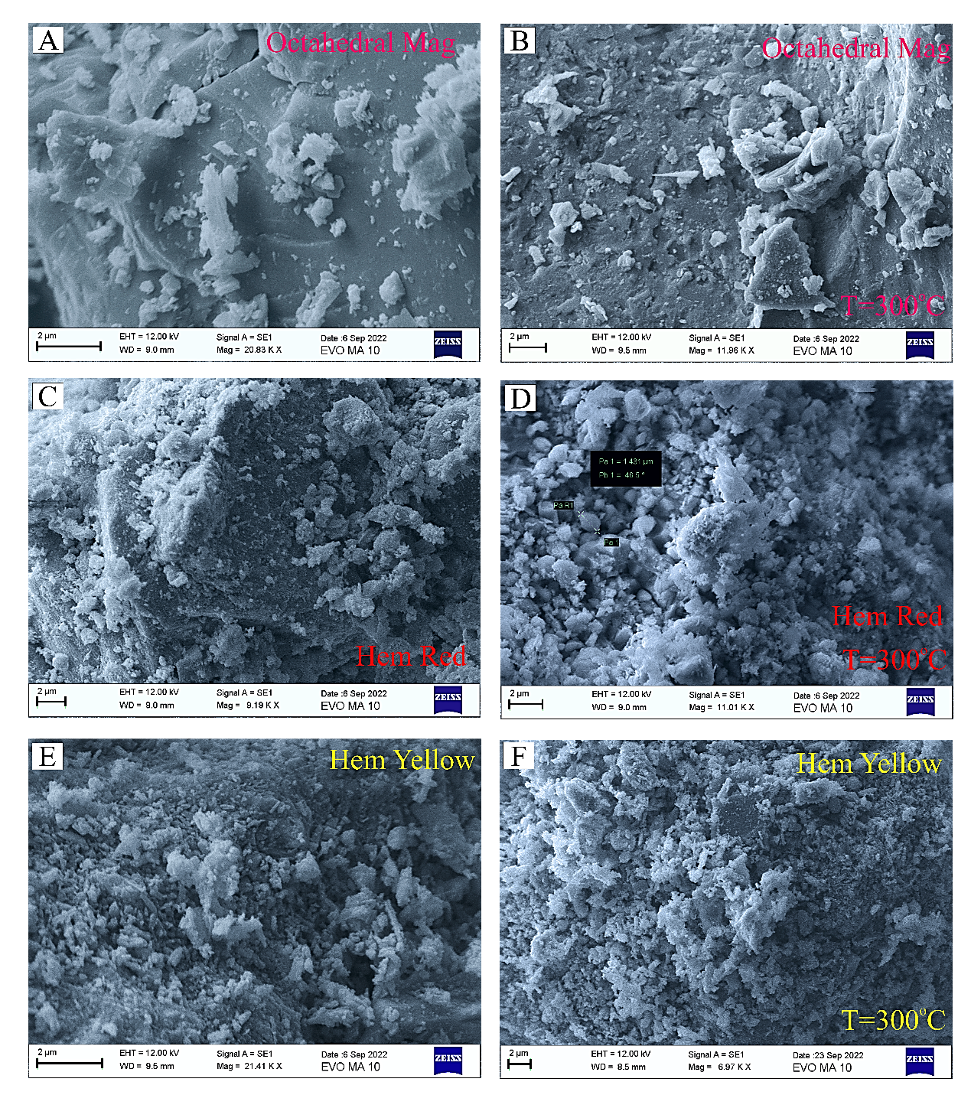

Electronic Supplementary Material Figure 8. Back-scattered electron photomicrographs of crystals of the mining wastes samples of: (a, b) Separates of octahedral magnetite; (c, d) Separates of red hematite; and (e, f) Separates of yellow hematite, before and after their calcination at T = 300ºC.

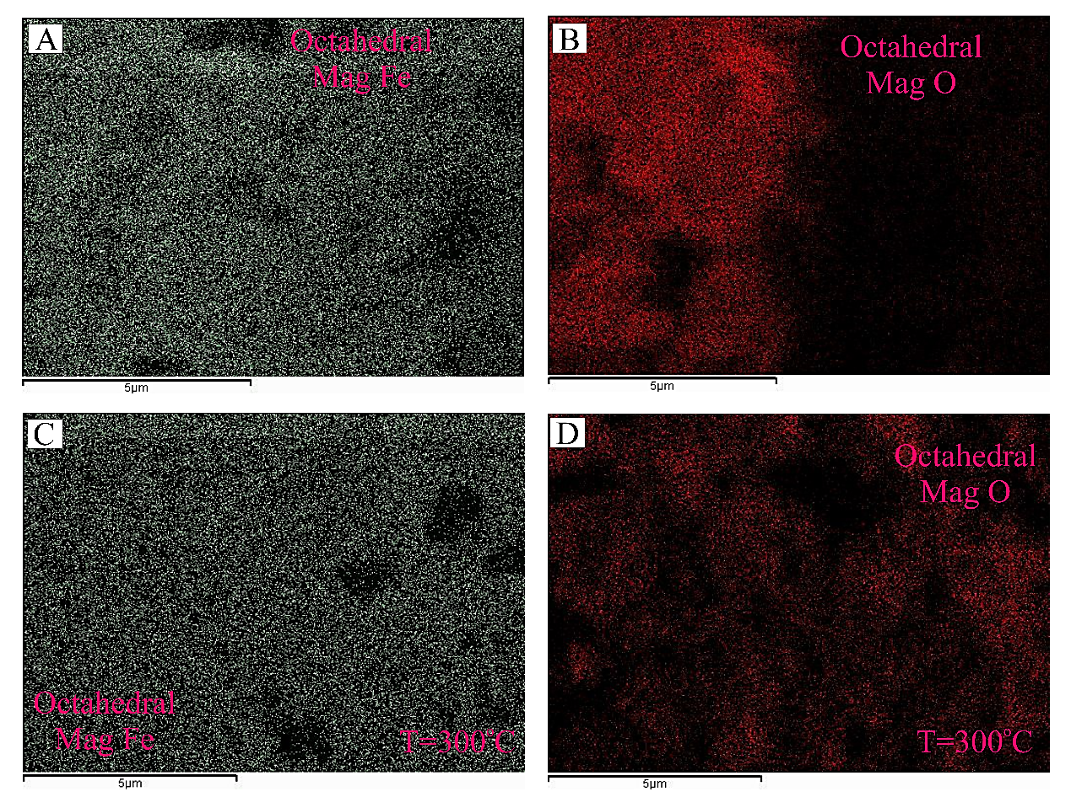(I)
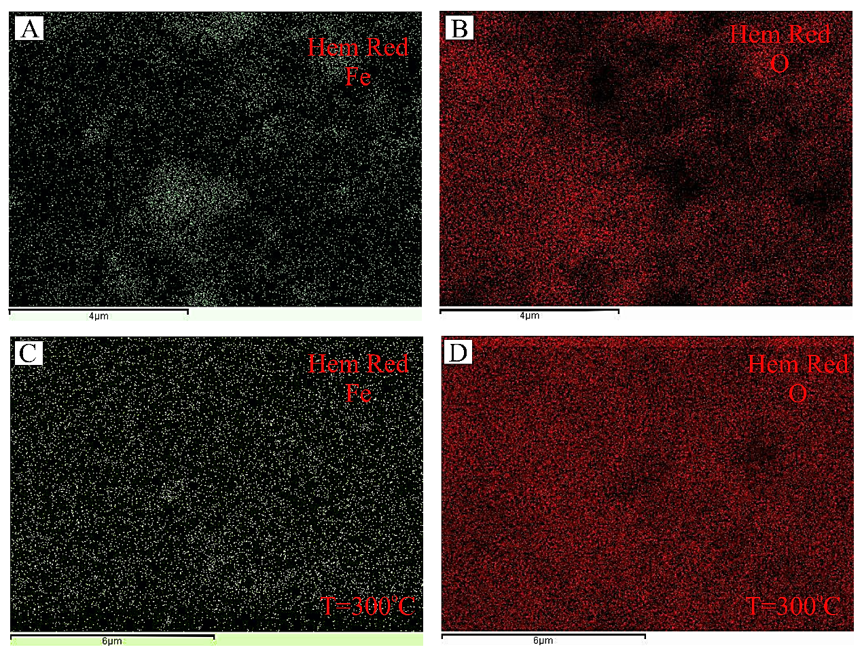
(II)

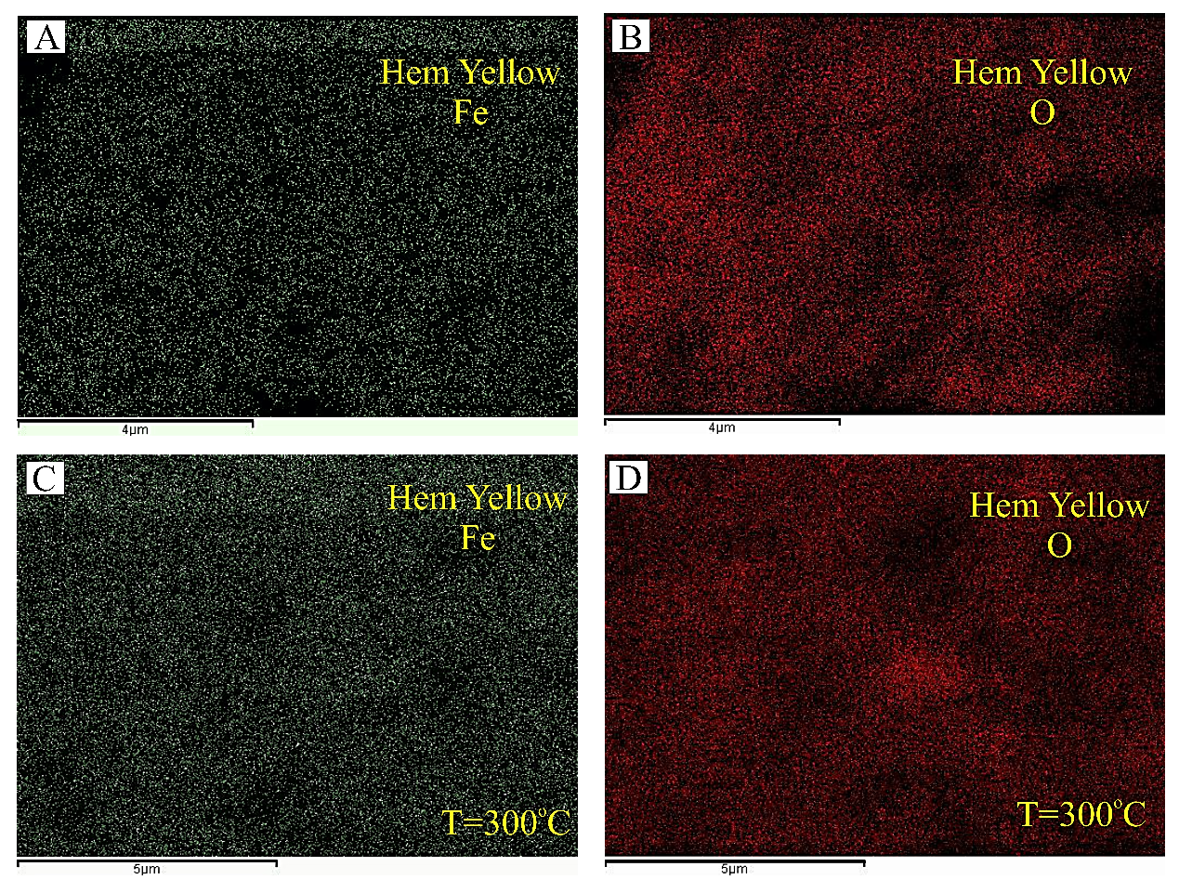
(III)

Electronic Supplementary Material Figure 9. X-Ray map of Fe (La) and O (Ka) of: I. Separates of octahedral Magnetite: (a, b) before and (c, d) after their calcination (at T = 300ºC); II. Separates of red hematite: (a, b) before and (c, d) after their calcination; and III. Separates of yellow hematite: (a, b) before and (c, d) after their calcination.

Electronic Supplementary Material Figure 10. Typical N₂ adsorption/desorption isotherm (measured at 77 K) and Barrett-Johner-Halenda (BJH) pore size distribution curves, obtained from: (a) Separates of yellow hematite; and (b, c) Separates of red hematite, used as substrates for deposition of Au nanoparticles (Au-doping).

ESM References
- Jolivet, L., & Brun, J.P. Cenozoic geodynamic evolution of the Aegean. J. Ear. Sc. (Geol. Ran.) 99, 109-138; doi.org/10.1007/s00531-008-0366-4 (2010).
- Fitros, M., Tombros, F.S., Williams-Jones, E.A., Tsikouras, B., Koutsopoulou, E., & Hatzipanagiotou, K. Physicochemical controls on bismuth mineralization: An example from Moutoulas, Serifos Island Cyclades, Greece. Am. Min. 102, 1622-1631 (2017).
- Ducoux, M., Branquet, Y. Jolivet, L., Arbaret, L., Grasemann, B., Rabillard, A., Gumiaux, C., Drufin, S. Synkinematic skarns and fluid drainage along detachments: The West Cycladic Detachment System on Serifos Island (Cyclades, Greece) and its related mineralization. Tectonophysics 695, 1–26 (2017).
- Salemink, J. Skarn and ore formation at Serifos, Greece as a consequence of granodiorite intrusion. Geol. Ultraiectina, PhD Thesis, 232 (1985).
- Stouraiti, C., Baziotis, I., Asimow, P.D., & Downes, H. Geochemistry of the Serifos calc-alkaline granodiorite pluton, Greece: Constraining the crust and mantle contributions to I-type granitoids. Int. J Ear. Sc. 107, 1657–1688 (2018).
- Marinos, G. Geology and metallogenesis of Serifos Island. Geol. Geoph. Sur. Athens 95-125, 126-127 in English (1951).
- St. Seymour, K., Zouzias, D., Tombros, S.F., & Kolaiti, E. The geochemistry of the Serifos pluton and associated iron oxide and base metal sulphide ores: Skarn or metamorphosed exhalite deposits? N. Jah. Min.-Abh. 186, 249-270 (2009).
- Moore, D.M. & Reynolds, R.C.Jr. X-Ray diffraction and the identification and analysis of clay minerals. 2nd edition, 378 (Oxford University Press, New York (1997).
- Whitney, D.L., & Evans, B.W. Abbreviations for names of rock-forming minerals. Am. Min. 95, 185-187; doi.org/10.2138/am.2010.3371 (2010).
- Warr, N. L. IMA-CNMNC approved mineral symbols. Min. Mag. 85, 291-320; https://doi.org/10.1180/mgm.2021.43 (2021).
- Lepage, L.D., ILMAT: an excel worksheet for ilmenite--magnetite geothermometry and geobarometry. Com. Geosc. 29, 673-678 (2003).
- Shebanova, N.O., & Lazor, P. Raman spectroscopic study of magnetite (FeFe2O4): a new assignment for the vibrational spectrum. J. Sol. St. Chem. 174, 424-430; doi.org/10.1016/S0022-4596(03)00294-9 (2003).
- Jain, S., Shah, J., Negi, N.S., Sharma, C., & Kotnala, R.K. Significance of interface barrier at electrode of hematite hydroelectric cell for generating eco-power by water splitting. Int. J. En. Res. 43, 4743-4755; https://doi.org/10.1002/er.4613 (2019).

