Appendices and supplementary data
figure 1as: expression of RET mRNA in insulin resistance and T2DM in Gene Atlas Database . Snapshot shows the expression of RET gene in T2DM (available at https://www.ebi.ac.uk)

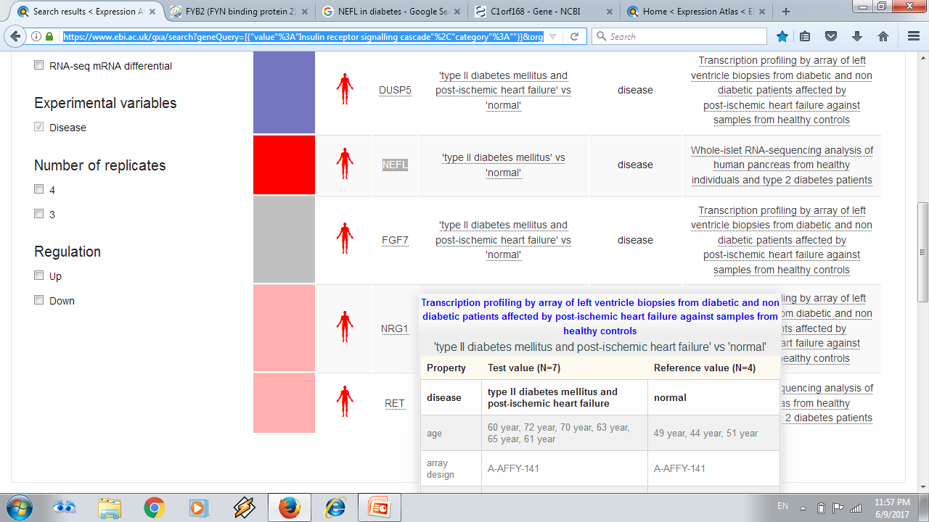

figure 1bs: differential expression of RET mRNA in normal adipose and skeletal muscle in Protein Atlas Database . Snapshot shows the expression of RET mRNA in normal skeletal muscle and adipose tissue
(available at https://www.proteinatlas.org/)
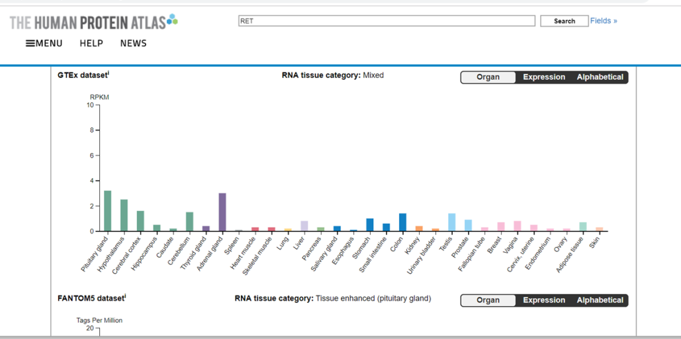
figure 1cs: verification of expression of RET mRNA in normal skeletal muscle, adipose tissue and in WBCs. Snapshot shows the verification of expression of RET mRNA in normal skeletal muscle and adipose tissue and in WBCs (available at https://www.genecards.org/)

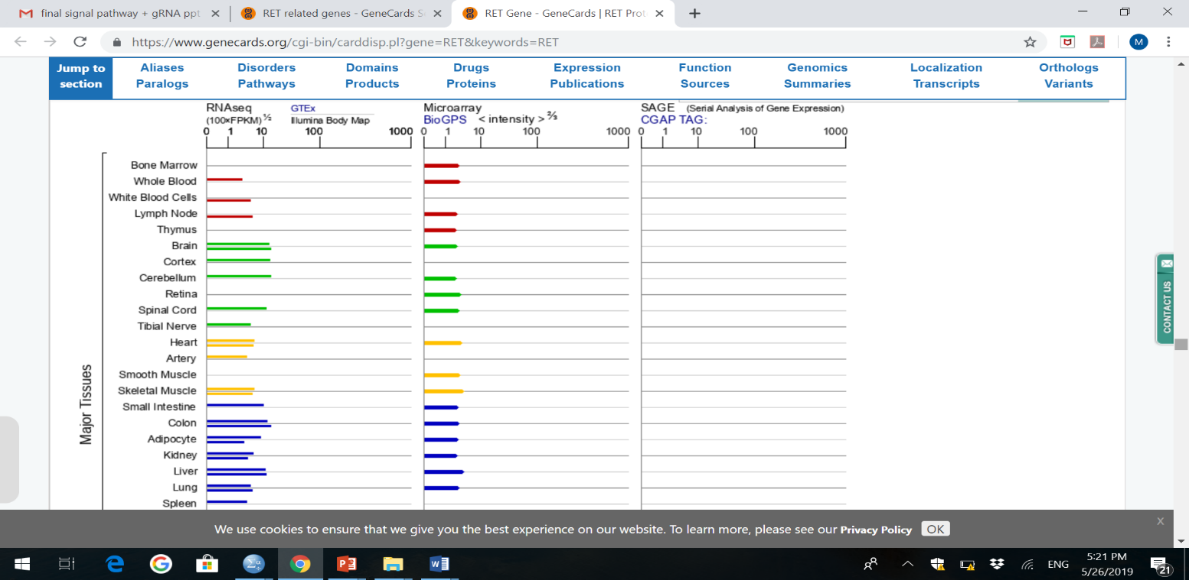

figure 1ds: expression of mTOR mRNA in insulin resistance and T2DM in Gene Atlas Database . Snapshot shows the expression of mTOR gene in IR (available at https://www.ebi.ac.uk)
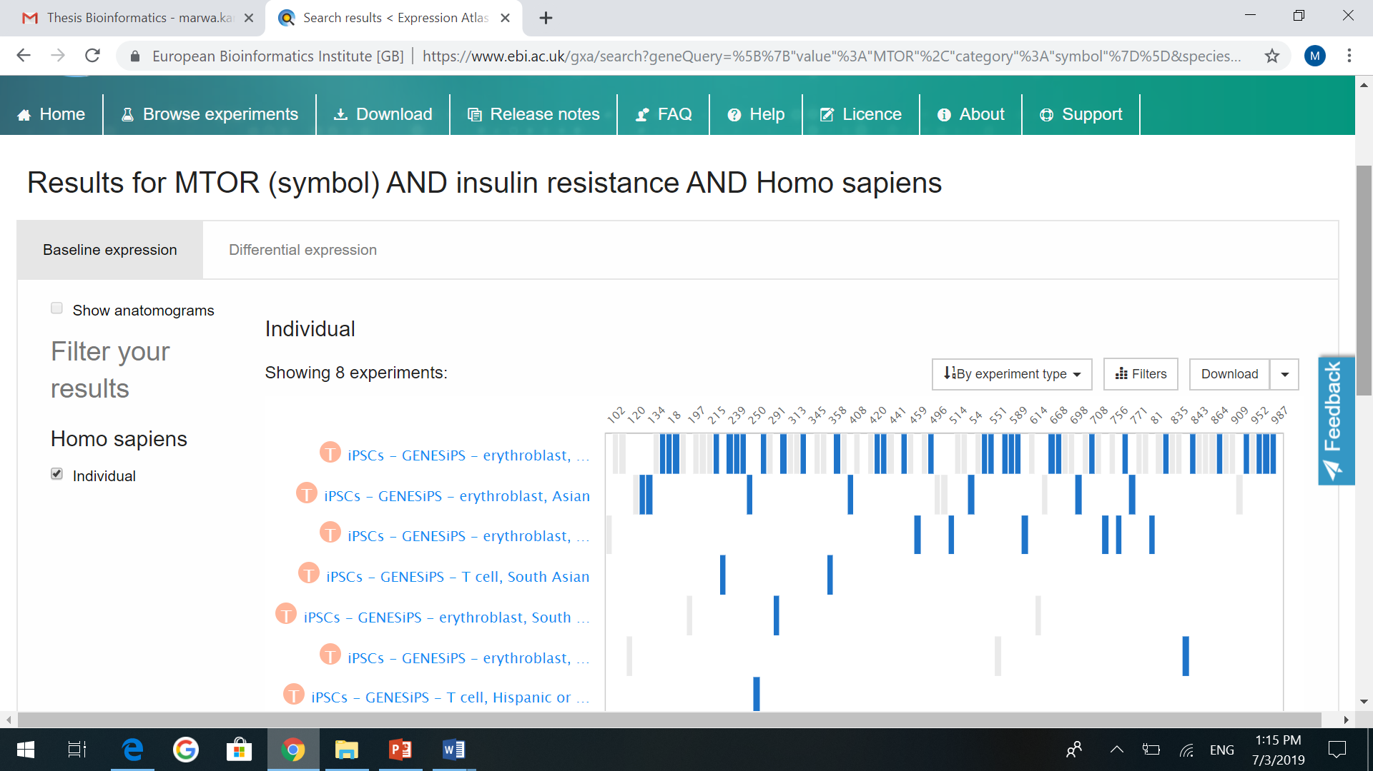
figure 1es:k map and string map show involvement of mTOR gene in insulin signaling pathway and its relation to RET gene in insulin resistance in T2DM. Snapshot verifying that the identified m-TOR gene is linked to IR in T2DM (available at http://www.kegg.jp/)

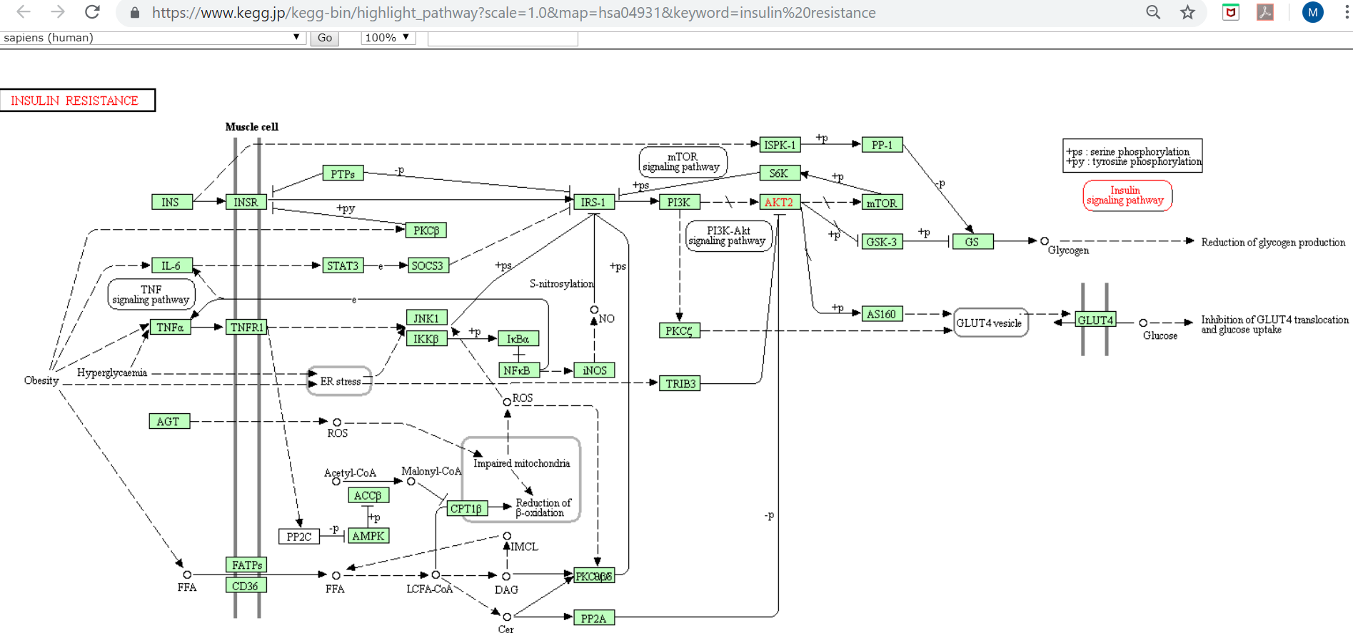

figure 1fs: snapshot shows verification of the identified candidate genes interaction in the pathogenesis of IR in T2DM (available at: http://string-db.org/

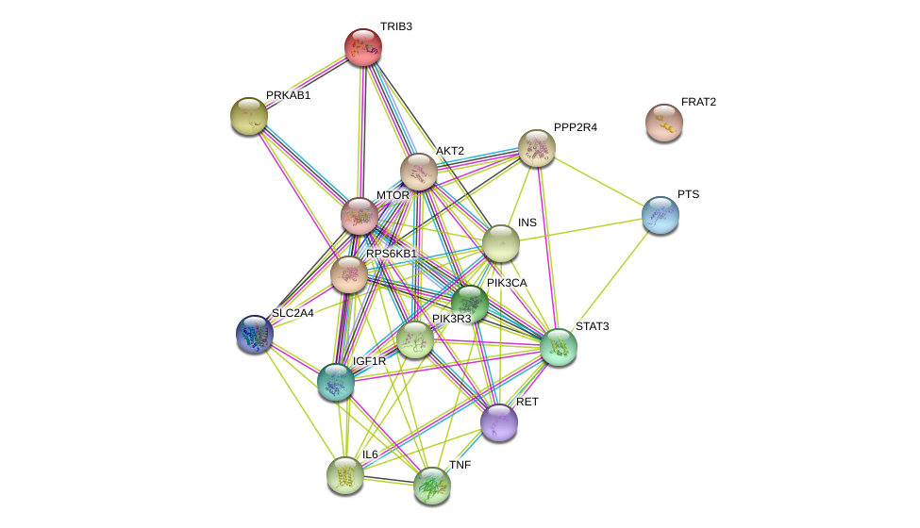

figure 1gs: retrieval of long non-coding RNA LncRNA-RP11-773H22.4 and the associated miRNAs: miR-3163 & miR-1 that acting as ceRNAs for RET mRNA through Database of LncRNA acting as competing endogenous. Snapshot shows search for LncRNA-RP11-773H22.4(ENSG00000266969) and miR-3163 miRNA
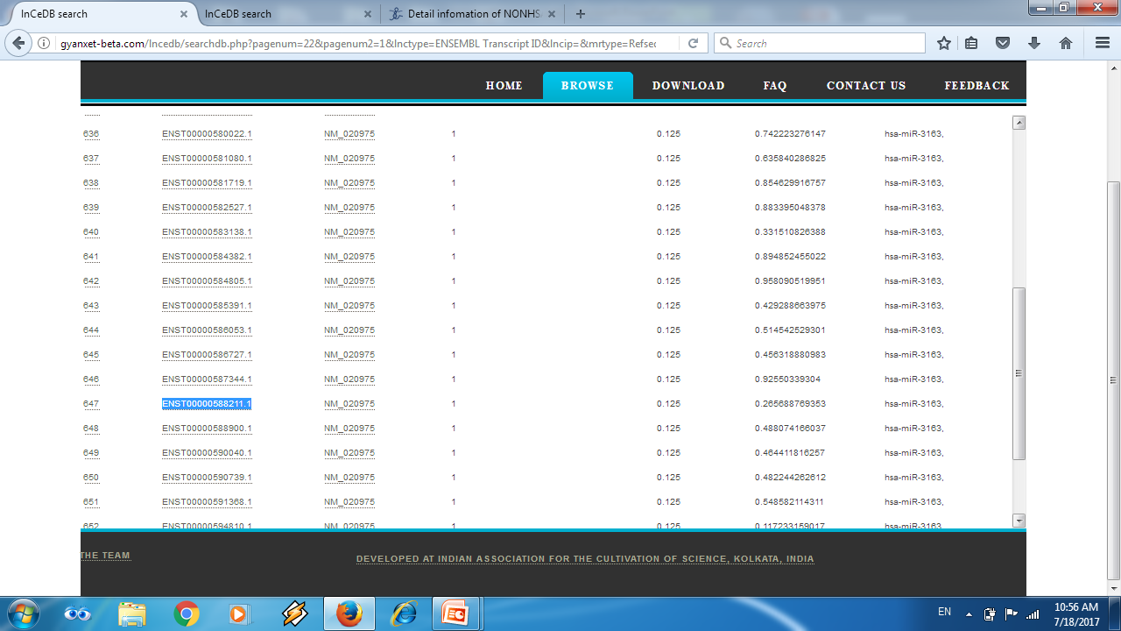
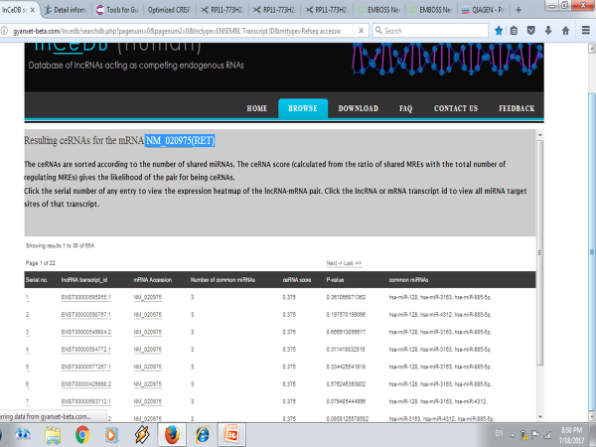
figure 1hs: snapshot shows identification of miR-1 miRNA related to LncRNA-RP11-773H22.4 in T2DM (available at http://gyanxet-beta.com/lncedb/index.php)

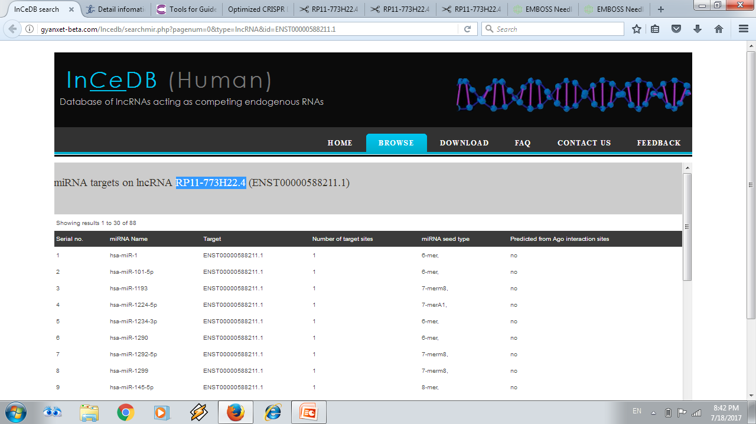

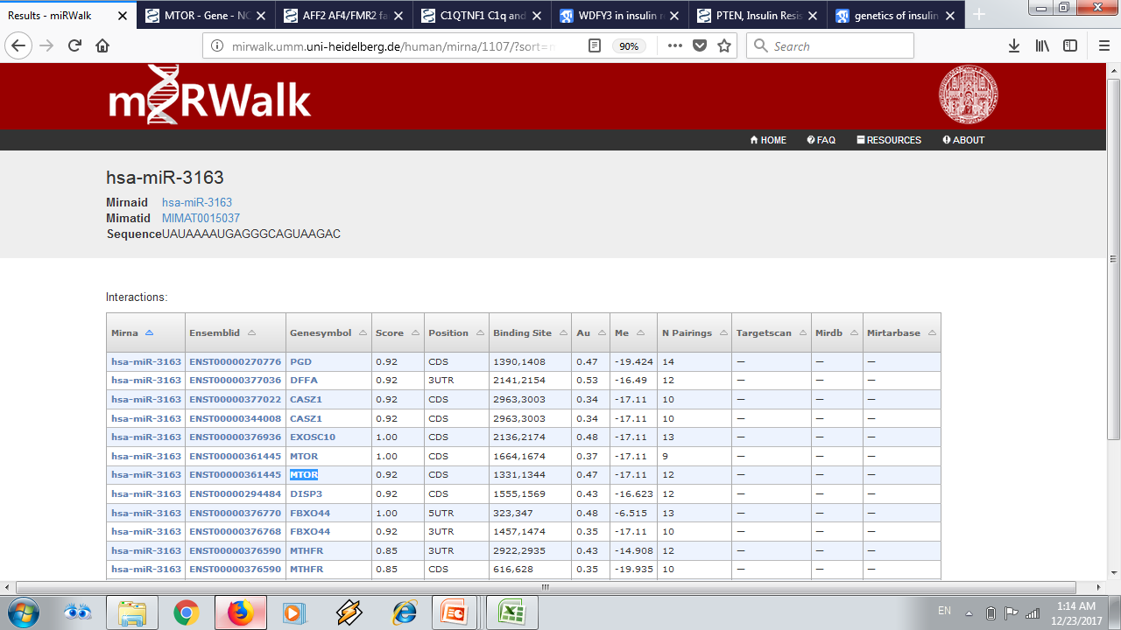
figure1is: verification of miR-3136 and miR-1 miRNAs that act as epigenetic regulators for RET and mTOR mRNAs in IR in T2DM . Snapshot shows identification of m-TOR mRNA related to miR-3163miRNA in IR and in T2DM (available at http://mirwalk.umm.uni-heidelberg.de/)

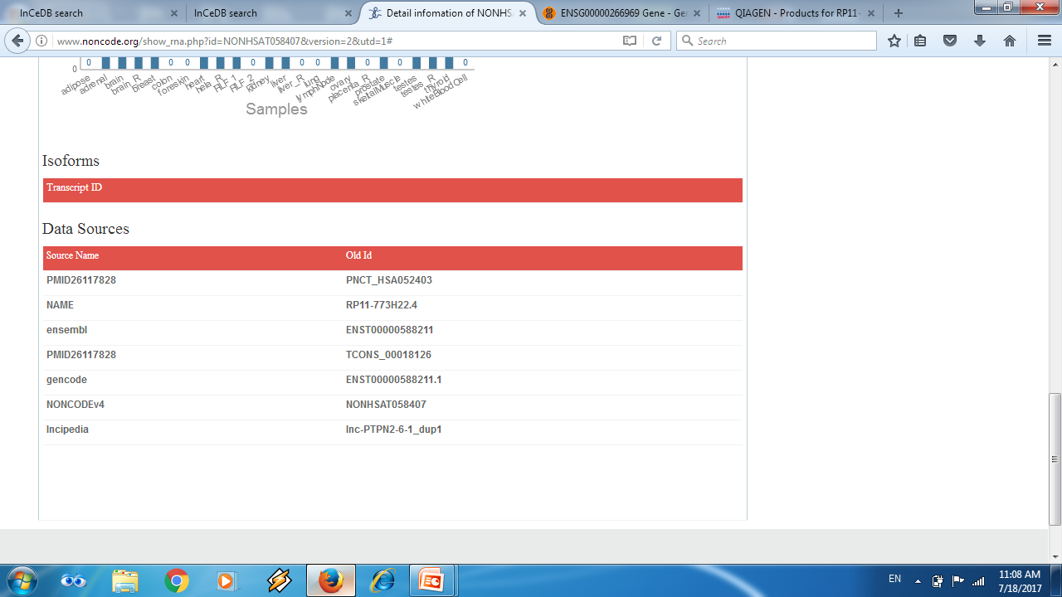
figure 1js: verification of expression of LncRNA-RP11-773H22.4 in normal skeletal muscle, adipose tissue and in WBCs .Snapshot shows the verification of expression of LncRNA-RP11-773H22.4 or ENSG00000266969 in normal skeletal muscle, adipose tissue and in WBCs (available at http://www.noncode.org/)

figure1ks: verification of expression of miR-3163 miRNA in normal skeletal muscle and adipose tissue.
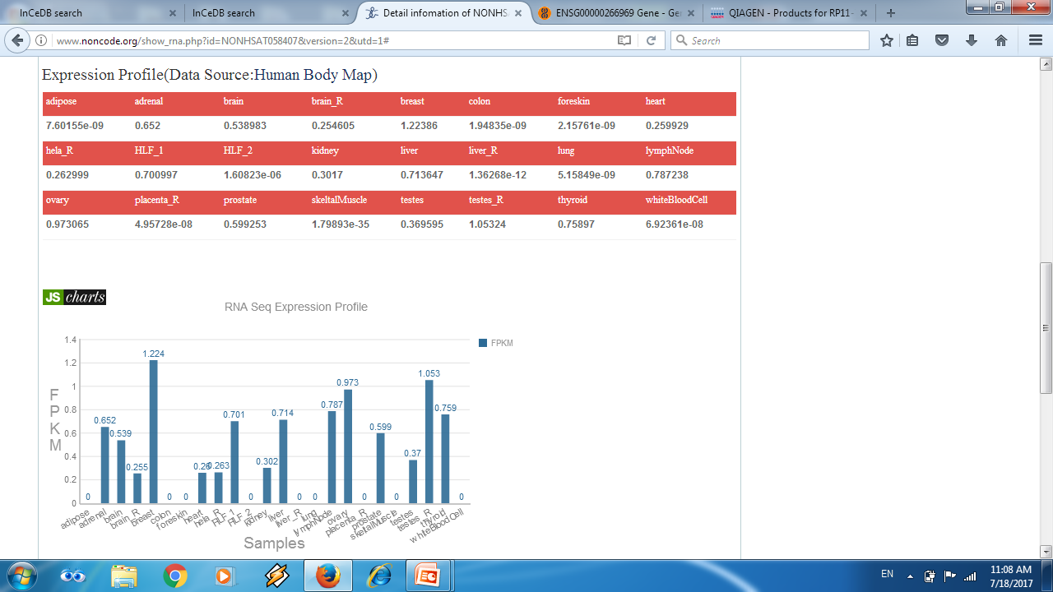
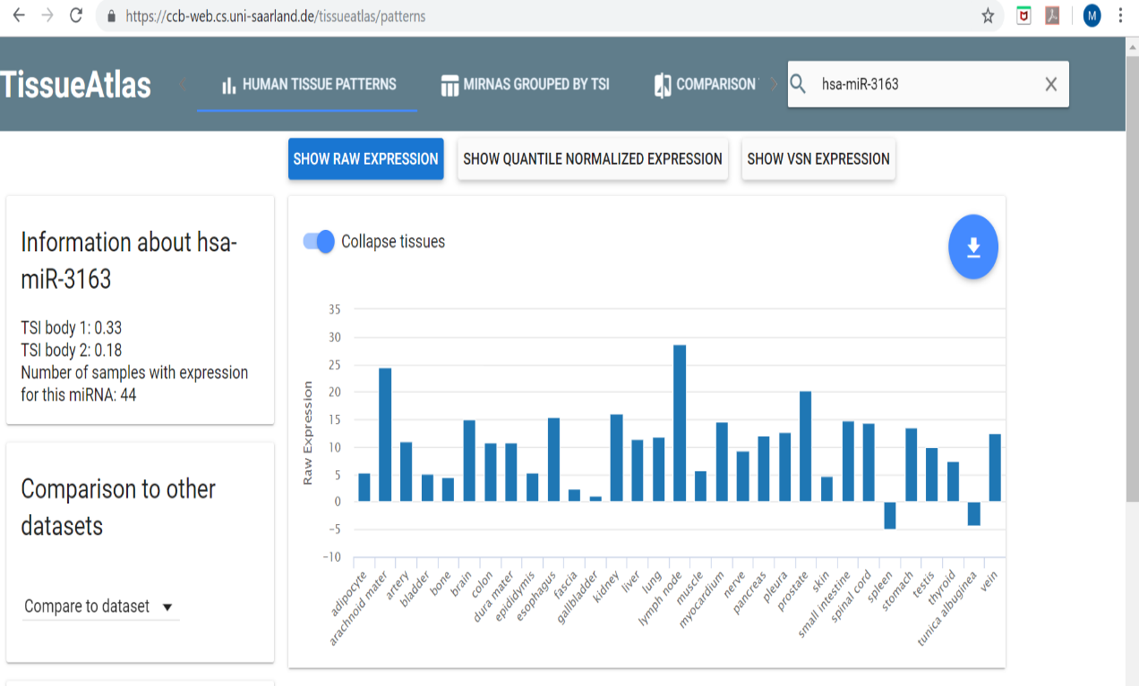

figure 1ls: alignment between LncRNA-RP11-773H22.4 and miR-3163 miRNA (available at https://www.ebi.ac.uk)

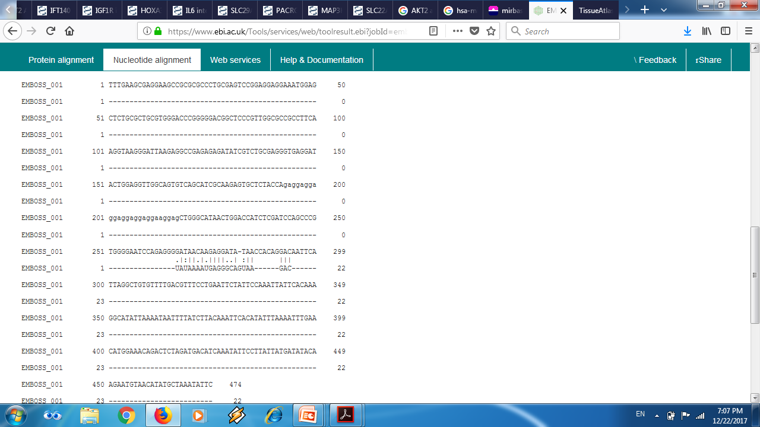

figure1ms: Snapshot shows alignment of miR-1 miRNA with LncRNA-RP11-773H22.4
(available at https://www.ebi.ac.uk)

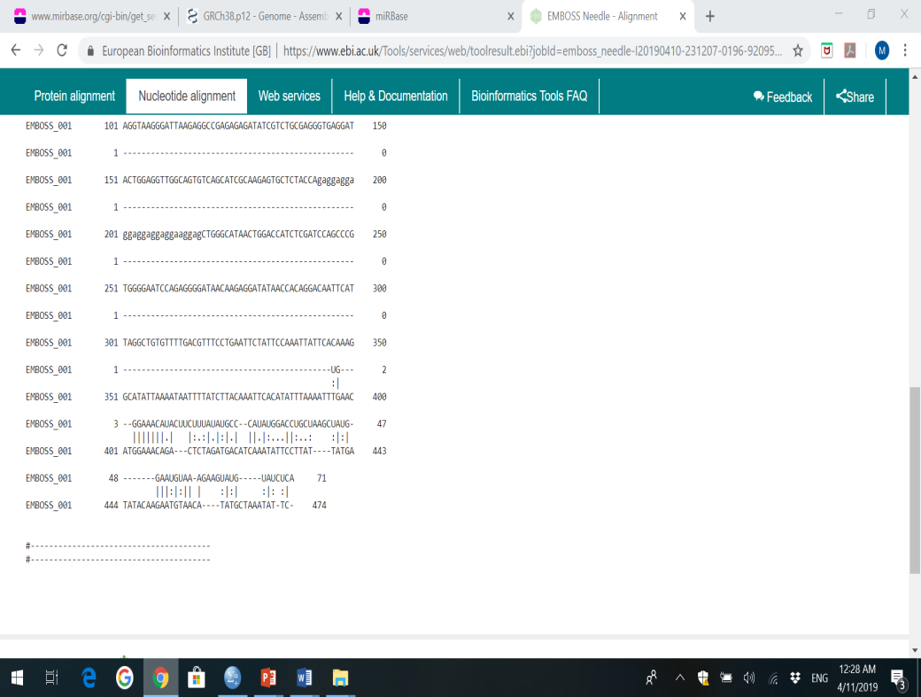
figure 1ns: alignment between mTOR mRNA miR-3163 (available at https://www.ebi.ac.uk)
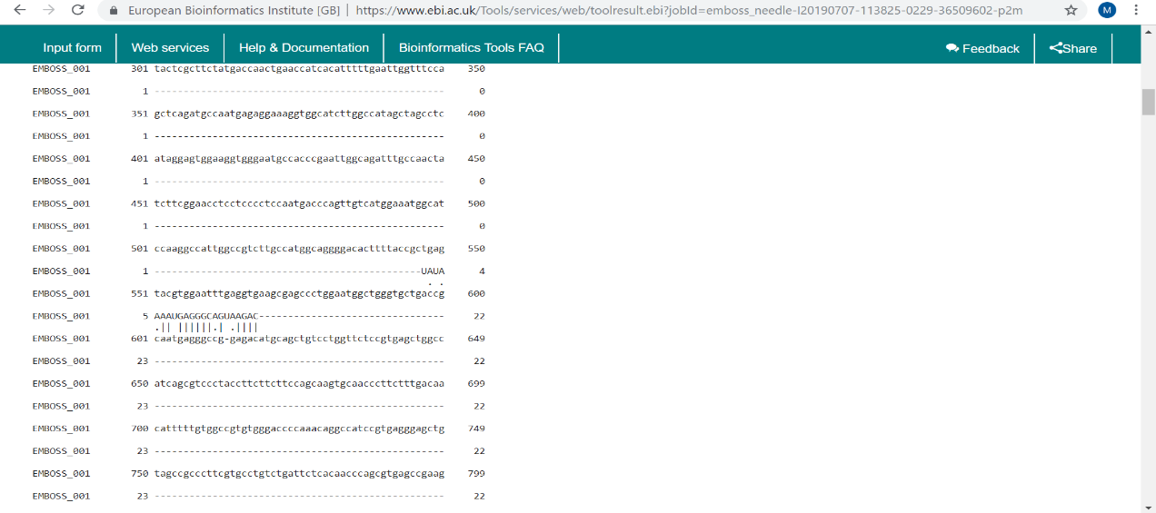

Figure 1os: snapshot shows alignment of miR-1 miRNA with mTOR mRNA (available at https://www.ebi.ac.uk)
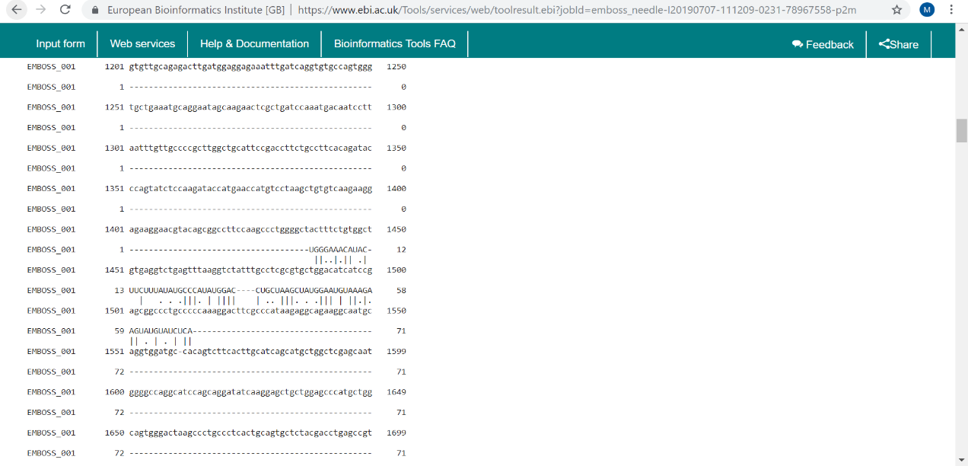

figure 2s: snapshot shows alignment between lncRNA and the 2 guides, flanking the sequence of lncRNA and miRNAs interaction (available at https://www.ebi.ac.uk).

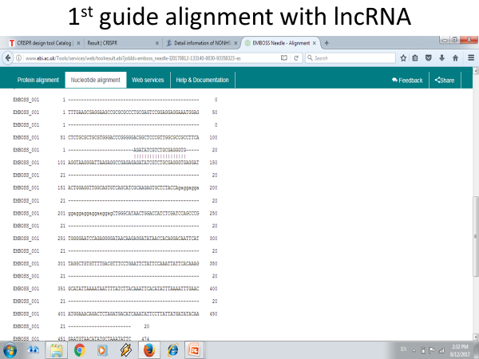

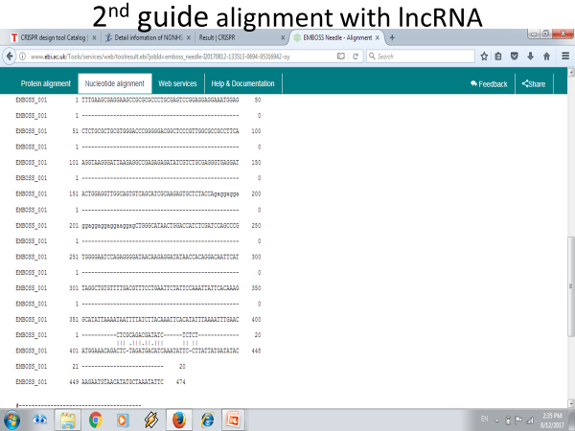

Table 1s: Sequences of the forward and reverse primers of the 2 guide RNAs:
Sequence | Primer name | GUIDE
TAATACGACTCACTATAGAGATATCGTCTG  CGAG | IVT-NONHSAT0584-gRNA-T1-fwd | 1st guide
TTCTAGCTCTAAAACCACCCTCGCAGACGA  TATC | IVT-NONHSAT0584-gRNA-T1-rev | 1st guide
TAATACGACTCACTATAGCTCGCAGACGAT  ATCT | IVT-NONHSAT0584-gRNA-T5-fwd | 2nd guide
TTCTAGCTCTAAAACAGAGAGATATCGTCT  GCGA | IVT-NONHSAT0584-gRNA-T5-rev | 2nd guide

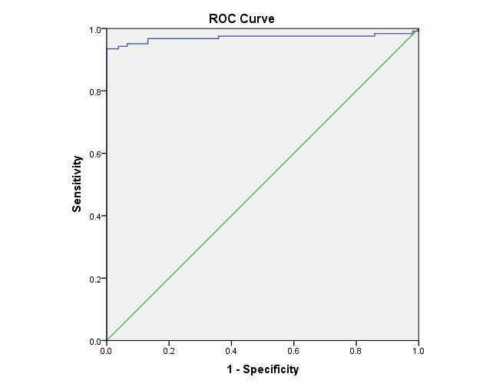
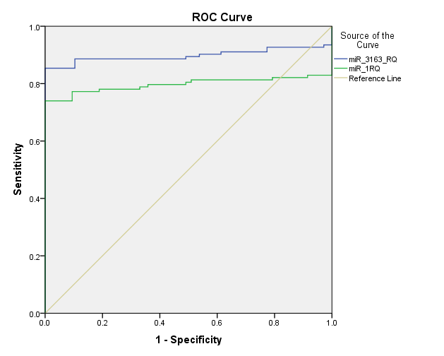
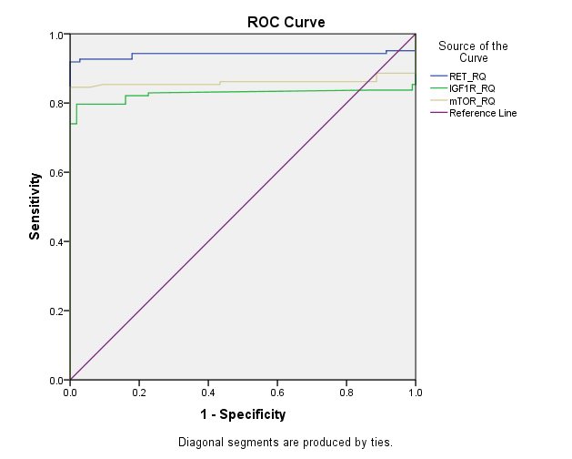
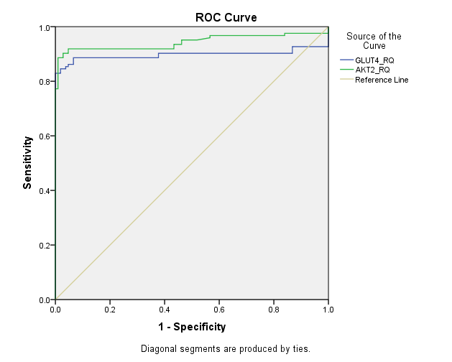
figure 2s: ROC curve analysis for differential expression of investigated network panel between T2DM and control
ROC curve of RP11-773H22.4 lncRNA AUC: 0.971,95% CI: 0.944-0.998, P<0.01).
ROC curve of miR-3163 miRNA(AUC: 0.898, 95% CI: 0.848-0.948, P<0.01). and mir-1 (AUC: 0.797, 95% CI: 0.729-0.865, P<0.01)
ROC curve for RET mRNA (AUC:0.941, 95% CI: 0.900-0.981, P<0.01), IGF1-R (AUC: 0.826,95% CI: 0.761-0.892, P<0.01) and m-TOR ( AUC : 0.860, 95% CI: 0.800-0.920, P<0.01).

ROC curve for GLUT4 mRNA (AUC: 0.897, (95% CI: 0.846-0.948, P<0.01), AKT-2 (AUC: 0.943, 95% CI: 0.908-0.978, P<0.01).

Table 2s: Comparison between lymphocytes count and viability among the 3 investigated cell lines:

Dependent Variable | (I) Cell Lines | (J) Cell Lines | Mean Difference (I-J) | Std. Error | Sig. | 95% Confidence Interval
 |  |  |  |  |  | Lower Bound | Upper Bound
Lymphocytes Count (x10*4) | T2DM lymphocytes without Cas9 editing | T2DM lymphocytes with Cas9 editing | 5.000 | 2.735 | NS  .117 | -1.69 | 11.69
Lymphocytes Count (x10*4) | T2DM lymphocytes without Cas9 editing | Healthy Control lymphocytes | -6.667 | 2.735 | .051 | -13.36 | .03
Lymphocytes Count (x10*4) | T2DM lymphocytes with Cas9 editing | T2DM lymphocytes without Cas9editing | -5.000 | 2.735 | NS  .117 | -11.69 | 1.69
Lymphocytes Count (x10*4) | T2DM lymphocytes with Cas9 editing | Healthy Control lymphocytes | -11.667* | 2.735 | .005** | -18.36 | -4.97
Lymphocytes Count (x10*4) | Healthy Control lymphocytes | T2DM lymphocytes without Cas9 editing | 6.667 | 2.735 | .051 | -.03 | 13.36
Lymphocytes Count (x10*4) | Healthy Control lymphocytes | T2DM lymphocytes with Cas9 editing | 11.667* | 2.735 | .005** | 4.97 | 18.36
Lymphocytes Viability (%) | T2DM lymphocytes without Cas9 editing | T2DM lymphocytes with Cas9 editing | 1.5000 | .6242 | .053 | -.027 | 3.027
Lymphocytes Viability (%) | T2DM lymphocytes without Cas9 editing | Healthy Control lymphocytes | -1.6333* | .6242 | .040* | -3.161 | -.106
Lymphocytes Viability (%) | T2DM lymphocytes with Cas9 editing | T2DM lymphocytes without Cas9 editing | -1.5000 | .6242 | .053 | -3.027 | .027
Lymphocytes Viability (%) | T2DM lymphocytes with Cas9 editing | Healthy Control lymphocytes | -3.1333* | .6242 | .002** | -4.661 | -1.606
Lymphocytes Viability (%) | Healthy Control lymphocytes | T2DM lymphocytes without Cas9 editing | 1.6333* | .6242 | .040* | .106 | 3.161
Lymphocytes Viability (%) | Healthy Control lymphocytes | T2DM lymphocytes with Cas9 editing | 3.1333* | .6242 | .002** | 1.606 | 4.661
One-way ANOVA, Post Hoc test, p: NS, not significant (>0.05), **p < 0.01: is highly significant, *p<0.05: is significant.

