Supplementary information
Bone Disease Imaging through the Near-Infrared-II Window
Chao Mi^{1,#,}*, Xun Zhang^{1,#}, Chengyu Yang², Jianqun Wu⁵, Xinxin Chen³, Chenguang Ma¹, Sitong Wu^{1,4}, Zhichao Yang^{1,4}, Pengzhen Qiao¹, Yang Liu², Weijie Wu¹, Zhiyong Guo^{1,5}, Jiayan Liao⁴, Jiajia Zhou⁴, Ming Guan¹, Chao Liang^{3,}*, Chao Liu^{2,5,}*, and Dayong Jin^{1,4,}*
- UTS-SUSTech Joint Research Centre for Biomedical Materials and Devices, Department of Biomedical Engineering, Southern University of Science and Technology, Shenzhen, China
- Department of Biomedical Engineering, Southern University of Science and Technology, Shenzhen, China
- Department of Biology, School of Life Sciences, Southern University of Science and Technology, Shenzhen, China
- Institute for Biomedical Materials and Devices (IBMD), Faculty of Science, University of Technology Sydney, Australia
- Guangdong Provincial Key Laboratory of Advanced Biomaterials, Southern University of Science and Technology, Shenzhen, China
*Corresponding author (email to: jindy@sustech.edu.cn (D. Jin); liuc33@sustech.edu.cn (C. Liu); liangc@sustech.edu.cn (C. Liang); mic@sustech.edu.cn (C. Mi))
#These authors contributed equally to this work.

(This file includes the methods, Figure S1-S17 and figure legends, and the legends of Video 1 and 2.)

Materials synthesis and characterization
- Materials
YCl₃·6H₂O (99.99%), YbCl₃·6H₂O (99.99%), ErCl₃·6H₂O (99.99%), CeCl₃·6H₂O (99.99%), NdCl₃·6H₂O (99.99%), HoCl₃·6H₂O (99.99%), PrCl₃·6H₂O (99.99%), TmCl₃·6H₂O (99.99%), NH₄F (99.99%), NaOH (99.9%), oleic acid (OA, 90%), 1-octadecene (ODE, 90%), poly(maleic anhydride-alt-1-octadecene) (PMH; 3000-5000 m. W.), 4-(dimethylamino)pyridine (DMAP), 4-morpholineethanesulfonic acid (MES), tris hydrochloride (Tris-HCl), 1-(3-dimethylaminopropyl)-3-ethylcarbodiimide hydrochloride (EDC) were purchased from Sigma-Aldrich. Cyclohexane, chloroform, ICG were bought from Aladdin Co. Ethanol (99.7%) and methanol (99.7%) were purchased from Shenzhen hs-science Co. Methoxy polyethylene glycol amine (mPEG-NH₂; 5000 m.W.) was purchased from Laysan-Bio and Cy3-mPEG-NH₂ (2000 m.W.) was purchased from Xi'an ruixibio Co. All reagents were used as received without further purification.
2. Synthesis of lanthanide doped nanocrystals (LnNCs)
LnNCs (Ln=Er, Nd) were synthesized by the coprecipitation method¹. Taking NaYbF₄: 4% Er³⁺, 4% Ce³⁺ as an example, 1 mmol RECl₃·6H₂O (RE = Yb, Er, Ce) with the molar ratio of 92:4:4 was added to a 50 mL flask containing 6 mL OA and 15 mL ODE. The mixture was heated to 160 °C under argon for 30 minutes (min) to obtain a clear solution and then cooled down to room temperature. Then 8 mL methanol solution of 6 mmol NaOH was added to the mixture followed by 15 min stirring. By heating the solution to 100 °C for 15 min, the methanol was removed under argon. Again, the mixture was cooled down to room temperature. After that 8 mL methanol solution of 4 mmol NH₄F was added to the mixture followed by 30 min stirring. Then the temperature was set at 100 °C and the solution was heated for 30 min to remove methanol, next the solution was further heated to 300 °C for 40 min. Finally, the reaction solution was cooled down to room temperature, and NaYbF₄: 4% Er³⁺, 4% Ce³⁺ nanocrystals were precipitated by ethanol and washed with cyclohexane, ethanol and methanol for 3 times. NaYF₄: 3% Nd³⁺ nanocrystals were prepared by the similar method.
3. Epitaxial-growth to form NaYF₄ coated core-shell structure LnNCs
NaYF₄ shell precursors were prepared firstly. Firstly 1 mmol YCl₃·6H₂O were added to a 50 mL flask containing 6 mL OA and 15 ml ODE. The mixture was heated to 160 °C under argon for 30 min to obtain a clear solution and then cooled down to room temperature, followed by the addition of 8 mL methanol solution of NH₄F (4 mmol) and 5 mL methanol solution of NaOH (2.5 mmol). Then after stirring for 30 min, the temperature was set at 100 °C and the solution was heated under argon for 30 min to remove methanol, and the solution was further heated to 150 °C for another 30 min. Finally, the reaction solution was cooled down to room temperature as NaYF₄ shell precursors.
The epitaxial-growth of LnNCs (Ln=Er, Nd) to form core-shell structure was realized by a hot-injection method. Taking NaYbF₄: 4% Er³⁺, 4% Ce³⁺@NaYF₄ for example, 0.2 mmol NaYbF₄: 4% Er³⁺, 4% Ce³⁺ core samples in cyclohexane were added to a 50 mL flask containing 4.5 mL OA, 11.5 mL ODE. The mixture was heated to 150 °C under argon for 20 min, and then the solution was further heated to 300 °C. After that, 5 mL of NaYF₄ shell precursors in total were injected into the reaction mixture step by step with an injection rate of 0.2 mL every 2 min. After the injection of 5 ml NaYF₄ shell precursors, the reaction solution was ripened at 300 °C for 5 min. Finally, the reaction solution was cooled down to room temperature and NaYbF₄: 4% Er³⁺, 4% Ce³⁺@NaYF₄ nanocrystals were precipitated by ethanol and washed with cyclohexane, ethanol and methanol. NdNCs were prepared in same method by using NaYF₄: 3% Nd³⁺ nanocrystals as the core samples.
4. Preparation of PEG coated LnNCs
The surface modification to form PEG coated LnNCs (Ln=Er, Nd) is according to a literature method². The OA-capped LnNCs (30 mg) in 1 mL cyclohexane was added with 3 mL chloroform. Then 80 mg PMH was added to the mixture under ultrasonic condition and kept stirring for 10 hours (h). After that the solution was evaporated by rotary evaporation for 15 min and transparent precipitation appeared at bottom. Next, 40 mg DMAP dissolved in 4 mL water was added to dissolve the residue again under ultrasonic condition for 30 min. Then the solution containing PMH coated LnNCs was centrifuged at 15000 rpm for 30 min and the sediment was washed 2 times by MES solution (10 mM; pH 8.5) to remove excess DMAP and PMH.
After that, 2 mg EDC dissolved in 200 μL water was then added to the 4 mL MES sample solution and sonicated for 15 min. 4 mg mPEG-NH₂ dissolved in 2 mL MES solution (10 mM; pH = 8.5) was added into above solution and shaken for 3 h. 3 mg Tris-HCl dissolved in water was added, then the solution was shaken for another 1 h. Finally, the solution was centrifuged at 4400 rpm for 5 min and the supernate containing PMH-PEG coated LnNCs was washed with centrifugal filter (100 K) for 2 times by saline.
5. Preparation of Cy3 coated ErNCs
The Cy3 coated ErNCs were prepared by a similar process, instead of that the 4 mg mPEG-NH₂ was replaced by 4 mg Cy3-mPEG-NH₂.
6. Characterization techniques
The morphology of the formed nanocrystals was characterized by transmission electron microscopy (TEM) imaging (Hitachi HT7700) with an operating voltage of 100 kV. The samples were prepared by placing a drop of a dilute suspension of nanocrystals onto copper grids.
The NIR-II luminescence spectra for all samples were obtained by using a spectrometer (OmniFluo990-MLNIR02, Beijing Zolix) equipped with a NIR-II PMT (H10330C-75-C4, HAMAMATS). A 980 nm CW diode laser (Changchun New Industries Optoelectronics Technology) was used for LnNCs (Ln=Er, Ho, Pr, Tm) measurements, and an 808 nm laser was used for NdNCs and ICG spectra measurements. The OA-capped core and core-shell ErNCs in cyclohexane, and PEG-capped core-shell ErNCs in water were prepared to a concentration of 5 mg/mL for spectra intensity comparison under a 20 mWcm⁻² excitation density.
7. Cytotoxicity assay
The viability of 4T1 cells were evaluated by a standard CCK-8 assay. The cell proliferation and cytotoxicity assay kit CCK-8 was obtained from Beijing Solarbio Science & Technology Co., Ltd. The cells were seeded into 96-well plates at a density of 2×10³ cells/well. After incubation overnight, the cells were further incubated in fresh culture medium containing different concentrations of PEG-ErNCs (0, 0.25, 2.5, 25, 100, 250, 500 and 1,000 μg/mL) for another 18 h. Then, 10 μL of CCK-8 solution was added into each well. After incubated for another 1.5 h, the absorbance at 450 nm was measured using a spectrophotometer (Varioskan LUX, Thermo Fisher Scientific, USA). The cell viability was calculated from the ratio of the absorbance value of PEG-ErNCs treatment group to that of untreated group.

Animal handling and bone disease mouse model preparation
- Animal
All mice were purchased from Guangdong Medical Laboratory Animal Center (Guangdong, China), including 6-week-old male DBA/1 mice for collagen-induced arthritis (CIA) preparation and 6-week-old male BALB/c mice for other experiments. The mice were grown in an animal facility under filtered air conditions (21-22°C) in plastic cages with sterilized wood shavings for bedding and provided pure water. The mice were raised in a specific pathogen-free (SPF) environment. Before NIR-II mouse imaging, the mouse hair was removed carefully by depilatory creams under anesthetization. All animal experiments were strictly performed under the guidelines of the Chinese Council for Animal Care, approved by the Animal Care Committee of the Laboratory Animals in Southern University of Science and Technology.
- Bone defect surgery
Under isoflurane anesthesia, a small skin incision was made over the midline of the anteromedial aspect of the tibia to build bone defect. A 1.0 mm circular defect centered between the tibiofibular junction and the tibial tubercule was made using a precision surgical drill. The defect center was located 4.3 mm below the proximal articulating surface of the proximal tibia. After saline irrigation, the incision was closed with 7-0 nylon sutures, and mice were transferred into a clean cage positioned on a 37 °C heating pad.
- Collagen-induced arthritis (CIA) model preparation
CIA is the gold standard animal model for rheumatoid arthritis (RA). In our experiments, CIA was induced by immunization with bovine type II collagen (2 mg/mL, Chondrex Inc.) emulsified in Complete Freund’s adjuvant (CFA, 4 mg/mL, Chondrex Inc.). A homogenizer with a small blade was used to emulsify the CFA with the collagen solution. Firstly, seal the tip of the syringe with a 3-way stopcock. Next, place the syringe in the ice bath to keep the emulsion cool during mixing. Add the same volume of CFA and collagen to the end of the syringe sealed with the 3-way stopcock. Then continue mixing the emulsion at maximum speed of the homogenizer for 2 minutes. After that, cool down the emulsion in the ice bath for 5 minutes. Repeat the mixing and cooling for other 3 times until obtain stable emulsion, which will not diffuse in water. Finally, 6-week-old male DBA/1 mouse was immunized with 100 uL of the prepared emulsion by tail vein injection and CIA usually develops between 21-28 days after injection.
- Anterior cruciate ligament transection (ACLT) surgery
For ACLT surgery, the mice were anesthetized firstly and a small skin incision was made over the side of the knee joint to allow to find the anterior cruciate ligament. The anterior cruciate ligaments were transected surgically to induce mechanical instability-associated osteoarthritis (OA) in 8 weeks. Then the incision was closed with 7-0 nylon sutures, and mice were transferred into a clean cage positioned on a 37 °C heating pad.
For sham surgery as control, only the small skin incision was made and then closed with 7-0 nylon sutures same with the ACLT surgery, with no surgery to the anterior cruciate ligament.

NIR-II, X-ray and μCT bone imaging
- NIR-II planar and 3D optical bone imaging
The mice were firstly anaesthetized and then injected with the NIR-II contrast agent. An NIR-II animal imaging system (NIROPTICS ltd., China) equipped with an InGaAs camera (Photonic Science, UK) and laser source was used for the NIR-II fluorescent Imaging. Emission from ErNCs under 980 nm laser excitation was typically collected with a 1319 nm long-pass filter, and emission from NdNCs under 808 nm laser excitation was collected with a 900 nm long-pass filter.
The 3D images were taken by using a home-made NIR-II whole-animal light sheet imaging system with a NIR-II camera (C-RED2, First Light Advanced Imagery). The excitation source is a 980 nm laser with tunable power up to 5 W. The emission signals from the animal were filtered through a 1319 nm long-pass filter (Chroma Technology Corporation). For in vivo imaging, the anesthetized mice were placed on a rotating platform, and for ex vivo the soft tissue on tibia was removed. During the measurement, the tibias of the mice were fixed and well coincident with the axis of rotation. The horizontal position was set as 0° and perpendicular to the camera, then the automatic stage was rotated to both sides for 30° respectively with the step of 1°, the three-dimensional stack of 61 NIR-II images were taken at all angles. Finally, the 3D images are obtained by spatial rotation transformation and interpolation algorithm and displayed by Imaris software.
- In vivo and ex vivo X-ray and μCT bone imaging
For in vivo X-ray and μCT imaging, the mice were anesthetized and fixed in the chamber and a small animal μCT (SkyScan 1276, Bruker) was used for test. For ex vivo test, the bone was dissected and the soft tissue on the bone was removed. The metaphyseal areas of the tibia and femur were scanned by a μCT scanner (Skyscan 1172, Bruker). The 3D reconstructions of the knee joint were performed by Mimics 17 (Materialise, USA).

Immunofluorescence bone-tissue-slice imaging and histological analysis
- Bone immunofluorescence staining for nanoparticles localization and inflammation test
Fresh tibias and hind paws were fixed in 4% paraformaldehyde at 4ºC for 4 hours and decalcified in 0.5 M EDTA at 4ºC for 24 hours. The tibias were cryo-protected in 20% sucrose solution at 4ºC for 24 hours, then embedded in a gelatin-based medium and stored at -80ºC. Samples were cryosectioned into 80 μm thick tissue slices along the coronal plane using a cryostat (Leica CM1950, Weztlar, Germany). Tibia sections were stained with endomucin (EMCN, 1:200, sc-65495, SantaCruzBiotechnology, USA), anti-F4/80 antibody (1:200; sc-65495, Santa Cruz Biotechnology, USA) followed by Alexa Fluor secondary antibodies from donkey (1:400; Thermo Fisher Scientific, Waltham, MA, USA). Toe joint sections were stained with a rabbit anti-IL-1β (ab283818, Abcam, UK), and Alexa Flour 594 labeled goat anti-rabbit IgG (ab150080, Abcam, UK) was used as the secondary antibody. The slices were mounted with DAPI Fluoromout-G (0100-20, SouthernBiotech, Birmingham, USA) and coverslipped.
- Confocal imaging on immunofluorescence-stained bone tissue slices
Three-dimensional fluorescent images were acquired with a 20× objective lens of Nikon A1R confocal microscope (Tokyo, Japan). Z-stacks of 100 μm in thickness were taken at a size of 1024×1024 pixels, x-y resolution of 0.624 mm with z-step of 2 μm. The confocal microscope was used to image EMCN and F4/80 (500 to 530 nm filter) with 488 excitation, Cy3 (570 to 617 nm filter) with 561 nm excitation, and DAPI (425 to 475 nm filter) with 405 nm excitation provided by a Nikon laser.
- Histological analysis
Mouse knee joints were fixed in 4% paraformaldehyde for 24 h, and decalcified in 10% ethylenediaminetetraacetic acid (EDTA) for 3 weeks, dehydrated in graded ethanol, then embedded in paraffin for histological analyses.
Sagittal sections were obtained at a 6 μm thickness using a rotary microtome (Leica RM2255; Leica, Wetzlar, Germany). The paraffin sections of the organs were stained with Safranin O/Fast Green kit (G1371, Solarbio, China) or Hematoxylin and eosin (H&E) kit (G1031, Solarbio, China) according to the staining kit instructions.

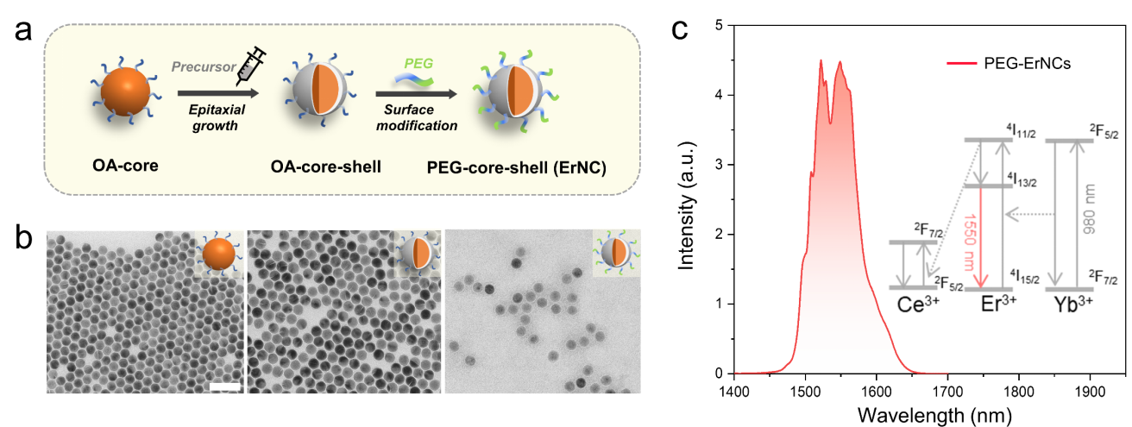
Figure S1. a, The preparation of 35 nm ErNCs. b, The TEM results of synthesized OA(olic acid)-capped core and core-shell ErNCs, and PEG-capped core-shell ErNCs from left to right, respectively. The doping concentration is 92% for Yb³⁺, 4% for Er³⁺ and 4% for Ce³⁺. Scale bar: 100 nm. c, The emission spectrum of the prepared PEG-capped core-shell structure ErNCs under a 980 nm continuous wave laser excitation. The insert illustrates the simplified energy transfer route among the doped Yb³⁺, Er³⁺ and Ce³⁺ ions for ~1550 nm emission.

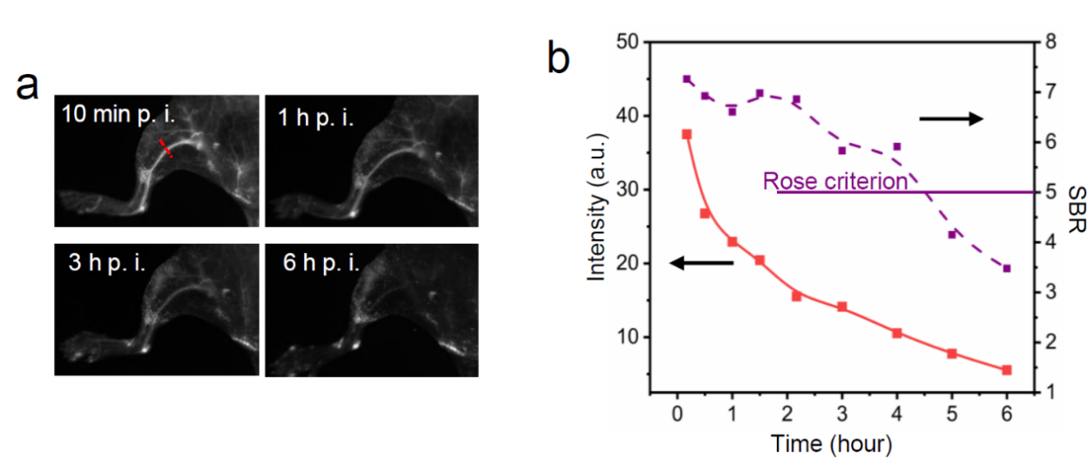
Figure S2. a, In vivo NIR-II imaging of blood vessel in mouse hindlimb at different time points after the injection of ErNCs (980 nm excitation, 38 mWcm⁻², 1319 nm long-pass, 60 ms). b, The time series of peak fluorescent intensity and signal to background ratio (SBR) along the same position represented by the red line in (a).
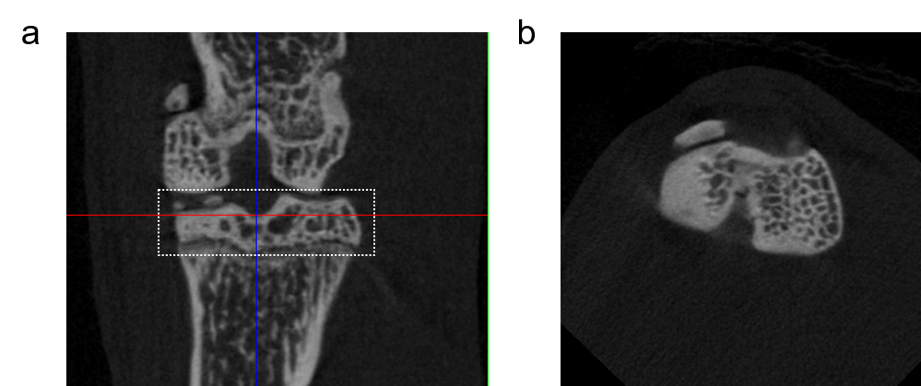
Figure S3. a, The subchondral bone in the dotted box confirmed by μCT. b, The cross-section view of the subchondral bone along the red line in (a).
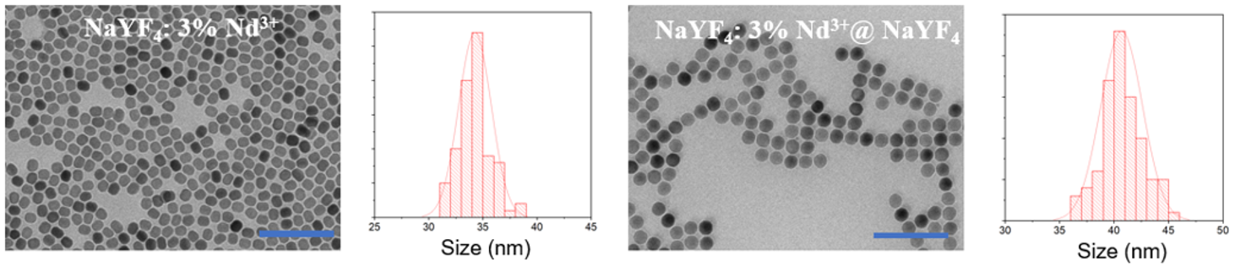
Figure S4. The TEM results and size distributions of synthesised NaYF₄: 3% Nd³⁺ and NaYF₄: 3% Nd³⁺@ NaYF₄ (NdNCs) nanocrystals. Scale bars: 200 nm.

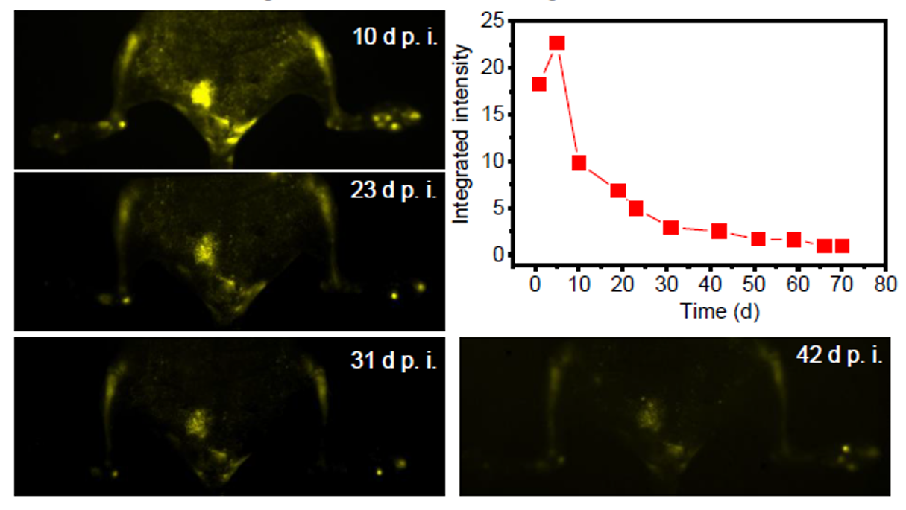
Figure S5. Long-term in vivo NIR-II imaging, and the fluorescent intensity change on mouse tibias from 1 to 71 d p. i. of ErNCs via tail vein (980 nm excitation, 38 mWcm⁻², 90 ms).

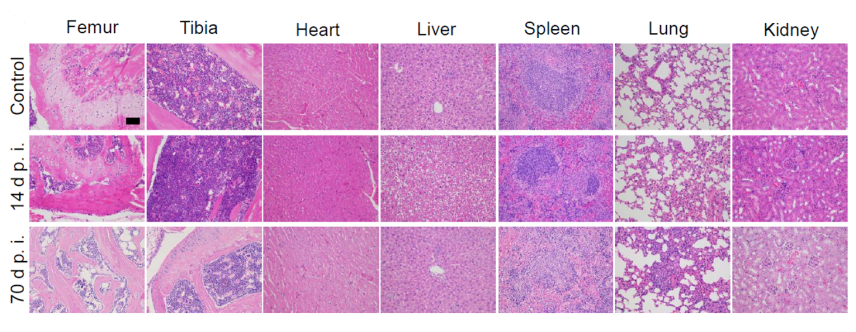
Figure S6. Hematoxylin and eosin (H&E) staining of the sectioned tissues (femur, tibia, heart, liver, spleen, lung, and kidney) from ErNCs treated mouse after 14 and 70 days of injection, and the PBS treated mouse as control. Scale bar: 100 μm.

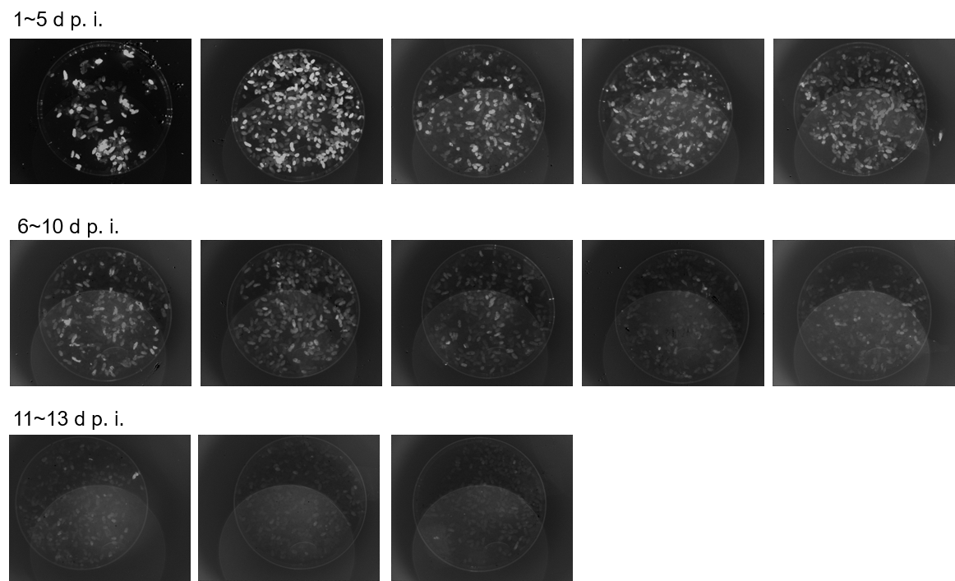
Figure S7. The long-term NIR-II imaging of all the feces excreted from the ErNCs-injected mice each day (980 nm excitation, 1 mWcm⁻², 1319 nm long-pass, 800 ms).

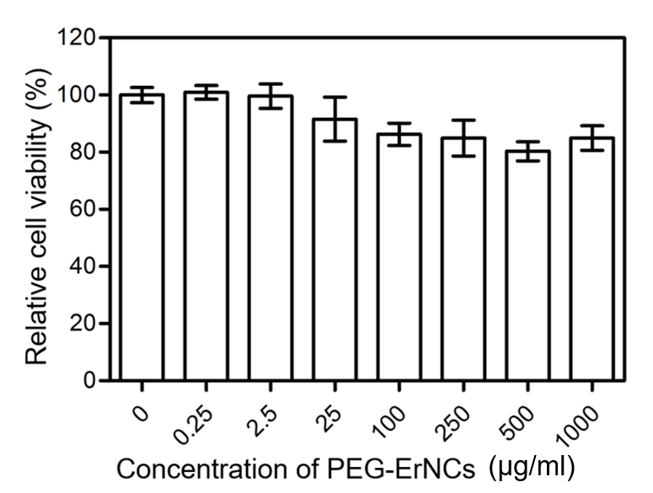
Figure S8. The cellular toxicity study of ErNCs in 4T1 cells.

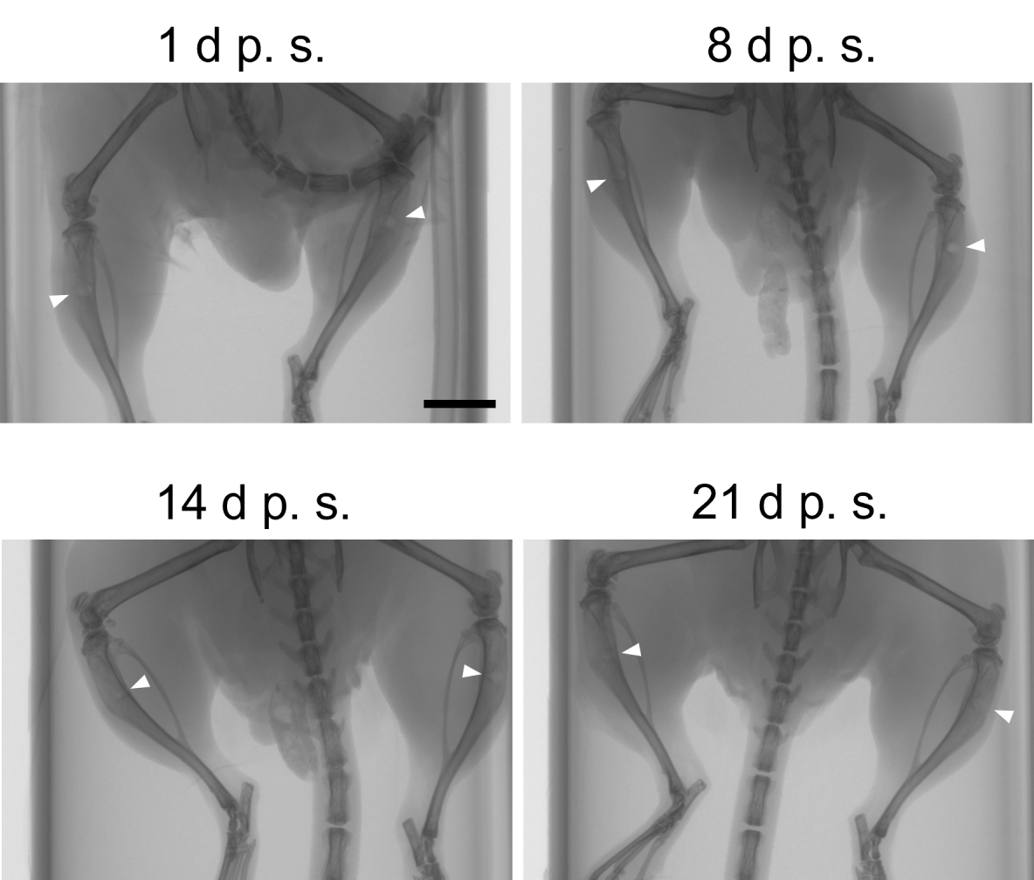
Figure S9. In vivo X-ray imaging on the ~1 mm tibia defects (arrowheads) on day 1, 8, 14 and 21 post surgery (p.s.). Scale bar: 5 mm.

Figure S10. In vivo NIR-II imaging on bone defects of 3 mice. These results were carried out within 10 days of the bone surgery making on the left tibias of the mice.

Figure S11. In vivo NIR-II and bright field imaging on the hind paws from normal mice, CIA model mice with mild RA, and the CIA model mice with severe RA, respectively.

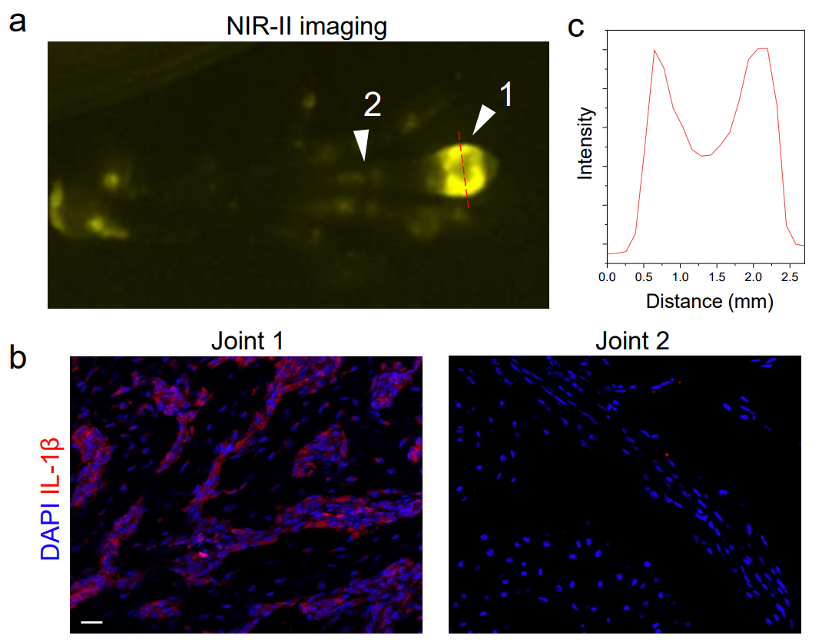
Figure S12. a, NIR-II imaging on the CIA mouse hind paw with early-stage arthritis. b, Immunofluorescence analyses of inflammation factor IL-1β in the synovium tissues from two toe joints (numbered arrowheads) in the hind paw in (a). Scale bar: 20 μm. c, The normalized intensity profiles along the cross section indicated by the dash line in (a).

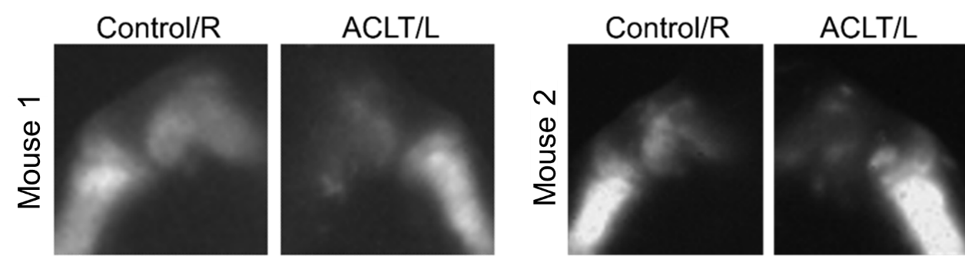
Figure S13. In vivo NIR-II imaging on the knee joints from two mice, the left knees of both Mouse 1 and Mouse 2 had an ACLT surgery 8 weeks ago, the right knees were untreated as control. (L: left, R: right)

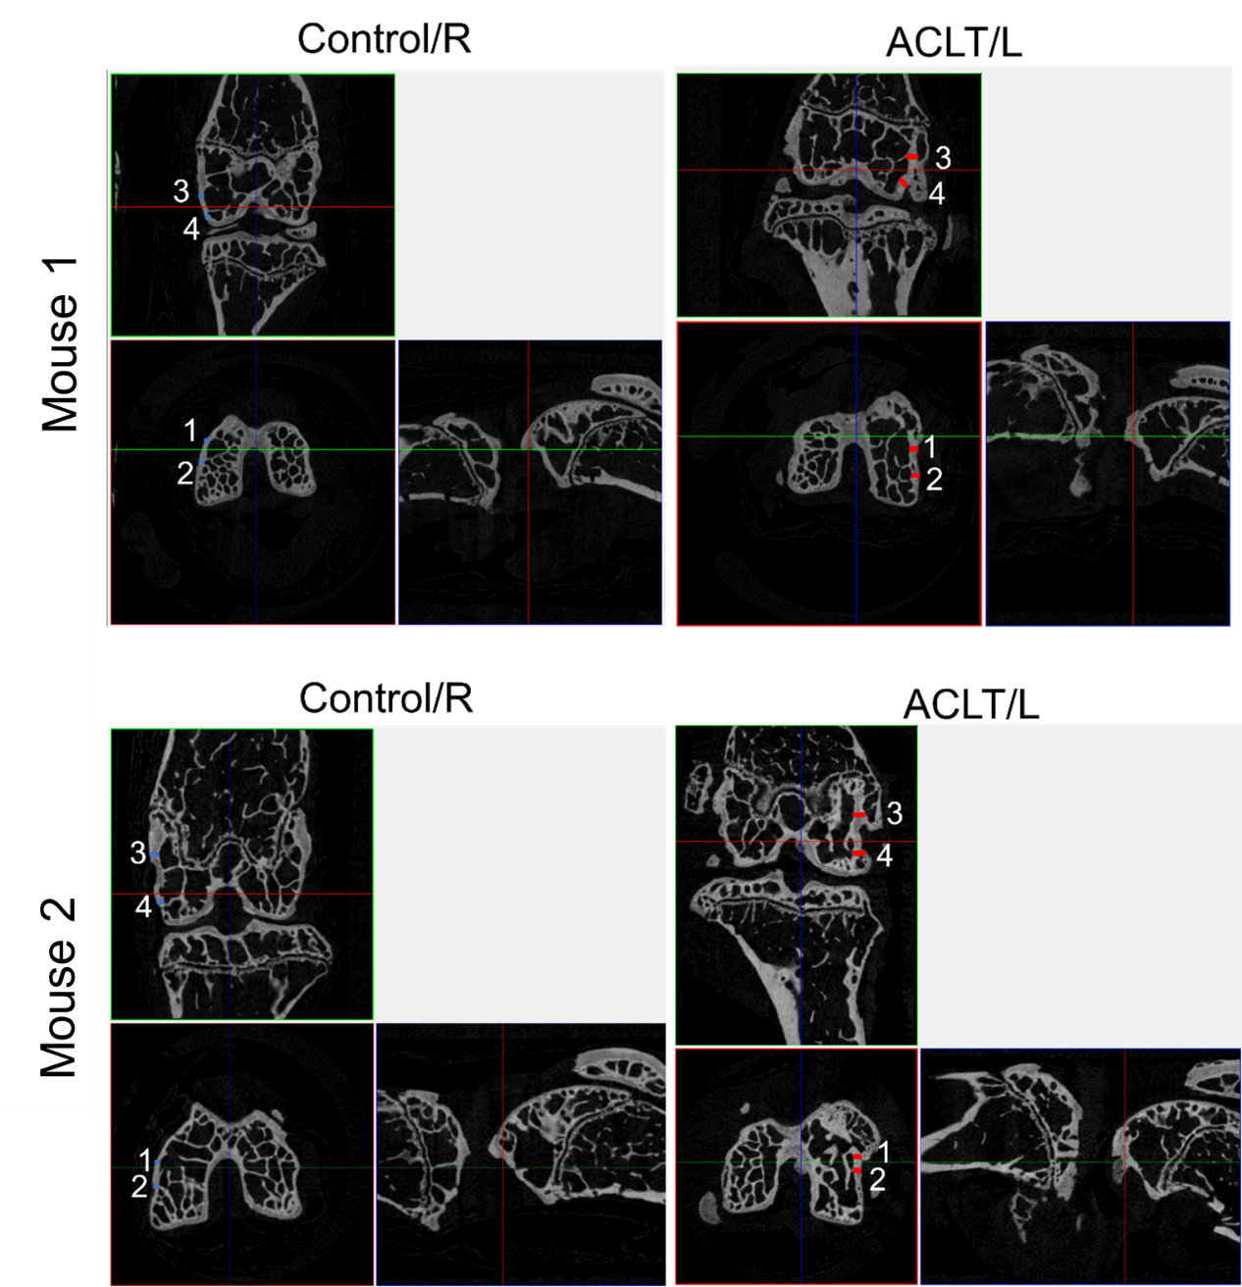
Figure S14. The ex vivo µCT cross-section images on the left and right femurs of Mouse 1 and 2 in Figure S13. The locations of the cross sections on the femurs are illustrated in Figure 5f.

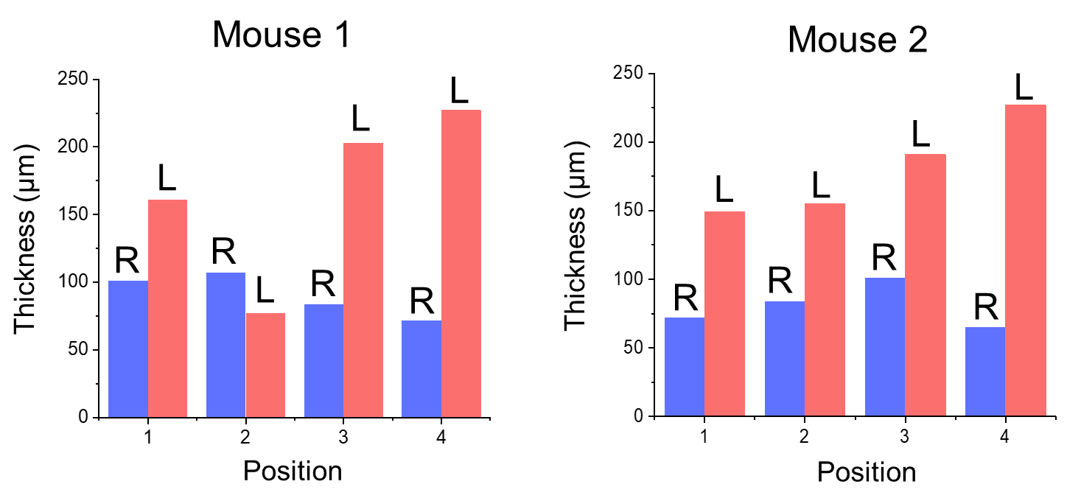
Figure S15. Comparison on the cortical bone thicknesses of 16 positions indicated by the numbered short lines (blue: Right femurs; red: Left femurs) in Figure S14. L: left, R: right.

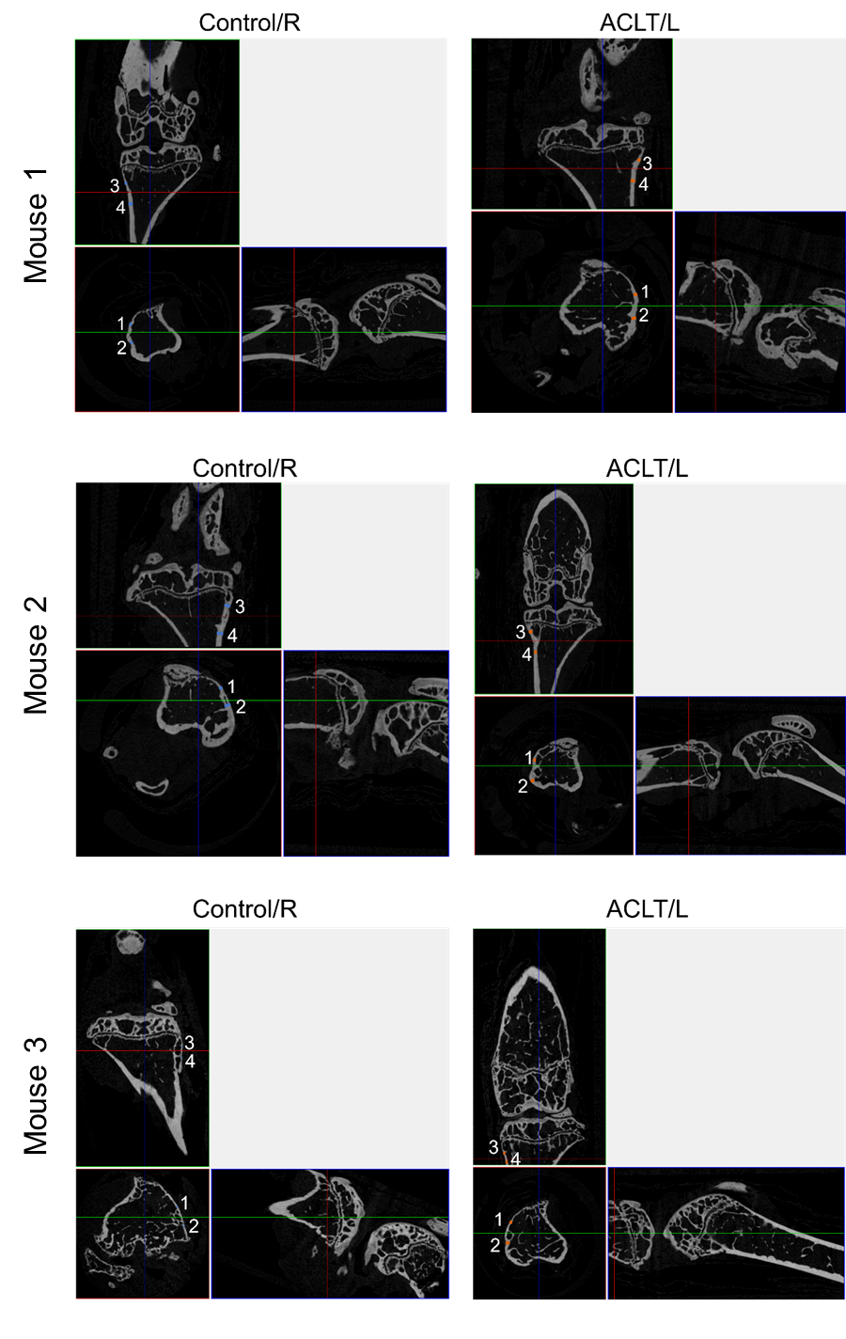
Figure S16. The ex vivo µCT cross-section images on the tibias of Mouse 1, 2 and 3. All the left knees had an ACLT surgery 8 weeks ago, and the right knees were untreated as control. L: left, R: right.
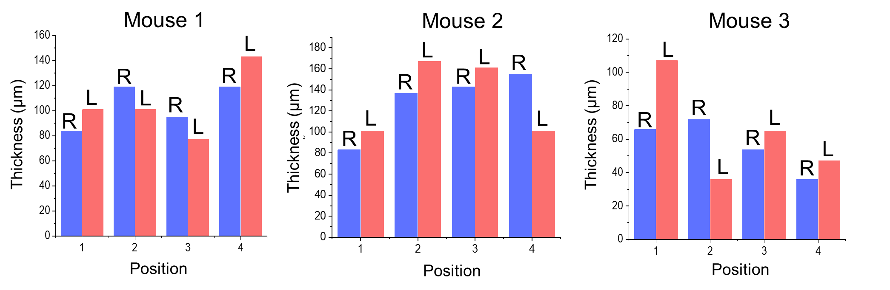
Figure S17. Comparison on the cortical bone thicknesses of 24 positions indicated by the numbered short lines (blue: Right tibias; red: Left tibias) in Figure S16 from all tibias of 3 mice.

Video 1
In vivo 3D NIR-II mouse tibia imaging by using ErNCs.

Video 2
Ex vivo 3D NIR-II mouse tibia imaging by using ErNCs.

References
1. Mi, C., Zhou, J., Wang, F., Lin, G. & Jin, D. Ultrasensitive Ratiometric Nanothermometer with Large Dynamic Range and Photostability. Chem. Mater. 31, 9480–9487 (2019).
2. Zhong, Y. et al. Boosting the down-shifting luminescence of rare-earth nanocrystals for biological imaging beyond 1500 nm. Nat. Commun. 8, 1–7 (2017).

