Supplementary information for
Cubic Fe-bearing majorite synthesized at 18-25 GPa and 1000 °C: implications for element transport, subducted slab rheology and diamond formation
Vincenzo Stagno^{1,9*}, Luca Bindi², Barbara Bonechi³, Steeve Greaux^{4,5}, Sonja Aulbach⁶, Tetsuo Irifune^{4,5}, Stefano Lupi^{7,10}, Giulia Marras¹, Catherine A. McCammon⁸, Manuela Nazzari⁹, Federica Piccirilli F.¹⁰, Brent T. Poe¹¹, Claudia Romano¹², Piergiorgio Scarlato⁹

¹Dipartimento di Scienze della Terra, Sapienza Università di Roma, Roma, Italy.
²Dipartimento di Scienze della Terra, Università di Firenze, Firenze, Italy.
³University of Manchester, Manchester, United Kingdom.
⁴Geodynamic Research Center, Ehime University, Matsuyama, Japan.
⁵Earth-Life Science Institute, Tokyo Institute of Technology, Tokyo, Japan.
⁶Goethe University, Institute for Geosciences; Frankfurt Isotope & Element Research Center (FIERCE), Altenhöferallee 1, 60438 Frankfurt, Germany.
⁷Department of Physics, Sapienza University of Rome, 00185 Rome, Italy.
⁸Bayerisches Geoinstitut, Bayreuth Universität, Bayreuth, Germany.
⁹Istituto Nazionale di Geofisica e Vulcanologia, Roma, Italy.
¹⁰CNR-IOM, Area Science Park, I-34012 Trieste, Italy.
¹¹Dipartimento di Scienze, Università di Chieti, Chieti, Italy.
¹²Dipartimento di Scienze, Università di Roma Tre, Roma, Italy.

*Corresponding author: Vincenzo Stagno (vincenzo.stagno@uniroma1.it).

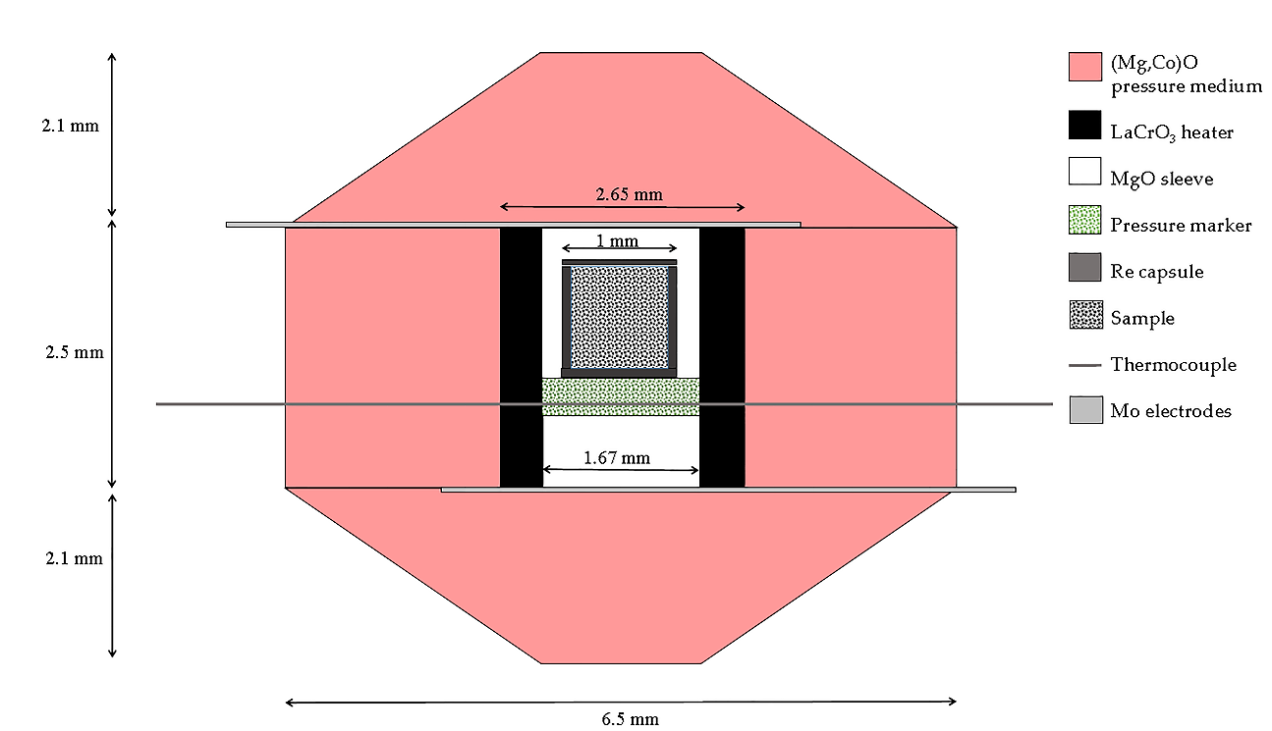

Figure S1. Schematic cross section of the cell assembly used in this study.

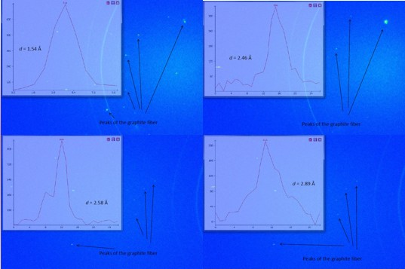
Figure S2. Selected single-crystal X-ray diffraction peaks of a majorite fragment extracted from run M82.

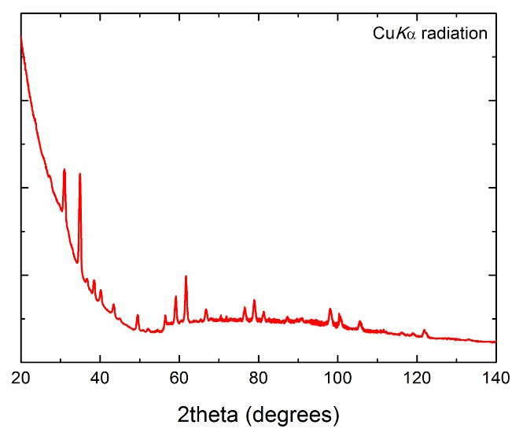
Figure S3. X-ray powder diffraction pattern collected from the majorite fragment (run M82). All peaks can be assigned to cubic majorite.
M82
M81
Figure S4. Fitted Mössbauer spectra showing the presence of Fe all as Fe³⁺. Spectra were fitted to one doublet.

Figure S5. Hyperfine parameters (center shift vs quadruple splitting) from our study plotted along with literature data for both natural^{28,48} and synthetic^{49,50} majorites.

Figure S6. Longitudinal and Shear velocities of MORB garnet solid solutions as a function of pressure, at 300 K. Plain lines represent our calculated velocities for [CaNaMg][SiAl]Si₃O₁₂ majorite (red), pyrolitic (blue) and MORB (thick black) majorite garnet, and an upper mantle MORB garnet (thin black) with an assumed composition (in wt.%) of 43% pyrope, 27% grossular and 30% almandine (e.g. ref. 60, Table 3, 5 GPa, 1200 °C). The open square and circle symbols represent the corresponding experimental data for the pyrolitic and MORB majorite garnet; Our calculated V_{P} and V_{S} are fairly consistent with those of experimental studies at P > 10 GPa, which corresponds to the depths of the mantle transition region.

Table S1. Chemical composition of the glass used as starting material.
This study  WM6.80 |  | Bobrov et al.³⁹
 | Wt%  Cpx [15] | Wt%  Di₄₀Hd₁₀Jd₅₀
SiO₂ | 54.60(42) | 56.55
MgO | 9.43(9) | 7.59
Al₂O₃ | 10.52(8) | 12
CaO | 15.30(17) | 13.20
FeO_{tot} | 3.36(4) | 3.38
Na₂O | 5.63(31) | 7.29
TiO₂ | 0.17(2) | -
Total | 99.01(44) | 100

Notes: In brackets is the number of points analysed by electron microprobe. WM6.80Cpx is synthetic glass with composition similar to natural Cpx reported by Stosch and Lugmair⁸⁵. Errors in parentheses are 1σ.

Table S2. Experimental run conditions.
Run | P (ton) | T(°C) | Duration (min) | Pressure marker | Phases
M81 | 400 | 1000 | 15 | rwd | Cubic majorite
M82 | 450 | 1000 | 30 | rwd + pv (+ per) | Cubic majorite
rwd = ringwoodite; maj = majorite; per = periclase; pv = Mg-perovskite

