Supplemental Information

Figure S1:

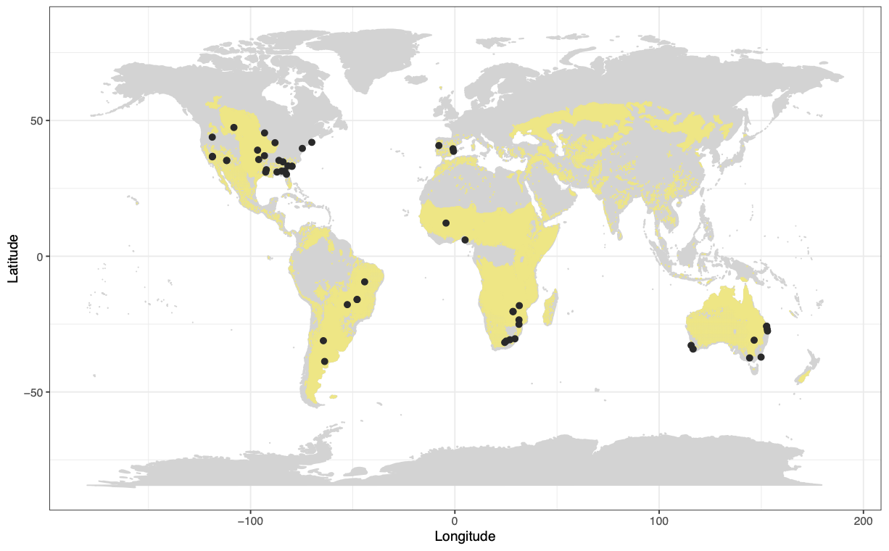
Figure S1: Distribution of semi-arid regions and savanna-grasslands with points identifying the locations of our sites in the meta-analysis. We determined the distribution of savanna-grasslands using the WWF ecoregions but excluded the Montane Grasslands & Shrublands category because this included steppe (https://www.worldwildlife.org/biomes/montane-grasslands-and-shrublands). Maps were downloaded on 1/1/2023. We also added the MODIS map of semidry shrub and savanna³⁷.

Figure S2:
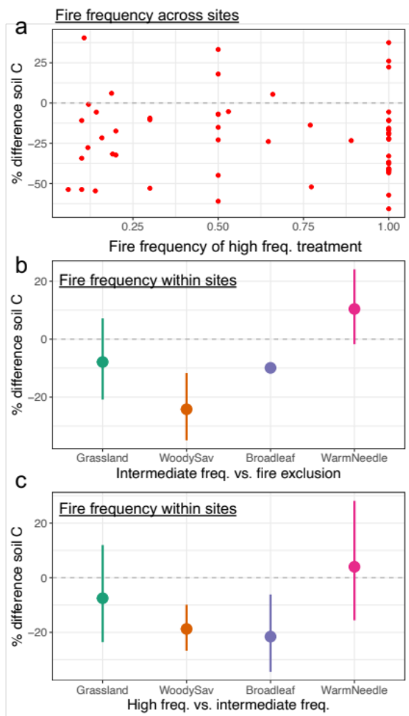

Figure S2: Fire frequency is not important at explaining the relative changes in soil carbon (C) across sites but it is important within sites. a) Each point is a site, displaying the percent difference in mineral soil C concentrations in the high frequency vs. unburned plots. b-c) comparisons using the intermediate fire frequency treatments on 34 sites containing the treatment levels illustrating the percent change in soil C between the higher frequency vs. lower frequency (i.e., negative illustrates lower carbon concentrations in the higher frequency treatment). Error bars are 95% confidence intervals. b) comparison of the intermediate frequency vs. unburned treatments; c) comparison of the high frequency vs. intermediate frequency treatments.

Figure S3: 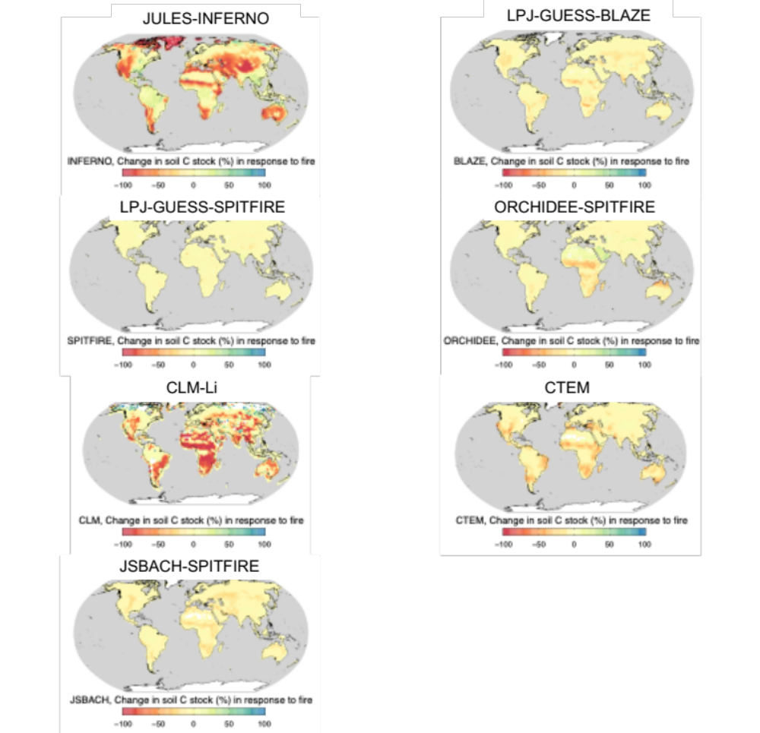
Figure S3: Global distribution of the percent difference in soil carbon stock between the fire on and fire off simulations. Spatial resolution of model output varies according to model structure.

Figure S4:
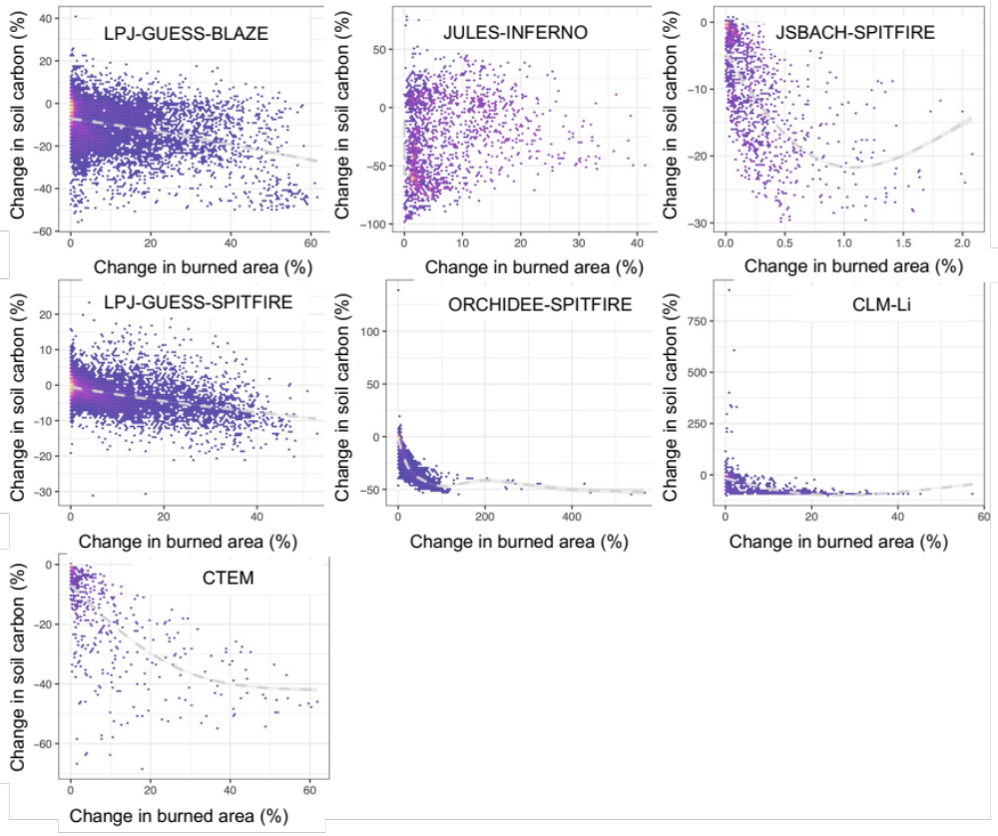
Figure S4: Model-based predictions of percent difference in soil carbon between the fire on vs. fire off simulations across global savanna-grasslands as a function of the burned area within a gridcell in the fire on scenario expressed as the percent of a gridcell that burns annually. Points are colored based on their densities (yellow indicates higher density). Dashed grey line is a generalized additive model fit to the model output.

Figure S5:
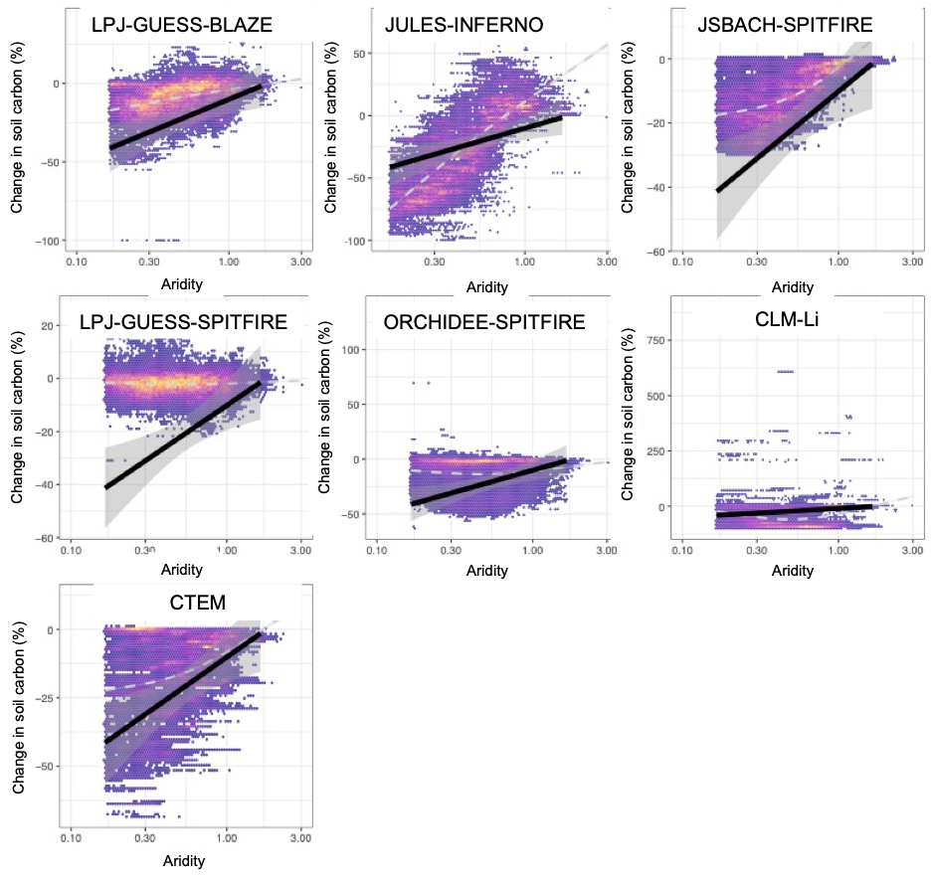

Figure S5: Model-based predictions of percent difference in soil carbon between the fire on vs. fire off simulations across global savanna-grasslands as a function of aridity. This comparison is meant to demonstrate the agreement in the direction of change in fire effects on soil C across the climate gradient, not direct comparisons of their quantitative values because of the fundamental differences in how model simulations are conducted compared to field experiments. Points are colored based on their densities (yellow indicates higher density). Dashed grey line is a generalized additive model fit to the model output and the solid black line is the relationship derived from empirical data with shaded grey illustrating +/- the standard error.

Figure S6:
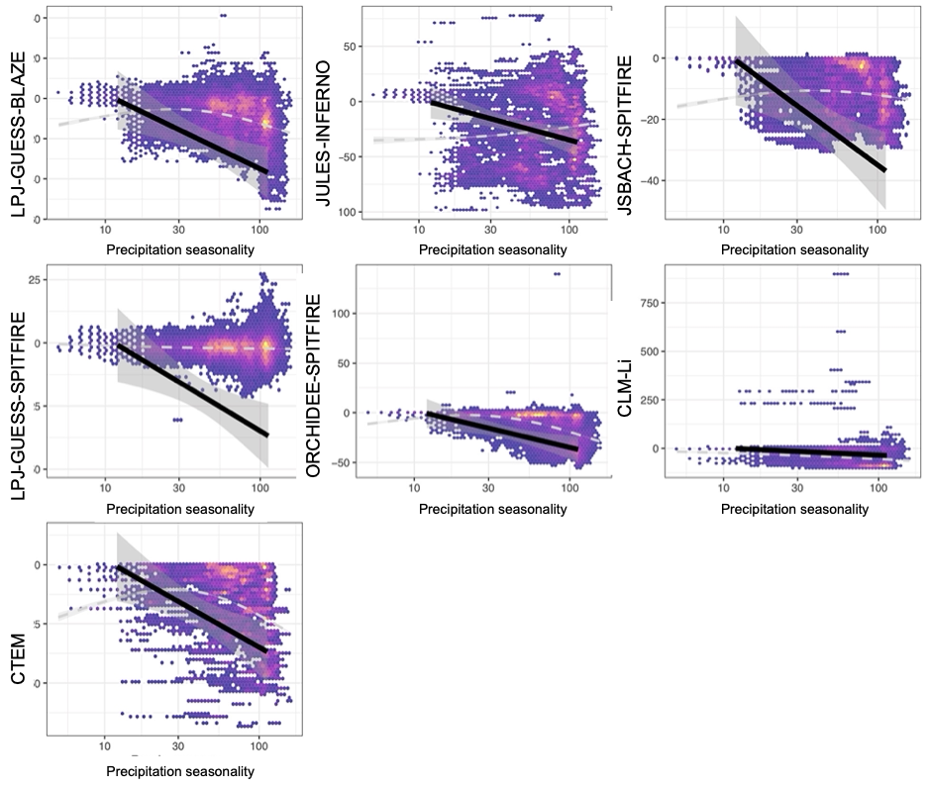
Figure S6: Model-based predictions of percent difference in soil carbon between the fire on vs. fire off simulations across global savanna-grasslands as a function of precipitation seasonality (coefficient of variation of annual precipitation across months). This comparison is meant to demonstrate the agreement in the direction of change in fire effects on soil C across the climate gradient, not direct comparisons of their quantitative values because of the fundamental differences in how model simulations are conducted compared to field experiments. Points are colored based on their densities (yellow indicates higher density). Dashed grey line is a generalized additive model fit to the model output and the solid black line is the relationship derived from empirical data with shaded grey illustrating +/- the standard error. Precipitation seasonality is the coefficient of variation of monthly precipitation within a year multiplied by 100.

Figure S7:

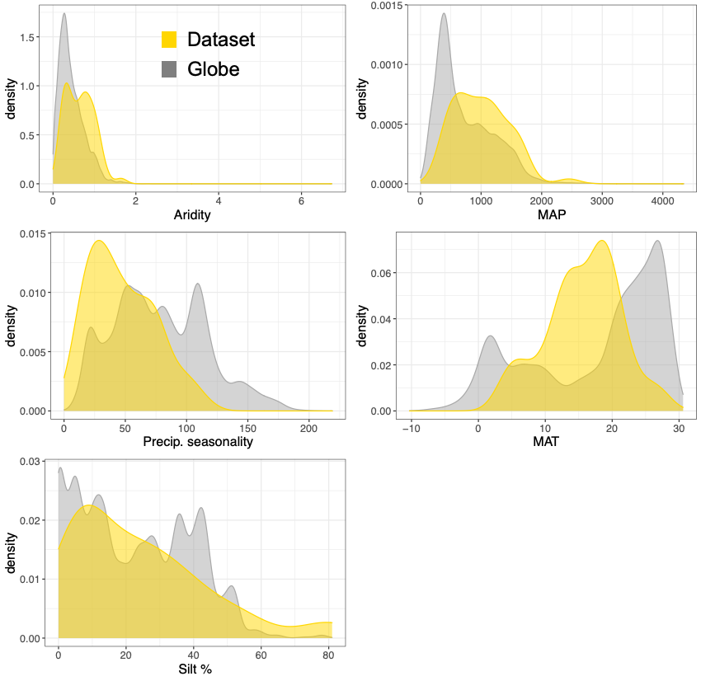

Figure S7: Density graphs of the distribution of variable values in our dataset used to train the model and the global values that we extrapolated our model across. MAP=mean annual precipitation in mm yr⁻¹, MAT= mean annual temperature in degrees Celsius. Aridity index is calculated as the ratio between precipitation and potential evapotranspiration. Precip. seasonality= Precipitation seasonality, which is the coefficient of variation of monthly precipitation within a year multiplied by 100. Sources for these values are explained in detail in the SI, but briefly the climate data come from WorldClim and soils data from the Harmonized World Soils Database v.1.2 (accessed 5/20/2020).

Table S1: List of sites. Full meta-data for each site are in Dataset 1. * indicates we either re-analyzed the soils or collected own samples from the experiment but the reference describes the experiment. The study duration is in years and max fire frequency is in terms of number of fires per-year of the high frequency treatment.

Site | Biome |  | Continent | Study duration | MaxFireFreq
Alapaha² | Needleleaf | WarmNeedle | NorthAmerica | 40 | 1.00
Bauple³⁸ | Broadleaf | Broadleaf | Australia | 44 | 0.89
BlueMountains³⁹ | Needleleaf | CoolNeedle | NorthAmerica | 17 | 0.20
Breaks⁴⁰ | Savgrass | WoodySav | NorthAmerica | 33 | 0.06
CedarCreek²⁴ | Savgrass | WoodySav | NorthAmerica | 53 | 0.77
ChacoSerrano²⁴ | Broadleaf | Broadleaf | SouthAmerica | 22 | 0.16
ChimneySprings*⁴¹ | Needleleaf | CoolNeedle | NorthAmerica | 42 | 1.00
DryPeachester⁴² | Broadleaf | Broadleaf | Australia | 22 | 0.50
Eden³⁹ | Broadleaf | Broadleaf | Australia | 34 | 0.10
Emas⁴³ | Savgrass | WoodySav | SouthAmerica | 12 | 0.50
EMBRAPA⁴⁴ | Savgrass | WoodySav | SouthAmerica | 21 | 0.50
Ferran⁴⁵ | Broadleaf | Broadleaf | Europe | 16 | 0.19
FESA/Wombat⁴⁶ | Broadleaf | Broadleaf | Australia | 23 | 0.30
FortHare/Alice⁴⁷ | Savgrass | Grassland | Africa | 16 | 1.00
Francis Marion⁴⁸ | Needleleaf | WarmNeedle | NorthAmerica | 30 | 1.00
HighlandRim⁴⁹ | Broadleaf | Broadleaf | NorthAmerica | 35 | 1.00
Hitchiti⁵⁰ | Needleleaf | WarmNeedle | NorthAmerica | 19 | 0.50
IBGE²⁴ | Savgrass | WoodySav | SouthAmerica | 64 | 0.30
IBGE2⁵¹ | Savgrass | WoodySav | SouthAmerica | 18 | 0.50
JosephJones⁵² | Savgrass | WarmNeedle | NorthAmerica | 15 | 0.50
Kings Canyon* | Needleleaf | CoolNeedle | NorthAmerica | 37 | 0.14
Kisatchie*⁵³ | Needleleaf | WarmNeedle | NorthAmerica | 37 | 0.53
Konza⁵⁴ | Savgrass | Grassland | NorthAmerica | 13 | 1.00
KrugerMopani*^{55,56} | Savgrass | WoodySav | Africa | 60 | 1.00
KrugerPretoriuskop*⁵⁷ | Savgrass | WoodySav | Africa | 63 | 1.00
KrugerSatara*⁵⁷ | Savgrass | WoodySav | Africa | 61 | 1.00
KrugerSkukuza*⁵⁷ | Savgrass | WoodySav | Africa | 62 | 1.00
Lakewood⁵⁷ | Needleleaf | WoodySav | NorthAmerica | 17 | 0.65
Lamto⁵⁸ | Savgrass | WoodySav | Africa | 25 | 0.30
LaPampa³⁵ | Savgrass | Grassland | SouthAmerica | 25 | 0.12
LimestoneFlats*⁵⁹ | Needleleaf | CoolNeedle | NorthAmerica | 48 | 1.00
Lombard⁴² | Broadleaf | Broadleaf | NorthAmerica | 12 | 1.00
Marondera*⁶⁰ | Savgrass | WoodySav | Africa | 54 | 1.00
MatoposClay⁶¹ | Savgrass | WoodySav | Africa | 50 | 1.00
MatoposSand²⁵ | Savgrass | WoodySav | Africa | 50 | 1.00
McKeeAlabama²⁵ | Needleleaf | WarmNeedle | NorthAmerica | 10 | 0.50
McKeeFlorida⁶² | Needleleaf | WarmNeedle | NorthAmerica | 20 | 1.00
Morton*⁶² | Broadleaf | Broadleaf | NorthAmerica | 23 | 0.66
Oakvale⁶³ | Savgrass | Grassland | Africa | 9 | 0.77
Okmulgee⁶⁴ | Broadleaf | Broadleaf | NorthAmerica | 19 | 0.50
RobertsPlots⁶⁵ | Needleleaf | WarmNeedle | NorthAmerica | 65 | 1.00
Santee⁶² | Needleleaf | WarmNeedle | NorthAmerica | 30 | 1.00
SavannahRiver⁶² | Savgrass | WoodySav | NorthAmerica | 38 | 0.14
Sequoia⁶⁶ | Needleleaf | CoolNeedle | NorthAmerica | 32 | 0.10
Tiogo²⁴ | Savgrass | WoodySav | Africa | 12 | 1.00
Toohey⁶⁷ | Broadleaf | Broadleaf | Australia | 20 | 0.20
Ukulinga⁶⁸ | Savgrass | Grassland | Africa | 52 | 1.00
UniversityMissouri⁶⁹ | Broadleaf | Broadleaf | NorthAmerica | 45 | 1.00
Valencia⁷⁰ | Needleleaf | Shrub | Europe | 28 | 0.11
Varzea⁷¹ | Needleleaf | Shrub | Europe | 34 | 0.12
WesternAU⁷¹ | Broadleaf | Broadleaf | Australia | 36 | 0.10
WetPeachester^{72,73} | Broadleaf | Broadleaf | Australia | 47 | 1.00
Yackelup⁷⁴ | Broadleaf | Broadleaf | Australia | 21 | 0.19

Table S2: Meta-regression model based on top model from model selection. Top section illustrates output from the model with the lowest AIC and the associated significance of the coefficients. Middle section illustrates the models within 2 AICs of one another and the change in coefficients with a (-) and (+) denoting the removal or addition of a variable from the top model. Bottom section illustrates variable importance from multi-model inference. Bolded variables in the weighted importance were included in the top model. Pseason=precipitation seasonality, MAT=mean annual temperature, MAP=mean annual precipitation, SiltPct= % silt content, ClayPct=% clay content, Trange= temperature range, PWQ=precipitation in the wet quarter. Duration=length of time that fire frequencies have been altered. Biome=savanna-grassland, broadleaf forest, needleleaf forest.

Top-model meta-regression output
n=53 | r²=0.82
Duration | QM(df = 1) = 11.1502, p-val = 0.0008
MAP | QM(df = 1) = 11.3209, p-val = 0.0008
Biome | QM(df = 2) = 16.2434, p-val = 0.0003
Pseason | QM(df = 1) = 11.0157, p-val = 0.0009
Aridity | QM(df = 1) = 13.8857, p-val = 0.0002
SiltPct | QM(df = 1) = 3.3243, p-val = 0.0683
MAT | QM(df = 1) = 12.0730, p-val = 0.0005
Model selection of top models within 2 AICs
AIC |  | Formula | New coef.
14.77 | C ~ 1 + Biome + Duration + SiltPct + MAT + MAP + Pseason + log(Aridity)
14.88 | C ~ 1 + Biome + Duration + ClayPct + SiltPct + Trange + MAP + Pseason + log(Aridity) |  |  | +ClayPct+Trange
15.90 | C ~ 1 + Biome + Duration + SiltPct + Trange + MAP + Pseason + log(Aridity) |  |  | +Trange, -MAT
15.99 | C ~ 1 + Biome + Duration + SiltPct + MAT + PWQ + log(Aridity) |  |  | -MAP

Weighted variable importance from model selection
Variable |  | Importance
Biome |  | 1
Duration |  | 1
Aridity |  | 0.99
Precipitation seasonality |  | 0.75
Mean annual precipitation |  | 0.69
Silt percent |  | 0.69
Mean annual temperature |  | 0.66
Annual temperature range |  | 0.43
Precipitation wet quarter |  | 0.43
Clay percent |  | 0.25
Fire frequency |  | 0.22
Temperature seasonality |  | 0.19

Table S3: Regression results from savannas with site-specific linear models between (top) total soil carbon (C) and $δ$¹³C, (middle) tree-derived C and total soil C, and (bottom)$δ$¹³C and fire treatment. Statistics are from the slope and standard error of the slope and the ANOVA tests of significance. The tree-derived C is calculated from mixing models (SI).

$δ$¹³C~ fire treatment
Site | Estimate | SE |  | T value | P value
KrugerSkukuza | -4.85 | 0.71 |  | -6.84 | 0.002
Breaks | -8.35 | 1.75 |  | -4.77 | 0.009
CedarCreek | -2.28 | 1.06 |  | -2.15 | 0.098
Hitchiti | 0.01 | 0.16 |  | 0.05 | 0.965
IBGE | -3.16 | 1.27 |  | -2.48 | 0.089
MatoposClay | -3.55 | 0.96 |  | -3.68 | 0.008
MatoposSand | -4.73 | 0.98 |  | -4.84 | 0.003
Tree-derived C ~ Total soil C
Site | Estimate | SE |  | T value | P value
KrugerSkukuza | 0.83 | 0.09 |  | 9.29 | <0.001
Breaks | 1.09 | 0.29 |  | 3.74 | 0.020
CedarCreek | 1.00 | 0.05 |  | 20.01 | <0.001
Hitchiti | 1.01 | 0.02 |  | 62.43 | <0.001
IBGE | 1.17 | 0.04 |  | 31.58 | <0.001
MatoposClay | 0.51 | 0.05 |  | 10.81 | <0.001
MatoposSand | 0.78 | 0.04 |  | 17.47 | <0.001

Supplemental Information

This section is partitioned into four parts.

1. Meta-analysis
2. Survey of savanna sites for soil carbon and δ¹³C
3. Fire Model Intercomparison Project simulations
4. Upscaling to global savanna-grasslands

1. Meta-analysis
The repeated burning treatments ranged from fire return intervals of 1-17 years (0.06-1 fires per-year). The mean duration that fire frequencies were altered was 33 years. The temperate and tropical sites with 9-65 years of manipulated fire frequencies. Sites spanned mean annual temperatures from 3.9-27.1°C, average of 15.6°C, mean annual precipitation from 342 to 2448 mm yr⁻¹, average of 995 mm yr⁻¹. Averages and ranges for soil properties are: carbon content=3.29% (range=0.565-9.37%), clay percent=18% (range=3-63%), silt percent=25% (range=2-81%), sand percent=57% (range=1-92%), bulk density 1.27 g cm⁻³ (range=0.48-1.72 g cm⁻³). Study design: 43 sites were experiments and 10 were from incidental fire histories.

1a. Study compilation and overview
Our methods were similar to previous meta-analyses of how fire affects soils by calculating a response ratio of soil carbon (C) in plots with different fire treatments within sites and then comparing responses across sites⁷⁵. To obtain data from the literature, we searched for studies that measured the response of mineral soils to repeated burning (completed in 05/2020). We used a threshold of plots experiencing at least two fires that had been running for a decade or longer. We made one exception for a site that had been running for nine years because it was in an ecosystem that was not well represented in the dataset.
We focused on the mineral soil because of our focus on understanding fire effects in drylands, where it dominates soil C storage pools. We analyzed data from the uppermost soil layers (<20 cm depth) because these are the most biologically active and likely to be the most responsive to burning. There is evidence that fire can alter soil C >20 cm deep in some ecosystems^{3,16}, suggesting our estimates could be conservative.
The majority of our sites were from fire manipulation experiments where fire treatments were prescribed (43 out of 53). The fire frequencies ranged from one fire every 17 years to one fire every year. The low fire treatments were usually complete fire exclusion. In some cases the authors note an incidental fire that burned through one of the fire exclusion plots, but these fires were mostly rare. One site was running for only 9 years⁷⁶, but we included this study because it came from a grassland that had received >5 fires and was one of the only sites in an arid region. Fire treatments were replicated at the landscape scale in all but 16 sites. Independent replicates of the fire treatments were generally defined based on the application of different fires (e.g., fire breaks separated the plots and the managers burned each plot separately).
In several sites, the plots had experience other types of land use prior to the establishment of the experiment. For example, many of the forested sites in the southeastern US were established on abandoned agricultural land or tree plantations. Other types of disturbances also occurred during the experiment such as intermittent drought and herbivory. We assume that there were no overarching biases in the land use history of the experiment that would drive our trends. Herbivory was clearly biased, however, with the African savanna sites exposed to browsing and grazing. We assume that these characteristics are important natural processes in the ecosystem (just as intermittent drought in many ecosystems) and thus included the sites in our analysis.
In addition to the literature search, we incorporated data from our own surveys of seven sites. Several of these sites replace previous measurements because we wanted to extend the timescale over which fire had been manipulated (e.g., in some cases plots had been surveyed in the 1990s and we re-surveyed them).

1a. Different sites and calculations from a previous meta-analysis and field surveys
Matopos studies: weighted the soil C under grasses vs. trees by the tree cover. Texture data are in ⁶⁴. Kruger: we used data from our own re-survey across all the plots in 2015. Morton, Hitchiti, Cedar Creek: re-analyzed the soil samples in our lab. Cedar Creek duration extended. Limestone & Chimney Springs: surveyed soils with our own sampling to extend the dataset by two decades. University Missouri: added data from Pellegrini et al. 2021⁷⁷. Wet Peachester: now from ²¹ because this extended the dataset.
1b. Soil texture
We compiled data on soil texture using either (i) measurements within the study site, (ii) extrapolations based on discrete soil classification (e.g., clay loam, sand, etc., http://www.fao.org/tempref/FI/CDrom/FAO_Training/FAO_Training/General/x6706e/x6706e06.htm). When percent texture did not add to 100, we used average clay, then silt and then took the difference with sand. In the cases where only clay was reported, we used the reported value of clay, mean silt in the texture class, and then subtracted out sand from 100. In the cases where texture was provided but class was not given, we used texture to assign it to a class.

1c. Bulk density
Bulk density was obtained using previously published values in ⁵², updated with new measurements in some of the sites from our resurveys, and used site-averages within soil types. Bulk density averages within soil types were taken from Part 618.7 in the USDA National Soil Survey Handbook³.

1d. Climate variables
We used WorldClim⁷⁸ to obtain climate variables for each site. In our model selection, we focused on variables related to growing season length and variability as well as water availability. Specifically, we analyzed mean annual temperature, annual temperature range, mean precipitation (mean annual, and broken down into the wettest and driest quarters), and precipitation seasonality (coefficient of variation of precipitation calculated with the standard deviation across months within a year divided by the annual precipitation, and multiplied by 100).
To integrate water and evaporative demand, we used an Aridity Index⁷⁹. Aridity was calculated from the WorldClim data based on data from 1950-2000. The aridity index is given as:
Aridity Index = (mean annual precipitation) / (mean annual potential evapotranspiration)
Potential evapotranspiration was calculated via the Hargreaves equation⁸⁰ (mm per-month) using the WorldClim data as input:

PET = 0.0023 * (extra-terrestrial radiation) * (mean temperature + 17.8) * (daily temperature range)^0.5
We divided the index by 10000.

Aridity classes are calculated from the UNEP World atlas of desertification, 2nd addition. Arid and semi-arid: 0<AI$≤$0.5; dry sub-humid: 0.5<AI$≤$0.65; humid: 0.65<AI$≤$0.75; hyper-humid: AI>0.75

1e. Imputed standard deviations
For nine of the sites, we imputed standard deviations. We did this by first calculating the co-efficient of variation across all the sites with reported standard deviations and then multiplying the coefficient of variation by the mean for the sites being imputed. Imputing standard deviations using values from studies included within the meta-analysis has been shown to be the most accurate⁸¹

1f. Meta-analysis statistics
All statistics were run in R ⁸². We calculated log response ratios on soil C concentrations in the high frequency plots divided by the concentrations in the unburned plots.
$$RR_{site1}=\ln\left(\frac{μ_{burn}}{μ_{unb}}\right)$$
To determine variable weights, we used the inverse of the variance within a site. We calculated the variance within each site by combining the variance ($σ$), sample size (n), and sample means ($μ$) for each site.
$$var_{site1}=\frac{σ_{burn}^{2}}{n_{burn}μ_{burn}^{2}}+\frac{σ_{unb}^{2}}{n_{unb}μ_{unb}^{2}}$$
We then calculated the overall effects, 95% confidence intervals, and their significance using multivariate meta-analysis models (rma.mv) in the metaphor package⁸³.
To evaluate the important predictors of fire effects on soil C, we performed model selection on linear meta-analysis models using the glmulti package⁸⁴ with the log response ratio as the predicted variable and environmental variables as the predictor variables. Models were fit using maximum likelihood estimation. For this analysis we only considered first-order effects and not interactions between environmental variables. To evaluate the top model, we first extracted the models with the lowest corrected Akaike Information Criterion within a value of 2. We calculated variable importance by summing the weights of the models that the variable occurred in. Sometimes a cutoff of 0.8 is used to delineate important vs. unimportant variables. Here, however, the top model contained several variables that were not above this cutoff, making it less straightforward to evaluate whether a variable was important. Consequently, we tested for variable significance in the top model (which included the variables that had an importance <0.80), which is reported in the main text. We allowed for aridity and precipitation to both be in the top model because they had a relatively low Pearson correlation coefficient ($σ$=0.34).
We compare ‘low’ and ‘high’ values of environmental covariates using the 1st and 3rd quartiles of the covariates, respectively.

2. Survey of savanna sites for soil carbon and $δ$¹³C
In 7 of the sites included in the meta-analysis, $δ$¹³C was measured in combination with soil C (Breaks, Cedar Creek, Hitchiti, IBGE, Satara, MatoposClay, and MatoposSand). These sites spanned tropical and temperate regions in North and South America and Africa. The savannas all contained C4 grasses, which allowed us to use $δ$¹³C values to partition tree vs. grass biomass contributions to soil C (although some contained a mix of C3 and C4 grass). The absolute number of soil samples collected varied across sites because of differences in tree cover, but we used plot-level averages in the analysis. Duration of fire frequency experiments ranged from 25-64 years. The ratio of ¹³C to ¹²C is assumed to be relatively unchanged by fire compared to to the difference between C3 vs. C4 photosynthetic pathways^{25,35,85}.
We used isotopic mixing models to calculate the proportion of soil C derived from grasses vs. trees. We performed these calculations in savanna sites where C4 grasses comprised a large proportion (if not all) of herbaceous biomass. We assumed a C4 signature of -15‰ and C3 of -28‰ for the sites where plant isotope values are not available. In other cases, site-specific values were used²¹.
We generated a two end-member mixing model to calculate the relative contribution of trees vs. C₄ grasses, where x denotes the proportion coming from trees.
$$δ^{13}C_{BulkSoil}={x*δ}^{13}C_{Tree Biomass}+{(1-x)*δ}^{13}C_{Grass Biomass}$$
We did not necessarily expect the functional form of the curve between soil $δ$¹³C and total soil C to be linear so we fit generalized additive models with a penalized spline. The maximum degrees of freedom was set to k=3. All fitting was done using the mgcv package in R^{24,76,86}.
We tested the overall effect of fire on $δ$¹³C values across sites using a mixed-effects model with site as a random effect. Within each site, we tested for significant effects using linear models (Table S3).

3. Fire Model Intercomparison Project simulations
The empirical spatial pattern and climate relationships of fire’s impact on soil carbon was compared to that simulated by a set of fire-enabled global vegetation models. Simulated global soil carbon output from seven global fire-vegetation models was obtained from a set of standardized simulations provided by the Fire Model Intercomparison Project (FireMIP^{34,87}):
Two sets of simulations were used, first a fully transient simulation with changing climate, population density, land use and [CO₂] and another identical sensitivity experiment in which fire was switched off. The difference between both runs indicated the long-term impact fire has on soil carbon as simulated by each model. Climate, land use, population density and [CO₂] forcing data was standardized so that inter-model differences can be traced back to differences in model structure and parameterization and not to differences in forcing data. Of the models we used, CLM-Li and LPJ-GUESS-SIMFIRE-BLAZE had nitrogen cycles.
A spin-up until the slowest C-pool was in equilibrium was performed for each run, during which climate was recycled over the 1901-1920 period and all other forcing data were kept constant at their initial value. After spin-up the models were forced by time varying land use, population density and [CO₂] (1700-2013) and climate (1901-2013). Two models slightly deviated from this protocol by starting their transient simulations later (CLM: 1850 & CTEM: 1861) but this should have minimal impact on the results used here. Soil carbon output averaged over the last two decades of each model’s simulations was used for analysis. More detailed information about the fire on/off simulations can be found in refs ^{7,87}. For our statistical analyses, we merged the WorldClim dataset with the model output for direct comparability between the spatial trends in our empirical data. Because we are interested in the factors that determine the impact of fire on soil C, we filtered the data to only include gridcells that had non-zero burned area.
All the DGVMs we used in this study explicitly simulate litter burning. The models do not simulate SOC burning except for CLM-Li. CLM-Li simulates SOC burning only over peatlands. However, for consistency with the other models, we did not consider its impact on SOC in the FireMIP simulations.

4. Upscaling calculations
We determined the distribution of savanna-grasslands using the WWF ecoregions but excluded the Montane Grasslands & Shrublands category because this included steppe (https://www.worldwildlife.org/biomes/montane-grasslands-and-shrublands). Maps were downloaded on 1/1/2023.
We included the main environmental variables determined in our main meta-regression: percent silt, precipitation seasonality, mean annual temperature, mean annual precipitation, and aridity. Climate data were acquired from the same sources as we described above. Percent silt data were taken from the Harmonized World Soils Database v.1.2 (accessed 5/20/2020). We used a 17-year duration of fire treatments based on the 1998-2015 GFED4 records.
We then applied our statistical model to each gridcell across savanna-grasslands. We determined the potential significance of cells using the 95% confidence intervals of the model fit. We present a comparison between global data extrapolated over and data used to fit the statistical model in Figure S10. For our calculations, we restricted our analysis to only include environmental conditions covered by our dataset used to build the statistical model.
Areas that were experiencing either gains or declines in burned area were determined using remote sensing data on fire occurrences from 1998-2015 from a previously published dataset⁸⁸. For the declines in burned area we re-calculated the response ratios in terms of fire exclusion/high frequency to illustrate the potential gain in soil C and transformed them to percent differences; this was repeated for the cases where fire frequency increased. These were then multiplied to the total SOC stocks in each gridcell calculated from the Harmonized World Soils Database v.1.2⁸⁸ to transport a percentage to a stock change.

