6WEY[22], [23] High-resolution structure of the SARS-CoV-2 NSP3 Macro X domain  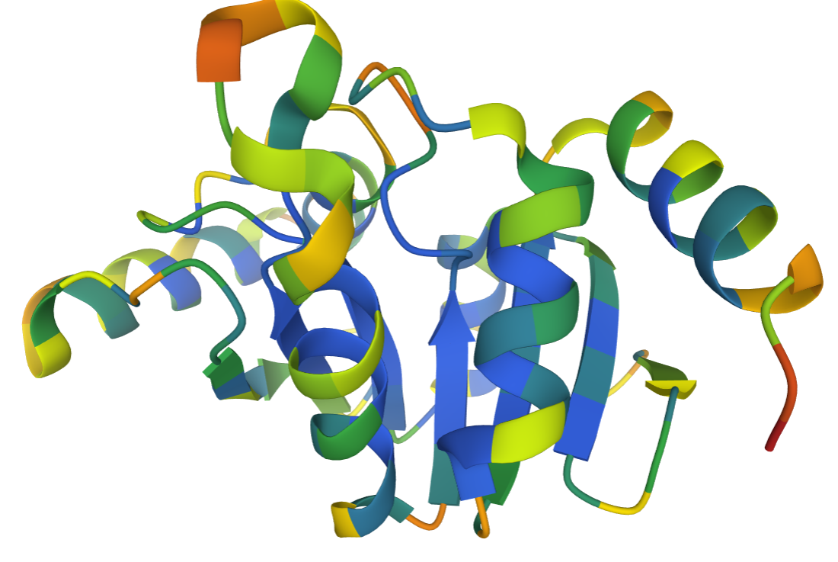 | 6Y2F[22], [23] Crystal structure of the complex resulting from the reaction of SARS-CoV-2 (2019-nCoV) main protease  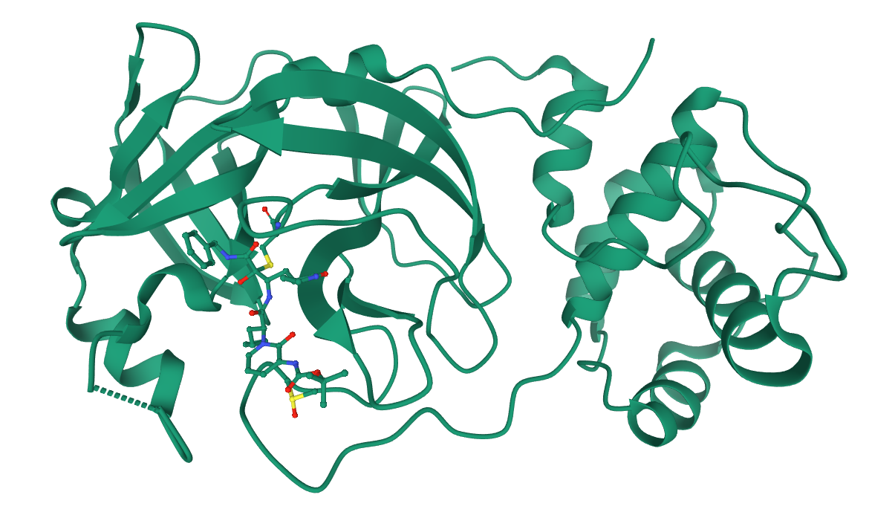
6WZO[25] Structure of SARS-CoV-2 Nucleocapsid dimerization domain, P1 form  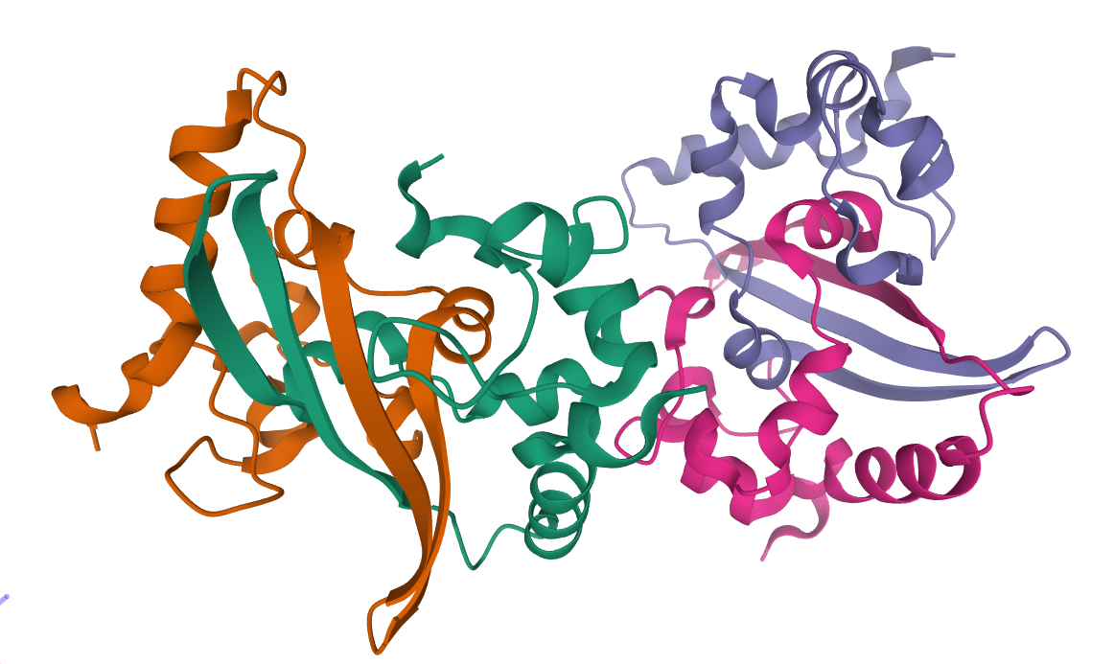 | 6VSB[22], [23] Prefusion 2019-nCoV spike glycoprotein with a single receptor-binding domain up 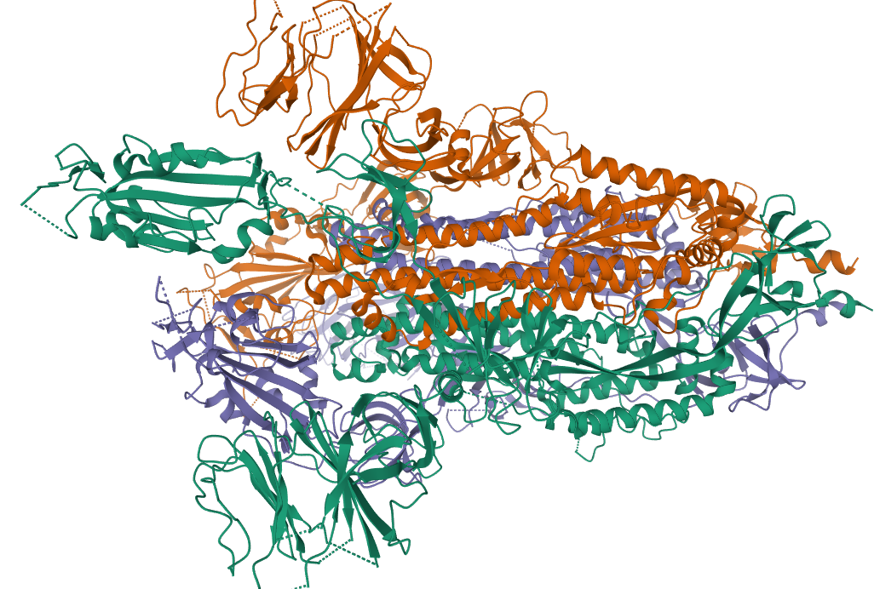
7BZ5[25] Structure of COVID-19 virus spike receptor-binding domain complexed with a neutralising antibody 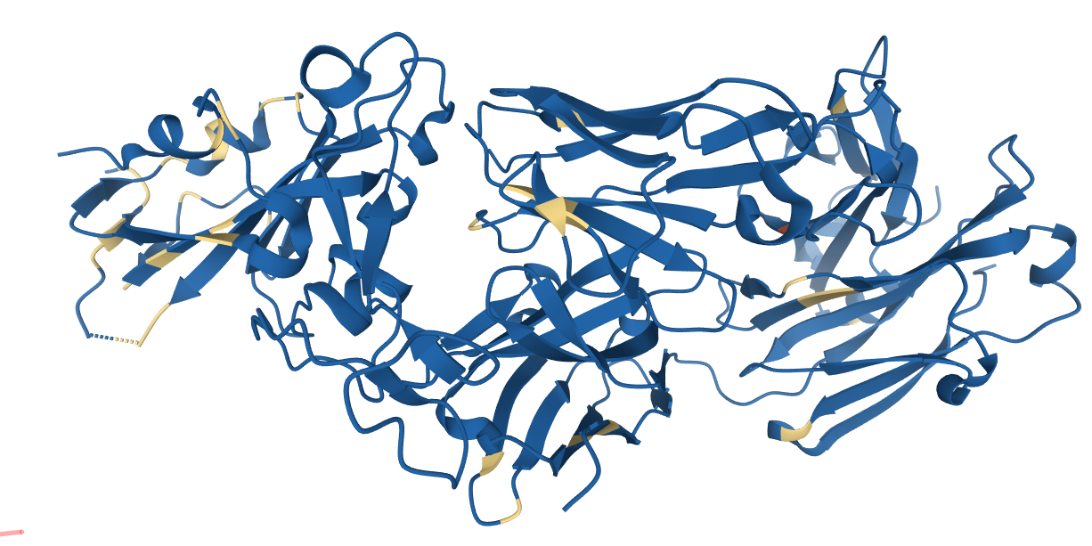 | 6M1V[22], [23] Crystal structure of the post-fusion core of 2019-nCoV S2 subunit 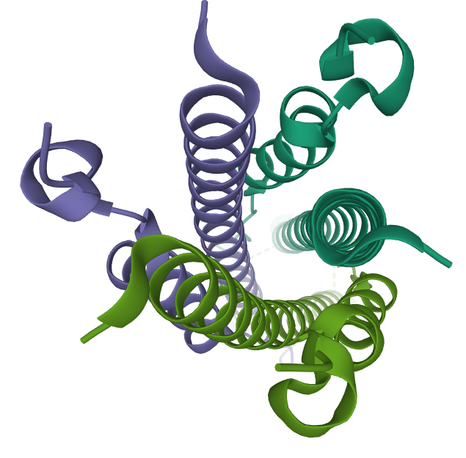
6VW1[25]

Structure of SARS-CoV-2 chimeric receptor-binding domain complexed with its human receptor ACE2
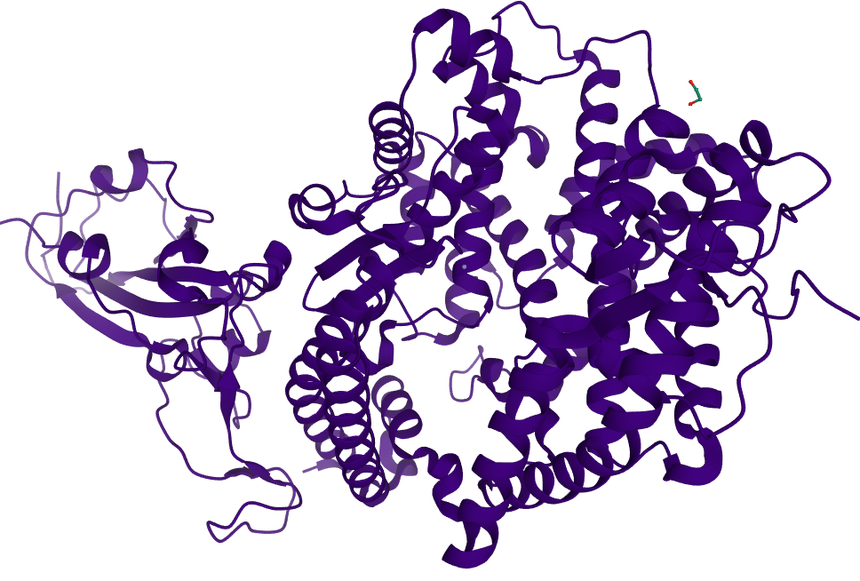
Table.1: Various Corona viral receptors selected for the in-silico analysis, their PDB id, name of the receptor as per the RCSB PDB website and the 3D structure of the proteins

S.No | PDB ID and Description | Resolution (Å) | Organism | Expression System | Mutation
1 | 7BZ5 Structure of COVID-19 alpha variant virus spike receptor-binding domain complexed with a neutralising antibody  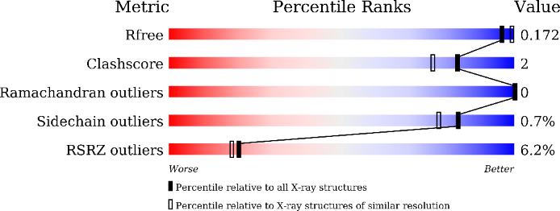 | 1.84 | Severe acute respiratory syndrome coronavirus 2, Homo sapiens | Homo sapiens | No
2 | 7V7V Cryo-EM structure of the SARS-CoV-2 Delta variant , Spike glycoprotein  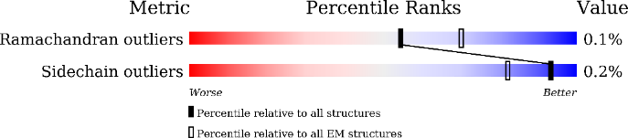 | 3.1 |  | Homo sapiens | Yes
3 | 7T9J Cryo-EM structure of the SARS-CoV-2 Omicron spike protein  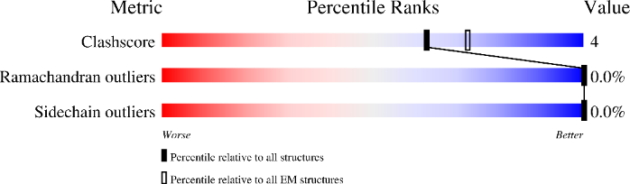 | 2.79 |  | Homo sapiens | Yes
Table.4: Selected proteins of multi variants of Corona Viral Spike protein
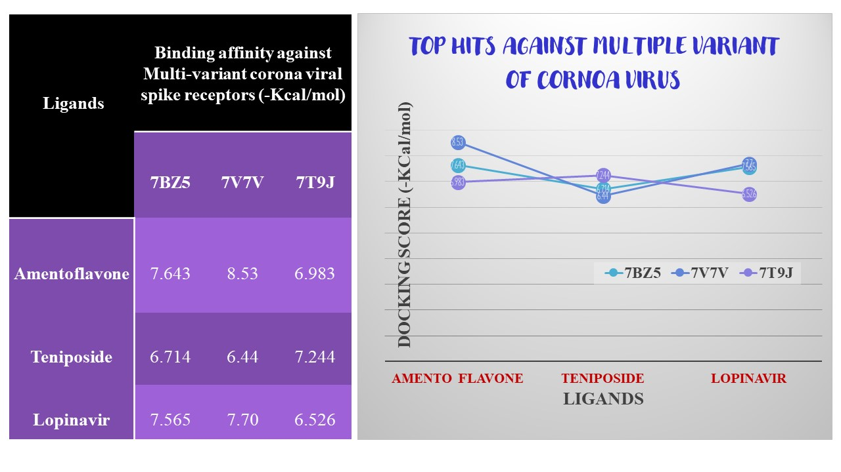
Table.5: Molecular docking studies of multi-targeting molecules against multiple variants of corona viral spike protein

